Patients With Devices: Prevent Infections During Your Hospital Stay PATIENT
Section 10-7
BATHE Daily With Chlorhexidine (CHG) Cloths

During your stay, bathing will occur every day with a special antiseptic (CHG) that removes germs and prevents infection better than soap and water.
Each packet has six cloths to be used on all skin areas as shown below:
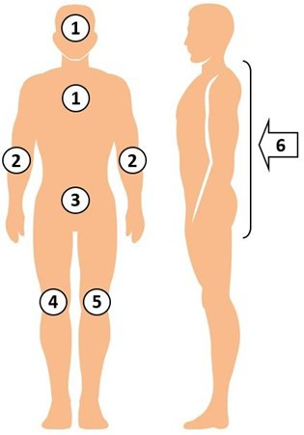

- Avoid eyes and ear canals.

Take a CHG Bed Bath

Bathing With CHG Cloths
- Use CHG every day. Starting on admission day works best to remove germs before insertion of urinary catheters or intravenous and other lines, and before procedures/ surgery.
- These no-rinse cloths are your protective bath. The CHG continues to get rid of germs for 24 hours.
- Use all six cloths. More, if needed.
- Firmly massage on all skin areas to ensure deep cleaning of skin.
- Clean over non-gauze dressings.
- Your nurse will clean parts of lines, tubes, and drains nearest the body.
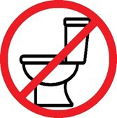

Protect Yourself Every Day

Important Points and Reminders
- CHG is proven to work better than soap and water to get rid of germs.
- Skin may feel sticky for just a few minutes due to lotion or aloe vera in the cloths. This will go away once skin completely dries.
- Do not rinse. Once massaged onto skin, CHG works to kill germs for 24 hours.
- Be thorough. Ask for help for hard-to-reach areas, backside, around devices.
- CHG is safe on rashes and wounds that are not very large or deep.
- Clean lines, drains, and tubes 6 inches closest to the body. Ask for help, if needed.

Clean All Skin Areas, With Attention to:
- Neck
- All skin folds
- Skin around all devices (tubes/drains)
- Wounds and open skin
- Armpits, groin, between fingers/toes

