Patients With Devices: Prevent Infections During the Hospital Stay STAFF
Section 10-3
Basin Bed Bathing With Chlorhexidine (CHG) Liquid

Bathe hospital patients with devices every day with a special antiseptic

(CHG) to help remove germs and prevent infection. Six cloths should be applied as below:
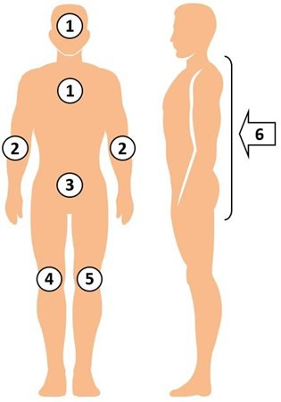

- Use all six cloths. Use more, if needed.
- Clean all skin. Avoid eyes and ear canals.
- Tell patient this is their protective bath.

Basin Bath Instructions
- Prepare one 4 oz bottle of 4% liquid CHG, a bed basin, and six disposable cloths (more if needed).
- Dispense one 4 oz bottle of 4% CHG liquid into basin.
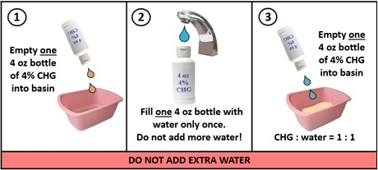

- Fill one 4 oz bottle with water and dispense into basin. Do not overdilute. Use equal parts water to CHG.
- Goal is to make 2% CHG liquid.
- Soak cloths in basin and wring before use. Do not put back in basin after use.
- Firmly massage skin with wipes.
- Discard cloths into trash. Do not flush.
- Allow CHG to air dry. Do not wipe off.

Clean All Medical Devices
- CHG replaces soap and water for showering.
- CHG is better than soap and water at removing germs and works for 24 hours.
- CHG is safe to use on normal skin and on surface wounds, rashes, and burns to remove germs.
- Your enthusiasm is the greatest predictor of patients wanting to use CHG.

Clean All Skin Areas, With Attention
- Neck (front and back)
- All skin folds
- Skin around all devices (line/tube/drain)
- Wounds, unless deep or large
- Armpits, groin, between fingers/toes

Clean All Medical Devices
CHG is safe on devices.
- Clean skin around device, clean over non-gauze dressings.
- Use clean part of cloth to clean device itself to remove bacteria. Be sure to clean the 6 inches of any line, tube, or drain that are closest to the body.

