Patients With Devices: Prevent Infections During the Hospital Stay STAFF
Section 10-1
BATHE Daily With Chlorhexidine (CHG)

Bathe hospital patients with devices every day with a special antiseptic

(CHG) to help remove germs and prevent infection. Six cloths should be applied as below:
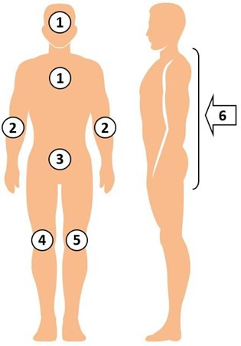

- Use all six cloths. Use more, if needed.
- Clean all skin. Avoid eyes and ear canals.
- Tell patient this is their protective bath.
- Encourage bathing every day.

Reminders
- CHG is better than soap and water at removing germs and works for 24 hours.
- CHG replaces soap and water for bathing.
- CHG is safe to use on normal skin and on surface wounds, rashes, and burns.
- Skin may feel sticky for just a few minutes until fully dry due to lotion or aloe vera in the cloths.
- Patients who self-bathe need direction on how to apply CHG thoroughly.
- Help patient clean 6 inches of all lines, tubes, and drains closest to the body.
- Your enthusiasm is the greatest predictor of patients wanting to use CHG.

Clean All Skin Areas
Pay special attention to:
  - Neck (front and back)
  - All skin folds
  - Skin around all devices (line/tube/drain)
  - Wounds unless deep or large
  - Armpits, groin, between fingers/toes
  - Safe on perineum, including female labia and genital surface

Clean All Medical Devices
- CHG is safe on devices.
- Clean skin around device. Clean over non-gauze dressings.
- Use clean part of CHG cloth to clean device itself to remove bacteria. Be sure to clean the 6 inches of any line, tube, or drain closest to the body.
- Allow CHG to air dry. Do not wipe off.

Bathing With CHG Cloths
- Firmly massage to clean skin. CHG will kill germs for 24 hours if applied well.
- Use only CHG-compatible lotions.
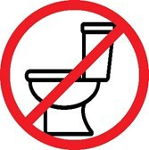
- Dispose of CHG cloths in a regular trash bin. Do not flush in commode.

