Patients With Devices: Prevent Infections During the Hospital Stay STAFF
Section 10-2
Shower With Chlorhexidine (CHG)

Shower hospital patients with devices every day with a special antiseptic (CHG) to help remove germs and prevent infection. Apply as shown below:
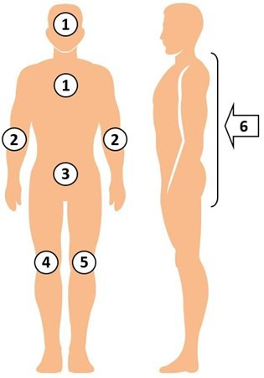

- Clean all skin. Avoid eyes and ear canals.
- Tell patient this is their protective bath.

Reminders
- CHG replaces soap and water for bathing.
- CHG is better than soap and water at removing germs and works for 24 hours.
- CHG is safe to use on normal skin and on surface wounds, rashes, and burns.
- Encourage showering every day.
- Use only CHG-compatible lotions.
- If barrier protection is needed, apply CHG and then apply barrier protection.
- Patients who self-bathe need direction on how to apply CHG thoroughly.
- Post-shower, unwrap devices and use CHG to clean dressings and the 6 inches of all lines, tubes, and drains that are closest to the body.
- Your enthusiasm is the best predictor of patients wanting to use CHG.

Clean All Skin Areas
Pay special attention to:
  - Neck (front and back)
  - All skin folds
  - Skin around all devices (line/tube/drain)
  - Wounds unless deep or large
  - Armpits, groin, between fingers/toes

Showering With CHG Soap
- Wrap all devices (e.g., central lines and midlines), as needed, to protect from water in shower.
- Rinse body with warm water.
- Wash hair and face with CHG.
- Avoid getting into eyes and ear canals.
- Turn off water, lather non-cotton cloth or mesh sponge with plenty of CHG.
- Massage CHG onto all skin areas.
- Leave soapy lather on skin for 2 minutes before rinsing.
- After shower, unwrap devices and perform the following with a single packet of two 2% CHG cloths:
- Clean the 6 inches of ALL lines, tubes, and drains (e.g., central lines, midline catheters, chest tubes, surgical drains, G-tube/J-tube, urinary catheter, rectal tube) that are closest to the body.
- Wipe over non-permeable dressings. CHG is safe on devices and should be used over non-gauze dressings.

