MRSA Carriers With Devices: Prevent Infections During the Hospital Stay STAFF
Section 10-4
How To Apply Nasal Mupirocin

Apply nasal mupirocin ointment twice daily for 5 days to all adult non-ICU patients with medical devices (e.g., central lines, midline catheters, lumbar drains) who are known to be methicillin-resistant Staphylococcus aureus (MRSA) carriers by history, screening, or clinical culture. This will help remove germs and prevent infection.

- Place patient’s bed at 30 degrees, if tolerated.
- Using swab, apply blueberry-sized amount into each nostril.
- Have patient pinch and massage nostrils together for 60 seconds.
- Time dosing to avoid other intranasal medications.

Directions for Dosing
Single patient multidose 22g tube with cotton swabs
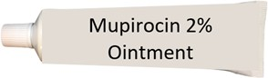
Place dose into disposable medicine cup prior to entering the patient’s room.
Do not bring multidose tube into contact precaution rooms.

Instructions

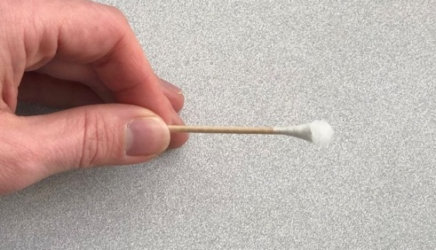

- Use twice daily for 5 days or until discharge.
- Clears bacteria like Staphylococcus aureus (S. aureus) including MRSA that live in the nose and can cause infection.
- Most S. aureus infections are caused by bacteria in the patient’s own nose.

Mupirocin Use in Specific Circumstances
- If nasal device in place (e.g., nasal intubation, NG tube), swab around tubing, if possible.
- If nasal packing in place, do not apply to that nostril.
- If patient is allergic to mupirocin, do not apply.

