Facilitator Guide for Engaging Stakeholders: Developing a Vision for Your Improving Surgical Care and Recovery Program
AHRQ Safety Program for Improving
Surgical Care and Recovery
Slide Title and Commentary | Slide Number and Slide
Engaging Stakeholders  Hello, I’m ____. As a member of the Improving Surgical Care and Recovery team at _________, I am eager to speak to you about a strategy for engaging stakeholders at this hospital to support our program for Improving Surgical Care and Recovery, or ISCR, implementation efforts. Specifically, we’ll be discussing the importance of, and how to, develop a vision for our ISCR work, which is a key component of engaging others. This was developed by the Agency for Healthcare Research and Quality, or AHRQ. | Slide 1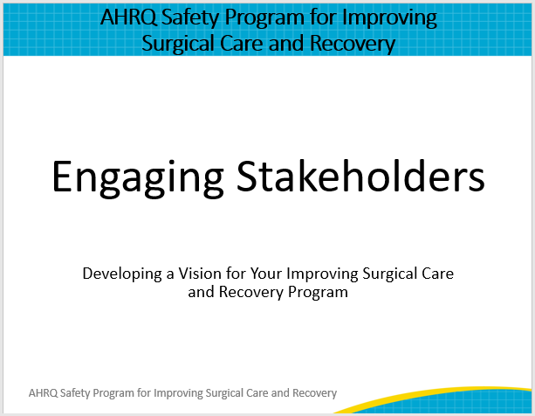
Multidisciplinary Approach  ISCR leverages AHRQ’s Comprehensive Unit-based Safety Program, or CUSP, to help introduce, embed, and sustain an evidence-based enhanced recovery program at this hospital. One feature of CUSP is that it uses a multidisciplinary approach that includes everyone impacted by the planned changes. Assembling a multidisciplinary team is recommended to engage others in this perioperative change initiative. Once you have identified your stakeholders, how do you engage people who have varying perspectives and opinions? And how does that team engage all healthcare providers involved in the patient’s surgical journey in change? You do so by developing a compelling vision for your ISCR Program, then communicating that vision to your stakeholders. The sooner stakeholders are engaged and have a shared mental model, the sooner their patients and the hospital will start seeing the positive effects of an ISCR program. | Slide 2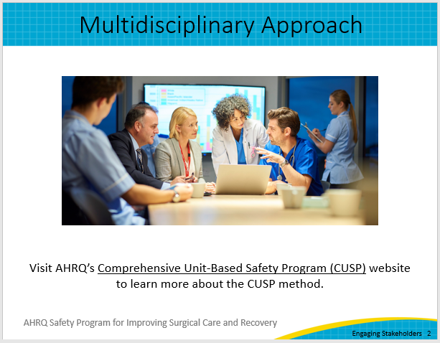
What Can We Learn From Bill Gates?  To develop a vision for the project, let’s look at an example from Bill Gates, the co-founder of Microsoft. Bill Gates had a clear vision statement back in 1980. He wanted to see a computer running Microsoft software on every desk and in every home. Reflecting on this in the present day, he states, “It was a bold idea and a lot of people thought we were out of our minds to imagine it was possible. It is amazing to think about how far computing has come since then.”  Now, each of us may not come up with as clear and bold a vision statement as that one for our Improving Surgical Care and Recovery work, but what might we learn from Bill Gates’ vision? | Slide 3  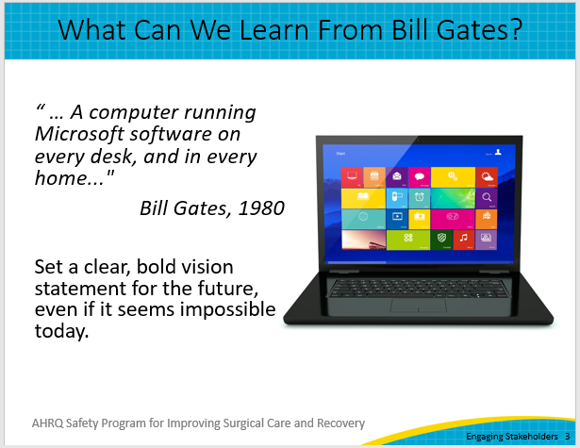
Vision Statements  What is a vision statement? First, it provides a clear picture of what we want (for the future of healthcare in this case).  Many of us probably visualized a computer on a desk in our homes back when Bill Gates created his vision statement. Is there one on every desk now? How does our current state differ from his vision? And consider that back in 1980s many of us did not even have computers in our homes. We had to go to an office and share computer time.  Many of us may play a sport or musical instrument. Mental rehearsal and imagery may be a part of your training for these activities. This same mental rehearsal technique can be used to develop a clear picture of the future state of the patients coming through your hospital for surgical care.  What does the patient look like? Envision a transformation from a patient who may be confused, frightened, vulnerable, and maybe even frustrated to a patient with courage, confidence, and clear expectations.  What does the surgical team look like? Envision a transformation from pessimism and exhaustion to a surgical team that looks like a winning Super Bowl team—clear roles, clear expectations, connected, communicating, and always trying to do better in each game.  Second, note that Bill Gates’ vision statement is not a plan. His vision statement explains the purpose of his company. It is the “why,” not the “how.”  So how do we develop our “why” or our vision for our work? | Slide 4  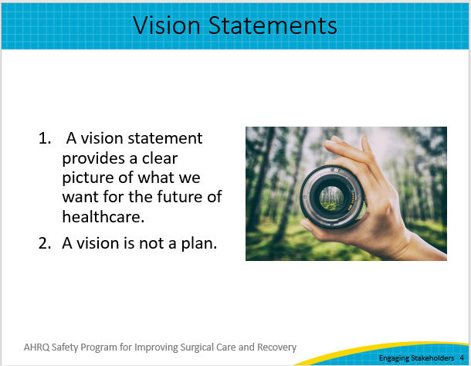
Imagine…  You might start with the word “imagine….”  - Imagine…surgical care where we eliminate confusion, rework, waste, and harm.  - Imagine…surgical care on the unit where nurses spend more time with patients and less time foraging through the electronic health record for orders and plan of care.  - Imagine…surgical care where patients are discharged from the hospital opiate free or near opiate free.  - Imagine…surgical care where we achieve the quadruple aim…where quality is improved, costs are lowered, patient experience is improved, and staff work/life experience is improved.  - Imagine…building teams to foster resilience in how we work together and in our patients’ ability to recover quickly.  - Imagine…surgical care for our elderly patients where frailty is not a barrier to recovery and a goal is building strength.  As you can see, compared to the Bill Gates vision statement, communicating a compelling vision or pitch does not have to be the same for every person.  In fact, for the best success, the compelling words should be different for different people. | Slide 5  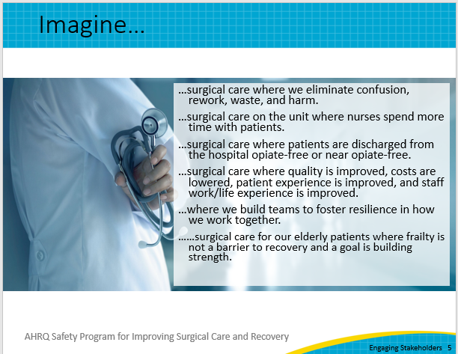
Developing an Elevator Pitch  Taking the time to develop your own compelling vision and words for describing the ISCR program is one of the ingredients for success. Once you create your vision for this work, use the Developing an Elevator Pitch tool to effectively and concisely communicate that vision to your stakeholders. The Developing an Elevator Pitch tool can be found in the Toolkit on the ISCR Program website. | Slide 6  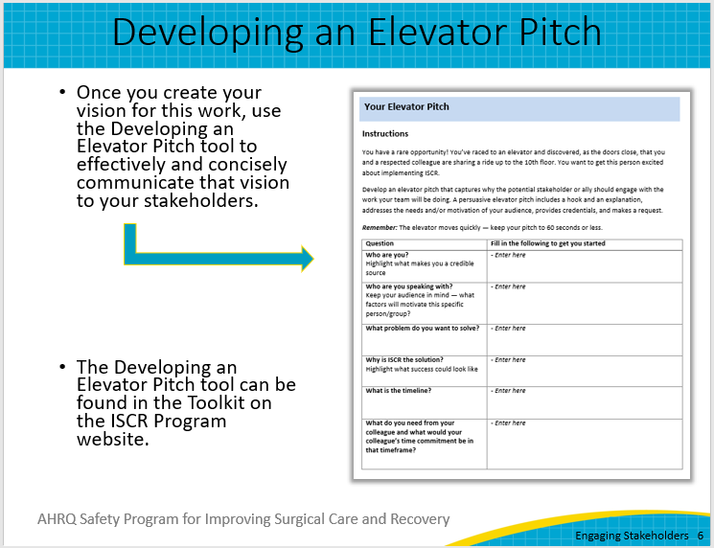
Follow Up With a Commitment  Finally, when you approach your stakeholders and share your vision, there is one more piece of advice.  Conclude the time that you have with the individual or group with some sort of followup commitment:  - May I attend your department , staff, unit, or quality meeting next week to share some of how and what we are going to do to achieve this?  - May I email you the most recent technical review and ask you to give us some feedback?  - Would you come to the floor and visit some of our Improving Surgical Care and Recovery patients postoperatively with me next week for 30 minutes?  These are just a few examples so think of how you will approach each of your stakeholders and commitment to a next step with them. | Slide 7  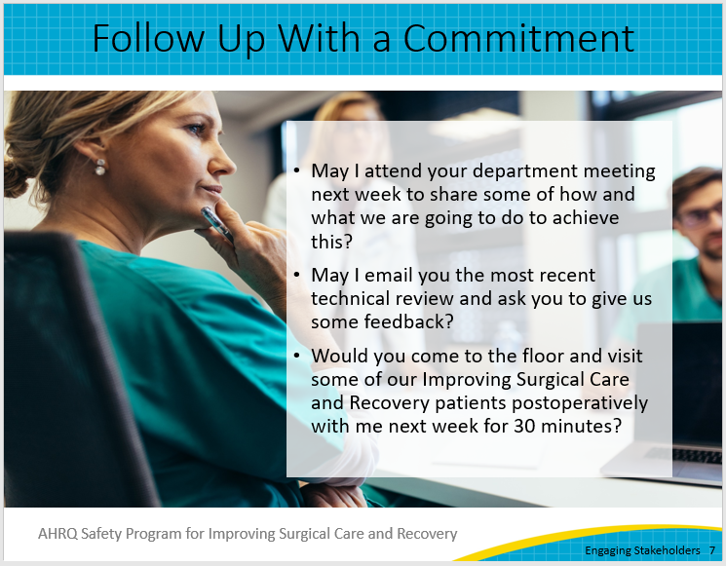
ISCR as a Framework for Improvement  So, as you and your stakeholders embark and continue your journey together in this work, consider the Improving Surgical Care and Recovery work as your framework to—  - define clear protocols,  - develop reliable implementation,  - connect for seamless care, and  - communicate expectations to continually improve the experience of the patient and the clinicians caring for our surgical patients. | Slide 8  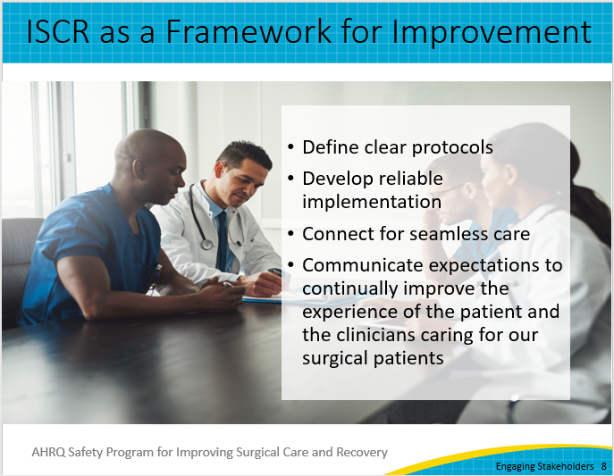
Thank You!  Thank you for your time today. Do you have any questions?  If you want to know more about the ISCR program, my contact information is listed on this slide. | Slide 9  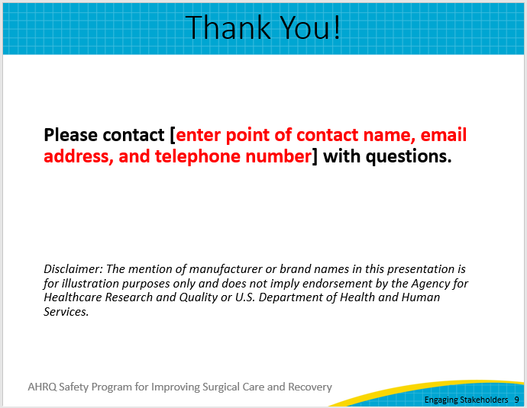
AHRQ Pub. No. 23-0052
June 2023

