AHRQ Safety Program for Improving
Surgical Care and Recovery

Facilitator Guide for Frontline Provider Education Presentation Template
Slide Title and Commentary | Slide Number and Slide
Frontline Provider Education  Title slide for the tool – delete this slide from the presentation to your frontline staff. | Slide 1  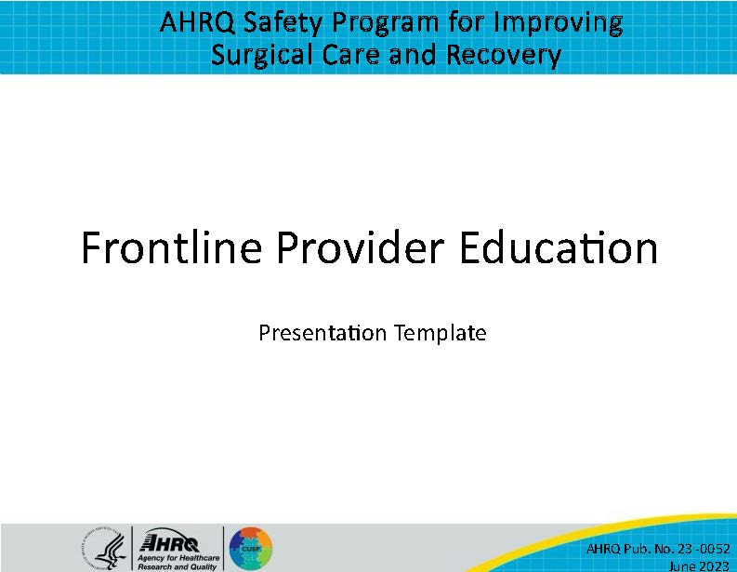
Purpose and Use of This Frontline Provider Education Tool  Information about this tool – delete this slide from the presentation to your frontline staff. | Slide 2  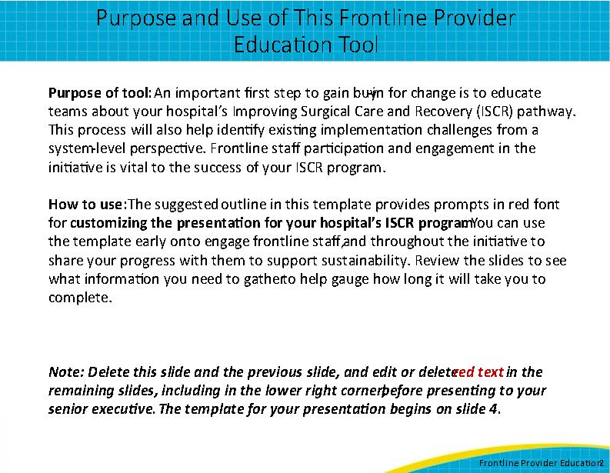
Communication Tips  Information about this tool – delete this slide from the presentation to your senior executive. | Slide 3  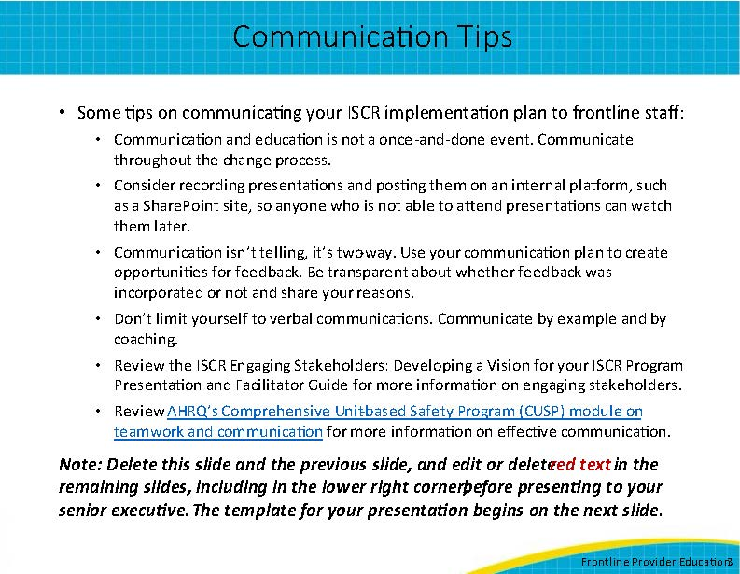
Presentation title slide: [Hospital Name] Improving Surgical Care and Recovery of Patients: [Service Line] Pathway  Hello and thank you for meeting with me today to discuss the Agency for Healthcare Research and Quality’s Safety Program for Improving Surgical Care and Recovery, or ISCR, initiative at [hospital name]. Today we will be reviewing the [service line] pathway. | Slide 4 of template; slide 1 of presentation to frontline providers  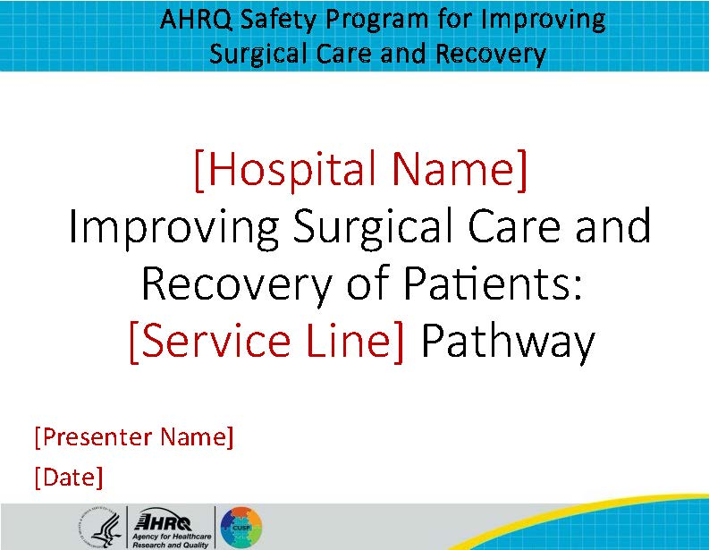
[Service Line] Surgery at [Hospital Name]  [Service line, e.g., colorectal, hip fracture] surgery procedures may have high morbidity (e.g., surgical site infections) and long lengths of stay  Care of [service line] surgery patients is highly variable for:  - Preoperative education  - Plan for anesthesia  - Pain management  - Fluid resuscitation  - Resumption of oral intake and mobility  An opportunity exists to improve collaboration in the perioperative area among surgery, anesthesiology, and nursing. | Slide 5  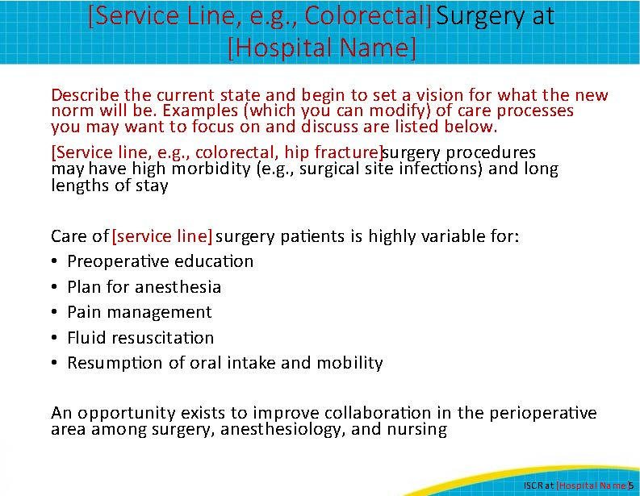
ISCR Program Goal  The goal of the AHRQ Safety Program for Improving Surgical Care and Recovery, or ISCR, is to implement a standardized, patient-centered protocol for the management of patients undergoing [specify procedures] that spans the perioperative continuum of care to improve patient outcomes, reduce length of stay, improve patient experience and satisfaction, and decrease variability. | Slide 6  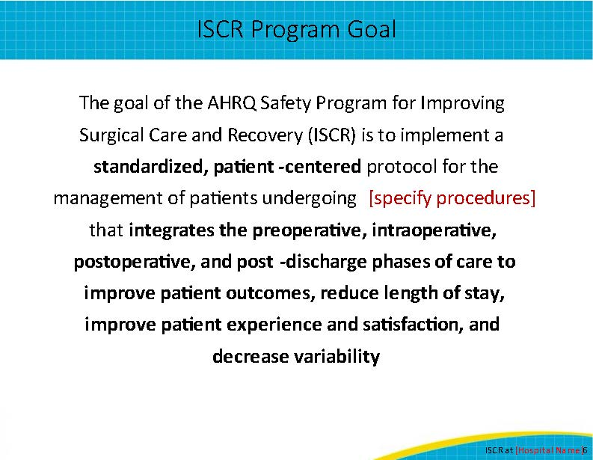
ISCR: Basic Principles  ISCR takes a multidisciplinary and collaborative approach to frequently discussed surgical topics such as:  - Best practices for preventable harms  - Patient and family education and engagement in perioperative care  - Standardized perioperative anesthesia and multimodal analgesia  - Early activity after surgery  - Optimal perioperative nutrition and early resumption of oral intake | Slide 7  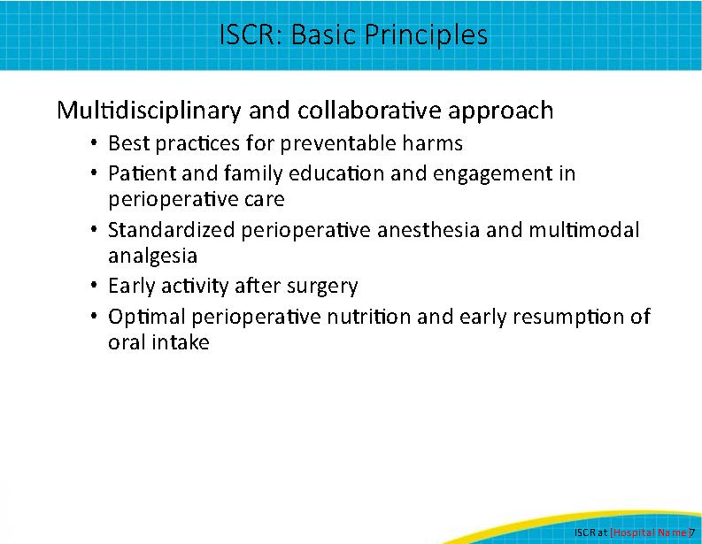
Partnership: We Are All Part of the Team!  With ISCR being a multidisciplinary and collaborative approach the initiative’s success will depend on Senior Executive, Champion, Project Lead, and key partner commitment:  - Senior Executive: List for your institution  - Surgeon Champion: List for your institution  - Anesthesia Champion: List for your institution  - Nurse Champion: List for your institution  - Project Lead: List for your institution  - Enter additional key partners for your team’s success (e.g., case managers, unit managers, pharmacists, residents, clinic staff, operating room and inpatient unit leads, and representatives from physical therapy, nutrition, and the emergency department) | Slide 8  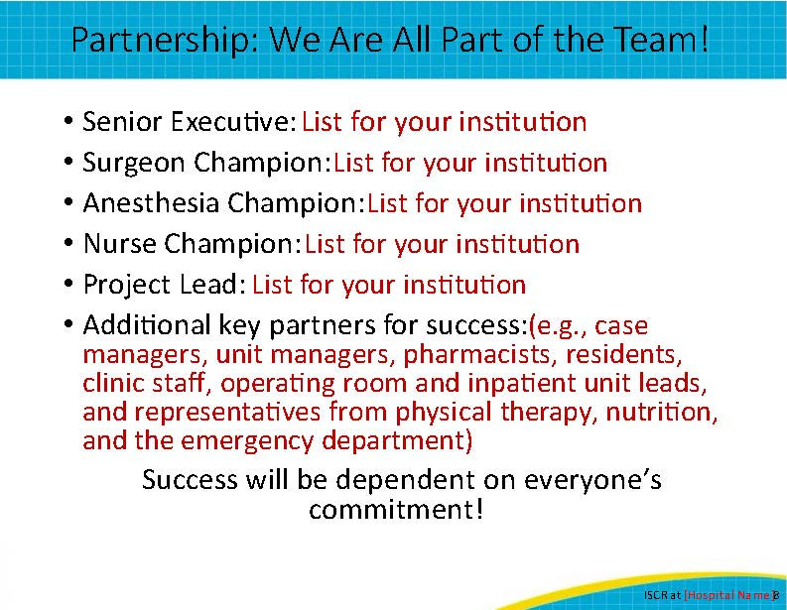
Overview of Gap Analysis  One of the first steps in the ISCR program is collecting baseline data to identify areas for improvement, such as our [enter example (e.g., surgical site infection rate)], and setting goals for improvement.  When our team conducted our gap analysis for [service line] surgeries in CY[XXXX], we found that we performed a total of [number of] cases.  Our mean and median length of stay are [X and X], respectively.  Our unplanned 30-day readmission rate (post-discharge) is [rate].  Our SSI rate for deep tissue is [rate] and [rate] for organ space.  Our all-cause inpatient mortality rate is [rate].  We also reviewed: [provide details on any other measures that were reviewed, for example, superficial SSI, VTE, and CAUTI]. | Slide 9  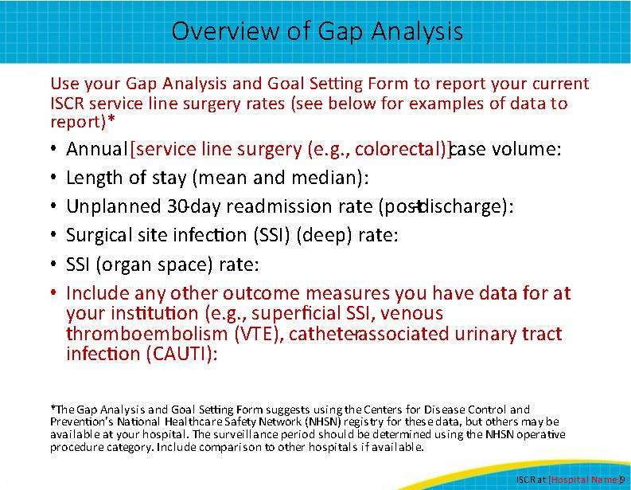
Our Top Three Goals  The results from our gap analysis helped us identify three specific goals for improvement over the next calendar year.  The first is: explain the goal and rationale behind it  The second is: explain the goal and rationale behind it  The third is: explain the goal and rationale behind it  Explain the three goals identified by your ISCR team. An example might be reducing your deep incisional SSI rate from 12 percent in the current calendar year to 7 percent in the next calendar year for patients undergoing abdominal surgery. | Slide 10  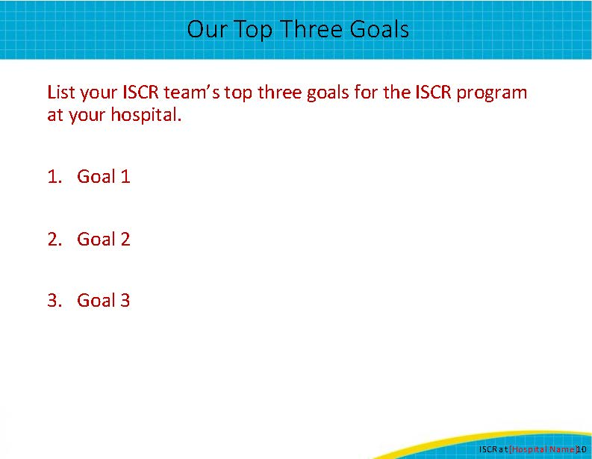
Key Preoperative Elements  (Days and Weeks Prior to Surgery)  This slide lists examples of ISCR elements that are relevant to presurgery work. The ISCR Program has provided evidence-based recommendations that we can implement at our hospital, but exactly how we do that is up to us. As we review these elements, think about how they can be implemented in your unit and what recommendations you have to make them successful. Think about where the challenges will be and what we can do to minimize them.  Nursing  - How will you identify pathway patients so all providers know they are on the pathway?  Patient Education  - How will you educate patients in the preoperative setting (reduced fasting, carbohydrate loading, setting pain management expectations, etc.)?  Preoperative Bathing  - What preoperative bathing protocol will you use?  Bowel Preparation  - For surgeries with a planned bowel resection, have bowel prep and oral antibiotics been prescribed?  Preop Medical Assessment  - For hip fracture surgery patients, how will you evaluate them for comorbidities and expedite their surgery so they are in the operating room within 24 hours of their fracture? | Slide 11  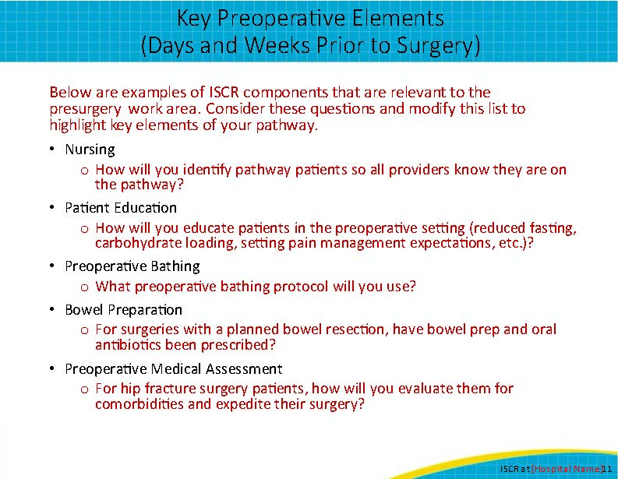
Key Preoperative Elements  (Day of Surgery)  This slide lists examples of ISCR elements that are relevant to the preop area on the day of surgery. Again, think about how to make them successful. Think about challenges and what we can do to minimize them.  Nursing  - How will you document compliance with prehospital processes (e.g., bathing, reduced fasting)?  Multimodal Pain Management  - Process for patients receiving multimodal pain management  - Regional analgesia protocol, if relevant  VTE Prophylaxis  - For specific surgeries (see pathway), process for patients to receive VTE prophylaxis before surgery | Slide 12  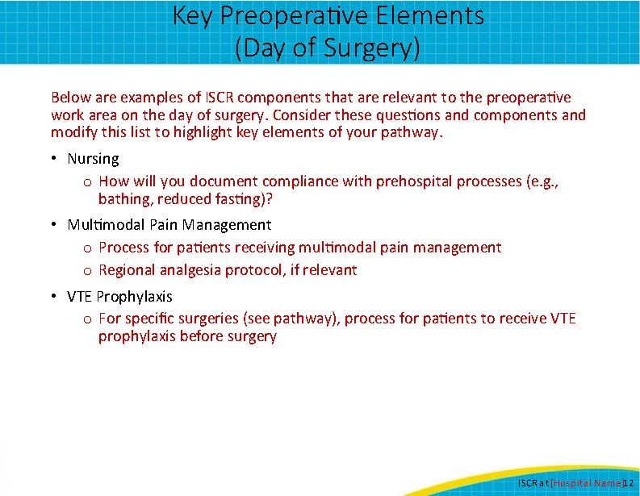
Key Intraoperative Elements  This slide lists examples of ISCR elements that are relevant to intraoperative work area. How will we make them successful, what are the challenges, and what will we do to minimize them?  Nursing  - What pathway elements will be the primary responsibility of the circulating nurse, scrub nurse?  SSI, VTE Prevention  - Processes for SSI, VTE prevention (antibiotic administration, skin preparation, sterile technique, maintenance of normothermia, and VTE prophylaxis if not already administered)  Anesthesia  - What is the process for the anesthesia provider to follow standardized intraoperative protocol?  - For orthopedics, what is the process for tranexamic acid administration? | Slide 13  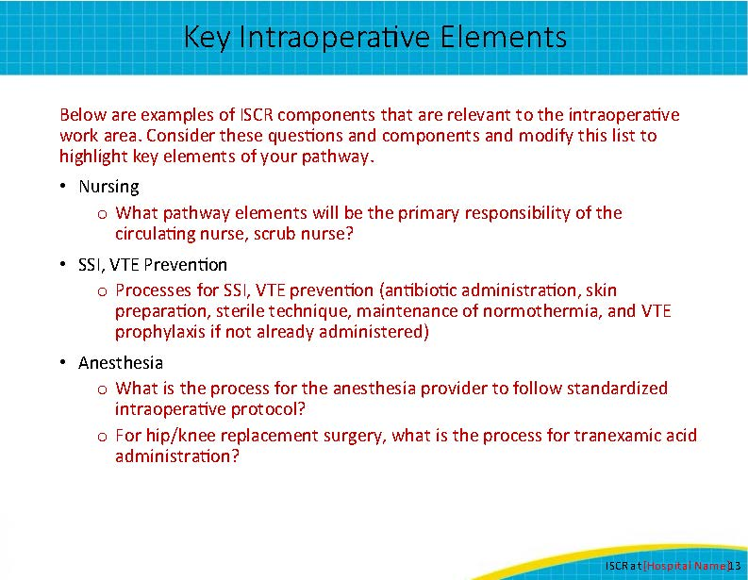
Key Elements Post Anesthesia Care Unit/Postoperative Day 0  Below are examples of ISCR components that are relevant to the PACU/postoperative day 0 work area. How will we make them successful, what are the challenges, and what will we do to minimize them?  Mobility  - Process for early and consistent mobility  - Documentation strategy  Diet  - Process for diet advancement  Multimodal Pain Management  - Process for multimodal pain management  VTE Prophylaxis  - Process for patients to receive VTE prophylaxis (if not already administered) | Slide 14  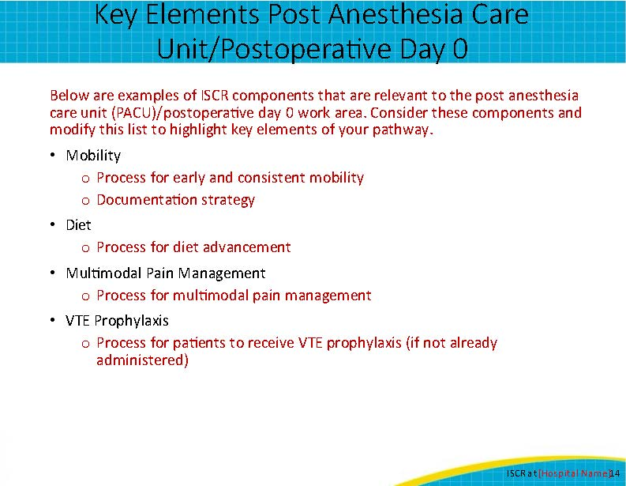
Key Elements Postoperative Days 1–3  Below are examples of ISCR components that are relevant to patient care in postoperative days 1–3. How will we make them successful, what are the challenges, and what will we do to minimize them?  Mobility  - Process for early and consistent mobility  - Documentation strategy  Diet  - Process for diet advancement  Multimodal Pain Management  - Process for multimodal pain management  VTE Prophylaxis  - Process for VTE prophylaxis  Discharge Planning  - What is your multidisciplinary approach for discharge planning? | Slide 15  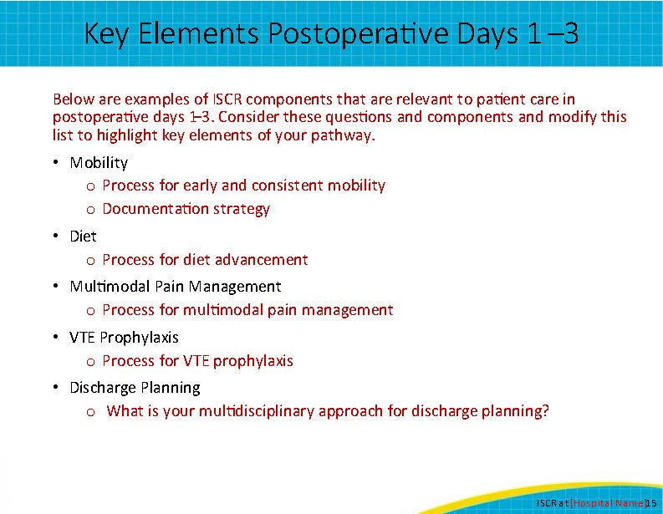
Summary  Reiterate goals and highlight top priorities for successful implementation | Slide 16  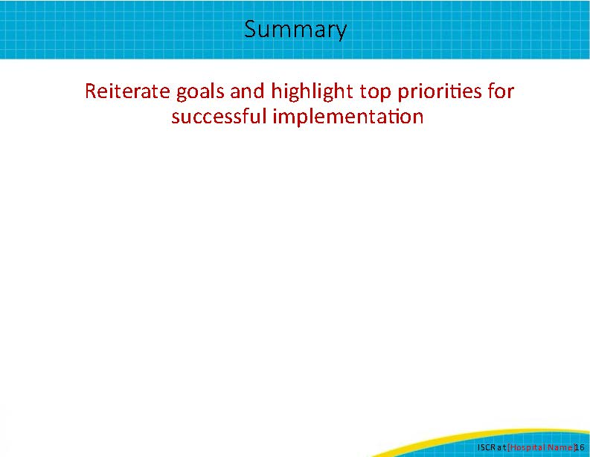
Thank You!  Thank you for your time today. Do you have any questions?  My information is listed on this slide if you have any followup questions about what I’ve shared. Please don’t hesitate to contact me by email or phone. | Slide 17  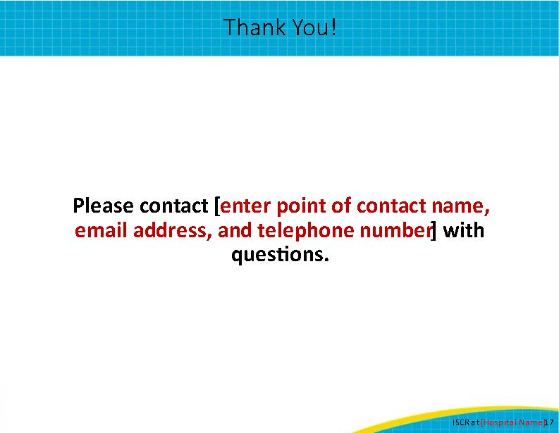
AHRQ Pub. No. 23-0052
June 2023

