AHRQ Safety Program for Improving
Surgical Care and Recovery

Implementation Guide

Purpose of This Guide

This guide intends to help hospitals integrate an enhanced recovery pathway into their perioperative area as part of the AHRQ Safety Program for Improving Surgical Care and Recovery (ISCR). ISCR is a collaborative program to enhance the perioperative care of surgical patients. The ISCR Overview Presentation provides additional information about how the program was developed and the evidence behind it. This guide is a general guide for all ISCR surgical pathways that are included in the ISCR Pathway Worksheet.

The program has three phases:
- Engagement and Development of Your ISCR Pathway (3 months)
- Implementation of Your ISCR Pathway (6 months)
- Sustaining and Spreading Your ISCR Pathway (ongoing)

This guide outlines activities and walks teams through recommended tasks during each phase.

Even though this guide has specific timeframes and tasks for each phase, hospitals are strongly encouraged to implement their ISCR program at their own pace. Teams should not feel rushed or behind because they are not completing the tasks in the recommended timeframe.

If it takes your team 6 or more months to complete phase 1, that is OK. Phase 1 is by far the most important phase because this is when you build out and gain buy-in for your local ISCR pathway.

How To Use This Guide

Your ISCR team should review this guide and work through the tasks. Please return to this guide as you become more familiar with the program to keep your team on track.

Look ahead several months to prepare for tasks in advance. For example, in month 1 it is recommended that you invite your senior executive partner to your monthly meeting (scheduled for month 3) to review the program and your baseline data. The sooner your senior executive knows about the meeting, the more likely he or she will be available to attend.

All resources referenced in this guide can be found on the AHRQ ISCR Toolkit website.
Table of Contents
Program Goal and Approach 3
Choosing a Scope 3
How To Implement This Program at Your Hospital 4
How To Measure Your Impact 4
Program Implementation (Phase 1) 5
Phase 1: Month 1 7
Phase 1: Month 2 10
Phase 1: Month 3 12
Check In: Have You Completed the Following Tasks? 14
Program Implementation (Phase 2) 15
Phase 2: Month 4 16
Phase 2: Month 5 18
Phase 2: Month 6 20
Phase 2: Month 7 22
Phase 2: Month 8 24
Phase 2: Month 9 26
Program Implementation (Phase 3) 28
Phase 3: Month 10 29
Phase 3: Month 11 31
Phase 3: Month 12 33
Phase 3: Month 13+ 35
Additional Success Factors for Sustaining Your ISCR Pathway 35
Notes Page 37

Program Goal and Approach

Goal
The AHRQ Safety Program for Improving Surgical Care and Recovery (ISCR) is a program to enhance the perioperative care of surgical patients. The goal is to improve patient outcomes.

Approach
The program aims to help hospitals implement enhanced recovery pathways by:
- Utilizing evidence
- Employing change management techniques
- Reviewing data
The program incorporates principles and methods from AHRQ’s Comprehensive Unit-based Safety Program (CUSP), a patient safety method that improves safety culture, teamwork, and communication to promote use of evidence-based practices. Additional CUSP tools on teamwork and communication can be found on the CUSP website.

Choosing a Scope

Your ISCR team will need to decide on a surgical service line. The ISCR service line pathways are listed below:

- Colorectal surgery
- Emergency general surgery (appendectomy, cholecystectomy, major abdominal surgery such as hernia repair)
- Gynecologic surgery
- Hip fracture surgery
- Total knee and total hip replacement surgery

Use the Gap Analysis and Goal-Setting Form to evaluate current performance and identify deficiencies or outcome measures that could be improved by implementing ISCR elements in one of the ISCR service lines. The Red Light, Green Light tool can help you identify barriers to and facilitators of implementing ISCR at your hospital.

How To Implement This Program at Your Hospital

As part of this program, your ISCR team will—

- Engage stakeholders
- Assemble a multidisciplinary team
- Identify a senior executive to partner and support the effort
- Designate a process and person for data collection
- Gather baseline data and set improvement goals
- Identify facilitators and barriers to implementing quality and safety improvement projects and plan ways to strengthen facilitators and mitigate barriers
- Adapt the program’s pathway to your hospital
- Kick off and follow your pathway for your designated surgery patients
- Troubleshoot and sustain your pathway

How To Measure Your Impact

Evaluate
- Patient process and outcome measures
- Staff survey of safety culture
- Patient experience survey

First, begin to gather process and outcome data in the few months before you implement your pathway. After you start your pathway, you will monitor your progress, share results, identify opportunities for improvement, implement changes, and celebrate successes. As you improve your compliance with process measures (elements of your ISCR pathway), you can evaluate whether there are improvements in outcomes such as:

- Surgical site infections (SSI)
- Catheter-associated urinary tract infections (CAUTI)
- Venous thromboembolism (VTE) events
- Reduced opioid use
- Patient experience with any existing surveys your hospital uses (e.g., Hospital Consumer Assessment of Healthcare Providers and Systems [HCAHPS])
- Teamwork and safety culture with any existing surveys your hospital uses (e.g., Surveys on Patient Safety Culture [SOPS] Hospital Survey)
- Length of stay and readmissions

Program Implementation (Phase 1)
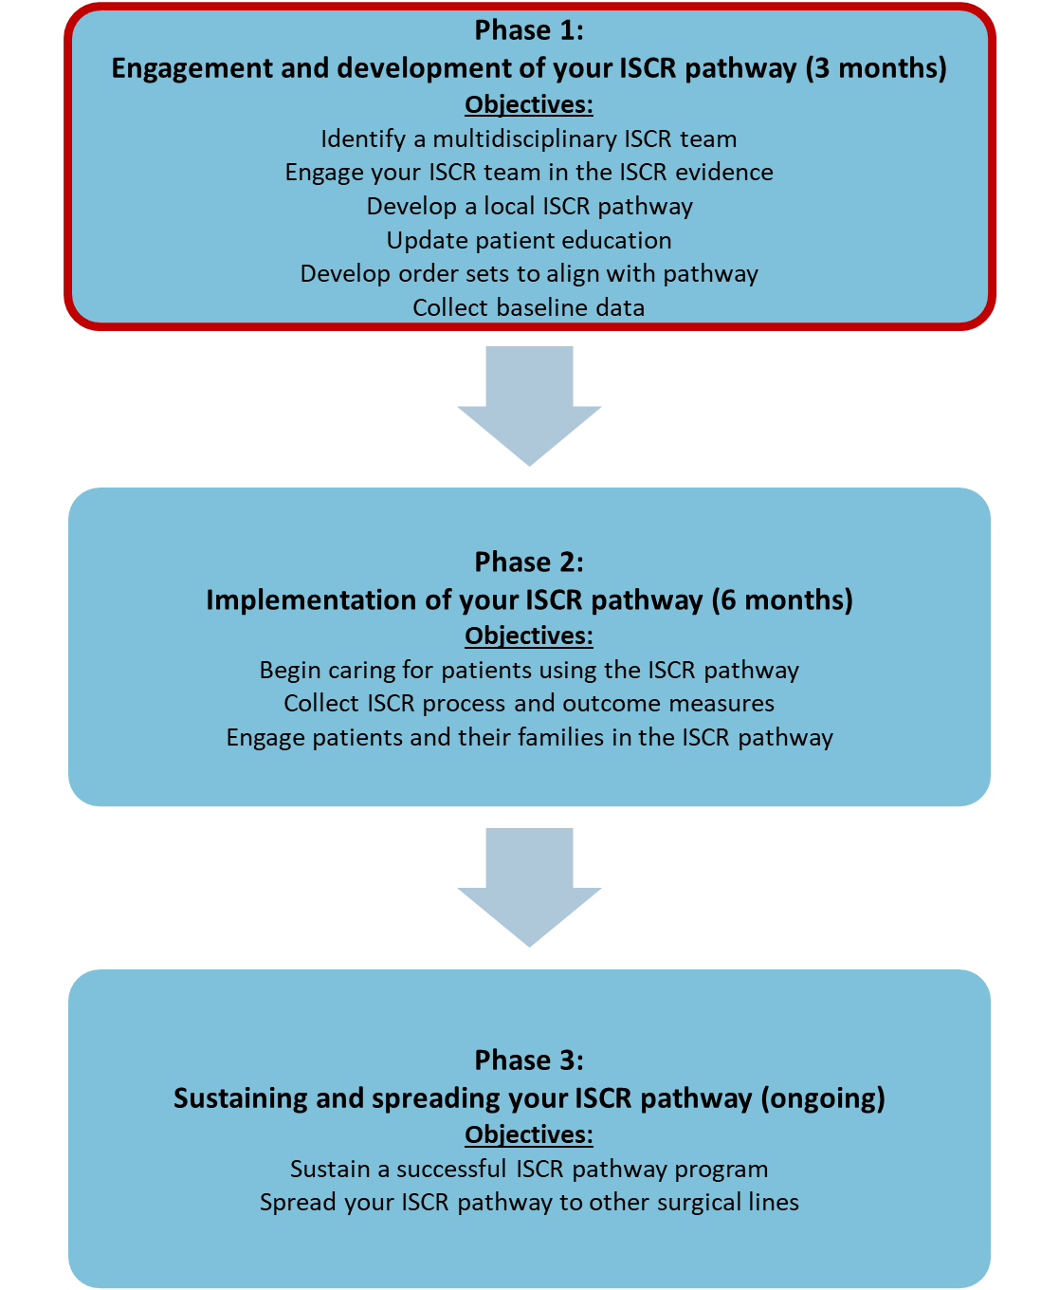

Phase 1: Month 1
Resources are available on the AHRQ ISCR website
Tasks | Accountable Parties | Resources | Tips
Prepare for the Improving Surgical Care and Recovery (ISCR) program | ISCR team leader | ISCR Overview (document,  presentation and facilitator guide)  ISCR Implementation Guide  ISCR Pathway Worksheet | Also review A Guide to Leading Successful Perioperative Teams
Build your multidisciplinary ISCR core team and identify time for regular meetings | ISCR team leader | Building Your ISCR Team  Identifying Your ISCR Stakeholders (presentation and facilitator guide)  Creating an Elevator Speech | The Building Your ISCR Core Team describes roles and responsibilities  It will be beneficial to have core team members meet weekly or biweekly to start  Talk to team members to find a time that works for everyone  Send calendar invites and reminders
Assess your hospital’s readiness to implement a quality and safety improvement program | ISCR team leader | Red Light, Green Light  AHRQ Hospital Survey on Patient Safety Culture (SOPS) (Optional)  Safety Attitudes and Safety Climate Questionnaire (Optional) | Review the Red Light, Green Light tool, a compilation of evidence-based facilitators and barriers to ISCR implementation to make sure you are anticipating all issues and have a preemptive plan.  Visit the Agency for Healthcare Research and Quality (AHRQ) website on Surveys on Patient Safety Culture (SOPS) for more information (Optional)
Develop your hospital’s ISCR pathway | ISCR team | ISCR Pathway Worksheet  ISCR evidence reviews: surgery and anesthesia  Multimodal Analgesia Tips (presentation and facilitator guide)  Regional Analgesia for Total Hip and Total Knee Arthroplasty (presentation and facilitator guide)  Oral Antibiotics and Mechanical Bowel Prep for SSI Prevention for Colorectal Surgery (presentation and facilitator guide) | No need to search for evidence. The ISCR Pathway Worksheet provides information on the evidence reviews that were used to create the ISCR program and links to relevant guidelines and resources.
Plan your ISCR pathway implementation | ISCR team | ISCR Pathway Checklist  Template for Building and Implementing Your ISCR Pathway | Modify the ISCR Pathway Checklist and Template for Building and Implementing Your ISCR Pathway to meet your needs
Develop an engagement strategy for frontline staff | ISCR team | Engaging Your ISCR Stakeholders (presentation and facilitators guide)  Stakeholder Analysis Tool  Engaging Frontline Staff With ISCR Process and Outcome Data | Consider completing a formal stakeholder analysis  Ideas to gain buy-in from staff  Present implementation plans at unit-based staff meetings  Show baseline data: where you are and where you hope to be  Share “what’s in it for me” benefits (e.g., less call bell usage, more satisfied patients)
Schedule the official kickoff meeting for the end of month 3 | ISCR team | None | Invite all staff and include hospital leadership  Make sure executives and other leaders are available to attend and show their support for the initiative
Invite your senior executive to the month 3 kickoff meeting | ISCR team leader | Engaging the Senior Executive (presentation template and facilitator guide) | Have date and time available as soon as possible to ensure attendance

Use the space below to track additional tasks for your team:

Phase 1: Month 2
Resources are available on the AHRQ ISCR website
Tasks | Accountable Parties | Resources | Tips
Finalize pathway and implementation tools | ISCR team | ISCR Pathway Worksheet  ISCR Pathway Checklist  ISCR Template for Building and Implementing Your ISCR Pathway | Have you identified a way to select patients who are on your pathway? Some strategies from teams that participated in the ISCR national collaborative are provided in the ISCR Final Report and appendixes. Some examples of what teams used include EMR flags, special bracelets, or removable stickers on patient rooms.  Modify sample material like the ISCR Pathway Checklist and the ISCR Template for Building and Implementing Your ISCR Pathway to meet your needs.
Begin collecting baseline data to help identify where your team is starting out  Develop a process to measure impact | ISCR data abstractor | ISCR Pathway Worksheet  ISCR Pathway Checklist  ISCR Audit Tool  Engaging Frontline Staff with ISCR Process and Outcome Data | Start a paper/electronic checklist for data collection of selected process measures, if you cannot build audits in the EHR
Adapt patient education booklet | ISCR team | Sample patient education booklets | None
Attend unit-based staff meetings to engage and educate on program. Potential locations include:  Outpatient or physician offices  Operating rooms  Preoperative and recovery units  Inpatient units | ISCR team leader with other specialty champions, as appropriate | Frontline Provider Education (presentation template and facilitator guide)  Red Light, Green Light  Engaging Frontline Staff With ISCR Process and Outcome Data | Discussion points to consider:  Review planned pathway  Address concerns about workflow, practice changes and barriers  Review roles and responsibilities of all staff for program success  Reinforce who the program champions are for future questions  Review baseline data (SSI, CAUTI, length of stay (LOS), readmissions, patient experience, etc.) and new process measures or changes to existing ones
Prepare for official kickoff meeting at end of month 3 | ISCR team | None | Start to promote the kickoff meeting to all areas involved. Consider providing food and coffee to increase attendance.

Use the space below to track additional tasks for your team:

Phase 1: Month 3
Resources are available on the AHRQ ISCR website
Tasks | Accountable Parties | Resources | Tips
Adapt and finalize staff education tools | ISCR team | Frontline Provider Education Presentation Template  ISCR Pathway Checklist  Template for Building and Implementing Your ISCR Pathway | No need to reinvent the wheel – adapt the templates provided on the ISCR website
Access and review report of your hospital’s baseline outcome data | ISCR team leader or data abstractor | Engaging Frontline Staff With ISCR Process and Outcome Data  Gap Analysis and Goal Setting Form | Highlight the areas that need improvement to help focus the meeting discussions (e.g., Mobility, surgical site infections, venous thromboembolism, LOS)  Use the Gap Analysis and Goal Setting Form to show your hospital’s baseline outcome data and discuss with ISCR team members which outcomes may yield the most improvement for patients. Also discuss and determine which related process measures to target in order to achieve improvement goals.
Hold month 3 ISCR team meeting | ISCR team | None | Discussion points to consider:  Update on pathway adaptation  Review baseline outcome data  Prepare for implementation kickoff meeting at end of month 3
Host official meeting to kickoff implementation phase | All perioperative staff | Gap Analysis and Goal Setting Form | Have senior executive, surgeon and anesthesiologist champions, and nurse managers speak about importance of ISCR and excitement around this new initiative  Discuss where the team is now and set both process measure and outcome measure goals (e.g., “SSI rate is X percent, our goal is to reduce it to Y percent by [date]”)—Use the Gap Analysis and Goal Setting Form  Consider providing food and coffee

Use the space below to track additional tasks for your team:

Check In: Have You Completed the Following Tasks?

- Engaged your ISCR senior executive partner
- Scheduled monthly meetings with ISCR team
- Adapted ISCR pathway and tools to your hospital
- Adapted ISCR patient education materials to your hospital
- Developed and adapted order sets to align with your ISCR pathway
- Collected baseline data
- Set improvement goals for selected process and outcome measures
- Completed safety culture survey administration

Use the space below to track additional tasks for your team:

Program Implementation (Phase 2)
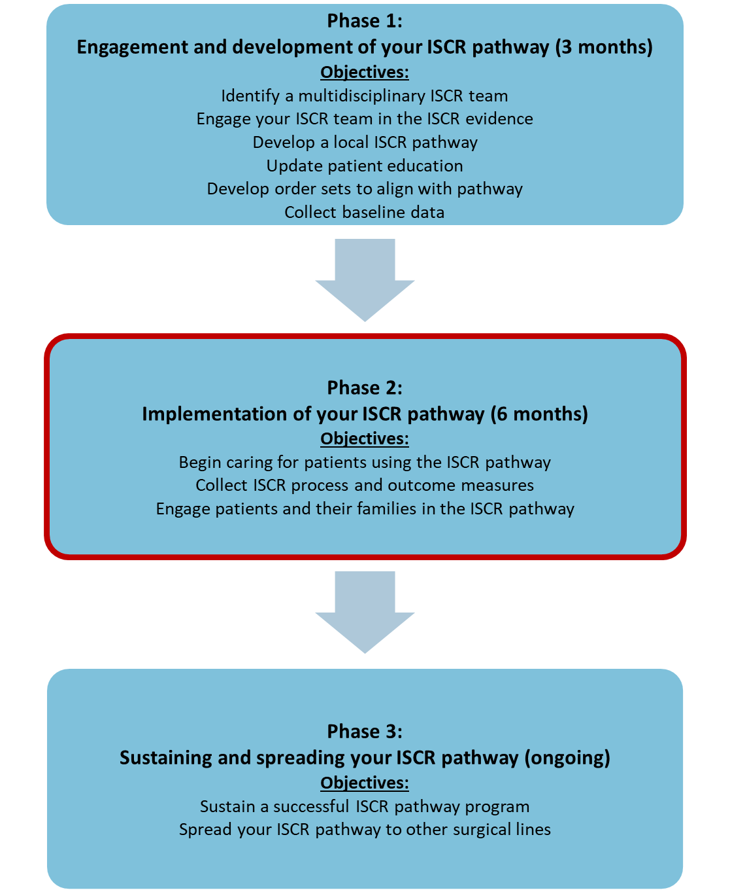

Phase 2: Month 4
Resources are available on the AHRQ ISCR website
Tasks | Accountable Parties | Resources | Tips
Start putting patients on the program pathway! | All perioperative staff | Sample ISCR Pathway Checklist | Start a paper/electronic checklist for data collection of all process measures, if you cannot build audits in the electronic health record system
Hold month 4 ISCR team meeting | ISCR team | Engaging Frontline Staff With ISCR Process and Outcome Data | Discussion points to consider:  Review performance report – where are you doing well and where do you need to improve? Refer to the goals set during kick off meeting in month 3.  Discuss any issues with implementation and modify approach, as needed, for example:  Are order sets working?  Are all your supplies available?  Are all your medications available?  Are patients compliant with preoperative processes?  Are patients getting out of bed and walking as expected?  Are the providers adhering to the pathway?  Are any providers resisting?  Do you have providers who are early adopters?  Do the patient education materials need updating?  How will you onboard new employees?
Attend monthly unit staff meetings with perioperative staff. Potential locations include:  Outpatient or physician offices  Operating rooms  Preoperative and recovery units  Inpatient units | ISCR team leader with other specialty champions, as appropriate | Engaging Frontline Staff With ISCR Process and Outcome Data | Discussion points to consider:  Share reports and additional updates  Ask: How is implementation going?  Ask: What’s working, what’s not working?  Share process measure performance relevant to the area and discuss ideas for improvement – refer to the goals set during kickoff meeting in month 3

Use the space below to track additional tasks for your team:

Phase 2: Month 5
Resources are available on the AHRQ ISCR website
Tasks | Accountable Parties | Resources | Tips
Hold month 5 ISCR team meeting | ISCR team | None | Discussion points to consider:  Review performance report – where are you doing well and where do you need to improve? Make changes/strategies for improvement as needed  Discuss any issues with implementation and modify approach, as needed (see examples in month 4)  Review another process measure with your lowest compliance and discuss improvement strategy. Set a goal (e.g., “preoperative oral antibiotics rate is X percent, our goal is to increase it to Y percent by [date]”). Be prepared to follow up on progress the following month.
Attend monthly unit staff meetings with perioperative staff. Potential locations include:  Outpatient or physician offices  Operating rooms  Preoperative and recovery units  Inpatient units | ISCR team leader with other specialty champions, as appropriate | Engaging Frontline Staff With ISCR Process and Outcome Data | Discussion points to consider:  Share reports and additional updates  Ask: How is the pathway going?  Ask: What’s working, what’s not working?  Share process measure performance relevant to the area and discuss ideas for improvement
Review safety culture report with ISCR team and develop plan for improvement with frontline staff |  | AHRQ Culture Check-Up Tool | Discuss areas of strength and opportunities for improvement

Use the space below to track additional tasks for your team:

Phase 2: Month 6
Resources are available on the AHRQ ISCR website
Tasks | Accountable Parties | Resources | Tips
Collect patient and family stories about their experience on the pathway | ISCR team | None | Find patients who have had previous surgeries who might be able to compare the program approach to the standard approach to perioperative care
Schedule meeting with senior executive for month 8 program presentation | ISCR team leader | None | None
Hold month 6 ISCR team meeting | ISCR team | Learn from Defects Tool | Discussion points to consider:  Review performance report – where are you doing well and where do you need to improve? Make changes/strategies for improvement as needed  Discuss any issues with implementation and modify approach, as needed (see examples in month 4)  Update on improvements made to process measure selected in previous month and compare to set goal  Review another process measure with low compliance and discuss improvement strategy. Set a goal (e.g., “preoperative oral antibiotics rate is X percent, our goal is to increase it to Y percent by [date]”). Be prepared to follow up on progress the following month.
Attend monthly unit staff meetings with perioperative staff. Potential locations include:  Outpatient or physician offices  Operating rooms  Preoperative and recovery units  Inpatient units | ISCR team leader with other specialty champions, as appropriate | Engaging Frontline Staff With ISCR Process and Outcome Data | Discussion points to consider:  Share reports and additional updates  Ask: How is implementation going?  Ask: What’s working, what’s not working?  Share process measure performance relevant to the area and discuss ideas for improvement

Use the space below to track additional tasks for your team:

Phase 2: Month 7
Resources are available on the AHRQ ISCR website
Tasks | Accountable Parties | Resources | Tips
Prepare presentation for senior executive on implementation progress | ISCR team | Engaging the Senior Executive (presentation template and facilitator guide) | Discussion points to consider:  Patient stories  Outcome and process data – highlight areas that have improved  Barriers
Think about the next surgical area to spread ISCR to at your hospital | ISCR team | None | Share your success story with other areas in your hospital!  Look at the other service line pathways on the website
Hold month 7 ISCR team meeting | ISCR team | None | Discussion points to consider:  Review performance report – where are you doing well and where do you need to improve?  Discuss any issues with implementation and modify approach, as needed (see examples in month 4)  Update on improvements made to process measure selected in previous month and compare to set goal  Review another process measure with low compliance and discuss improvement strategy. Set a goal (e.g., “preoperative oral antibiotics rate is X percent, our goal is to increase it to Y percent by [date]”). Be prepared to follow up on progress the following month.
Attend monthly unit staff meetings with perioperative staff. Potential locations include:  Outpatient or physician offices  Operating rooms  Preoperative and recovery units  Inpatient units | ISCR team leader with other specialty champions, as appropriate | Engaging Frontline Staff With ISCR Process and Outcome Data | Discussion points to consider:  Share reports and additional updates  Ask: How is implementation going?  Ask: What’s working, what’s not working?  Share process measure performance relevant to the area and discuss ideas for improvement

Use the space below to track additional tasks for your team:

Phase 2: Month 8
Resources are available on the AHRQ ISCR website
Tasks | Accountable Parties | Resources | Tips
Present progress to senior executive | ISCR team | Engaging the Senior Executive (presentation template and facilitator guide) | Discussion points to consider:  Patient stories  Outcome and process data – highlight areas that have improved  Barriers
Hold month 8 ISCR team meeting | ISCR team | None | Discussion points to consider:  Review performance report – where are you doing well and where do you need to improve?  Discuss any issues with implementation and modify approach, as needed (see examples in month 4)  Update on improvements made to process measure selected in previous month and compare to set goal  Review another process measure with low compliance and discuss improvement strategy. Set a goal (e.g., “preoperative oral antibiotics rate is X percent, our goal is to increase it to Y percent by [date]”). Be prepared to follow up on progress the following month.
Attend monthly unit staff meetings with perioperative staff. Potential locations include:  Outpatient or physician offices  Operating rooms  Preoperative and recovery units  Inpatient units | ISCR team leader with other specialty champions, as appropriate | Engaging Frontline Staff With ISCR Process and Outcome Data | Discussion points to consider:  Share reports and additional updates  Ask: How is the implementation going?  Ask: What’s working, what’s not working?  Share process measure performance relevant to the area and discuss ideas for improvement

Use the space below to track additional tasks for your team:

Phase 2: Month 9
Resources are available on the AHRQ ISCR website
Tasks | Accountable Parties | Resources | Tips
Hold month 9 ISCR team meeting | ISCR team | None | Discussion points to consider:  Review performance report – where are you doing well and where do you need to improve?  Discuss any issues with implementation and modify approach, as needed (see examples in month 4)  Update on improvements made to process measure selected in previous month and compare to set goal  Review another process measure with low compliance and discuss improvement strategy. Set a goal (e.g., “preoperative oral antibiotics rate is X percent, our goal is to increase it to Y percent by [date]”). Be prepared to follow up on progress the following month.
Attend monthly unit staff meetings with perioperative staff. Potential locations include:  Outpatient or physician offices  Operating rooms  Preoperative and recovery units  Inpatient units | ISCR team leader with other specialty champions, as appropriate | Engaging Frontline Staff With ISCR Process and Outcome Data | Discussion points to consider:  Share reports and additional updates  Ask: How is the pathway going?  Ask: What’s working, what’s not working?  Share process measure performance relevant to the area and discuss ideas for improvement

Use the space below to track additional tasks for your team:

Program Implementation (Phase 3)
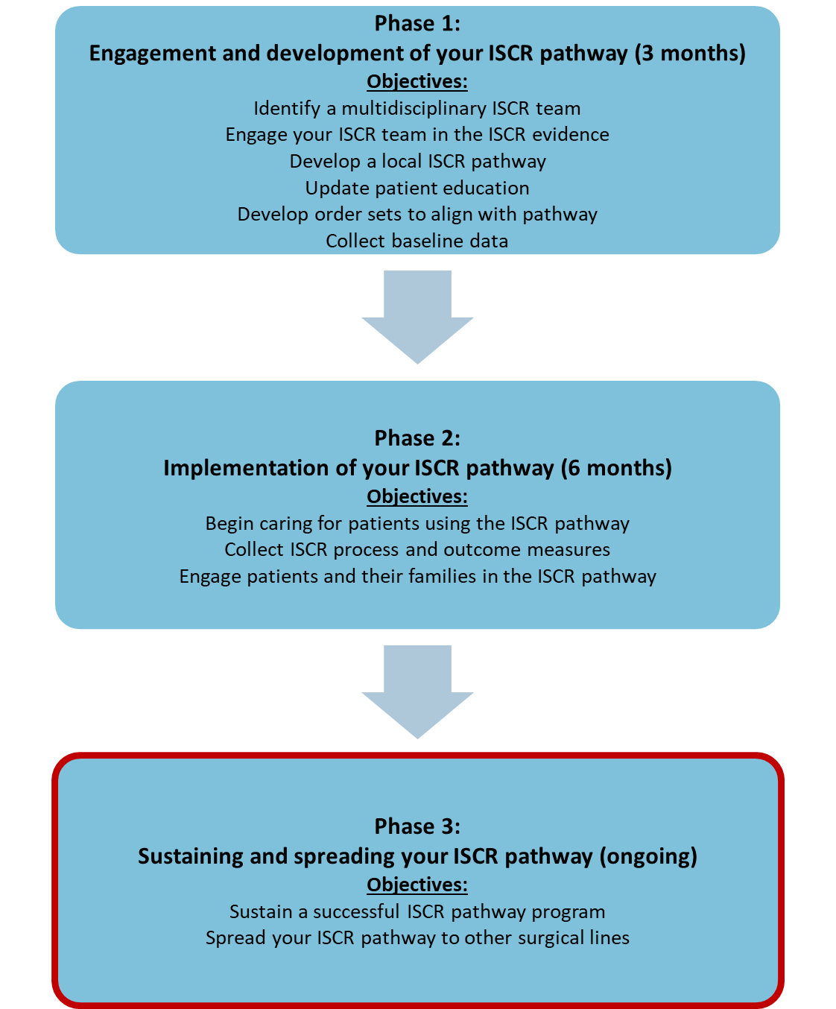

Phase 3: Month 10
Resources are available on the AHRQ ISCR website
Tasks | Accountable Parties | Resources | Tips
Write up progress and success in hospital newsletter or publication. | ISCR team | None | None
Hold month 10 ISCR team meeting | ISCR team | None | Discussion points to consider:  Review performance report – where are you doing well and where do you need to improve?  Discuss any issues with implementation and modify approach, as needed (see examples in month 4)  Update on improvements made to process measure selected in previous month and compare to set goal  Review another process measure with low compliance and discuss improvement strategy. Set a goal (e.g., “preoperative oral antibiotics rate is X percent, our goal is to increase it to Y percent by [date]”). Be prepared to follow up on progress the following month.
Attend monthly unit staff meetings with perioperative staff. Potential locations include:  Outpatient or physician offices  Operating rooms  Preoperative and recovery units  Inpatient units | ISCR team leader with other specialty champions, as appropriate | Engaging Frontline Staff With ISCR Process and Outcome Data | Discussion points to consider:  Share reports and additional updates  Ask: How is implementation going? How are we going to sustain this work?  Ask: What’s working, what’s not working?  Share process measure performance relevant to the area and discuss ideas for improvement

Use the space below to track additional tasks for your team:

Phase 3: Month 11
Resources are available on the AHRQ ISCR website
Tasks | Accountable Parties | Resources | Tips
Create surgical line focused sustainability and spread plan | ISCR team | Identifying Facilitators of and Barriers to Sustaining Gains in Enhanced Recovery  CUSP Spread Module | Discussion points to consider:  How do we sustain the use of this surgical line focused enhanced recovery pathway?  How and where could we spread the pathway in our hospital?
Hold month 11 ISCR team meeting | ISCR team | None | Discussion points to consider:  Review performance report – where are you doing well and where do you need to improve?  Discuss any issues with implementation and modify approach, as needed (see examples in month 4)  Update on improvements made to process measure selected in previous month and compare to set goal  Review another process measure with low compliance and discuss improvement strategy. Set a goal (e.g., “preoperative oral antibiotics rate is X percent, our goal is to increase it to Y percent by [date]”). Be prepared to follow up on progress the following month.
Attend monthly unit staff meetings with perioperative staff. Potential locations include:  Outpatient or physician offices  Operating rooms  Preoperative and recovery units  Inpatient units  Administer “post” safety culture survey | ISCR team leader with other specialty champions, as appropriate | Hospital Survey on Patient Safety Culture Overview and Survey Instructions (optional)  Engaging Frontline Staff With ISCR Process and Outcome Data | Discussion points to consider:  Plan roll out and communication about month 12 safety culture survey to encourage all perioperative staff to participate (optional)  Share reports and additional updates  Ask: How is implementation going? What issues can we anticipate for sustainability?  Ask: What’s working, what’s not working?

Use the space below to track additional tasks for your team:

Phase 3: Month 12
Resources are available on the AHRQ ISCR website
Tasks | Accountable Parties | Resources | Tips
Celebrate implementation success | ISCR team | None | Consider:  Breakfast for staff  Pizza party  Celebratory email  Posters with results in prime locations
Hold month 12 ISCR team meeting | ISCR team | None | Discussion points to consider:  Review performance report – where are you doing well and where do you need to improve?  Discuss any issues with implementation and modify approach, as needed (see examples in month 4)  Update on improvements made to process measure selected in previous month and compare to set goal  Review another process measure with low compliance and discuss improvement strategy. Set a goal (e.g., “preoperative oral antibiotics rate is X percent, our goal is to increase it to Y percent by [date]”). Be prepared to follow up on progress the following month.
Attend monthly unit staff meetings with perioperative staff. Potential locations include:  Outpatient or physician offices  Operating rooms  Preoperative and recovery units  Inpatient units | ISCR team leader with other specialty champions, as appropriate | Engaging Frontline Staff With ISCR Process and Outcome Data | Discussion points to consider:  Share performance reports and additional updates  Discuss sustainability and spread plan  Share process measure performance relevant to the area and discuss ideas for improvement

Use the space below to track additional tasks for your team:

Phase 3: Month 13+

Avoid drift, continue to sustain and spread!
Revisit activities/tips listed in months 10–12 to sustain your improvements and consider more opportunities for spread.

Additional Success Factors for Sustaining Your ISCR Pathway

Factor | Considerations for Each Factor | Resource
Standardize data collection  Develop a standard method to monitor compliance with process measures and to track outcomes. | - Automate process measure collection from the electronic health record system  - If automation is not possible, have role clarity for who collects the data | AHRQ Sustainability Tool
Use data to drive improvement  Identify forums for integrating data sharing and accountability. Integrate performance review and mini plan-do-study-act (PDSA) cycles into staff meetings and periodic updates in leadership meetings. | - Choose who, what, when, and how to measure  - What meetings are a forum for presenting this data?  - Create and share target compliance rates and develop an accountability plan that kicks in when rates go below the set goal  - Recognize and celebrate success | AHRQ Sustainability Tool
Maintain leadership support  Identify leaders who will take responsibility for reinforcing the new practices after the initial intervention is completed | - Leaders could be a physician, nurse, case manager, discharge planner, or other staff person committed to the patient population  - Consider co-champion roles to share the responsibility  - Pick champions passionate about the work  - Encourage active senior leader engagement | AHRQ Sustainability Tool
Hardwire improvement efforts  Embed these practices into the daily perioperative workflow | - Integrate training of the Safety Program for Improving Surgical Care and Recovery into the new employee orientation  - Update perioperative order sets to ensure all program elements are being captured  - Spread the program to other service lines | AHRQ Sustainability Tool

Notes Page

AHRQ Pub. No. 23-0052
June 2023

