Slide Title and Commentary | Slide Number and Slide
Title Slide  Toolkit 3. How To Develop and Implement an Antibiogram Program  Phase 3. Implementation  Training Slides for Nursing Home Nurses  SAY:  Today we will be talking about using antibiograms in the nursing home. | Slide 1  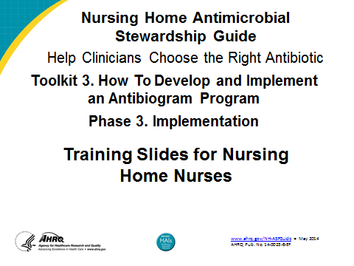

Slide Title and Commentary | Slide Number and Slide
Background: Prescribing Antibiotics  SAY:  Antibiotics are the most commonly prescribed medications in nursing homes.  The use of antibiotics can lead to problems. For example, bad side effects, multidrug-resistant organisms, and healthcare-associated infections, such as Clostridium difficile.  Prescribing clinicians often make decisions before a culture and sensitivity results are available, and clinicians often make decisions based on symptoms, residents’ characteristics, and preference. | Slide 2  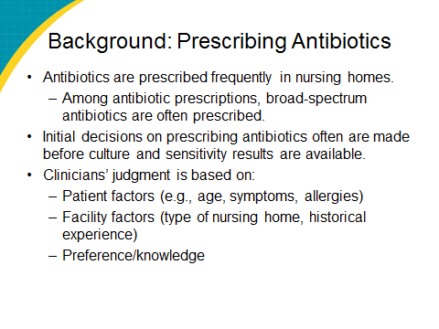
Background: Antibiograms  SAY:  What is an antibiogram? Essentially, it presents laboratory results of tests for sensitivities of bacterial strains to different antibiotics. It shows data at the nursing home for the previous year, and it helps prescribing clinicians understand which antibiotics will or will not work on specific bacteria.  Has anyone seen an antibiogram before? | Slide 3  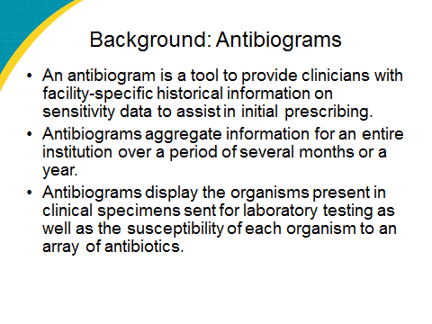
Background: Antibiograms  SAY:  Antibiograms are not new, but they are new to nursing homes. Antibiograms can help clinicians identify appropriate antibiotics and avoid ones that do not work as well. | Slide 4  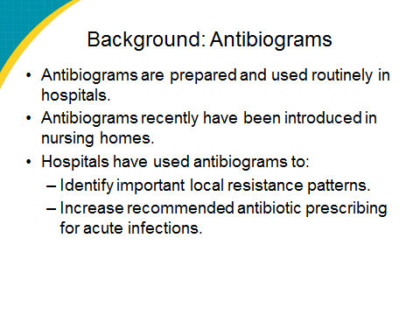
Antibiograms  [INSERT IMAGE OF NURSING HOME ANTIBIOGRAM IF DIFFERENT.]  SAY:  This is what an antibiogram looks like. As an example, the first column is the antibiotic tested, in this case Cipro. The following column headings list different bacteria, both gram negative and gram positive. In this case, the bubble shows Escherichia coli. | Slide 5  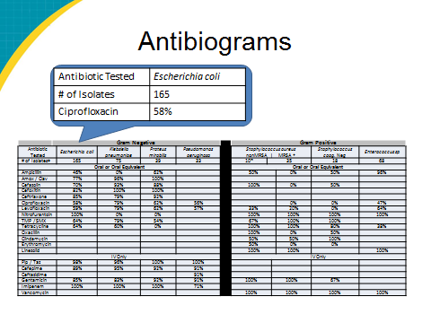
Key Findings From Antibiogram  [INSERT FACILITY-SPECIFIC ANTIBIOGRAM DATA WHERE THE RED X’S/#’S ARE.]  SAY:  What does the antibiogram tell us? First, most of the data are from XXXX cultures, and of the cultures used, the most common was urine/wound/sputum. Thus, the antibiogram will be most applicable when selecting urinary tract infection (UTI)/wound/respiratory infections.  What are the organisms at this nursing home of which we need to be aware? They are…. | Slide 6  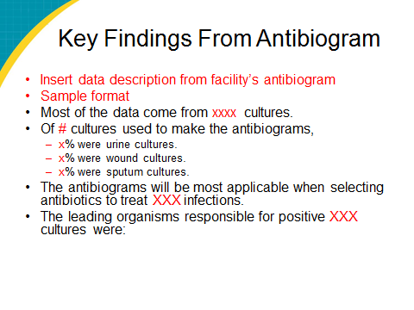
Limitations  SAY:  The limitation of using an antibiogram is the source of the infections. If a resident’s infection was acquired at a hospital, the microbiology is less applicable. | Slide 7  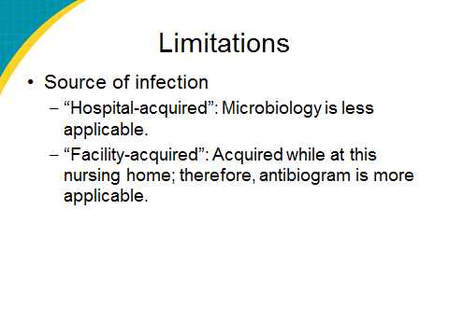
Questions?  SAY: | Slide 8

