Slide Title and Commentary | Slide Number and Slide
Title Slide  Toolkit 3. Minimum Criteria for Common Infections Toolkit  Tool 5. Nursing Staff Training on Importance and Use of SBAR Forms  SAY:  Welcome, everyone, to today’s training program.  First, let me introduce myself; I am (name), a (title) from (organization).  Today’s training is about improving communications with doctors, nurse practitioners, and physician assistants about possible infections by using the suspected infection SBAR forms.  For the purposes of this presentation, the term “prescribing clinician” will encompass physicians, physician assistants, and nurse practitioners. | Slide 1  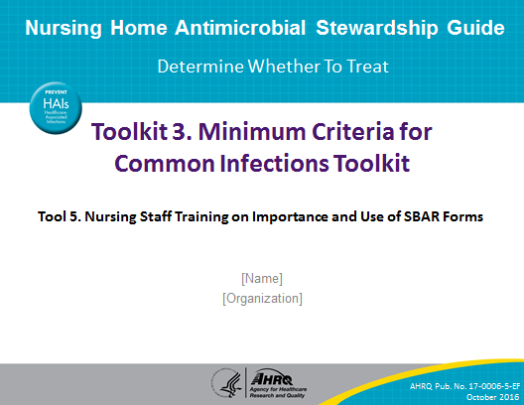

Slide Title and Commentary | Slide Number and Slide
Agenda  SAY:  To begin, these are the points I will cover today. Some areas we will just touch upon; for others, we will go into greater depth. Also, as we go through this presentation, please feel free to stop me and ask questions at any time.  The agenda for today’s training will include the following:  - Background and Purpose: Why are we here and what are we trying to accomplish?  - Suspected Infection SBAR forms: I’ll explain these tools, how they are designed to work, and how they will help you and the nursing home.  - Using the Suspected Infection SBAR form: We will discuss how to use each form specifically. And we will discuss potential challenges and how to address them. | Slide 2  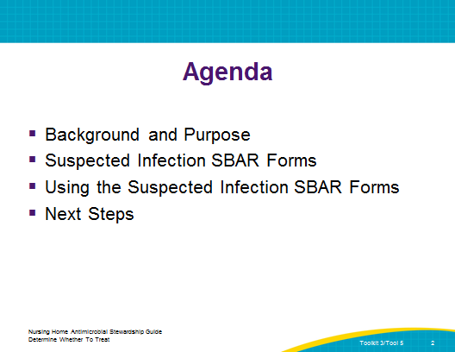
Objectives  SAY: | Slide 3  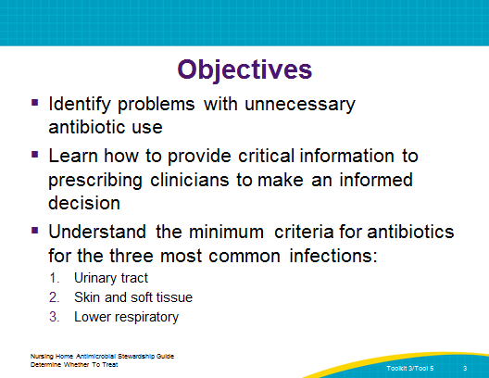
Background: Antibiotic Use in Nursing Homes  SAY:  Before we begin discussing the details of the forms and how to use them, it is important to understand the rationale for using them.  Research shows that somewhere between 50 and 70 percent of residents in a nursing home will receive at least one course of antibiotic during a year. Think about your residents for a minute. Who do you know in the facility that in the past 12 months has not been given an antibiotic for an infection? How many residents would you say you can name? | Slide 4  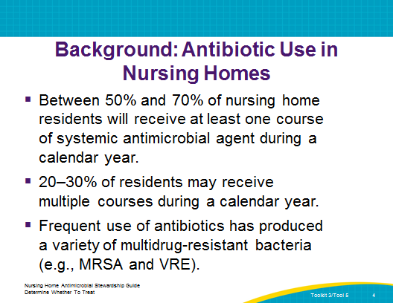
Problems With Antibiotics  SAY:  Antibiotics are great for treating bacterial infections. But can you think of any problems with antibiotics? Has anything happened recently at the nursing home? | Slide 5  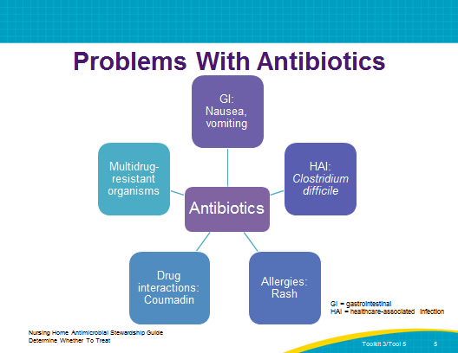
Antibiotic Use in Nursing Homes Creates Risks for Multiple Groups  SAY:  Infections from multidrug-resistant organisms are occurring more frequently in residents in nursing homes. As you provide care for these residents, you are also exposed to these multiantibiotic-resistant organisms, and you take these organisms home with you at the end of the day to your family and the community! | Slide 6  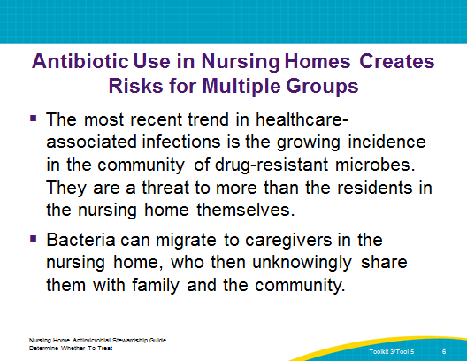
Resistant Strains Spread Rapidly  SAY:  Just looking at multidrug resistance, it is a huge issue and increasingly common.  For example, penicillin no longer works nearly as well to treat pneumococcal pneumonia.  Another example is, of course, MRSA, or methicillin-resistant Staphylococcus aureus.  More frightening is that prescribing antibiotics for urinary tract infections is much more difficult because of many multidrug-resistant organisms, or MDROs.  These are just some examples. This graph shows how rapidly resistant strains of MRSA, vancomycin-resistant Enterococcus, and fluoroquinolone-resistant Pseudomonas have spread nationally once they emerged. | Slide 7  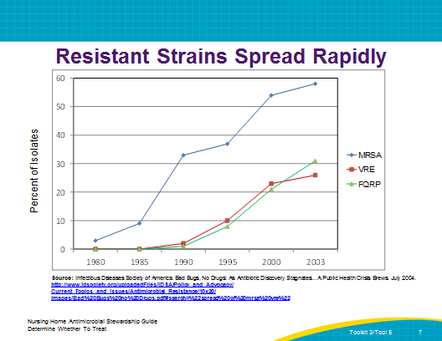
Few New Antibiotics  SAY:  At the same time, not only are antibiotics not working as well because of MDROs, we do not have enough antibiotics in development.  As of 2009, there were only 15 or 16 new antibiotics in development, none of which had made it to phase 3 trials, and none of which acted against bacteria that are resistant to all currently available drugs. | Slide 8  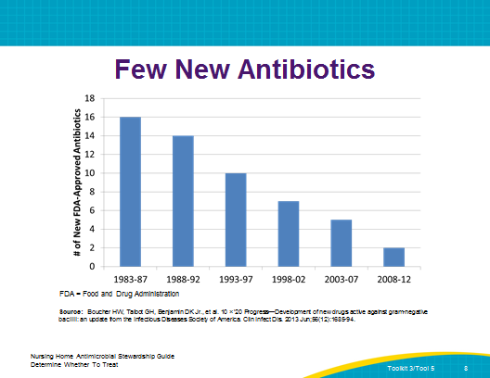
Antibiotic Use in Nursing Homes for Suspected UTIs  ASK:  How can a urinalysis cause a problem?  SAY:  It is difficult to obtain clean catches of urine from many nursing home residents who are frail or mentally impaired, which increases the likelihood of a false positive urinalysis (UA) test result. Residents without symptoms but who have a positive UA test result may not actually have bacteriuria or need antibiotics. Further, there is substantial evidence that treating asymptomatic bacteriuria (residents with a true positive test result but no symptoms) offers no benefits to patients and is harmful because it increases the chances of subsequent drug-resistant infections and potential drug reactions.  It is well proven in the health care industry that repeated use of antibiotics, necessary or not, has increased the variety of multiantibiotic-resistant organisms. Each time a resident receives an unnecessary antibiotic, the nursing home is actively contributing to the development of multidrug-resistant organisms. | Slide 9  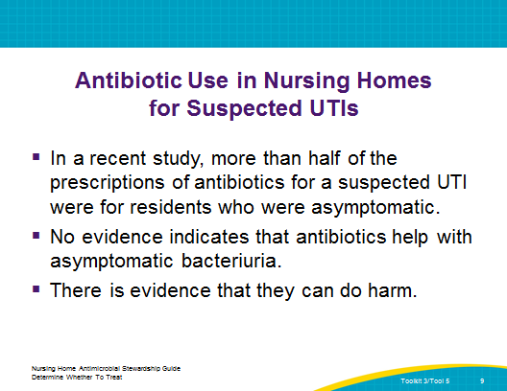
Overview  SAY:  To set the story, let’s discuss the SBAR briefly.  Have any of you heard of it?  The SBAR communication style has been shown to promote better communication and performance by addressing the specific types of information that prescribing clinicians are likely to need for decisionmaking.  The SBAR forms are based on criteria developed by an expert consensus panel and modified clinical practice guidelines for infections in older adults in nursing homes.  IF NECESSARY—The “r” in SBAR has been modified from “recommendation” to “request” to fit a nursing home environment. | Slide 10  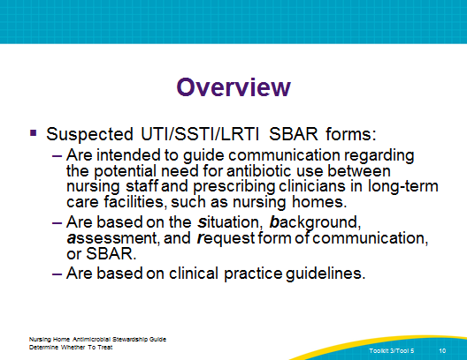
Guidelines for Antibiotic Use  SAY:  These criteria were developed by a group of experts brought together to establish a set of criteria (e.g., signs and symptoms) that, at a minimum, should be present before initiating antibiotics for residents in long-term care facilities for four types of suspected infection. They are often called the “Loeb criteria.”  One point to emphasize is that the SBAR form is NOT designed to tell prescribing clinicians whether they CAN or CANNOT order an antibiotic. The tool is designed to communicate to prescribing clinicians which conditions are present for a suspected infection and whether or not those signs and symptoms meet the guidelines for initiating an antibiotic. Whether or not to order an antibiotic or some other intervention is left to the discretion of the prescribing clinician.  Your Medical Director has been given this information and these tools to present to all of the prescribing clinicians who provide care for residents in your facility. They know this tool is coming and why you are using it. Do you have any questions about this? | Slide 11  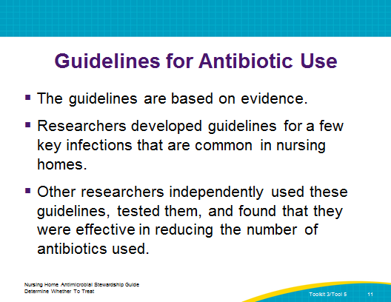
SBAR Tool Design  SAY:  We are going to discuss the idea behind the UTI SBAR form. It is based on the SBAR tool. Have any of you ever heard of the SBAR tool before? May I see a show of hands from those who have heard of this tool? (If hands are raised, ask audience members to explain their experience with this tool and what they know about it. If not, explain the tool and ask for comments throughout the explanation.)  SBAR is a technique that provides a standard, objective framework for members of the health care team to share information regarding a resident’s condition quickly.  SBAR focuses on all necessary data that require action.  And, just a little history: SBAR originated in the U.S. Navy submarine community to provide critical information to the captain quickly.  For us, SBAR provides a vehicle for nurses to express their concerns concisely. | Slide 12  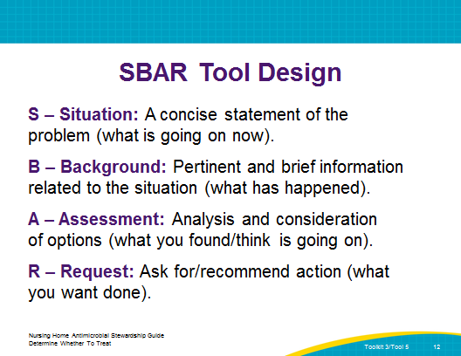
SBAR Form Page 1  SAY:  There are three forms: the UTI, Skin and Soft Tissue, and Lower Respiratory Tract Infection SBARs. This an overview of the first page of the tool from the UTI SBAR.  We will go through each tool.  We will go through each section of the tool in depth, but I just wanted you to see a copy of one entire form. | Slide 13  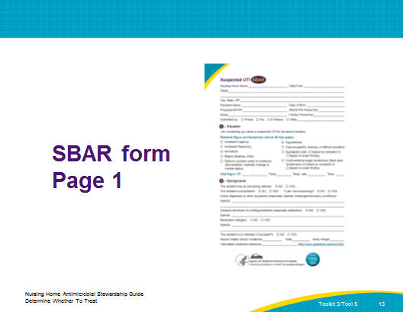
SBAR Form Page 2  SAY:  This is the second page of the tool. | Slide 14  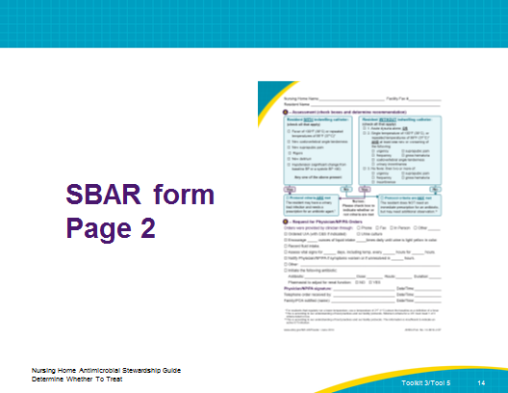
SBAR Form Page 1  SAY:  This is the header of each SBAR form. | Slide 15  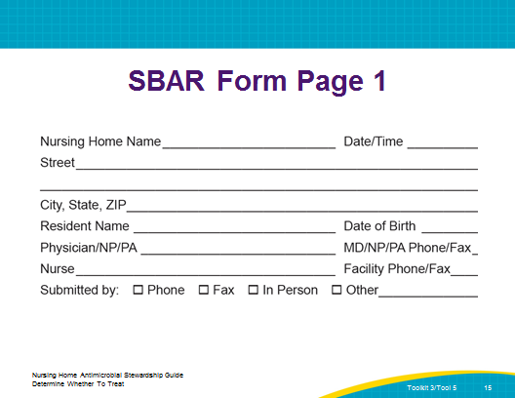
UTI SBAR Form Page 1  SAY:  After the header information, you start with “Situation.” This includes information only for the UTI SBAR.  Check each box that applies from your assessment of the resident.  Is there costovertebral tenderness? This is commonly called “flank pain.”  Is the resident shivering or experiencing “rigors?”  Is there a new onset of delirium? Delirium is defined as a sudden change in the resident’s mental status. For example, yesterday this resident could pick out his own clothes, and today he does not realize he is in a nursing home. This could be considered delirium.  Is the resident hypotensive? Normal blood pressure is a range from 110–130/60–80. Classic hypotension is blood pressure 90/60 or lower, but this can vary for each resident. | Slide 16  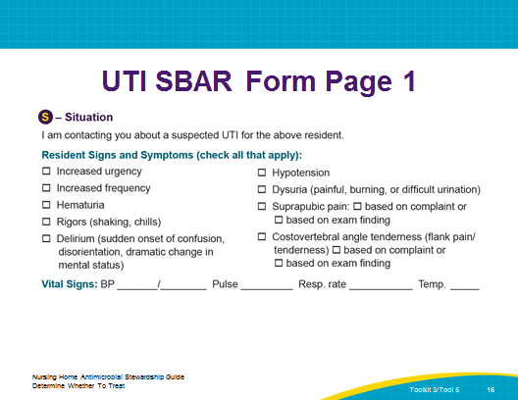
UTI SBAR Form Page 1  SAY:  If a resident has an indwelling catheter, mark the box in front of “YES”; if not, then mark the “NO” box. The same for incontinence. If the resident has always been continent but is not now, you would mark “YES” for incontinence and “YES” for a new or worsening condition.  Be sure to list ALL active diagnoses.  Active diagnoses are those that are currently being treated in your facility. If a resident broke her hip 5 years ago and has healed, that is not an active diagnosis. | Slide 17  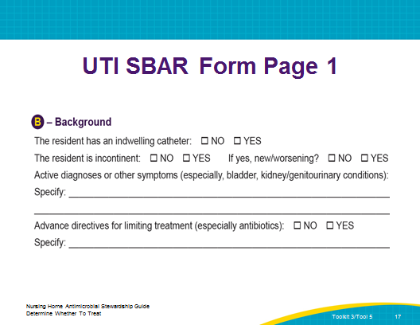
UTI SBAR Form Page 1  SAY:  Be sure to indicate whether or not the resident has any medication allergies, and specify which ones if she or he does.  Indicate whether the resident is on warfarin, because there are so many interactions with that particular drug.  To help the prescribing clinician decide on the dose of an antibiotic, provide the creatinine, date, and body weight. Then calculate the creatinine clearance. | Slide 18  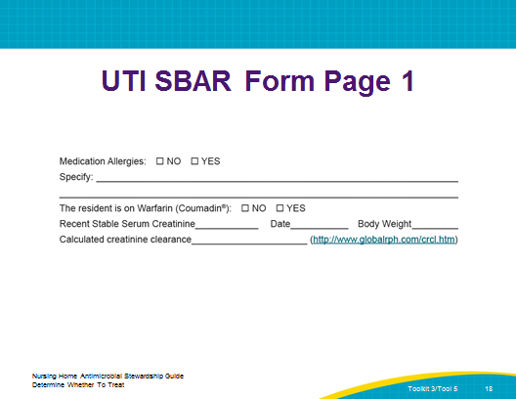
UTI SBAR Form Page 2  SAY:  This is the header part of page 2, and it is the same on all forms. The name of your nursing home will be printed on the top of the page. In many cases, facilities fax information, which is why this includes fax information.  Remember to include the resident’s name on this page in case the two pages become separated. | Slide 19  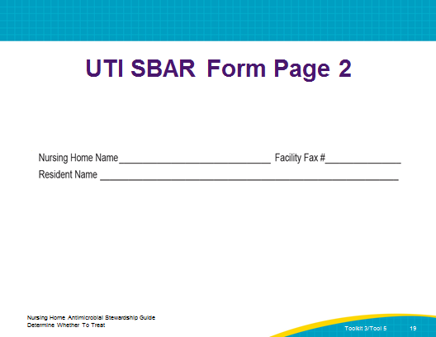
UTI SBAR Form Page 2  SAY:  This section is your actual assessment of the resident’s condition.  We are going to review each box at the top separately side by side, starting on the left, before we follow them down to recommendations with the arrows. I will keep the boxes separate on the screen, but follow along on your copy of the tool.  We start with an indwelling catheter. If there is no catheter, skip over to the other box.  If there is a catheter, is there a fever greater than 100 degrees or a repeated temperature of 99 degrees?  Alternatively, some residents have a normal baseline temp lower than the normal 98.6 degrees. If you know what it is, use a definition of 2 degrees above baseline. If your resident’s normal temperature is 96.4 but his or her current temp is 98.8, this would indicate a fever and you would then check the first box.  If you have checked “YES” in any of the criteria in this box, then follow the “YES” arrow to recommendations. If you have not checked any of the boxes, then follow the “NO” arrow to recommendations. | Slide 20  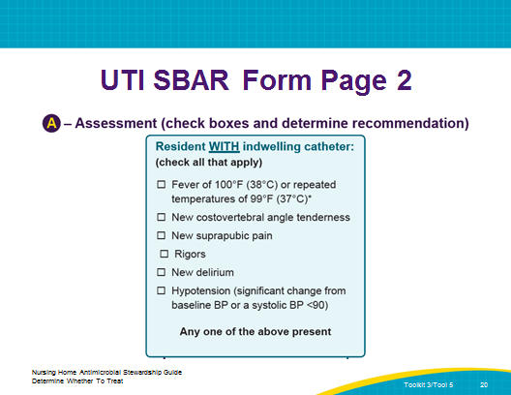
UTI SBAR Form Page 2  SAY:  If the resident does not have an indwelling catheter, this is the box to document your assessment.  This box describes the three different criteria to initiate antibiotics for residents without a catheter.  First, if there is acute dysuria (difficult or painful urination), that alone meets the criteria for the use of antibiotics.  Second, if the resident has a fever and at least one of the following new or worsening conditions—urgency, suprapubic pain, frequency, gross hematuria, flank pain, or new or worsening onset of incontinence—then she or he meets the criteria.  Third, if the resident does not have a fever, she or he must have at least two of the criteria listed here.  If a resident meets one of these three, then the criteria for antibiotic use have been met and you follow the “YES” arrow in recommendations. If not, you follow the “NO” arrow in recommendations.  Now here, I know you are going to ask, what if your evaluation comes up with “NO,” do you still need to notify the prescribing clinician? The answer is yes, because you have identified changes in the resident’s status, and those changes must be reported. This tool is your documentation to show that you reported these changes in status. | Slide 21  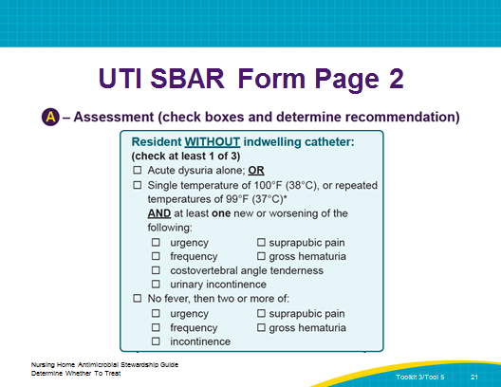
UTI SBAR Form Page 2  SAY:  Now, you have followed the “YES” arrow, and you have come to the box that says “Protocol criteria are met.”  Make sure you mark this box, especially if you are faxing this form. The prescribing clinician can also follow the arrow to this box and see exactly what your assessment indicates. If you are calling the prescribing clinician, you will need to mention that the UTI SBAR form guides you to this box and report what it says.  Understand that you are not telling the prescribing clinician that this resident must be started on antibiotics. But the prescribing clinician is now aware you are using this tool. The facility’s management, including the medical director, is on board. In addition, prescribing clinicians will be or have been sent a letter and an example of the protocol.  Again, let me remind you that this tool is not designed to tell prescribing clinicians when they must or must not order antibiotics; this tool is a guideline to help ensure that all pertinent data are provided for them to make their decisions. There are always underlying factors unique to each resident that might make the prescribing clinician decide in one way or another.  Now, you have followed the “NO” arrow and you have come to the box that says “Protocol criteria are NOT met.” Again, you need to mark the box.  And, if calling in the report, read what the box tells you to say to the prescribing clinician. | Slide 22  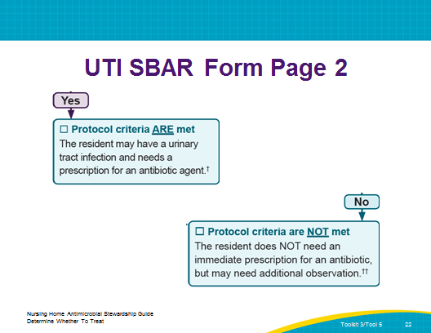
UTI SBAR Form Page 2  SAY:  This section is for the prescribing clinician. If you call this information in to the prescribing clinician, you are responsible for making notations in this section, just as with a telephone order.  The advantage of these orders is that they are not only about antibiotics. They address followup and care, and—if appropriate—antibiotics. That is another reason to provide this information to a prescribing clinician even if the resident does not meet the criteria for initiating an antibiotic.  If the prescribing clinician elects to start antibiotics, this is where you would document which antibiotic is prescribed, how frequently it will be given, and for how many days.  If the prescribing clinician orders anything not listed on the tool, be sure to document that as “Other.” | Slide 23  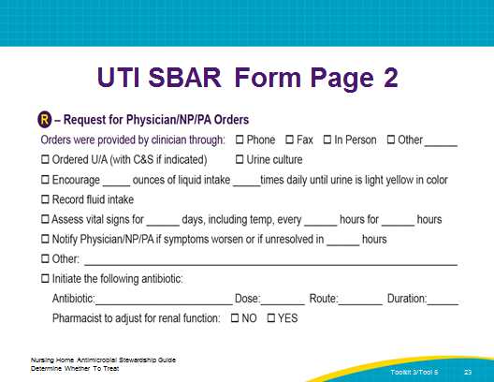
All SBAR Forms Page 2  SAY:  Finally, if the Suspected Infection SBAR form is faxed to the prescribing clinician, it should be returned to you signed with the order section completed. If you use this tool to call the information in to the prescribing clinician, you must sign your name and date the UTI SBAR form as you would on a telephone order. As always, when there is an order from a prescribing clinician, you must notify a family member regarding the new order.  Remember, it is possible the prescribing clinician will return only the second page to you, so make sure you have the resident’s name on page 2. | Slide 24  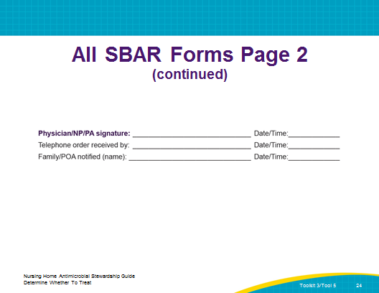
Review  SAY:  Now I would like you to get into 2/3/4 groups of about 4 people each. Discuss the following two questions for about 10 minutes, and then we will report back.  - First, think about a resident who had a UTI recently. Do you think that person met the criteria shown on page 2? How do you know? Discuss what happened.  - Second, have you seen a situation in which someone was given antibiotics but did not meet these new criteria?  Report back: Allow 2–3 minutes per group per question. Reinforce and support meeting the criteria. For problems, address the following as necessary.  Why doesn’t the UTI SBAR form state that “cloudy urine,” “smelly urine,” or other symptoms indicate a UTI? In the past, cloudy or smelly urine and other symptoms not mentioned in the Suspected UTI SBAR form were considered an indicator of a UTI. However, newer research indicates that they do not indicate the need for an antibiotic. For example, when some people eat asparagus, their urine smells—that clearly isn’t a UTI. For others, if they have not urinated in a long time, their urine may smell. Cloudy urine is typically an indication of protein—not bacteria—in the urine. Discuss with staff anything else that might be considered symptoms but that is not listed on the UTI SBAR form. In all cases, stress that this is the newest research, and recommendations for antibiotics should be based on the UTI SBAR form. | Slide 25  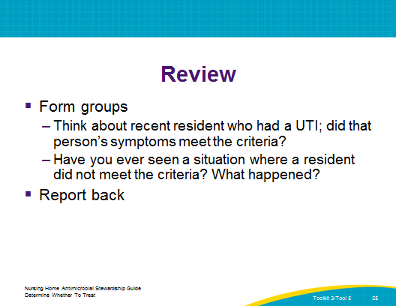
Review (continued)  SAY:  At the same time many symptomatic UTIs are accompanied by cloudy or smelly urine. However, there are many other causes of changes in the urine, such as poor oral intake, dehydration, crystallization after urine passage, and other noninfectious causes. Studies have shown that a positive culture obtained solely because of a change in urine appearance will over-diagnose infection at least one-third of the time. Therefore, they should not be used to identify a UTI.  Why aren’t their orders for regular—say, monthly—urinalyses? Although the “new” criteria and protocol are based on research that has been around for a long time, some doctors still believe in monthly or regular tests. But, unless there are actual symptoms, antibiotics shouldn’t be prescribed. | Slide 25
Suspected Skin and Soft Tissue Infection SBAR  SAY:  Okay, now we are switching to the Suspected Skin and Soft Tissue Infection SBAR.  This section is the situation section for the suspected SSTI. Just like before, fill out everything as appropriate.  What is purulent drainage? Pus, which can be white, yellow, gray, green, pink, or brown. | Slide 26  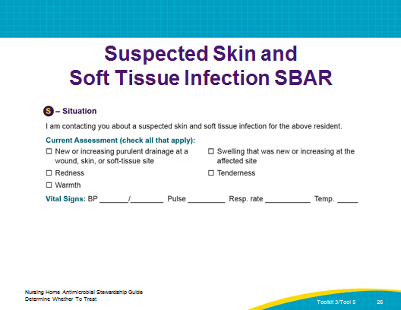
Suspected SSTI Infection SBAR  SAY:  The background is pretty much the same, except that it includes noting whether the resident has diabetes, because that is important for determining how to treat, and providing different examples of other active diagnoses.  Again, indicate whether there are advance directives, allergies, whether the resident is on warfarin, and the creatinine information. | Slide 27  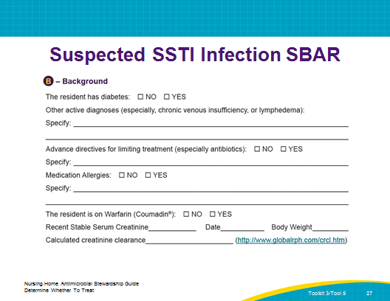
Suspected SSTI SBAR Page 2  SAY:  Flipping the page over, you can see the minimum criteria again. There are two options:  - New or increasing purulent drainage—OR  - At least two of the following symptoms: fever, redness, tenderness, warmth, or swelling that is new or increasing at the affected site  Again, this uses the same definition of fever: 100 degrees, or repeated temperatures of 99. Alternatively, if you know the baseline temperature, then a fever is 2 degrees above the baseline. | Slide 28  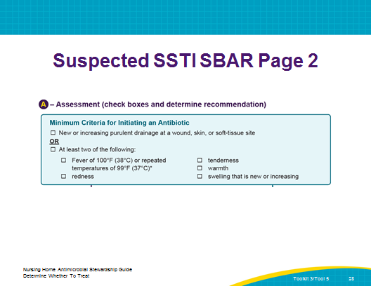
Suspected SSTI SBAR Page 2  SAY:  Again, you will need to check the box as to whether the criteria have been met. | Slide 29  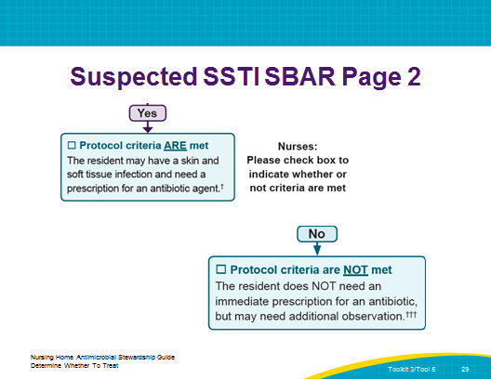
Suspected SSTI SBAR Page 2  SAY:  Again, here the clinician can select the next course of action, and just as in the Suspected SBAR, there are nonantibiotic options. You will also note that these are different from the ones for a suspected UTI. It also allows for more than one antibiotic. | Slide 30  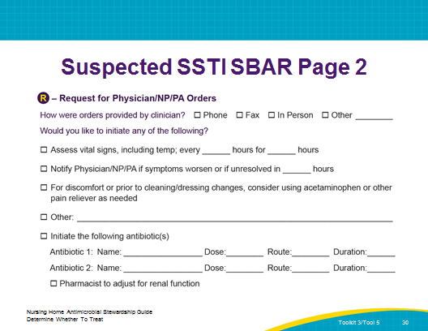
Suspected Lower Respiratory Tract Infection SBAR  SAY:  Okay, now we are switching to the Suspected Lower Respiratory Tract Infection SBAR.  This section is the situation section for the suspected SLRTI. Just as before, fill out everything, as appropriate. | Slide 31  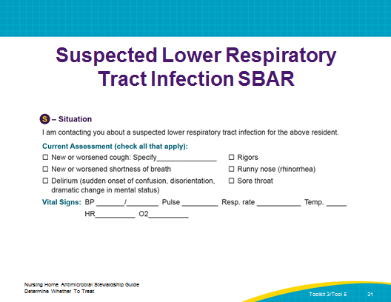
Suspected LRTI SBAR  SAY:  This is a portion of the background section. It includes a section that is a bit different from the UTI and SSTI SBAR forms.  It asks about COPD, diabetes, smoking—all helpful to clinicians for making decisions.  The examples of other active diagnoses are specific and relevant to a potential LRTI. | Slide 32  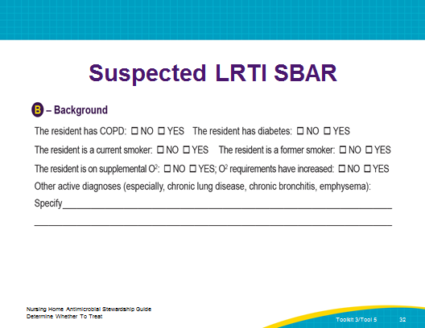
Suspected LRTI SBAR Page 2  SAY:  The Suspected LRTI is the most complicated in terms of minimum criteria for initiating an antibiotic. There are four different situations, first based on temperature and then, if no temperature, COPD status.  So first, you need to know whether the resident has a fever, and if so, what it is.  If a resident has a high temperature, or a fever of 102 or higher, the resident needs to have symptoms of a new or worse cough, new or increased sputum, a respiratory rate higher than 25 breaths a minute, or an oxygen rate of less than 94 percent; then the resident meets the criteria.  If a resident has a fever of 100 to 102, she or he needs to have a cough AND one other symptom—a pulse of 100 or more, new delirium, rigors, or a high respiratory rate.  If a resident has no fever but has COPD, she or he only needs a new or increased cough with purulent sputum production.  Residents with no fever and no COPD must have a new or increased cough with purulent sputum production AND at least one of the following: a respiratory rate >25, or a sudden onset of confusion, disorientation, or dramatic change in mental status.  Questions? | Slide 33  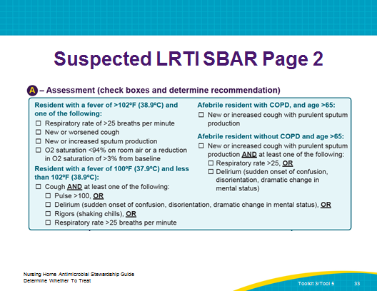
Suspected LRTI SBAR Page 2  SAY:  Finally, we have the prescribing clinician orders. Again, we suggest options other than a prescription following this section. | Slide 34  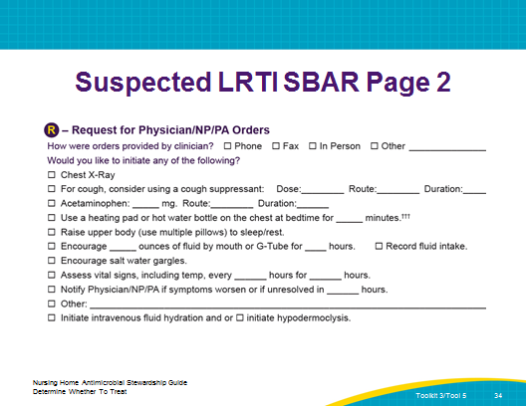
Questions and Review  ASK:  Does anyone have any questions?  Were there any surprises?  [IF NOTHING IS BROUGHT UP, DISCUSS THE FOLLOWING]:  Why is rhinorrhea listed under Situation for LRTI? Did you notice that, under “Situation,” it states rhinorrhea, or runny nose? Why would that be there? Runny nose is not an indication of a LRTI, and this is just a way to cross it off the list. | Slide 35  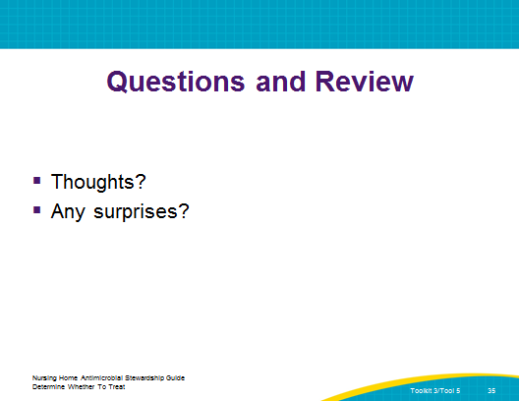
Summary  SAY:  To recap: The Suspected Infection SBAR form represents a protocol to communicate changes in condition that lead you to suspect an infection.  These protocols are communicated to the prescribing clinician via this tool, and even if the prescribing clinician is in the facility when a suspected infection is identified, this is your documentation to show that you have identified a potential change in condition. It is part of your medical record, even if you then write a T.O. to order an antibiotic. | Slide 36  