Slide Title and Commentary | Slide Number and Slide
Auditing Your Briefing and Debriefing Process  SAY:  Let’s continue our discussion around briefings and debriefings. The previous module, Optimizing Your Briefings and Debriefings, focused on defining them. We also discussed key elements of a successful briefing process, including a thorough system to follow up on defects identified by the surgical team. | Slide 1  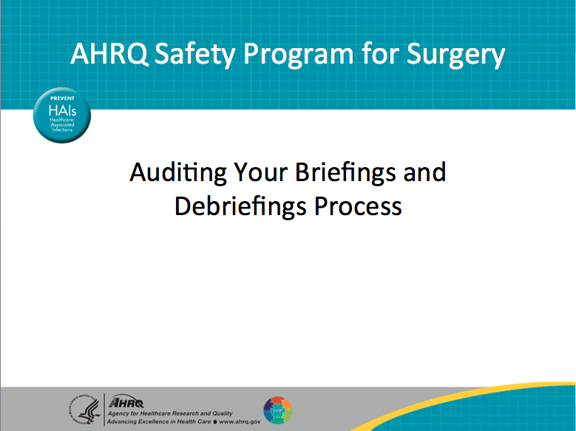
Learning Objectives  SAY:  Today we will recap the briefing and debriefing process. We will introduce the concept of an audit tool. Just as you can audit clinical processes, you can audit briefing and debriefing processes. This can be performed efficiently without the burden of excessive measurement.  Good data should drive all implementation decisions. However, it can be labor intensive and burdensome to collect that data. Today we will introduce some tools to support a streamlined audit process and use those tools to provide feedback to your operating room providers.  The best way to build engagement and surgeon buy-in is to add value for them.  ASK:  What are they getting out of this process?  SAY:  A solid audit process will support your surgical team and coach the team on how to maximize the process with real support to elicit the best possible outcome. | Slide 2  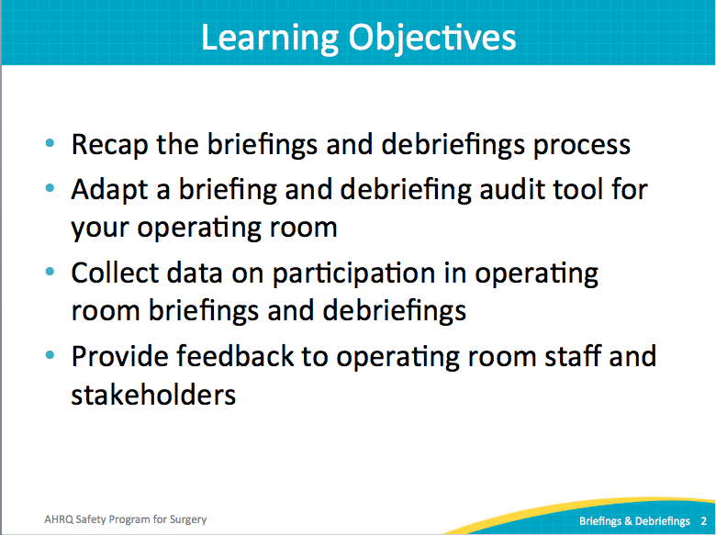
AHRQ Pub. No. 16(18)-0004-15-EF
December 2017
Slide Title and Commentary | Slide Number and Slide
Recapping Our Approach  SAY:  This safety program focuses on two types of work: technical components and adaptive or cultural components. The technical work involves evidence-based clinical practices. The adaptive work centers on cultural issues, like attitudes and values. With technical and adaptive efforts and an understanding of the science of safety, quality improvement teams can reinforce a systems approach to safety.  Briefings and debriefings are based on the adaptive elements of our work, but they can be very technical as well. They provide a great opportunity to build from a teamwork perspective to get people thinking about systems. A structured process provides a concrete way to improve your safety culture. | Slide 3  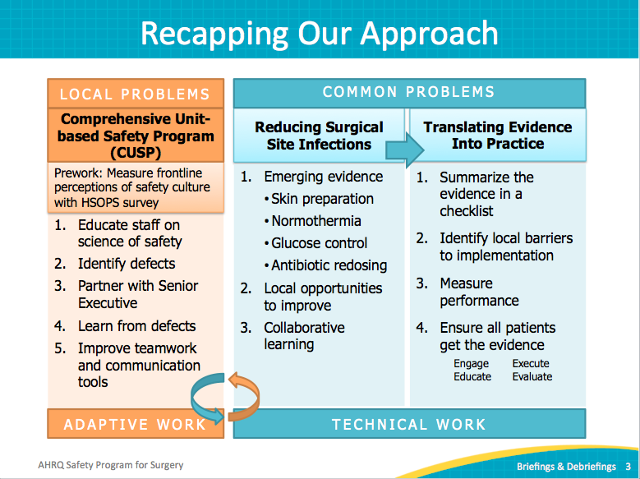
Why Briefings and Debriefings?  ASK:  Why briefings and debriefings?  SAY:  While it makes sense logically and evidence supports the claim, teams across all industries perform better when they have a good plan. Plans are good when they are shared with teammates, when people understand what that plan is, when they have a sense of what’s going to happen, and when they understand how they fit into the big picture. Planning and sharing the plan allows teams to learn and improve over time.  This is not a groundbreaking discovery. It is, however, fundamental to how we manage teams. Briefings and debriefings are a way to ensure our teams have good plans that everyone understands that plan.  ASK:  Does briefing guarantee good planning or good outcomes?  Have you encountered briefings or debriefings on autopilot that added no value?  SAY:  Briefings can be checklist in nature, providing a consistent framework. The risk is when that checklist becomes an administrative task. We go through the steps, but we are not really paying attention. Once they become rote and familiar, we are no longer mindful during tasks and the value is poor. Every checklist can present this risk. | Slide 4  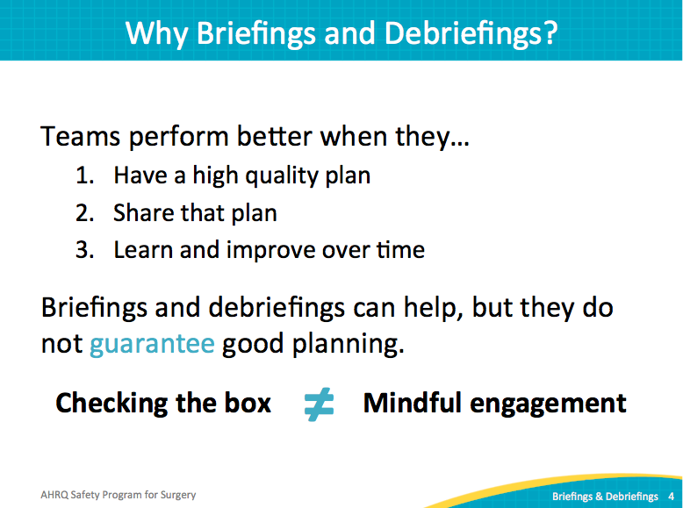
Briefing and Debriefing  SAY:  Briefings and debriefings can impact our outcomes in many ways: by reducing operating room delays, reducing nursing time in the core, reducing complications, reducing surgical site infections or SSIs, or reducing mortality rates. Time spent improving communication among surgical teams improves outcomes. Briefings and debriefings reinforce all of your SSI interventions.  Note: The core is usually a storage facility for operating supplies and equipment. Operating rooms are grouped around a clean core used for sterile supply storage. It is the cleanest area of the entire operating suite. Only staff wearing appropriate surgical attire should be allowed in the core. | Slide 5  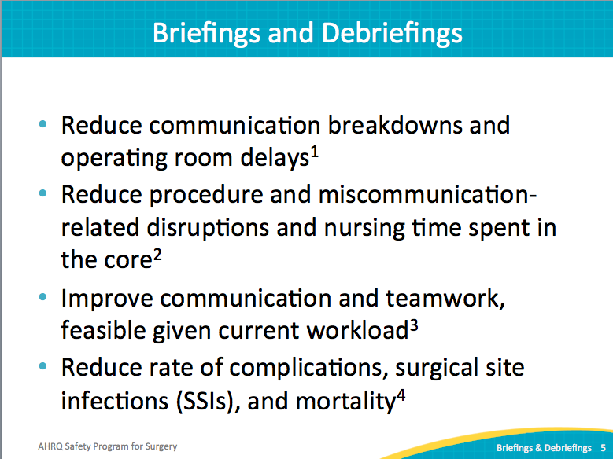
Auditing Briefing Practices  SAY:  This is the four-step procedure used at The Johns Hopkins Hospital to audit briefing practices.  First, the Briefing and Debriefing Audit tool is based on global best practices. It was customized to incorporate the specific elements addressed in the surgical setting. Use the audit tool as a starting place to develop one that reflects your clinical setting and bundle.  Second, select and train observers to collect consistent data on your process. It does not require a significant investment of time. The data will be used to drive change and improve your briefing process. Decide how much information you need to collect evidence that your providers will find valid.  ASK:  Do you want to observe five briefings from each surgeon?  What about all morning cases for a week?  Would a random sample of cases throughout the month provide enough data?  SAY:  Third, once observers have been selected and trained, make a plan and collect your data. Finally, provide feedback. Use the data to coach providers and improve the process. | Slide 6  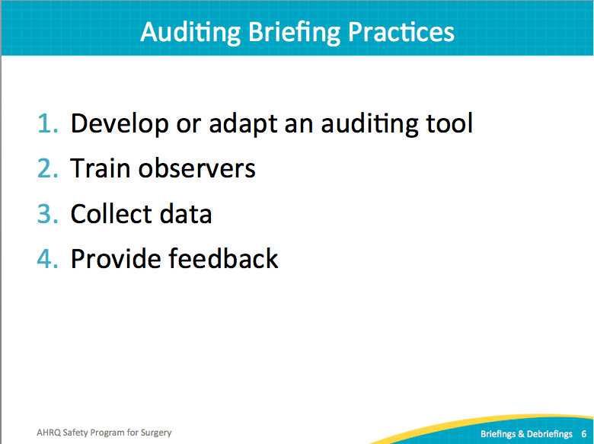
Developing a Briefing Audit Tool  ASK:  How do you think briefings and debriefings should happen?  How are they actually happening?  What can we do to close that gap?  SAY:  After auditing early briefings, you may discover a great deal of variability. It is important to understand the expectations in order to converge on a more consistent practice.  First, understand the internal expectations. Identify any policies on briefings. Be prepared to question the process and paperwork in place.  ASK:  How often are specific forms used?  Who completes those forms?  Next, evaluate external expectations. We researched best practices in the literature, much of which is summarized here for your teams. Staff at one hospital identified a gaping hole in the hospital’s policy surrounding contingency plans. The former process did not anticipate worst-case scenarios.  ASK:  What is the worst thing that could happen, and what are we going to do about it if it did?  SAY:  Last, make sure both internal and external expectations are incorporated into your audit tool. Either modify the tool provided in this safety program to fit your needs or modify a tool from the literature. | Slide 7  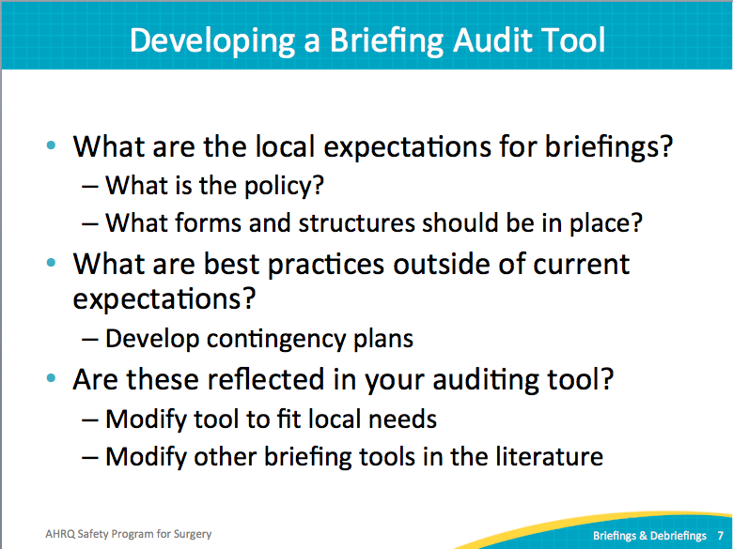
Example Briefing Audit Tool  SAY:  This Operating Room Briefing and Debriefing Audit tool begins with space to record the name of the observer, the date and time of the observation, and the location. The tool itself has four sections: logistics, basics, specific content, and participation. | Slide 8  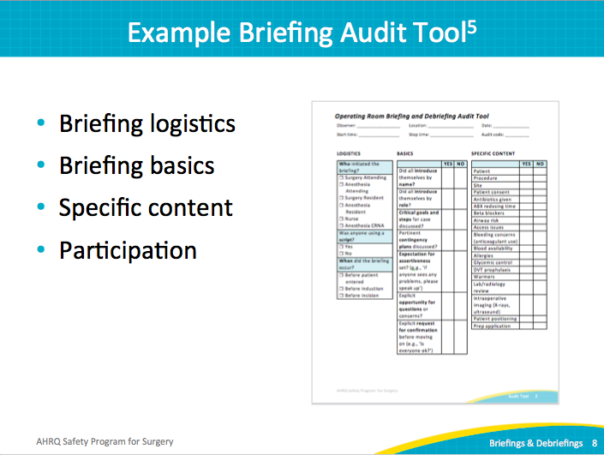
Example Briefing Audit Tool  SAY:  The logistics section identifies who initiated the briefing, whether a script was used, and when the briefing occurred. | Slide 9  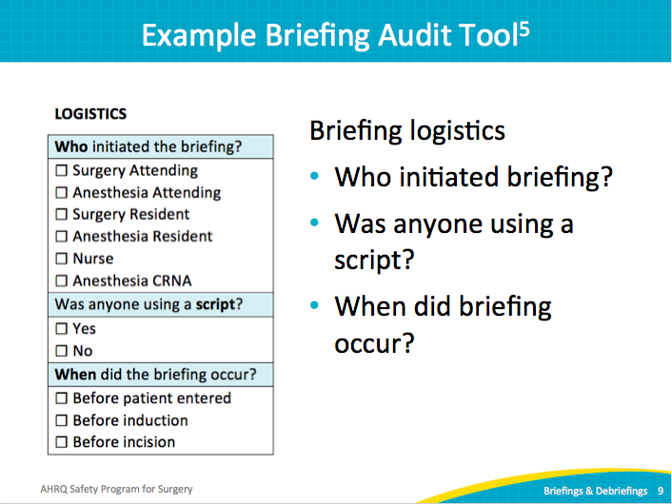
Example Briefing Audit Tool  SAY:  The briefing basics section looks for several best practices. Evidence shows that having team members introduce themselves by name and role drastically improves team communication.  ASK:  How likely is it to expect a new nurse to speak up about a safety concern if she doesn’t know the people on her team and they haven’t asked anything about her relevant experience?  SAY:  Not very likely. Effective briefings encourage team members to share relevant experience. For instance, the new nurse in the question above can share her name, role, and expertise with the procedure. She may be new to the surgeon or new to the team, though well trained to handle the case.  ASK:  Were expectations set for people to be assertive in speaking up?  Did briefing lead explicitly ask for questions or confirmation? | Slide 10  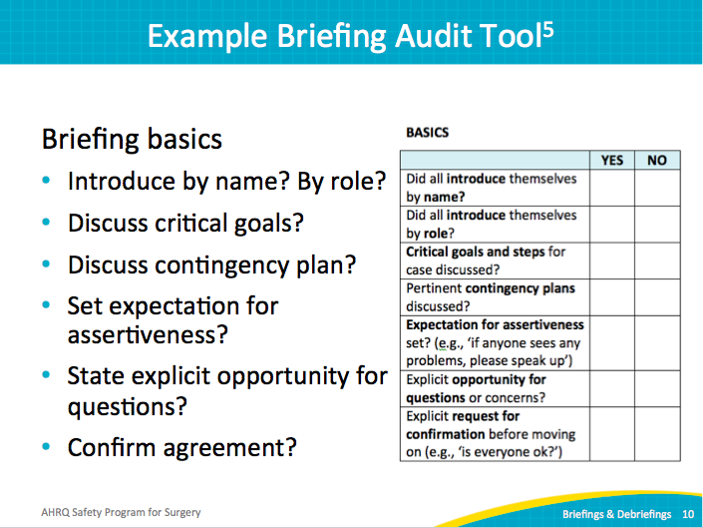
Example Briefing Audit Tool  SAY:  The hospital’s policy is to measure specific clinical items related to the procedure, like deep vein thrombosis prophylaxis or antibiotics given, any blood product needs, and preoperative skin preparation. This section would of course need to be modified to reflect your clinical setting. | Slide 11  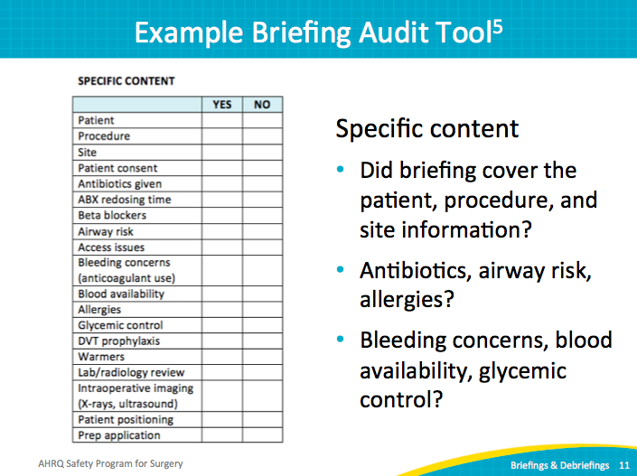
Example Briefing Audit Tool  SAY:  The participation section aims to capture individual engagement in the briefing discussion. If you have participated in or seen many briefings, you may have found a circulator nurse reading through the checklist while the rest of the team continues multitasking with other activities. Picture a monotonous recitation with no verbal interaction. That briefing is on the low end of the quality briefing spectrum.  ASK:  How engaged are the care team members?  First, are the surgeon, the anesthesiologist, the circulator nurse, et cetera, present?  Did the attending surgeon pause all competing activities?  Did the resident speak to the group?  Did the scrub nurse participate?  Did anyone raise an issue or ask a clarifying question?  SAY:  Record each role that speaks up and verbalizes absolutely anything in this process—that counts as participation. The goal is to get a gross and measurable sense of how engaged and interactive the care team is during the briefing. The initial data may not be flattering, but it is useful in coaching and targeting improvement efforts. | Slide 12  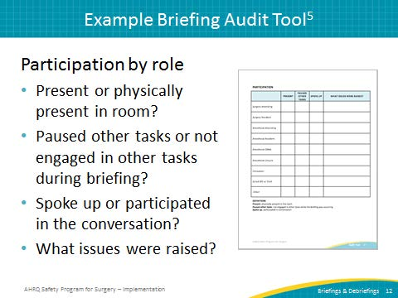
Training Observers  SAY:  The first step in training observers is to select observers. The concise audit tool looks for concrete information. Your observers will not have to make many judgment calls, but rather will be looking for discrete tasks. Good observers will be those who have the time and interest.  SAY:  To familiarize your newly appointed observers with the audit tool, walk them through each section on the form. Describe what you are looking for and give them the chance to ask questions. Consider a dry run either with a reenactment or a video of a briefing. We also had success with scoring a few briefings in pairs and talking about any differences. Strive for consistent expectations. | Slide 13  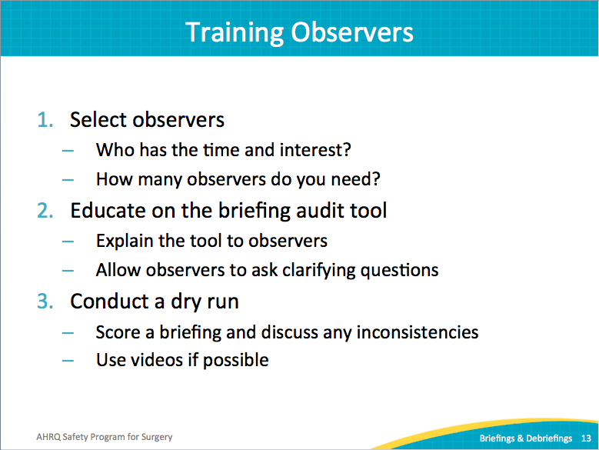
Training Observers  SAY:  Nurses, medical students, volunteers, psychologists, physicians, and technicians have been observers with strong data results. It comes down to using what you have available. Observers tend to find the process interesting and informative.  This chart shows an example of a hospital’s reliability data for observers that performed audits on briefing and debriefing sessions. Most sections yielded high reliability with little time investment and training. The basics and specific content sections achieved high mean kappa results above 0.8, or in other words, the observers agreed with each over 80 percent of the time. This included the highly clinical elements of the case, which was a nice surprise. It proved more difficult to discriminate the participation. Observing whether people were pausing, speaking up and participating was harder. The briefing basics and specific content sections obtained higher reliability. This table validated the data so that frontline providers found the audit data meaningful. | Slide 14  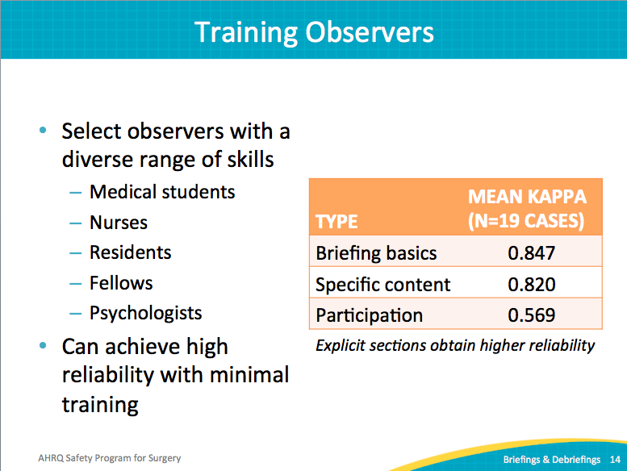
Collect Data  ASK:  How many observers do you need? That’s really how much data you want to collect  How do you determine how much data to collect? How much, where to look and start improvement efforts?  SAY:  Identifying staff available to observe audits and collect data can be a challenge. Be prepared to work within the boundaries of your current project team. Successful hospital teams often start small and grow into a bigger initiative over time. Once teams start achieving visible results, it is easier for management to support those efforts with more concrete resources. Start small with a single service or a specific number of surgeons and anchor your observations around that focused group. As an example, we evaluated a few cases for each surgeon. By evaluating several surgeons, we were able to learn about the current processes.  For the first pass of observations, we started with the first case of the day. While this biases the initial data some, it is easier to manage logistically. Early cases tend to start on time, so your observer is not hanging around waiting for the case to start. After collecting the predetermined observations either by count, surgeon, or time period, enter and analyze the data. | Slide 15  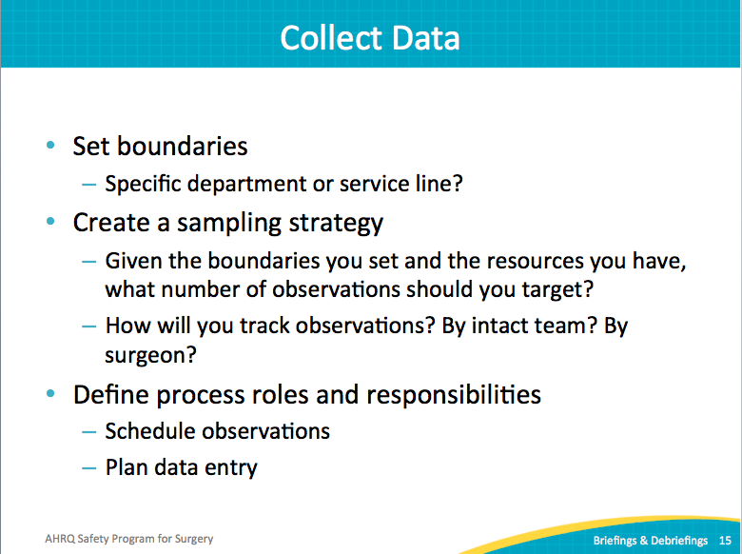
Briefing Basics  SAY:  This is an example of results from a surgical briefing audit. For the purposes of this exercise, 64 case briefings across 4 different service lines were audited. It covers a wide cross-section of the surgical providers and provides a lot of variation. While these data are not flattering, they are representative of current briefing practices in many hospitals nationwide. We have a lot of work to do on just the basics.  This group introduced by name and role between 40 percent and 50 percent. Minimal cases stated critical goals or contingency plans. A very low 20 percent of the cases provided an opportunity for questions. Worse still, in none of the 64 cases did anyone explicitly make a statement about being assertive, speaking up during the case, or setting that tone for the care team. We know this is important, but it’s tough to make happen. It only happens with mindful execution of best practices, coaching and continual focus on, and team openness to process improvement. | Slide 16  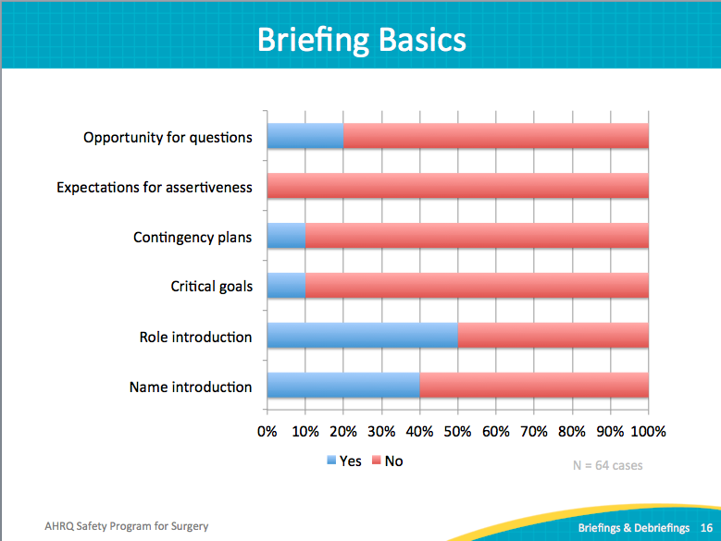
Specific Briefing Content  ASK:  Yes or no?  Did they talk about any of these specific content pieces to manage the clinical work for the case?  SAY:  In this sample audit of briefing practices, several items are covered in a high percentage of cases. Things at the bottom of the slide are patient procedure insight. These should be happening all of the time, and it is scary that they are not. It is possible that some of the content was covered loosely before the formally observed briefing, but it was often not explicitly performed with the entire team present.  Some things are done universally, like deep vein thrombosis prophylaxis and allergies. The audit found that for almost all cases that gave antibiotics the surgical team discussed it formally, and that no surgical teams discussed antibiotic redosing. Many others categories scored extremely low: blood availability, access issues, and airway risk.  For this example, we must recognize the potential misfit between the briefing process and the workflow. All of these steps happen before the case begins, or prior to incision. It is perhaps too late at this point to discuss airway risk and even access issues. So this data prompted a lot of discussion for this team to make the briefing process effective. Effective is defined as discussing the important information with the right team members present at the right point in the case.  In summary, the first round of auditing briefings provided phenomenal learning opportunities for the teams and prompted good discussions on how to improve the current practice around briefings. | Slide 17  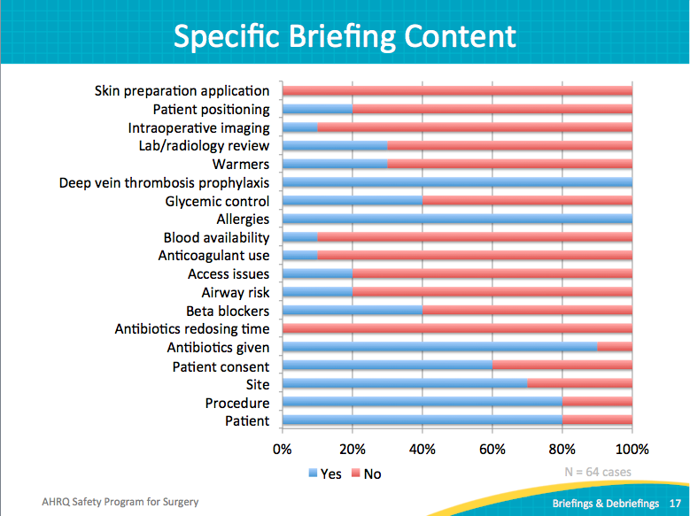
Participation: Pausing Other Tasks  SAY:  The data also isolated interesting behavior regarding participation in the briefing. It shows who attends and who pauses competing tasks. Almost across the board, only in 20 percent of the cases did the scrub nurse pause what he or she was doing and focus on the briefing. Circulator nurses almost always paused other tasks. Typically, one anesthesia team member was present and almost always paused other tasks. The blue on those three anesthesia rows means one of them wasn’t present. Both the surgical resident and the attending surgeon have some room to improve in participation during briefings; too often their attention was on other tasks. | Slide 18  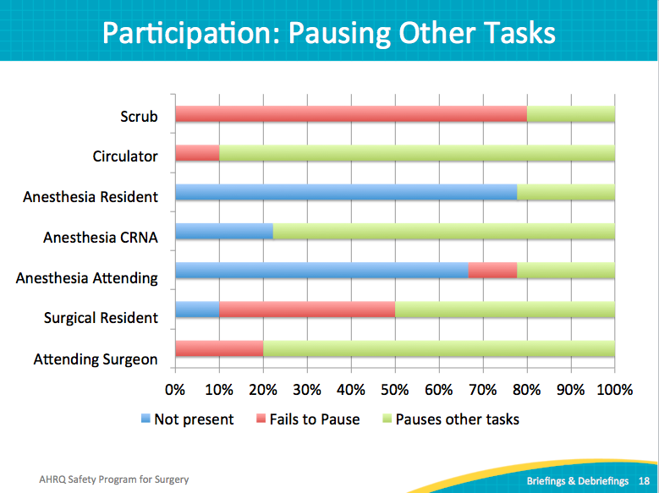
Participation: Contributing To Briefing  ASK:  Who is contributing to the briefing?  Did those present and focused on the briefing actually say anything?  SAY:  The circulator nurse, of course, consistently contributes, as this role leads the briefing. However, attending surgeons and surgical residents could be far more engaged in the process. Scrub technicians and scrub nurses rarely engaged in the process; they should have information to share important things to learn about the case. Again, the audit provides good input to the team about which professionals need to be active in the briefing process. | Slide 19  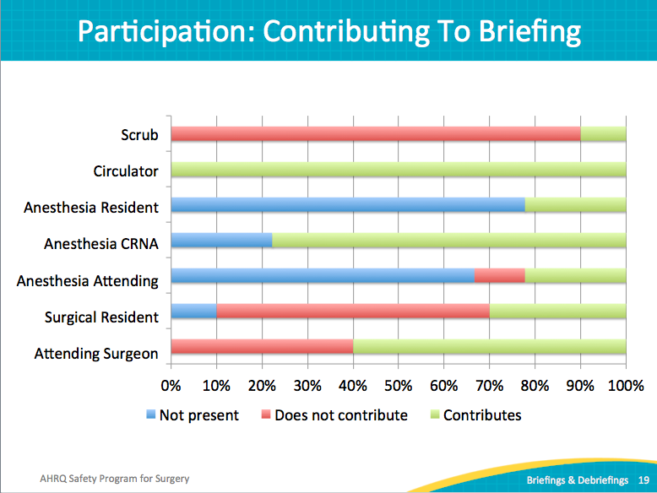
Provide Feedback  SAY:  Your team can audit briefings without a significant investment of time or resources. Training and collecting data can be performed relatively quickly and will yield interesting data relevant to your providers. Rather than focusing on theoretical briefings, your data will generate insights and ideas to jumpstart your discussions about your process. This is the ultimate goal, to clarify any disconnects between the current practice and best practice.  Share your audit data at safety meetings and with the surgical teams. Display charts in common areas for all frontline providers.  Use the data to improve your briefings. It can drive coaching efforts and reinforce desired behaviors. Armed with evidence about current practices, you can revise and refine expectations in policies, processes, and checklists. | Slide 20  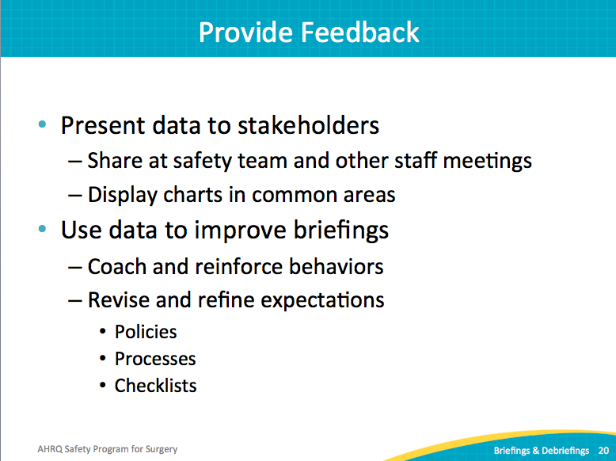
References | Slide 21  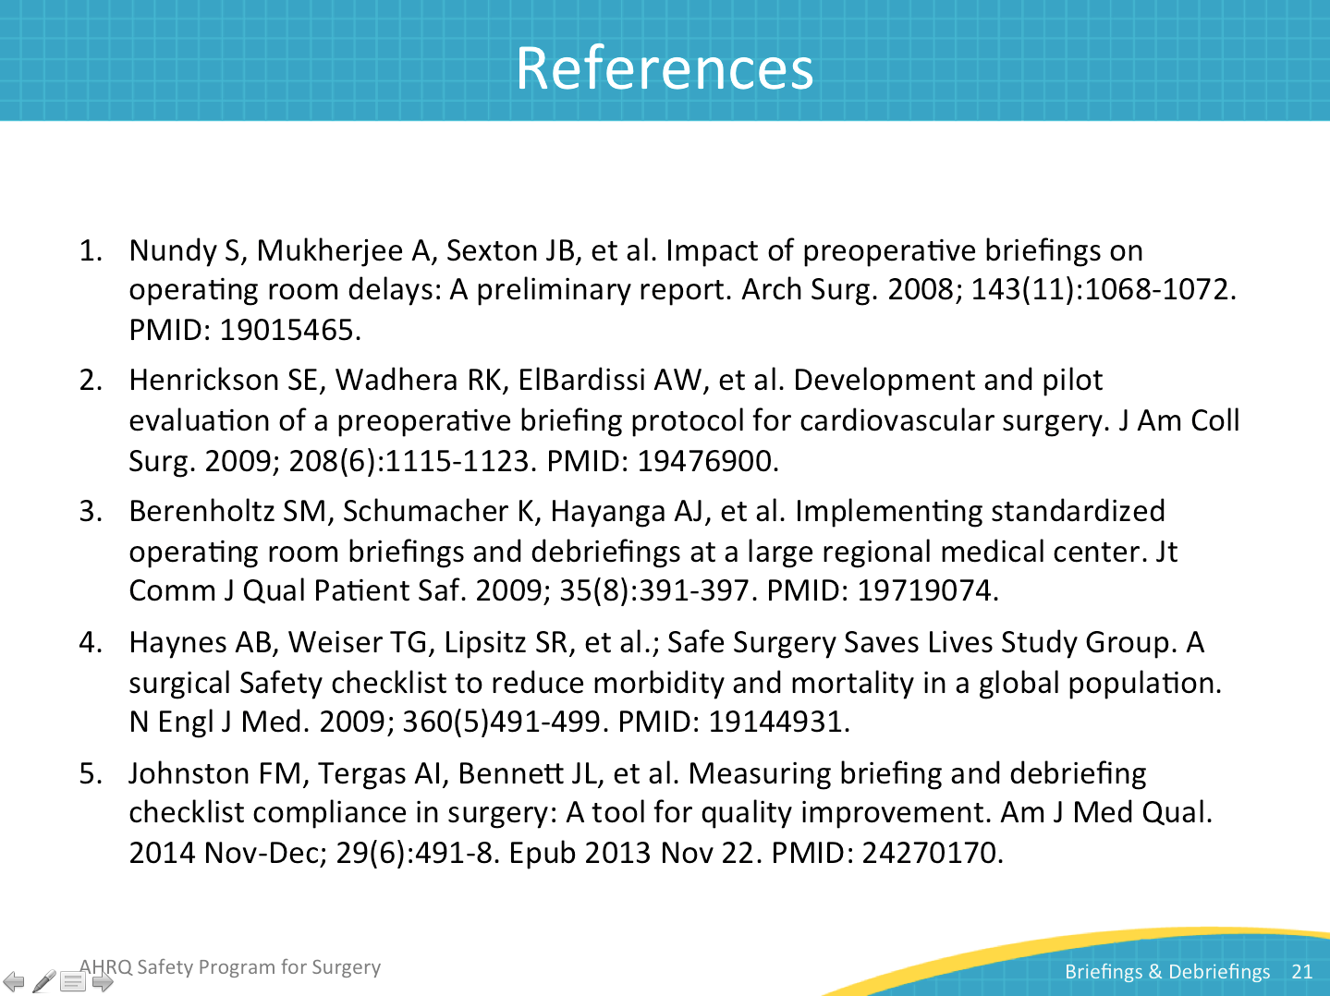
Hospital Case Study | Slide 22  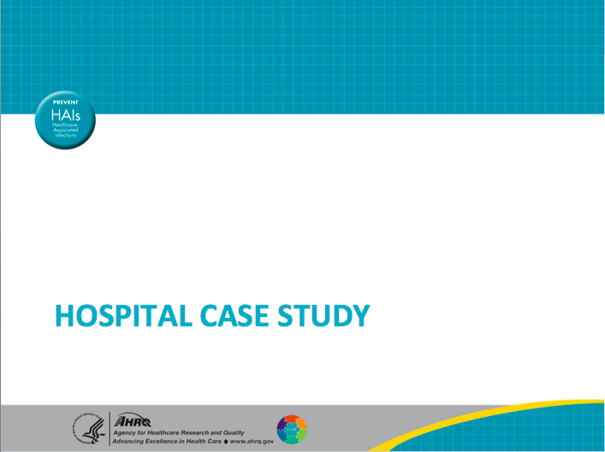
Debriefing Form: One Team’s Approach  SAY:  The debriefing form is a two-sided form. It is initiated in the preoperative area. The preoperative nurse will start documentation with the checklist. It serves as a communication tool for the operating room nurse, who reviews it to begin an assessment. The operating room nurse takes this form to the operating room and uses the second side for the debriefing. The debriefing form captures things that need improvement, any issues, and good catches.  After the debriefing is complete, the nurse takes the patient to the postoperative area and performs the handoff. The nurse takes the form and drops it off in a bin at the front desk. The forms are collected entered into a spreadsheet. The operating room charge nurse reviews the debriefing comments, paying particular attention to issues that require immediate attention from management. In addition, the process for followup action begins on nonurgent issues.  The information is easy to filter into categories on the spreadsheet. Any specialty-specific comments are presented to the appropriate groups with surgeons present. All comments are reviewed in weekly meetings with the charge nurse. Issues are shared with management and operating room staff during morning huddles. It is a transparent process.  Debriefing results are posted on the department communication board, so every staff member, surgeon, and resident can review all comments. This ensures that their voices are heard. | Slide 23  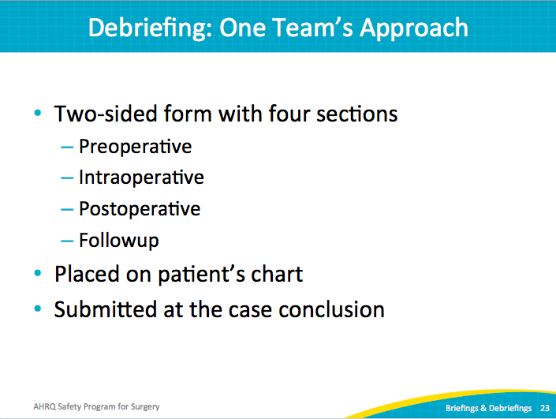
Debriefing Process  SAY:  Here is an overview of the debriefing process. | Slide 24  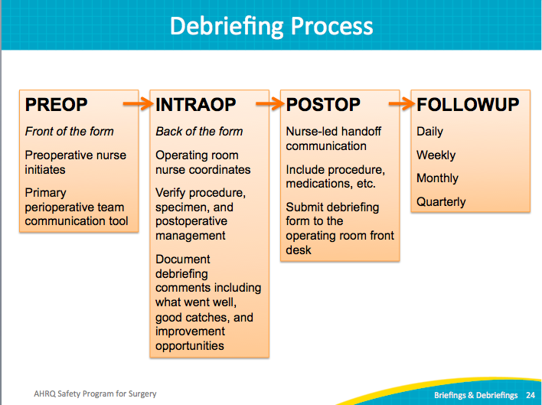
Debriefing Process  SAY:  Here is a breakdown of the followup process for debriefing comments. | Slide 25  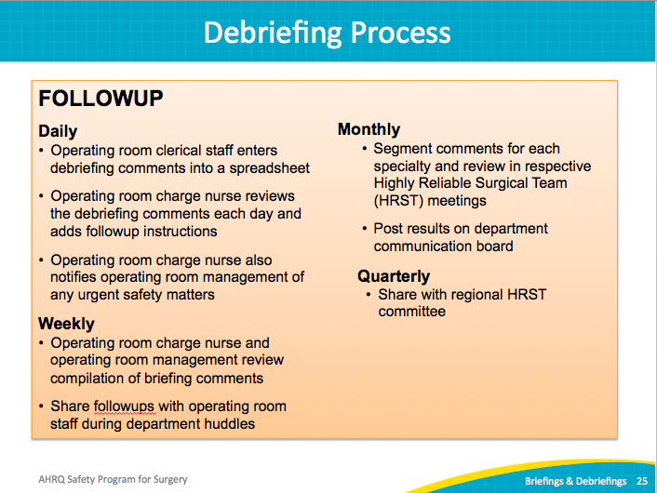
Examples of Debriefing Comments  SAY:  This process includes a section for items that need improvement as well as things that went well. Often, the comments are positive and document appreciations. Examples include staff coming in to support a complex case, helping to set up a room that was an add-on. Nurses have even thanked surgeons for communicating the needs and expectations for the case well, allowing everyone to be prepared. They also acknowledge other departments, like the emergency department for prepping the patient so well and efficiently.  Comments sometimes relate to labeling specimens properly, checking accuracy of procedure name, identifying patients with religious-based care choices, checking consents, and matching schedules, as well as noting instrument and equipment needs. Many of these issues are time sensitive, making it especially important to catch in time. In the event of a single piece of equipment needed in multiple cases, arrangements need to be made to adjust case schedules. | Slide 26  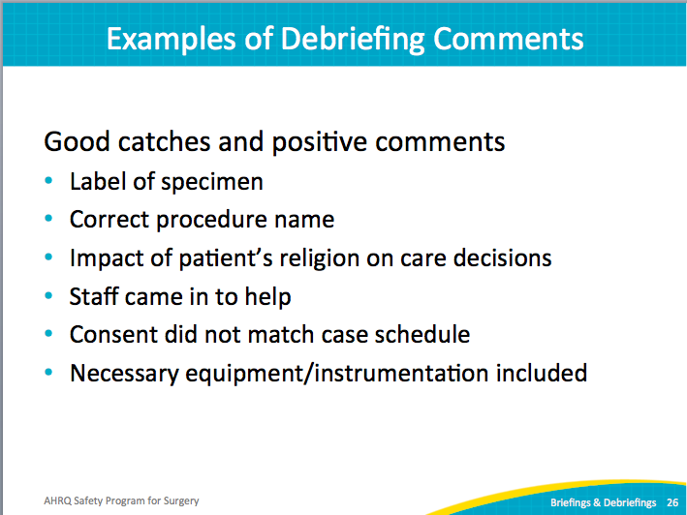
Examples of Debriefing Comments  SAY:  Debriefing uncovered many examples of defects and safety issues: scheduling errors, radiology delays, inferior equipment, inefficient or insufficient instruments, and outdated preference cards. | Slide 27  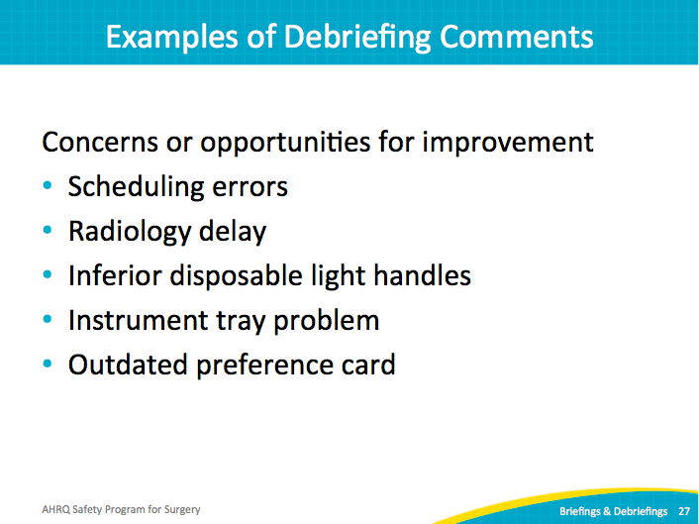
Examples of Debriefing Comments  SAY:  One unit had issues with incorrect procedures in the electronic scheduling system. The scheduler is depended on to communicate the correct procedure. Several cases were booked as an open case instead of the correct laparoscopic case, and vice versa. Because they require different equipment, this type of mistake causes chaos right before the case.  Sometimes surgeons changed a procedure or added procedures. It might mean additional equipment or supplies, or different patient positioning. Sometimes patients were positioned supine when the procedure required prone. There were also laterality errors. Scheduling indicated one side, but the patient or the x-rays indicated a discrepancy.  When incorrect instruments or supplies are picked, it can lead to delays. Team members may have to leave the operating room to get the appropriate equipment or possibly convert what is already opened for the case.  Debriefing uncovered safety issues regarding staff scheduling. For instance, when a case finished, sometimes assistance was not available to transfer a patient from bed to gurney or adjust a patient from prone to supine position.  The followup action involved sharing the downstream effects of poor scheduling. More accurate supply needs and preparation for surgery would result in fewer delays. These issues are addressed at surgeon meetings, management meetings, and quality improvement meetings. Positive results were achieved through safety team initiatives in this area. | Slide 28  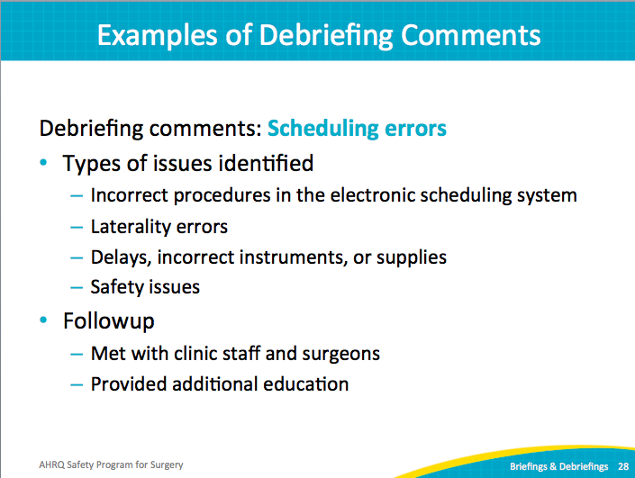
Examples of Debriefing Comments  SAY:  When the radiology department changed the process for calling a technician, the surgery department experienced excessive delays getting x-rays in the operating room during cases. Prior to the change, surgery called radiology and requested a technician, and a technician was sent. Rather than have someone answer the phone, the radiology department switched to an answering machine and pager system. Unfortunately, the responsiveness was lacking and cases stalled waiting for radiology. Surgeons and teams got upset as patients remained under anesthesia longer.  With detailed tracking data from the debriefing process, the radiology department was highly responsive to the surgical complaints. The process was updated to accommodate the emergent needs of the surgical teams, and no delays have been experienced since it was implemented. | Slide 29  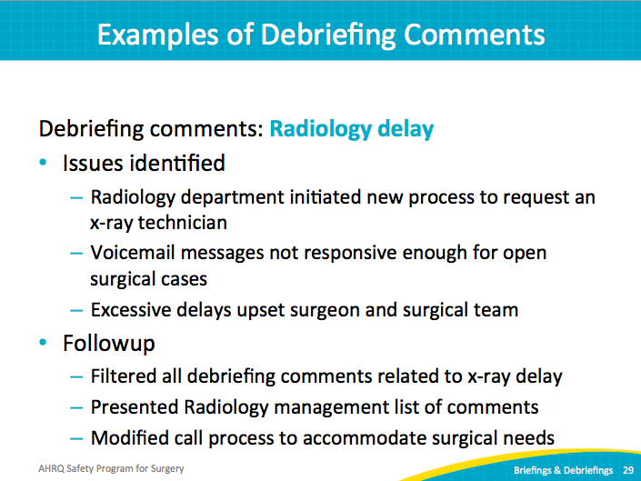
Examples of Debriefing Comments  SAY:  Disposable light handles caused issues as well. The surgeons were unhappy with a new soft plastic handle; the previous product was rigid. They cited an increased likelihood of contamination and struggled to install the light handles during cases. There was even one case where the light handle fell onto the sterile field.  The handle vendor was contacted with the concerns. The vendor shared a rigid handle option that was tried in one operating room. Staff and surgeons tried it and liked it. Then the disposable lights in each operating room were converted to the rigid handles. | Slide 30  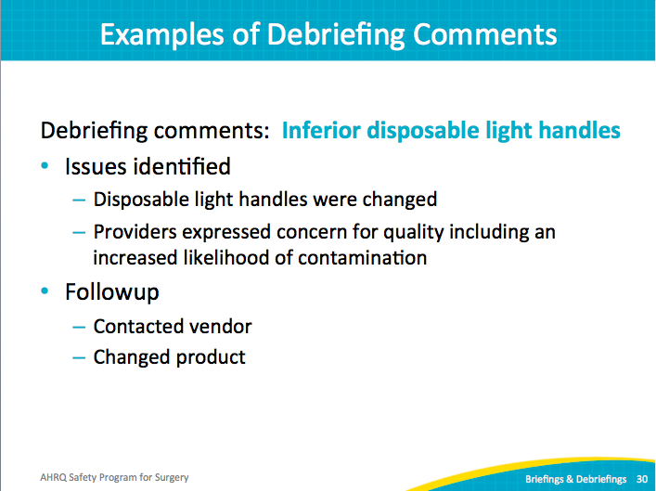
Examples of Debriefing Comments  SAY:  The instrument tray problem has proven slow to change. Often the count sheet in the tray did not match the number of instruments in the tray. Sometimes even the types and sizes of instruments did not match. It was frustrating for the surgical teams.  Working with the sterile processing department management, it was clear that the staff was supposed to inventory the items instrument by instrument. However, the management discovered that the staff technicians found a loophole that let them check all instruments at once without selecting each individual instrument. A fix to that system issue is underway to enforce the individual inventory process.  While the safety team works through the solution from a technology standpoint, the sterile processing management also took steps to identify staffing issues contributing to the problem—is it a particular shift or certain staff members, and are specific sets causing more issues, and why? The management is drilling down on the issue from multiple angles in order to increase the accuracy of their sets. | Slide 31  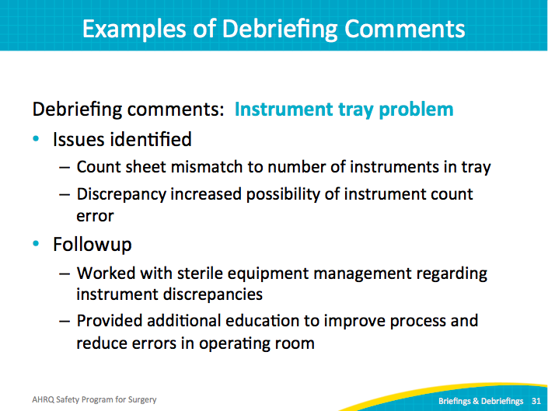
Examples of Debriefing Comments  SAY:  One of the most difficult areas to manage has been the preference card system, due to the large number of procedures and surgeons. Incorrect supplies and instruments impact and delay cases. Surgeons often would get frustrated because a requested change for one case did not automatically transfer to future cases. It was unrealistic to expect the team scrambling to prepare for the current case to address long-term system issues. The lack of a procedure to capture the evolution of equipment needs was leading to big teamwork issues.  One surgical nurse was allowed protected time to update preference cards. Specialty team leads also work on their preference cards. In addition, a core pick system was implemented for common procedures. Regardless of surgeon, each common procedure pulled from this core list. Then each individual surgeon could add specialty items if requested. Rather than creating a new card for every surgeon and for every type of procedure, the core picks standardize equipment for the common procedures. | Slide 32  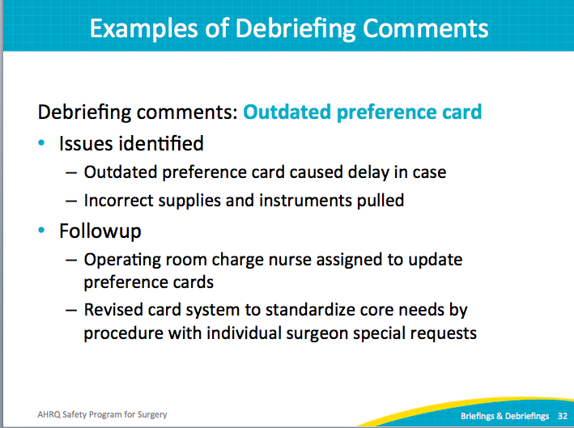
Debriefing Process  SAY:  Here is a recap of the debriefing process. | Slide 33

