Sharing My Story: A Planning Worksheet
Use this worksheet to help plan what you want to share about your hospital experiences.

Key points about your hospital experiences
When you or your family member was in the hospital, what things went well?
What things did people say or do that were helpful?
When you or your family member was in the hospital, what things did not go well?
What things did people say or do that were not helpful?
What improvements would you suggest to make things better for other patients and families?

Adapted from University of Washington Medical Center, Patient and Family Centered Care and Education Services, 1959 N.E. Pacific Street, Box 358126 Seattle, WA 98195.
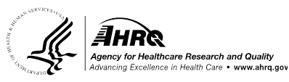 Guide to Patient and Family Engagement

