Fall Prevention Toolkit

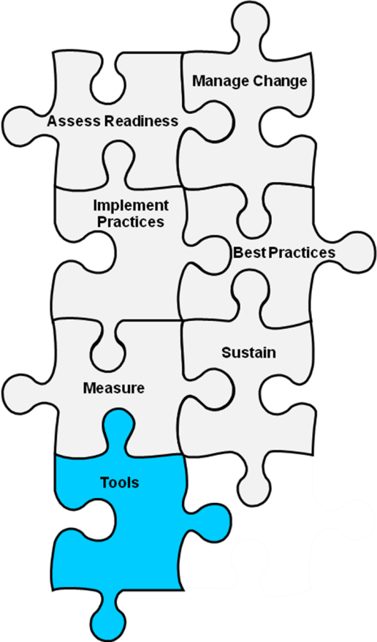
Module 5 Tools
Tool 5A: Information to Include in Incident Reports
Tool 5B: Assessing Fall Prevention Care Processes
Action Plan Tool to Measure Fall Rates and Fall Prevention Practices

5A: Information To Include in Incident Reports
Background: The purpose of this tool is to audit incident reports of falls to see if the reports provide adequate information for root cause analysis. Alternatively, the information below may be used in conjunction with Tool 3O, “Postfall Assessment for Root Cause Analysis” to develop a template to be filled out when reporting a fall.
Reference: Adapted from National Health Service publication Slips, Trips, and Falls in the Hospital, available at www.nrls.npsa.nhs.uk/resources/?EntryId45=59821.
How to use this tool: Review your last 10 incident reports for falls and see whether the information below is captured in the report. This tool should be used by the quality improvement manager. Information systems staff may also use this tool to develop or update electronic templates for submitting incident reports.
Use this tool to identify areas for improvement and develop educational programs where there are gaps.

Information To Include in Incident Reports
Examples of Information |  | Reason To Collect This Information
Reporting factors | Witnessed/not witnessed | Make a clear distinction between what was seen or heard and the patient’s account of what happened.
 | Outcome of investigations recorded | When patients are reported as having x rays or other investigations after a fall, the results of the x ray or other investigation should be included in the report.
 | Type of injury | Be specific, e.g., “fractured tibia,” not “broken leg.”
Environmental factors | Buzzer/bell available within reach before fall | Highlight whether there is an issue about accessing call bells.
 | If a fall from bed, whether bedrails were in use | Help assess how bedrail use is affecting falls or injury.
 | Floor wet/dry/talcum powder | Reflect on cleaning regimen and need for nonslip surfaces.
 | Footwear | If problems with missing or unsuitable footwear are highlighted, organizations could develop systems for providing alternatives.
 | Walking aid in use/in reach | It may highlight bedside storage issues or access to walking aids for patients admitted in the evenings or on the weekend.
Patient factors | Mental state | Identify those patients most vulnerable to falls because of sedation, dementia, or delirium.
 | First fall this admission or repeat fall | Balance resources between preventing initial falls and secondary prevention.
 | Days since admission | Ensure timescales for assessing and preventing falls are tailored to when falls are most likely to occur.
 | Medication affecting risk of falls | Sedative and psychotropic medication, or medication with drowsiness as a side effect, may contribute to falls.

5B: Assessing Fall Prevention Care Processes
Background: This sample protocol illustrates how to evaluate whether fall prevention care processes are occurring as they should be.
Reference: Adapted with permission from: Royal College of Physicians Implementing FallSafe: Care bundles to reduce patient falls. London, UK: Royal College of Physicians; 2012. Available at: www.rcplondon.ac.uk/resources/falls-prevention-resources.
How to use this tool: Use this form to observe the patient at bedside and check the notes of 20 patients on your unit every month (ideally the same date each month). To select patients:
If you are a small unit, collect it from the first 20 patients who come first in handoffs.
If your unit has two teams, take the first 10 patients from each team.
And so on if you have three teams, etc.
The assessment requires different types of information. Depending on your hospital’s record system and workflow, the information may be found in multiple locations. Make sure the people completing the form know where to find the information, which may require modifying the form to include explicit directions or cues.
Observations at the bedside should occur at the time of day when most patients who are well enough would be out of bed. If your hospital uses hourly rounding logs, these can also be checked for completeness during the observations. For the chart review, check the medication administration record (MAR) and any notes easily accessible on the unit, including nursing notes, medical notes, physical therapy notes, and occupational therapy notes. The bedside observations and the chart review can be completed separately but should be done on the same day.
This form should be completed by the unit manager or unit champions. This tool should be used to determine whether your hospital unit is carrying out its fall prevention care processes according to plan. It can be modified according to the needs of your specific hospital or unit by adding/deleting rows to customize the processes you want to monitor. Your hospital or unit might use this as an initial screen for assessing progress and then use the results to identify specific components for additional evaluation.

Example | Sample of 20 patients (or all patients if ward has fewer than 20 patients) |  |  |  |  |  |  |  |  |  |  |  |  |  |  |  |  |  |  |  | Totals (yes out of total plus N/A)
 | 1 | 2 | 3 | 4 | 5 | 6 | 7 | 8 | 9 | 10 | 11 | 12 | 13 | 14 | 15 | 16 | 17 | 18 | 19 | 20
Use to track patient names/initials/bed number/room number if you need to | FH | AB | ST | YH | LT | YT | TY | UP | KL | MJ | NM | HK | LT | FR | GT | HY | DE | ES | FR | TT
All 20 patients: | If small ward with fewer than 20 patients, write total here:
Observe: call bell in sight & reach? | Y | N | n/a | Y | Y | Y | Y | Y | n/a | Y | Y | Y | Y | N | Y | Y | n/a | N | Y | Y | 14/17 + 3 n/a
Observe: safe footwear on feet? | Y | Y | Y | Y | Y | Y | Y | Y | N | Y | Y | Y | Y | N | Y | Y | n/a | n/a | N | N | 14/18 +2 n/a
Observe: room free of clutter? | Y | Y | Y | Y | N | Y | Y | Y | Y | Y | Y | N | Y | Y | N | N | Y | Y | Y | Y | 16/20
Medication administration record: given night sedation last night? | N | N | N | N | N | N | N | N | N | N | Y | N | N | N | N | N | N | N | Y | N | 2/20
Chart: asked about history of falls? | Y | Y | Y | Y | Y | Y | Y | N | N | Y | Y | Y | Y | Y | Y | Y | Y | Y | Y | Y | 18/20
For any of the 20 pts age 70+: | Number of patients AGE 70+: |  |  |  |  |  |  |  |  |  |  |  |  |  |  |  |  |  |  |  | 13
Chart: cognitive screen? | Y | N | - | - | - | - | - | Y | n/a | Y | Y | Y | Y | N | Y | - | - | N | Y | Y | 9/12 + 1 n/a
For any of the 20 patients who are “higher risk”*: | Number of higher risk patients: |  |  |  |  |  |  |  |  |  |  |  |  |  |  |  |  |  |  |  | 8
Chart: full medication review requested? | Y | Y | - | - | - | - | - | - | - | Y | Y | N | Y | Y | - | - | - | - | Y | - | 7/8
* In some wards all patients are counted as high risk, for other wards only some. Follow your local policy.
© 2012, Royal College of Physicians. Adapted with permission.

*** Sample of 20 patients (or all patients if ward has fewer than 20 patients). Remember “not documented=not done” ***
Filled out by: |  |  |  |  |  | WARD: |  |  |  |  |  |  |  |  |  |  |  |  |  |  | TOTALS (YES out of total plus N/A)
DATE: | 1 | 2 | 3 | 4 | 5 | 6 | 7 | 8 | 9 | 10 | 11 | 12 | 13 | 14 | 15 | 16 | 17 | 18 | 19 | 20
Use to track patient names/initials/bed number/room number if you need to
All 20 patients: | If small ward with fewer than 20 patients, write total here:
Observe: call bell in sight & reach?
Observe: safe footwear on feet?
Observe: room free of clutter?
Medication administration record: given night sedation last night?
Chart: asked about history of falls?
For any of the 20 pts age 70+: | Number of patients AGE 70+:
Chart: cognitive screen?
For any of the 20 patients who are “higher risk”*: | Number of higher risk patients:
Chart: full medication review requested?
* In some wards all patients are counted as high risk, for other wards only some. Follow your local policy.
© 2012, Royal College of Physicians. Adapted with permission.

Measure Fall Rates
Key Indicator | Who is responsible? | Completion Date for Plan
Fall Rates (e.g., falls per 1,000 occupied bed days) are calculated
Fall Rates are monitored at least quarterly, preferably monthly
Information on rates is disseminated to key stakeholders and staff
Root cause analysis is conducted for each fall with at least moderate level of injury
Measure Fall Prevention Practices
Key Indicator | Who is responsible? | Completion Date for Plan
Fall risk factor assessment is performed within 24 hours of admission
Care plan addressing every deficit on fall risk factor assessment has been developed and is being implemented
Staff know definition of fall and definition of injurious fall
Action Plan Tool to Measure Fall Rates and Fall Prevention Practices

