Best Practices in the Management of Patients with Antibiotic Allergies
Ambulatory Care

Slide Title and Commentary | Slide Number and Slide
Best Practices in the Management of Patients With Antibiotic Allergies  Ambulatory Care  SAY:  Welcome to the presentation titled, “Best Practices in the Management of Patients With Antibiotic Allergies.” | Slide 1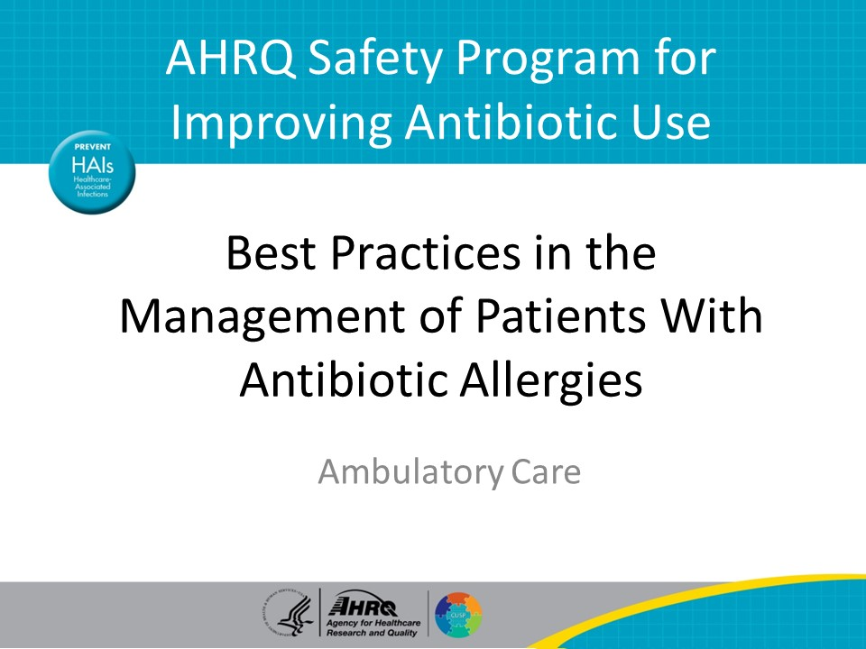
Objectives  SAY:  The objectives of this presentation are to—  - Explain the importance of clarifying antibiotic allergies before prescribing antibiotics  - Recognize types of reactions to antibiotics commonly prescribed in the outpatient setting  - Review the cross-reactivity between antibiotic classes, and  - Describe approaches to evaluating patients with reported antibiotic allergies | Slide 2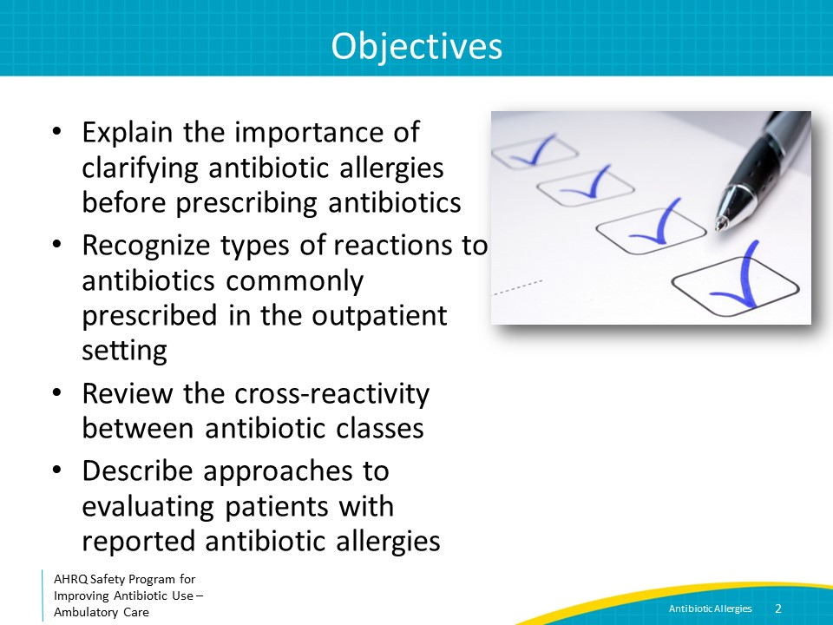
Antibiotic Allergy Prevalence  SAY:  This presentation will primarily address allergies to beta-lactam antibiotics, a class of antibiotics that includes penicillins, cephalosporins, aztreonam, and carbapenems. In particular, it will focus on antibiotics in the penicillin class such as penicillin, amoxicillin, and amoxicillin-clavulanate, because these are the most commonly reported agents to which allergies are reported—in about 10 percent of the U.S. population. In this presentation, “penicillin” allergies refers to all drugs in the penicillin class unless otherwise noted.  About 95 percent of people who report a penicillin allergy can safely tolerate penicillin antibiotics. Clarifying penicillin allergy status can reduce the need for exposure to potentially less effective, more expensive, and occasionally harmful alternative antibiotics. | Slide 3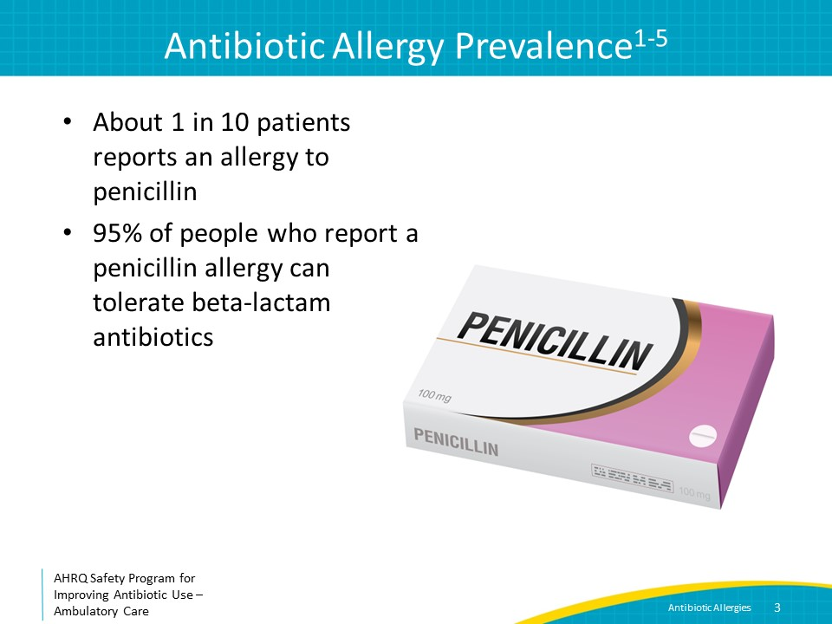
Reasons for Overdiagnosis of Antibiotic Allergies  SAY:  There are a number of reasons for the overdiagnosis of antibiotic allergies.  Viral exanthems appear during the same time period that antibiotics are mistakenly prescribed for a viral infection. Thus, a rash associated with a viral infection can be ascribed incorrectly to the antibiotic. This can be avoided by not prescribing antibiotics for upper respiratory tract infections.  Patients often are unable to recall the specific symptoms that led to the diagnosis of the penicillin allergy, particularly when the reaction occurred in childhood. However, once such a diagnosis is made, it is often perpetuated in the patient’s medical record without additional clarifying information.  Additionally, nonimmunologic side effects such as nausea or diarrhea are often inaccurately identified as allergies. Intolerances to medications are often inaccurately recorded in the allergy section of the medical record, leading to avoidance of certain classes of antibiotics.  Another cause of incorrect penicillin allergy labels occurs when other family members report antibiotic allergies, especially to penicillins, and these family members tell the patient that they may have an allergy, too. However, antibiotic allergies do not follow a clear inheritance pattern. A family history alone should not lead to avoidance of beta-lactam antibiotics or other classes of antibiotics. | Slide 4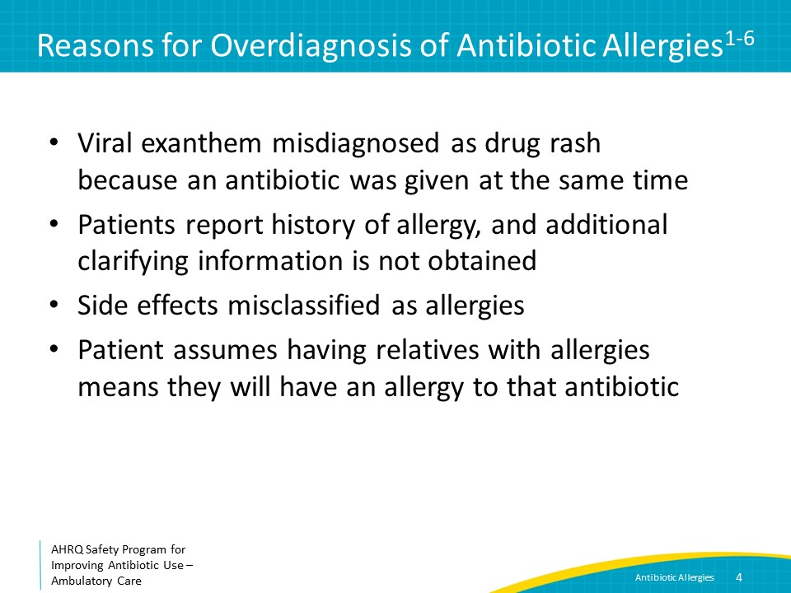
Importance of Assessing Antibiotic Allergies  SAY:  Correct assessment of antibiotic allergies is important because when a patient reports an allergy to penicillin or another beta-lactam antibiotic, they are more likely to get an alternative, broader spectrum antibiotic. These alternatives are often less effective, lead to more side effects, are more expensive, and may be associated with future colonization or infection with antibiotic-resistant organisms. | Slide 5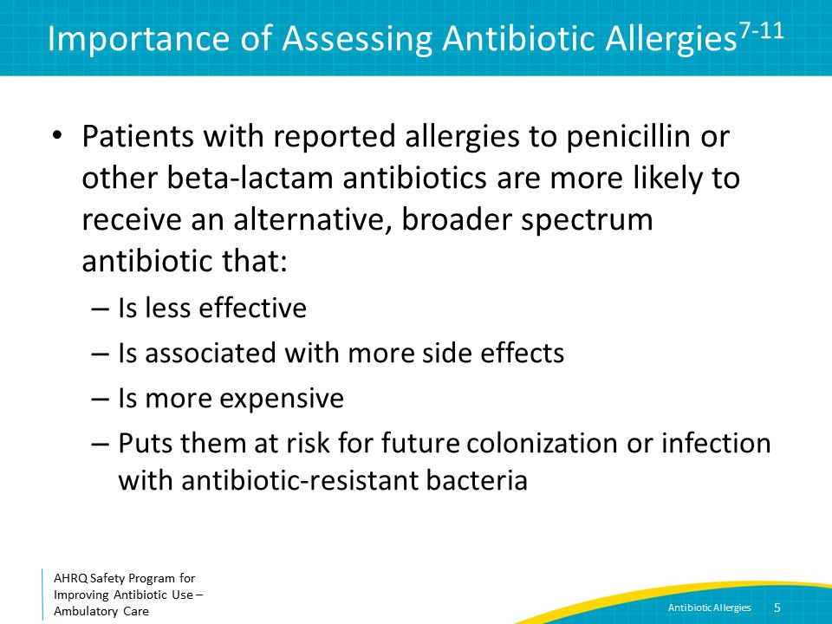
Importance of Assessing Antibiotic Allergies  SAY:  One study examined the impact of having a documented penicillin allergy in a patient’s chart on the patient’s surgical outcomes. On closer investigation, 9 percent of reactions were intolerances, such as nausea or vomiting. Patients who reported a penicillin allergy and went on to receive second-line perioperative antibiotic prophylaxis as a result were 50 percent more likely to develop a surgical site infection. Preoperative visits provide an opportunity to assess allergies to determine if patients can receive first-line perioperative antibiotic prophylaxis.  In addition, patients with penicillin allergies documented in their medical charts have increased odds of Clostridioides difficile infections, methicillin-resistant Staphylococcus aureus colonization, and vancomycin-resistant Enterococcus colonization. This again may be related to receipt of suboptimal antibiotic therapy that increases the risk of infection or colonization with these organisms.  Because of the adverse consequences associated with incorrect penicillin allergy documentation, the Centers for Disease Control and Prevention has recommended that verifying antibiotic allergies be part of antibiotic stewardship activities. | Slide 6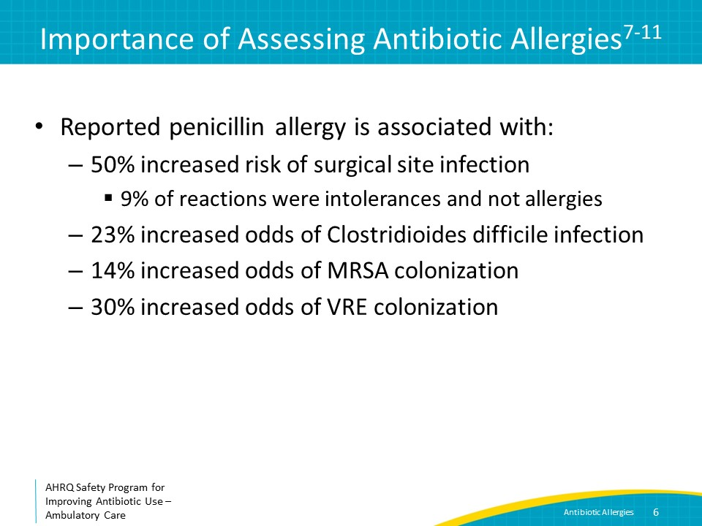
Take Action  SAY:  To summarize the last few slides, the presence of a penicillin allergy in a patient’s chart is associated with adverse outcomes; thus, incorrect penicillin allergy labels should be clarified and removed from the medical record. If someone had intolerance to an antibiotic, document that it is an intolerance and not an allergy, because it is likely that the patient will tolerate other medications in the same class, and maybe even the same antibiotic if taken in a different way, such as with food. | Slide 7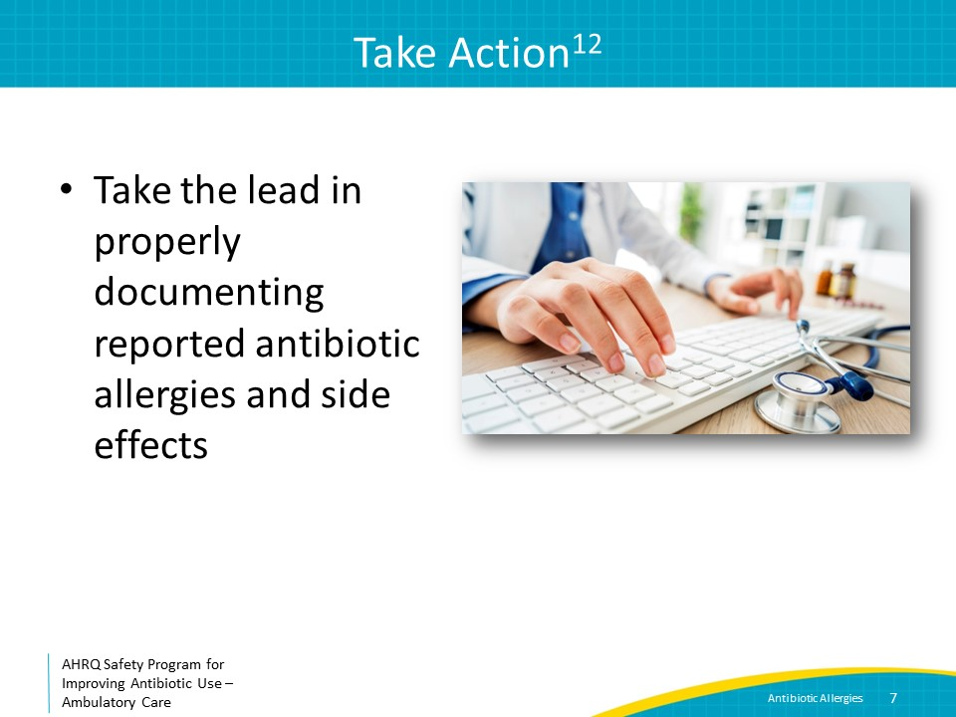
Types of Allergic Reactions  SAY:  It is helpful to review the different types of drug allergies to facilitate correct classification of antibiotic reactions that patients report. A drug allergy is an immunologically mediated response to a pharmaceutical agent in a sensitized person. There are four main types, conveniently arranged from type 1 to type 4. | Slide 8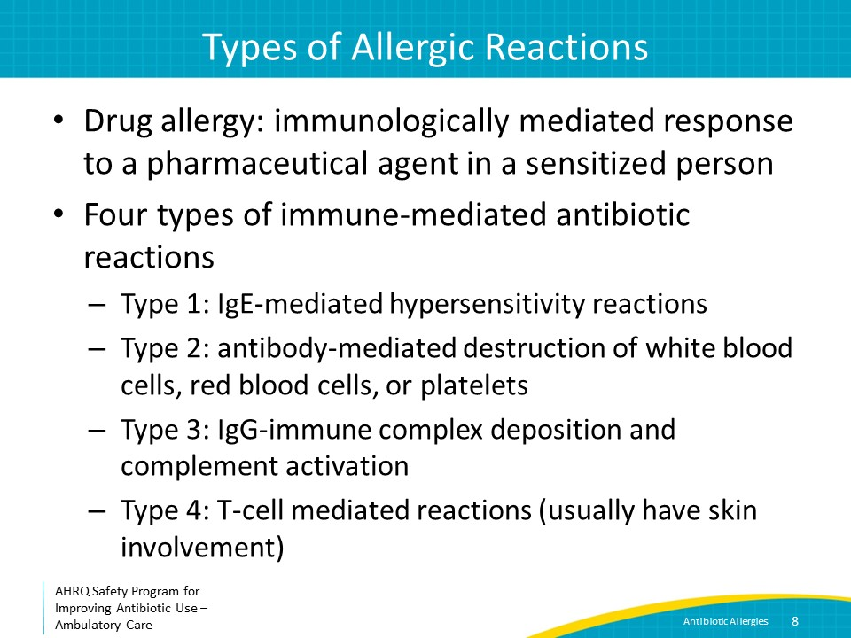
Type 1 Reactions  SAY:  Type 1 reactions are IgE-mediated hypersensitivity reactions. They generally manifest as urticaria, which are irregular, pruritic papules that develop rapidly, also known as hives. They can also manifest as angioedema, which is characterized by swelling of the face, extremities, or airways, and can lead to bronchospasm. Type 1 reactions include anaphylaxis, which is characterized by the rapid onset of urticaria as well as respiratory failure and hypotension. They occur within minutes to hours of receipt of an antibiotic. In most cases, patients who develop type 1 reactions to antibiotics like penicillin have had prior exposure to the agent causing the reaction, which has led to sensitization. Among antibiotic classes, penicillin agents are the most commonly associated with these reactions. | Slide 9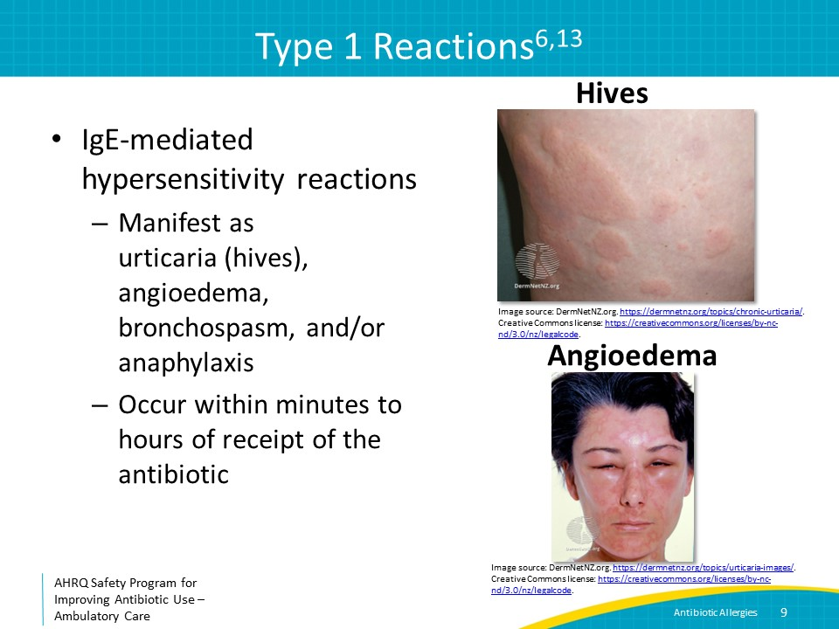
Type 2 Reactions  SAY:  Type 2 reactions to antibiotics involve antibody-mediated destruction of white blood cells, red blood cells, or platelets. Hematologic abnormalities most often are detected on routine blood count testing, although some patients with this type of reaction may have signs of hemolysis such as jaundice or dark urine, or signs of thrombocytopenia such as petechiae. Type 2 reactions can occur soon after antibiotics are started, but also during subsequent days and weeks of antibiotic therapy. Penicillins and cephalosporins are most commonly implicated in type 2 reactions. Type 2 reactions are uncommon. | Slide 10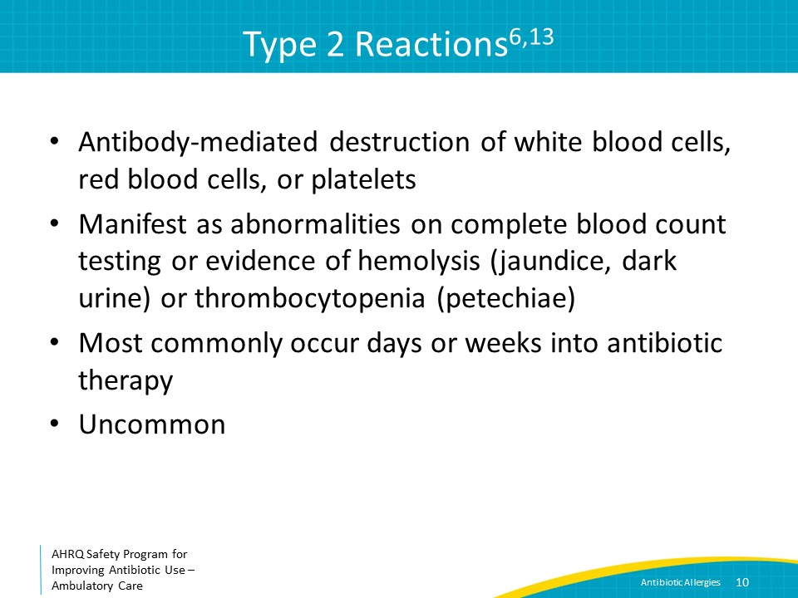
Type 3 Reactions  SAY:  Type 3 reactions to antibiotics involve IgG-immune complex deposition and complement activation. They generally manifest as serum sickness or vasculitis and present with palpable purpura, joint pain, urticaria, lymphadenopathy, and fevers. They occur after a patient had been on antibiotics for several days. Type 3 reactions to antibiotics that present as fevers can be particularly confusing because they may be difficult to distinguish from a worsening infection. Type 3 reactions are uncommon. | Slide 11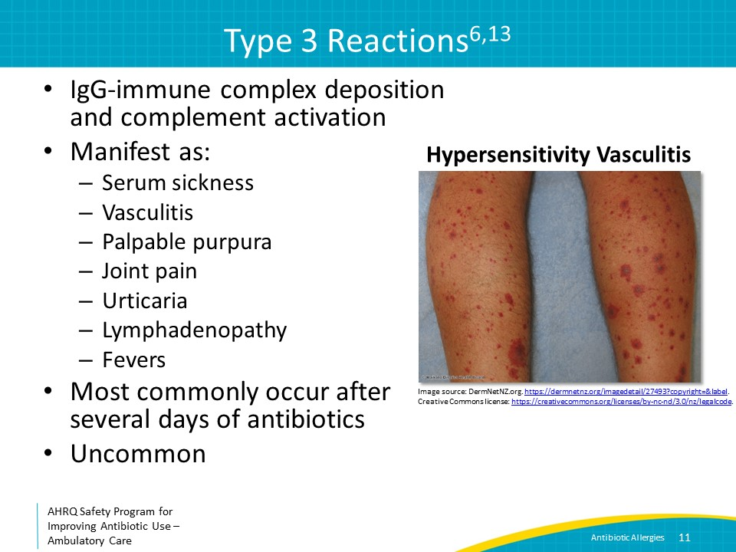
Type 4 Reactions  SAY:  Finally, type 4 reactions to antibiotics result from the activation of T-cells. They can range from relatively mild reactions such as maculopapular rashes to severe reactions such as Stevens-Johnson syndrome, toxic epidermal necrolysis, or DRESS syndrome, an abbreviation that stands for “drug reaction with eosinophilia and systemic symptoms.” They also tend to occur after a patient has been on antibiotics for several days.  Nonsevere type 4 reactions to antibiotics are the most common, and the associated maculopapular rash is often documented incorrectly as hives. Many antibiotics can cause type 4 reactions, including penicillins and trimethoprim-sulfamethoxazole. | Slide 12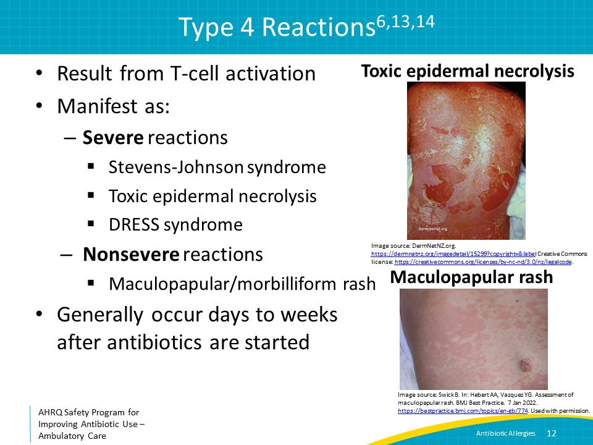
Taking an Allergy History  SAY:  Obtaining a brief, focused history can be very helpful in understanding the type of reaction a patient has had.  First, determine that the reaction reported is a real allergy. As noted previously, side effects such as nausea, vomiting, diarrhea, headaches, dizziness, fatigue, and taste alterations are common and upsetting to patients but are not true allergies. It is, however, important to know about side effects because if the patient needs to receive the same agent again, you can take steps to mitigate the side effects such as prescribing antiemetics for nausea. | Slide 13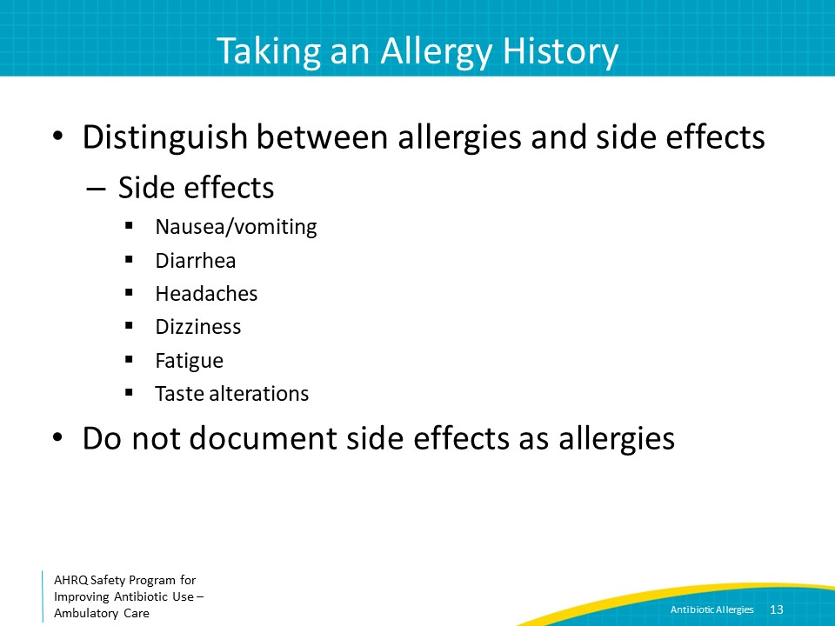
Allergy History: Timing  SAY:  If the patient reports an allergy, ask how long after they started the antibiotic the reaction occurred. Remember, type 1 reactions usually happen soon after the first dose of antibiotics, whereas other reactions usually occur after several days of therapy. If the reaction was sudden, it is more likely to be a type 1 reaction.  Also, ask how long ago the reaction occurred. If it was more than 5 years ago, the patient may not still have the allergy because even true penicillin allergies can go away over time. IgE-mediated penicillin hypersensitivity decreases with time with 50 percent of skin-test–positive patients losing their hypersensitivity by 5 years and 80 percent by 10 years. | Slide 14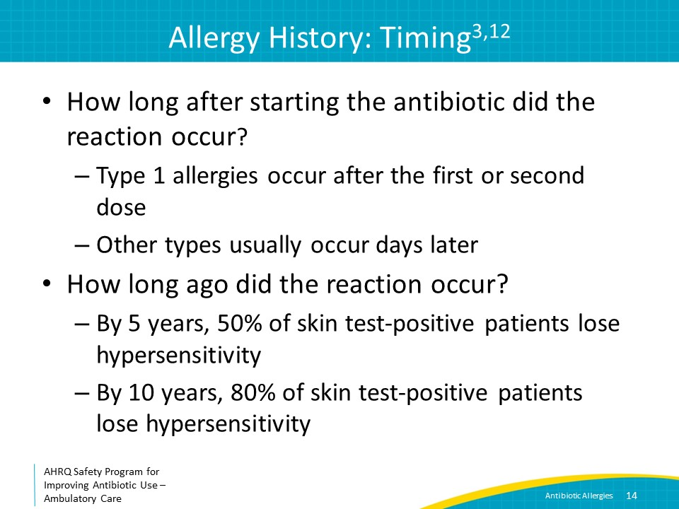
Allergy History: Defining the Rash  SAY:  If the patient reports a rash, ask the patient to describe the rash. Hives are red, raised, smooth, itchy bumps often with white centers that can be different sizes. They may look like fresh mosquito bites. Type 4 rashes are red, minimally raised and rough to the touch, like fine-grit sandpaper. Clinicians often describe type 4 rashes as maculopapular or morbilliform. Rashes that were blistering or led to skin peeling and/or involved mucous membranes suggest a Stevens-Johnson-like syndrome.  Ask how severe the rash was, including whether it resolved on its own or required medical attention. The severity of the rash should weigh into the decision about whether to rechallenge a patient with a particular antibiotic. | Slide 15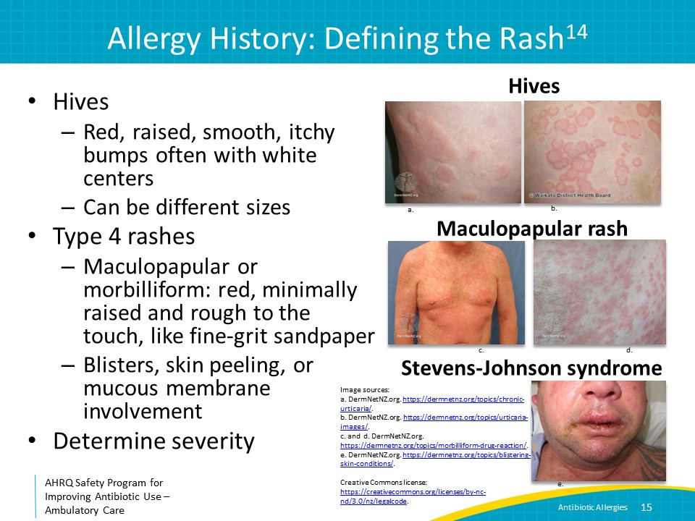
History: Evidence of a Type 1 Reaction  SAY:  Ask if the patient had swelling of the throat, tongue, lips, or eyes; wheezing or trouble breathing; low blood pressure; or hives. These are all symptoms and signs of a type 1 reaction. | Slide 16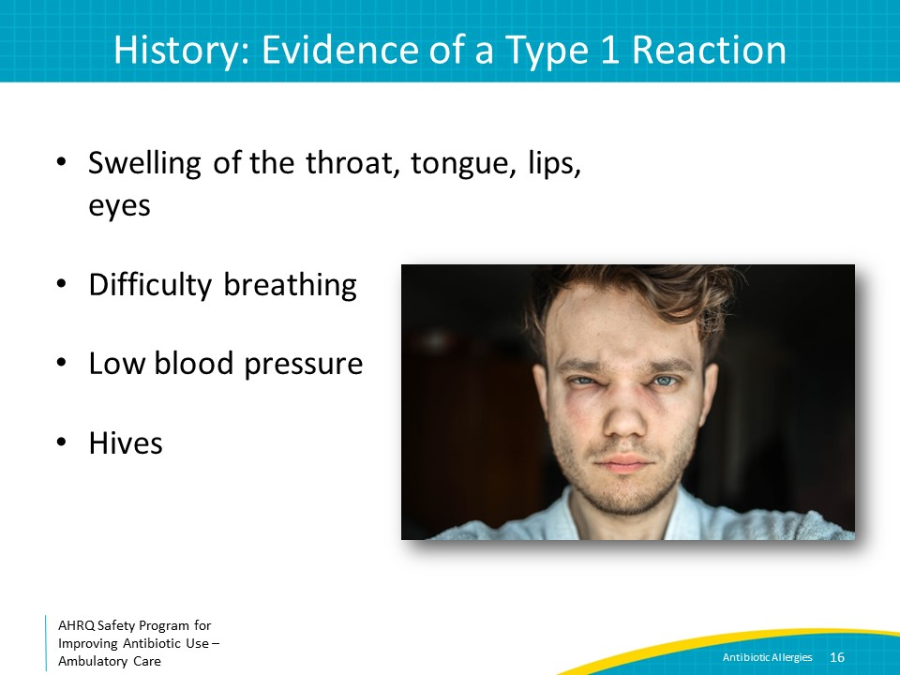
History: Alternative Causes  SAY:  Ask if the patient was on other medications at the time of the reaction. This helps to ascertain whether a different medication may have caused the reaction. Ask if the patient was undergoing treatment for other medical conditions at the time of diagnosis which could account for abnormal lab values. | Slide 17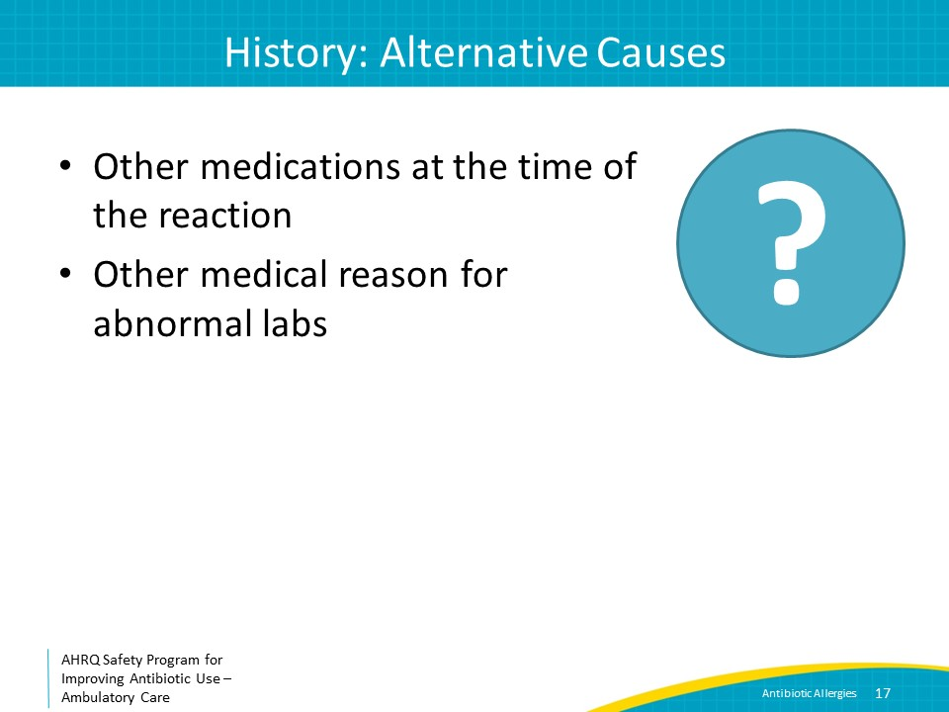
History: Rechallenge  SAY:  Finally, determine if the patient has received the same medication or a different penicillin or cephalosporin since the reaction. Ask about specific brand names of antibiotics that the patient may be able to recognize. If the patient has received another penicillin or cephalosporin, ask what happened after exposure to these other beta-lactams. Often patients will have taken and tolerated other beta-lactam antibiotics besides the one they report an allergy to, which generally indicates that they can tolerate alternative beta-lactams. In particular, amoxicillin is the most likely beta-lactam antibiotic to cause a rash, and even with a history of an amoxicillin rash, most patients will not have a problem with other beta-lactam agents. Frequently, patients with Epstein-Barr virus infections, or EBV, who are treated concomitantly (and unnecessarily) with amoxicillin or amoxicillin-clavulanate can develop a maculopapular rash that is more related to the EBV than the amoxicillin.  Also, ask if the patient has ever seen an allergist or undergone skin testing to further assess existing allergies. | Slide 18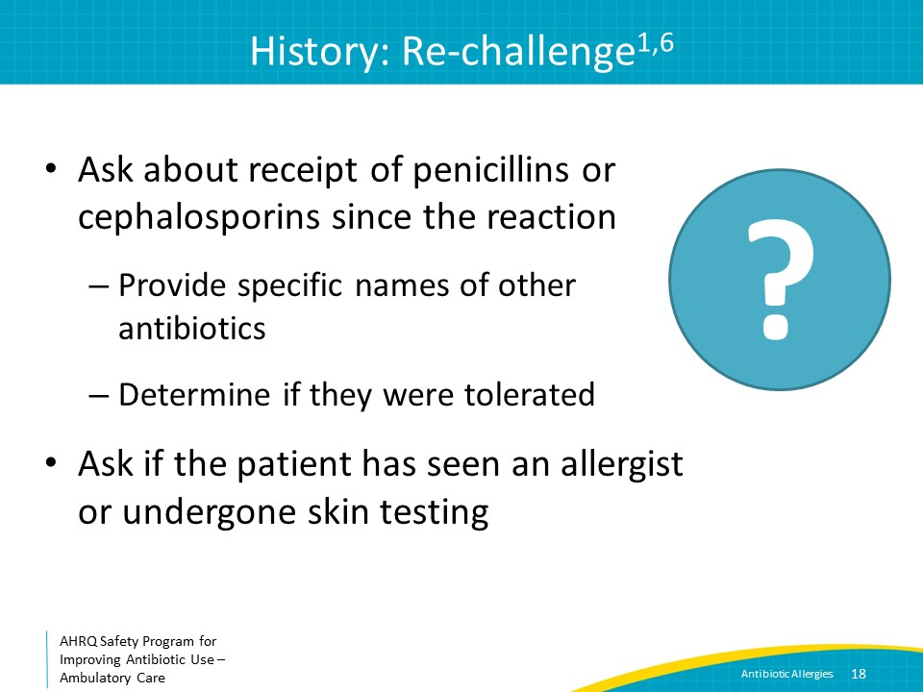
Documentation  SAY:  Remember to be as descriptive as possible and to document your findings in a place in the chart where they will be easily found. If the patient has side effects that are labeled as allergies in the medical record, they should be removed as allergies and noted as side effects. Document the specific allergy reported for each antibiotic and remove incorrect allergies such as hives if the patient clearly describes a non-hives rash. Also, note what antibiotics the patient has tolerated previously as well as any information regarding skin testing. Further, make sure your patient understands that the allergy label was removed or modified and why it was changed. It is especially important that patients and their families are aware that they are no longer allergic to penicillin and that they should update their other healthcare practitioners. In one study, 36 percent of patients with negative penicillin skin testing and no evidence of an interval reaction had their penicillin allergy redocumented at a subsequent admission within 1 year. | Slide 19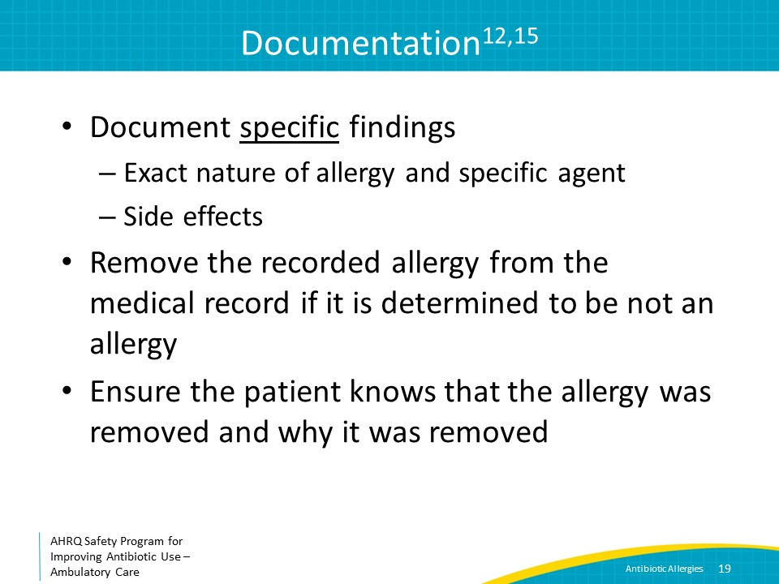
Management of Penicillin Allergies  SAY:  In general, rechallenge with an alternative beta-lactam in outpatients with nonsevere type 4 reactions is reasonable. Patients with a history suggesting a type 2 or 3 reaction, a type 1, IgE-mediated hypersensitivity reaction, or a severe type 4 reaction, such as Stevens-Johnson syndrome, toxic epidermal necrolysis, or DRESS syndrome, should not be rechallenged without input from an allergy specialist. In these cases, the patient should be referred to an allergist for further evaluation, particularly if the patient is likely to need antibiotics in the immediate future such as for perioperative prophylaxis.  The allergist may recommend penicillin skin testing, which is typically performed in an allergist’s office where rescue medications are available in case someone has a serious reaction. Penicillin is the only antibiotic with a commercially available skin test in the United States.  A negative penicillin test is useful for ruling out a type 1 reaction but does not help with the diagnosis of non-type 1 reactions, including severe non-IgE–mediated reactions such as Stevens-Johnson syndrome or DRESS.  Patients who have positive tests can be considered for desensitization if alternative agents are not available or provide suboptimal therapy. Remember, desensitization is not effective for non-type 1 reactions.  When done correctly, penicillin skin testing is highly predictive of serious anaphylactic reactions. In the United States, penicillin skin testing has a negative predictive value of about 98 percent for type 1 reactions.  The allergist may also recommend a graded oral challenge in which the patient is exposed to one-tenth of the dose and escalated every 30 to 60 minutes. | Slide 20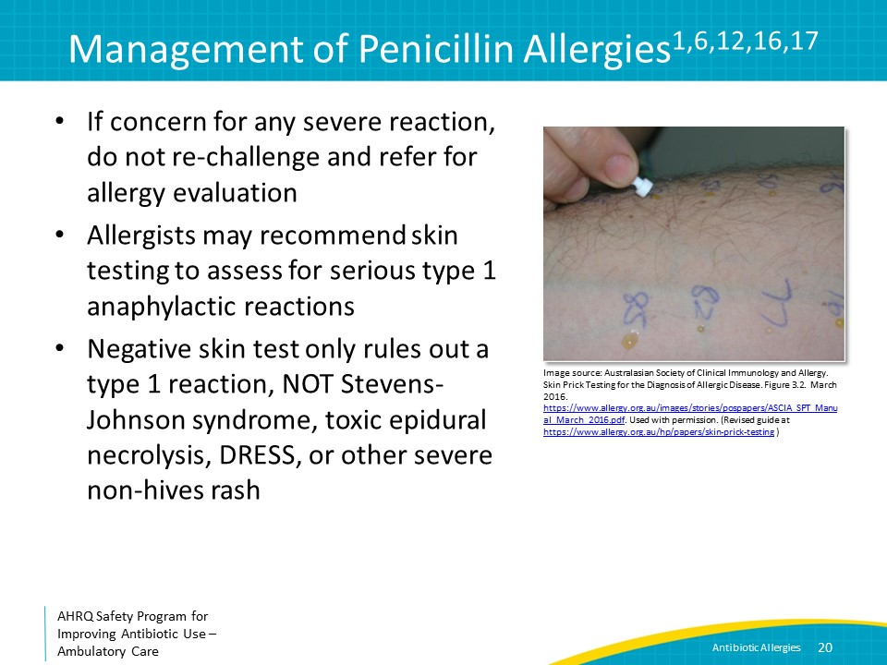
After Negative Penicillin Skin Testing  SAY:  The rate of developing a penicillin allergy in skin test–negative patients following up to three courses of penicillin has been shown to be negligible, indicating that patients cleared of penicillin allergies via negative skin test do not carry an increased future risk compared with the general population. | Slide 21
Cephalosporin Allergies  SAY:  In general, fewer people react to cephalosporins than penicillins—approximately 10-fold less. About 0.5 to 2 percent of American patients have documented cephalosporin allergies.  Often, the cephalosporin reactions are not to the beta-lactam ring itself that is shared with all beta-lactam antibiotics, but instead to one of the side chains of the chemical structure. Thus, patients sometimes will react to one cephalosporin but not to other cephalosporins. In these cases, it might be good to avoid similar cephalosporins and consider an allergy consultation. | Slide 22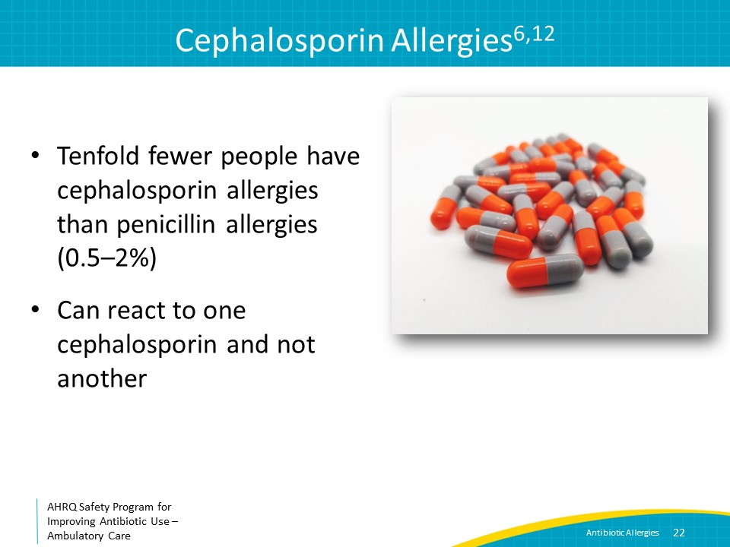
Cephalosporins and Penicillins  SAY:  It was previously taught that the cross-reactivity between penicillins and cephalosporins is as high as 10 to 15 percent. More recent data indicate that this is no longer true. Thirty to 40 years ago or more, early cephalosporins may have been contaminated with trace particles of penicillin.  Now, if a patient has a positive penicillin skin test, he or she has just a 2 to 5 percent chance of having a type 1 reaction to a cephalosporin.  If there is a penicillin allergy listed in the chart and it is unclear if the patient is actually allergic, the likelihood of the patient reacting to a cephalosporin is quite low, well under 1 percent, and similar to that of the general population. | Slide 23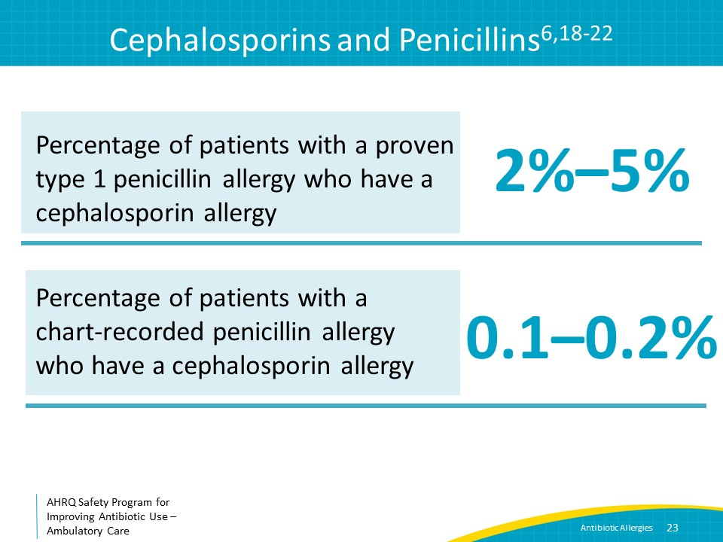
Trimethoprim-Sulfamethoxazole (TMP/SMX)  SAY:  It is important to also consider reactions to non-beta-lactam antibiotics.  Trimethoprim-sulfamethoxazole is the second most frequent cause of antibiotic allergies after amoxicillin. Up to 4 percent of patients will react to this medication.  The most common reaction is a rash. It can occur days to weeks into therapy and can vary in severity. Patients with a rash and a new fever are at risk for progression to multisystem organ involvement; thus, the medication should be stopped if the rash is more than mild or the patient has fevers not related to underlying infection.  Other less common reactions include serum sickness, hemolytic anemia, hepatitis, aseptic meningitis, blistering reactions such as Stevens-Johnson syndrome, toxic epidermal necrolysis, or erythema multiforme. IgE-mediated reactions are uncommon.  There is no skin testing available for trimethoprim-sulfamethoxazole. Take a good history, and if it appears that the patient has had one of these reactions in the past, it is best to avoid trimethoprim-sulfamethoxazole. | Slide 24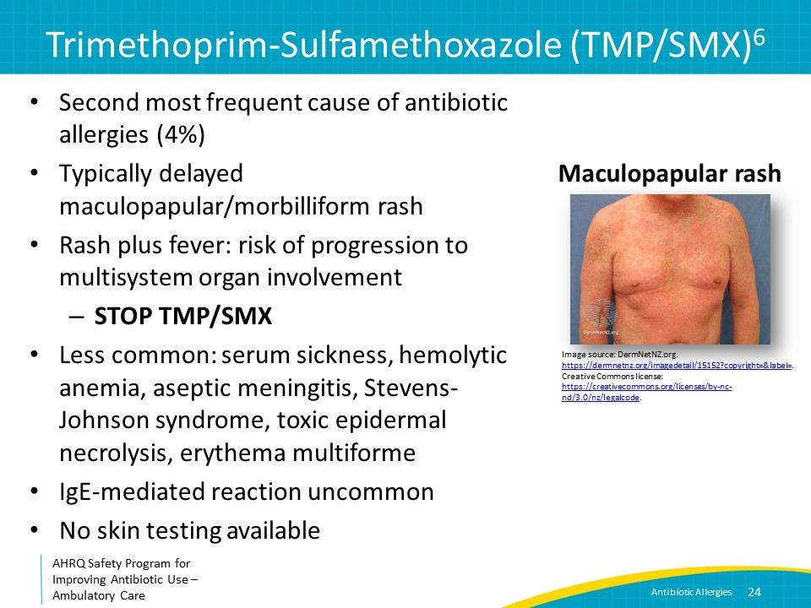
Tetracyclines  SAY:  Tetracyclines, which include tetracycline, doxycycline, and minocycline, frequently cause photosensitivity leading to sunburn. This is not a drug allergy. It is important to counsel patients taking tetracycline antibiotics about sun exposure, and to make recommendations such as wearing sunscreen or covering up with hats and long-sleeve shirts and pants. If someone reports a rash to a tetracycline, ask if it was only on sun-exposed parts of the skin. IgE-mediated reactions to tetracyclines, like to other non-beta-lactam antibiotics, are very rare. | Slide 25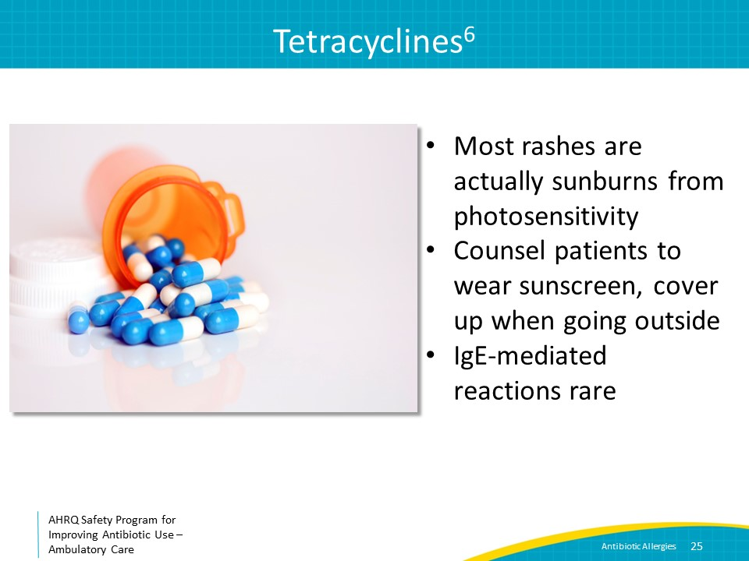
Case 1: 50-Year-Old Patient Establishing Care  SAY:  So, let’s go through an example. You are seeing a new patient who is establishing care with you. She is 50 years old with a past medical history of depression. On her intake form, she noted a penicillin allergy. Your medical assistant has already entered the penicillin allergy into the electronic medical record, but there are no additional details.  What should you do next? | Slide 26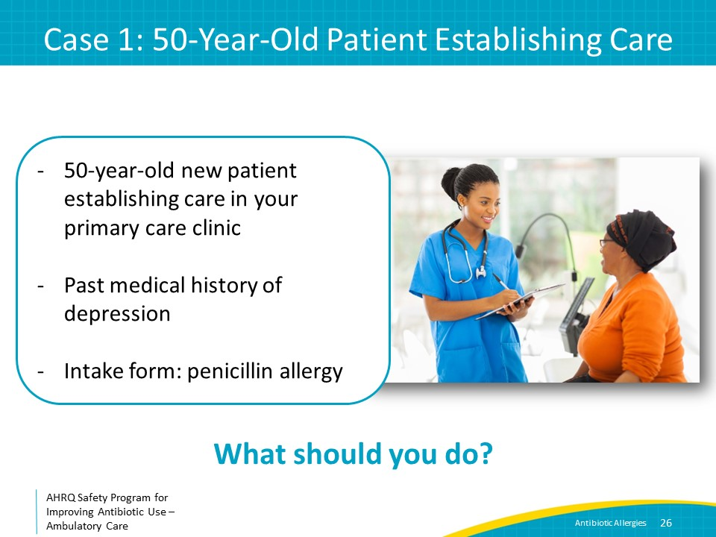
Case 1: Next Step  SAY:  You should ask her about her allergy history.  Suppose she says, “I had horrible diarrhea when I took amoxicillin-clavulanate for sinusitis when I was a teenager.”  What should you do? | Slide 27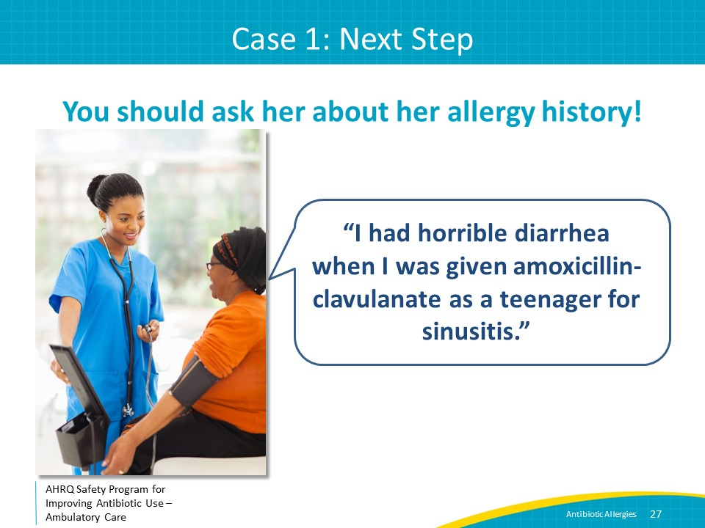
Case 1: Next Step  SAY:  Diarrhea is a frequent side effect of amoxicillin-clavulanate but is not an allergy. Most patients who have had diarrhea in the past with amoxicillin-clavulanate will tolerate not only other penicillins, but amoxicillin-clavulanate as well, especially if the patient takes probiotics or eats foods containing probiotics such as yogurt. You should remove the penicillin allergy from her chart and explain to her why she does not have an allergy. | Slide 28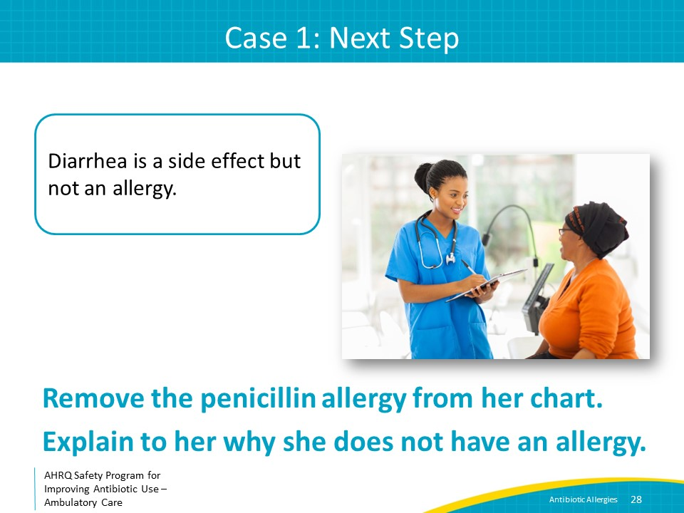
Case 2: The Same 50-Year-Old Patient  SAY:  Suppose you asked that same 50-year-old patient about her allergy and she says, “I had a rash when I was given amoxicillin as a child for a throat infection.” What should you do? | Slide 29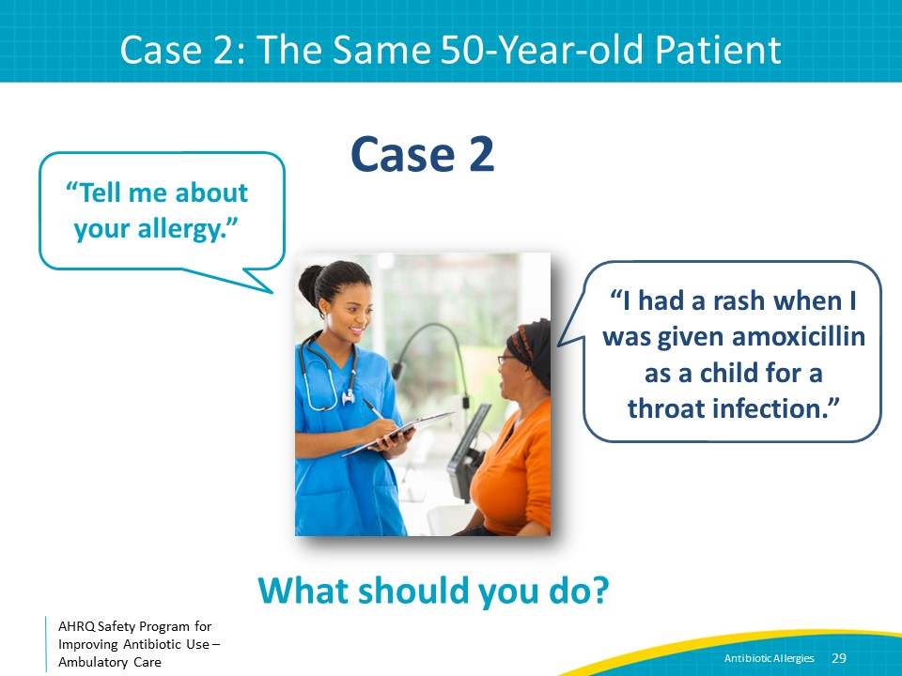
Case 2: Next Steps  SAY:  You need some more information. It is possible that she had a virus, and the rash was actually a viral exanthem. Ask her to describe what the rash looked like, how often after the first dose of antibiotics it occurred, and whether she was diagnosed with hives at the time. Ask if she has taken other antibiotics, particularly amoxicillin, amoxicillin/clavulanate, or cephalosporins, and if she had a reaction. Document what antibiotics she has reacted to and the type of reaction as well as antibiotics she has tolerated in her chart. If she has an infection that requires beta-lactam antibiotics and has tolerated a beta-lactam agent before, a new course is unlikely to cause a reaction, and can be considered for treatment. | Slide 30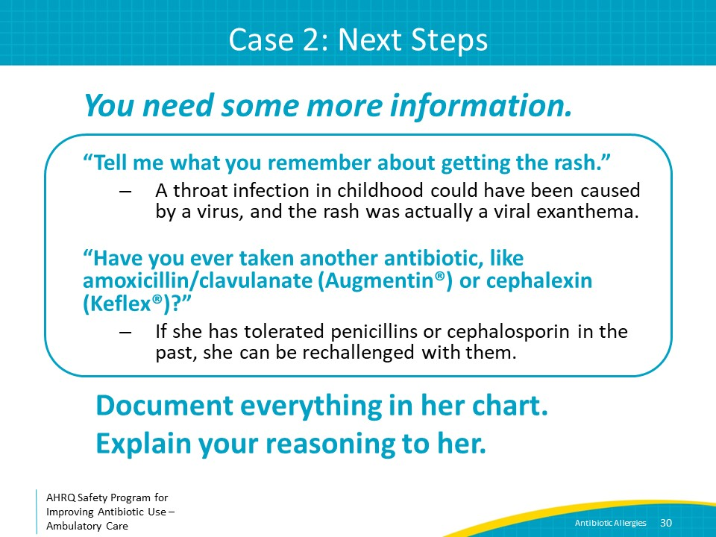
Take-Home Messages  SAY:  In conclusion, ensuring appropriate documentation of antibiotic allergies is an important part of antibiotic stewardship, and may improve patient outcomes. Take a good history about the type of antibiotic allergy, modify the medical record as needed, and ensure that the patient understands the importance of correctly describing the reaction at future visits to other clinicians. Patients are likely to need antibiotics again, especially those undergoing elective surgery, so consider referring patients to an allergist if a type 1 reaction cannot be ruled out or if the allergy description remains unclear. | Slide 31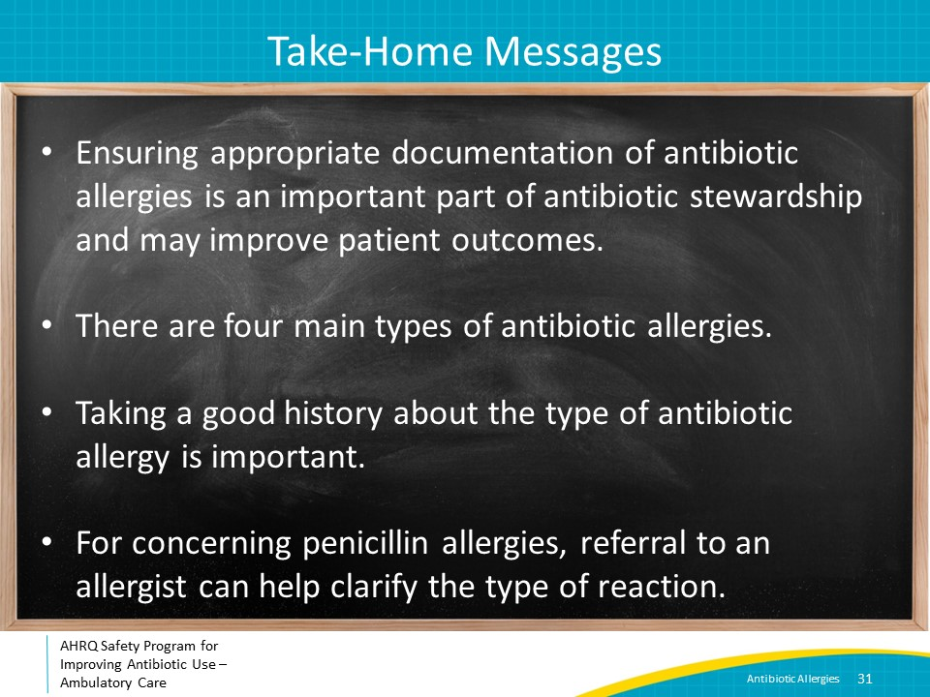
Additional Toolkit Resources  SAY:  For more resources on antibiotic allergies, please access tools listed below, available on the AHRQ Toolkit To Improve Antibiotic Use in Ambulatory Care.  Refer to the Discussion Guide to find materials to help your practice develop a standardized approach to address patient-reported antibiotic allergies.  Refer to the One-Page document for a concise summary on collecting patient information regarding their penicillin allergy history.  The Patient Handout explains allergic reactions to the patient, as well as the importance of sharing accurate information with their health care provider regarding possible antibiotic allergies. This is available in both English and Spanish. | Slide 32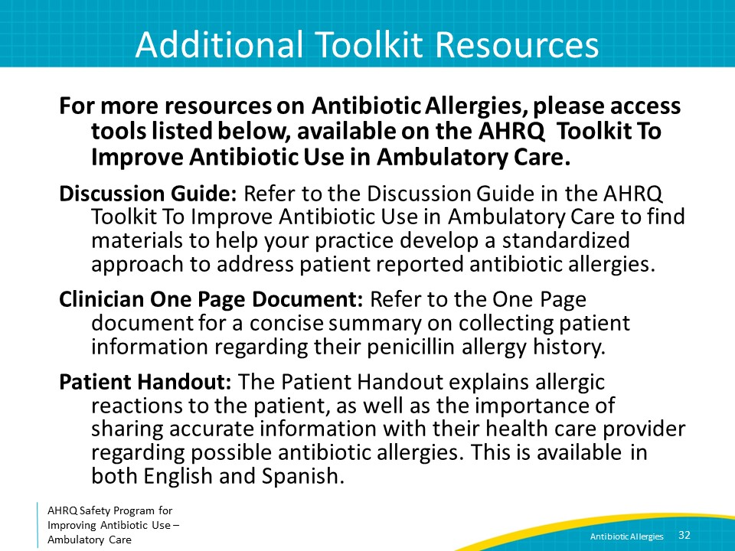
Disclaimer  SAY:  The findings and recommendations in this presentation are those of the authors, who are responsible for its content, and do not necessarily represent the views of AHRQ. No statement in this presentation should be construed as an official position of AHRQ or of the U.S. Department of Health and Human Services.  Any practice described in this presentation must be applied by healthcare practitioners in accordance with professional judgment and standards of care in regard to the unique circumstances that may apply in each situation they encounter. These practices are offered as helpful options for consideration by healthcare practitioners, not as guidelines.  Use of brand, manufacturer, or vendor names is for identification only and does not imply endorsement by the Agency for Healthcare Research and Quality of the U.S. Department of Health and Human Services. | Slide 33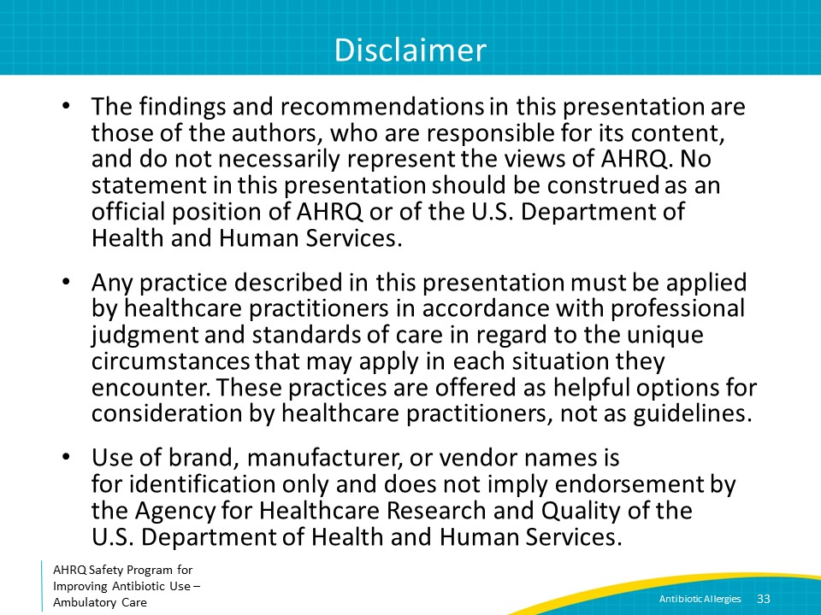
References  SAY:  Here are the references. | Slide 34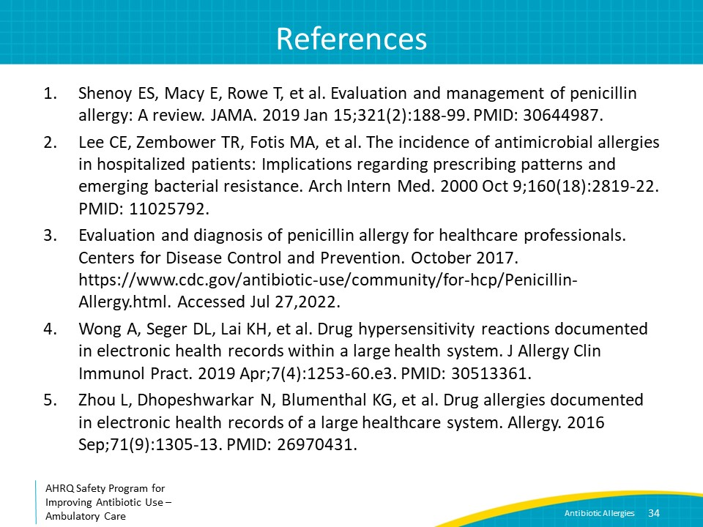
References | Slide 35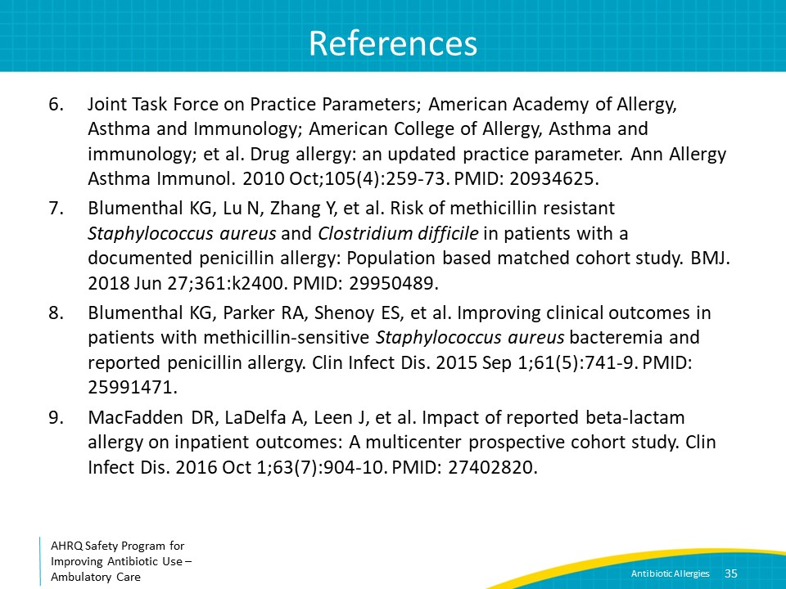
References | Slide 36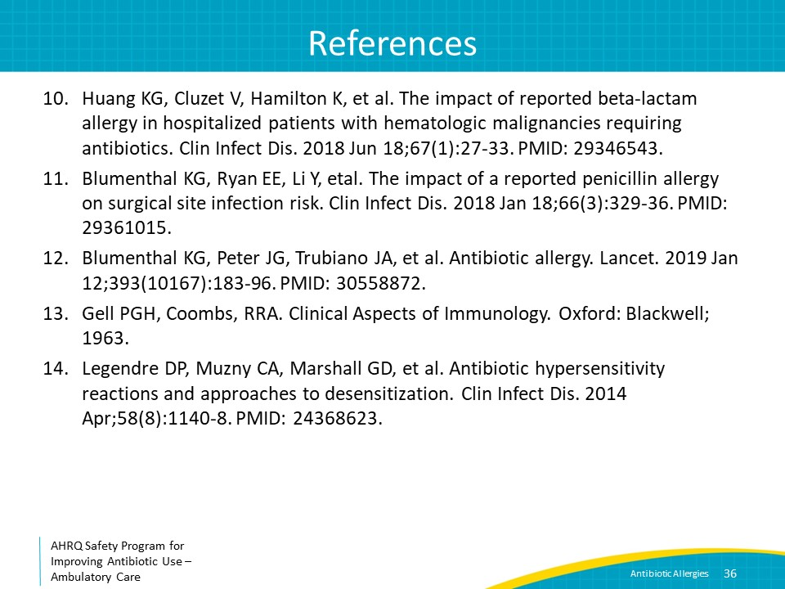
References | Slide 37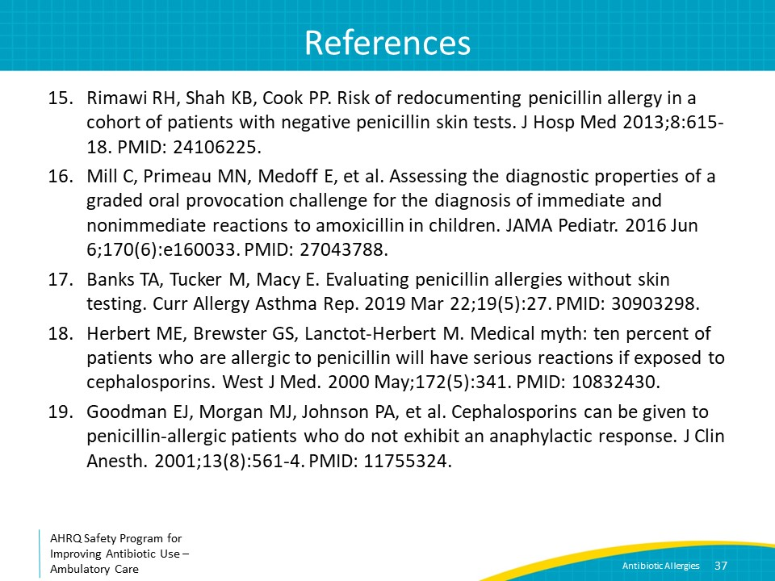
 | Slide 38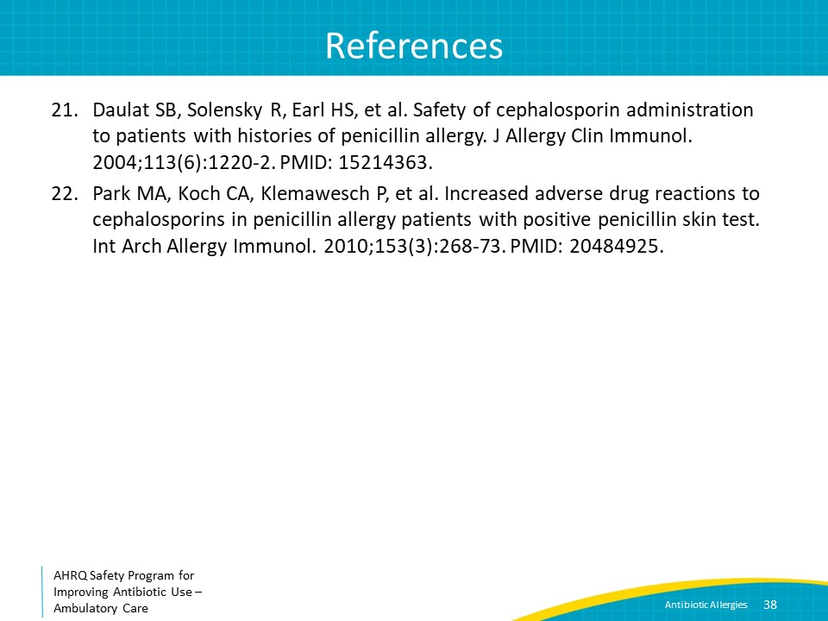
AHRQ Pub. No. 17(22)-0030
September 2022

