Why Should Your Practice Focus on Improving Antibiotic Prescribing?
Ambulatory Care

Slide Title and Commentary | Slide Number and Slide
Why Should Your Practice Focus on Improving Antibiotic Prescribing?  SAY:  Welcome to the presentation titled, “Why Should Your Practice Should Focus on Improving Antibiotic Prescribing?” | Slide 1
Objectives  SAY:  By the end of this presentation participants will be able to—  - Explain why optimizing antibiotic prescribing is necessary for patient safety  - Understand how antibiotic stewardship teams can improve antibiotic prescribing practices in the ambulatory care setting | Slide 2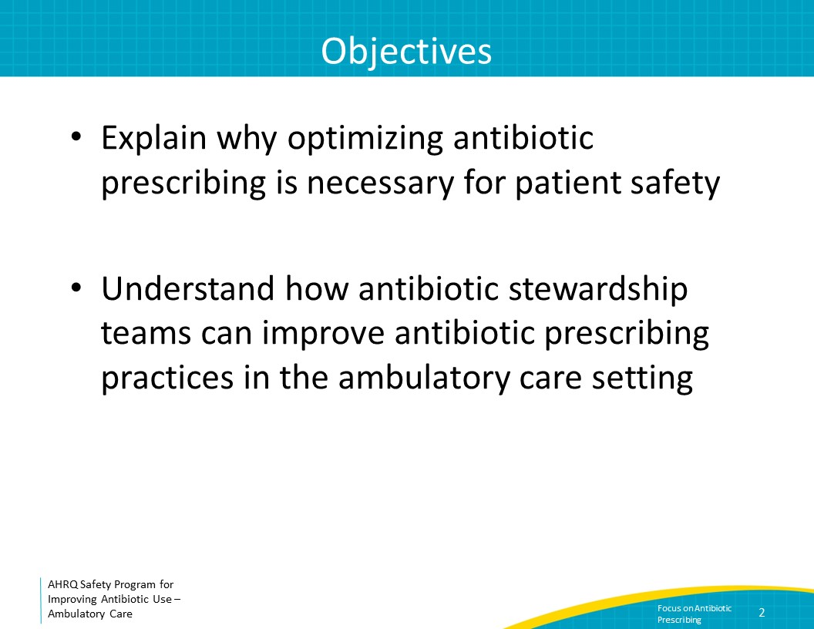
The Importance of Antibiotics  SAY:  The discovery of antibiotics has led to countless lives being saved compared to the pre-antibiotic era. For patients with serious bacterial infections, prompt administration of the right antibiotic at the right dose is critical to improving outcomes.  However, all antibiotics, whether necessary or not, are associated with risks. | Slide 3
Antibiotic-Associated Adverse Events  SAY:  Every time an antibiotic is being considered, it is important to consider the potential side effects associated with the antibiotic. Examples of adverse events include allergic reactions, acute kidney injury, hepatotoxicity, seizures, and Clostridioides difficile infections.  Antibiotic use is the primary driver of antibiotic resistance, which makes future infections in the same patient increasingly challenging to treat. | Slide 4
Antibiotic Overuse  SAY:  At least 30 percent of all antibiotics prescribed in ambulatory practices are unnecessary, and approximately 59 percent of antibiotic expenditures occur in the outpatient setting. There is room for improvement in antibiotic prescribing in the ambulatory setting.  A successful approach to work toward the common goal of safe and effective antibiotic prescribing is to implement antibiotic stewardship activities in a practice. This will help ensure that members of the clinic understand best practices in the diagnosis and management of common outpatient infections as well as develop approaches to improve teamwork and communication within the practice around antibiotic prescribing. Additionally, this will improve patient satisfaction as it will help patients understand why a decision is being made to prescribe or not prescribe antibiotics.  Please refer to the presentation, “Implementing Antibiotic Stewardship in your Practice,” as a resource for how to develop successful antibiotic stewardship approaches. | Slide 5
Clinical Case  SAY:  Consider the following case to underscore why optimizing antibiotic prescribing is necessary for patient safety.  A 62-year-old man with no past medical history presents with 1 week of an increased, nonproductive cough after a visit with his grandson. The cough is disrupting his daily activities and his sleep. On his physical exam, he is afebrile and the remainder of his vital signs are within normal limits. He has a normal respiratory examination. His healthcare practitioner obtains a chest x ray, which demonstrated slight bronchial thickening.  He is diagnosed with bronchitis and prescribed 10 days of levofloxacin.  He continued to have a cough and called the clinic on day 9. His healthcare practitioner extended the levofloxacin prescription to complete a total of 14 days of therapy. | Slide 6
Clinical Case Continued  SAY:  One week later, he presents to the hospital with severe Clostridioides difficile infections.  He requires a colectomy and spends 30 days in the hospital. | Slide 7
Where Are the Issues in This Case?  SAY:  A number of factors led to this patient having a poor outcome. First, he was diagnosed with acute bronchitis. Acute bronchitis is generally caused by a virus, and therefore antibiotics are not necessary. Second, his vital signs and lung exam were normal, making pneumonia unlikely. Thus, there was no need to obtain a chest x ray. | Slide 8
Where Are the Issues in This Case?  SAY:  Third, even if there was a concern for community-acquired pneumonia, levofloxacin is not first-line therapy, and rather should generally only be considered in cases of severe penicillin allergy for the treatment of community-acquired pneumonia. Further, the duration of therapy for community-acquired pneumonia should be 5 days, not 10 or more days. Levofloxacin is a broad-spectrum antibiotic that increases the risk for C. difficile infections, and this risk increases with each additional day of antibiotics.  Moreover, fluoroquinolones have a number of other side effects, including prolonged QTc intervals, tendinitis and tendon rupture, aortic dissections, seizures, and peripheral neuropathy—highlighting the importance of weighing the risks versus benefits of antibiotics whenever they are being considered. | Slide 9
Where Are the Issues in This Case?  SAY:  After several days of antibiotics, the patient’s symptoms remained unchanged, suggesting that a viral process was likely. The decision to reconsider the need for antibiotics did not occur.  Rather, a decision was made to extend the treatment course by an additional 4 days despite no evidence of a bacterial infection or demonstration of a response to therapy. These extra days of exposure to a broad-spectrum antibiotic may have further increased his risk of C. difficile infection. | Slide 10
Antibiotics & Clostridioides difficile  SAY:  In the case presented, the patient developed a severe C. difficile infection. Virtually all antibiotics can increase the risk of C. difficile infections.  However, the greatest risk occurs with clindamycin, third-generation cephalosporins, and fluoroquinolones.  The risk is highest when patients are actively receiving antibiotics, but this risk remains elevated even for several months after antibiotics are discontinued. | Slide 11
Another Case  SAY:  Consider another case. A 76-year-old female presents to her primary care practitioner, or PCP, for her annual visit.  She complains of difficulty falling asleep but otherwise reports feeling well.  Her PCP sends a urinalysis and a urine culture in case her symptoms are related to a urinary tract infection (or UTI).  Her urinalysis shows pyuria, which is urine containing at least 10 white blood cells per high powered field.  The urine culture results are available 2 days later. She has over 100,000 colony forming units per mL of Escherichia coli growing in her urine culture. It is susceptible to all tested antibiotics. Another clinician in the practice sees these results and prescribes a 7-day course of ciprofloxacin for a UTI. | Slide 12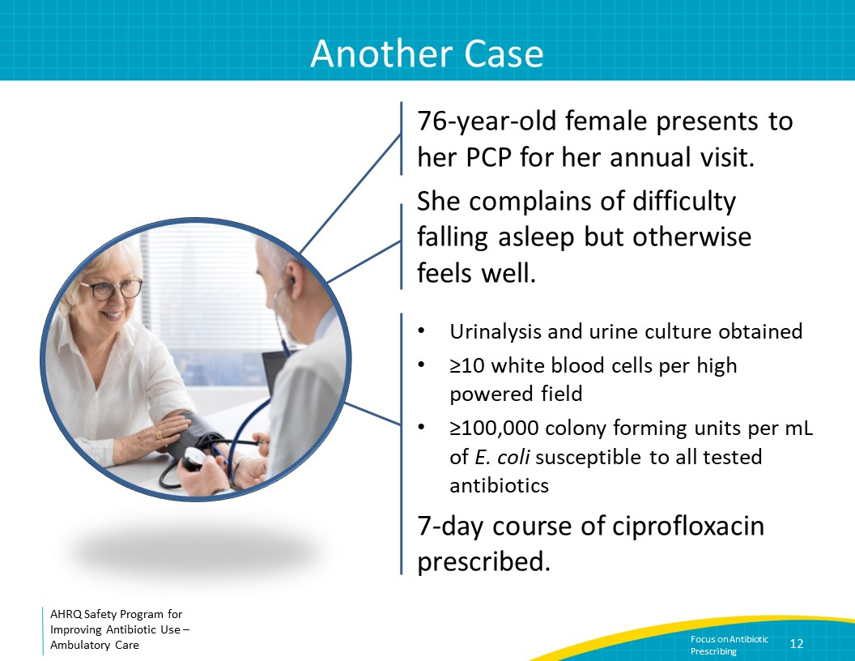
Case Continued  SAY:  She completes the antibiotic course. Two months later, she has fevers, dysuria, and flank pain. Her PCP starts her on ciprofloxacin. However, she continues to have fevers. She presents to her local ED where she is noted to be hypotensive. She is admitted with sepsis and initiated on cefepime.  Her urine culture grows greater than 100,000 colony forming units per mL of E. coli resistant to ciprofloxacin and all other oral antibiotics that were tested. She is hospitalized and completes a 7-day course of cefepime for pyelonephritis. | Slide 13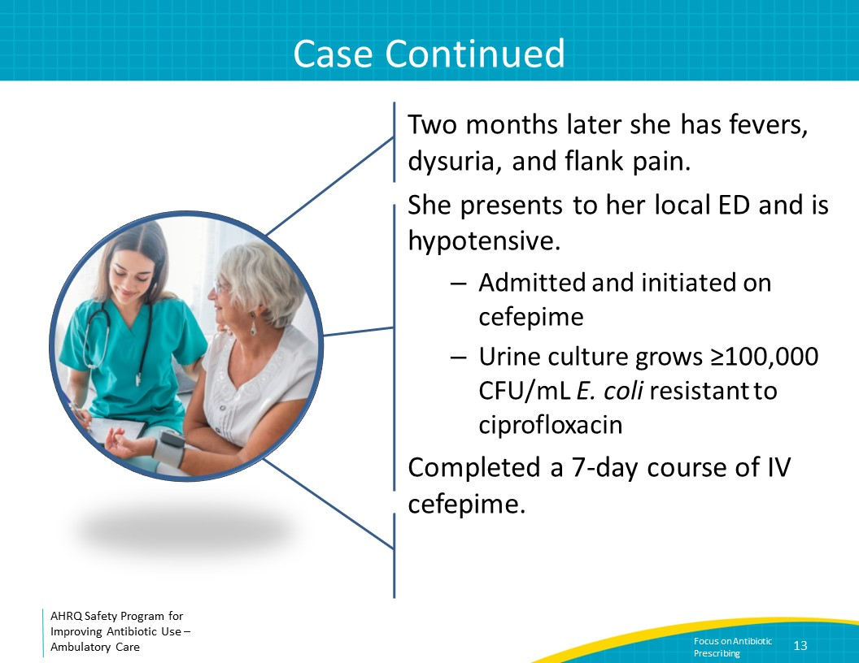
Where Are the Issues in This Case?  SAY:  When the patient first presented to her primary care doctor (or PMD in the figure), she did not have any signs or symptoms consistent with a UTI. During this visit, a urinalysis and urine culture did not need to be obtained. | Slide 14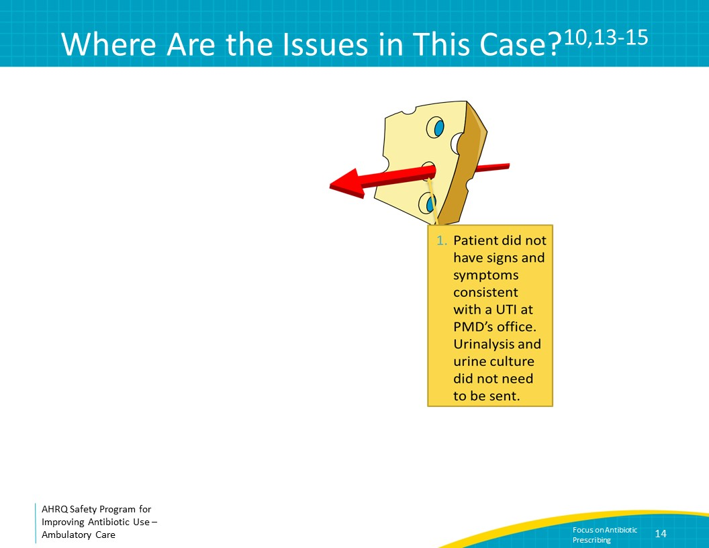
Where Are the Issues in This Case?  SAY:  The results of her urinalysis and culture were consistent with a diagnosis of asymptomatic pyuria and bacteriuria, which do not require treatment. As reviewed in the presentation titled “Best Practices in the Diagnosis and Treatment of Asymptomatic Bacteriuria and Urinary Tract Infections,” it is not uncommon for postmenopausal women to have pyuria and bacteriuria without any clinical signs or symptoms of a UTI.  Further, data show that treating women with asymptomatic bacteriuria both increases the risk of subsequent, clinically significant UTIs and increases the risk that these future UTIs are caused by antibiotic-resistant organisms. Treating asymptomatic bacteriuria can be harmful to patients.  When being notified of positive culture results, a reflex decision is often made to prescribe an antibiotic. In the case presented, the clinician should have called the patient to see if she was symptomatic before deciding to prescribe antibiotics. | Slide 15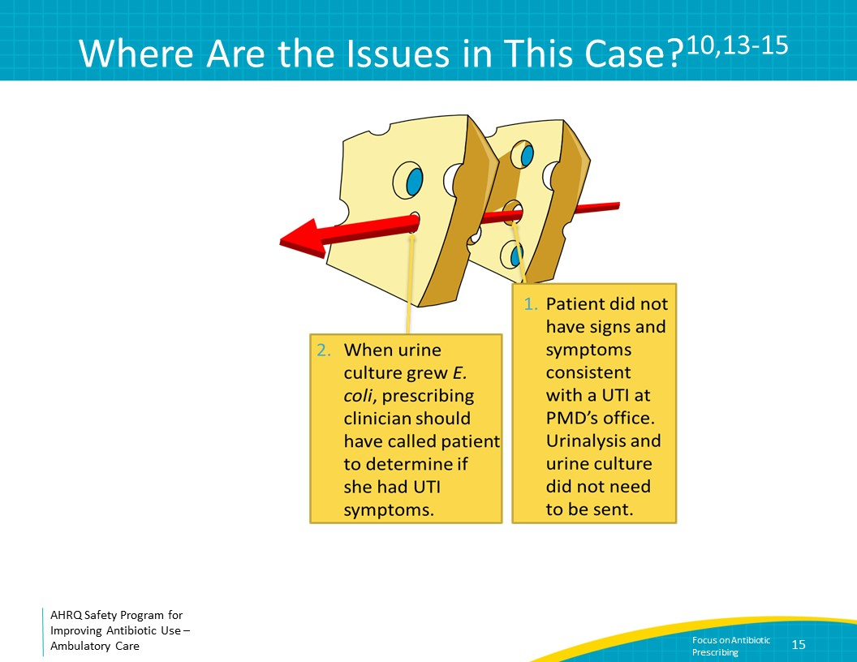
Where Are the Issues in This Case?  SAY:  If the patient did have dysuria and was diagnosed with cystitis, a different antibiotic and a shorter course could have been prescribed. Fluoroquinolones such as ciprofloxacin are not considered first-line antibiotic treatment for uncomplicated cystitis due to the likelihood of subsequent antibiotic resistance and because of their side effect profile. Instead, preferred options include nitrofurantoin and trimethoprim-sulfamethoxazole. Furthermore, uncomplicated cystitis can generally be treated with between 3 and 5 days of antibiotics, depending on the agent prescribed.  From the time the patient presented for medical care to the time harm occurred, there were several opportunities to prevent harm. | Slide 16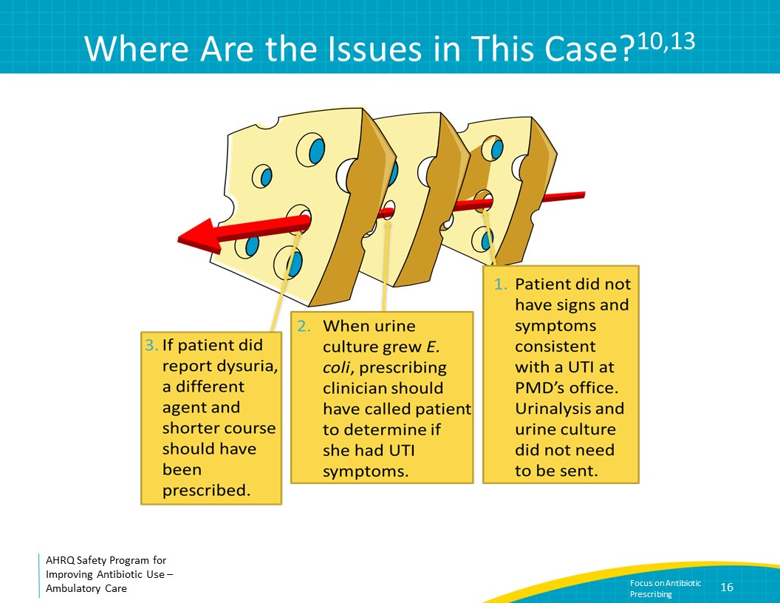
Social Determinants of Antibiotic Prescribing  SAY:  A number of factors influence antibiotic prescribing decisions beyond clinicians’ knowledge of infections and antibiotics.  Some of these decisions are related to relationships between clinicians and relationships between clinicians and patients. Clinicians may be concerned that they will be viewed as dismissive or disrespectful if they stop or change antibiotics started by another clinician. Clinicians may also worry about reactions from patients or family members if antibiotics are not prescribed.  However, inappropriate antibiotic prescribing is a safety problem, and it exposes patients to unnecessary risks. Implementation of antibiotic stewardship practices in a clinic can help ensure that patients receive antibiotics only when needed to minimize harm and maximize the chance of a good outcome. | Slide 17
Take-Home Messages  SAY:  In summary, although antibiotics are critical for ill-appearing patients with bacterial infections, all antibiotics also have associated harm. Promoting antibiotic stewardship in your practice can improve patient outcomes by ensuring the most effective antibiotic is prescribed for patients, and only when necessary. Implementation of antibiotic stewardship activities assists clinicians with remaining up to date on best practices in antibiotic prescribing, improving teamwork and communication around antibiotic prescribing, and improving patient satisfaction. | Slide 18
Disclaimer  SAY:  The findings and recommendations in this presentation are those of the authors, who are responsible for its content, and do not necessarily represent the views of AHRQ. No statement in this presentation should be construed as an official position of AHRQ or of the U.S. Department of Health and Human Services.  Any practice described in this presentation must be applied by health care practitioners in accordance with professional judgment and standards of care in regard to the unique circumstances that may apply in each situation they encounter. These practices are offered as helpful options for consideration by healthcare practitioners, not as guidelines. | Slide 19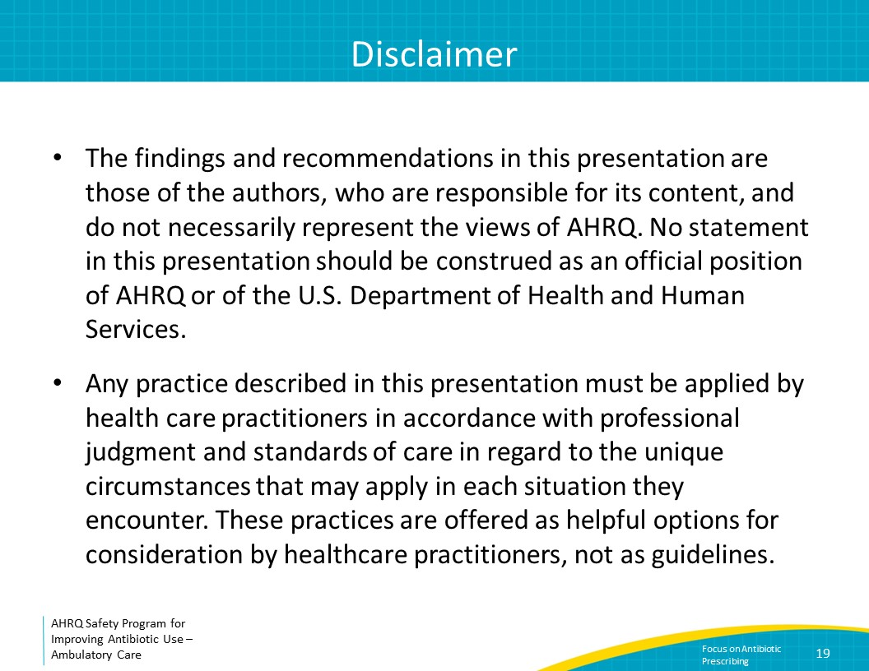
References  SAY:  Here are the references from this presentation. | Slide 20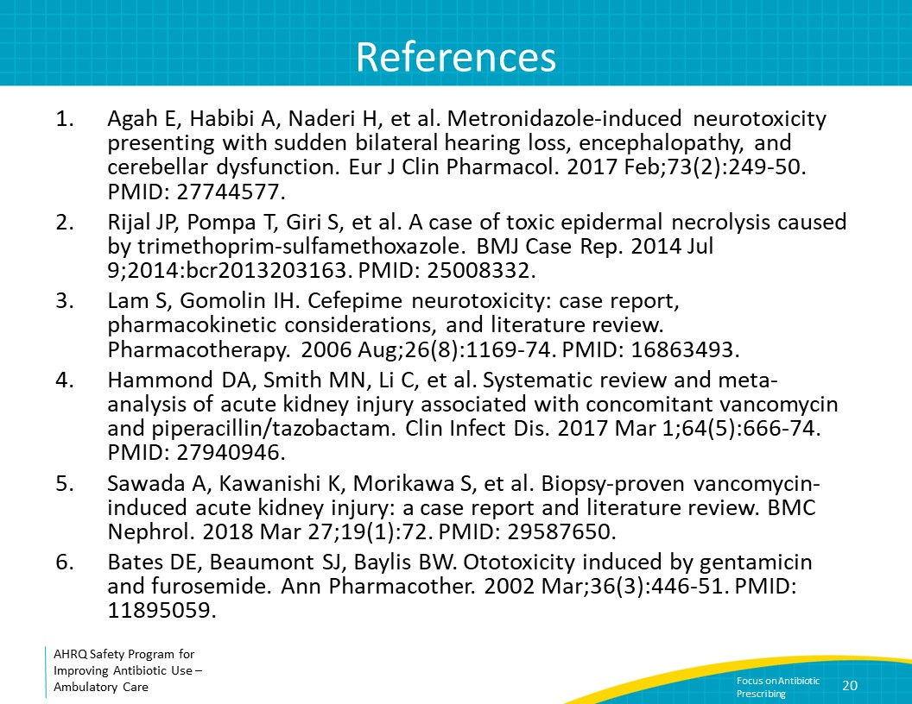
References | Slide 21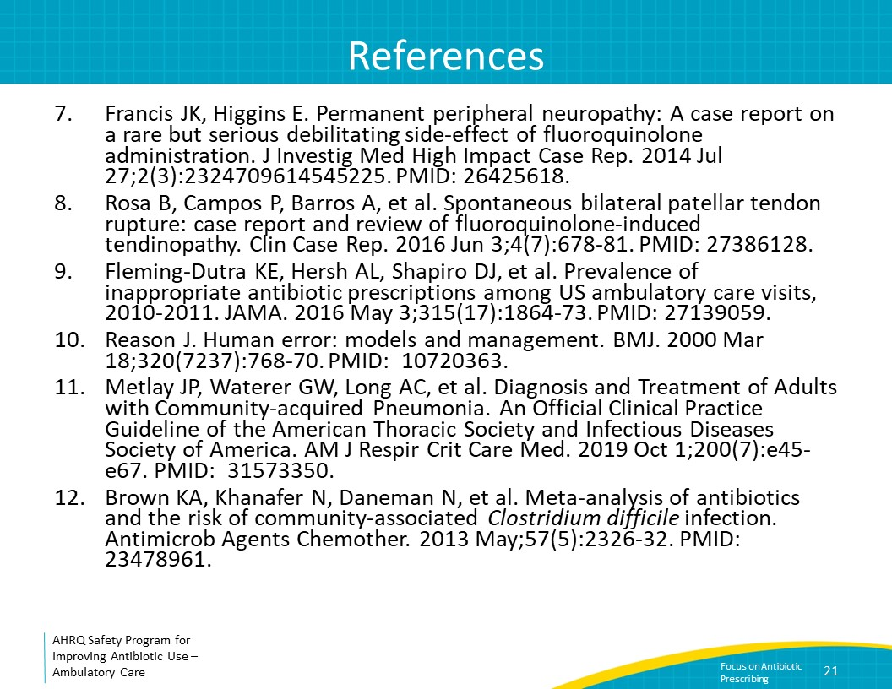
References | Slide 22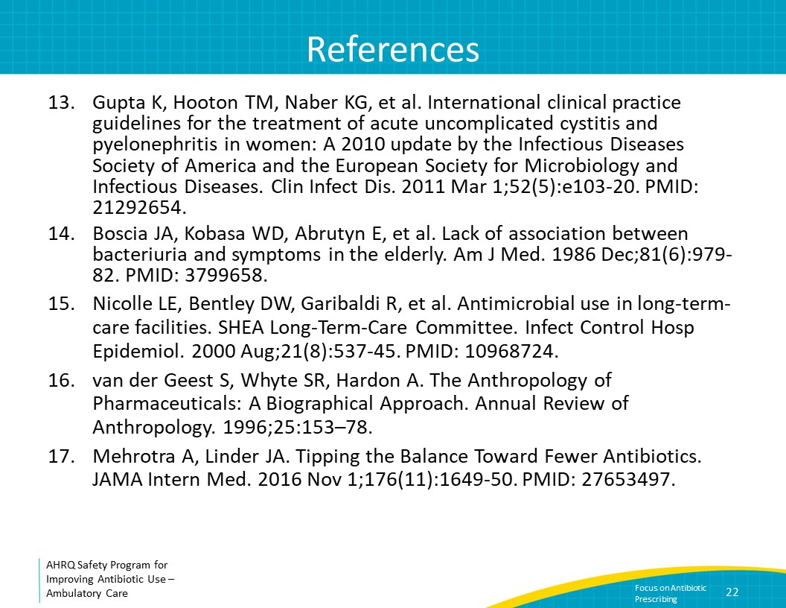

AHRQ Pub. No. 17(22)-0030
September 2022

