The “Sometimes Antibiotics” Diagnoses: Acute Otitis Media in Children
Ambulatory Care
Slide Title and Commentary | Slide Number and Slide
The “Sometimes Antibiotics” Diagnoses: Acute Otitis Media in Children  Ambulatory Care  SAY:  Welcome to the presentation titled, “The ‘Sometimes Antibiotics’ Diagnoses: Acute Otitis Media in Children.” | Slide 1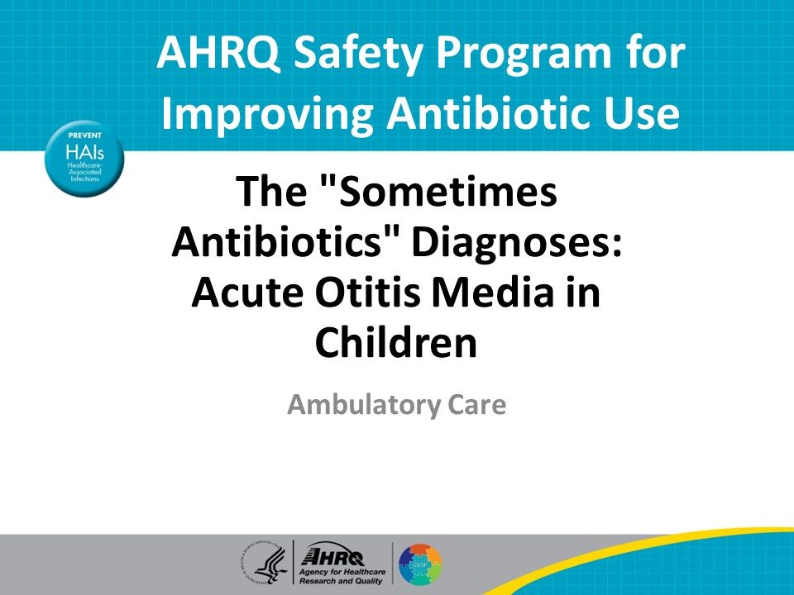
Objectives  SAY:  By the end of this presentation, participants will be able to:  - Describe the pathophysiology and clinical presentation of acute otitis media  - Identify criteria for the diagnosis of acute otitis media and  - Discuss evidence-based recommendations for the management of acute otitis media | Slide 2  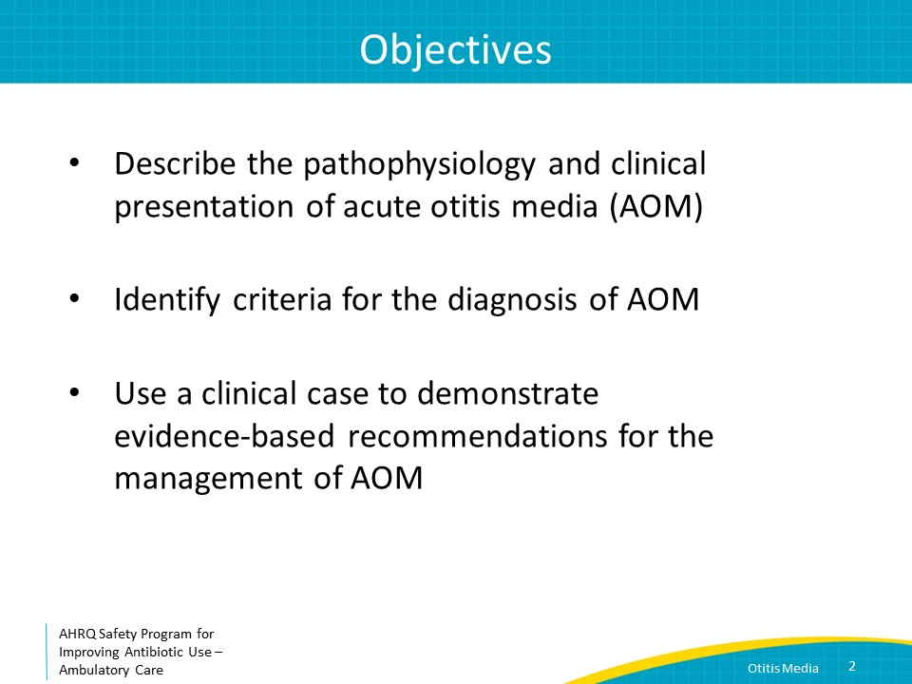
The Four Moments of Antibiotic Decision Making  SAY:  We will be referring to the Four Moments of Antibiotic Decision Making in this presentation. To review, the Four Moments include four critical questions related to antibiotic prescribing:  - Does my patient have an infection that requires antibiotics?  - Do I need to order a diagnostic test?  - If antibiotics are indicated, what is the narrowest, safest, and shortest regimen I can prescribe?  - Does my patient know what to expect and the followup plan? | Slide 3  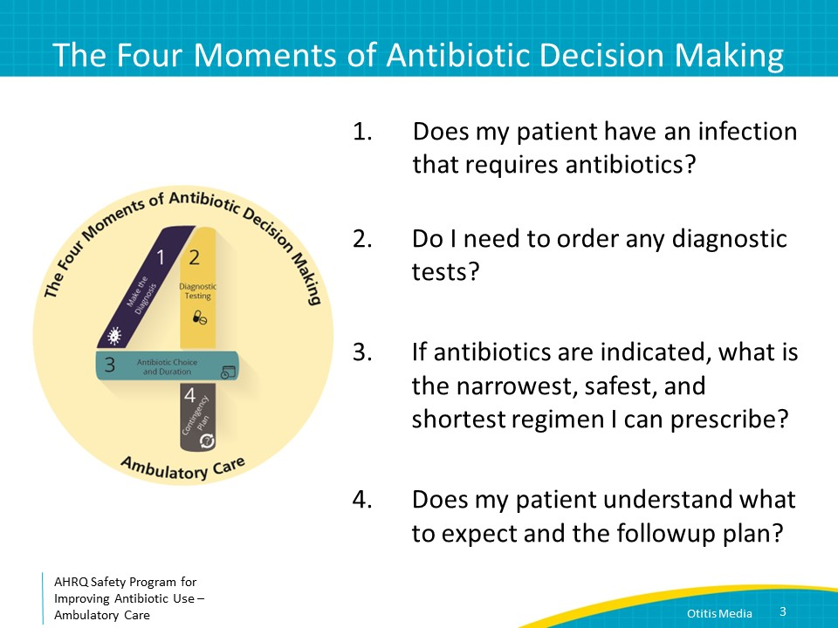
The Four Moments of Antibiotic Decision Making  SAY:  Moment One is: Does my patient have an infection that requires antibiotics? | Slide 4  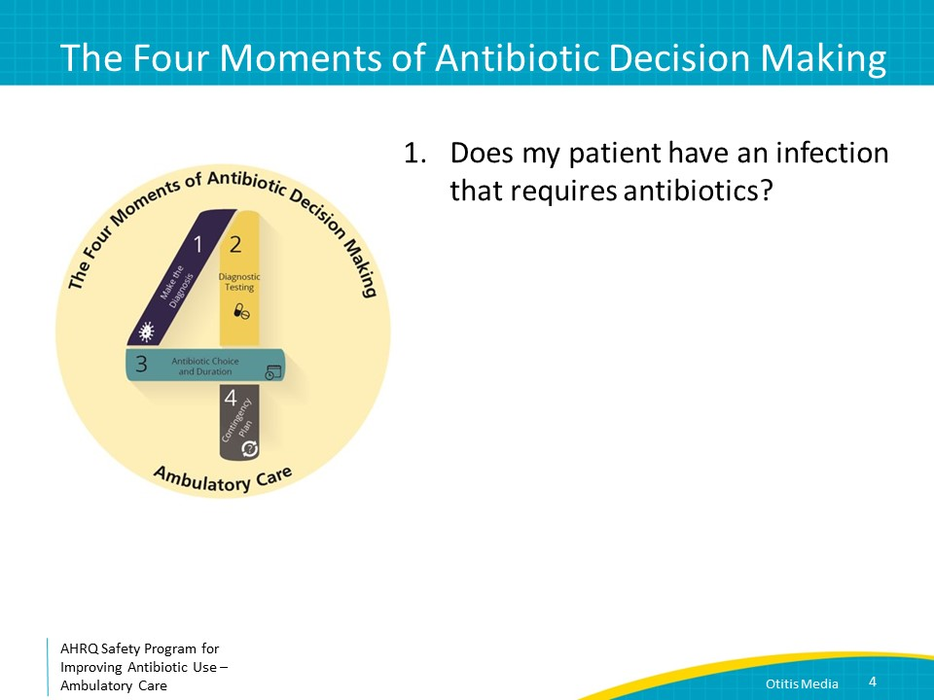
What Is Acute Otitis Media (AOM)?  SAY:  Acute otitis media or AOM is defined as moderate to severe bulging of the tympanic membrane or new-onset ear drainage, also known as otorrhea, with signs and symptoms of middle-ear inflammation such as ear pain and fever.  The most common bacterial pathogens causing AOM are Streptococcus pneumoniae, nontypeable Haemophilus influenzae, and Moraxella catarrhalis. These organisms cause approximately 25 percent, 50 percent, and 15 percent of AOM cases, respectively.  Even though rates of AOM due to S. pneumoniae are declining in the setting of high rates of pneumococcal vaccines, therapy for AOM primarily targets S. pneumoniae as this organism is associated with higher morbidity and mortality compared to other organisms. S. pneumoniae is associated with greater clinical severity than other otopathogens, as reflected by high fever, more intense otalgia, and a higher potential for complications such as bacteremia, meningitis, and mastoiditis, compared to H. influenzae and M. catarrhalis. | Slide 5  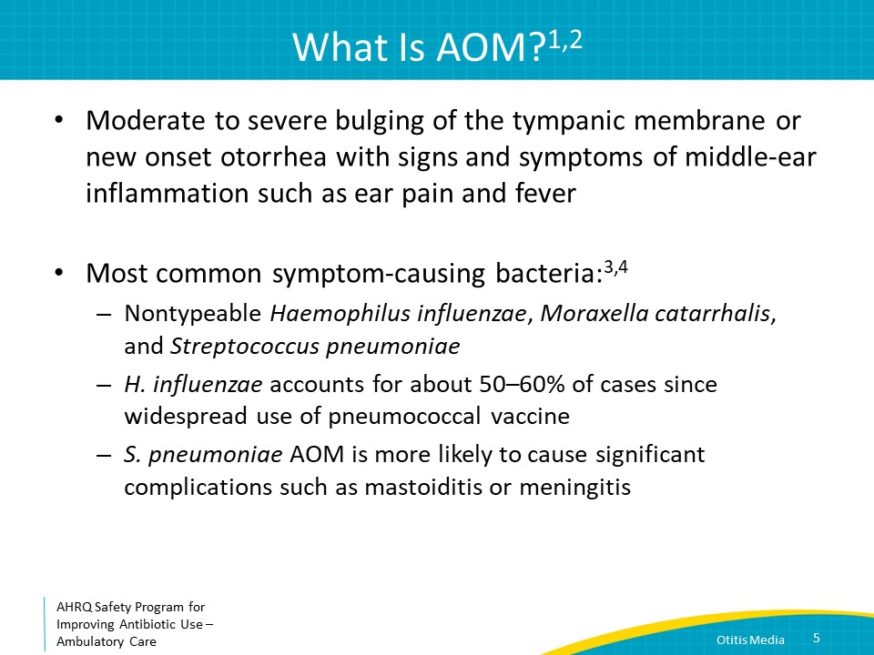
Risk Factors  SAY:  Otitis media most commonly occurs in children 6 to 24 months of age.  The increased prevalence of otitis media at younger ages is in part due to a shorter, more horizontal eustachian tube than in older children or adults, facilitating the accumulation of fluid.  The risk of AOM in younger children is increased by the immature immune system of young children caused by a combination of waning maternal antibodies and inadequate production of protective antibodies by the child because of limited prior bacterial exposures. | Slide 6  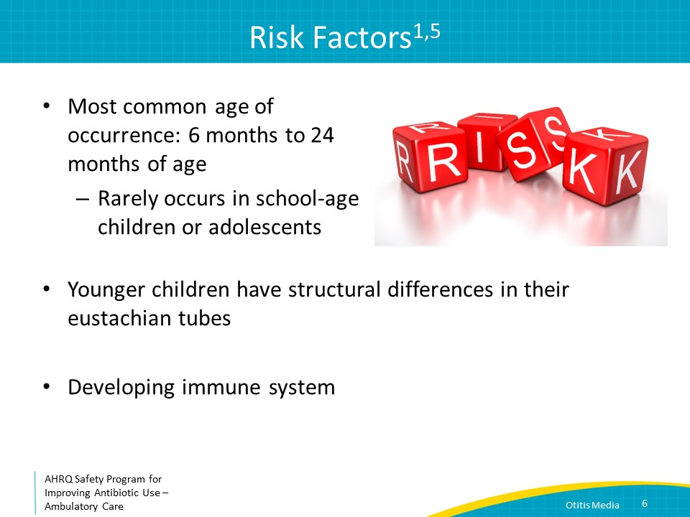
How Does AOM Develop?  SAY:  Otitis media generally starts with a viral upper respiratory tract infection. This results in edema and inflammation of the mucosa of the nasopharynx and eustachian tube—the small passageway that connects the nasopharynx to the middle ear, leading to obstruction of the eustachian tube and accumulation of fluid in the middle ear.  Bacteria that colonize the human nasopharynx such as Strep pneumoniae multiply in this fluid, leading to a bacterial infection that manifests as bulging of the tympanic membrane and the classic symptoms of acute otitis media. | Slide 7  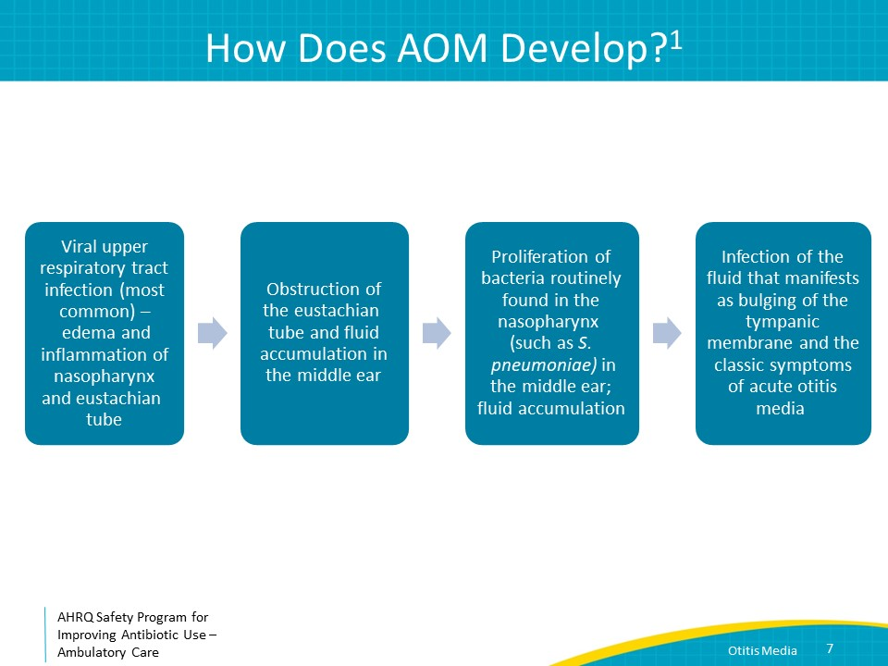
Clinical Case  SAY:  Let’s start with a case and incorporate the Four Moments of Antibiotic Decision Making.  A mother and her 1-year-old come to your clinic in the late afternoon. The mother is concerned because her daughter has not been sleeping well over the past 2 days. She is tossing and turning, fussy during nap time, and holding her hand over her ear.  Her temperature was 100.4 degrees Fahrenheit. Her mother says her teeth are coming in and thinks they are bothering her. | Slide 8  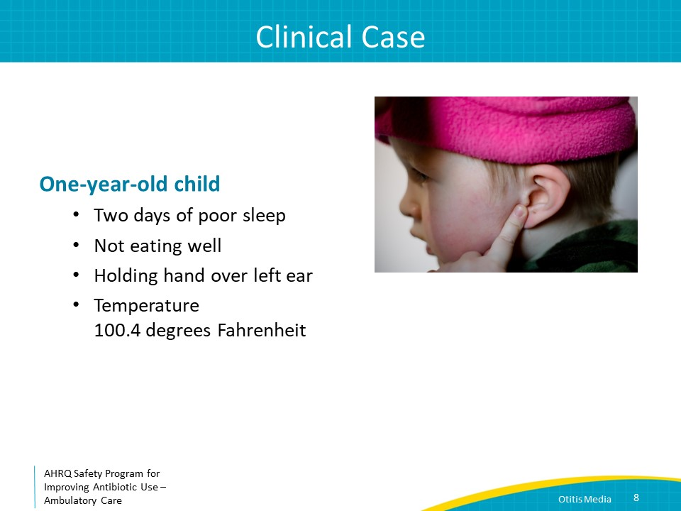
Moment 1  SAY:  So, let’s start with Moment One. Does my patient have an infection that requires antibiotics?  The diagnosis of otitis media should be considered in a child with recent onset of ear pain and a bulging tympanic membrane. Ear pain can be difficult to elicit in young children, but it usually manifests as irritability, restless sleep, poor feeding, and rubbing or tugging the ear. About half of children with otitis media have a fever. Mild signs and symptoms of otitis media are otalgia for less than 48 hours and a temperature of less than 102.2 degrees Fahrenheit.  Severe signs and symptoms include ill appearance, moderate to severe otalgia, otalgia lasting at least 2 days, or temperature of 39 degrees Celsius or 102.2 degrees Fahrenheit or greater. The stratification of severe and not-severe infection is helpful in informing antibiotic decision making. | Slide 9  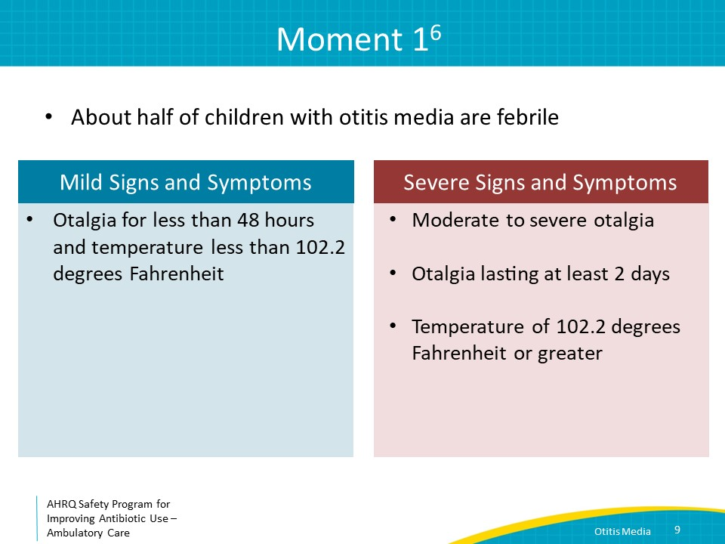
When Antibiotics Are Indicated  SAY:  Infants under 6 months of age have immature immune systems and waning maternal antibodies, putting them at increased risk for severe and systemic infection. It is reasonable to prescribe antibiotics for infants in this age group with signs and symptoms consistent with otitis media. The diagnostic evaluation of infants under 1 month of age with fever should typically be managed in emergency room settings, as an evaluation for meningitis will likely be necessary.  Antibiotics are indicated for children 6 months to under 2 years for otitis media with otorrhea or bilateral ear findings, regardless of otorrhea. For unilateral otitis media without otorrhea either antibiotic therapy can be initiated, or observation can be considered if symptoms are mild, the caregiver is in agreement, and a plan is made for followup.  For children 2 years of age and older, antibiotics should be considered when otorrhea is present or when severe symptoms are present. Observation can be considered if there is no otorrhea and the presentation is not severe. | Slide 10  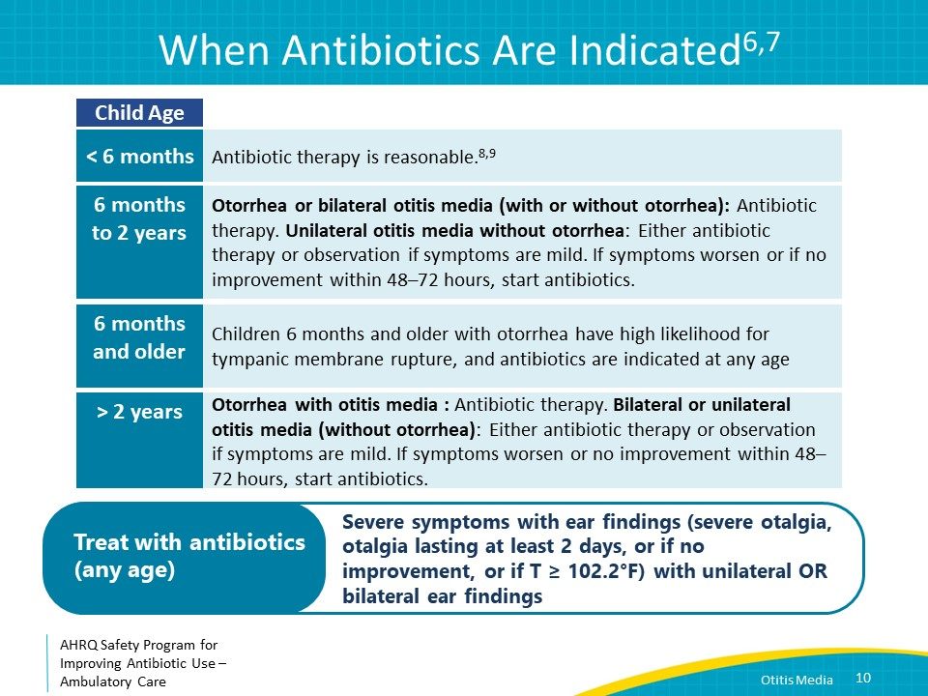
The Four Moments of Antibiotic Decision Making  SAY:  Moment Two is: Do I need to order any diagnostic tests? | Slide 11  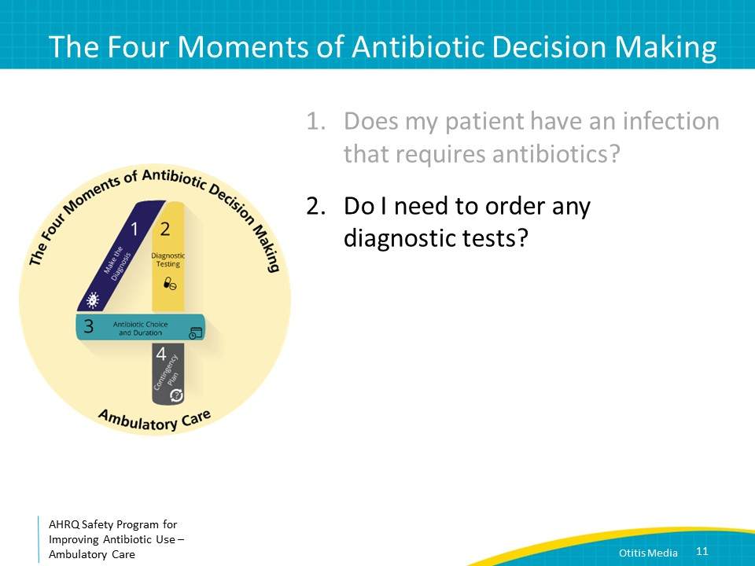
Moment 2  SAY:  Because primary care clinicians do not typically perform tympanocentesis for children with otitis media, empiric antibiotics are prescribed based on the presumption of a bacterial infection and knowledge of the common bacteria anticipated to be recovered.  There is no indication to culture ear discharge in the setting of otorrhea as there would be a high likelihood of culturing skin flora.  An exception would be the failure of multiple courses of antibiotic therapy or a child who has had frequent ear infections where there is a concern for increasingly antibiotic-resistant organisms. In these cases, a referral to a pediatric ear, nose, and throat doctor for a potential tympanocentesis should be considered. | Slide 12  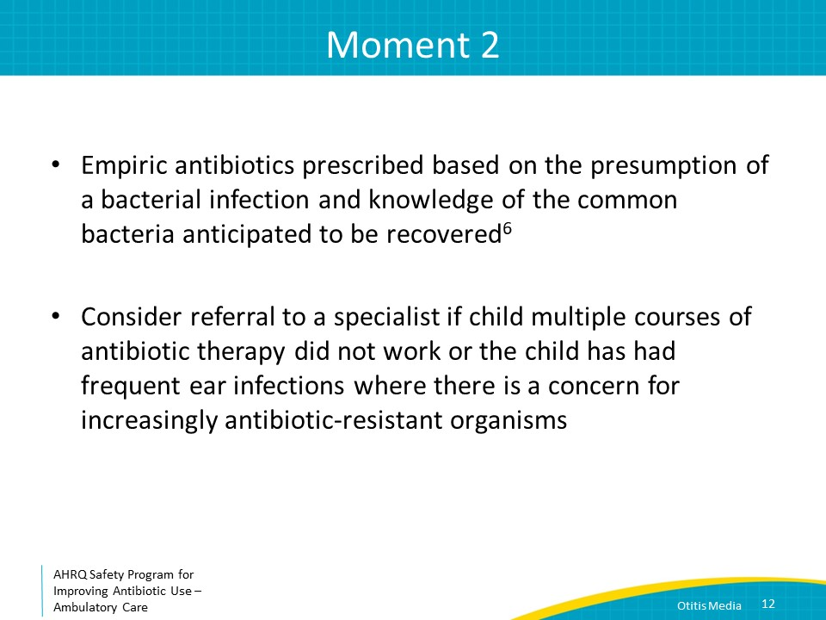
The Four Moments of Antibiotic Decision Making  SAY:  Moment Three is, “If antibiotics are indicated, what is the narrowest, safest, and shortest regimen I can prescribe?” | Slide 13  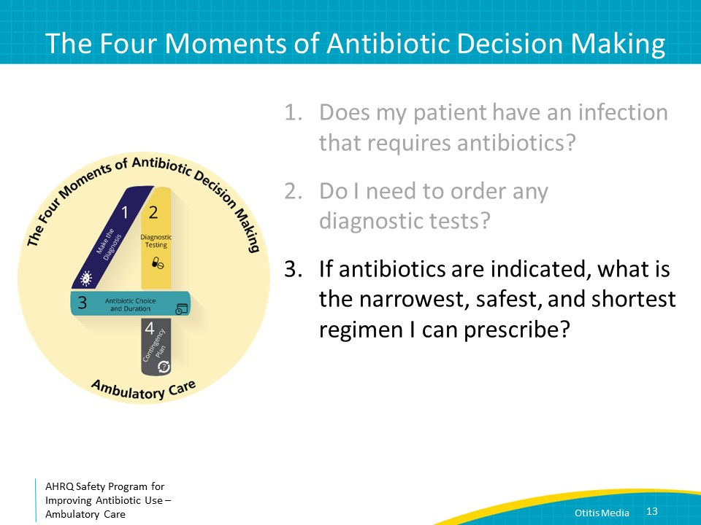
Moment 3  SAY:  Pain control, regardless of antibiotic decision making, should always be addressed. Ibuprofen or acetaminophen for ear pain and/or fever can help alleviate symptoms.  The American Academy of Pediatrics 2013 Otitis Media clinical practice guidelines state that high-dose amoxicillin is the narrowest, safest, and shortest antibiotic regimen in all age groups. Amoxicillin is also relatively affordable and has an acceptable taste. A high dose of amoxicillin is 45 milligrams per kilogram per dose of amoxicillin every 12 hours.  The recommendations for oral antibiotics are no different if you suspect otorrhea due to tympanic membrane rupture. No additional topical antibiotic ear drops are necessary. This is true for children receiving antibiotic therapy as well as those who are being observed without antibiotics.  Amoxicillin-clavulanate is first line for children who received amoxicillin within the previous 30 days, and/or children with concurrent purulent conjunctivitis and/or children with a history of recurrent AOM unresponsive to amoxicillin. AOM with concurrent purulent conjunctivitis is most commonly caused by H. influenzae.  The reason amoxicillin-clavulanate is first choice in these cases is that otitis media refractory to amoxicillin is most likely caused by microbes that produce beta-lactamase enzymes. Beta-lactamase enzymes causes resistance to amoxicillin. Approximately 30 to 50 percent of H. influenzae and 100 percent of M. catarrhalis are β-lactamase producing. Beta-lactamase–producing H. influenzae and M. catarrhalis do remain susceptible to amoxicillin-clavulanate.  For children with nonsevere penicillin allergies, meaning no history of hives or anaphylaxis with a penicillin antibiotic in the past, oral second- and third-generation cephalosporins like cefuroxime or cefdinir, or intramuscular ceftriaxone are reasonable antibiotic choices. Of note, these antibiotics are also effective for beta-lactamase producing H. influenzae or M. catarrhalis.  For children with severe penicillin allergy, the fluoroquinolone levofloxacin can be considered. | Slide 14  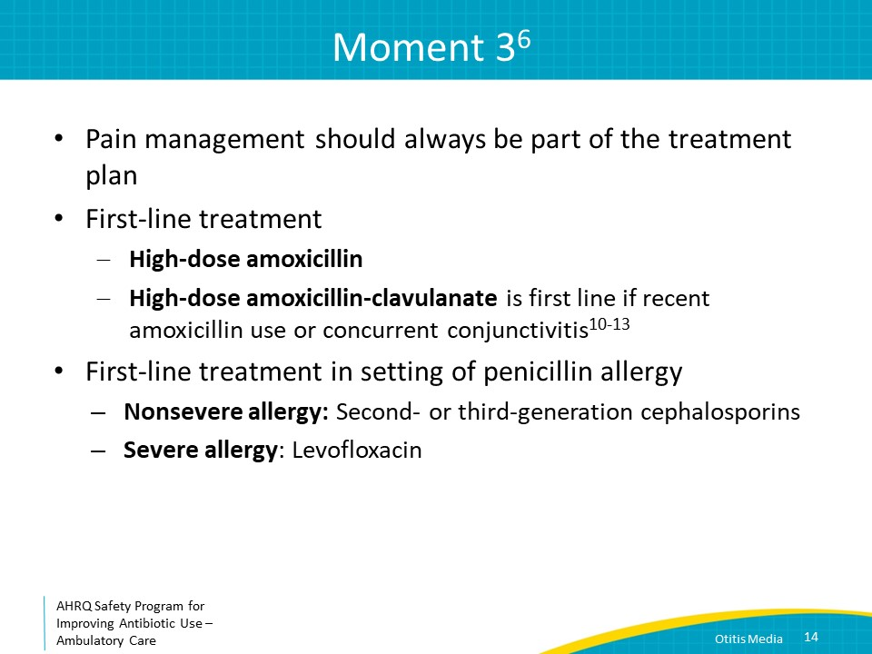
Duration of Antibiotic Therapy  SAY:  The treatment course depends on age and symptom severity. For children younger than 2 years and for children of any age with severe symptoms, a 10-day course of antibiotics is recommended. A 5-day randomized controlled trial demonstrated less favorable outcomes than a 10-day course for this age group.  A 7-day antibiotic course is recommended if a decision is made to treat a child 2–5 years of age with mild to moderate symptoms of acute otitis media. A 5- to 7-day course is recommended if a decision is made to treat a child 6 years and older with antibiotics for mild to moderate symptoms. | Slide 15  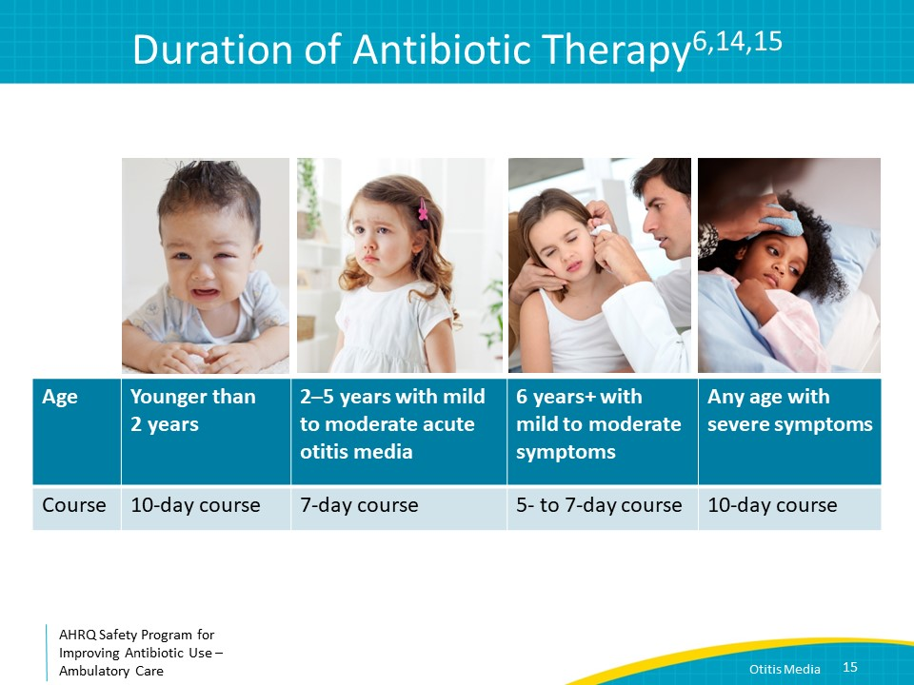
The Four Moments of Antibiotic Decision Making  SAY:  Moment Four is, Does my patient know what to expect and the followup plan? | Slide 16  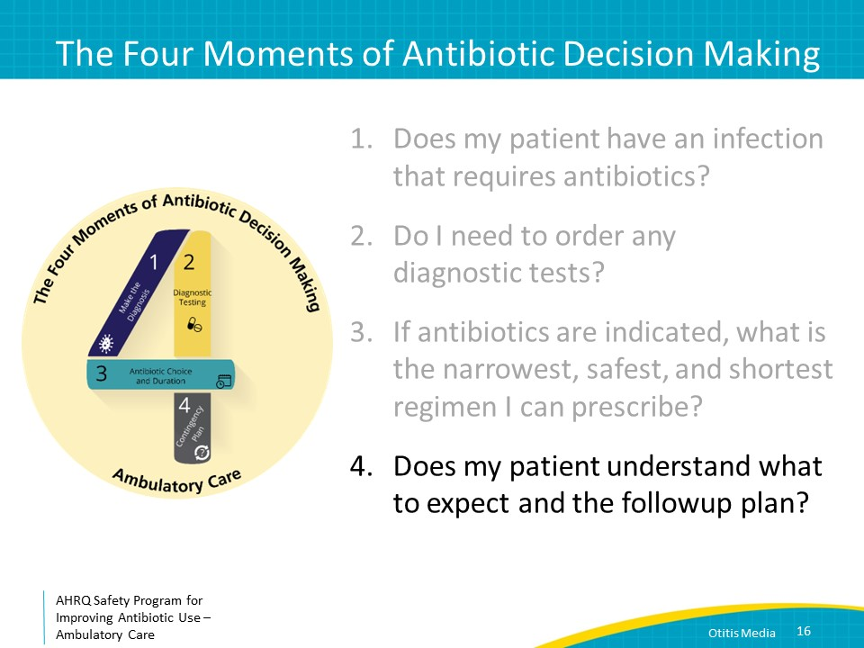
Moment 4  SAY:  Clinical symptoms should begin improving within 48 to 72 hours of treatment. Sleeping patterns, irritability or fussiness, and body temperature should all return close to normal within 72 hours of antibiotic initiation.  Acute mastoiditis is an important but rare complication of AOM. Acute mastoiditis is a serious bacterial infection of the mastoid bone that may occur in the setting of otitis media. It is important to counsel caregivers on the signs of acute mastoiditis, such as tender postauricular mass or protrusion of the earlobe. If symptoms appear, an emergency room referral is warranted for further assessment.  A followup otoscopic exam is not necessary if the child is symptomatically improving, but some clinicians may choose to follow younger children more closely or children with more severe initial symptoms. For children with presumed tympanic membrane rupture, you may see evidence of healed tympanic membrane.  Persistent middle-ear effusion may be present in 60 to 70 percent of children 2 weeks after successful otitis media treatment. Because persistent middle-ear effusions may manifest as mild transient hearing loss, it is important to counsel caregivers on the potential of this phenomenon and that resumption of baseline hearing generally occurs once the effusion is resolved. | Slide 17  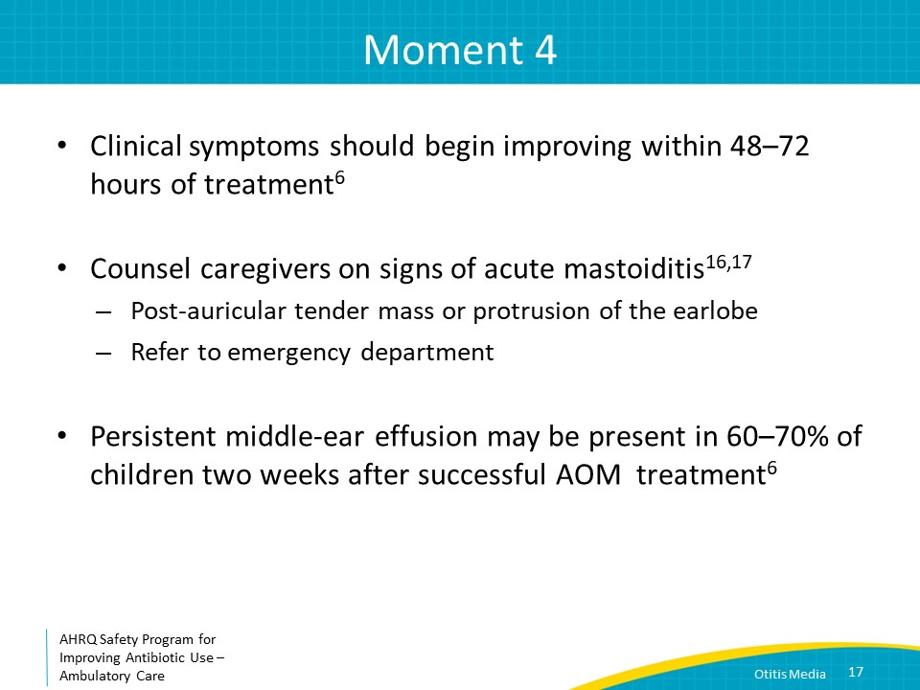
Moment 4, Continued  SAY:  Patients should seek medical attention if symptoms worsen or fail to improve within 48 to 72 hours of initiating antibiotics. If the child is becoming confused, lethargic, or increasingly tired or if the child is ill appearing, he or she should promptly return to medical care.  If a child is not improving after 48–72 hours of amoxicillin, consider switching to oral amoxicillin-clavulanate or up to 3 days of intramuscular ceftriaxone. If the child is ill appearing, he or she should be sent to the emergency department for evaluation for more invasive disease.  Consultation with a pediatric otolaryngologist should be considered if a child is nontoxic but has persistent symptoms despite antibiotic changes. Consultation with a pediatric otolaryngologist should also be considered for children with chronic otitis media effusion, defined as persistence of middle-ear effusion without infection lasting greater than 3 months or recurrent ear infections, defined as at least 3 episodes of otitis media in 6 months or 4 episodes of otitis media in 12 months. | Slide 18  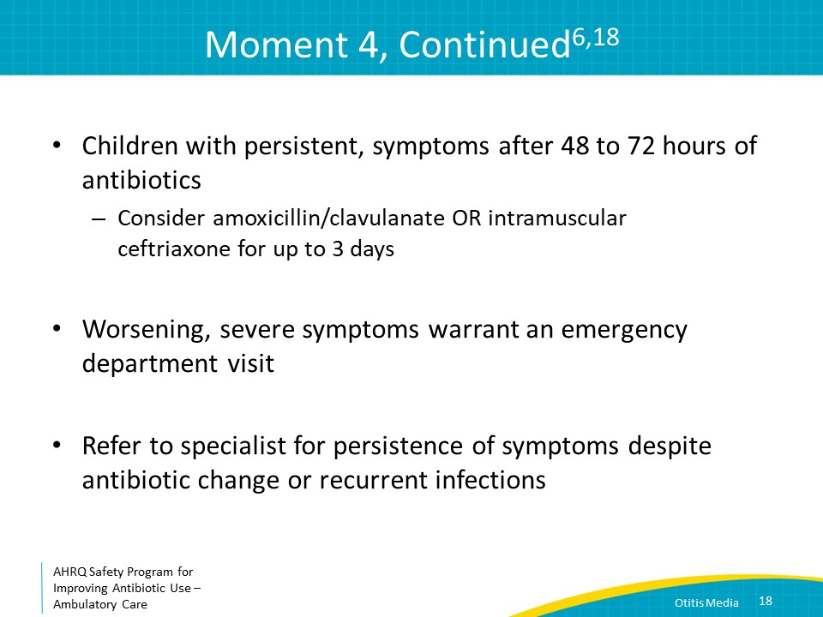
Take-Home Messages  SAY:  Acute otitis media is a “sometimes antibiotics” diagnosis. Severe presenting symptoms support antibiotic use while other factors like age, focality of ear findings, and otorrhea guide antibiotic treatment decision making. The decision to treat with antibiotics versus careful observation off of antibiotics should be made in collaboration with caregivers.  Antibiotic treatment duration depends on age and symptom severity.  A plan for when to return to medical care should always be discussed with parents, and pain control is always part of the treatment plan. | Slide 19  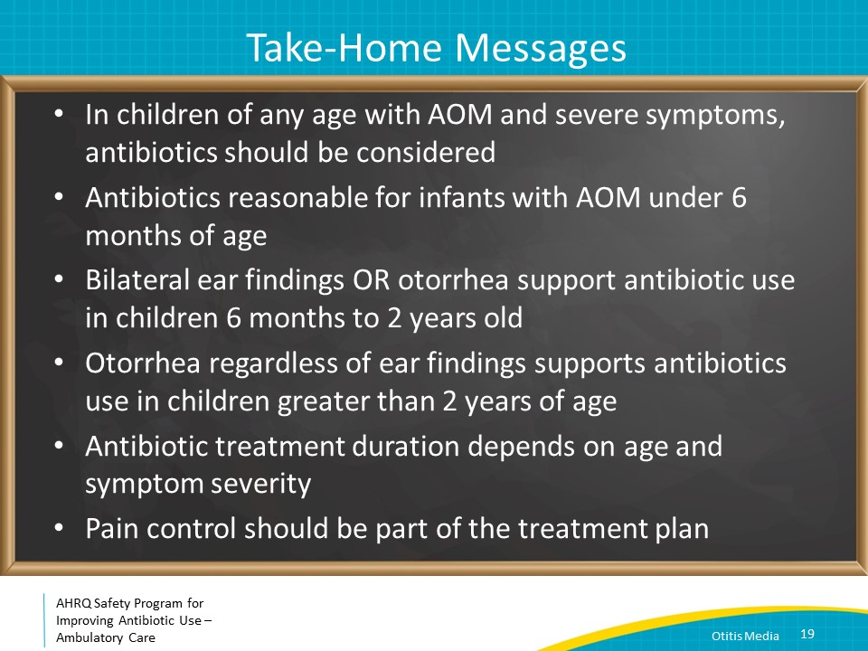
Additional Toolkit Resources  SAY:  For more resources on otitis media, please access tools listed below, available in the AHRQ Toolkit To Improve Antibiotic Use in Ambulatory Care.  Refer to the Discussion Guide to help your practice develop a standardized approach to the diagnosis and management of patients with acute otitis media.  Refer to the One-Page document for a concise summary on the diagnosis and treatment of acute otitis media.  The patient handout explains the symptoms and symptomatic treatment of acute otitis media. This is available in both English and Spanish. | Slide 20  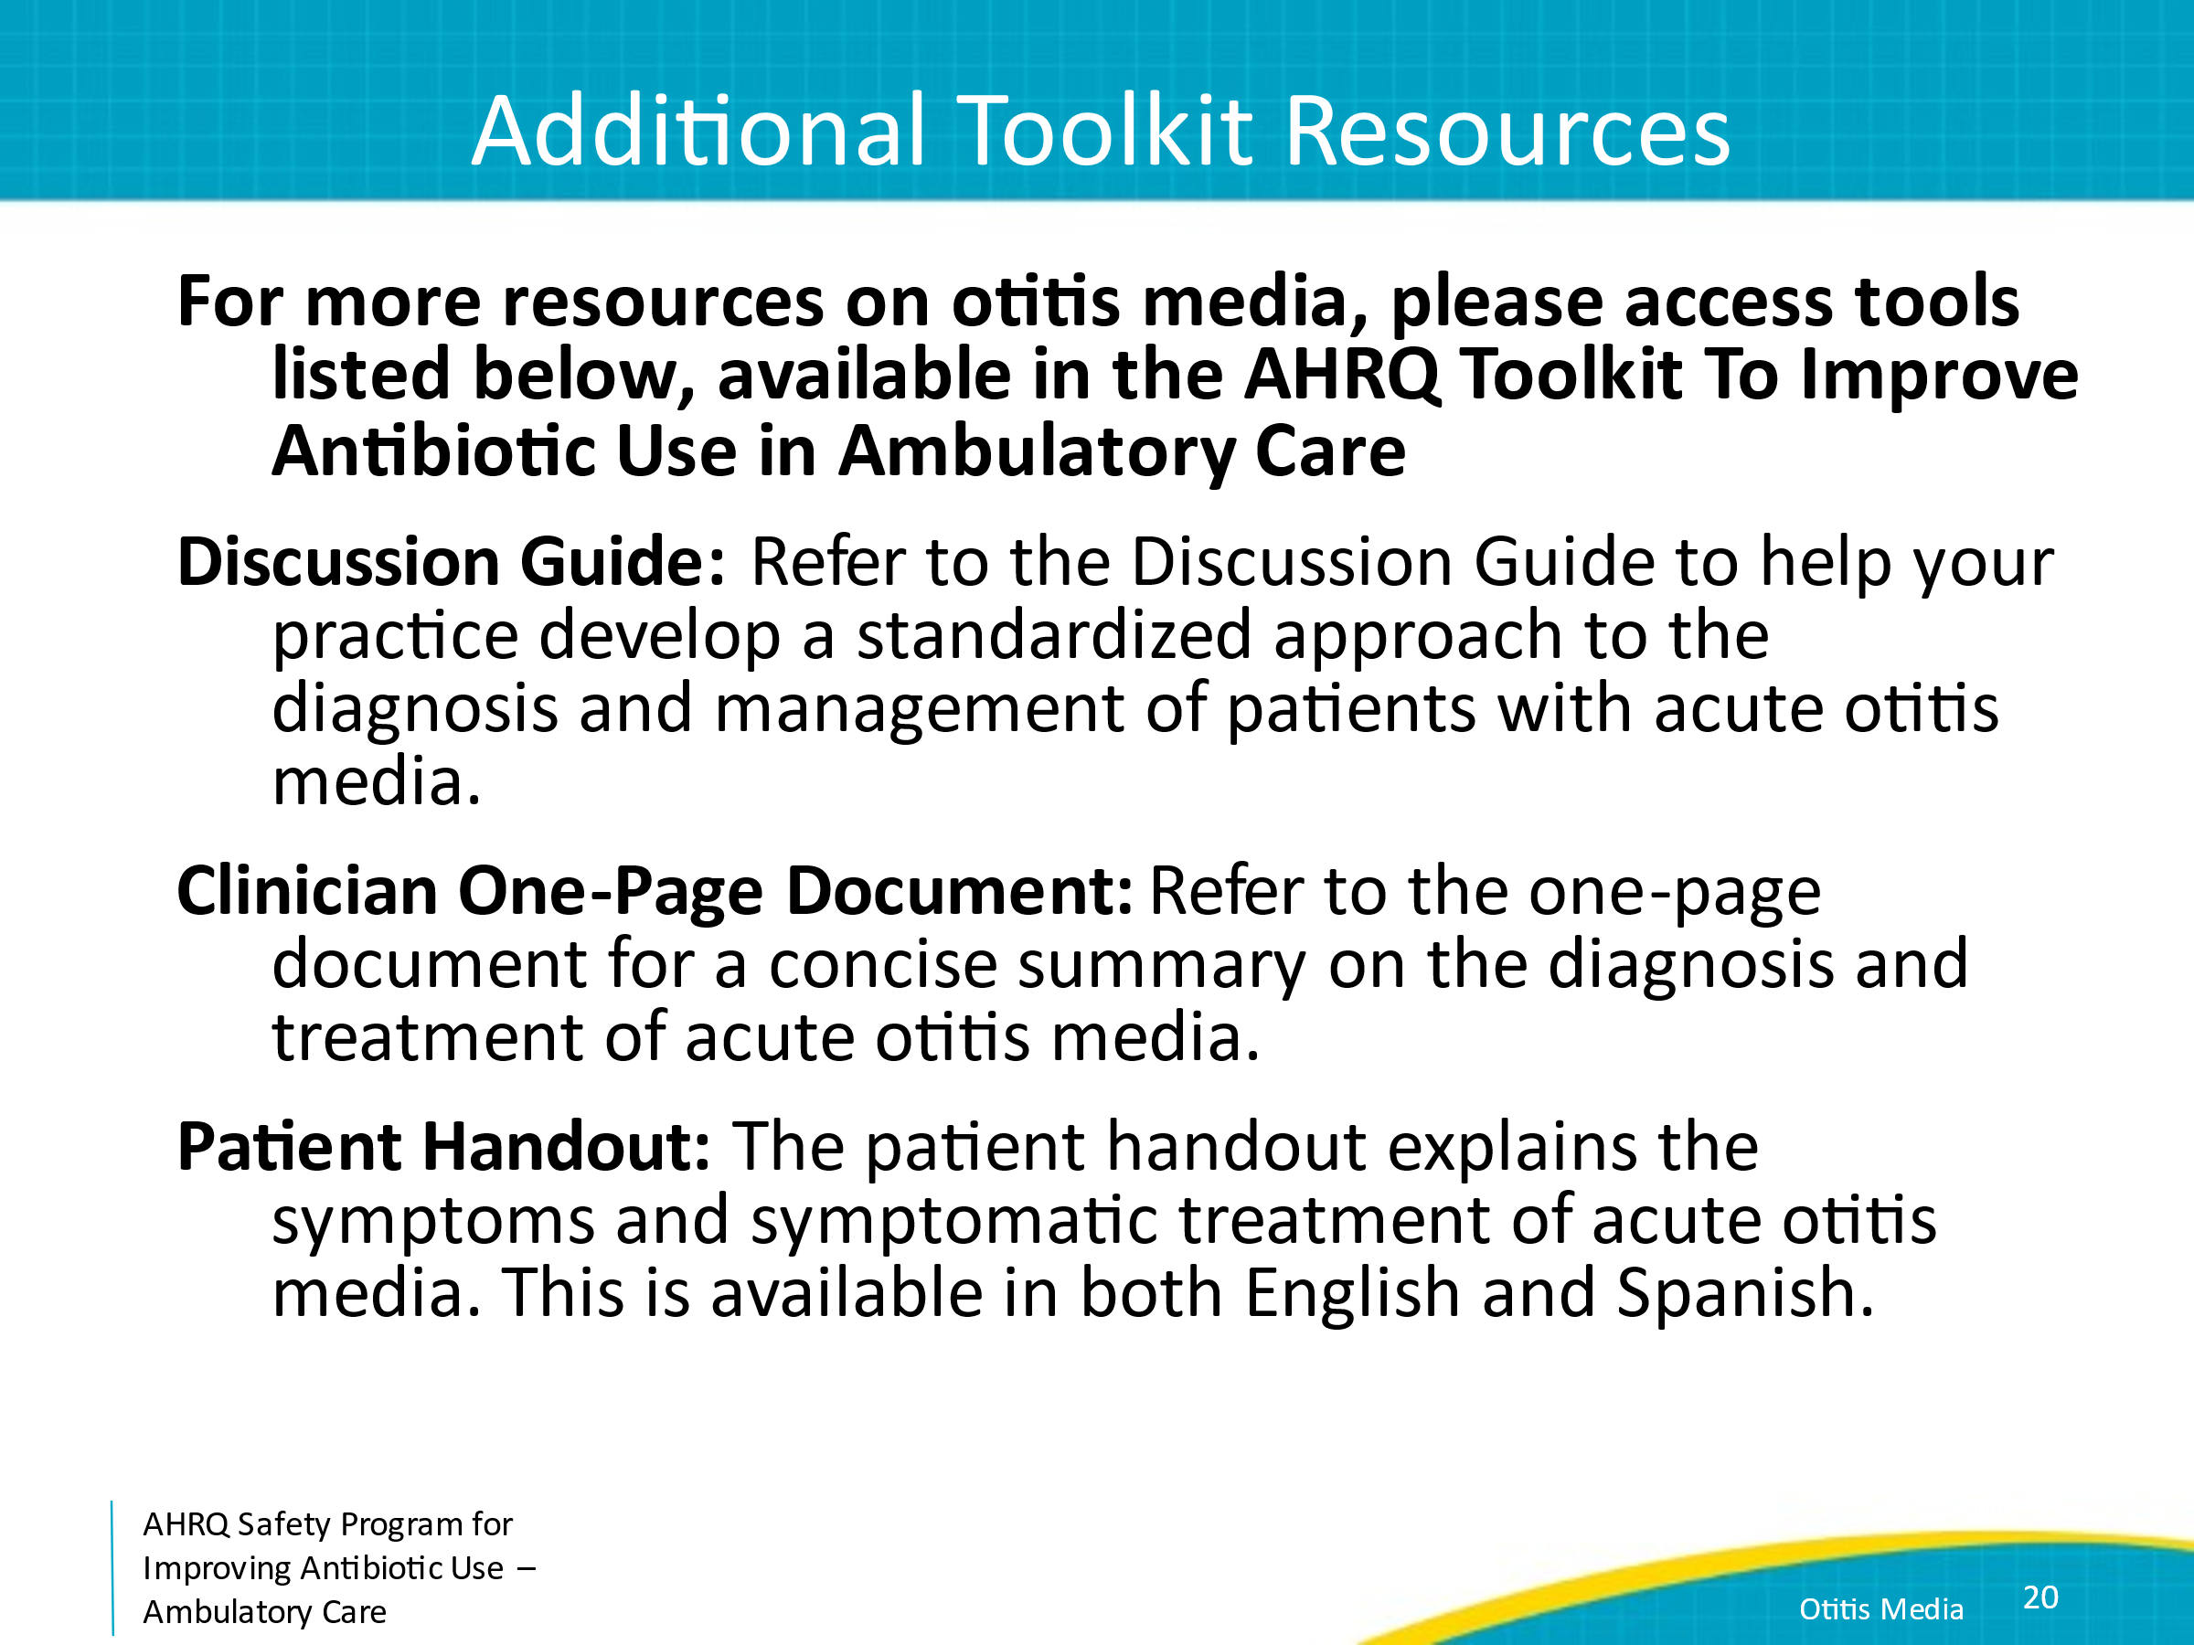
Disclaimer  The findings and recommendations in this presentation are those of the authors, who are responsible for its content, and do not necessarily represent the views of AHRQ. No statement in this presentation should be construed as an official position of AHRQ or of the U.S. Department of Health and Human Services.  Any practice described in this presentation must be applied by healthcare practitioners in accordance with professional judgment and standards of care in regard to the unique circumstances that may apply in each situation they encounter. These practices are offered as helpful options for consideration by healthcare practitioners, not as guidelines. | Slide 21  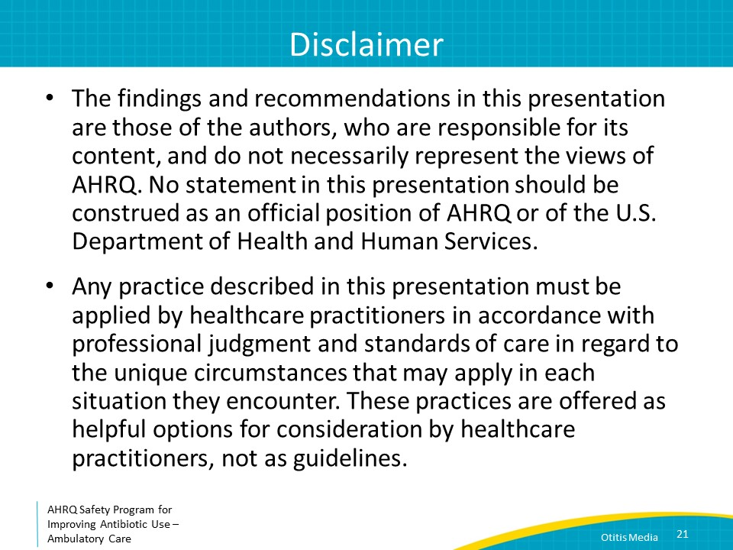
References  SAY:  Here are the references from this presentation. | Slide 22  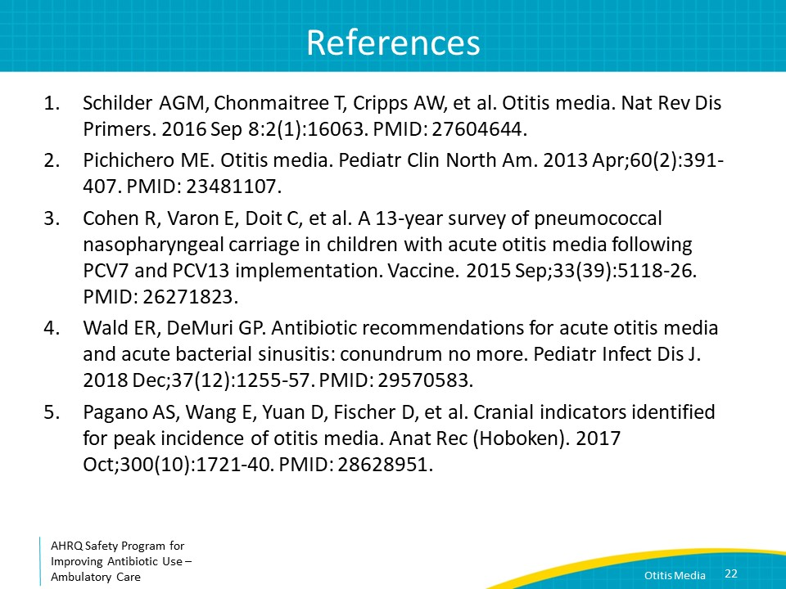
References | Slide 23  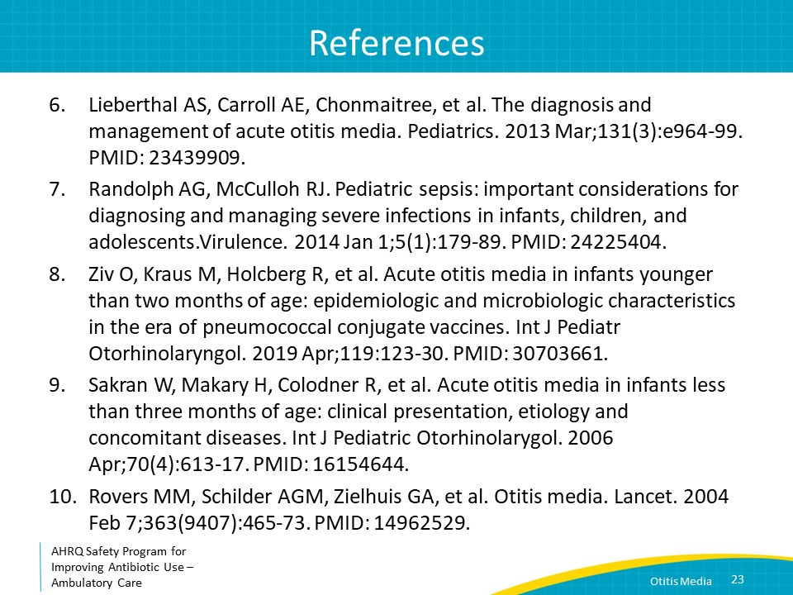
References | Slide 24  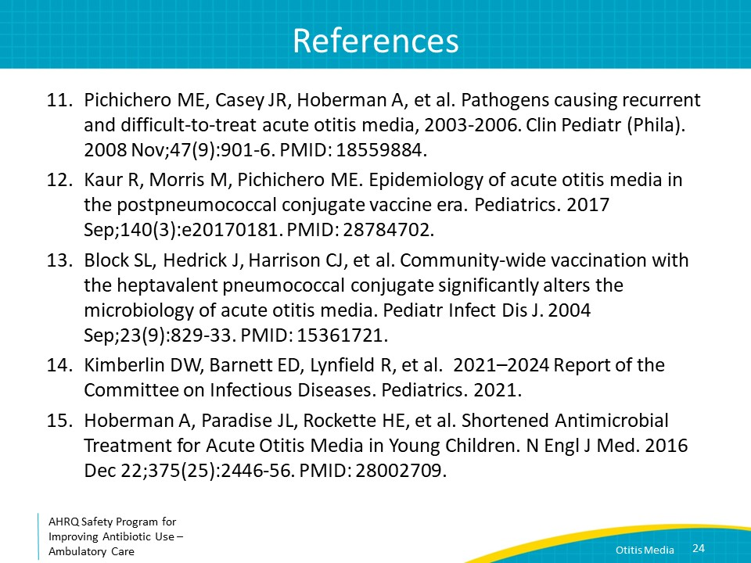
References | Slide 25  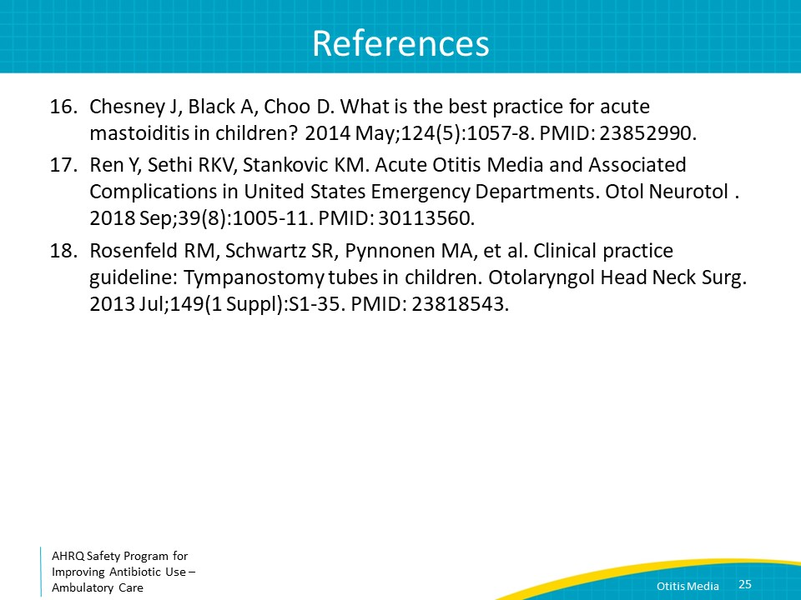
AHRQ Pub. No. 17(22)-0030
September 2022

