The “Never Antibiotics” Diagnoses:
Acute Bronchitis
Ambulatory Care
Slide Title and Commentary | Slide Number and Slide
The “Never Antibiotics” Diagnoses: Acute Bronchitis  Ambulatory Care  SAY:  Welcome to the presentation titled, “‘The Never Antibiotics’ Diagnoses: Acute Bronchitis.’” | Slide 1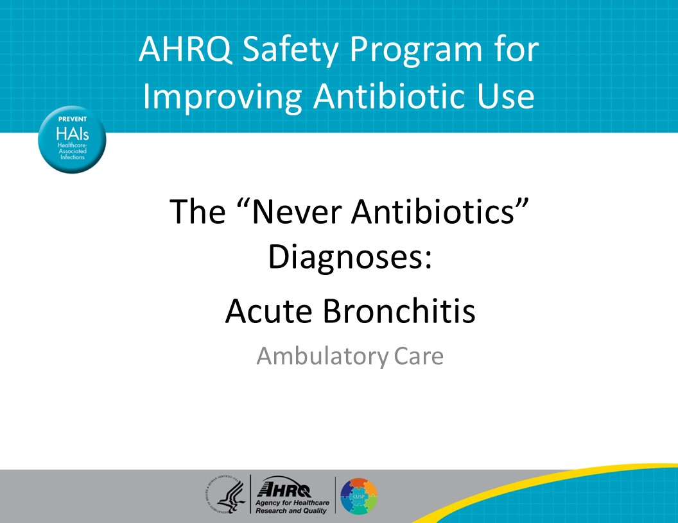
Objectives  SAY:  By the end of this presentation participants will be able to:  - Diagnose acute bronchitis  - Manage patients with acute bronchitis without antibiotics, and  - Effectively communicate the time course of acute bronchitis to patients | Slide 2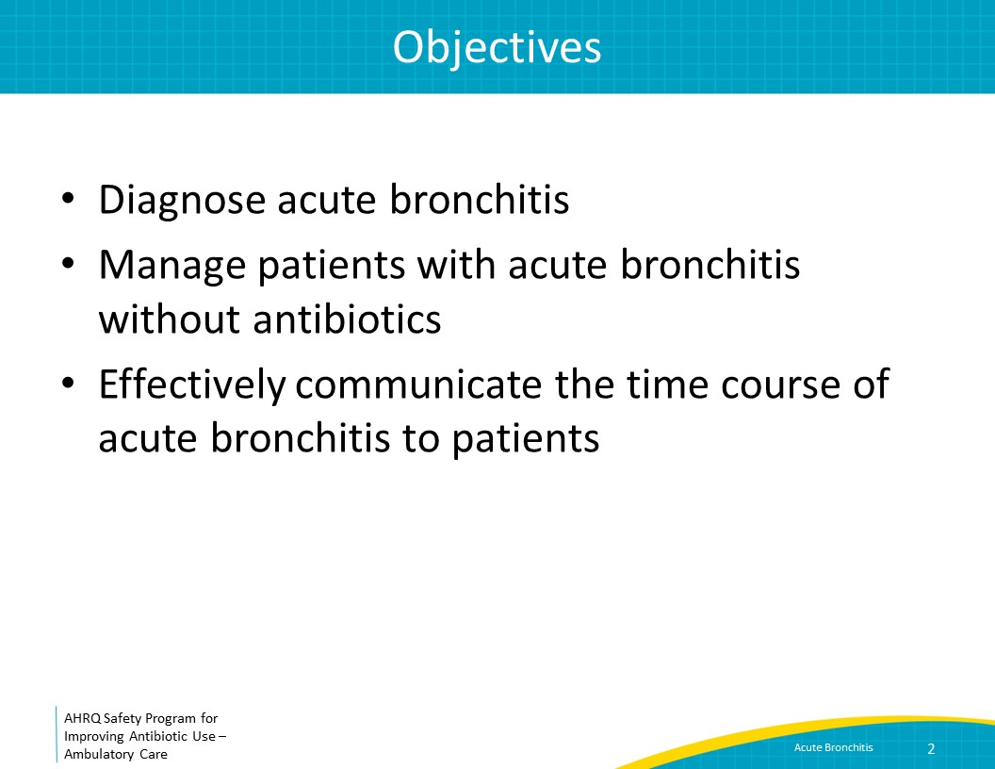
The Four Moments of Antibiotic Decision Making  SAY:  We will review bronchitis using the Four Moments of Antibiotic Decision Making.  1. Does my patient have an infection that requires antibiotics?  2. Do I need to order a diagnostic test?  3. If antibiotics are indicated, what is the narrowest, safest, and shortest regimen I can prescribe?  4. Does my patient understand what to expect and the followup plan? | Slide 3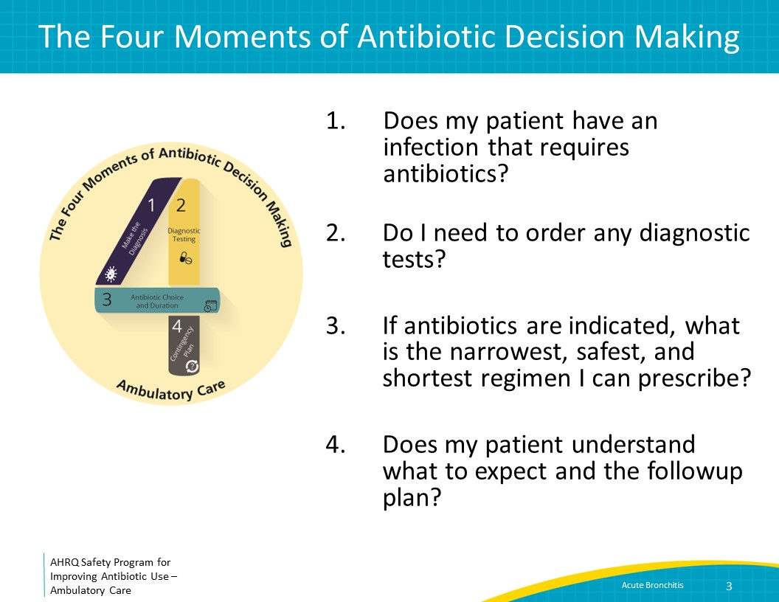
Case Presentation  SAY:  We will start with a case. A healthy 54-year-old man who is a nonsmoker and has no past medical history presents to clinic. He has a cough that started when he had a cold 2 weeks ago. He reports occasional production of white- or yellow-tinged sputum. The cough is worse at night. He has had no fevers or shortness of breath. He wakes up several times a night with the cough and as a result is more tired than usual. He is worried that he has pneumonia because the cough has been going on for so long and asks if he should have a chest x ray.  He is afebrile and the remainder of his vital signs are normal. His lungs are clear to auscultation. | Slide 4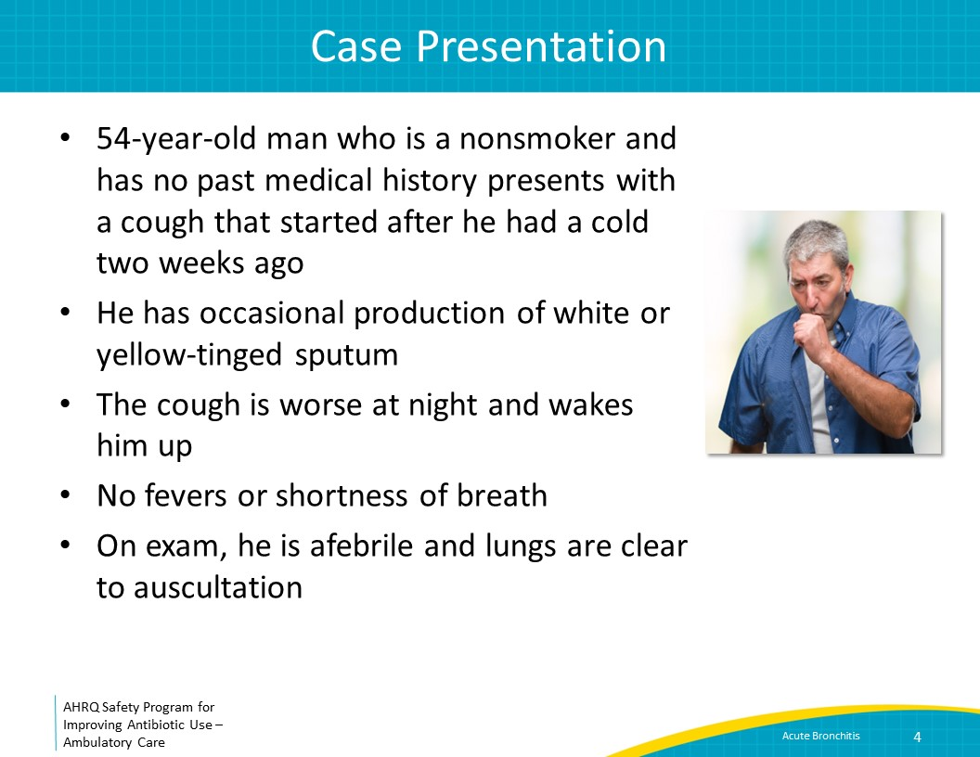
The Four Moments of Antibiotic Decision Making  SAY:  We will discuss the case using the Four Moments of Antibiotic Decision Making. Moment One is: Does my patient have an infection that requires antibiotics? | Slide 5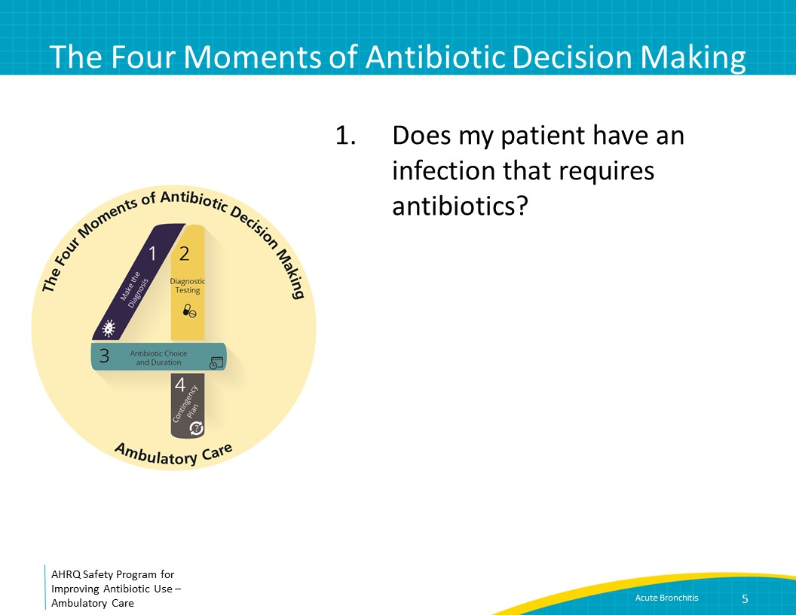
Moment 1: Acute Bronchitis  SAY:  Based on his symptoms, this patient has acute bronchitis. The definition of acute bronchitis is the presence of a cough with or without sputum production that lasts less than 3 weeks, generally starting in the setting of a viral upper respiratory tract infection. Antibiotic treatment of acute bronchitis is not recommended, regardless of the duration of the cough, because antibiotics do not help with resolution of cough.  Of note, the term “bronchitis” is not applied to children. However, children commonly have lingering viral upper respiratory infections with a cough that can also last up to 3 weeks. This cough also will not respond to antibiotics. | Slide 6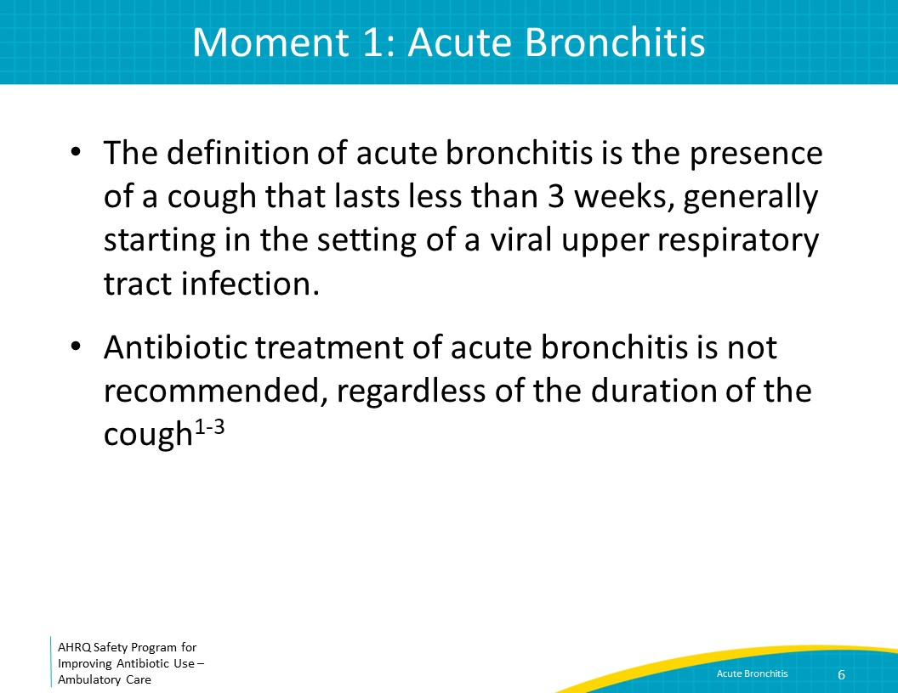
Antibiotics Do Not Improve Post-Viral Cough  SAY:  Antibiotics do not hasten the resolution of acute bronchitis that occurs after a viral infection. This graph shows the proportion of patients with resolution of cough on the y-axis and the number of days from the initial physician visit on the x-axis. There were three different groups of patients with cough studied. Patients represented by the orange line did not receive an antibiotic prescription, patients represented by the yellow line were given an antibiotic prescription and instructed to fill if they were not feeling better in 3-4 days, and patients represented by the green line were given an antibiotic prescription to fill immediately. Among the three groups, there was no difference in the timing of or proportion of patients who experienced resolution of cough.  In this study, 96 percent of patients who were given an antibiotic prescription right away took antibiotics, but only 20 percent of patients who were instructed to fill the prescription if they were not feeling better took antibiotics. Additionally, 16 percent of patients who were not given an antibiotic prescription obtained and took antibiotics.  While antibiotics do not help with cough, they can put patients at risk for adverse events that may necessitate an emergency room or clinic visit. | Slide 7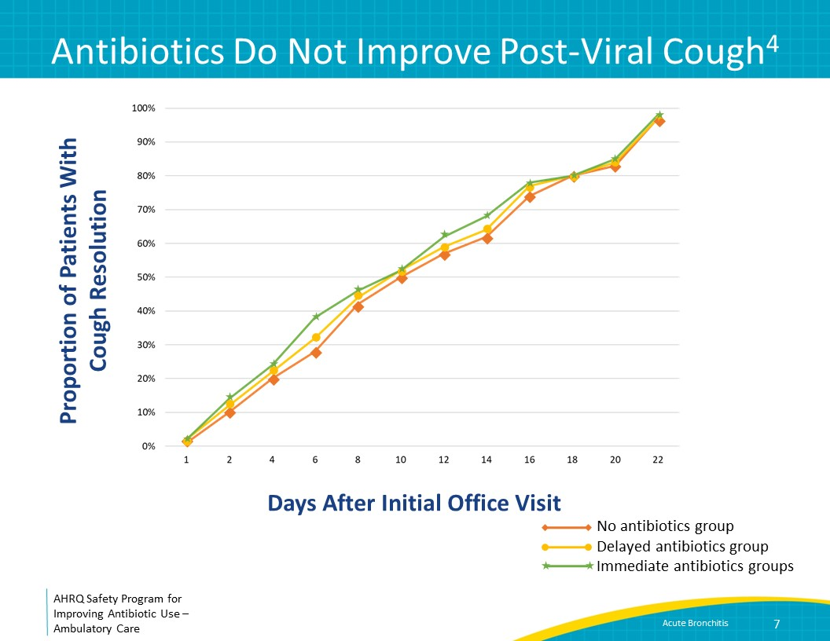
The Four Moments of Antibiotic Decision Making  SAY:  Moment 2 is: Do I need to order a diagnostic test? | Slide 8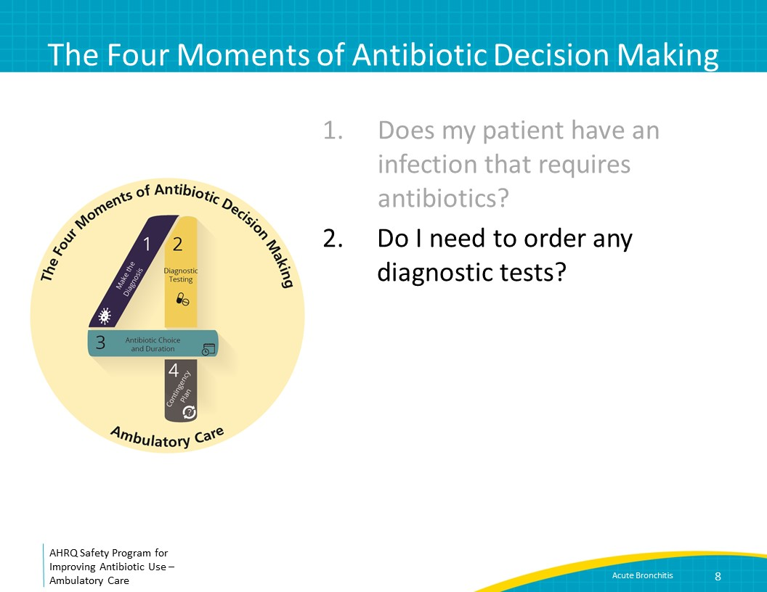
Moment 2: Diagnostic Testing in Acute Bronchitis  In general, no diagnostic testing is needed for patients with acute bronchitis, including chest x ray, spirometry,  peak flow measurement, respiratory samples for culture or respiratory virus testing, or biomarkers. The patient described in the case queried whether he needed a chest x ray. He does not have signs and symptoms of pneumonia including fever, the remainder of his vital signs are normal, and his chest exam is normal. Therefore, a chest x ray is unnecessary. If the patient reported fevers or shortness of breath, had abnormal vital signs, or had focal findings on his chest exam, a chest x ray may be warranted. | Slide 9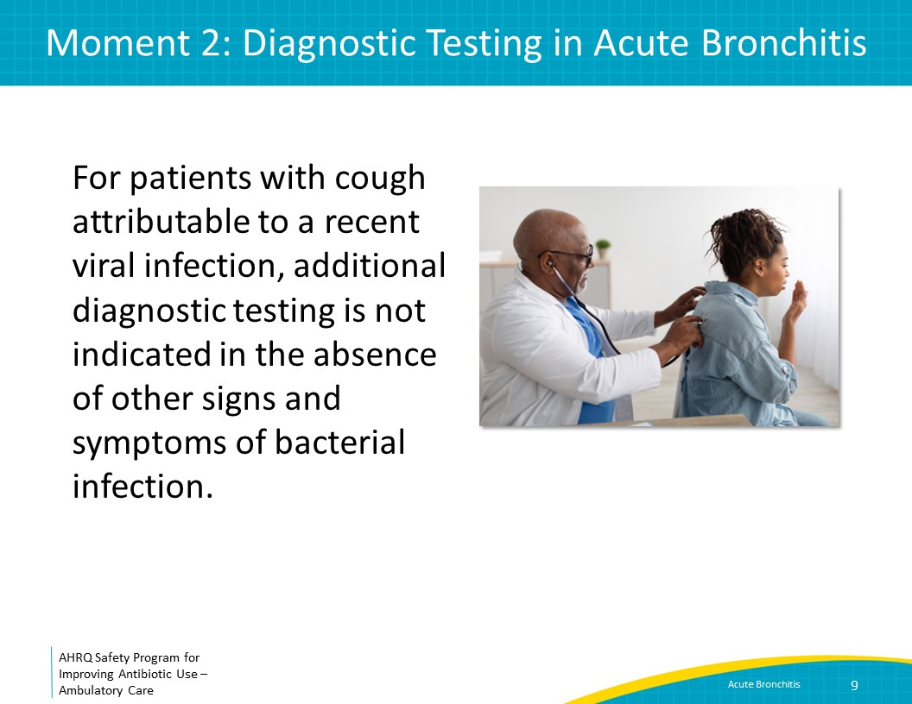
The Four Moments of Antibiotic Decision Making  SAY:  Moment 3 is: If antibiotics are indicated, what is the narrowest, safest, and shortest regimen I can prescribe? | Slide 10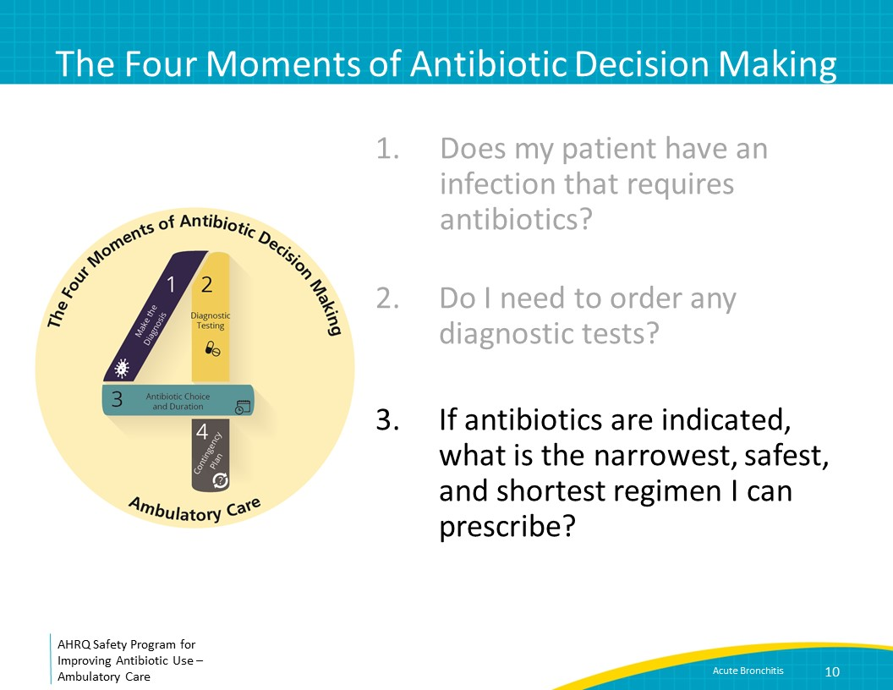
Moment 3: Avoiding Antibiotics for Acute Bronchitis  SAY:  As discussed previously, antibiotics are not indicated for acute bronchitis. Unfortunately, many healthcare practitioners continue to prescribe antibiotics for this condition. Here is a graph showing antibiotic prescriptions for acute bronchitis over time. As you can see from the study depicted on this slide, although guidelines going back to at least 2001 state that antibiotics are not indicated for acute bronchitis, over the following 10 years, about 75 percent of emergency department or primary care visits for acute bronchitis continued to result in a prescription for an antibiotic.  Discussions about antibiotics should focus on how antibiotics will not help, how they could hurt, and options for symptomatic treatment to help patients feel better. More details about how to respond specifically to concerns of patients who ask for antibiotics can be found in “The ‘Never Antibiotics’ Diagnoses: Acute Viral Upper Respiratory Infection: the Common Cold.” (slides and facilitator guide) | Slide 11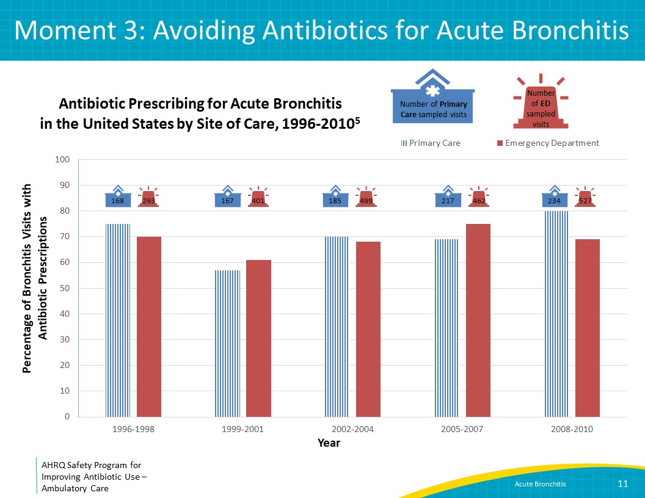
Moment 3: Symptomatic Treatment of Acute Bronchitis  SAY:  After informing the patient of the good news that antibiotics are not needed, it is helpful to provide recommendations for medications that might bring symptomatic relief for an acute cough if it is causing disruption in daily activities or sleep.  Some patients may experience relief with a cough suppressant such dextromethorphan, although limited data support the efficacy of cough suppressants. A nighttime dose of honey has been found to be as effective as dextromethorphan in reducing cough.  The expectorant guaifenesin and combination antihistamine-decongestant products have been shown to have marginal effects in studies. However, if patients report previous positive experiences with them, they can be considered. Dextromethorphan, guaifenesin, and combination products should be avoided in children under 6 years of age and are not suggested in children under 12 years of age due to serious side effects such as hypertension, cardiac arrythmias, and even death in young children. Also, honey should not be given to children under 1 year of age given its association with botulism.  Other medications that can be considered for severe cough—benzonatate and codeine—require a prescription. Benzonatate suppresses the cough reflex by numbing stretch receptors in the lower respiratory tract. It should not be given to children under 10 years old due to fatalities reported with overdoses. Codeine is an effective cough suppressant but can cause reduced alertness and can be abused. It should not be prescribed to patients under 18 years of age due to reports of respiratory depression and death.  Beta-agonist inhalers such as albuterol can improve symptoms from acute cough if there is wheezing on exam. | Slide 12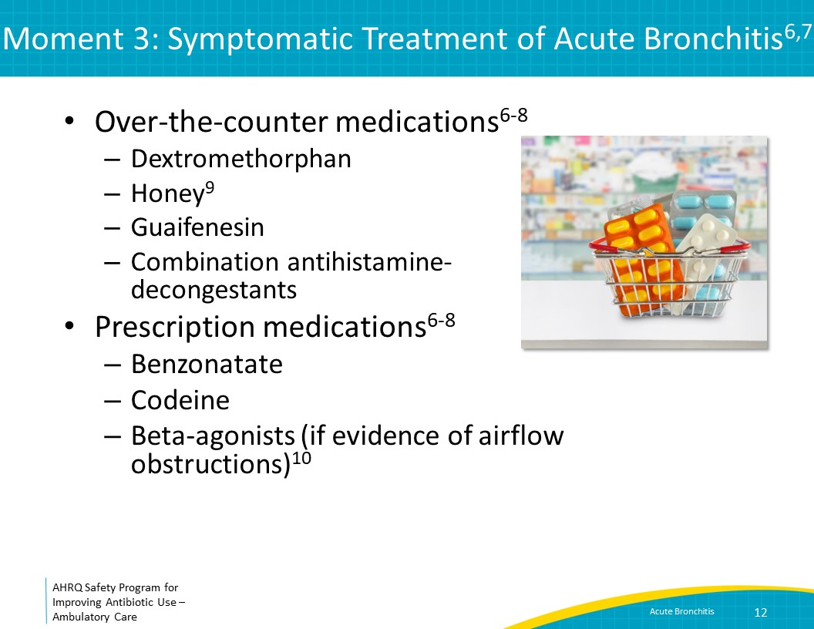
The Four Moments of Antibiotic Decision Making  SAY:  Moment 4 is: Does my patient understand what to expect and the followup plan? | Slide 13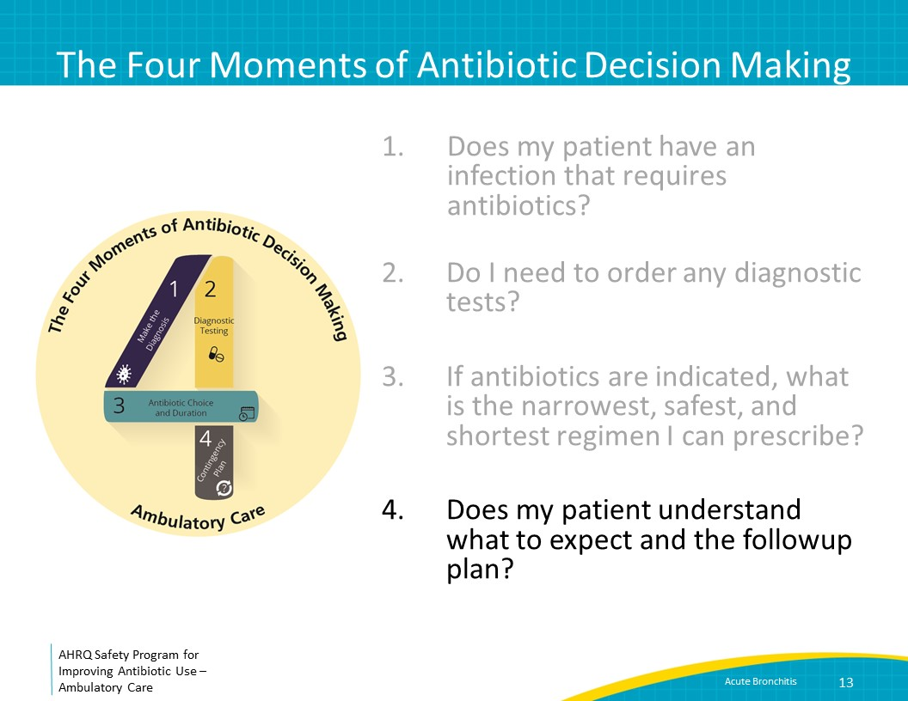
Time Course of Acute Bronchitis  SAY:  Patients with acute bronchitis should be told that their cough may last for at least 3 weeks and that antibiotics will not hasten resolution of the cough.  Patients should be instructed to return to or call the clinic if they develop fever, shortness of breath or chest pain, if the cough increases in extent or frequency, or if a significant cough persists beyond three weeks. | Slide 14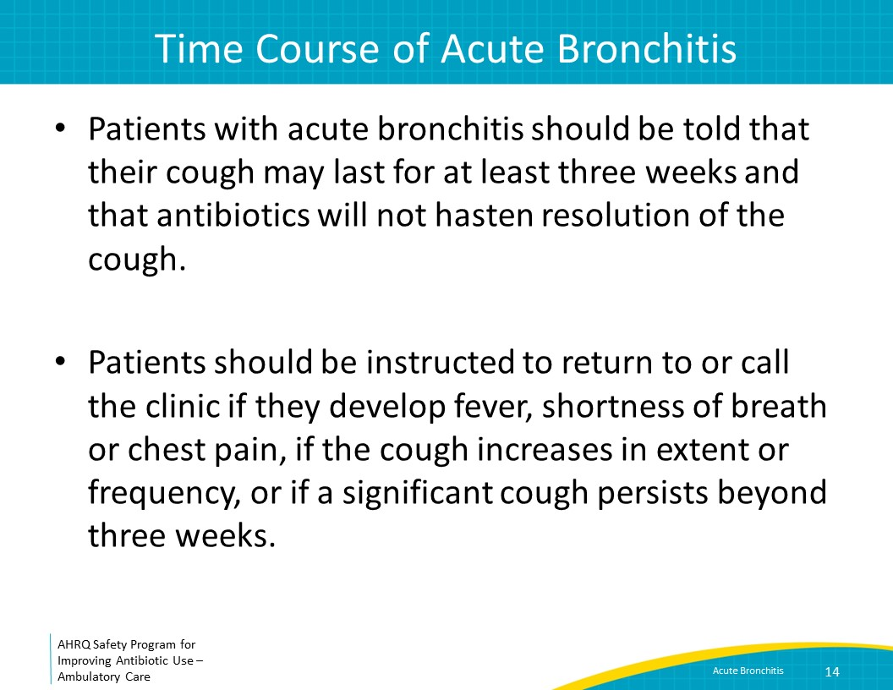
Take-Home Messages  SAY:  Antibiotics are not indicated for adults with acute bronchitis or for children with lingering cough following a viral URI. Antibiotics do not impact the magnitude or duration of cough in either of these syndromes.  Options for symptomatic treatment can be provided to patients who are experiencing cough that interferes with daily activities or sleep, although data for their efficacy are limited. | Slide 15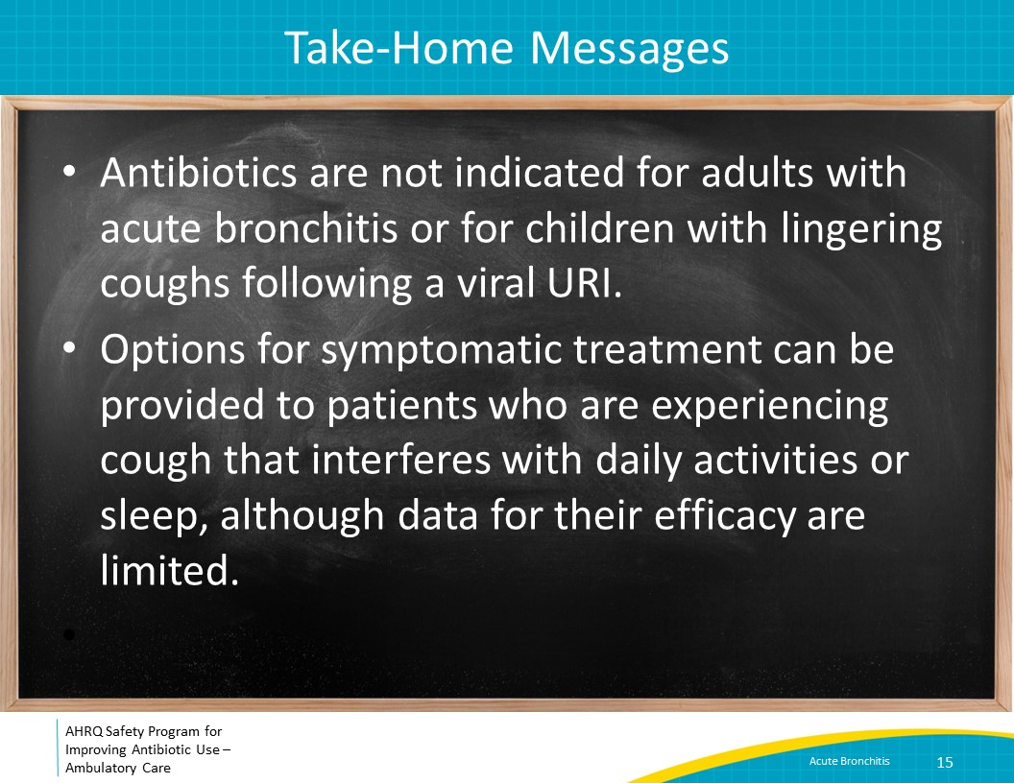
Additional Toolkit Resources  SAY:  For more resources on bronchitis, please access tools listed below, available on the AHRQ Toolkit To Improve Antibiotic Use in Ambulatory Care.  Refer to the Discussion Guide to help your practice develop a standardized approach to the diagnosis and management of patients with bronchitis.  Refer to the One-Page document for a concise summary of the diagnosis and treatment of bronchitis.  The Patient Handout explains the symptoms and symptomatic treatment of bronchitis and emphasizes that antibiotics are not always needed. It is available in both English and Spanish. | Slide 16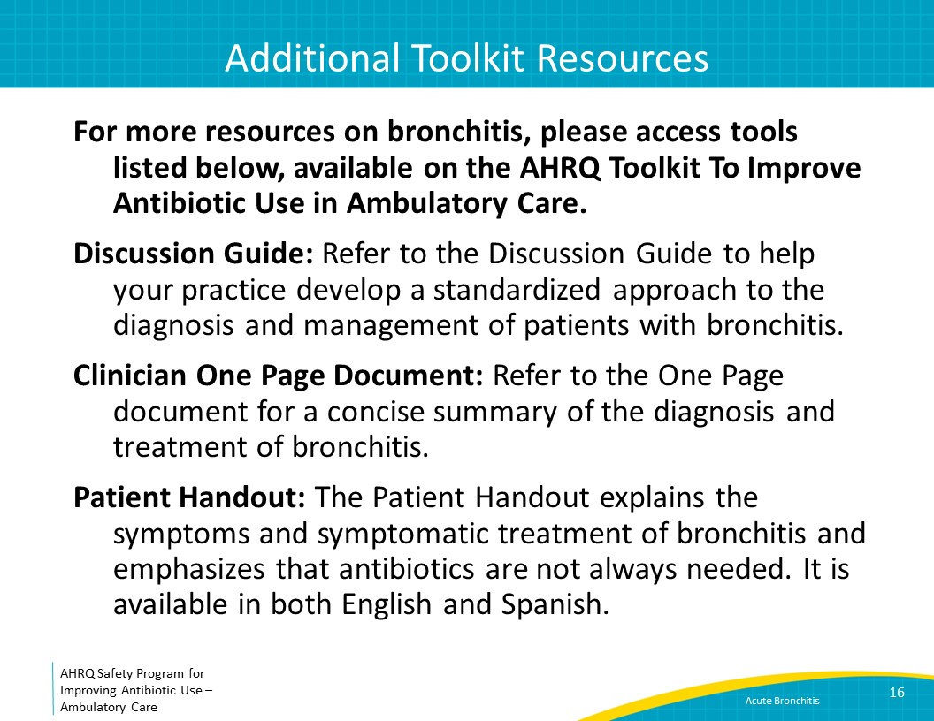
Disclaimer  SAY:  The findings and recommendations in this presentation are those of the authors, who are responsible for its content, and do not necessarily represent the views of AHRQ. No statement in this presentation should be construed as an official position of AHRQ or of the U.S. Department of Health and Human Services.  Any practice described in this presentation must be applied by healthcare practitioners in accordance with professional judgment and standards of care in regard to the unique circumstances that may apply in each situation they encounter. These practices are offered as helpful options for consideration by healthcare practitioners, not as guidelines. | Slide 17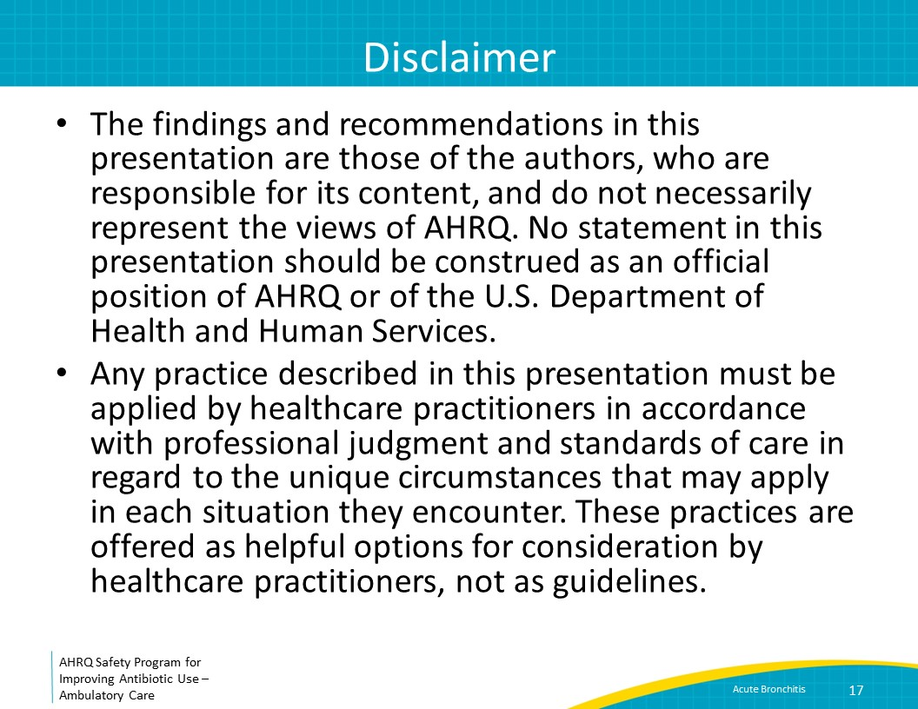
References  SAY:  Here are the references. | Slide 18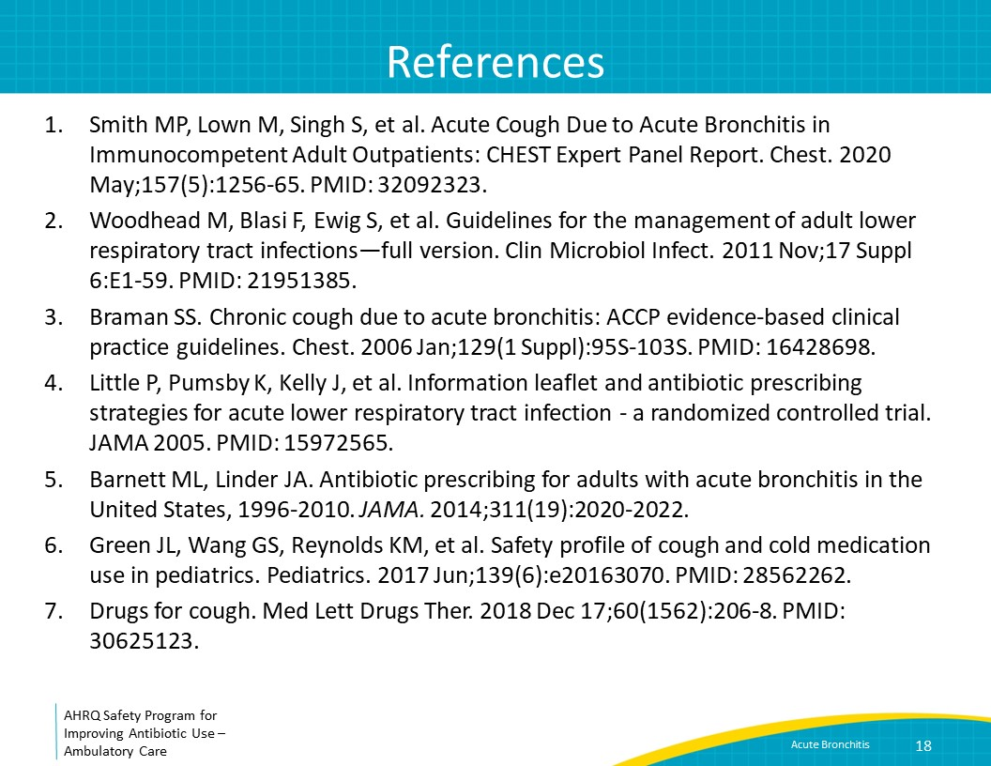
References | Slide 19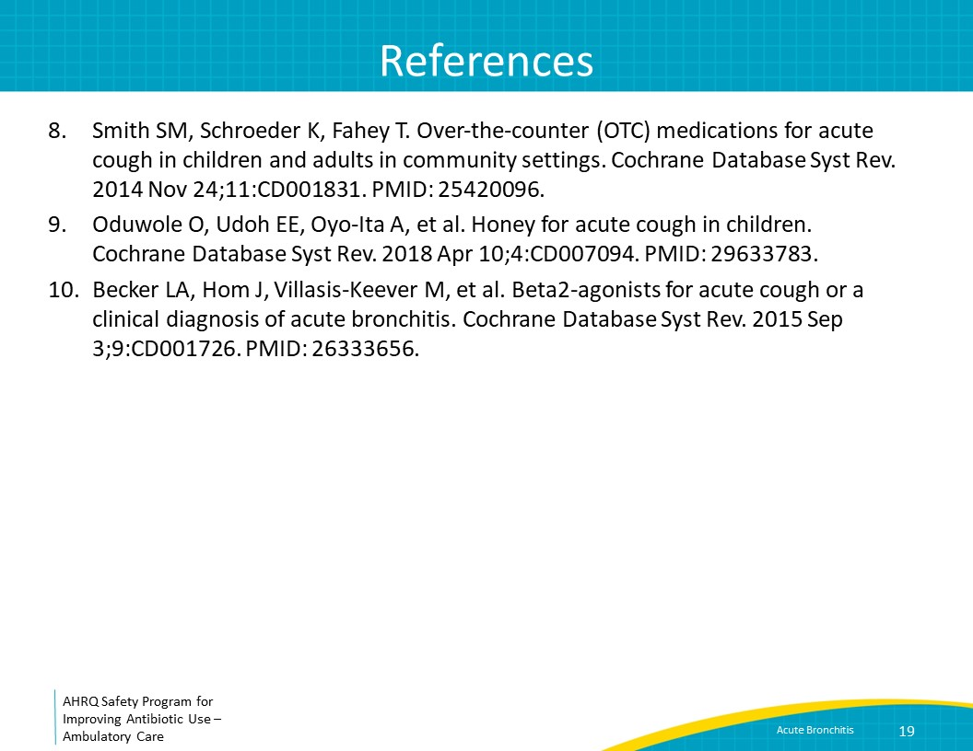

AHRQ Pub. No. 17(22)-0030
September 2022

