The “Usually Antibiotics” Diagnoses: Community-Acquired Pneumonia
Ambulatory Care

Slide Title and Commentary | Slide Number and Slide
The “Usually Antibiotics” Diagnoses: Community-Acquired Pneumonia  SAY:  Welcome to the presentation titled, “ ‘The Usually Antibiotics’ Diagnoses: Community-Acquired Pneumonia.” | Slide 1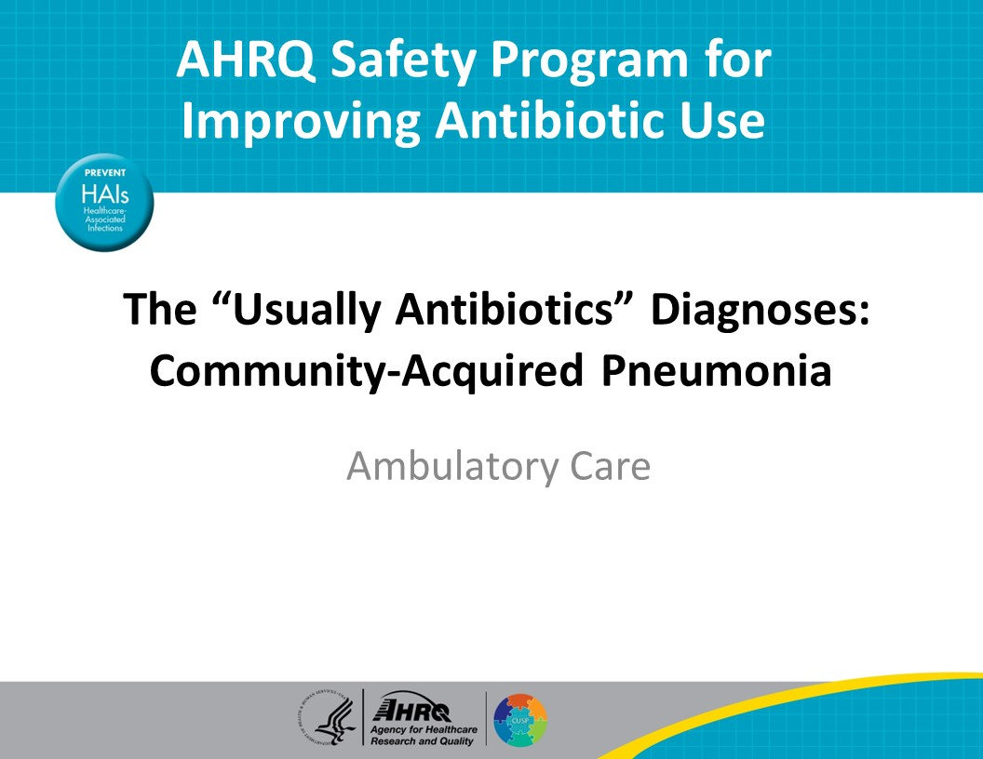
Objectives  SAY:  By the end of this presentation, participants will be able to—  - Describe the approach to diagnosing patients with community-acquired pneumonia, also known as “CAP”  - Describe how to determine if patients with CAP warrant hospitalization  - Describe treatment options for CAP in the outpatient setting and  - Develop followup plans for patients diagnosed with CAP | Slide 2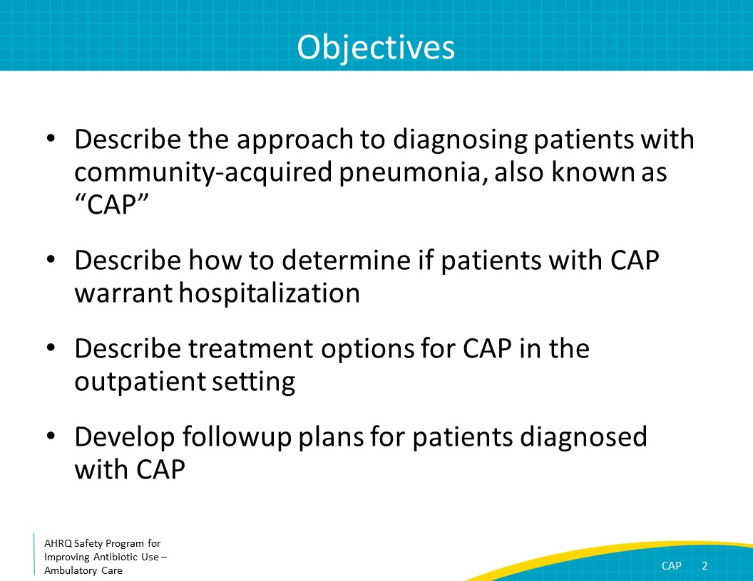
The Four Moments of Antibiotic Decision Making  SAY:  CAP will be reviewed using the Four Moments of Antibiotic Decision Making. | Slide 3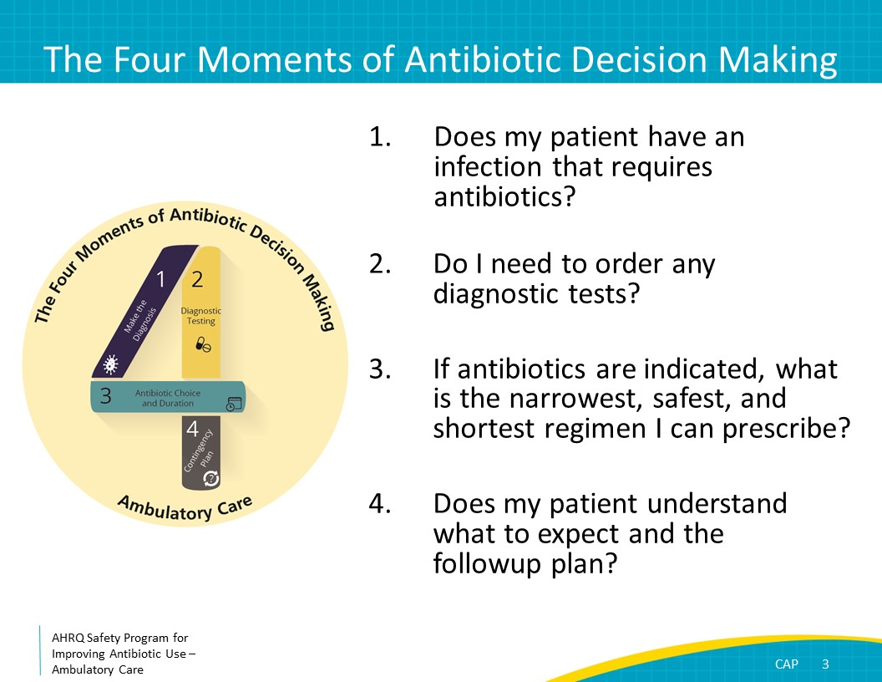
The Four Moments of Antibiotic Decision Making  SAY:  Moment One is: Does my patient have an infection that requires antibiotics? | Slide 4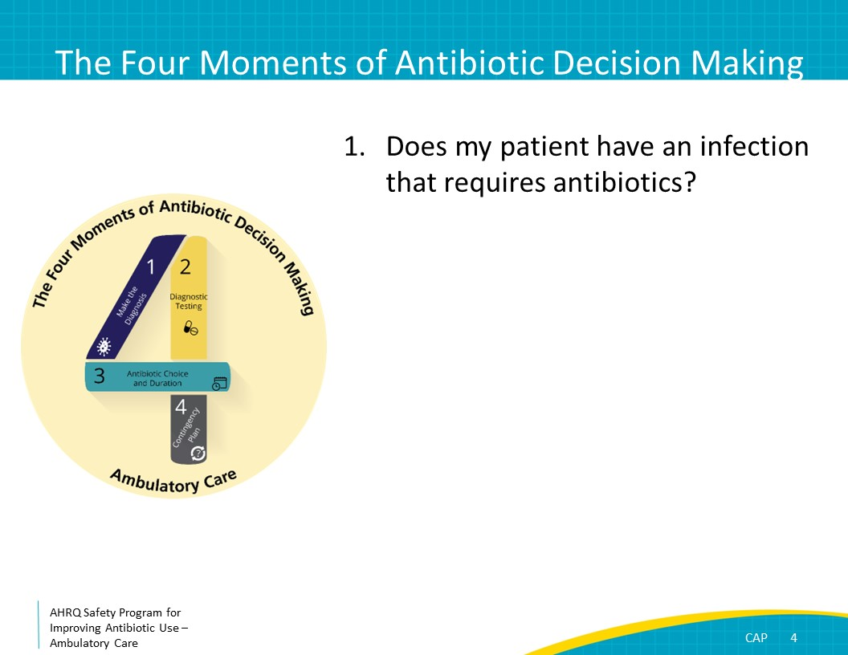
Moment 1: Diagnosis of CAP  SAY:  The symptoms of CAP are similar in adults and children. CAP caused by typical bacterial pathogens such as Streptococcus pneumoniae or Haemophilus influenzae almost always presents with cough, shortness of breath, and fevers, although fevers may be less common in the elderly. Other associated symptoms include fatigue or chest pain. Tachycardia, tachypnea, or decreased oxygen saturation may be present. Rhonchi, dyspnea, or crackles may be identified on the lung exam.  “Atypical” bacteria include Mycoplasma pneumoniae and Legionella pneumophila. Both organisms have intrinsic resistance to beta-lactam antibiotics, but their clinical manifestations differ. Mycoplasma pneumoniae can cause what is sometimes referred to as a “walking pneumonia” and affects children and young adults. In contrast to pneumonia caused by bacteria such as Streptococcus pneumoniae, Mycoplasma pneumoniae generally presents with more subacute symptoms such as low-grade fevers, malaise, headache, sore throat, and cough that linger for more than a week. Mycoplasma pneumonia can be distinguished from viral causes of pneumonia by the absence of congestion or rhinorrhea.  In contrast, Legionella pneumonia is seen more commonly in older adults, particularly in those who smoke, have underlying comorbidities, or have immunocompromise. Patients with Legionella pneumonia generally present with acute signs and symptoms such as those described previously for typical bacterial pathogens. | Slide 5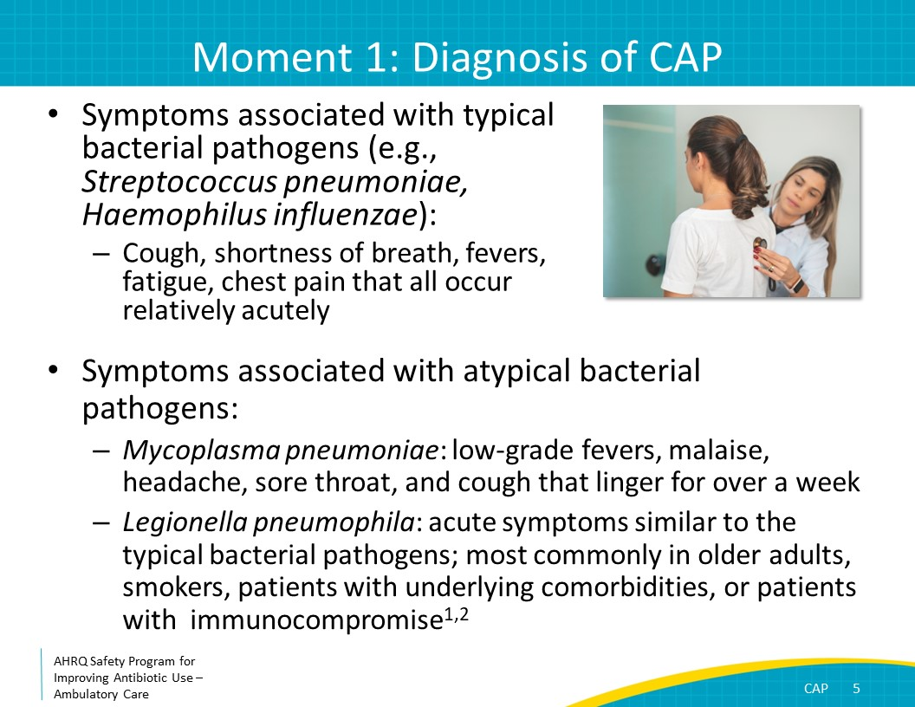
Etiology of CAP  SAY:  A study investigating the organisms causing CAP in a cohort of more than 2,000 U.S. adults hospitalized between 2010 and 2012 found that a pathogen was identified in 38 percent of cases.  Of the 38 percent of cases of suspected CAP where a pathogen was identified, a virus was detected in 63 percent of cases, a bacteria in 29 percent of cases, and both a virus and a bacteria in 8 percent of cases.  The most common bacteria identified was Streptococcus pneumoniae. It was recovered in approximately half of patients for whom a bacterial organism was identified. | Slide 6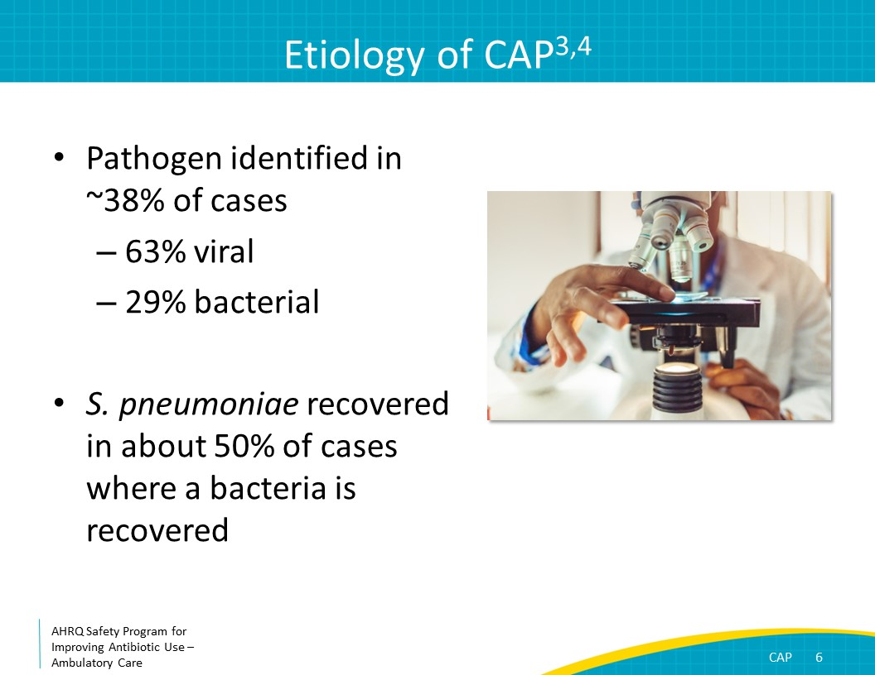
The Four Moments of Antibiotic Decision Making  SAY:  Moment Two is: Do I need to order any diagnostic tests? | Slide 7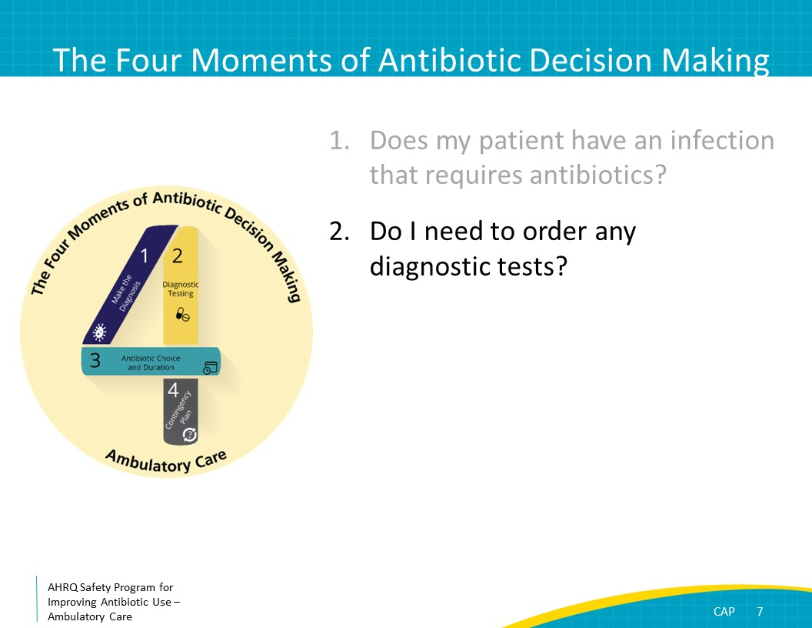
Moment 2: Chest X Ray  SAY:  In both adults and children in the ambulatory setting who have clear signs and symptoms of CAP including fever, cough with sputum production, and evidence of lobar consolidation on exam, it is reasonable to initiate treatment without a chest x ray. However, if there is uncertainty about the diagnosis, obtaining a chest x ray can help with determining whether antibiotic therapy is indicated.  Chest x rays, including posteroanterior and lateral views, also should be obtained for patients with hypoxia, significant dyspnea, and those patients diagnosed with CAP without any improvement 48 to 72 hours after initiating antibiotic therapy. Imaging will help verify the presence or absence of complications of pneumonia, including parapneumonic effusions, necrotizing pneumonia, and pneumothorax. If there is concern for mental status changes and/or hemodynamic instability, this evaluation should be performed in an emergency department setting.  If a chest x ray was obtained and no infiltrate is seen, bacterial pneumonia is unlikely, and an alternate diagnosis should be considered. For outpatients with no infiltrate on chest x ray, the most common diagnosis in adults is acute bronchitis due to a viral infection. In children who have no infiltrate on chest x ray, symptoms are most likely caused by a viral respiratory tract infection. | Slide 8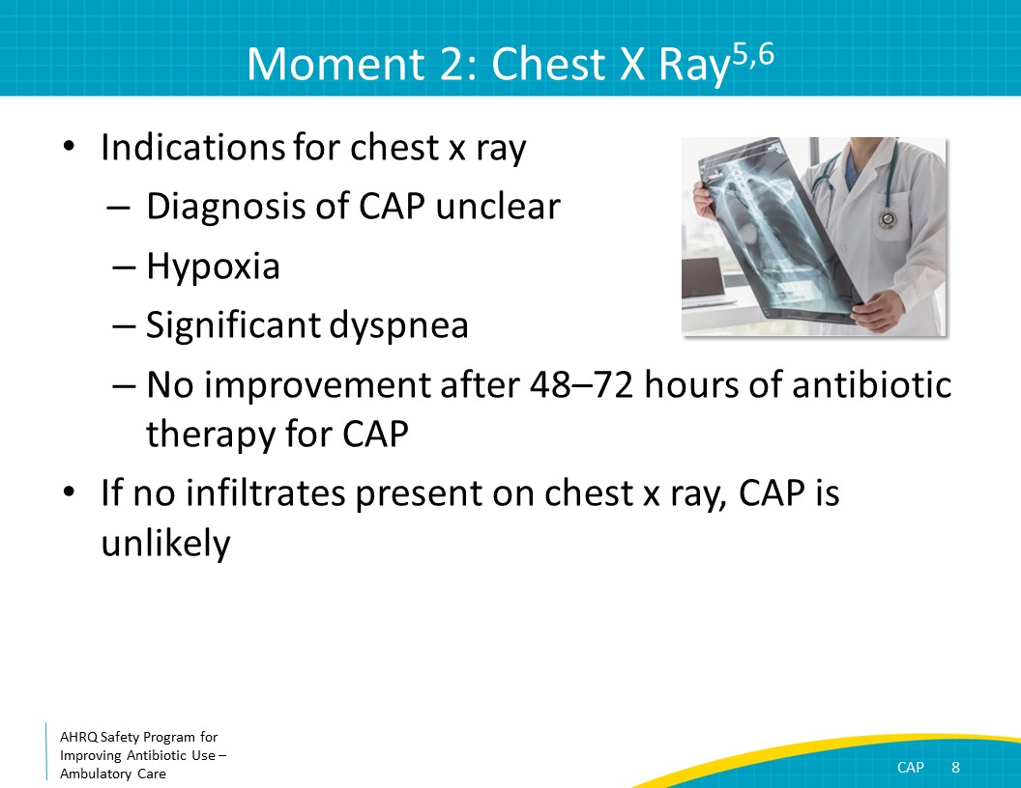
Moment 2: Viral Testing  SAY:  Tests to diagnose the organism causing CAP are generally not necessary in ambulatory settings for children or adults. Diagnostic testing for influenza or SARS-CoV-2 should be considered when these viruses are circulating. If these viruses are detected in children, antibiotics are generally not necessary, as viral pneumonia is more likely than a pneumonia caused by a viral and bacterial co-infection.  Although acknowledging the low quality of evidence supporting this recommendation, the Infectious Diseases Society of America recommends antibacterial treatment be prescribed for adults who test positive for influenza and have evidence of CAP based on exam findings—such as crackles in a lung field—or radiographic evidence—such as a focal consolidation—because of the possibility of a bacterial co-infection. For relatively stable adults meeting these criteria, consider a short course of no more than 3–5 days of antibiotics. We will discuss short-course therapy for CAP further in the presentation.  Both children and adults with a recent case of influenza or recent flulike symptoms (with fevers) who were initially improving but have new fevers, worsening shortness of breath, or a progressively ill appearance, a bacterial superinfection may have developed. A chest x ray should be obtained to assess for infiltrate and antibiotics should be considered. | Slide 9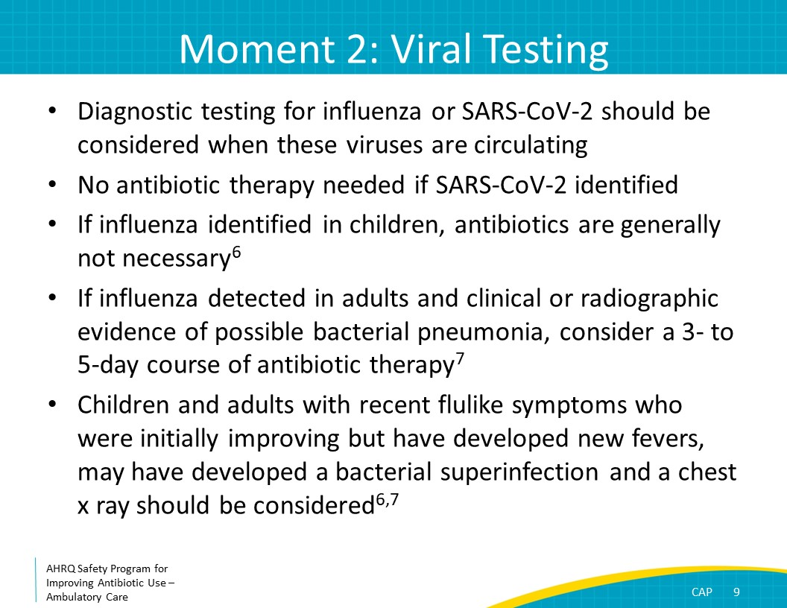
Triaging Decisions: CURB-65  SAY:  There are additional data that can guide triage decisions for patients suspected of having CAP. Two commonly used scoring systems in adults with CAP are the CURB-65 score and the Pneumonia Severity Index, or PSI.  The CURB-65 score includes one point for each criterion: C, confusion; U, uremia (or an elevated blood urea nitrogen level); R, elevated respiratory rate; B, low blood pressure, or hypotension; and 65, age of at least 65 years.  Patients with a score of 0 can be treated as outpatients.  Patients with a score of 2 need either intensive outpatient monitoring or a short inpatient stay.  Patients with a score of 3 should be admitted.  Patients with a score of 4 or 5 should be admitted and may need an intensive care unit stay.  If a patient has a normal mental status, is well hydrated, and is otherwise healthy, it is fair to assume the patient is not uremic. However, if a patient has an altered mental status, appears dehydrated, or meets some of the other CURB-65 criteria, ordering a blood urea nitrogen level may be helpful in triaging the patient.  Patients who are confused, tachypneic, or hypotensive should be triaged to the emergency department or admitted to the hospital. | Slide 10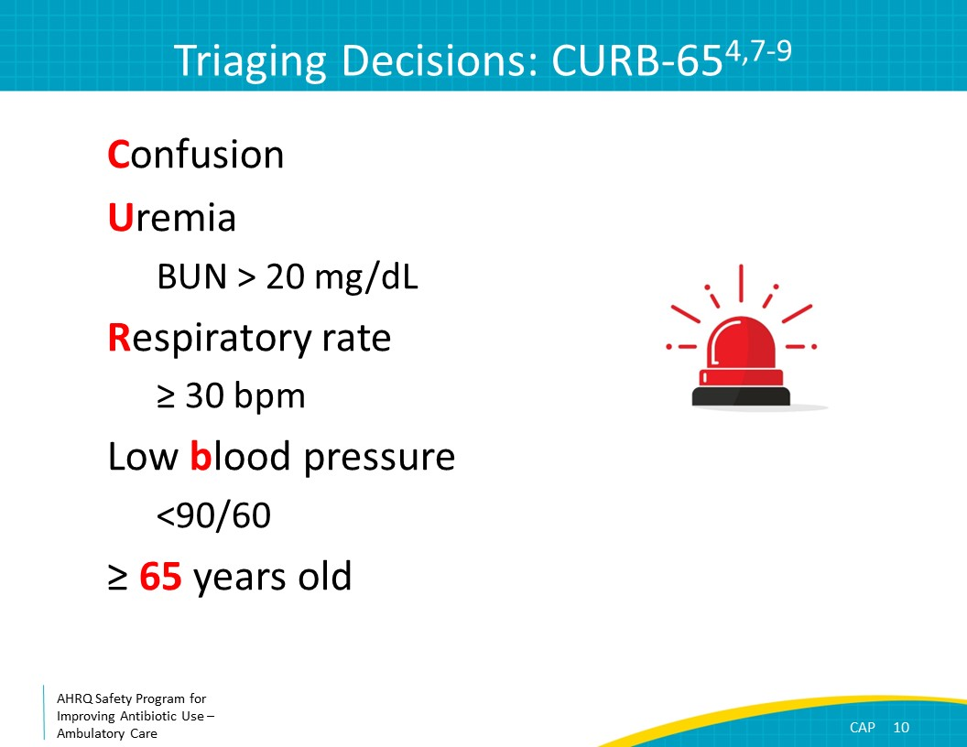
Triaging Decisions: Pneumonia Severity Index (PSI)  The 2019 Infectious Diseases Society of America community-acquired pneumonia guidelines recommend using the PSI score to help with triage decisions as it performs slightly better at predicting mortality than the CURB-65 score. However, the PSI score may be more complicated to use in the ambulatory setting than a CURB-65 score.  To summarize the PSI score, patients younger than 50; without a history of neoplastic disease, congestive heart failure, cerebrovascular disease, renal disease, or liver disease; at their baseline mental status; and with a pulse less than 125 beats per minute, a respiratory rate less than or equal to 30 breaths per minute, a systolic blood pressure of greater than or equal to 90 millimeters of mercury, and a temperature higher than 35 degrees Celsius but lower than 40 degrees Celsius, are considered low risk and can be treated as outpatients.  For patients not meeting all of these initial criteria, patient-specific need for hospitalization can be calculated based on demographic data, medical history, clinical presentation, and laboratory and radiographic findings. To access the PSI scoring system, refer to the article by Fine and colleagues in the New England Journal of Medicine from 1997 (https://pubmed.ncbi.nlm.nih.gov/8995086). This reference can also be found in the reference list for this presentation.  Regardless of the CURB-65 or PSI scores, patients with known moderate to large pleural effusions or with severe immunocompromise should be referred to the emergency room as they may be in need of additional diagnostic testing and therapeutic interventions.  There is no scoring system for CAP in children. Hospital admission should be based on the overall clinical assessment. Any child with mental status changes, in respiratory distress, or with hemodynamic instability should be referred to an emergency department. | Slide 11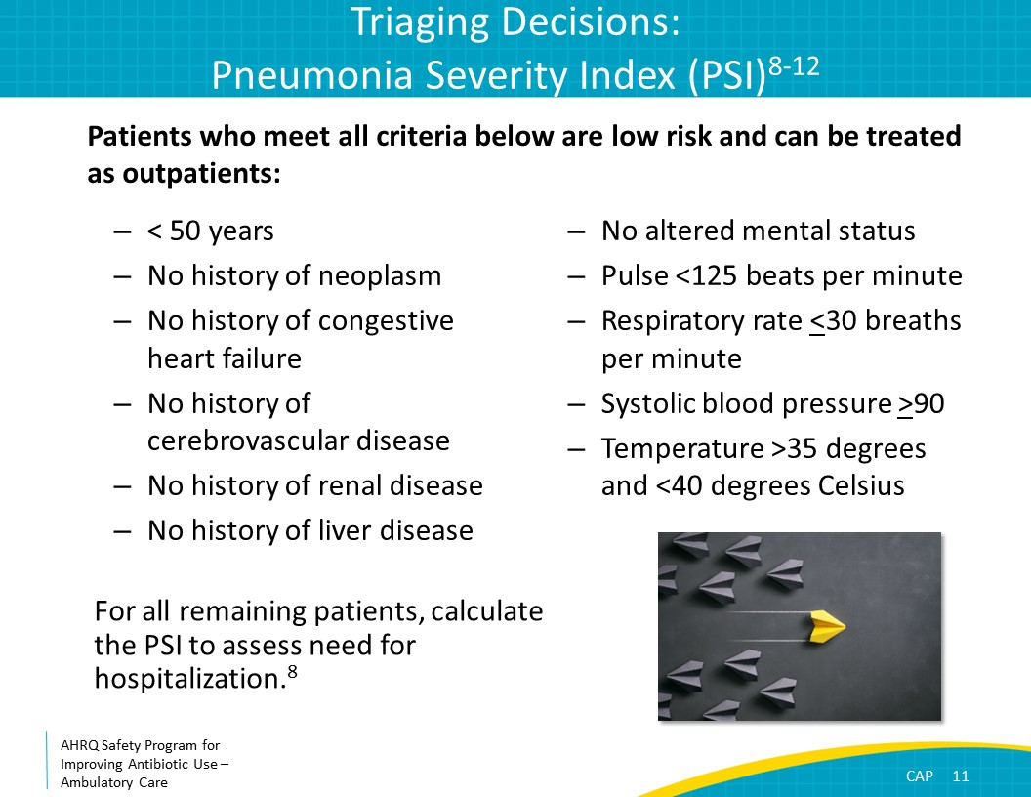
The Four Moments of Antibiotic Decision Making  SAY:  Moment Three is: If antibiotics are indicated, what is the narrowest, safest, and shortest regimen I can prescribe? | Slide 12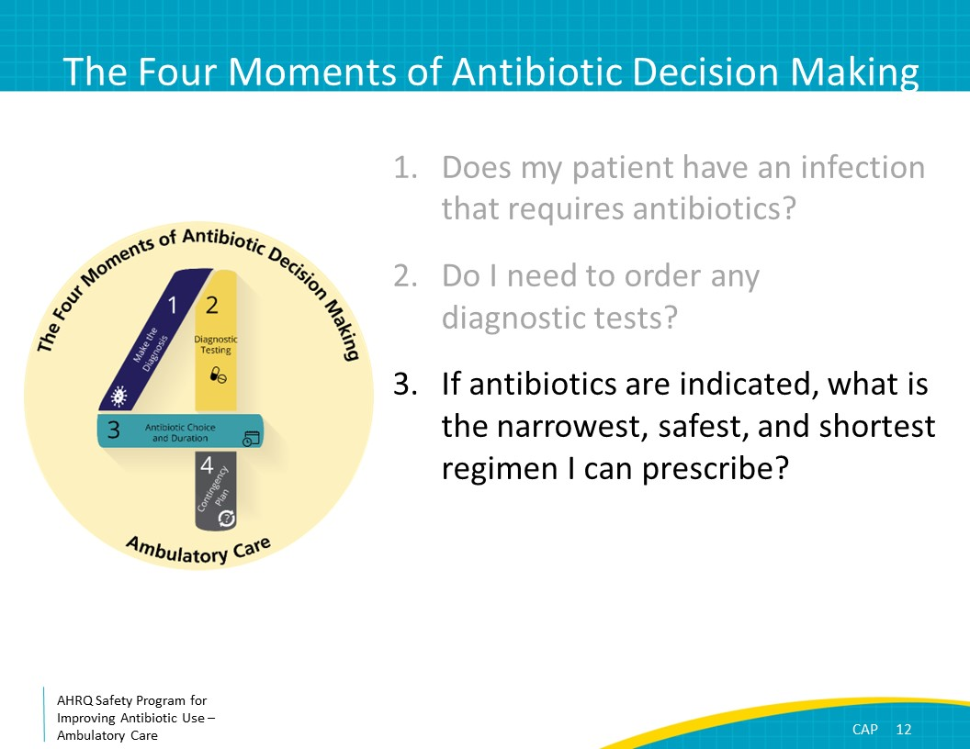
Moment 3: Antibiotic Choice  SAY:  Most patients with CAP can be treated with amoxicillin 1 gram three times daily or doxycycline 100 mg twice daily.  Although macrolide antibiotics, such as azithromycin and clarithromycin, have traditionally been recommended as options for monotherapy of CAP among outpatients, rates of pneumococcal resistance have increased in many parts of the county. National guidelines recommend that if less than 25 percent of pneumococcus isolates are resistant to macrolides, you can use azithromycin 500 mg on the first day followed by 250 mg daily, clarithromycin 500 mg twice daily, or clarithromycin extended release 1,000 mg daily. However, if the local rate of pneumococcal resistance exceeds 25 percent or is unknown, then amoxicillin or doxycycline are preferred.  Note that respiratory fluoroquinolones—which include levofloxacin and moxifloxacin—are not recommended as first-line therapy due to concerns about fluoroquinolones causing adverse events like Clostridioides difficile, tendonitis and tendon rupture, low blood sugar, changes in mental status, prolonged QTc interval, and ruptured aortic aneurysm. | Slide 13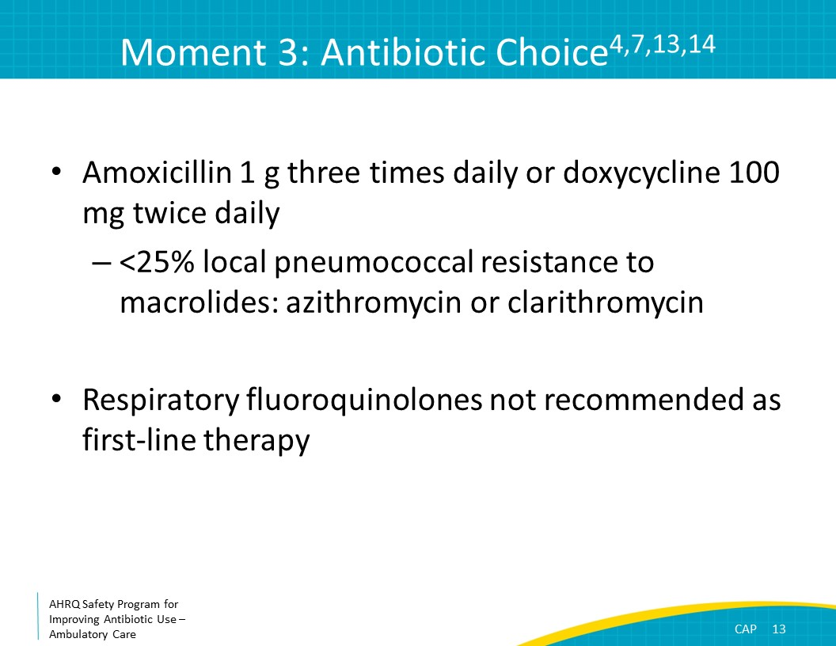
Moment 3: Antibiotic Choice in Adults  SAY:  For adult patients with significant pre-existing medical conditions such as chronic heart, lung, liver, or renal disease, diabetes, alcoholism, malignancy, asplenia, or immunocompromise and those who have received antibiotics in the prior 3 months, therapy with two antibiotics is generally recommended—a beta-lactam plus either a macrolide or doxycycline. Beta-lactam options include amoxicillin-clavulanate or a second- or third-generation oral cephalosporin such as cefuroxime or cefpodoxime.  For patients with severe beta-lactam allergies, a respiratory fluoroquinolone such as moxifloxacin or levofloxacin can be considered as monotherapy. The addition of a macrolide to moxifloxacin or levofloxacin is unnecessary as fluoroquinolones cover atypical organisms and the combination of these agents can increase cardiac toxicities. Note that ciprofloxacin should not be used given inadequate coverage for pneumococcus. | Slide 14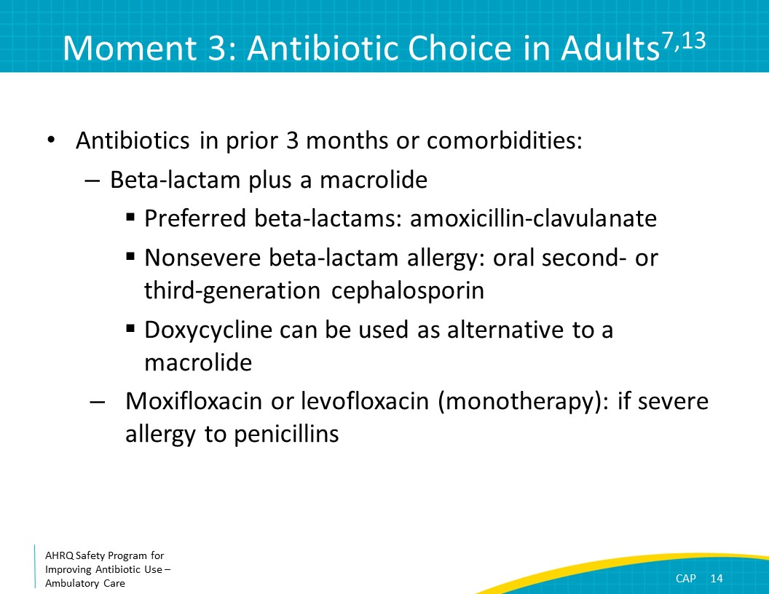
Moment 3: Antibiotic Choice in Children  SAY:  For children, first-line CAP therapy generally consists of high-dose amoxicillin. Consider amoxicillin/clavulanate if the child received amoxicillin within 30 days to broaden coverage for beta-lactamase producing Haemophilus influenzae.  If the child has a nonsevere reaction to penicillin, consider a second- or third-generation cephalosporin such as cefuroxime or cefpodoxime.  If the child has had a severe penicillin allergy, consider a respiratory fluoroquinolone or macrolide. A family history of penicillin allergies alone is not a reason to avoid penicillin therapy.  The first-line treatment for presumed Mycoplasma pneumoniae for patients of all ages is a macrolide. | Slide 15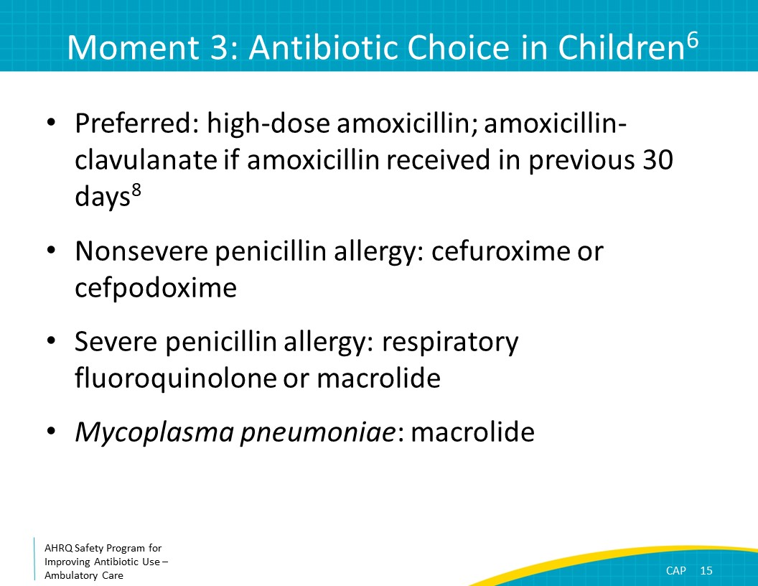
Moment 3: Duration of Therapy  SAY:  Numerous clinical trials indicate that 5 days of antibiotic therapy is sufficient for most patients with CAP, regardless of the antibiotic chosen or whether the patient is admitted to the hospital or not. Notably, a recent randomized clinical trial of noncritically ill adult inpatients demonstrated that 3 days of antibiotics was noninferior to 8 days of antibiotics. For most outpatients, no more than 5 days of antibiotics are indicated for CAP.  Consider prolonging therapy to at least 7 days if the patient has immunocompromise, underlying structural lung disease (not including asthma), or does not have an adequate clinical response to therapy within 72 hours.  Since the publication of the 2011 Infectious Diseases Society of America pediatric CAP guidelines that recommended 10 days of therapy for children, at least three randomized controlled trials have shown that no more than 5 days of therapy is sufficient for children with CAP. To summarize, 5 days of antibiotics is sufficient for most patients with CAP. | Slide 16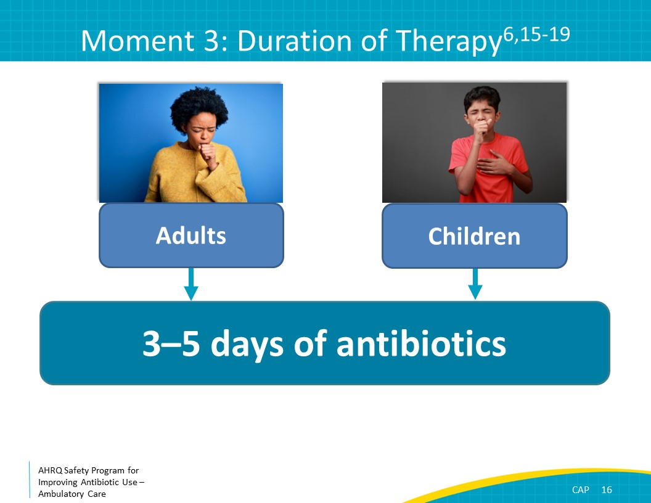
SAY:  The last moment to consider is, Does my patient understand what to expect and the followup plan? | Slide 17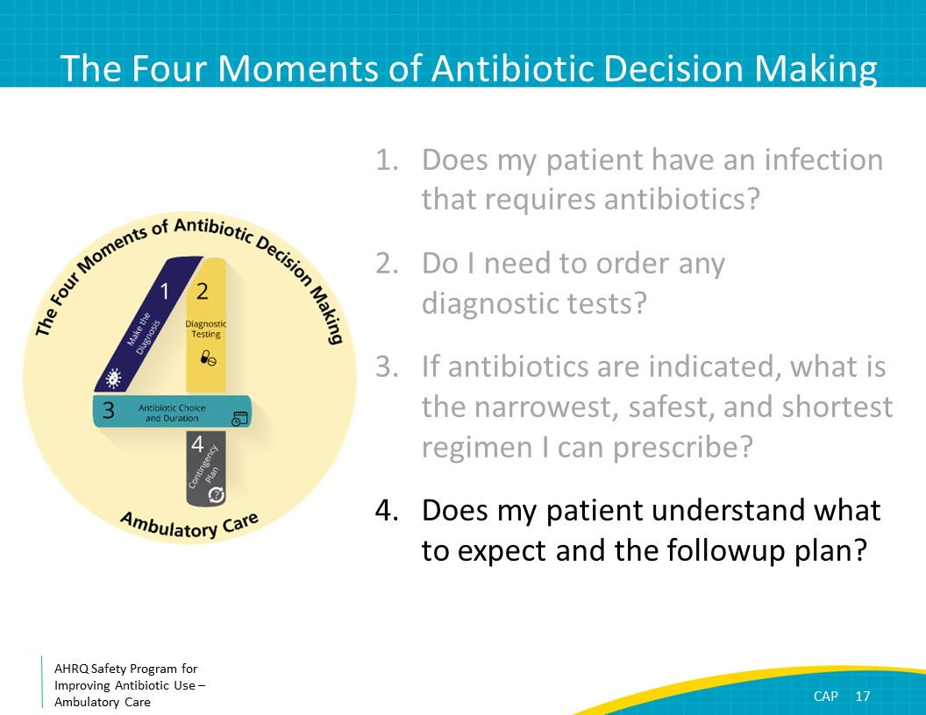
Moment 4: What To Expect  SAY:  In general, patients are expected to demonstrate gradual clinical improvement by the third day of antibiotic therapy. If improvement is not observed by day 3 and amoxicillin was initially prescribed, consider broadening to amoxicillin/clavulanate. For adults, if a macrolide or doxycycline was not initially added to the beta-lactam antibiotic, consider the addition of one of these agents or broadening to a respiratory fluoroquinolone.  A chest x ray should be considered to evaluate for abscesses or empyema in patients who are not improving by day 3 of antibiotics. Patients should be instructed to return to medical care if they experience mental status changes or become increasingly ill, regardless of how many days of antibiotics they have taken.  Although patients should report general improvement in symptoms by day 3, it is normal to have some residual fatigue and cough for several weeks after completing a course of antibiotics. | Slide 18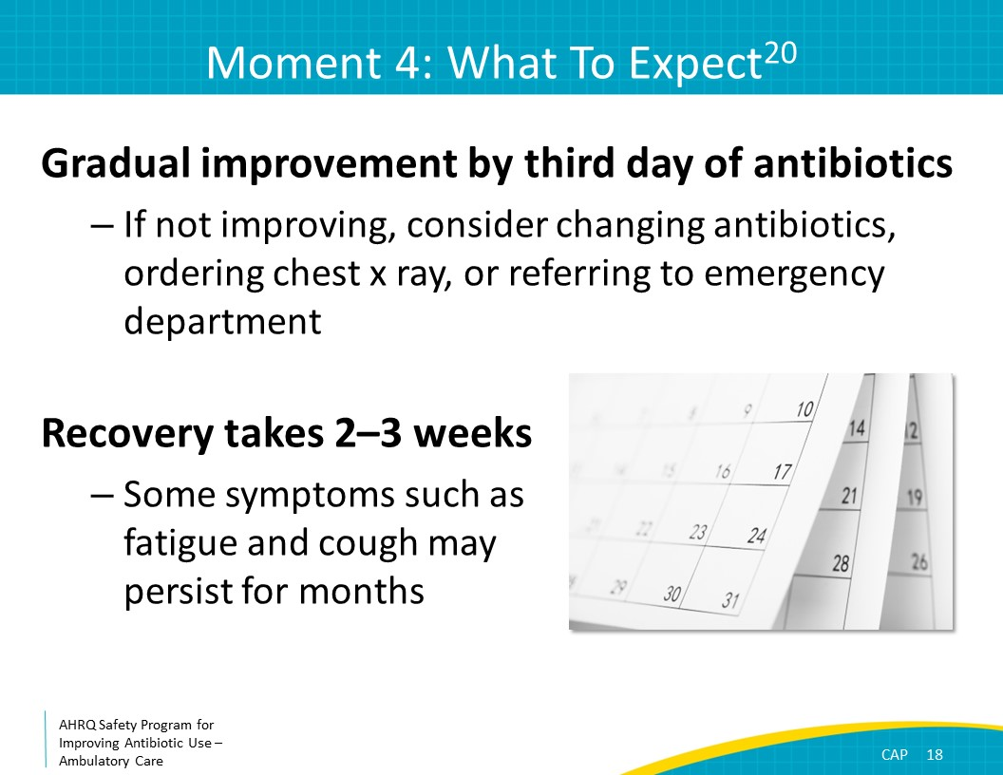
Case Presentation  SAY:  Now let’s discuss a case.  A 50-year-old male who is otherwise healthy presents in December with 3 days of shortness of breath, a productive cough, and fevers. He does not have mental status changes. He hasn’t taken any antibiotics recently.  On exam, his temperature is 101 degrees Fahrenheit which is 38.3 degrees Celsius, his heart rate is 104 beats per minute, his respiratory rate is 12 breaths per minute, his blood pressure is 110/70, and his oxygen saturation is 95 percent on room air. Rhonchi are heard in the right middle lobe. | Slide 19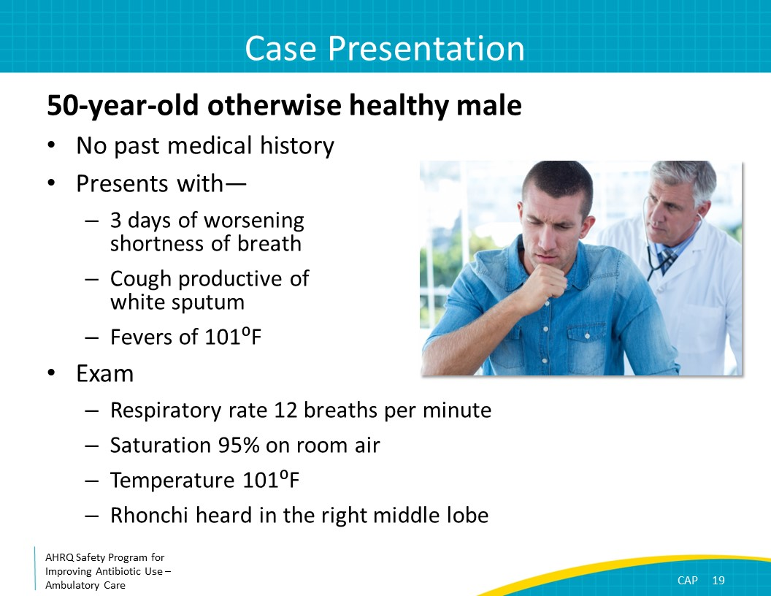
Moment 1  SAY:  Let’s review the Four Moments.  First, does he have an infection that requires antibiotics?  The patient’s clinical signs and symptoms of worsening shortness of breath, a productive cough, and fevers make the likelihood of bacterial CAP reasonably high. Viral infections such as influenza and COVID-19 should also be considered. | Slide 20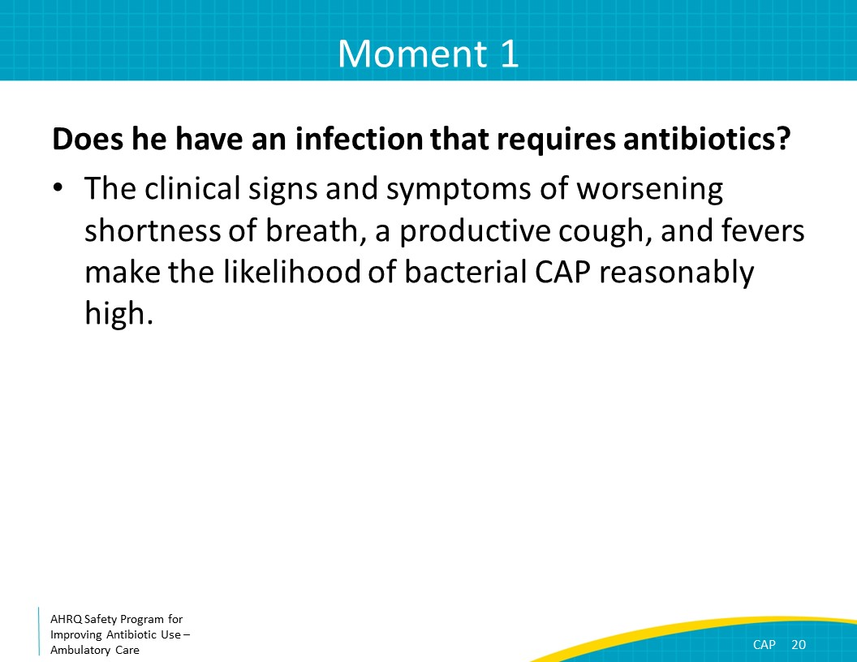
Moment 2  SAY:  Second, do I need to order a diagnostic test?  The patient has signs and symptoms consistent with pneumonia and localized rhonchi on lung exam suggestive of lobar pneumonia. Because he is likely to have pneumonia, a chest x ray is not needed. If there are more equivocal signs and symptoms, or if there is concern for a pleural effusion based on history and physical exam, then a chest x ray should be obtained. | Slide 21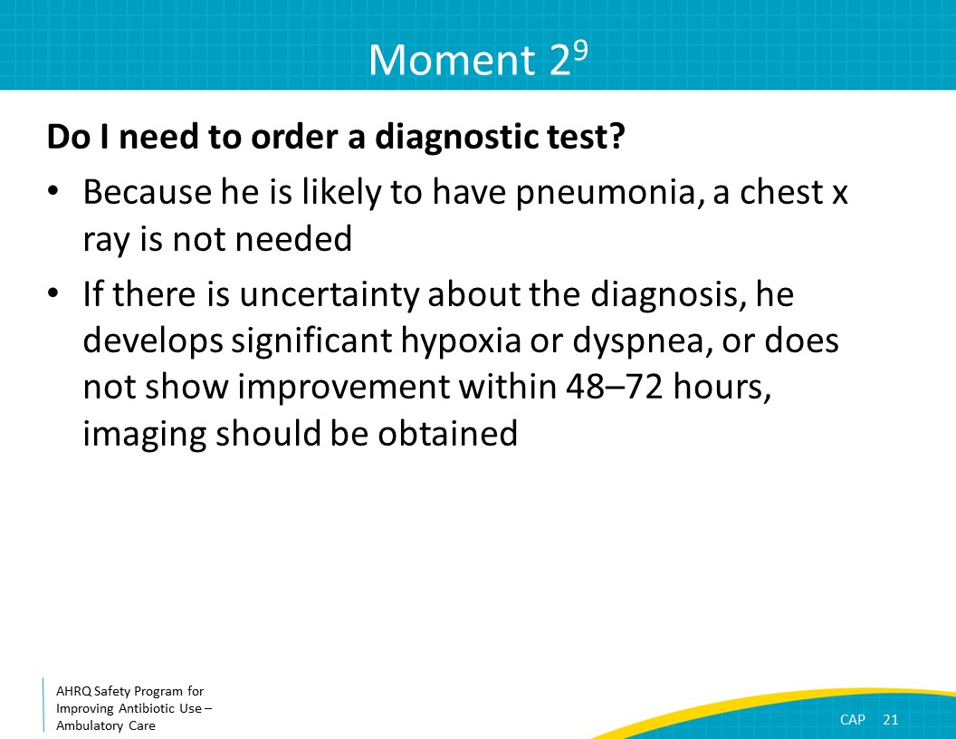
Triaging Decisions  SAY:  Either the CURB-65 or PSI should be reviewed to determine if is reasonable to manage the patient in the ambulatory setting or if referral to an emergency department is necessary. Using the CURB-65 criteria:  C is for Confusion, which the patient does not have.  U is for Uremia with an elevated blood urea nitrogen. The results of a metabolic panel are not available, so the blood urea nitrogen level is unknown. However, since the patient does not have confusion and is not ill appearing, it can be assumed that his blood urea nitrogen level is likely normal.  R is for an elevated respiratory rate, which he does not have.  B is for low blood pressure, which he does not have.  And finally, he is not over 65 years old.  As he does not meet any of the CURB-65 criteria, it is reasonable for him to be managed as an outpatient. | Slide 22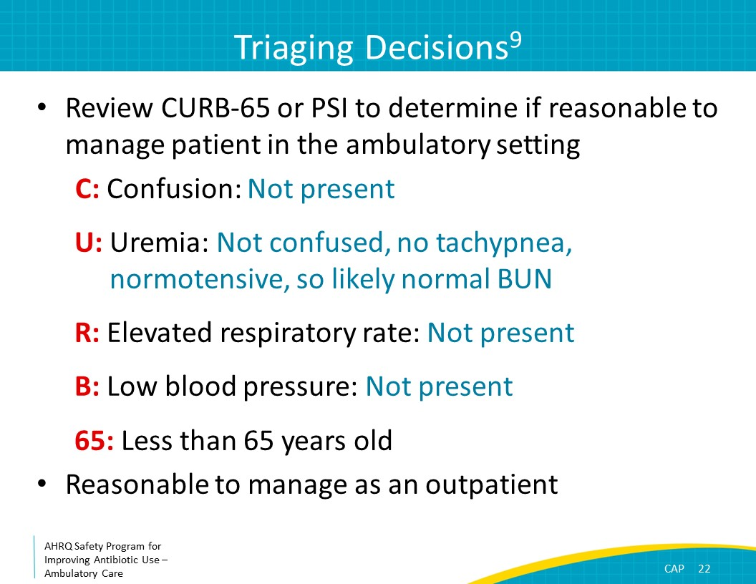
Moment 3  SAY:  Third, if antibiotics are indicated, what is the narrowest, safest, and shortest regimen I can prescribe?  For a patient with pneumonia who has not recently received antibiotics and does not have comorbid illnesses, amoxicillin or doxycycline would be good choices. If rates of macrolide-resistant pneumococcus are low in your region, azithromycin and clarithromycin may also be considered. | Slide 23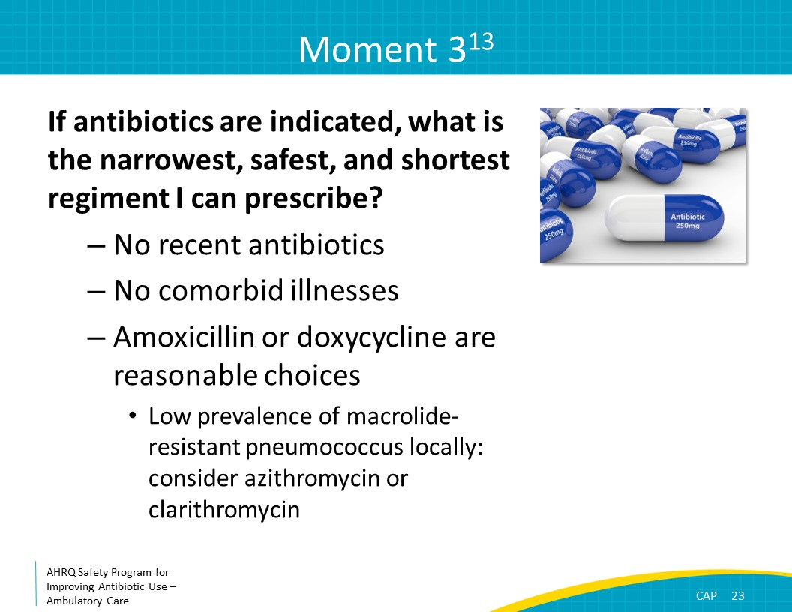
Moment 4  SAY:  Fourth, does my patient know what to expect and the followup plan?  Five days of antibiotics should be sufficient, and the patient should expect to demonstrate gradual improvement in the first 72 hours of treatment. If he is not showing improvement by the third day of antibiotics, he should return to medical care. If he is clinically worsening, he should go to the emergency department. | Slide 24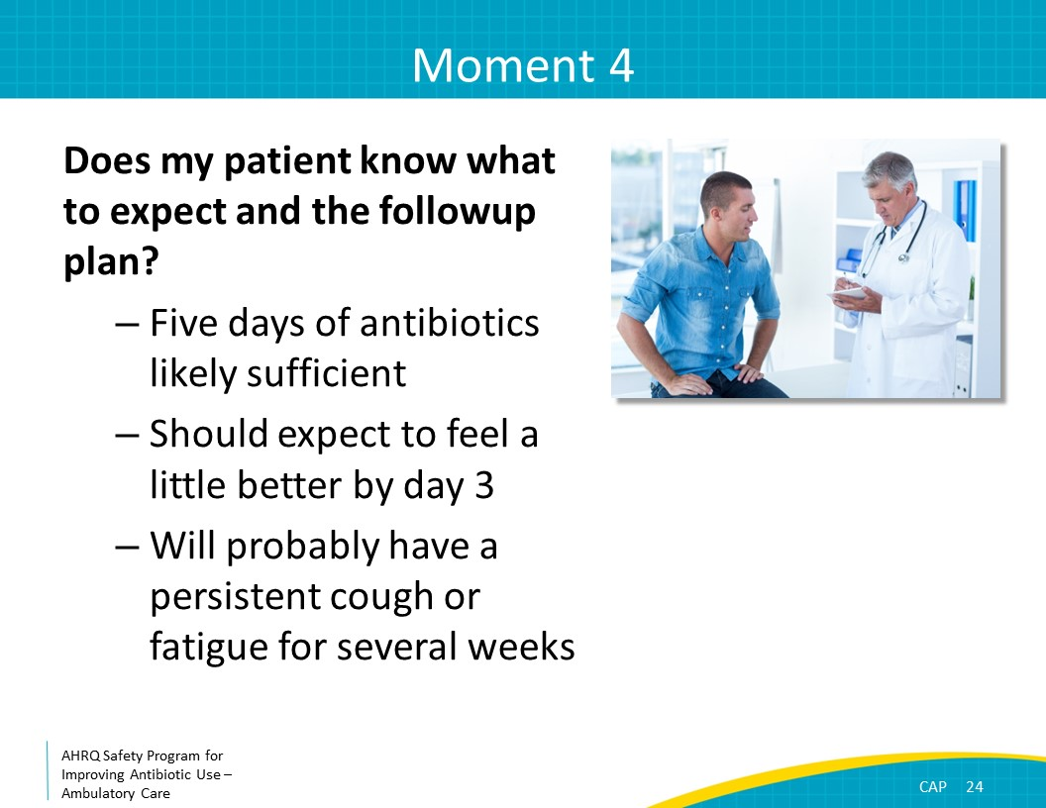
Take-Home Messages  SAY:  To summarize, patients with CAP generally present with fevers, cough, and increased work of breathing. A chest x ray should be considered if the diagnosis is uncertain, but if the patient has signs, symptoms, and physical exam findings consistent with pneumonia, it can be deferred. If a chest x ray is obtained and does not demonstrate an infiltrate, an alternative diagnosis should be considered.  The CURB-65 or PSI criteria can be used to determine if adults with CAP require hospitalization. For most patients with CAP, amoxicillin and doxycycline are good options. Azithromycin and clarithromycin are also good options if your local community has low rates of macrolide-resistant pneumococcus.  For adults with comorbidities, consider amoxicillin/clavulanate or a second- or third-generation cephalosporin. A macrolide or doxycycline should be co-administered with whichever beta-lactam agent is selected. For patients with beta-lactam allergies, consider a fluoroquinolone as monotherapy.  Amoxicillin should be considered as first-line therapy for most children with CAP.  For both adults and children with CAP, the duration of therapy can generally be limited to no more than 5 days. | Slide 25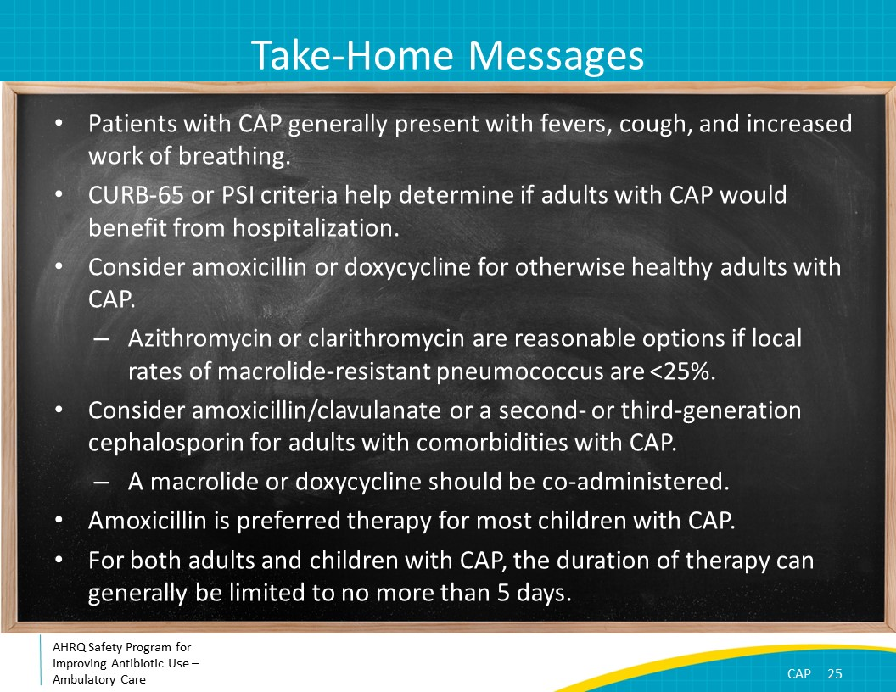
Additional Toolkit Resources  SAY:  For more resources on community-acquired pneumonia, please access tools listed below, available in the AHRQ Toolkit To Improve Antibiotic Use in Ambulatory Care.  Refer to the Discussion Guide to help your practice develop a standardized approach to the diagnosis and management of patients with community-acquired pneumonia.  Refer to the One-Page document for a concise summary of the diagnosis and treatment of community-acquired pneumonia.  Share the Patient Handout with your patients. It explains the symptoms and treatment of community-acquired pneumonia. It is available in both English and Spanish. | Slide 26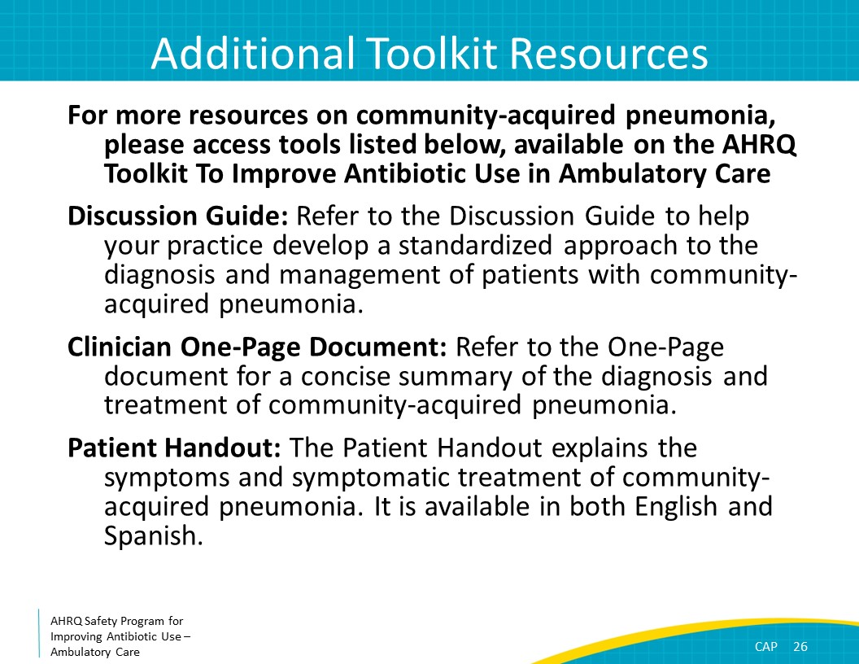
Disclaimer  SAY:  The findings and recommendations in this presentation are those of the authors, who are responsible for its content, and do not necessarily represent the views of AHRQ. No statement in this presentation should be construed as an official position of AHRQ or of the U.S. Department of Health and Human Services.  Any practice described in this presentation must be applied by healthcare practitioners in accordance with professional judgment and standards of care in regard to the unique circumstances that may apply in each situation they encounter. These practices are offered as helpful options for consideration by healthcare practitioners, not as guidelines. | Slide 27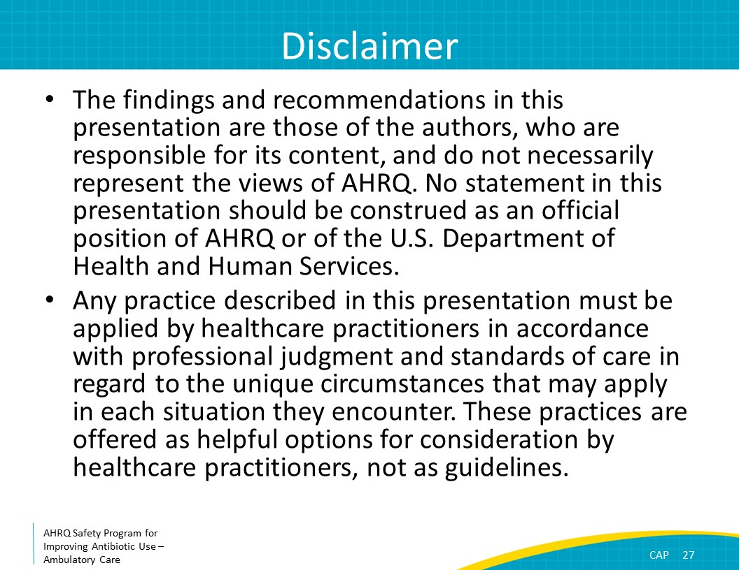
References  SAY:  Here are the references. | Slide 28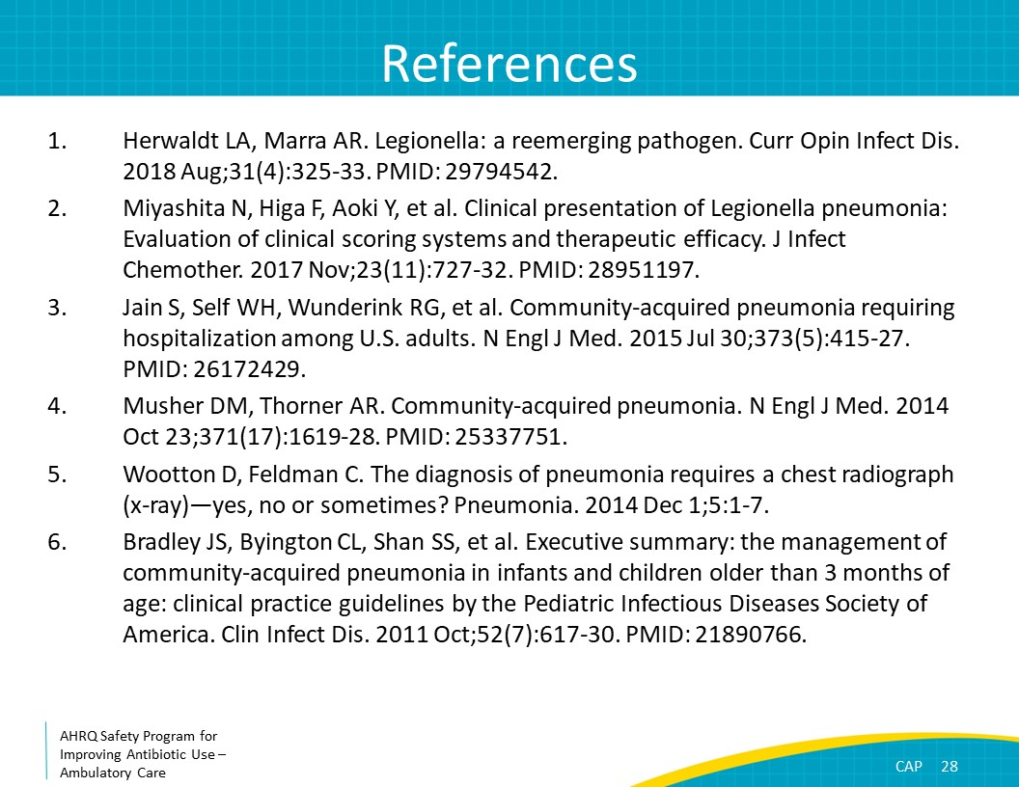
References | Slide 29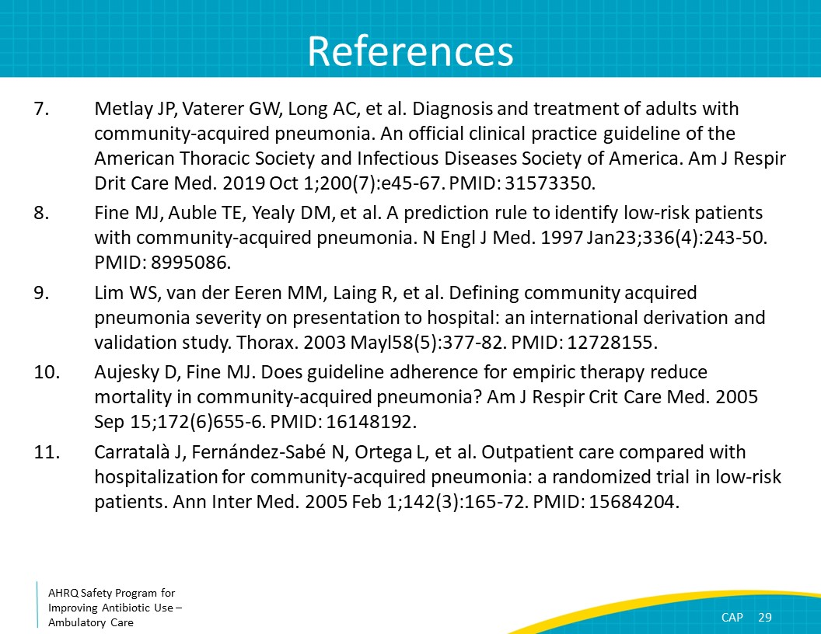
References | Slide 30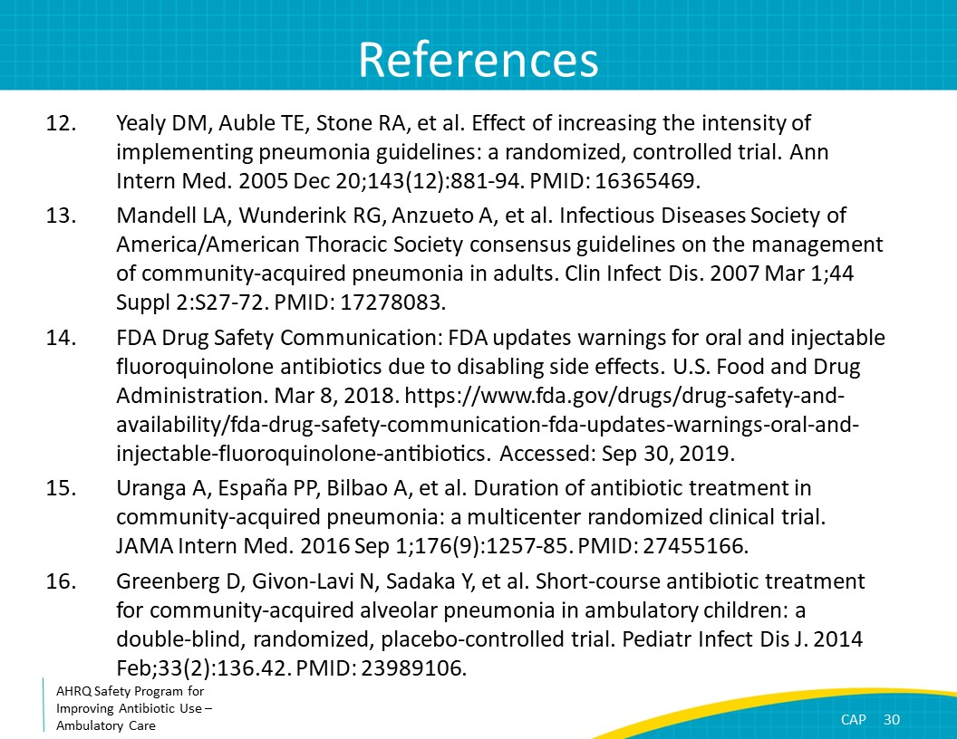
References | Slide 31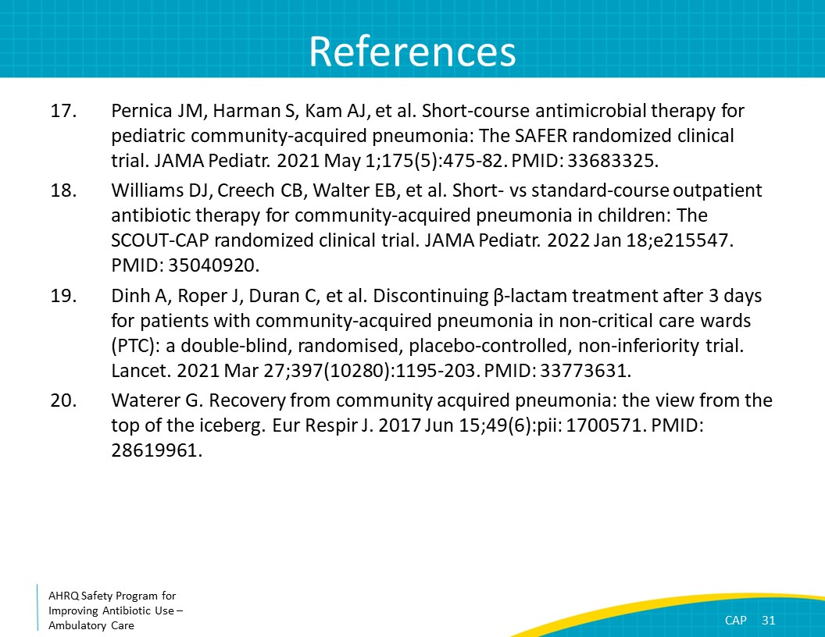
AHRQ Pub. No. 17(22)-0030
September 2022

