The “Never Antibiotics” Diagnosis: Acute Viral Upper
Respiratory Infection: the Common Cold

Slide Title and Commentary | Slide Number and Slide
The “Never Antibiotics” Diagnoses: Acute Viral Upper Respiratory Infection: the Common Cold  SAY:  Welcome to the presentation titled, “The ’Never Antibiotics’ Diagnoses: Acute Viral Upper Respiratory Infection: The Common Cold.” | Slide 1  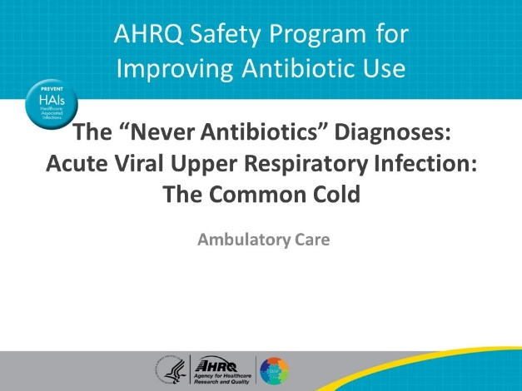
Objectives  SAY:  By the end of this presentation, participants will be able to—  - Describe how to diagnose a viral upper respiratory infection, also known as the common cold  - Explain why antibiotic therapy is not useful in the treatment of viral upper respiratory tract infections  - Describe treatment options to manage the symptoms of viral upper respiratory infections and  - Discuss strategies to communicate with patients the appropriate management of viral upper respiratory tract infections | Slide 2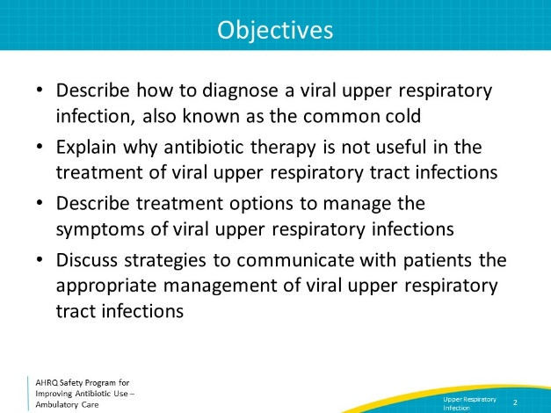
Background  SAY:  It has been estimated that there are about 500 million viral upper respiratory tract infections each year in the United States. Approximately one-quarter of these episodes result in a telephone or office encounter. | Slide 3
Case Presentation  SAY:  Let’s review a common clinical scenario. A healthy 30-year-old woman presents to clinic in February with 3 days of rhinorrhea, sore throat, and a productive cough. She had a negative SARS-CoV-2 PCR performed on the first day she was ill. She has no sinus tenderness and no cervical lymphadenopathy. Her lungs are clear to auscultation bilaterally. Her heart rate is 80 beats per minute and her temperature is 99 degrees Fahrenheit. She tells you that her temperature is normally 97 degrees Fahrenheit and that whenever she feels like this, she is prescribed azithromycin, which helps her symptoms.  The patient’s symptoms—acute onset of rhinorrhea, sore throat, cough—in combination with a nonconcerning physical exam—in this case, a lack of high fever, a normal heart rate, and lungs that are clear to auscultation bilaterally—is most consistent with the common cold.  The patient asks for a prescription for azithromycin. | Slide 4  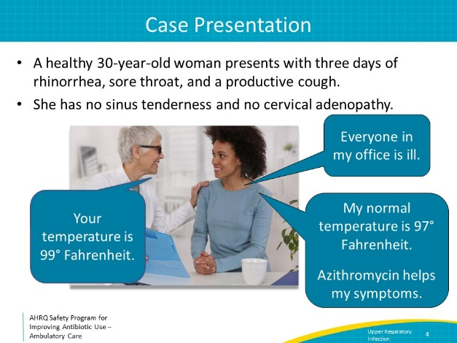
Harm Associated With Antibiotics  SAY:  Antibiotics should not be prescribed for the common cold. Colds are viral upper respiratory infections. Antibiotics will not help a patient with a viral upper respiratory infection, and they can cause harm.  Harm associated with antibiotics includes adverse drug events, microbiome disruption, and antibiotic resistance.  Adverse drug events from antibiotics are very common. About 10 percent of people who receive an antibiotic develop diarrhea. Antibiotics are associated with other anxiety-provoking, disruptive adverse effects such as yeast infections and rashes, and rarely they can cause life-threatening allergies.  Prescribing antibiotics for viral infections is not effective for subsequent prevention of bacterial superinfections. Patients are four times as likely to require an emergency department visit for an adverse event related to antibiotics than to develop a bacterial infectious complication from a viral infection.  Antibiotics also disrupt the normal bacteria that colonize the gastrointestinal tract and the upper respiratory tract, called the microbiome. Taking antibiotics can cause changes to the microbiome composition that can last for up to a year. Disruption of the microbiome allows the gastrointestinal and upper respiratory tract to be colonized with antibiotic-resistant bacteria that not easily killed by commonly used antibiotics, making future bacterial infections more difficult to treat. These resistant organisms can be the cause of subsequent bacterial infections in the individual patient and can be spread to family members.  Additionally, disruptions to the gastrointestinal microbiome increase the likelihood of colonization with Clostridioides difficile—or “C. diff.” Some people with C. diff colonization will go on to develop C. diff infection. In the United States every year, there are half a million C. diff infections and 15,000 deaths due to C. diff. | Slide 5  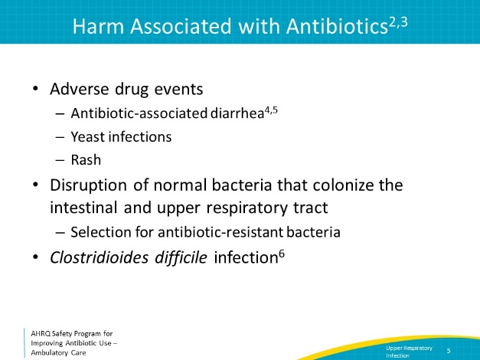
Four Moments of Antibiotic Decision Making  SAY:  We will review viral acute upper respiratory tract infections using the Four Moments of Antibiotic Decision Making framework. We will start with the first three Moments.  Moment One is: Does my patient have an infection that requires antibiotics?  Because the common cold is caused by viruses, antibiotics are not indicated.  Moment Two is: Do I need to order any diagnostic tests?  Most patients with viral upper respiratory tract infections do not need additional diagnostic testing. If there is concern for infection with SARS-CoV-2 or influenza, testing for these viruses should be considered. More information about influenza testing and treatment can be found in the Influenza material available in the AHRQ Safety Program Ambulatory Toolkit.  Moment Three is: If antibiotics are indicated, what is the narrowest, safest, and shortest regimen I can prescribe?  As noted previously, antibiotics will not help to treat the common cold. However, there are non-antibiotic treatments that can help relieve symptoms. | Slide 6  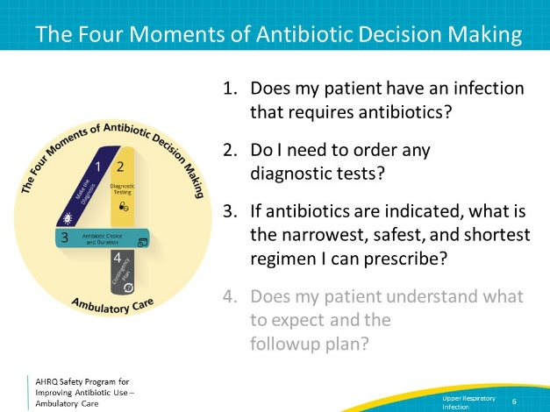
Over-the-Counter Medications  SAY:  For adults and older children, acetaminophen and nonsteroidal anti-inflammatory drugs may help relieve pain, such as sore throat or sinus tenderness, associated with the common cold. Several systematic reviews suggest that other over-the-counter medications—intranasal decongestants (which should not be used for more than 5 days), oral decongestants, antihistamine-decongestant combinations, and antihistamine-decongestant-analgesic combinations—have only a limited benefit, if any, and the risk of adverse events from the medications should be taken into consideration before recommending them to individual patients.  When making recommendations regarding over-the-counter medications to patients, it is helpful to be as specific as possible about what agents to choose. | Slide 7  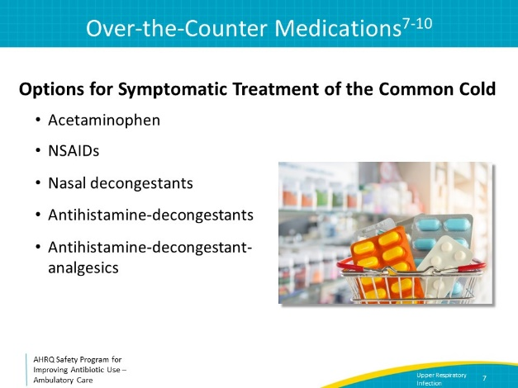
Over-the-Counter Medications for Children  SAY:  The American Academy of Pediatrics does not recommend cough and cold medicines and multi-ingredient products for children under 6 years of age because of reports of harm occurring in young children receiving these medications, including apnea and serious overdoses. For children over a year of age, honey can soothe cough. Cool-mist humidifiers can provide comfort and symptom relief for cough and congestion. Using nasal saline drops or spray followed by bulb suctioning may also provide congestion relief for younger children, particularly prior to sleeping or nursing. | Slide 8  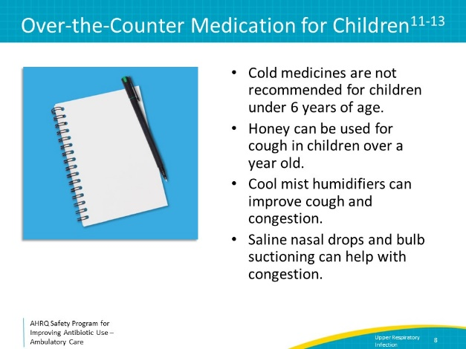
Communicating With Patients  SAY:  It is important to think about effective approaches to communicate the diagnosis and treatment approaches of viral upper respiratory tract infections to patients. Often patients request unnecessary antibiotics, but clinicians also assume that patients are expecting to receive antibiotics even when they may not be. There are a few reasons why patients and clinicians may have different views on the prescription of antibiotics. First, patients want to hear that the clinician is taking their symptoms seriously, and historically as a profession, clinicians have prescribed antibiotics as a decisive way of addressing the patient’s concerns about their symptoms. Second, patients may expect an antibiotic because in previous medical encounters an antibiotic has been prescribed for the same symptoms. A study from 2021 found that receipt of antibiotics for one acute upper respiratory tract infection is associated with increased likelihood of receipt of antibiotics for future acute respiratory tract infections in both patients and their spouses. Third, patients may be worried about becoming even more sick, and assume an antibiotic will prevent worsening symptoms. They may also have concerns about difficulties reaching a provider if their symptoms worsen.  It is useful to review each of these three concerns and possible solutions. | Slide 9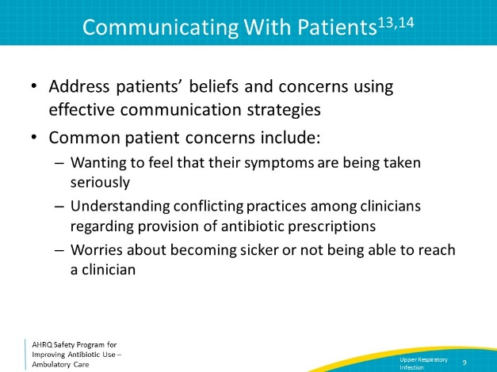
Communication: Validate Patient Concerns  SAY:  First, patients want to hear that the clinician is taking their symptoms seriously. They don’t feel well and want to feel better. They want to be sure the clinician understands that. | Slide 10  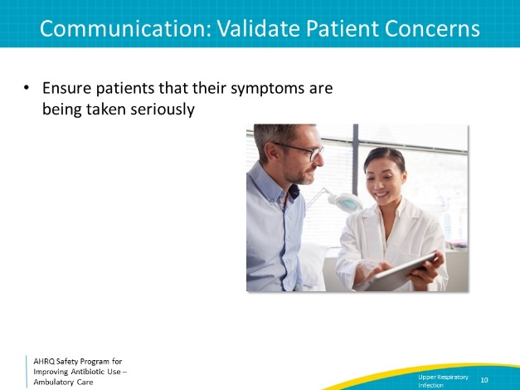
Solution: Validate Patient Concerns  SAY:  The solution is to validate the patient’s symptoms. Make sure that they understand they are being taken seriously. Some example phrases might be:  “You have a bad cold.”  “I can see you’re feeling pretty miserable.”  “Let’s work on making you feel better.”  After making statements like these, consider saying,  “Antibiotics won’t help, but here are some things that might help.”  This statement can be followed with options to treat symptoms. | Slide 11  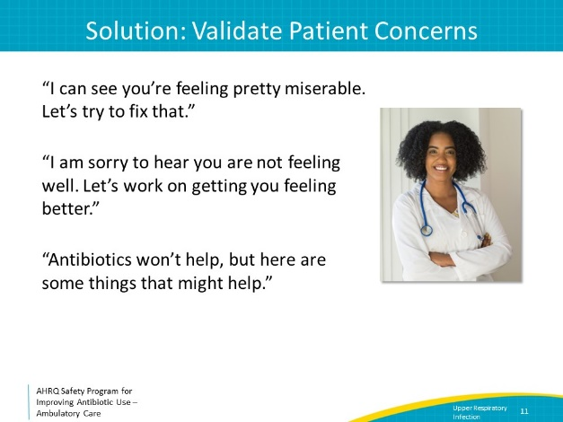
Communication: Patients Getting Conflicting Messages  SAY:  Another concern is that patients may be getting conflicting messages around antibiotic prescriptions for colds. Patients may have received antibiotics for colds in the past, and so they may expect antibiotics now.  For example, in primary care clinics with more than one clinician, a patient might say: “The last time I had this, you were out of town, and your partner gave me an antibiotic.”  Someone working in an urgent care center might see a patient who says: “I know this is my first time coming into this urgent care center, but my doctor always gives me a prescription for an antibiotic when I have this.”  A parent bringing their child in for an appointment might say: “I have the same thing as my child, and my doctor gave me an antibiotic. Will you give my child one too?” | Slide 12  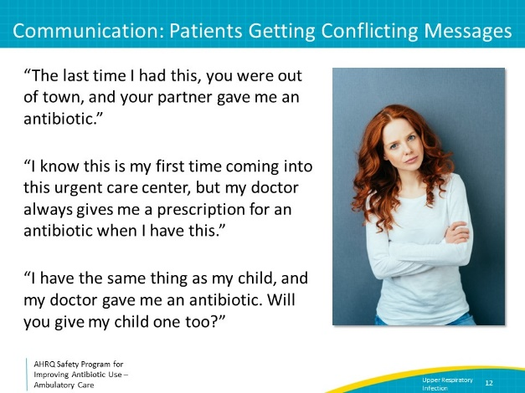
Solution: Communication and Sample Phrases  SAY:  There are several approaches to manage these types of statements.  First, be prepared with explanations for them. For example, discuss the fact the newer evidence suggests that antibiotics are not helpful and possibly harmful. Say something such as: “There’s a lot of newer evidence showing antibiotics have more side effects than we used to think. We are being more careful about only prescribing antibiotics when you really need them.”  Let the patient know that it is good news that antibiotics are not needed. For new patients, say something like: “While I can’t say for certain what type of infection you had in the past, the good news is that this time you don’t have an infection that requires antibiotics.”  Consider reminding patients that it may be coincidental that their cold symptoms got better after they started taking antibiotics by saying, “Viral infections often last a week or so and almost always get better on their own. People often start feeling better after about 3 days, which often coincides with when antibiotics were started. Even though it might seem like the antibiotic helped, you most likely experienced the natural and expected course of the viral infection.” | Slide 13
Communication: Other Patient Concerns  SAY:  Patients may ask for antibiotics because they feel insecure without them. They may be concerned that they won’t be able to reach the clinician if they get sicker, or they have upcoming travel or another commitment and want antibiotics in case they may help. | Slide 14  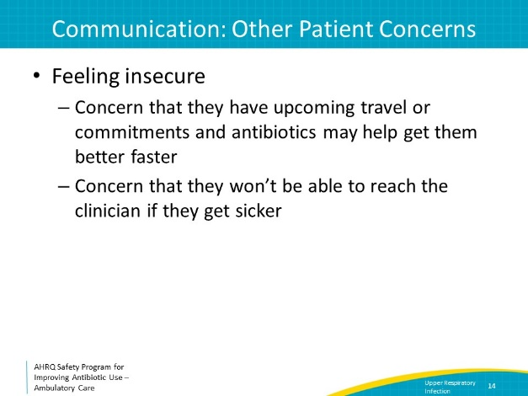
Solutions: Managing Patient Expectations  SAY:  A patient might say, “I have an important family commitment this weekend, and I can’t be sick!”  Consider responding, “I understand that you have important commitments this weekend, but antibiotics won’t make this go away faster. In fact, they could lead to an adverse event, like diarrhea, that could make it harder to participate in the family event.”  In addition, make it clear that there will be someone available from the practice to address new or worsening symptoms. | Slide 15  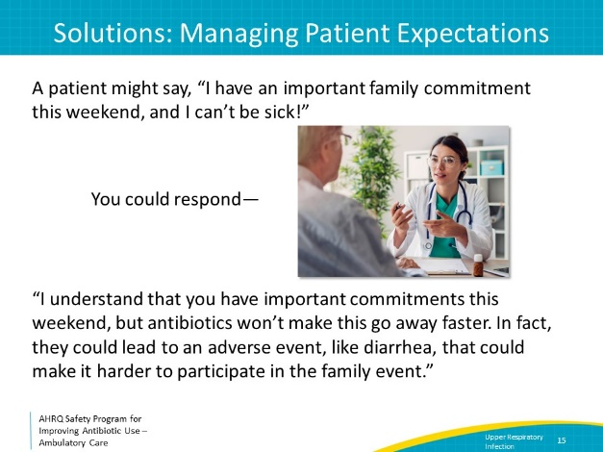
Clinicwide Protocols  SAY:  To ensure that patients do not get conflicting messages from different providers in the same practice, develop a practice-wide approach to make sure patients have appropriate expectations around antibiotic prescriptions for the common cold. You likely already have protocols or workflows when considering a COVID-19 diagnosis, so your practice can also decide how to approach upper respiratory tract infection in patients who are not being considered for COVID-19. Work together as a practice to reach a consensus on when antibiotics will and won’t be prescribed for outpatient infectious conditions and develop lists of symptomatic treatments that all members of the practice will recommend for the common cold as well as other infectious disease processes. Consider developing approaches to manage some patients with colds over the phone so that they don’t come into the clinic and inadvertently expose other patients and healthcare workers. For example, if the practice has a nurse that triages acute visits, consider developing a protocol for which of these patients don’t need to be seen in person. | Slide 16  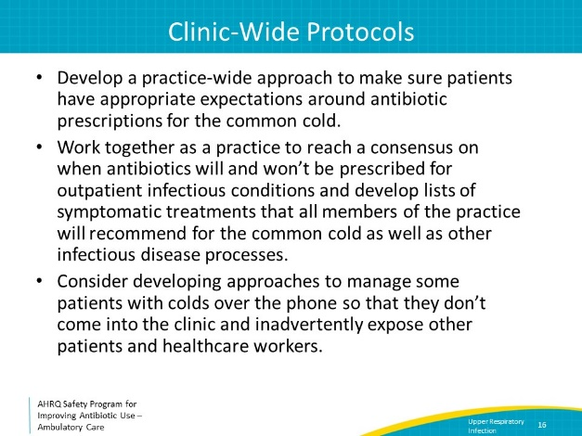
The Four Moment of Antibiotic Decision Making  SAY:  Returning to the Four Moments of Antibiotic Decision Making, Moment 4 is: Does my patient know what to expect and the followup plan? | Slide 17  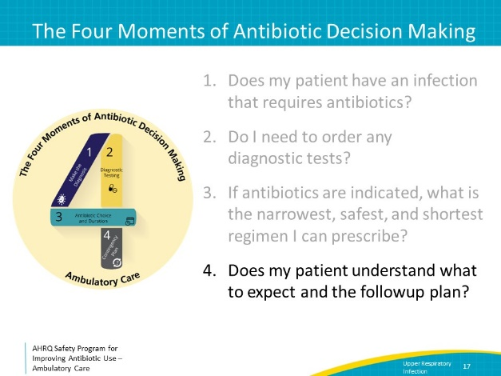
Moment 4: What to Expect and Followup Plan  Provide patients with information about the expected symptoms and time course of their illness including that it is normal for nasal discharge to change color, that their cough may last 2–3 weeks, and that while they should start to feel better within a few days, symptoms can linger for a few weeks.  In addition, give patients recommendations for when to return to care. These may include advice to call or return to the clinic or to go to the emergency department if the following develop: high fever (above 102°F), confusion, difficulty breathing or swallowing, severe headache, pain in the face or forehead, severe fatigue, or a rash, or if symptoms are not improving after 10 days.  You can share with your patient the handout, “The Common Cold,” in both English and Spanish. | Slide 18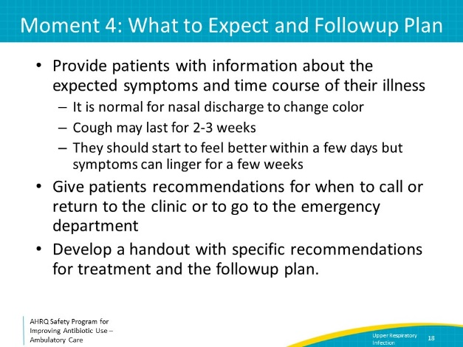
Take-Home Messages  SAY:  Antibiotics should not be prescribed for acute viral upper respiratory infections because they don’t help with symptoms and could cause avoidable harm.  When talking to patients about colds, focus on acknowledging their symptoms and that you understand they feel poorly, giving recommendations for symptomatic therapy, outlining the expected time course of the infection, and explaining when to call or return to medical attention.  Develop communication strategies for patients, such as validating the patient’s concerns and reiterating why antibiotics are not needed (and why this is good news).  Develop a common practicewide strategy to manage patients with these infections. | Slide 19  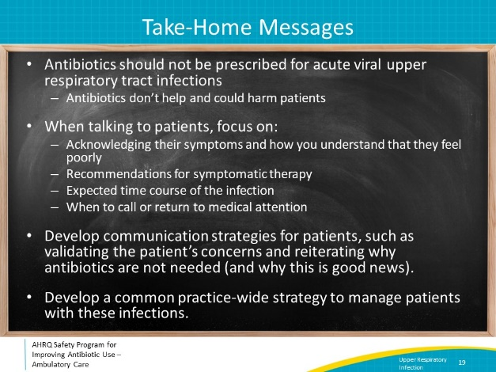
Additional Toolkit Resources  SAY:  For more resources on acute viral upper respiratory infection, please access tools listed below, available on the AHRQ Toolkit To Improve Antibiotic Use in Ambulatory Care.  Discussion Guide: Refer to the Discussion Guide to help your practice develop a standardized approach to the diagnosis and management of patients with acute viral upper respiratory infection.  Refer to the One-Page document for a concise summary of the diagnosis and treatment of acute viral upper respiratory infection.  The Patient Handout explains the symptoms and symptomatic treatment of acute viral upper respiratory infection. It is available in both English and Spanish. | Slide 20  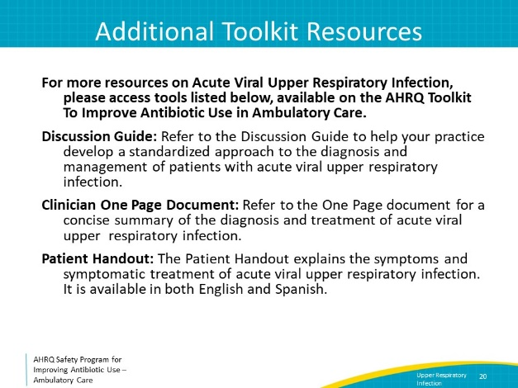
Disclaimer  SAY:  The findings and recommendations in this presentation are those of the authors, who are responsible for its content, and do not necessarily represent the views of AHRQ. No statement in this presentation should be construed as an official position of AHRQ or of the U.S. Department of Health and Human Services.  Any practice described in this presentation must be applied by healthcare practitioners in accordance with professional judgment and standards of care in regard to the unique circumstances that may apply in each situation they encounter. These practices are offered as helpful options for consideration by healthcare practitioners, not as guidelines. | Slide 21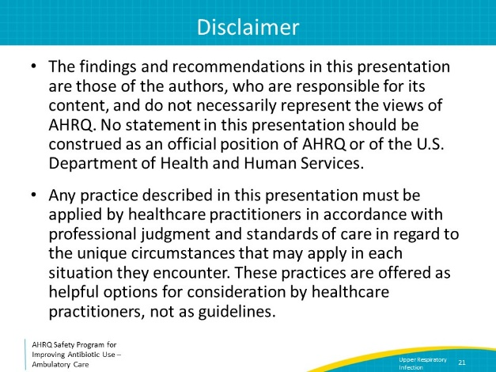
References  SAY:  Here are the references. | Slide 22  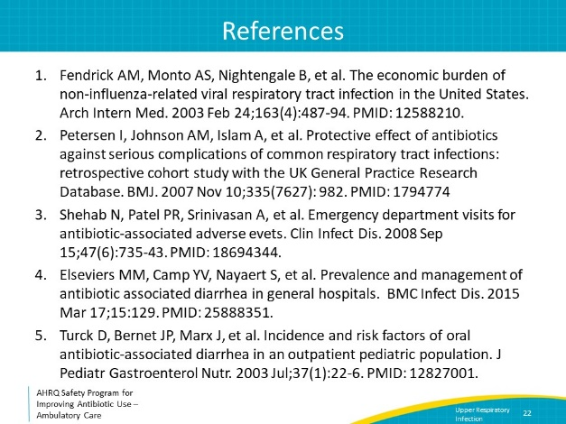
References | Slide 23  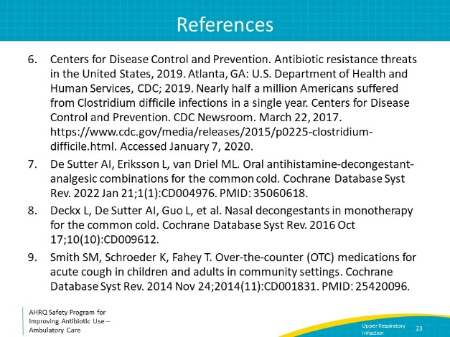
References | Slide 24  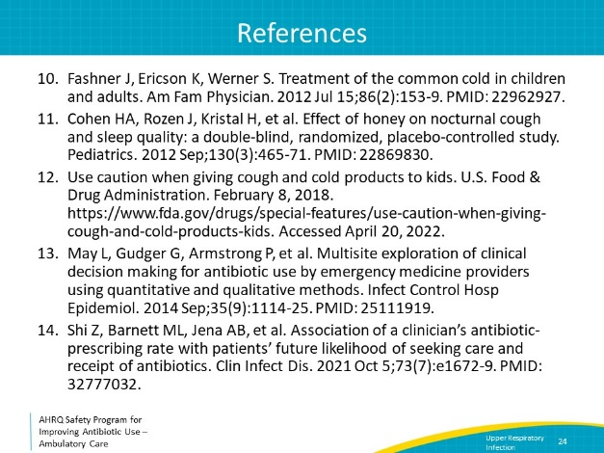
AHRQ Pub. No. 17(22)-0030
September 2022

