Improving Communication Between Members of the Practice Around Antibiotic Decisions
Ambulatory Care

Slide Title and Commentary | Slide Number and Slide
Improving Communication Between Members of the Practice Around Antibiotic Decisions  Ambulatory Care  SAY:  Welcome to the presentation titled “Improving Communication Between Members of the Practice Around Antibiotic Decisions.” | Slide 1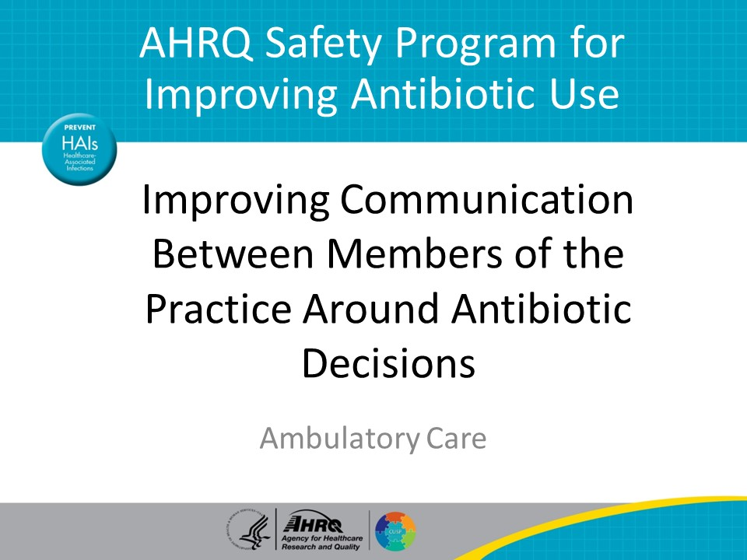
Objectives  SAY:  By the end of this presentation, participants will be able to—  - Explain how to improve teamwork in the practice  - Identify members of the practice who should be involved in developing management strategies for patients with infectious concerns and  - Describe how to reach consensus around communication in the practice | Slide 2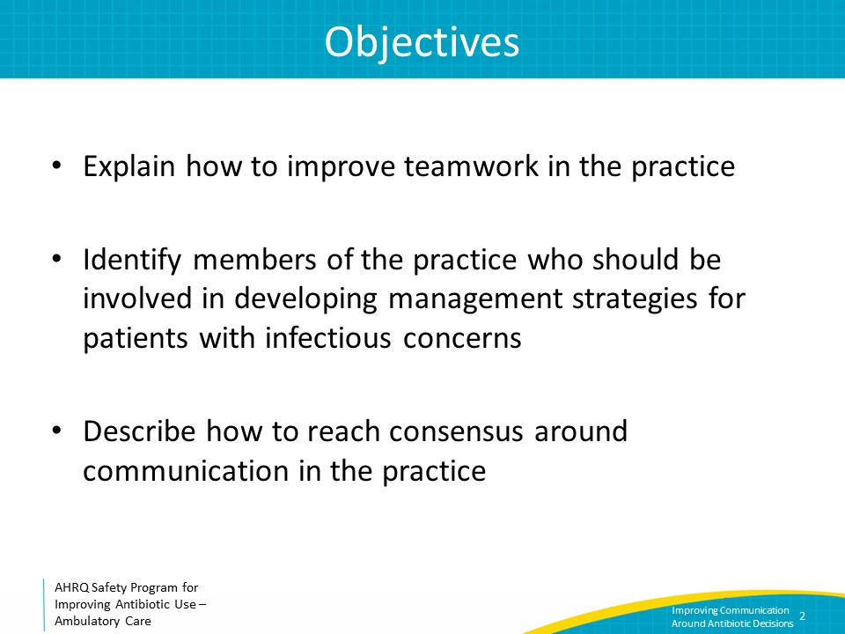
Messaging & Goals  SAY:  Patients commonly expect to receive antibiotic prescriptions during outpatient visits, and some patients may be disappointed when no antibiotic prescription is given. To temper expectations and ensure patients understand why the decision to not prescribe antibiotics might be made, it is important to develop a practicewide consensus that is clear, simple, and applied routinely by all healthcare practitioners. Consistent messages for managing infectious processes will allow the practice to function more efficiently and likely improve patient satisfaction. | Slide 3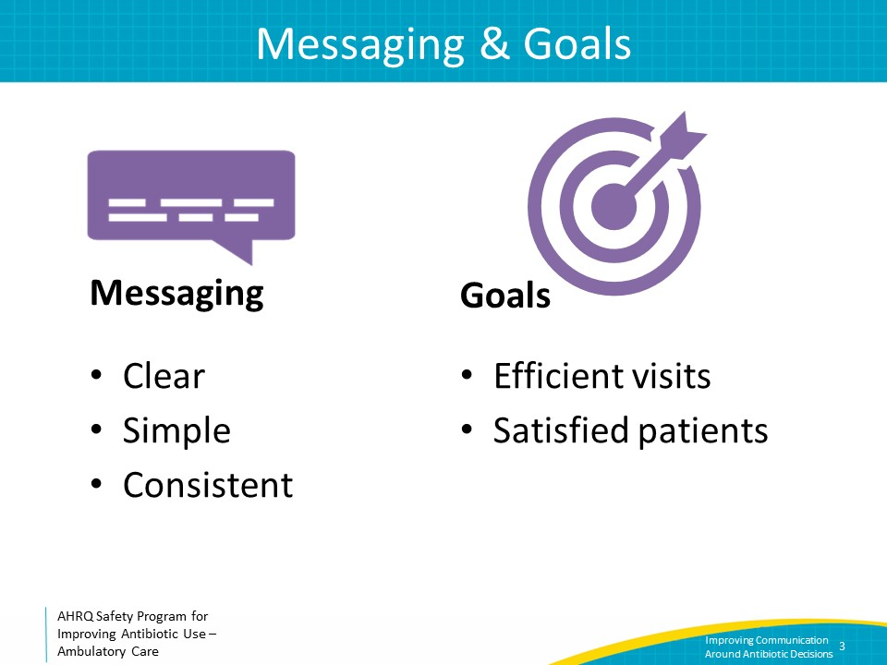
Improving Teamwork and Communication  SAY:  While developing practicewide management strategies, consider how to establish effective teamwork and communication among members of the practice. Consensus should be obtained from the entire healthcare team rather than only the prescribers in the practice.  Over the past few decades there has been an emphasis on the use of multidisciplinary teams in hospital settings to advance the care of patients. While some ambulatory practices have adopted a similar approach, others may not be used to considering all members of the practice such as schedulers, medical assistants, nurses, pharmacists, advanced practitioners, and physicians as part of the same team when making practice-level management decisions. Further, some ambulatory practices may be logistically challenged to consider all areas of patient contact if scheduling and after-hours triage are outsourced to larger, centralized companies. While the makeup of ambulatory multidisciplinary teams may look different, team members bring different perspectives and information regarding what is needed to solve problems within the practice. For this reason, it is crucial that practice members have skills, tools, and strategies to ensure they can work together effectively. | Slide 4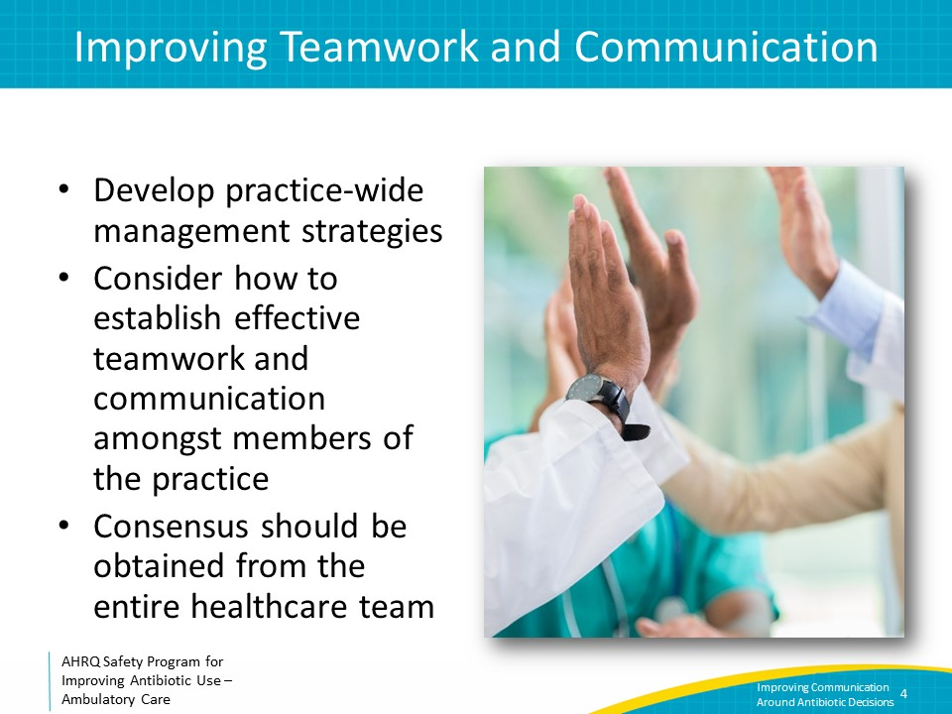
Who Is in the Practice?  SAY:  Think through everyone in the practice who might engage with a patient, whether by telephone, by virtual or telemedicine visits, or in person. This includes prescribers, nurses who triage patients, medical assistants who room patients, pharmacists who counsel patients about medications, and front desk staff who schedule appointments. All team members should be on the same page regarding the practice’s approach to the general management of infectious concerns.  Let’s use patients presenting with concerns for viral upper respiratory tract infections or viral URIs as an example. A practice could develop a protocol for when patients need to be seen by a healthcare practitioner. The protocol could include information on whether the clinic should see every patient with a viral URI in the office or whether symptomatic treatment advice over the telephone or through a telemedicine visit will suffice. | Slide 5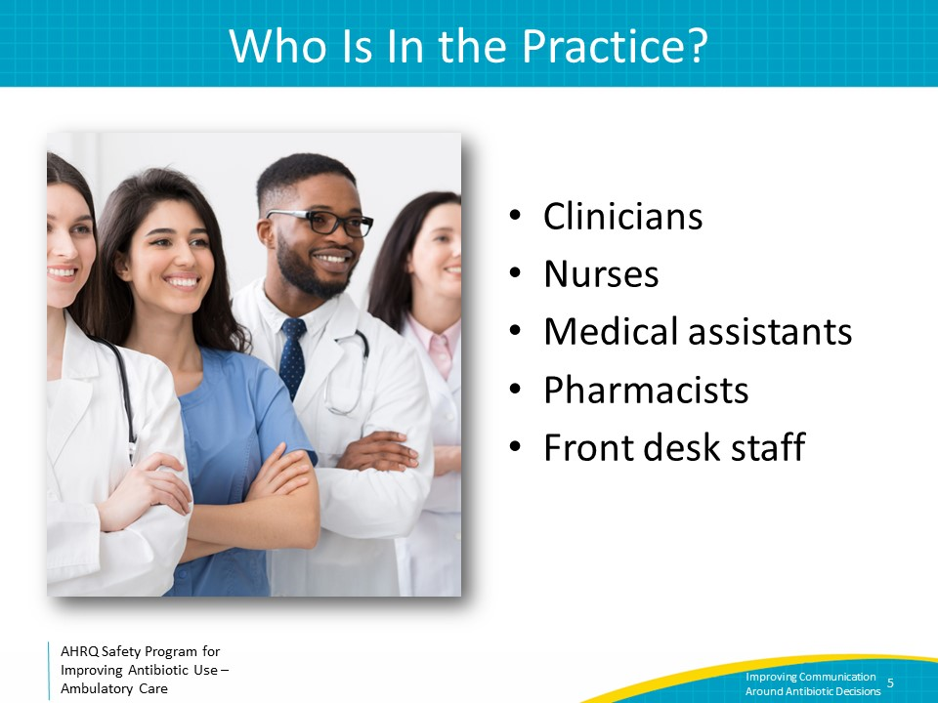
How To Improve Communication  SAY:  Ineffective communication can cause medication errors, delays in treatment, and other situations that can cause patient harm.  A 2017 review identified four qualities of good communication among nurses and physicians. Although the focus of the review was on nurses and physicians, the essence of these findings can be applied to communication among all interdisciplinary team members.  First, it is important to understand different communication styles. Nurses and physicians may approach communication differently. For example, nurse satisfaction with nurse-physician communication is associated with a communication style that includes self-introductions, immediacy of response, clarity of information, humor, listening, and empathy.  Physicians reported satisfaction when nurses communicated their input on patient care. Both groups identified mutual understanding of roles combined with opportunities to clarify information as important for meaningful communication.  Second, information sharing should be transparent. Providing regular updates and having opportunities to clarify information are associated with more meaningful communication between nurses and physicians.  Third, creating space for communication opportunities is also critical to reduce miscommunication and misinterpretation, provide support, and clarify information. This may include an electronic health record “instant” or “secure chat” feature, sharing physical office space with different team members, or direct-line phone or text communication.  Fourth, develop a work environment with a collaborative attitude in which all staff are treated with respect, trust, and professionalism. Interest and openness to staff’s views and suggestions, proactive communication, and calm and collegial dispositions promote satisfaction and positive communication between staff and physicians. | Slide 6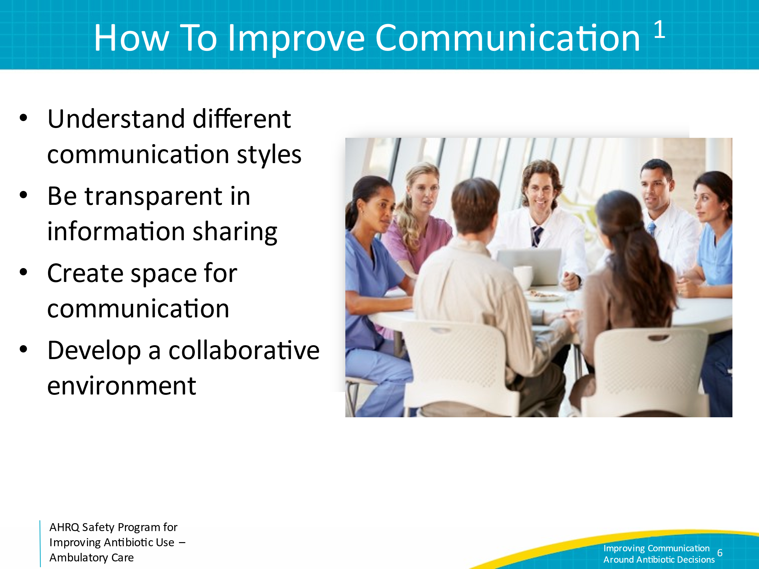
Communication Model  SAY:  Even with the best of intentions, failures of communication can happen. When sending a message, it is “encoded” in words. This message then passes through “the message medium” or the setting for the message. In ambulatory practices, this often involves noisy, distracting environments and may contain assumptions. The receiver is tasked with decoding the message (whatever the sender is attempting to pass along). If the sender and receiver know each other well, it is less likely that there will be a translation error. However, in work atmospheres, problems can arise.  For instance, a medical assistant or nurse could send the message, “The patient called and wanted a call back right away. He feels sick and thinks he needs an antibiotic.” How does the clinician decode that? What does the nurse or medical assistant mean by “sick” or “right away”? What symptoms is the patient having? These terms should be clarified before communication to the clinician.  For effective communication, the receiver should use active listening techniques during which he or she repeats back the message to let the sender know that it was received and decoded correctly.  In this example, the medical assistant or nurse should ask clarifying questions on the phone call with the patient. Then, the receiver should clarify with the medical assistant whether a patient who needs an urgent callback should be scheduled for an acute same-day appointment to assess if he or she has an infection that may require an antibiotic. The receiver, whether it be the doctor, nurse practitioner, or physician assistant, should actively listen to or read the information given, and ask clarifying questions if needed. The receiver should also focus on the speaker and use verbal signals such as occasionally saying “OK” or nonverbal signals such as eye contact to indicate that he or she is listening. | Slide 7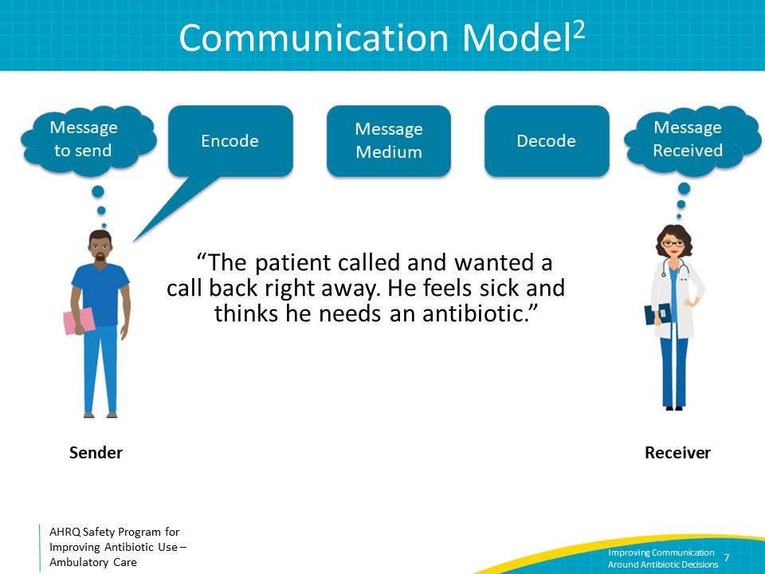
Developing Consensus  SAY:  Continuing with the example of viral URIs, translating improved teamwork and communication to the management of viral URIs could include decisions on how to handle telephone calls from patients with symptoms of viral URIs, what to say to a patient at check-in, how to talk to a patient or family member as they are being brought into a room, and what healthcare practitioners should suggest to patients for symptomatic treatment.  Nurses, medical assistants, front desk staff, clinicians, and any other members of the practice should be involved in the process of developing the protocol to ensure it has a better likelihood of being effective. After a protocol is implemented, all members of the practice should make note of what works and what doesn’t work and discuss as a group during routine practicewide meetings. Make any needed changes as a team. | Slide 8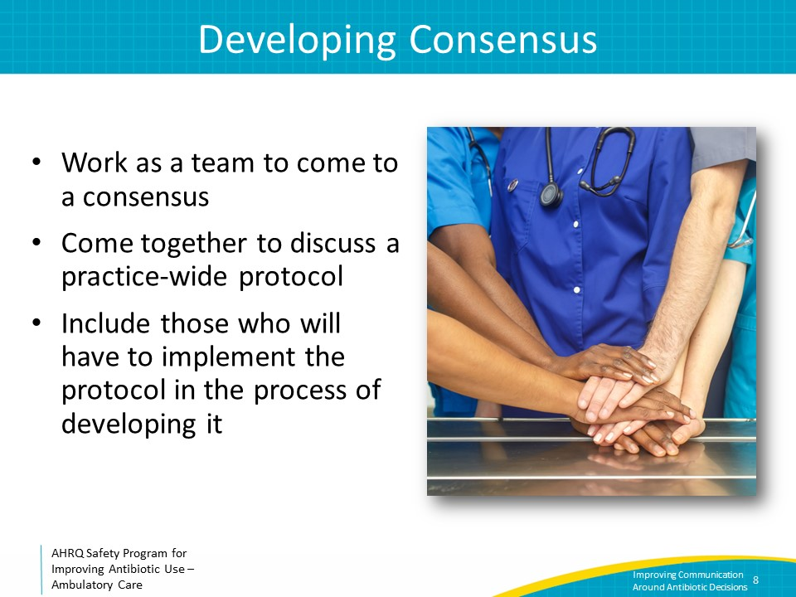
Communicating Concerns  SAY:  It is important that everyone using the protocol feels comfortable with it. Sometimes, it is hard to communicate concerns, especially if there are power differentials in the workplace. For example, medical assistants may have trouble telling the medical director or physicians that they don’t understand a certain part of the protocol.  Knowing how to communicate concerns is important. We will discuss a few techniques that can be used in the clinic. These include assertiveness and the two-attempt rule. | Slide 9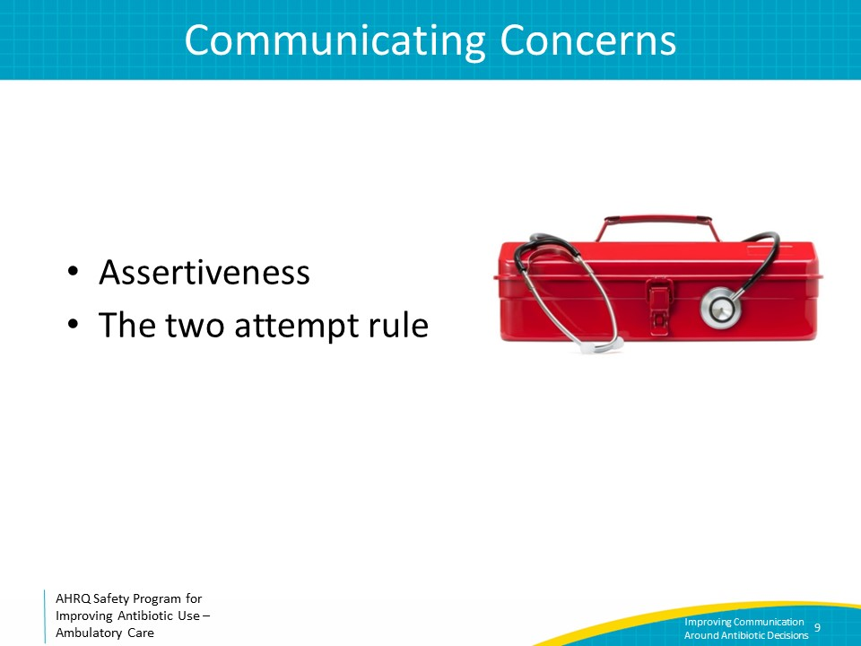
Use Assertiveness (Not Aggressiveness)  SAY:  In communication, there is a difference between being assertive and being aggressive. Assertiveness is standing up for one’s own or a patient’s interests in a calm and positive manner. It is an approach that leads to effective communication. Aggressiveness (whether passive or active) is attacking or ignoring others' opinions in favor of one’s own.  Being appropriately assertive means seeing oneself as having worth; valuing others equally and respecting their right to an opinion; and engaging in communication respectfully while also respecting one’s own opinions. Nonverbal communication, or body language, is also important. An assertive physical manner includes speaking calmly, sitting or standing with good posture, and making eye contact while speaking.  Being assertive does NOT mean being aggressive, hostile, confrontational, demeaning, or condescending. Ineffective communication hinders teams.  Passive aggressiveness can be as bad as active aggression. Vague communication is a threat to patient safety, as is procrastination or avoidance. | Slide 10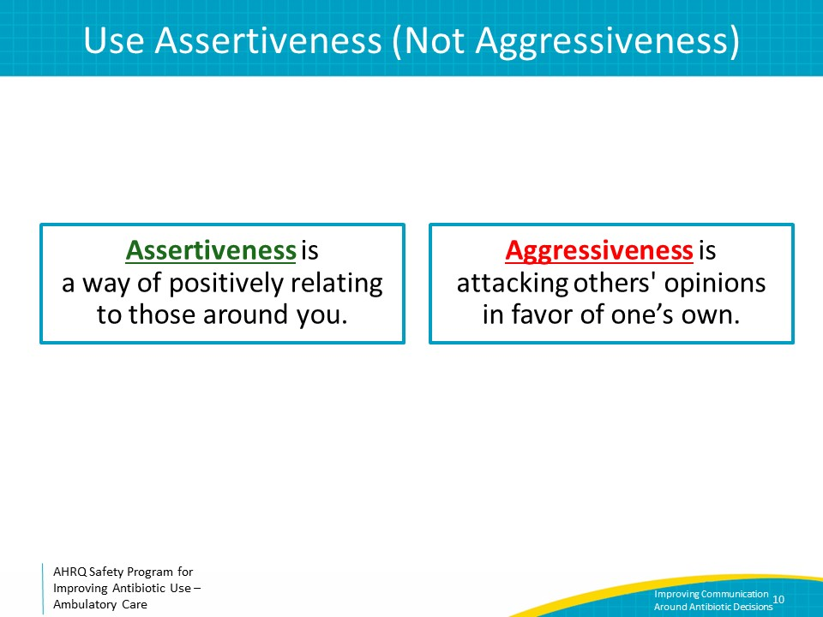
Tips for Being Assertive  SAY:  Some approaches to facilitate appropriate assertiveness include the following.  - First, focus on the common goal, which is high-quality care, the welfare of the patient, and patient safety. Everyone wants safe and high-quality care for patients.  - Second, do not cast blame. Again, focus on what is best for the patient.  - Third, don’t attack the person you are talking to. Depersonalize the conversation.  - Fourth, do not be judgmental. This can be hard—think actively as you are talking to make sure what you’re saying won’t be perceived as judgmental.  - Fifth, focus on the problem. Be hard on the problem and not on the people.  Let’s consider an example. If one clinician tends to always prescribe antibiotics for acute bronchitis, and a patient has had a reaction to antibiotics, perhaps a reasonable comment is, "I am concerned that the patient had a reaction to an antibiotic that she may not have needed. How do you think we can ensure that our patients get antibiotics only when appropriate to make things safer for them in the future?"  Legitimate patient safety concerns can be raised without attacking the prescriber and by focusing on approaches to improving patient care. | Slide 11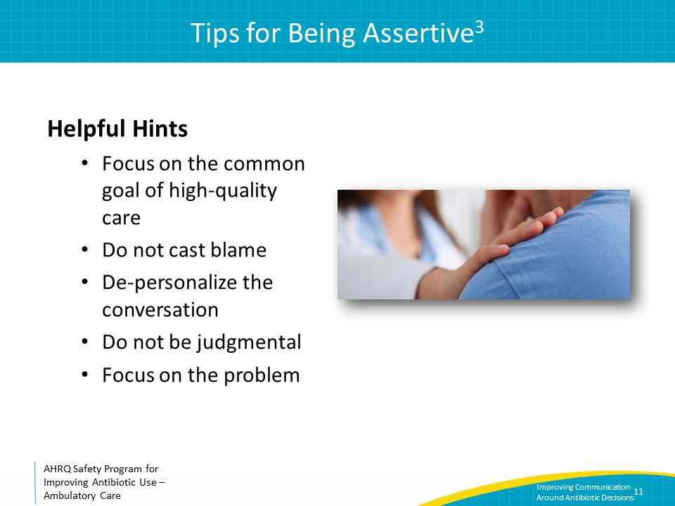
Advocacy and Assertiveness  SAY:  Advocacy and assertion are used to support the patient when a practice member’s viewpoints do not coincide with those of another practice member. When advocating for the patient, practice members should assert their opinion in a firm and respectful manner, providing evidence or data to support their concerns.  Assertive statements should—  - Open the discussion  - State the concern  - Offer a solution  - Obtain an agreement | Slide 12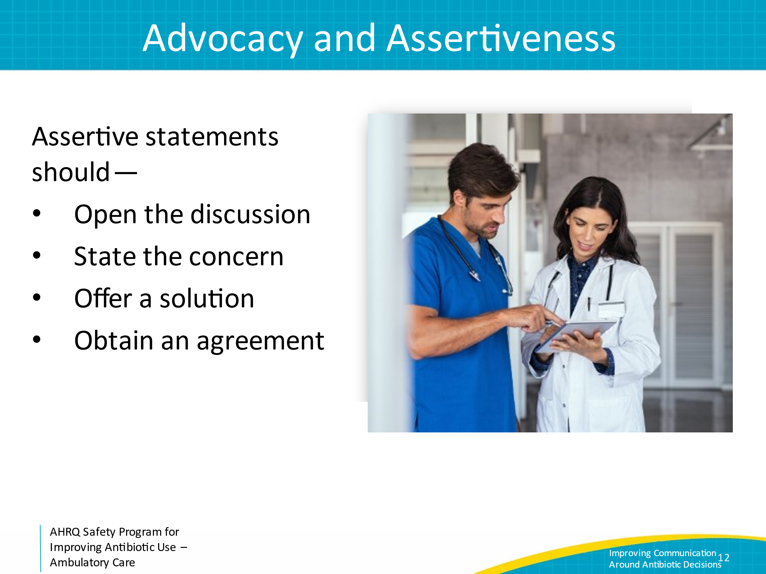
Two-Attempt Rule  Whenever communication is not effective, use the two-attempt rule. Always make two attempts to reach a common goal. If still not being heard, escalate concerns to the next level.  For example, one may state the following to a colleague: “I am concerned that we have been seeing several patients with severe hypersensitivity reactions when receiving trimethoprim-sulfamethoxazole. During our next practice meeting, should we discuss the guidance we want to provide to patients when receiving this antibiotic and think of conditions for which alternative antibiotics could be considered?  The colleague may state, “I’ve not noticed this to be a problem. We have enough other things to focus on.”  In this situation, the first clinician might want to respond with a comment such as, “I agree there are several other topics that warrant discussion during our practice meetings but there have been two patients prescribed trimethoprim-sulfamethoxazole in the past 2 weeks alone who went to urgent care clinics because they developed severe rashes soon after starting this medication.”  If the second clinician remains dismissive, the first clinician could consider discussing his or her concerns with a more senior member of the practice. | Slide 13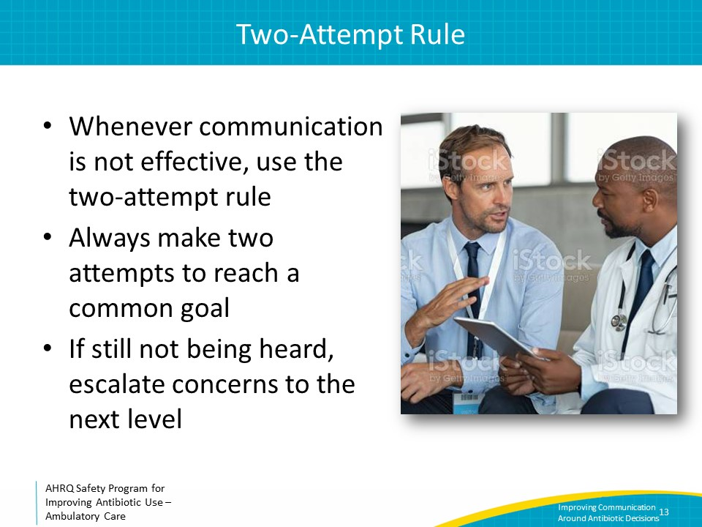
Take-Home Messages  SAY:  Consistent practicewide messages and management strategies that have been developed with input from all members will enable the practice to function more efficiently, improve patient satisfaction, and improve patient safety.  Effective communication between members of the practice includes being assertive and not aggressive, focusing on best care for the patient rather than being judgmental about colleagues, and making two attempts to reach a consensus before escalating a problem. | Slide 14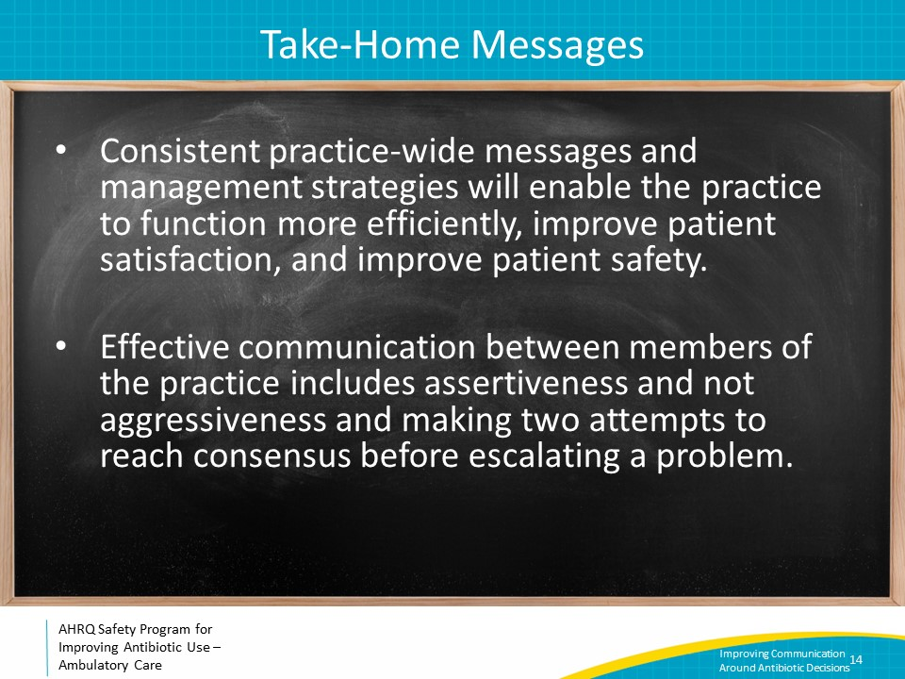
Disclaimer  SAY:  The findings and recommendations in this presentation are those of the authors, who are responsible for its content, and do not necessarily represent the views of AHRQ. No statement in this presentation should be construed as an official position of AHRQ or of the U.S. Department of Health and Human Services.  Any practice described in this presentation must be applied by healthcare practitioners in accordance with professional judgment and standards of care in regard to the unique circumstances that may apply in each situation they encounter. These practices are offered as helpful options for consideration by healthcare practitioners, not as guidelines. | Slide 15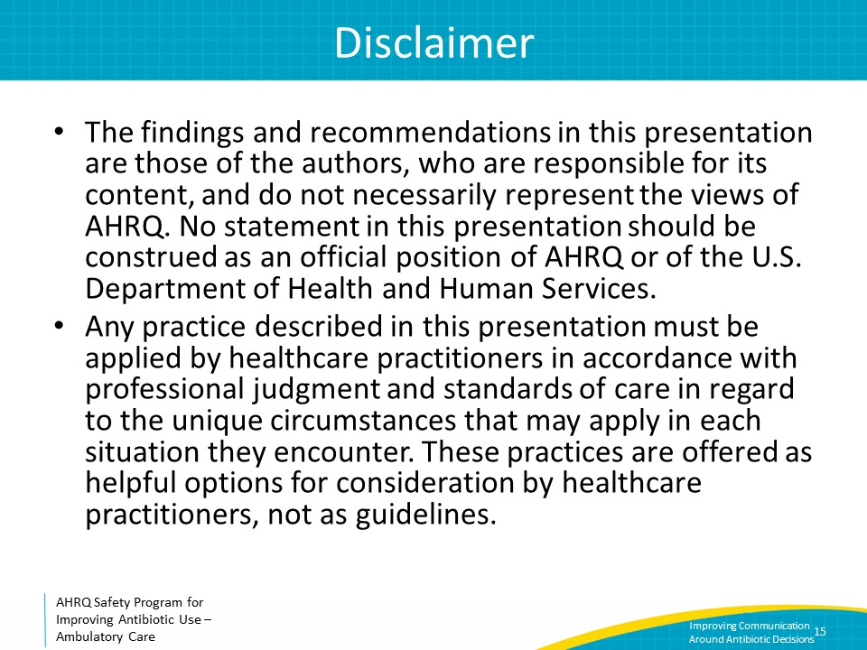
References  SAY:  Here are the references. | Slide 16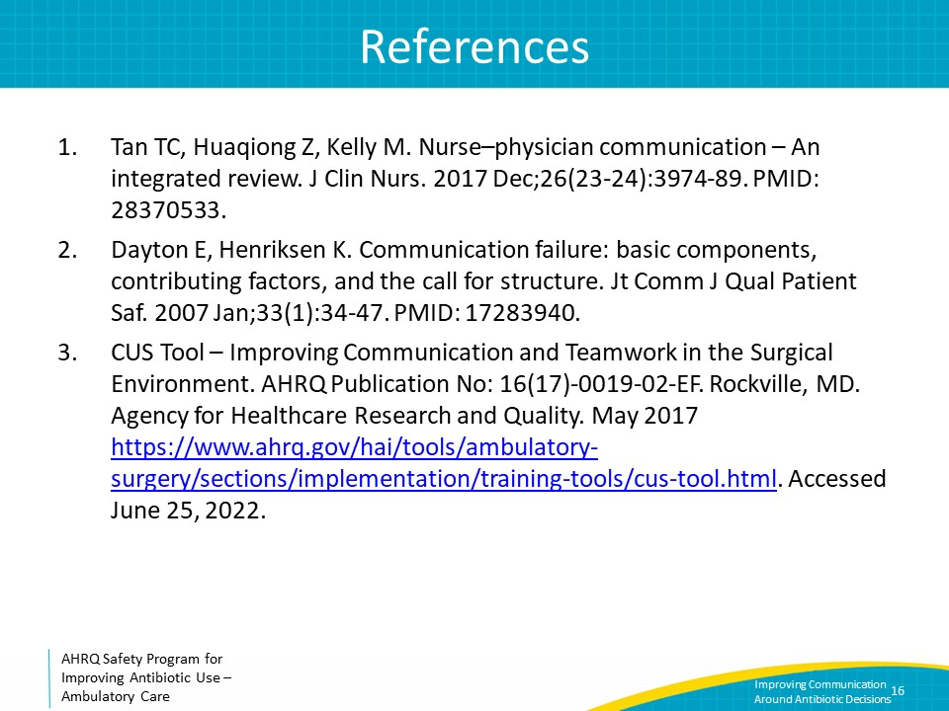
AHRQ Pub. No. 17(22)-0030
September 2022

