The “Never Antibiotics” Diagnoses:
Influenza and RSV
Ambulatory Care

Slide Title and Commentary | Slide Number and Slide
The “Never Antibiotics” Diagnoses: Influenza and RSV  Ambulatory  SAY:  Welcome to this presentation titled, “The ‘Never Antibiotics’ Diagnoses: Influenza and Respiratory Syncytial Virus, or RSV.” | Slide 1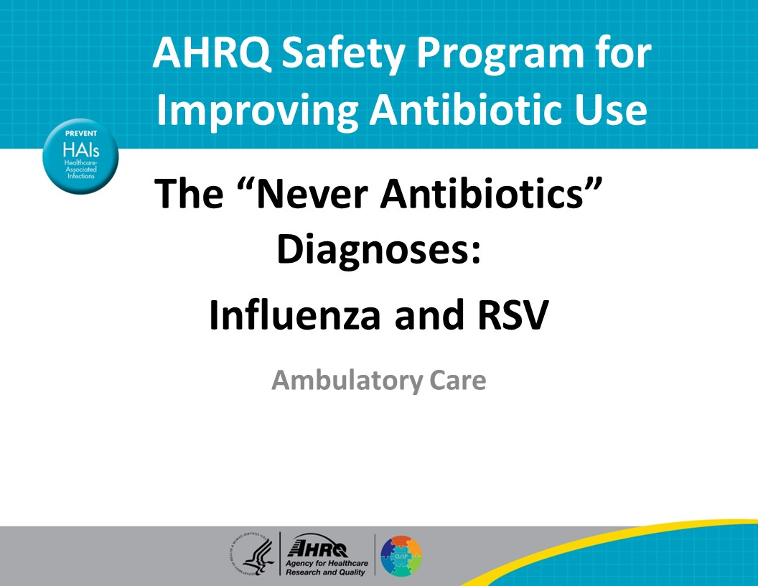
Objectives  SAY:  By the end of this presentation participants will be able to—  - Describe how to diagnose influenza  - Explain the role of antivirals for treatment of influenza and  - Describe how to diagnose and treat RSV | Slide 2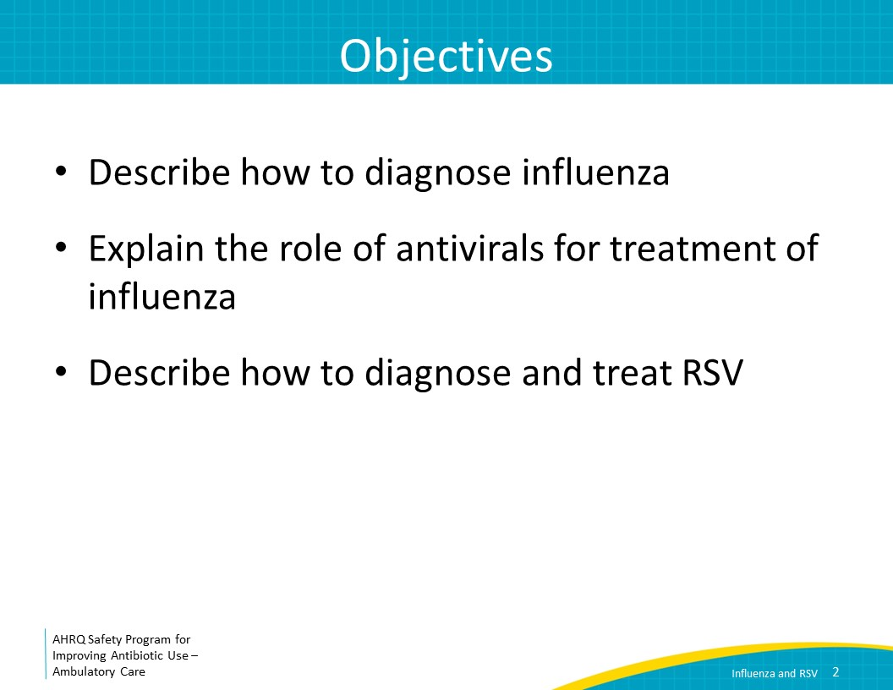
The Four Moments of Antibiotic Decision Making  SAY:  We will review influenza and RSV using the Four Moments of Antibiotic Decision Making. These are the questions you should ask yourself while seeing a patient with a presumed infectious diseases syndrome.  First, does my patient have an infection that requires antibiotics?  Second, do I need to order a diagnostic test?  Third, if antibiotics are indicated, what is the narrowest, safest, and shortest regimen I can prescribe?  Fourth, does my patient understand what to expect and the followup plan? | Slide 3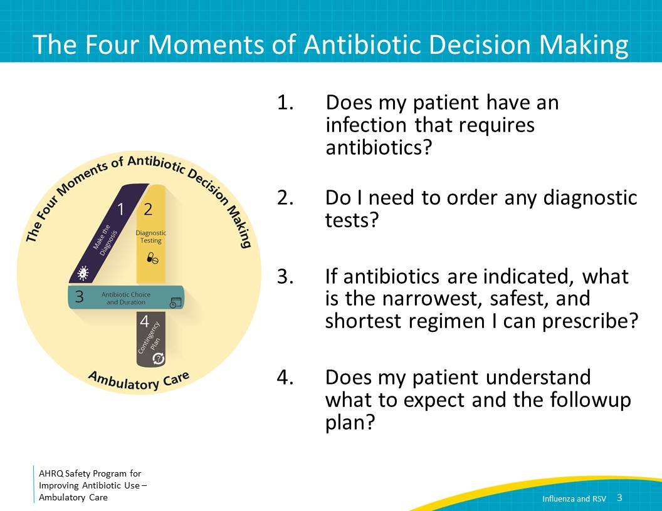
The Four Moments of Antibiotic Decision Making  SAY:  Moment One is: Does my patient have an infection that requires antibiotics? | Slide 4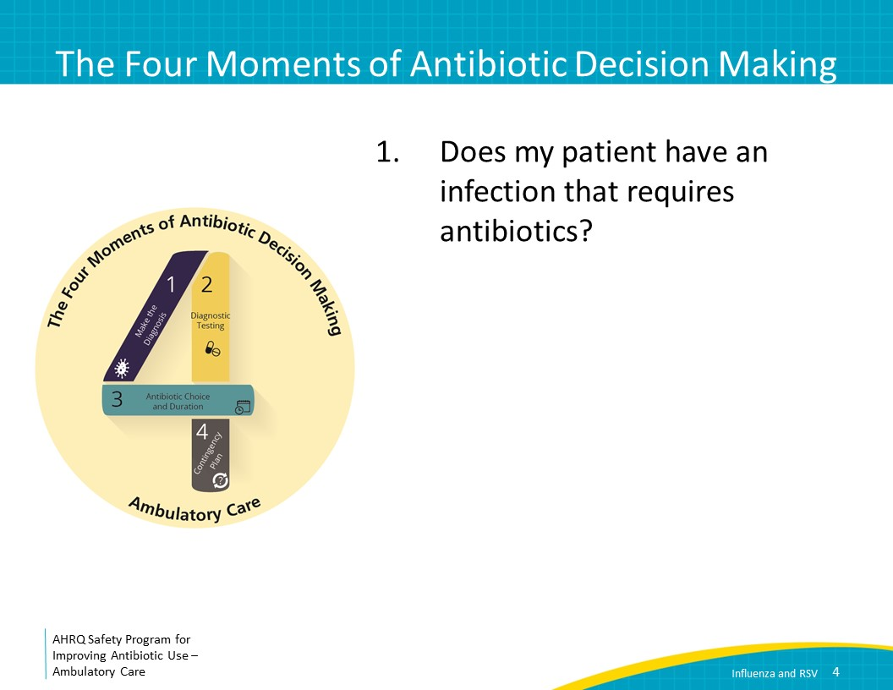
Case Presentation #1  SAY:  Let’s start with a case.  You see a 35-year-old man with no past medical history who reports 2 days of myalgias, subjective fevers, and cough. It is February, and he did not get his influenza vaccination this year.  On exam, his temperature is 101, his blood pressure is 130/85, his pulse is 74 beats per minute, and his oxygen saturation is normal at 97 percent. He appears ill and uncomfortable, with pharyngeal erythema and diffuse rhonchi on exam of his lungs.  What should you recommend? | Slide 5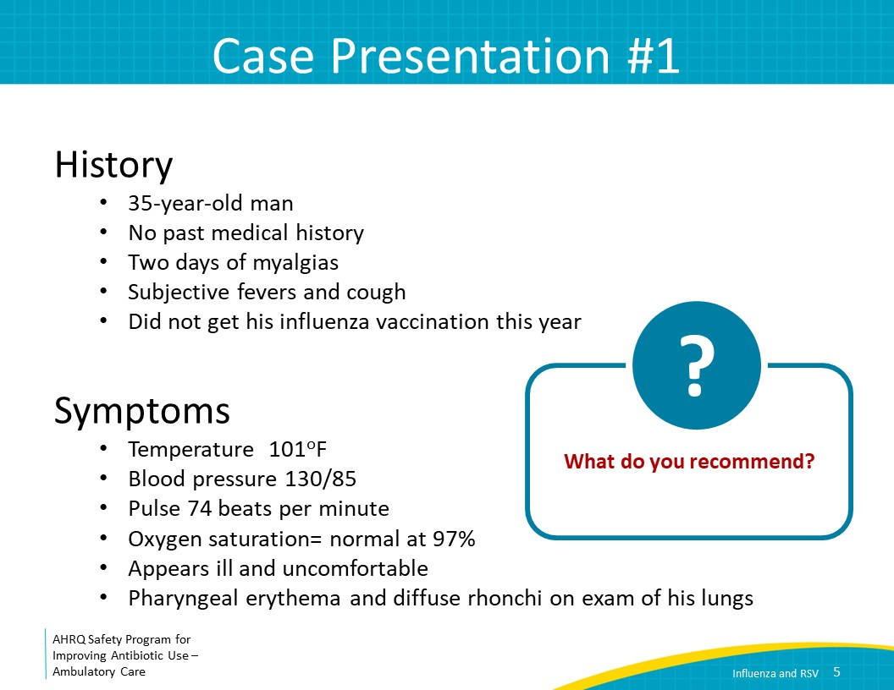
Moment 1: Influenza  SAY:  Let’s talk about Moment One. Does my patient have an infection that requires antibiotics?  This patient most likely has influenza. Patients with a high clinical likelihood of or confirmed influenza should not be treated with antibiotics unless there is concern for a bacterial pneumonia superinfection. We will discuss this later in the presentation. | Slide 6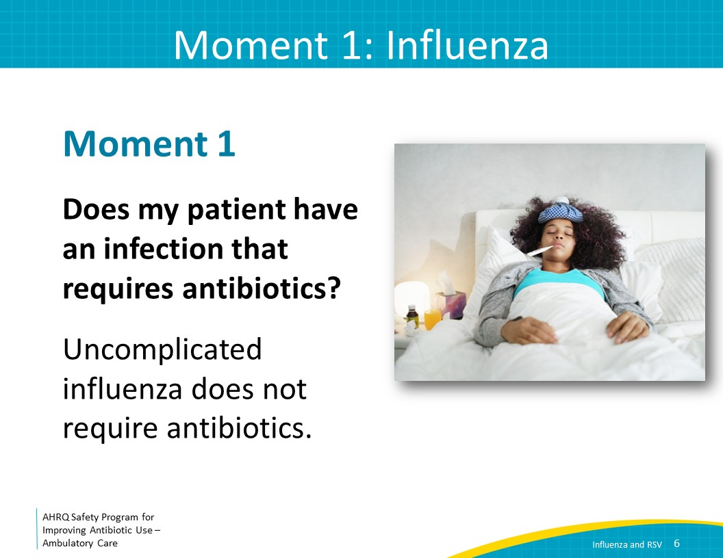
Influenza Statistics  SAY:  Between 3 percent and 11 percent of all people in the United States develop symptomatic influenza in a typical season. Most have a mild illness that seems like a cold. However, a subset of people develops severe influenza. Influenza is responsible for up to 960,000 hospitalizations and up to 79,000 deaths in the United States annually. | Slide 7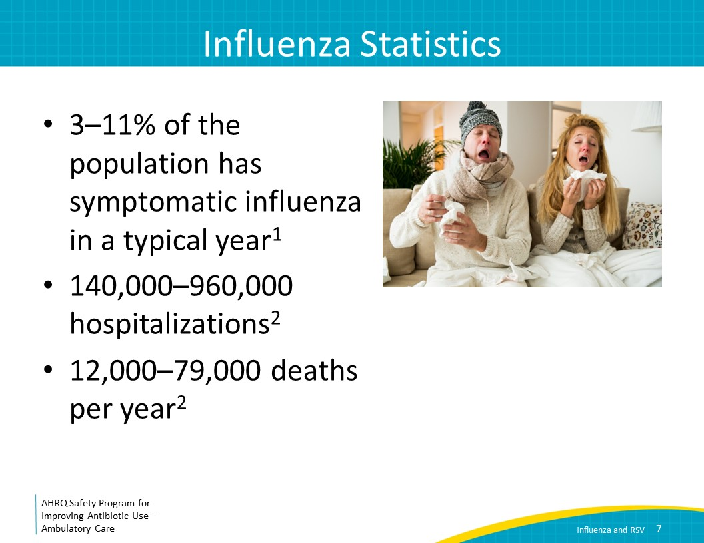
Moment 1: Diagnosis  SAY:  You should suspect influenza in patients with typical symptoms if influenza is prevalent in the community.  Although the influenza season is typically considered to start in October and end in May, moderate or high influenza activity generally begins in December and lasts through March. There is variation by State and by year, so it is useful to seek information about influenza prevalence for your area. This can be found on the Centers for Disease Control and Prevention’s influenza website. You should also check State and local health department websites for more local data. | Slide 8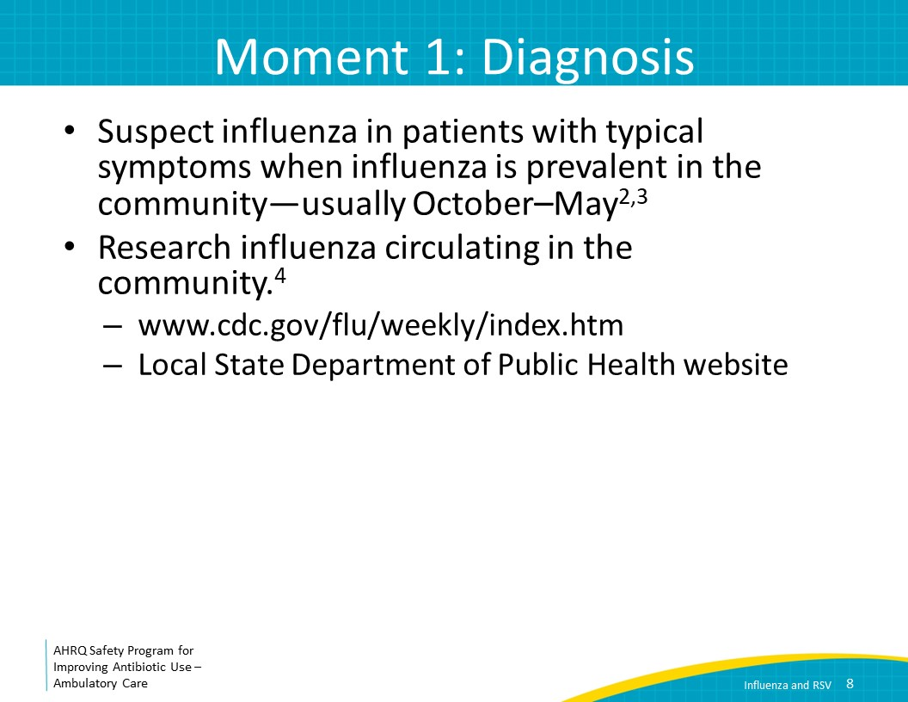
Moment 1: Diagnosis  SAY:  The most common symptoms of influenza are fever, headache, sore throat, myalgias, cough, and rhinorrhea.  An acute onset of a cough and fever has a positive predictive value of at least 70 percent in adult outpatients when influenza is known to be circulating.  This means that if influenza is in the community, 70 percent of adult patients coming in with acute-onset cough and fever have influenza.  The physical exam in patients with suspected influenza can be helpful to clarify whether the patient has bacterial pneumonia. While diffuse rhonchi suggest a viral process, focal findings—rhonchi, crackles, or decreased breath sounds—may indicate a lobar bacterial pneumonia.  Note that while the influenza vaccine is the most important way of preventing influenza and, importantly, its complications, patients can have received the vaccine and still contract influenza. Depending on the patient, the vaccine, and its match with the circulating strains, the effectiveness of the vaccine can range from approximately 40 percent to 60 percent. Even if the vaccine does not prevent developing the flu, it can lessen the severity, which is very important to stress to patients. | Slide 9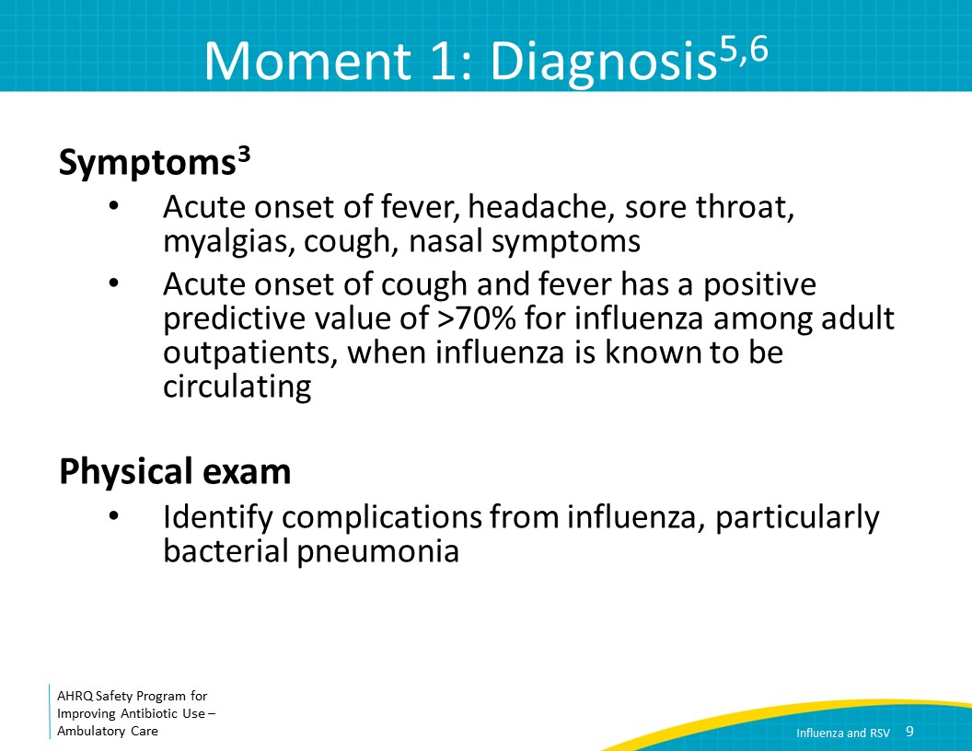
The Four Moments of Antibiotic Decision Making  SAY:  Let’s move on to moment Two.: Do I need to order any diagnostic tests? | Slide 10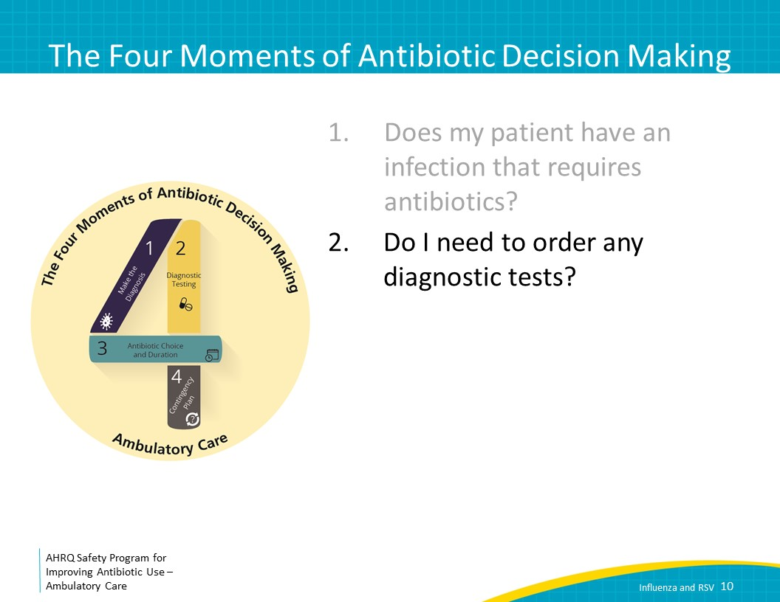
Moment 2: Testing  SAY:  In a patient with influenza symptoms, the decision to test for influenza depends on the prevalence of influenza and on your patient’s risk for complications or hospitalization.  If the prevalence of influenza is low and the patient’s symptoms are nonspecific, testing for influenza is not necessary because influenza is less likely, and a false positive test result is more likely than a true positive.  If there is a high prevalence of influenza or a regional epidemic, influenza testing is also not needed since patients who meet criteria for treatment can receive empiric therapy. Further, if the patient is stable, treatment can be started over the phone, preventing the patient from exposing other patients in your waiting room to the flu.  Influenza testing should be considered in circumstances where influenza is not highly prevalent but if the influenza test were positive, you would treat the patient.  Examples of these include when a high-risk patient including those with immunocompromising conditions present with influenzalike illness, pneumonia, or nonspecific respiratory illnesses when influenza is circulating locally.  Another example includes patients who present with the acute onset of a respiratory condition and either exacerbation of chronic conditions or a potential complication of influenza, where influenza is circulating locally, and testing will influence management.  You can also consider testing patients not at high risk for complications who present with influenzalike illness, pneumonia, or nonspecific respiratory illness when influenza is circulating if you would consider treating the patient with antivirals or providing prophylaxis to household contacts at risk of complications from influenza.  You can consider testing patients who have symptoms and history that are classic for influenza and the local prevalence is low or unknown.  Finally, you can consider testing if there was an acute onset of respiratory symptoms with or without fever, especially if the patient is immunocompromised or at high risk of complications, and influenza is not circulating at a high prevalence. | Slide 11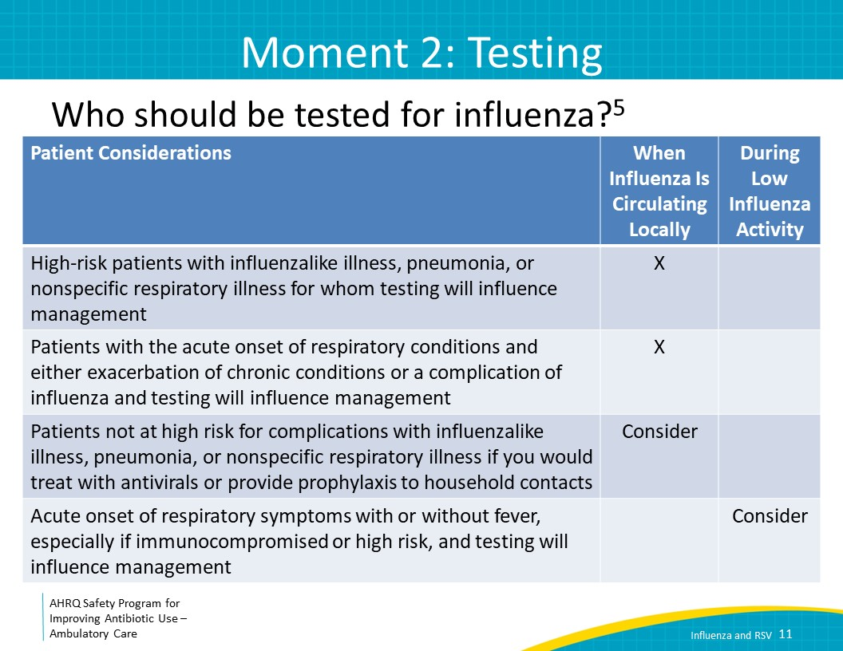
Moment 2: Testing  SAY:  Accurate influenza testing requires attention to both specimen collection and test selection.  The optimal specimen is a nasopharyngeal sample obtained with a flocked swab. Collection requires inserting the swab into the nasal cavity. There is a video on the New England Journal of Medicine website demonstrating how to obtain a nasopharyngeal swab properly. The specimen should be collected as soon as possible after the onset of illness, preferably within 4 days of the start of symptoms. | Slide 12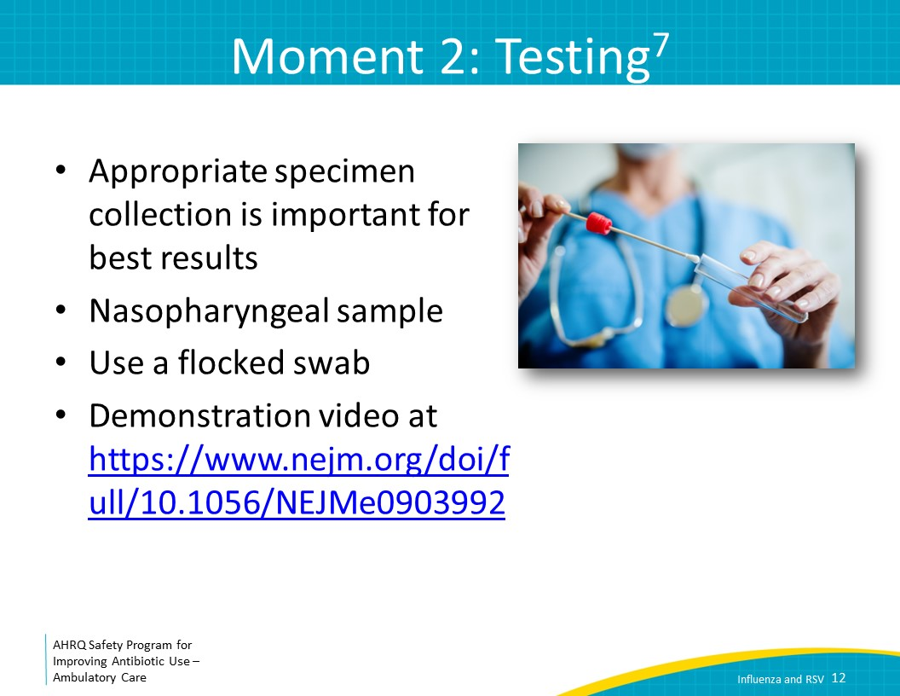
Moment 2: Testing  SAY:  Clinics use two types of tests to obtain rapid results: rapid antigen testing and rapid molecular assays. Rapid influenza direct antigen diagnostic tests look for viral antigens. These tests take only 10 to 15 minutes to run, and many are available as point-of-care tests. Most of these tests are specific—around 90 percent—so if the test is positive, you generally can trust the results. However, the tests are only 50 to 70 percent sensitive, so they frequently miss cases of influenza. Furthermore, these tests are generally better at detecting influenza A than influenza B.  Because rapid influenza antigen tests are not very sensitive, rapid molecular assays, which detect the presence of viral nucleic acids in upper respiratory tract samples, are preferred. These rapid molecular assays are both highly sensitive and highly specific. Some of these rapid molecular assays take as little as 15 to 30 minutes for results to be available and many are cleared to be used as point-of-care tests in clinics. Note that some but not all rapid antigen and molecular tests also detect the presence of RSV.  Besides the rapid tests we just discussed, other molecular tests are more commonly used in the hospital setting. Some allow for detection of other respiratory viral pathogens such as RSV, adenovirus, rhinovirus, and parainfluenza. However, these tests are not rapid, taking 45 minutes to several hours, and usually have to be conducted in a lab. Thus, they will generally not provide immediate results that clinicians can act on during an outpatient visit. If there is not access to point-of-care testing in the clinic and it is important to make the diagnosis of influenza or another respiratory virus such as in an immunocompromised patient with fever, sending out these tests can be considered.  You should determine what influenza test, if any, is available to your clinic so that you know how accurate the test is, as well as how long it takes to get a result, and what sample to collect. If you do not have a rapid test available, consider whether this might be useful for your practice.  Finally, note that viral cultures and influenza serologies do not have a role in the evaluation of patients with influenzalike illnesses and should not be sent for the purposes of routine clinical care. | Slide 13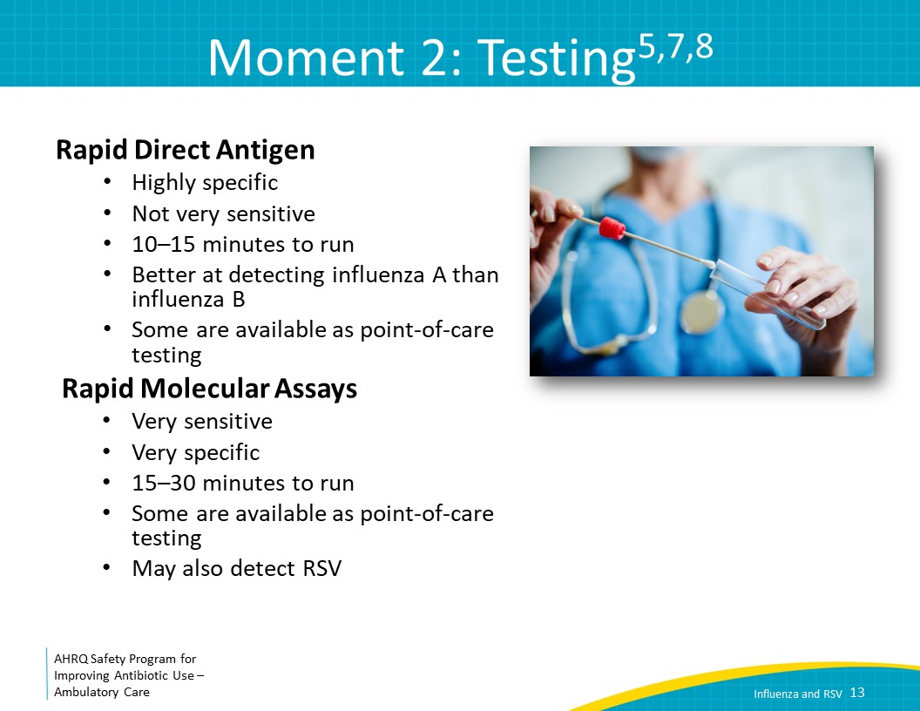
The Four Moments of Antibiotic Decision Making  SAY:  Now we will move on to Moment Three: If antibiotics are indicated, what is the narrowest, safest, and shortest regimen I can prescribe? | Slide 14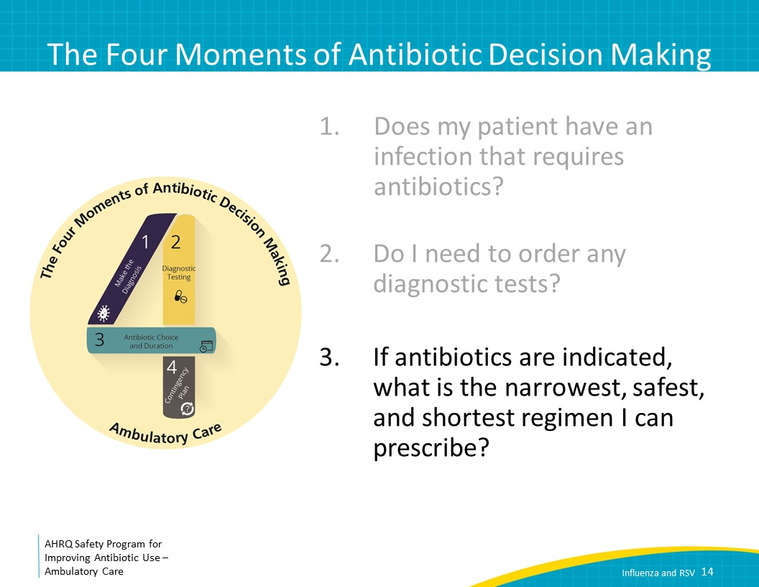
Moment 3: Treatment  SAY:  Antibiotics are not indicated to treat uncomplicated influenza in the absence of pneumonia on presentation. In addition, a small subset of patients may develop a secondary bacterial pneumonia after presenting with influenza. These patients will usually report that they were getting better and then developed new fevers and often worsening dyspnea or cough. If a patient reports these symptoms, they should be evaluated in the office or if they sound ill, be referred directly to the emergency room. | Slide 15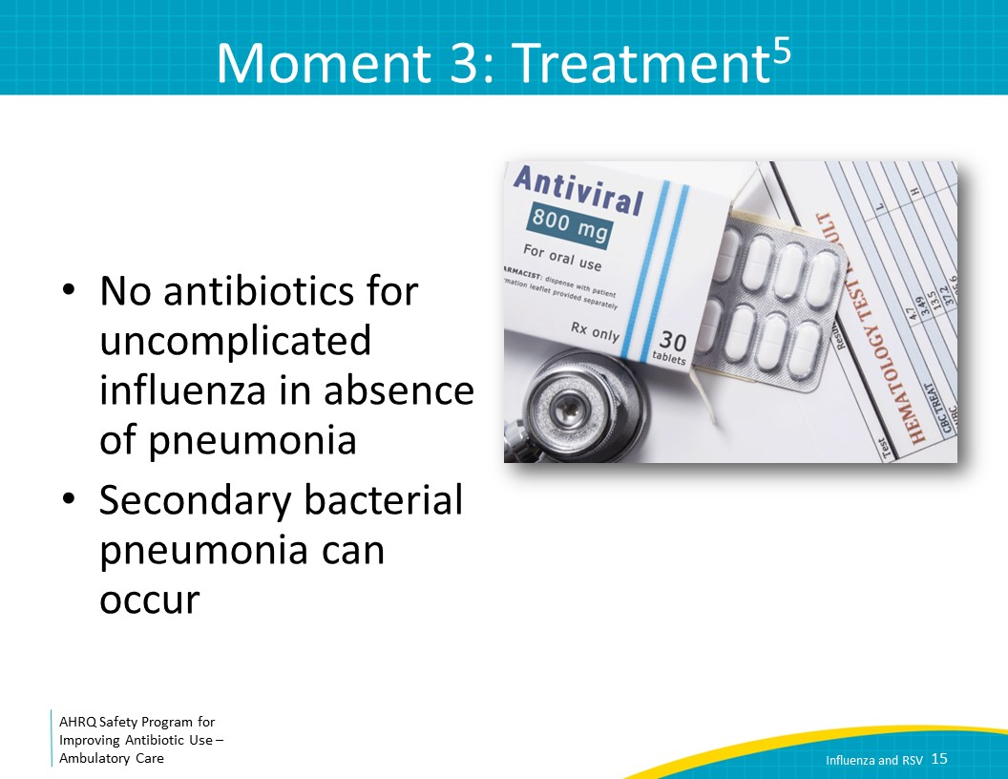
Moment 3: Treatment  SAY:  Antiviral medications should be prescribed for adults and children with documented or suspected influenza who are at high risk of complications, regardless of influenza vaccination status. This includes those with severe or progressive illness, no matter how long they have been sick, those with chronic medical conditions or with immunocompromise, children under the age of 2 years, adults 65 years or older, and pregnant women and those within 2 weeks postpartum. For patients who are at high risk for influenza complications, antiviral medications should be started as soon as possible, even as late as 5 days after symptom onset. | Slide 16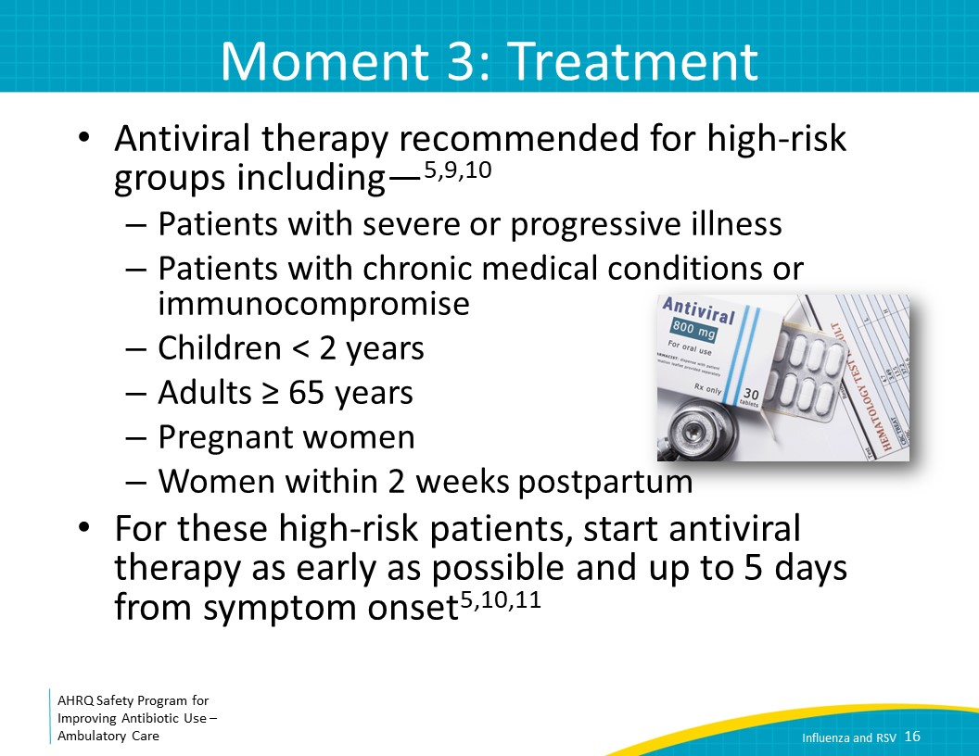
Moment 3: Treatment  SAY:  Consider antiviral treatment for adults and children who are household contacts of persons at risk of developing complications from influenza, and healthcare workers who care for patients who are at risk of developing complications from influenza.  Finally, you can consider treatment for any previously healthy outpatient with confirmed or suspected influenza. Antivirals should be initiated within 48 hours of symptom onset to have a benefit, such as reduced duration of fever and symptoms, reduced likelihood of developing acute otitis media in children, and reduced lower respiratory tract complications or hospitalizations in adults. If initiated within 48 hours of symptom onset, antiviral therapy is expected to reduce the duration of symptoms by 1 to 2 days. | Slide 17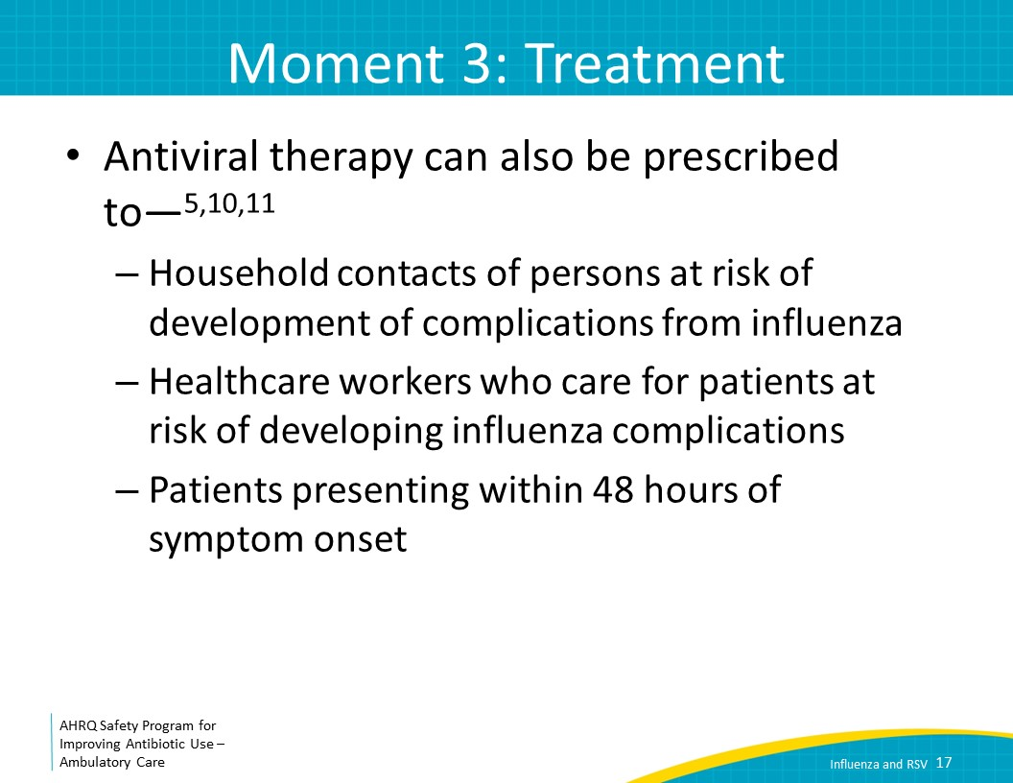
Moment 3: Treatment  SAY:  There are a few options for antiviral medications. Oral oseltamivir for 5 days can reduce the risk of complications from influenza including hospital admission in high-risk patients. Oseltamivir can reduce the duration of symptoms by 1 to 2 days in lower risk patients who are initiated on therapy within 48 hours of symptom onset.  Although the U.S. Food and Drug Administration has not approved oseltamivir in children younger than 14 days old, both the Centers for Disease Control and Prevention and the American Academy of Pediatrics recommend use of oral oseltamivir for the treatment of infants under 14 days of age with the flu. Pregnant women are at high risk of serious complications from influenza including adverse outcomes to the fetus and maternal mortality. For this reason, while data are limited, oseltamivir is encouraged for the treatment of influenza in pregnancy.  The 2018 Infectious Diseases Society of America influenza guidelines recommend inhaled zanamivir for outpatients, as an alternative to oseltamivir. The recommended dose is two inhalations twice daily for 5 days. Of note, zanamivir is approved in children ages 7 and older. There is a concern for a potential increased risk of bronchospasm with use of inhaled zanamivir, so for this reason, oseltamivir is preferred in patients with chronic lung disease such as chronic obstructive pulmonary disease, or COPD, and asthma. However, in a placebo-controlled trial of patients with influenza and mild to moderate asthma or COPD, inhaled zanamivir was well tolerated.  Baloxavir was approved in October 2018 as a single oral dose for otherwise healthy patients 12 years of age and older who have been symptomatic with the flu for less than 2 days. It works differently than other influenza antiviral drugs, so can be particularly helpful if there is known resistance circulating to antiviral drugs like oseltamivir. | Slide 18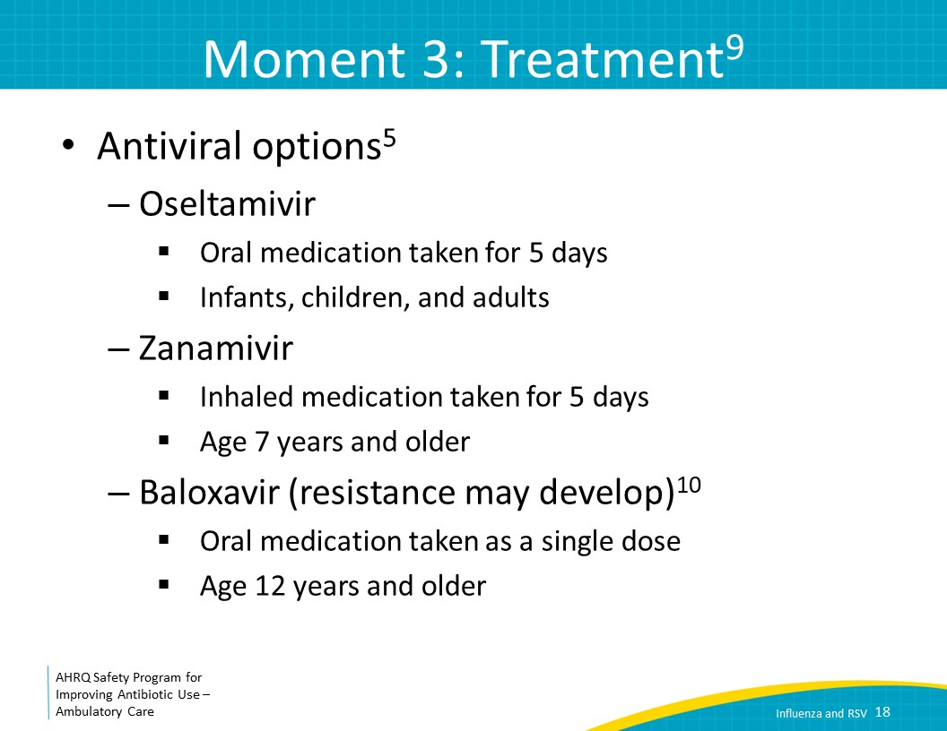
Antiviral Prophylaxis  SAY:  As an additional question, what about people who are exposed to influenza? Should they be given antiviral medications?  Patients with significant immunocompromise and other groups at high risk for complications who are household contacts to someone with influenza should be considered for prophylaxis, especially if they were unable to be vaccinated or it was thought that the vaccine would not be effective. If prophylaxis is administered to high-risk contacts of patients with influenza, it should begin within 48 hours of exposure to the infected individual. Prophylaxis should continue for 7 days after the most recent exposure, with either oseltamivir or inhaled zanamivir.  Inhaled zanamivir is also an option for adults and children at least 5 years of age requiring prophylaxis. | Slide 19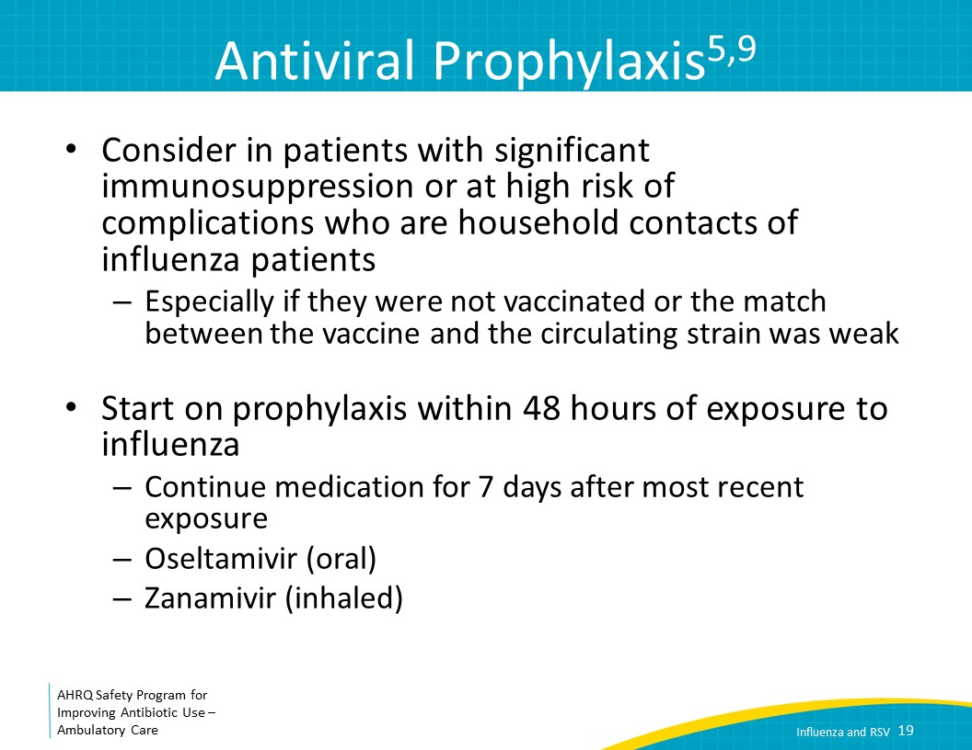
Influenza Symptomatic Treatment  SAY:  There is no good evidence for or against the effectiveness of over-the-counter medicines for symptom relief in patients with influenza. However, some medications that may help your patients include—  - acetaminophen  - nonsteroidal anti-inflammatory medications (NSAIDS)  - nasal decongestants  - oral decongestants  - antihistamine-decongestants  - and antihistamine-decongestant-analgesic combinations.  Albuterol is suggested only for patients with known issues with airflow obstruction. | Slide 20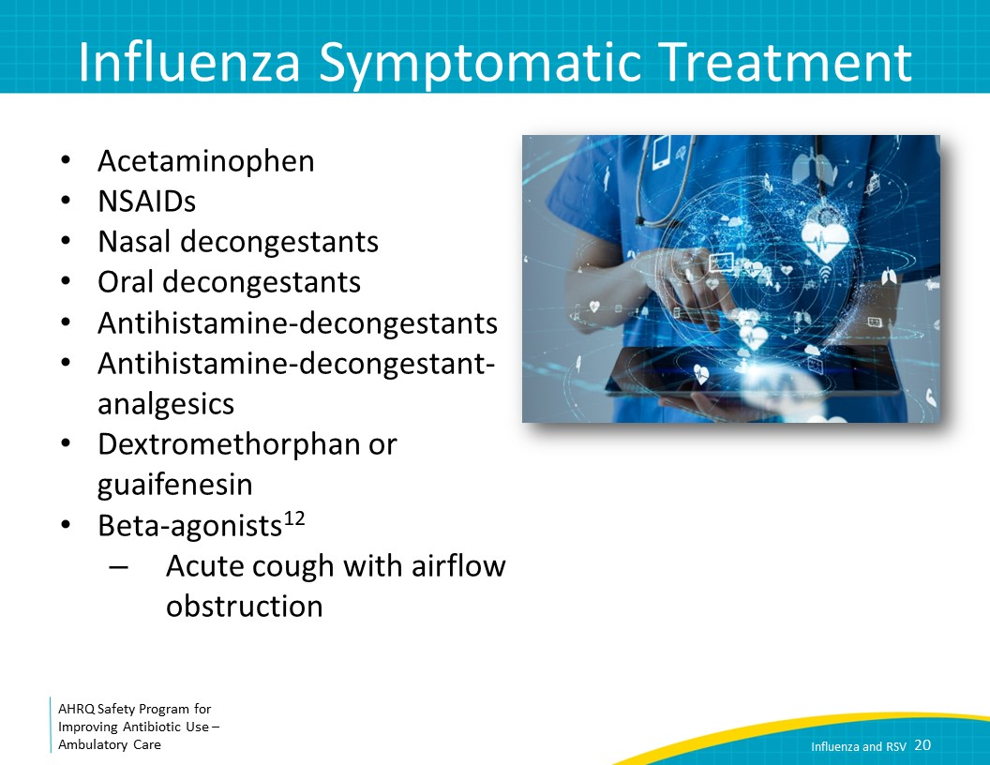
The Four Moments of Antibiotic Decision Making  SAY:  The last moment to consider is, Does my patient understand what to expect and the followup plan? | Slide 21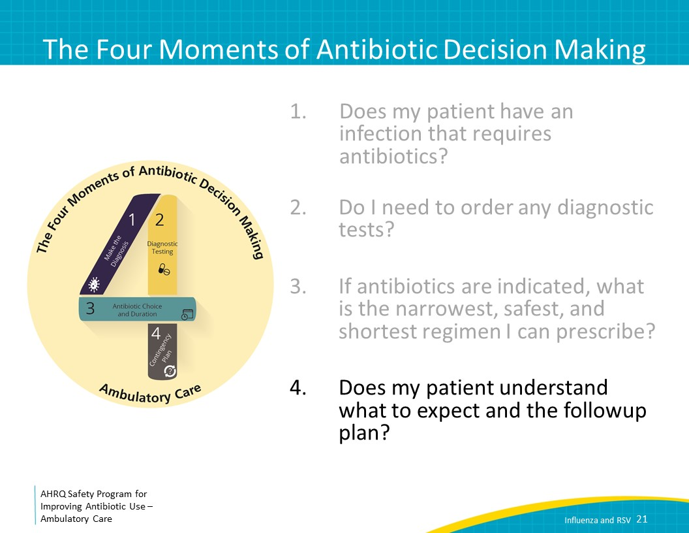
Moment 4: Followup Plan  SAY:  Patients should be aware that they will likely feel ill for a week or more. For the followup plan, give them specific reasons to return or call. For example, statements such as the following can be considered: “Call the clinic if you develop a persistent high fever, severe headache, pain in your face or forehead, severe fatigue or a rash. Go to the emergency room if you develop confusion or difficulty breathing or swallowing.” These symptoms may be signs of complications from influenza, such as a secondary bacterial pneumonia or encephalitis that should be evaluated and treated. | Slide 22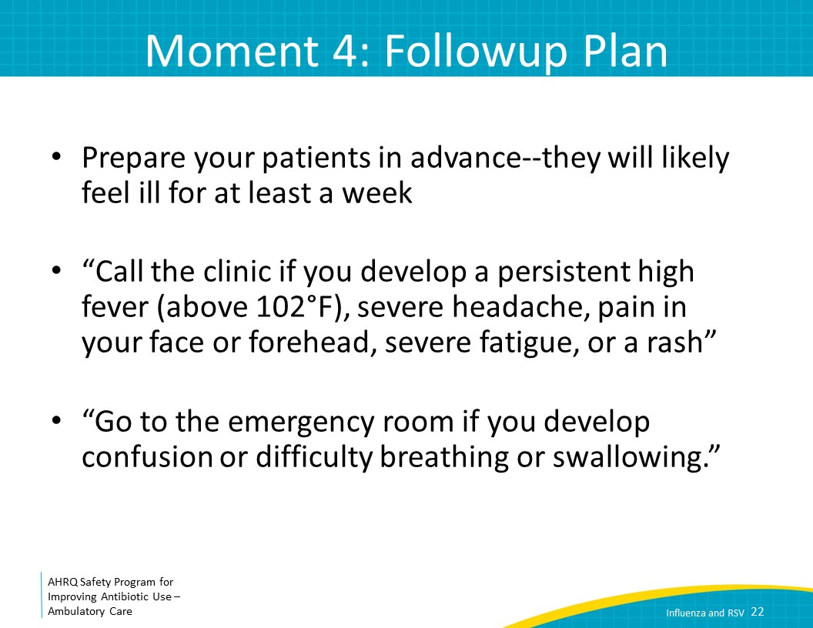
RSV  SAY:  We will now touch on respiratory syncytial virus, or RSV. While adults may get RSV, symptoms are generally mild in immunocompetent people, so we will focus the discussion on RSV in children. | Slide 23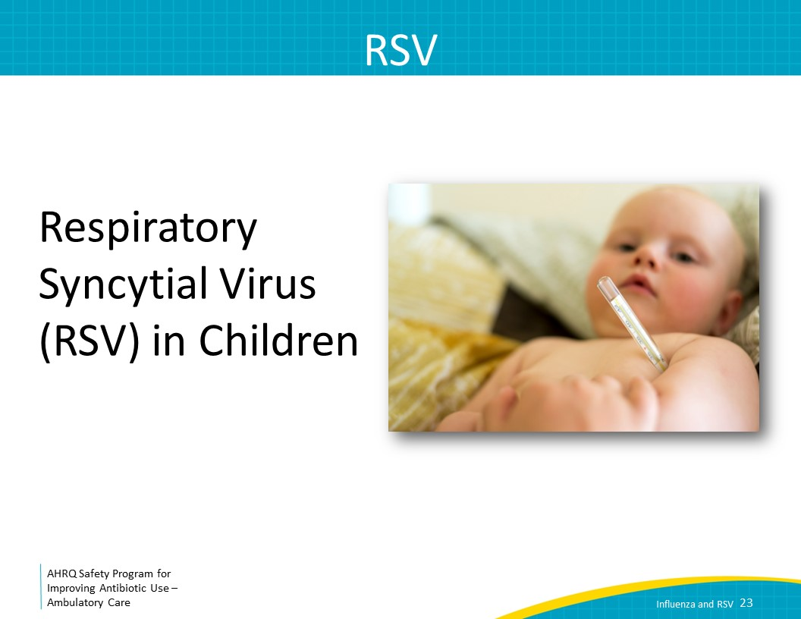
The Four Moments of Antibiotic Decision Making  SAY:  Moment One is: Does my patient have an infection that requires antibiotics? | Slide 24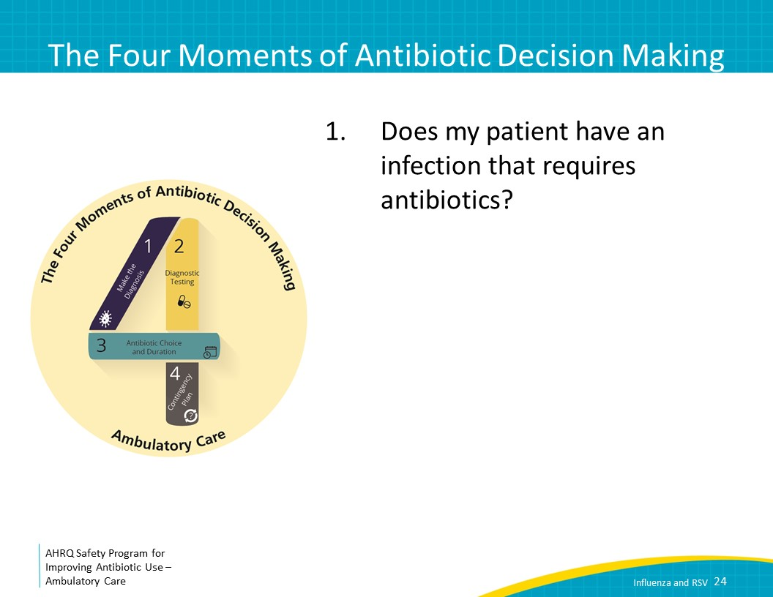
Case Presentation 2  SAY:  Let’s start with a case. It is December and you have a visit with a 4-month-old female with decreased oral intake over the past 4 days. Her temperature at home was 101 degrees Fahrenheit. Her parents bring her to your clinic as she just started coughing significantly today. On exam she has rhinorrhea and cough, and her lung exam sounds like rhonchi with some wheezing throughout. She is mildly tachypneic but has normal oxygen saturation and is breathing comfortably with no nasal flaring or retractions. | Slide 25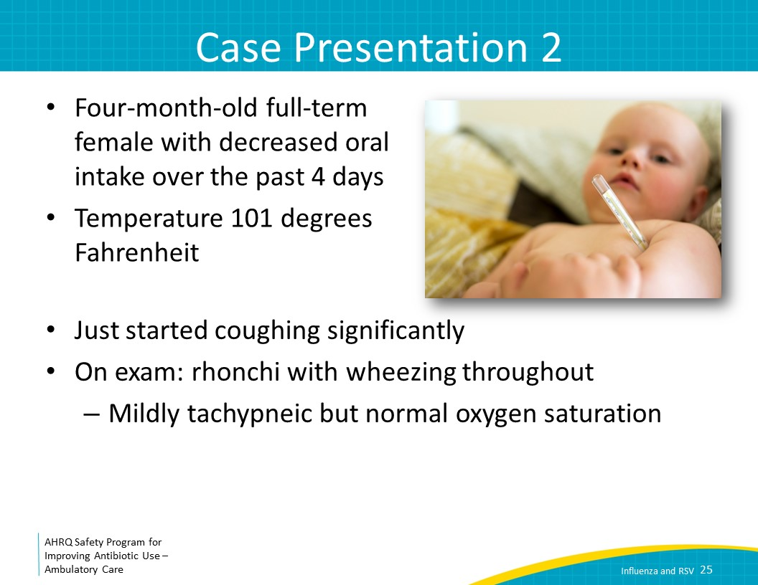
Moment 1  SAY:  Now, does my patient have an infection that requires antibiotics?  In infants this age with this clinical presentation, the most likely diagnosis is bronchiolitis, which is inflammation and congestion in the bronchioles. A common cause of bronchiolitis is RSV. RSV circulates in most of the United States in the fall through spring months. Cough and wheezing occur in about 50 percent of infected children. RSV can present with coldlike symptoms in older children, but children under 2 years old may present with more severe symptoms like high fever, decreased appetite, and progressive cough. Premature infants, infants younger than 6 months old, children younger than 2 years of age with chronic lung or heart disease, and children with immunodeficiency have an increased risk for severe symptoms of RSV—including apnea.  Antibiotics will not help. RSV should be treated with supportive care, careful anticipatory guidance, and close followup, particularly in young children. | Slide 26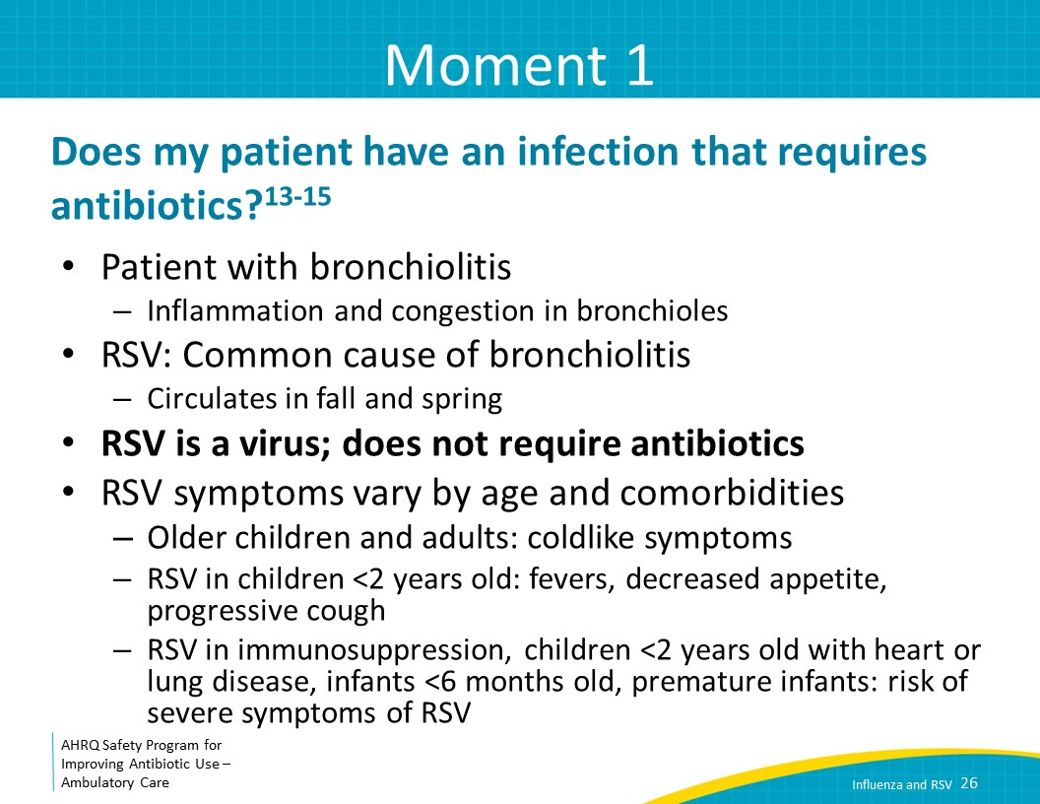
The Four Moments of Antibiotic Decision Making  SAY:  Let’s move to Moment Two: Do I need to order a diagnostic test? | Slide 27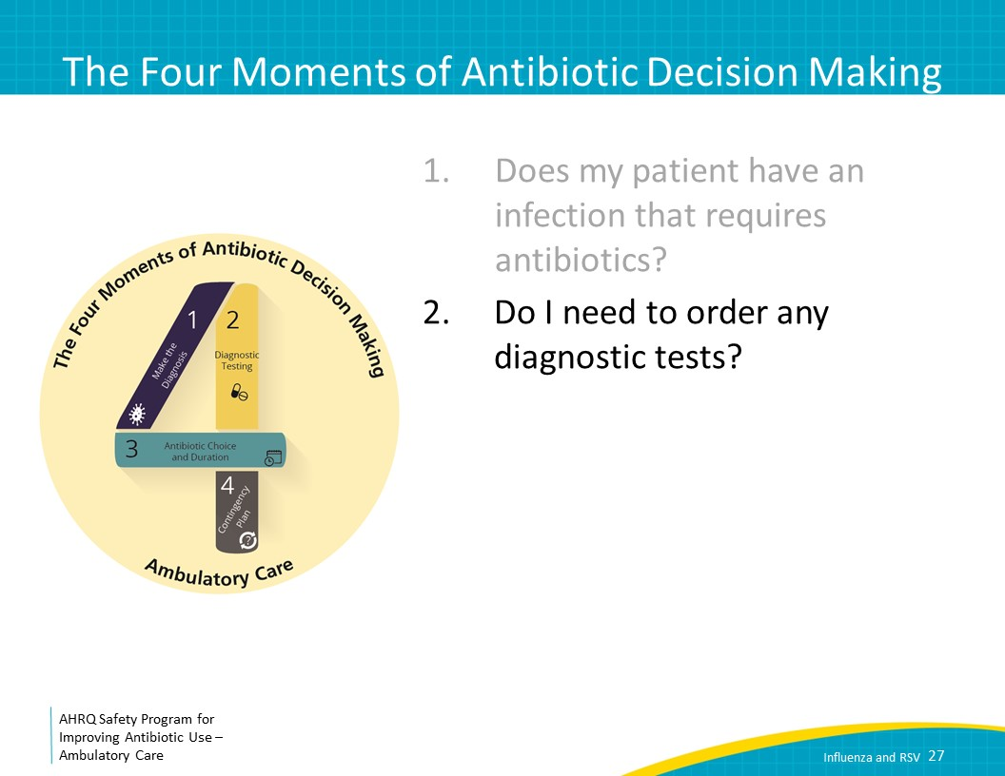
Moment 2: Diagnosis  SAY:  RSV can be suspected in young children with lower respiratory tract disease in the winter. In this circumstance, like in the height of influenza season, you may not need to test unless you are concerned about differentiating RSV and influenza.  The rest of the time, consider testing for RSV if knowing whether the patient has RSV will affect how you would manage them. For severely immunocompromised patients, testing is recommended. In this population, clinical symptoms of RSV are nonspecific and may be similar to other viral respiratory illnesses or even pneumonia. As we will discuss, it is very unusual that someone with RSV needs specific treatment other than supportive care in ambulatory care. | Slide 28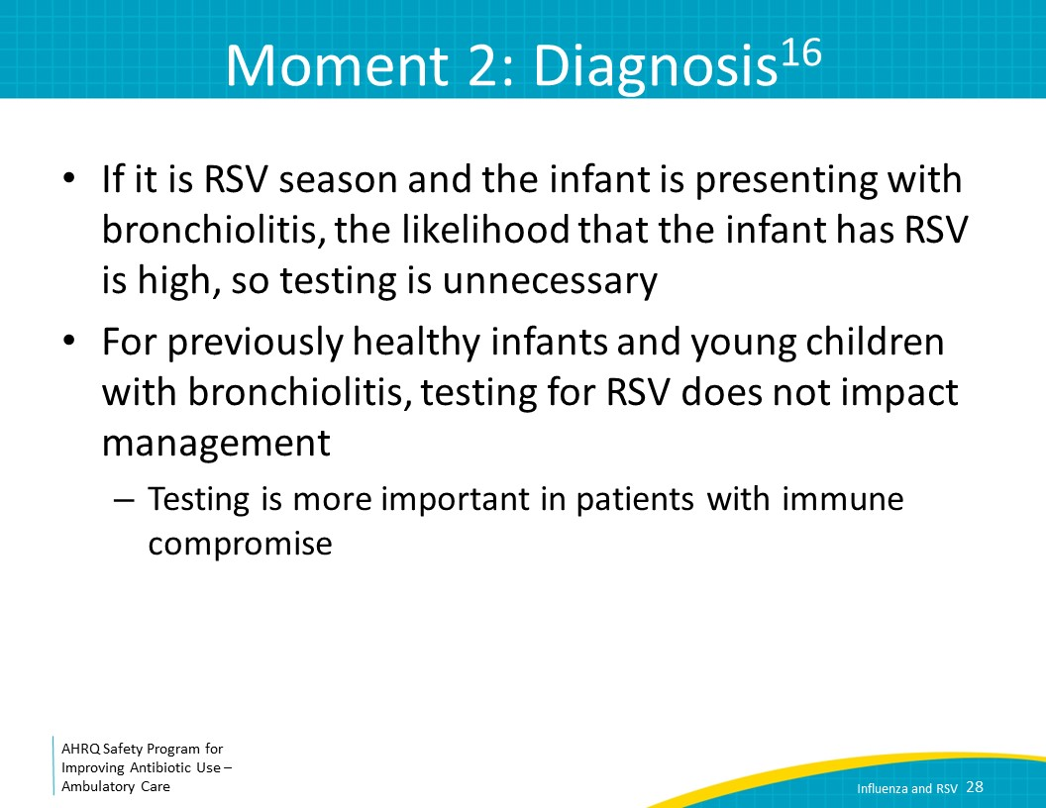
Moment 2: Diagnosis  SAY:  There are two effective methods for RSV testing, both of which involve swabbing the nasopharynx or throat. Rapid antigen testing is recommended for infants and young children with a sensitivity of 80–90 percent in this age group. Real-time reverse transcriptase-polymerase chain reaction, or RT-PCR, is recommended for older children and adults, and is usually designed as part of a PCR assay that can detect several other respiratory viruses as well. | Slide 29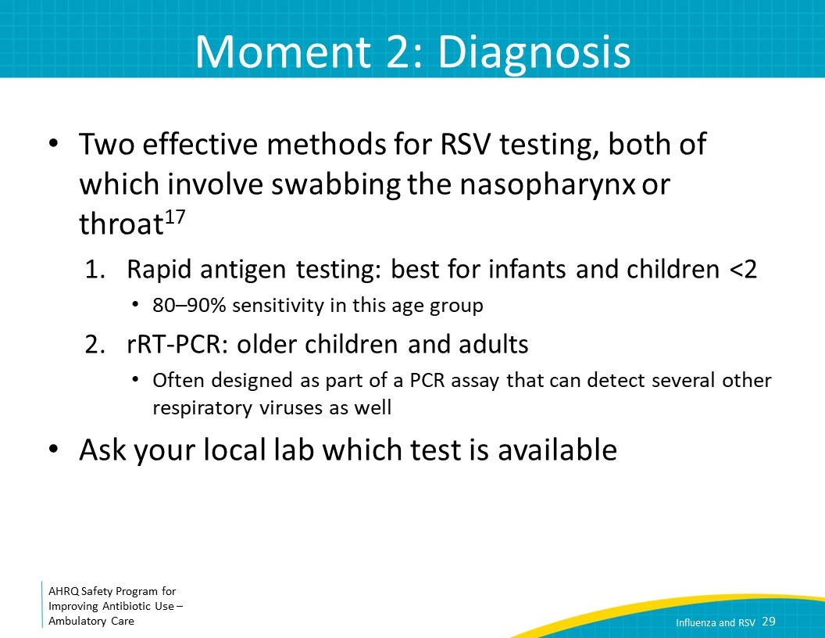
The Four Moments of Antibiotic Decision Making  SAY:  Let’s talk about Moment Three: If antibiotics are indicated, what is the narrowest, safest, and shortest regimen I can prescribe? | Slide 30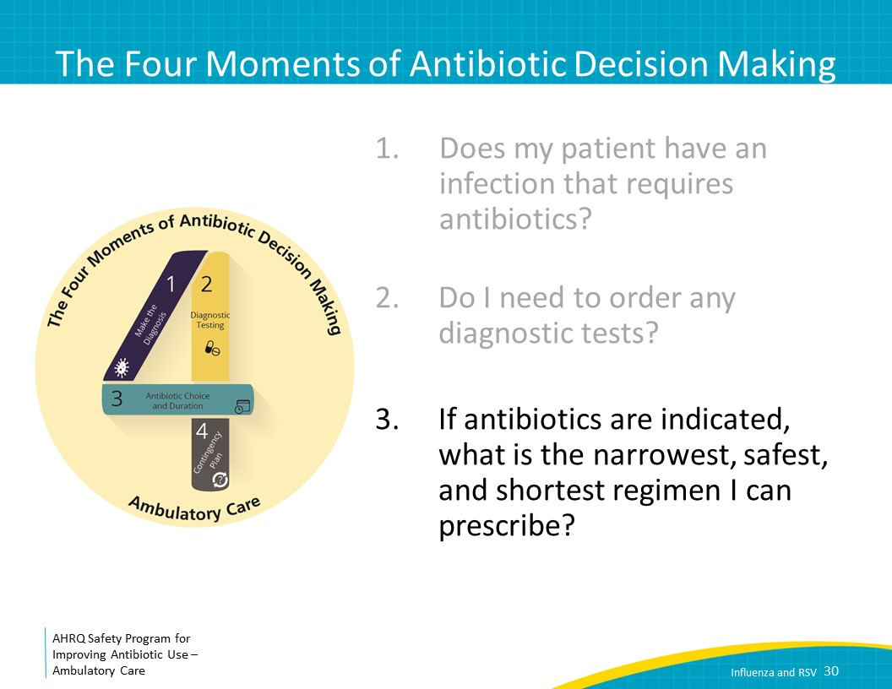
Moment 3: Treatment  SAY:  Antibiotics are not indicated for RSV. Supportive care in the home setting may include nasal bulb suctioning, ibuprofen or acetaminophen for fever, and oral rehydration solution if the child is refusing other oral intake. Steroids, inhalers, and chest physiotherapy have not been shown to be effective in reducing symptoms or the duration of illness. | Slide 31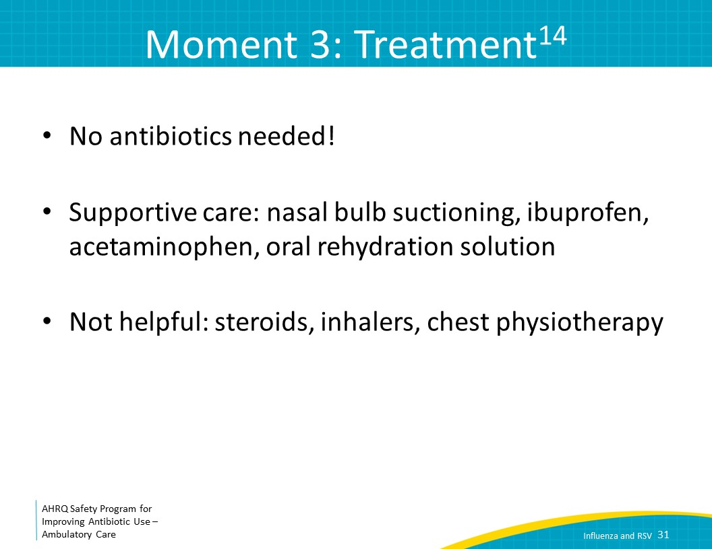
Moment 3: Treatment  SAY:  Antiviral therapy, such as ribavirin, should not be routinely used for infants or children with RSV, especially in the outpatient setting. Severely immunocompromised children such as those with hematologic malignancies, bone marrow transplants, or solid organ transplants generally require hospitalization and treatment with ribavirin regardless of the severity of illness. Outside of these groups, RSV is treated with supportive care, careful anticipatory guidance, and close followup, particularly for young children. | Slide 32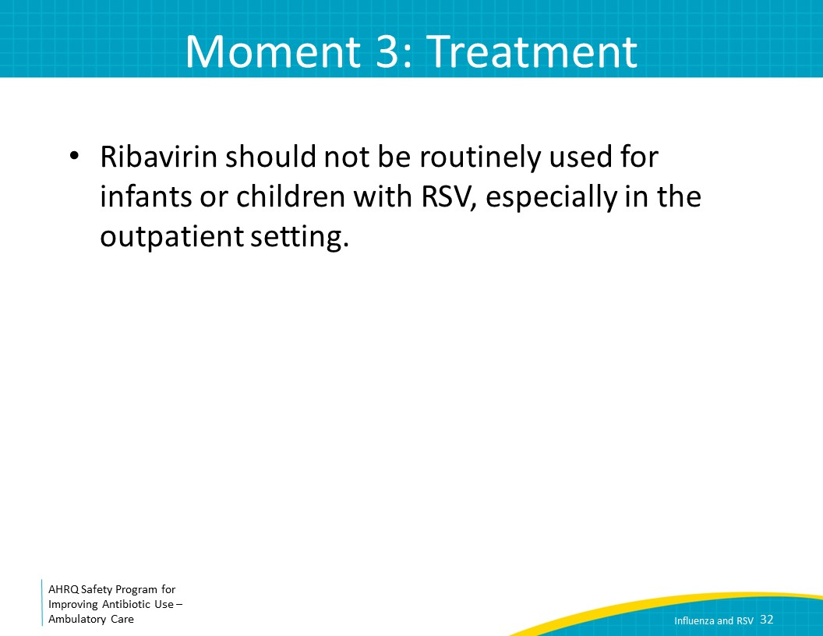
RSV Prevention  SAY:  Premature infants, healthy infants younger than 6 months old, children younger than 2 years of age with chronic lung or heart disease, and children with immunodeficiency may be at increased risk for severe illness. Infants in the first 2 years of life with increased risk for severe illness may qualify for palivizumab monoclonal antibody prophylaxis during RSV season. Criteria for use of palivizumab are regularly changing, so consult with the American Academy of Pediatrics or AAP policy statement on palivizumab prophylaxis for the most current recommendations for administration. | Slide 33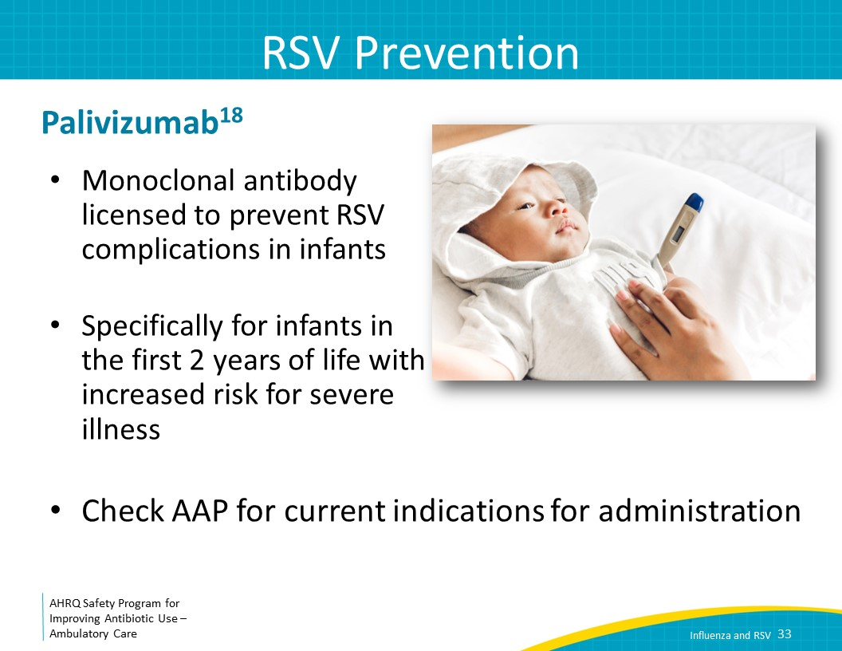
The Four Moments of Antibiotic Decision Making  SAY:  The last moment to consider is, Does my patient understand what to expect and the followup plan? | Slide 34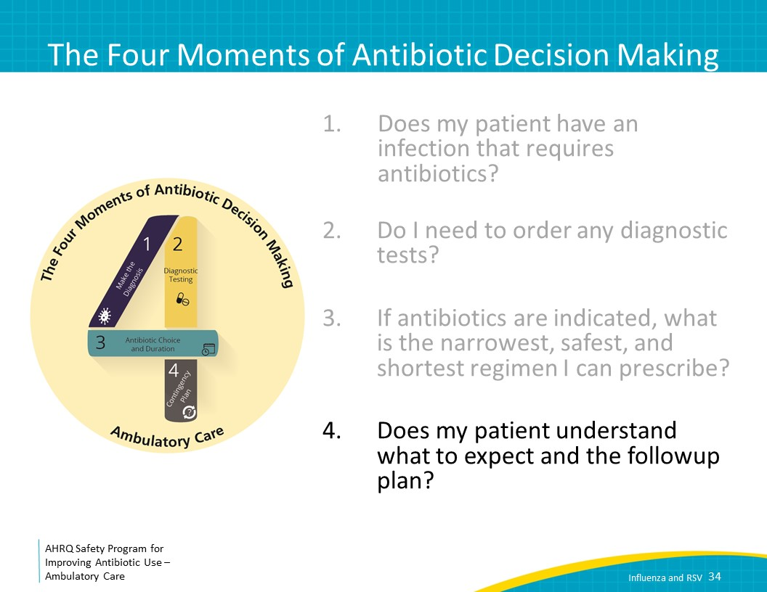
Moment 4: Followup Plan  SAY:  Does my patient know what to expect and the followup plan? RSV symptoms peak around day 5 of illness and start to improve by 7–10 days. For the family of the 4-month-old, it is prudent to counsel them to expect possible increased cough and work of breathing as the child goes into her fifth day of illness. Respiratory distress, hypoxia, and dehydration may result in hospitalization. Premature infants, healthy infants less than 6 months old, children less than 2 years of age with chronic lung or heart disease, and children with immunodeficiency may be at increased risk for severe illness, so close followup is recommended for these groups. | Slide 35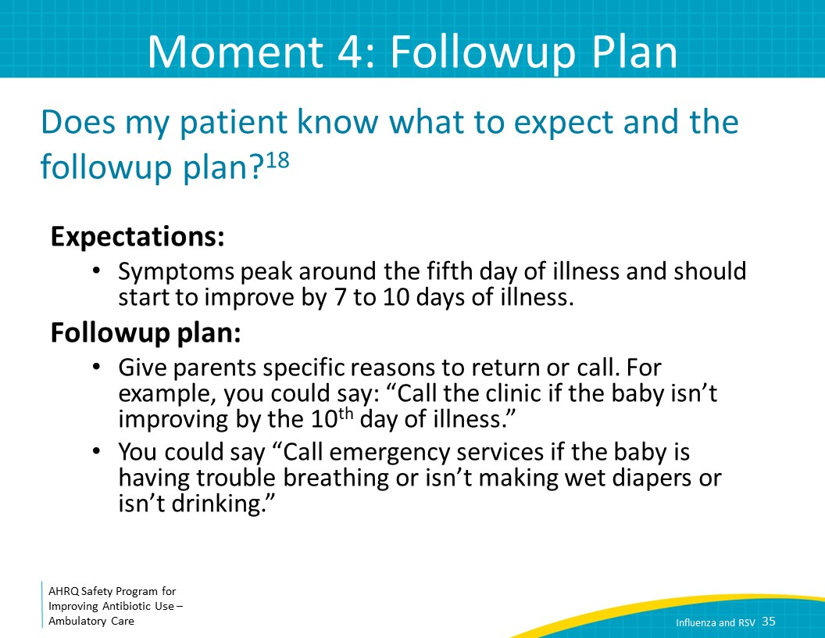
Take-Home Messages  SAY:  Let’s summarize this presentation.  The most important information to know when considering a diagnosis of influenza is whether influenza is prevalent in your community and whether the patient has typical symptoms. Testing should be considered in patients in whom a positive result would lead to treatment, most commonly with oseltamivir.  Critical groups of patients who should be treated include those with severe or progressing illness, those with chronic medical conditions, including the immunocompromised, children under age 2 years, adults age 65 years and older, pregnant women, and women within 2 weeks postpartum.  For RSV, antibiotics are not indicated. Instead, treat with supportive therapy such as oral rehydration solution, acetaminophen or ibuprofen, and nasal bulb suctioning. Most of the time, diagnostic testing is not indicated as it will not change management of patients with RSV. Infants and children with RSV often get worse through around day 5 of illness but should slowly start to get better thereafter. | Slide 36 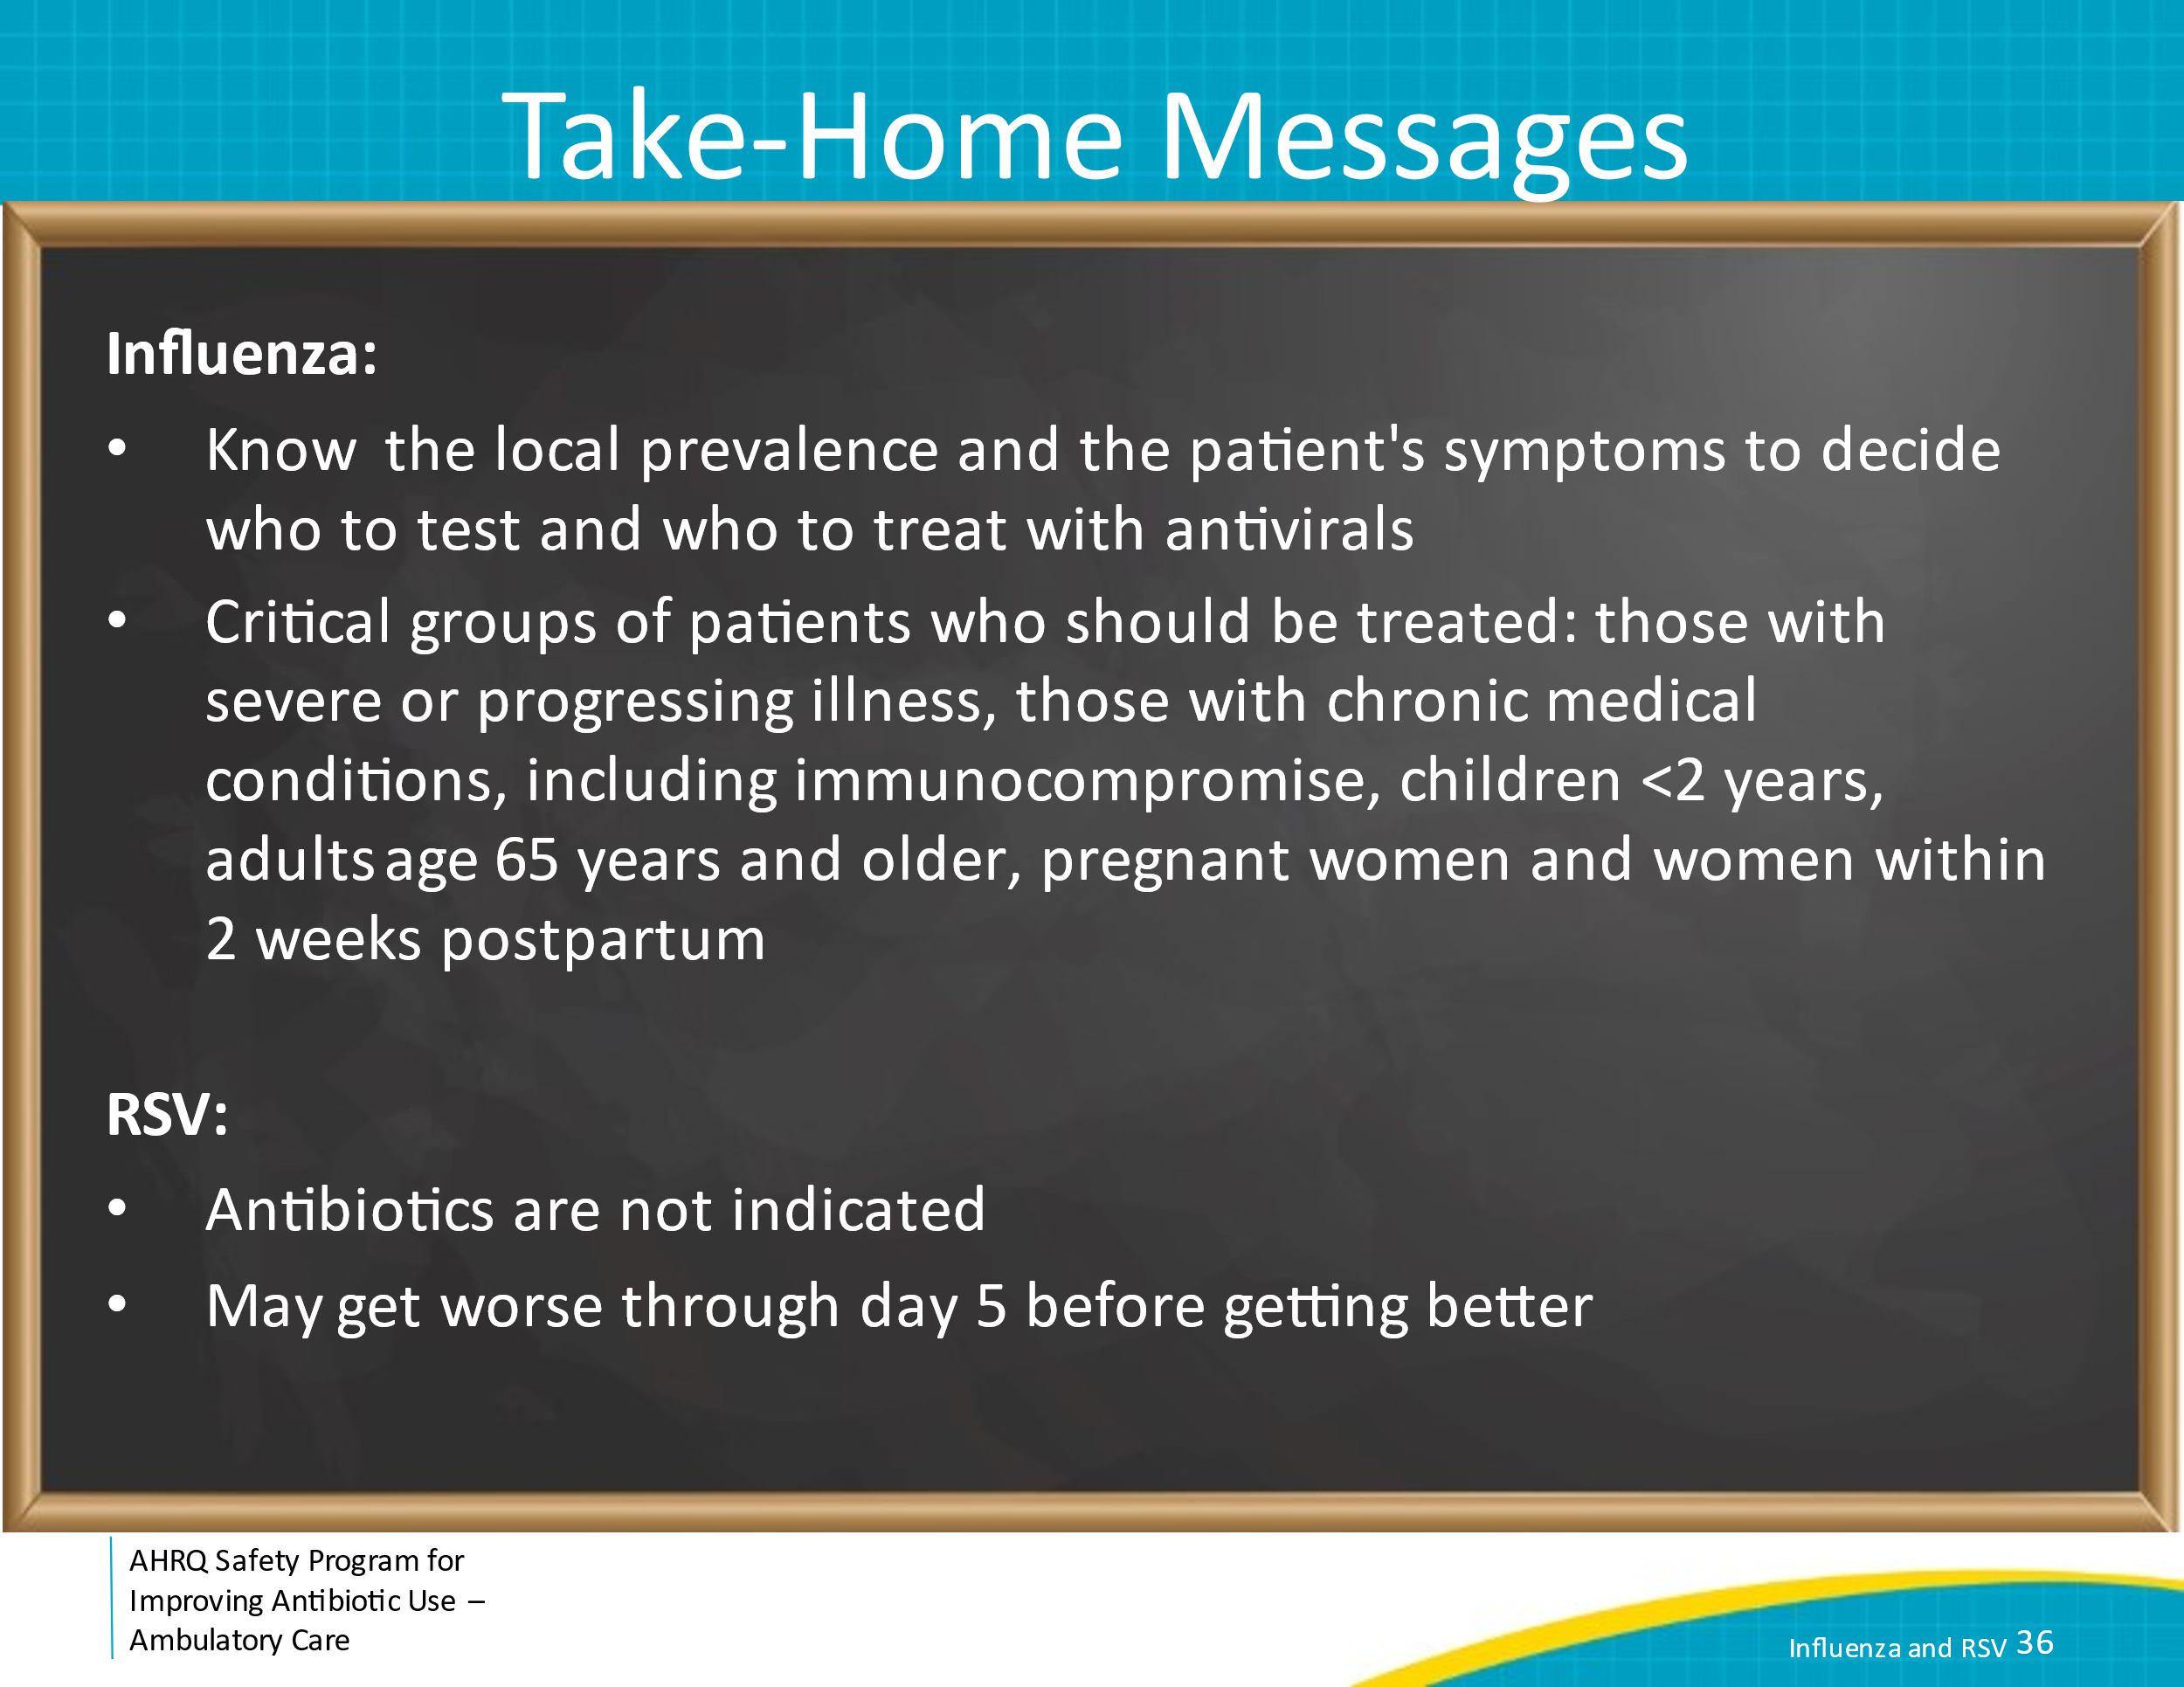
Additional Toolkit Resources  SAY:  For more resources on influenza and RSV, please access the tools listed below, available on the AHRQ Toolkit To Improve Antibiotic Use in Ambulatory Care.  Refer to the Discussion Guide to help your practice develop a standardized approach to the diagnosis and management of patients with Influenza and RSV.  Refer to the One-Page document for a concise summary of the diagnosis and treatment of Influenza and RSV.  The Patient Handout explains the symptoms and symptomatic treatment of Influenza and RSV. It is available in both English and Spanish. | Slide 37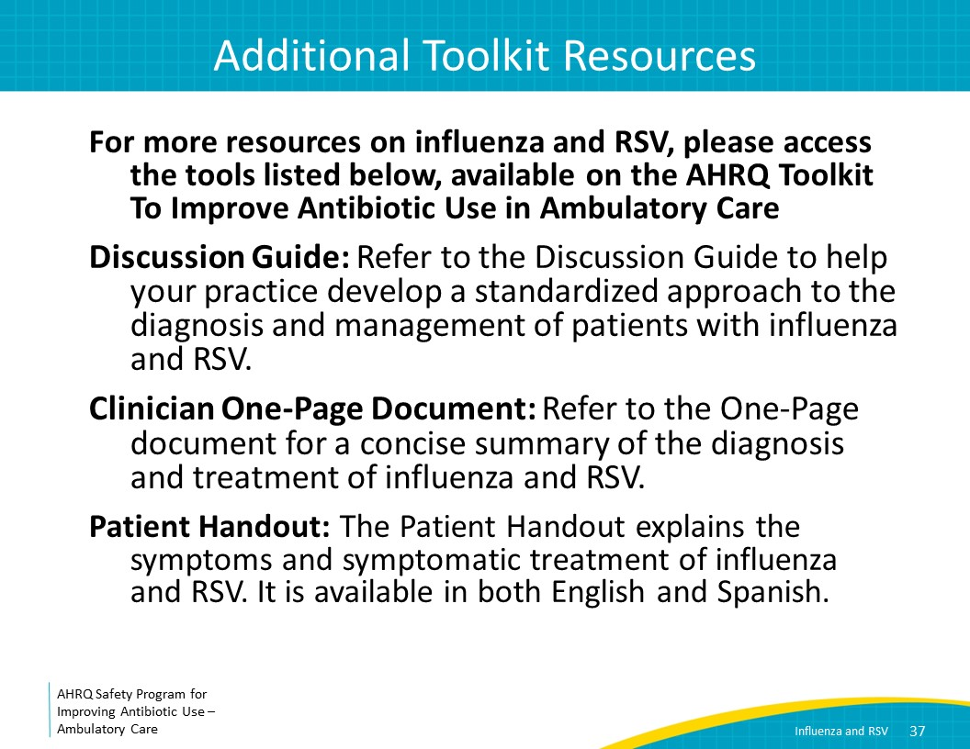
Disclaimer  SAY:  The findings and recommendations in this presentation are those of the authors, who are responsible for its content, and do not necessarily represent the views of AHRQ. No statement in this presentation should be construed as an official position of AHRQ or of the U.S. Department of Health and Human Services.  Any practice described in this presentation must be applied by healthcare practitioners in accordance with professional judgment and standards of care in regard to the unique circumstances that may apply in each situation they encounter. These practices are offered as helpful options for consideration by healthcare practitioners, not as guidelines. | Slide 38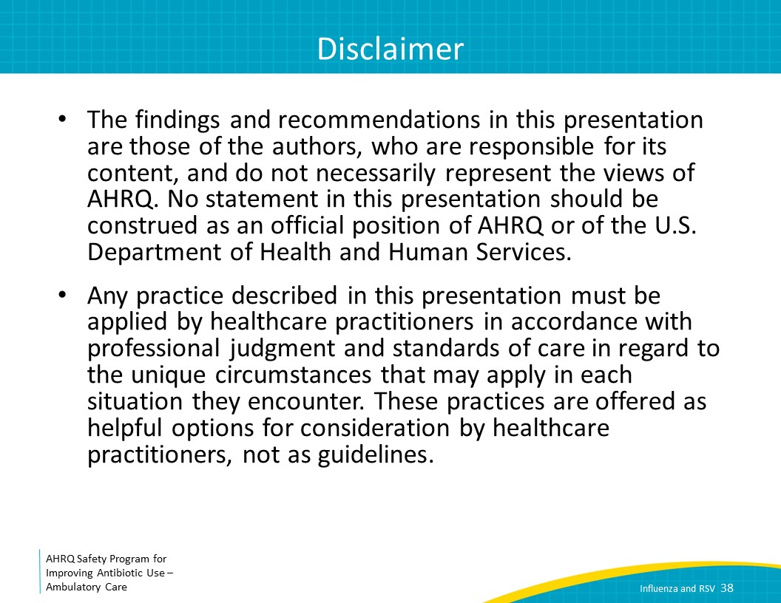
References  SAY:  Here are the references. | Slide 39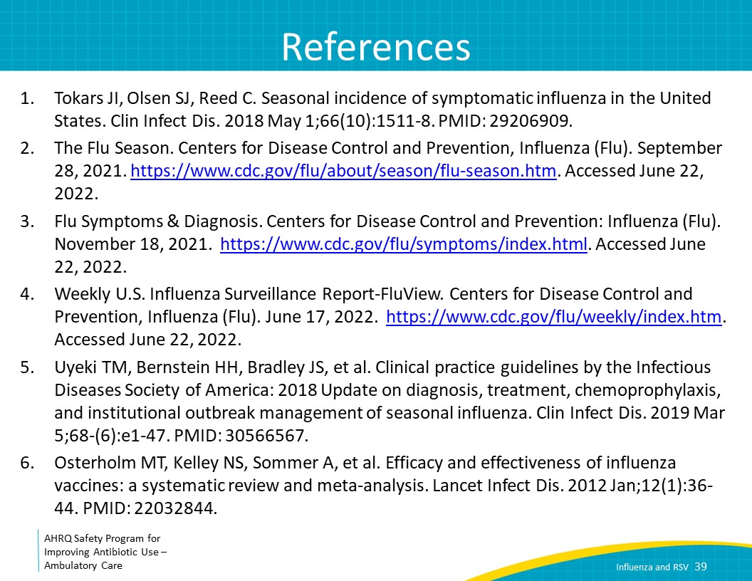
References | Slide 40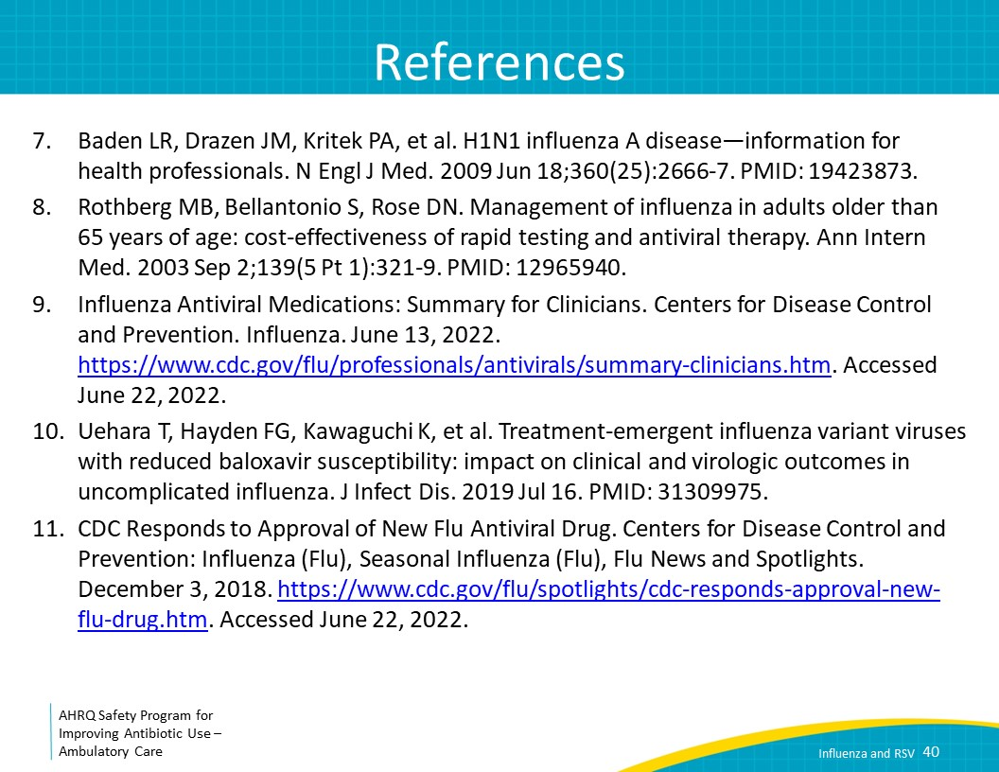
References | Slide 41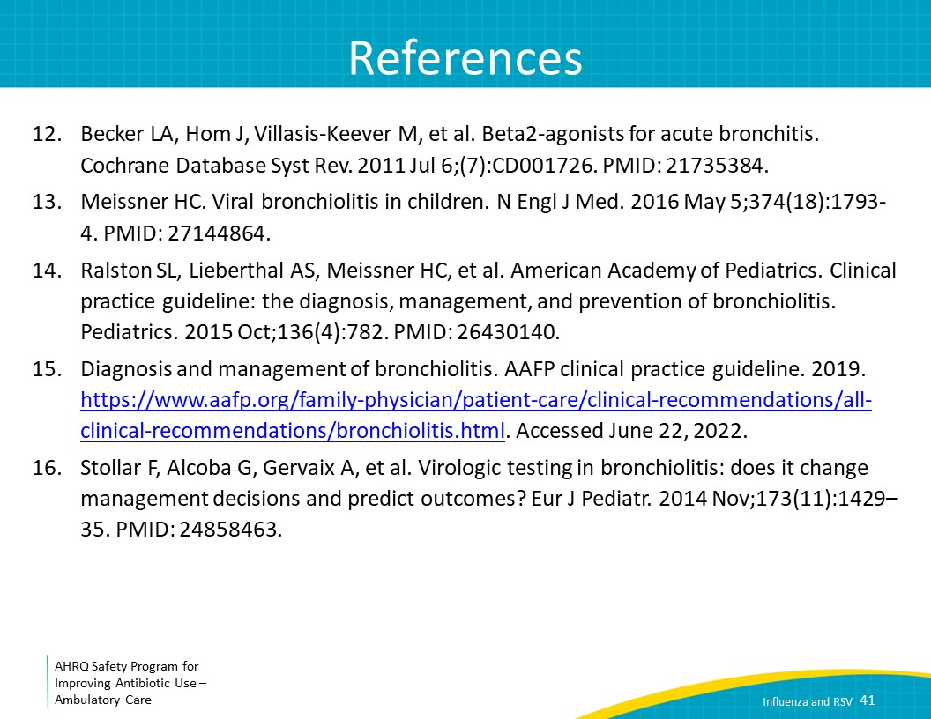
References | Slide 42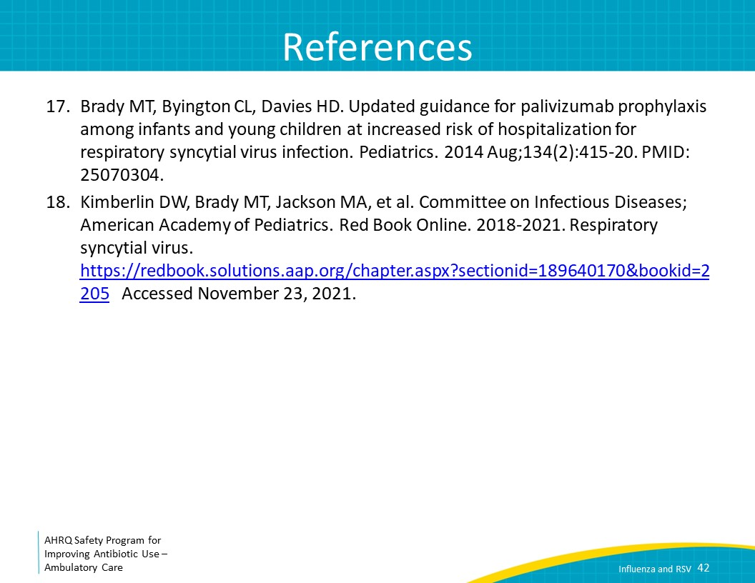
AHRQ Pub. No. 17(22)-0030
September 2022

