Antibiotic Allergy: Discussion Guide 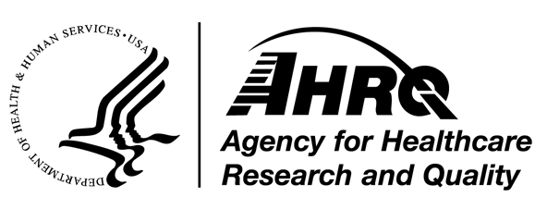
During a regularly scheduled staff meeting, the stewardship leader(s) should ask all clinical staff which of the components of the AHRQ Toolkit To Improve Antibiotic Use in Ambulatory Care related to penicillin allergy have been reviewed. It is recommended that all clinical staff review at least one of the following: the audio presentation, the slide set with accompanying facilitator guide, or the clinician one-page document. Remind staff that even if they have not had a chance to review the material, they should still do so. Remind staff how they can access the AHRQ Toolkit To Improve Antibiotic Use in Ambulatory Care content.
During the same meeting the stewardship leader(s) should generate conversation among staff members to determine how the practice can collectively improve the assessment for and documentation of allergies in their patients. Consider taking minutes and distributing them after the meeting to remind everyone present (and those not present) what was decided. Finally, it is also recommended to discuss progress on implementation of previous stewardship activities that the group is engaging in.
Suggested questions include the following:
- Does the practice have a standardized approach to address patient-reported antibiotic allergies?

- Who is responsible for obtaining the allergy assessment? Have the responsible staff reviewed the AHRQ Safety Program Toolkit information related to performing an antibiotic allergy assessment?

- Does the practice have an approach for removing antibiotic allergies from the medical record that are no longer considered relevant or accurate?

- Does the practice have an approach for providing patients who report a penicillin allergy the Penicillin Allergy patient handout prior to visiting with the healthcare practitioner?

- Does the practice have an allergist to whom it can refer patients when necessary?
AHRQ Pub. No. 17(22)-0030
September 2022

