The “Sometimes Antibiotics” Diagnoses:
Sinusitis

Ambulatory Care

Slide Title and Commentary | Slide Number and Slide
The “Sometimes Antibiotics” Diagnoses: Sinusitis  Ambulatory Care  SAY:  Welcome to the presentation titled, ‘’The ’Sometimes Antibiotics’ Diagnoses: Sinusitis.” | Slide 1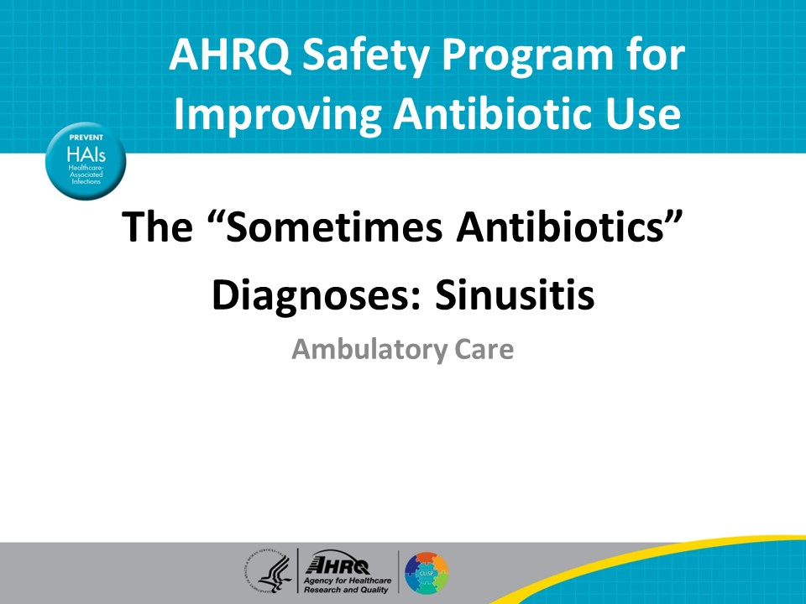
Objectives  SAY:  By the end of this presentation, participants will be able to—  - Explain how to diagnose sinusitis  - Explain when to treat sinusitis with antibiotics and  - Describe the non-antibiotic management of sinusitis | Slide 2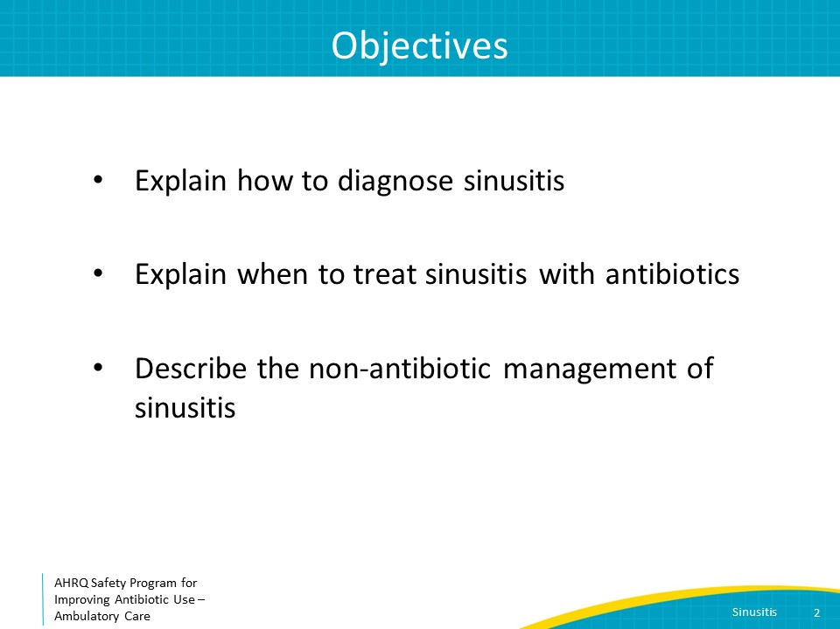
The Four Moments of Antibiotic Decision Making  SAY:  We will review sinusitis using the Four Moments of Antibiotic Decision Making.  1. Does my patient have an infection that requires antibiotics?  2. Do I need to order a diagnostic test?  3. If antibiotics are indicated, what is the narrowest, safest, and shortest regimen I can prescribe?  4. Does my patient know what to expect and the followup plan? | Slide 3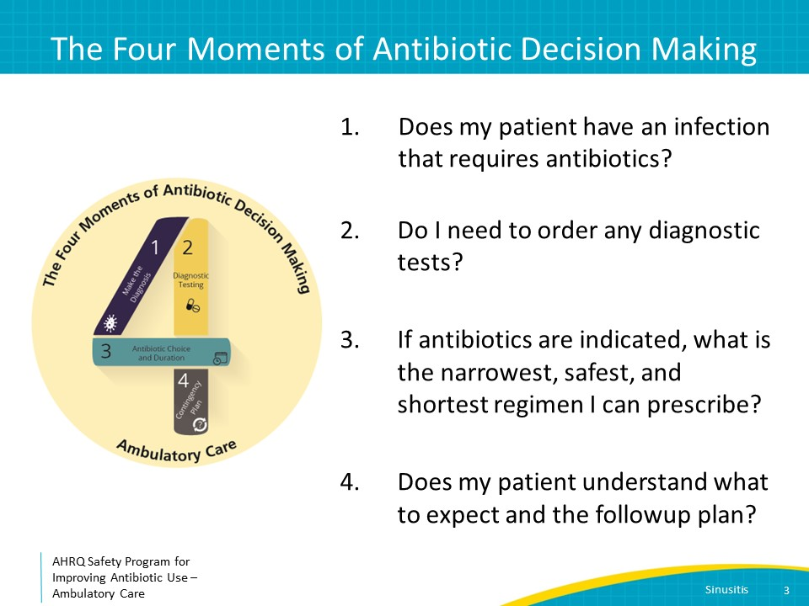
The Four Moments of Antibiotic Decision-Making  SAY:  Moment One is: Does my patient have an infection that requires antibiotics? | Slide 4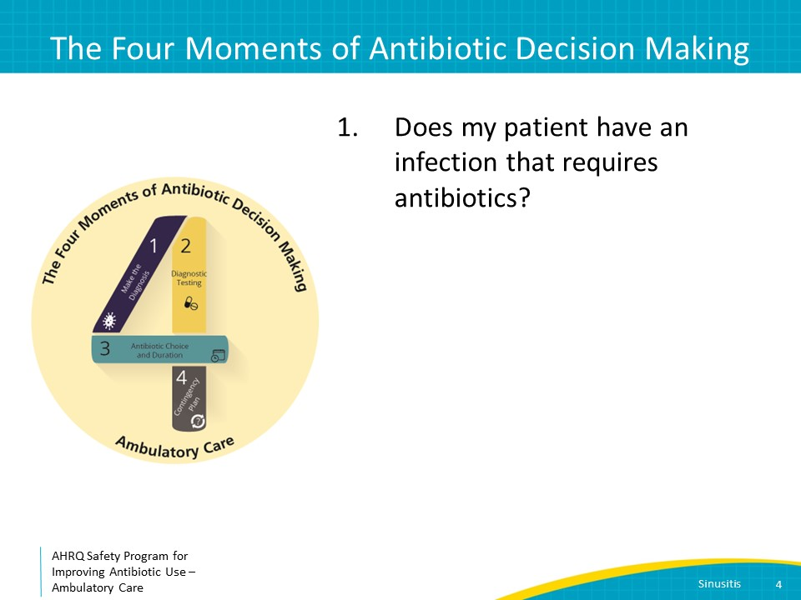
Sinusitis Case  SAY:  We will start with a case. A 40-year-old woman comes to clinic after 3 days of headache, cough, subjective fever, yellow nasal discharge, and facial pain and pressure. She is uncomfortable and frustrated with the duration of her symptoms. She is hoping to get a prescription for something to resolve her symptoms immediately as she has an important work meeting tomorrow. | Slide 5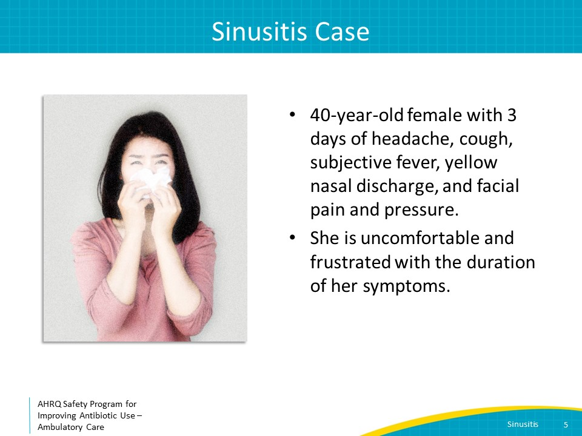
Moment 1: Does My Patient Have an Infection That Requires Antibiotics?  SAY:  This patient has sinusitis based on the clinical presentation of nasal discharge and facial pain and pressure. Patients may also report nasal congestion, reduced or absent sense of taste or smell, headache, ear pain or pressure, bad breath, dental pain, and fatigue. | Slide 6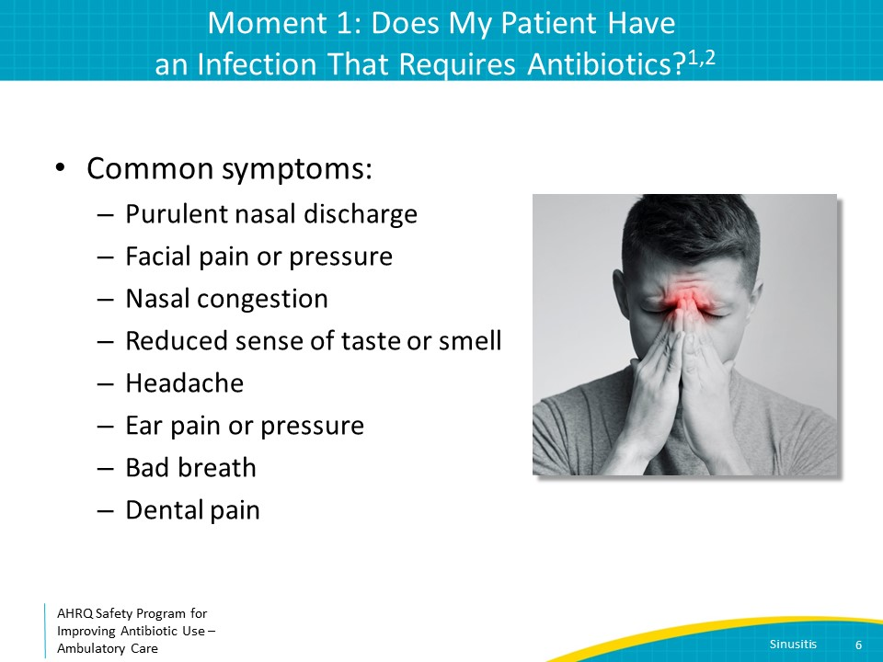
Moment 1: Indications for Antibiotics  SAY:  This patient has symptoms consistent with sinusitis, but does she have bacterial sinusitis that requires antibiotics?  It has been estimated that 0.5–2 percent of cases of viral sinusitis are complicated by bacterial infection.  The Infectious Diseases Society of America or IDSA recommends assessing the patient for three clinical features to guide decisions about prescribing antibiotics: persistent symptoms, severe symptoms, and worsening of symptoms. Antibiotics are indicated if one or more of these features are present.  Persistent symptoms are defined as symptoms that have lasted 10 or more days without improvement.  Severe symptoms are defined as fever of greater than or equal to 102 degrees Fahrenheit and either purulent nasal discharge or nasal pain for 3 to 4 consecutive days.  Worsening symptoms are defined as initial improvement of viral upper respiratory tract symptoms with subsequent worsening of sinus symptoms after 5 to 6 days.  Note that the presence of low-grade fever, facial or dental pain, or colored nasal discharge are not accurate predictors of a bacterial etiology in patients who do not meet the criteria just reviewed. | Slide 7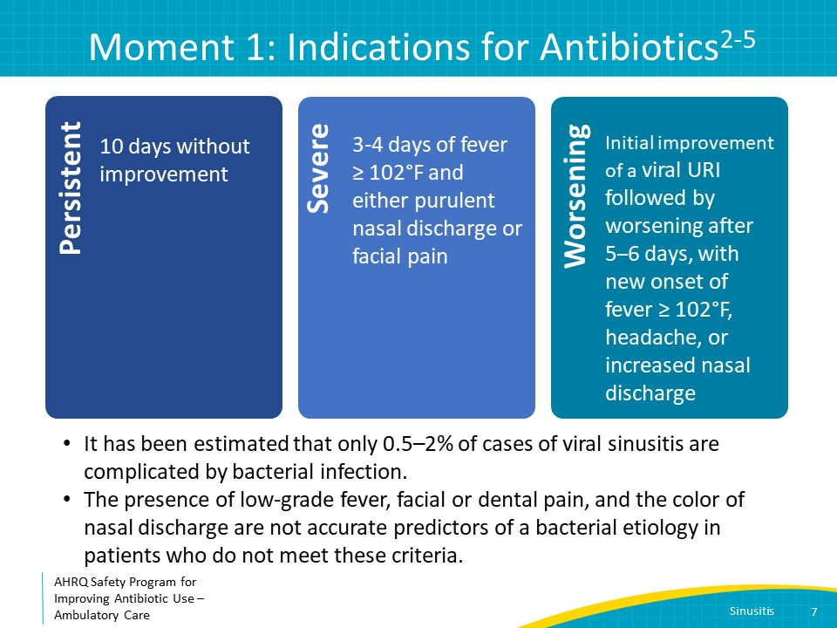
Case Presentation  SAY:  Based on symptoms and time course, what is the best recommendation for the patient?  Read:  Prescribe amoxicillin  Prescribe amoxicillin-clavulanate  Prescribe azithromycin  Prescribe or recommend decongestants | Slide 8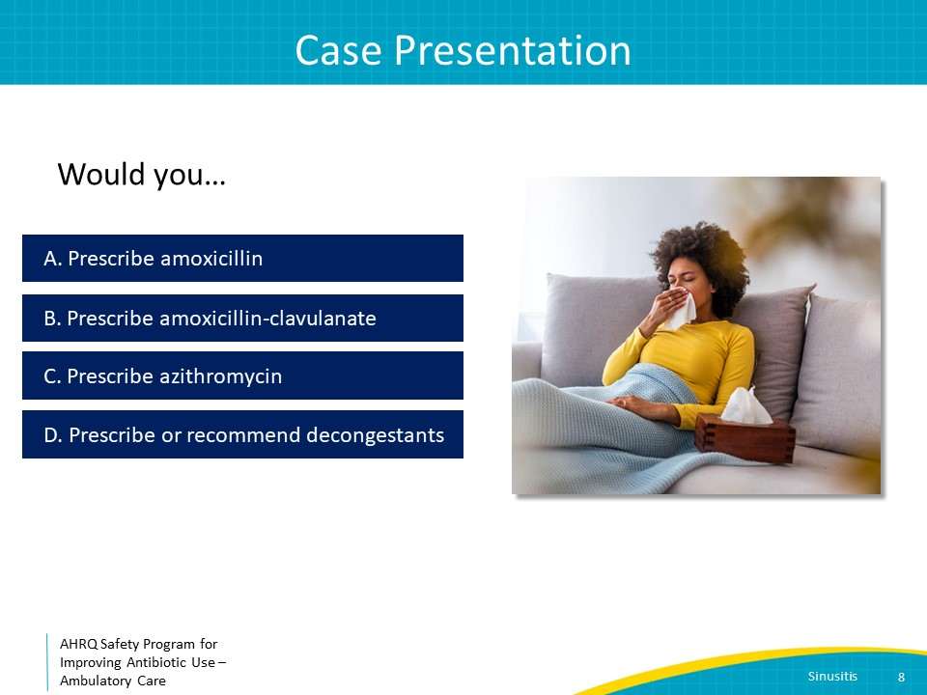
Treatment  SAY:  Antibiotics are not indicated for the patient as she does not meet any of the three criteria that suggest a bacterial infection. However, decongestants may help with her symptoms.  As in adults, the majority of sinusitis in children is viral, and the same diagnosis and treatment guidelines can be applied to children. However, decongestants are not suggested for children under 12 years of age and should be avoided in children under 6 years of age because of potential toxicities such as agitation, hypertension, and cardiac arrhythmias. | Slide 9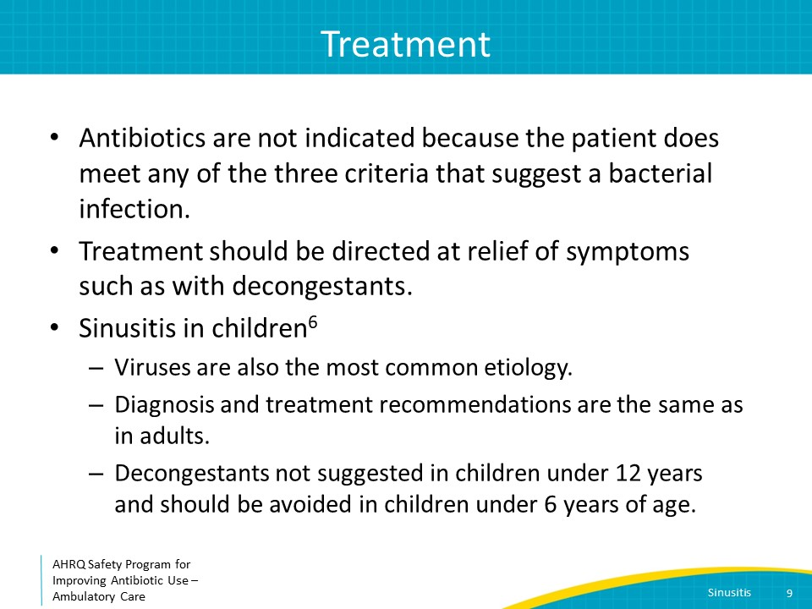
The Four Moments of Antibiotic Decision-Making  SAY:  Moment Two is: Do I need to order any diagnostic tests? | Slide 10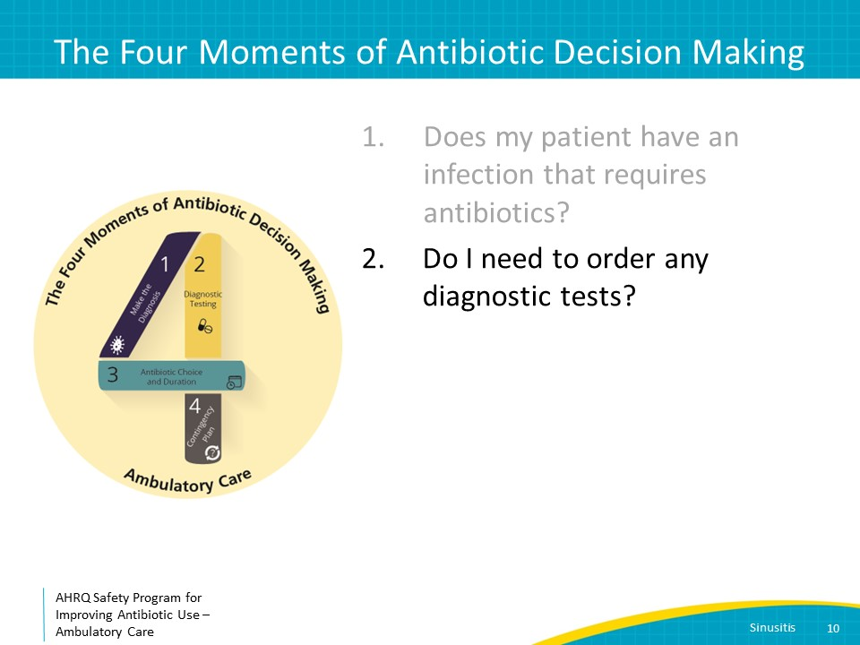
Moment 2: Diagnostic Testing  SAY:  Diagnostic tests are not needed in most patients with sinusitis. Cultures or swabs of nasal discharge are not indicated in acute sinusitis, and the majority of patients do not require imaging.  Patients with sinusitis who have or develop evidence of spread of infection to the orbits or the central nervous system should be referred to the emergency department for further evaluation including imaging via a computed tomography or CT scan. Symptoms suggestive of orbital cellulitis or central nervous system infection include limited ocular movements, acute vision changes, proptosis, confusion, and unilateral weakness. | Slide 11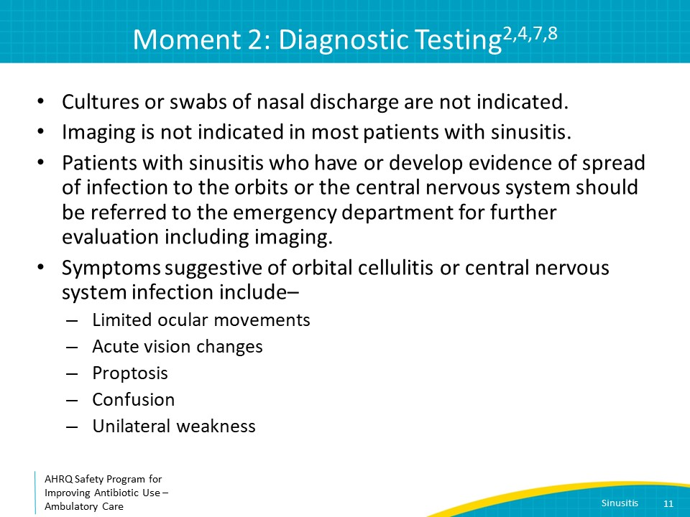
The Four Moments of Antibiotic Decision-Making  SAY:  Moment Three is: If antibiotics are indicated, what is the narrowest, safest, and shortest regimen I can prescribe? | Slide 12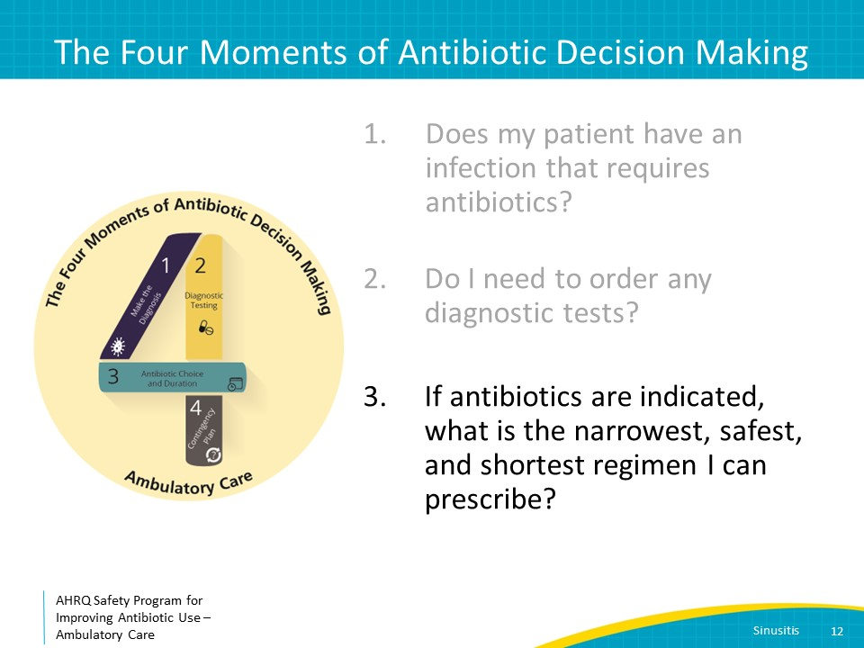
Moment 3: Choice of Antibiotic Regimen  SAY:  For adults who meet criteria for persistent, severe, or worsening symptoms, the first-line treatment is amoxicillin-clavulanic acid for 5–7 days.  Amoxicillin-clavulanate is also recommended as first-line treatment for children. As there are no available clinical trials to define the optimal duration of therapy for sinusitis in children, a duration of 10 days is commonly used. However, because the pathogens causing sinusitis are identical in children and adults, durations of therapy of 5–7 days also may be adequate for children, and are likely associated with less antibiotic-associated adverse events.  While both amoxicillin-clavulanic acid and amoxicillin have excellent activity against Streptococcus pneumoniae, amoxicillin-clavulanic acid is recommended because it provides better coverage for nontypeable Haemophilus influenzae which has become more common since the widespread use of pneumococcal vaccine in children and older adults.  For both children and adults with nonsevere penicillin allergies, options include doxycycline or oral third-generation cephalosporins. IDSA guidelines recommend addition of clindamycin to oral third-generation cephalosporins because of concern for Strep pneumoniae resistance, acknowledging that the strength of this recommendation is weak. Other experts recommend the addition of clindamycin to oral third-generation cephalosporins only if there is high risk of S. pneumoniae resistance such as extensive prior antibiotic exposure, multiple comorbidities, or high community rates of S. pneumoniae resistance given the risk of Clostridioides difficile infection with the combination regimen.  Traditional teaching was that doxycycline should generally be avoided in children under 8 years of age because of risks of enamel hypoplasia and permanent teeth staining. However, newer data indicate that permanent teeth staining with doxycycline is extremely unlikely to occur when using durations of therapy of 10 days or less.  For patients with severe penicillin allergies who cannot take doxycycline, levofloxacin or moxifloxacin can be used.  Because S. pneumoniae is often resistant to trimethoprim/sulfamethoxazole, azithromycin, and clarithromycin, they are not recommended for bacterial sinusitis. | Slide 13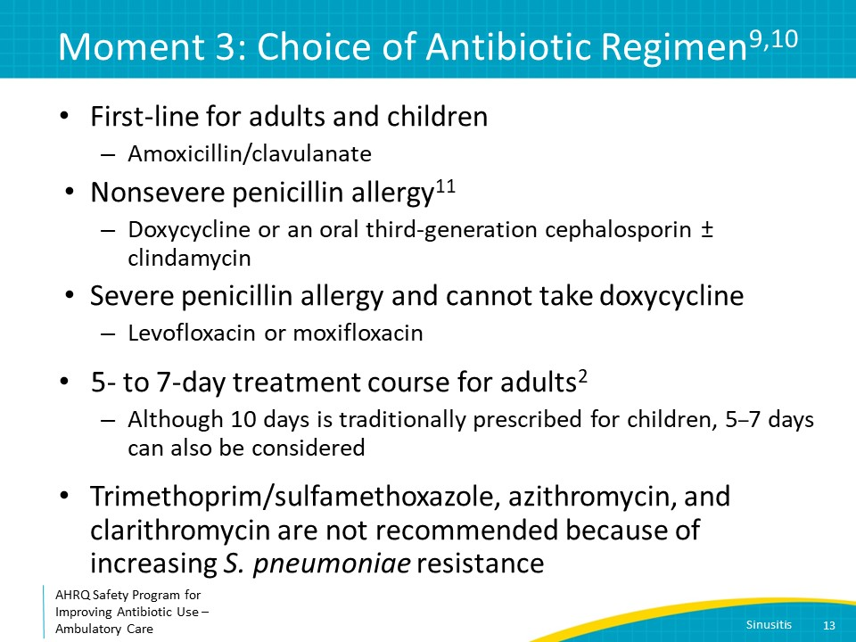
Symptomatic Treatment  SAY:  Whether patients have viral or bacterial sinusitis, symptomatic treatment can help them feel better. Analgesics or antipyretics like acetaminophen or ibuprofen may relieve fever, sinus pressure, and headache.  Decongestants such as oxymetazoline nasal spray or pseudoephedrine can help decrease sinus pressure and congestion. Topical decongestants should not be used more than 3 to 5 consecutive days due to risk of rebound congestion.  Nasal saline irrigation and intranasal corticosteroids such as fluticasone nasal spray may also reduce sinus pressure and nasal congestion. | Slide 14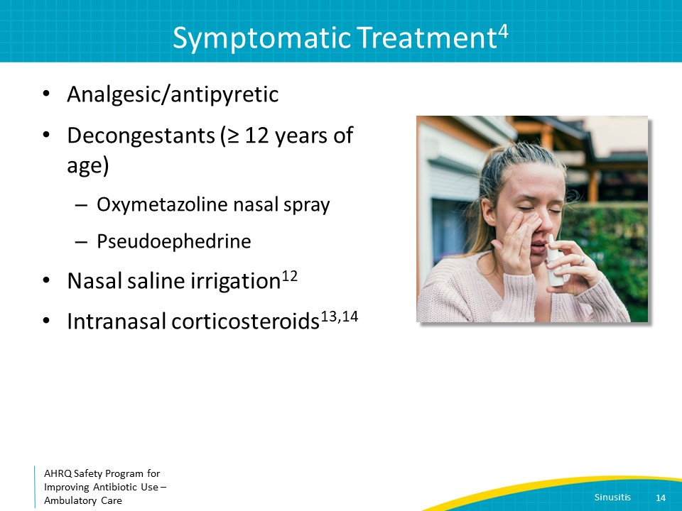
The Four Moments of Antibiotic Decision-Making  SAY:  The last moment to consider is, Does my patient understand what to expect and the followup plan? | Slide 15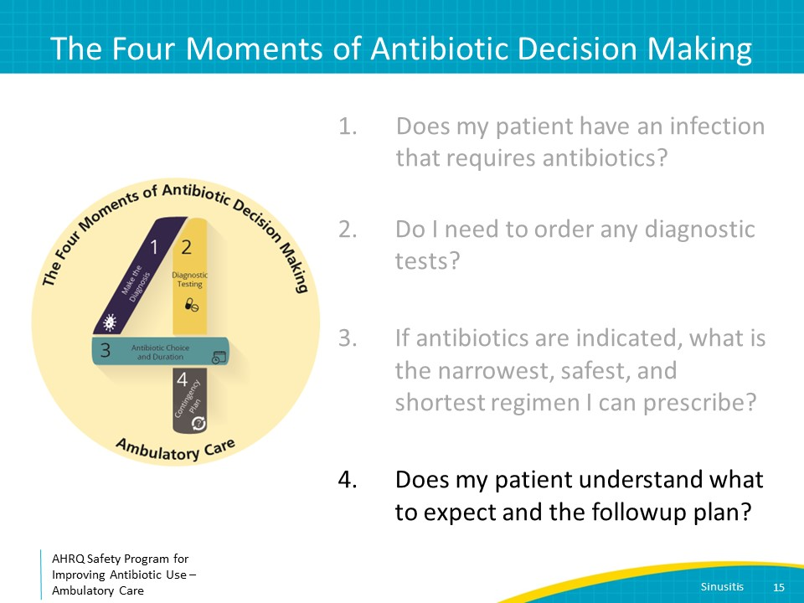
Moment 4: Followup Plan  SAY:  Patients should expect to have sinusitis symptoms improve over a week to 10 days. Patients should return to medical care if symptoms continue for at least 10 days without improvement, if they develop fever of at least 102 degrees Fahrenheit with purulent nasal discharge, or if symptoms start to improve and then worsen. If they develop severe headaches, emesis, weakness on one side of the body, visual changes, or confusion, they should present to the emergency department. | Slide 16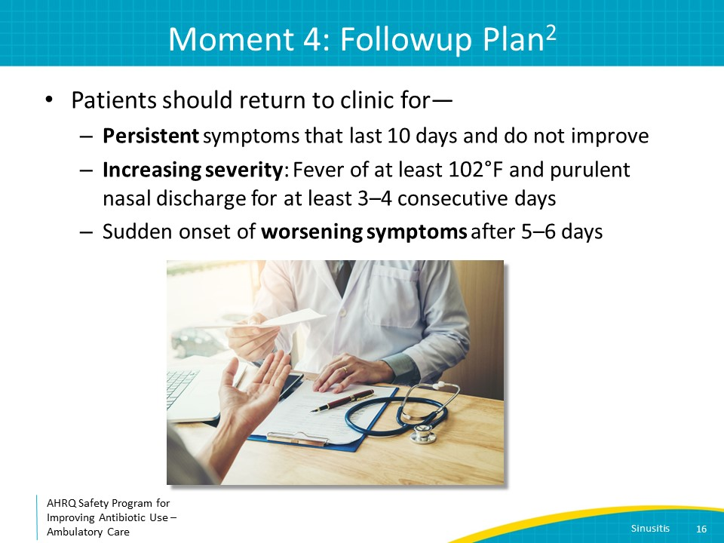
Case Presentation: 1 Week Later  SAY:  The previous patient returns 8 days after symptom onset because she does not feel completely better. She is frustrated that her sinuses are still tender, although not as severe. She continues to have thick nasal discharge which worries her. She is no longer febrile, but she is concerned that she is not getting better. Her physical examination is unremarkable.  What is the next step?  The patient does not meet criteria for severe, worsening, or persistent symptoms; therefore, recommend decongestants and analgesia, and provide anticipatory guidance. | Slide 17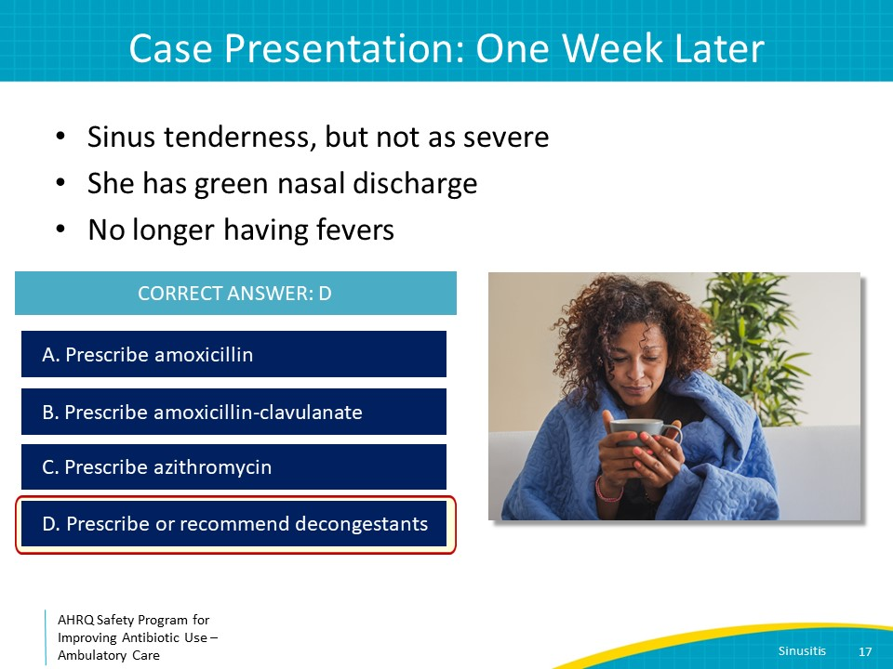
Case Presentation: 3 Days Later  SAY:  The patient returns 3 days later, which is now 11 days after initial symptom onset. Her sinus pain has become more severe.  Her symptoms have now persisted for more than 10 days, and she is worsening. Antibiotic therapy with 5–7 days of amoxicillin-clavulanate is recommended.  Remember that criteria for antibiotic therapy are either worsening symptoms OR persistent symptoms OR severe symptoms. It does not have to be all three. | Slide 18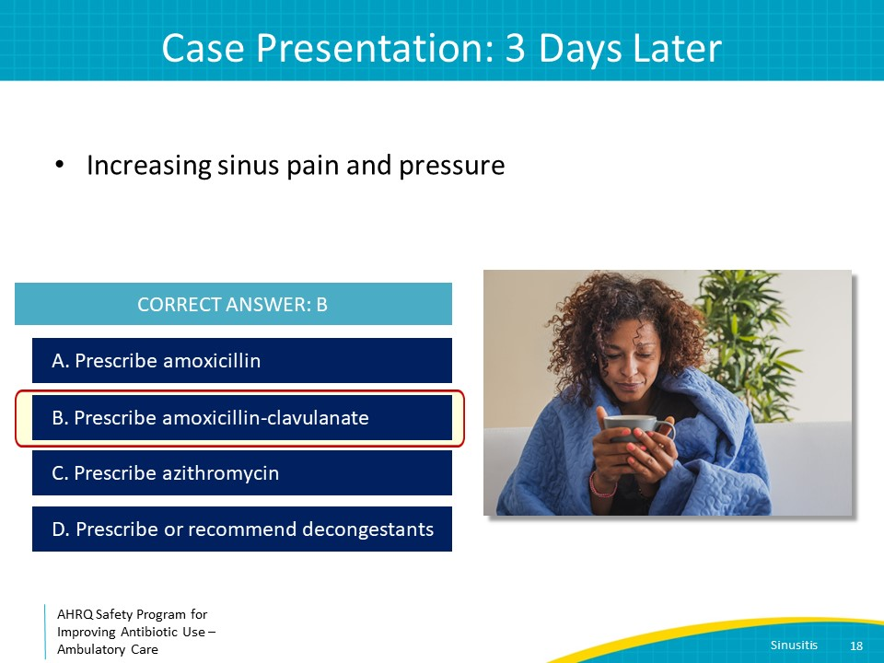
Take-Home Messages  SAY:  Most cases of sinusitis are viral. Only consider treating sinusitis with antibiotics if symptoms are persistent, severe, or progressive. Amoxicillin-clavulanate for 5–7 days is the first-line treatment for bacterial sinusitis for adults and can be considered for children also. Symptomatic therapy such as oxymetazoline, pseudoephedrine, and fluticasone nasal spray, as well as acetaminophen or ibuprofen for pain, should be recommended unless contraindicated. Patients should be advised to return to medical attention if they develop persistent, severe, or progressive symptoms. | Slide 19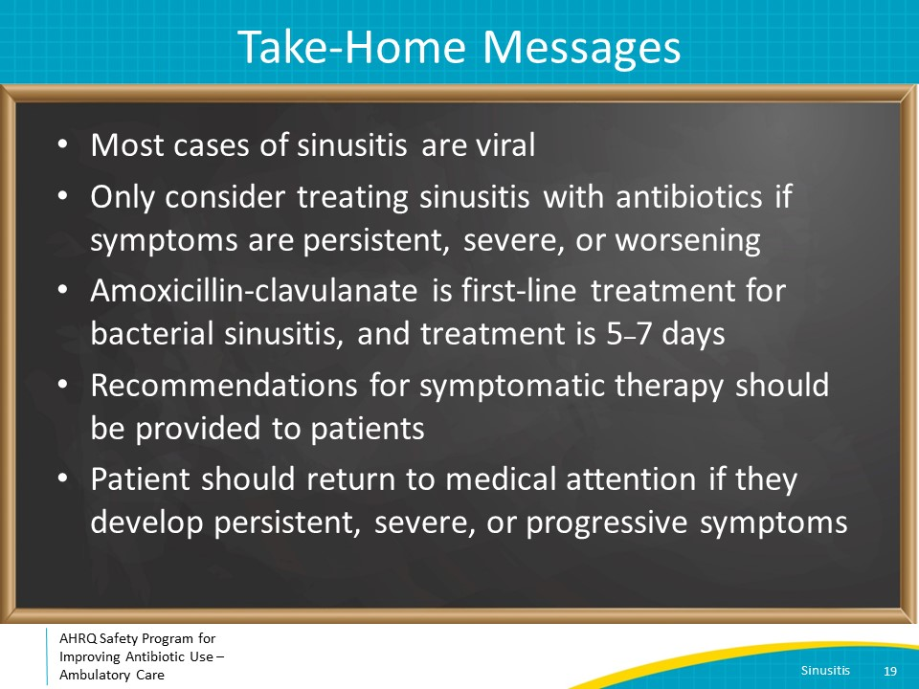
Additional Resources Toolkit  SAY:  For more resources on sinusitis, please access the tools listed below, available in the AHRQ Toolkit To Improve Antibiotic Use in Ambulatory Care.  Refer to the Discussion Guide to help your practice develop a standardized approach to the diagnosis and management of patients with sinusitis.  Refer to the One-Page document for a concise summary of the diagnosis and treatment of sinusitis.  The Patient Handout explains the symptoms and symptomatic treatment of sinsuitis and emphasizes that antibiotics are not always needed. It is available in both English and Spanish. | Slide 20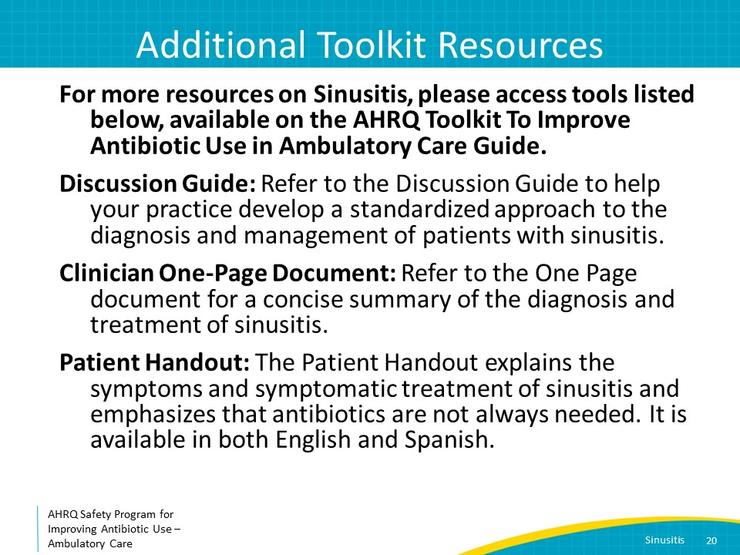
Disclaimer  SAY:  The findings and recommendations in this presentation are those of the authors, who are responsible for its content, and do not necessarily represent the views of AHRQ. No statement in this presentation should be construed as an official position of AHRQ or of the U.S. Department of Health and Human Services.  Any practice described in this presentation must be applied by healthcare practitioners in accordance with professional judgment and standards of care in regard to the unique circumstances that may apply in each situation they encounter. These practices are offered as helpful options for consideration by healthcare practitioners, not as guidelines. | Slide 21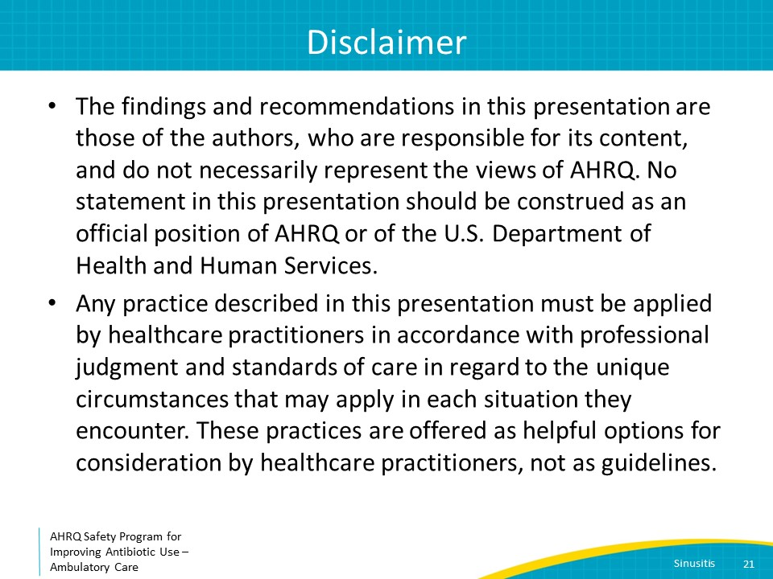
References  SAY:  Here are the references. | Slide 22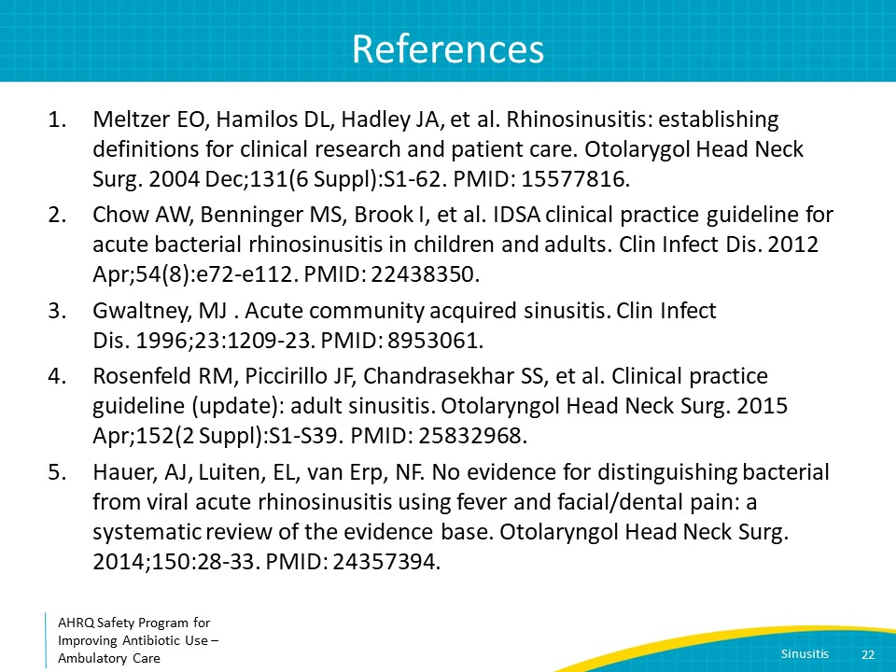
References | Slide 23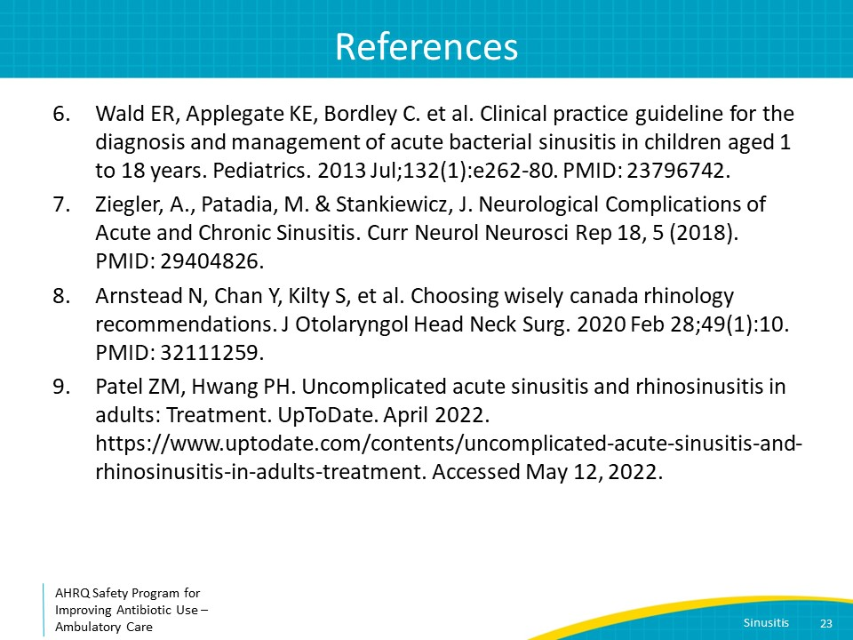
References | Slide 24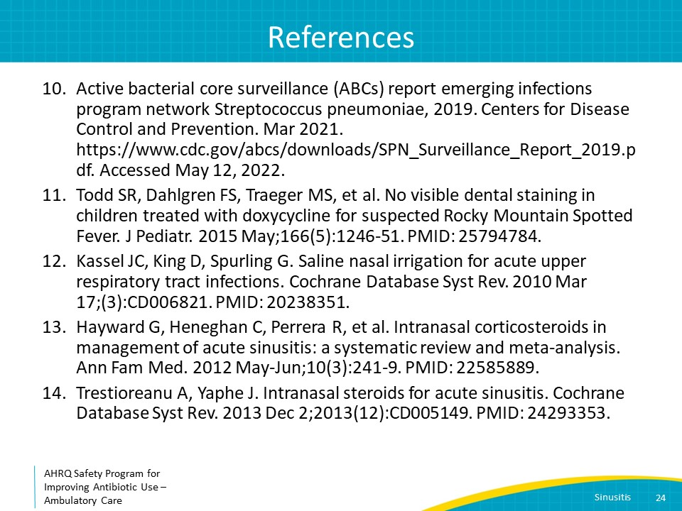
AHRQ Pub. No. 17(22)-0030
September 2022

