Best Practices in the Diagnosis and Treatment of Cellulitis and Skin and Soft Tissue Abscesses
Acute Care
Slide Title and Commentary | Slide Number and Slide
Best Practices in the Diagnosis and Treatment of Cellulitis and Skin and Soft Tissue Abscesses  Ambulatory Care  SAY:  Welcome to the presentation titled, “Best Practices in the Diagnosis and Treatment of Cellulitis and Skin and Soft Tissue Abscesses.” | Slide 1
Objectives  SAY:  By the end of this presentation, participants will be able to—  - Describe the approach to diagnose cellulitis and distinguish it from mimicking conditions  - Describe the microbiology of cellulitis and how that informs empiric therapy  - Identify empiric antibiotic regimens for cellulitis that minimize adverse events  - Discuss duration of antibiotic therapy for cellulitis and  - Discuss the expected time course of a case of cellulitis and when patients should return for followup | Slide 2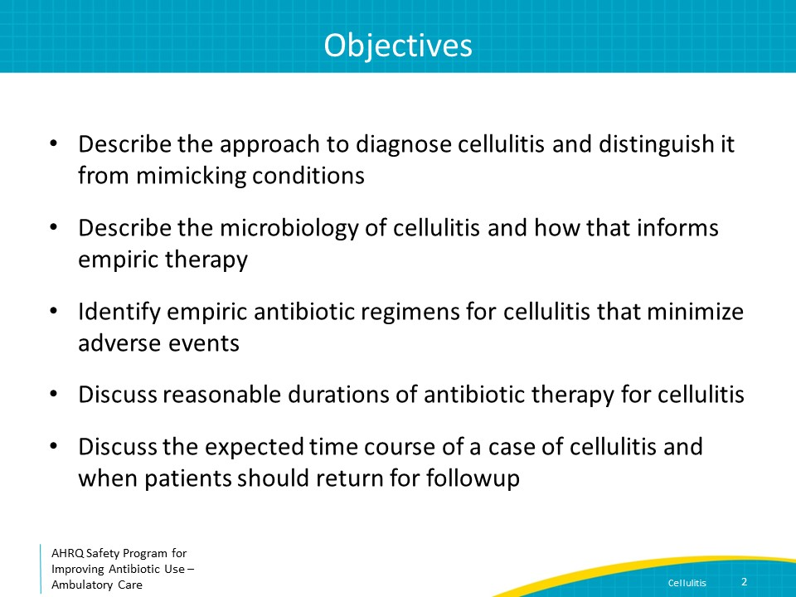
The Four Moments of Antibiotic Decision Making  SAY:  We will review cellulitis using the Four Moments of Antibiotic Decision Making. | Slide 3
The Four Moments of Antibiotic Decision Making  SAY:  Moment One is: Does my patient have an infection that requires antibiotics? | Slide 4
Moment 1: Diagnosis of Cellulitis  SAY:  Patients with cellulitis present with redness, warmth, tenderness, and swelling of the skin that is of relatively sudden onset.  Cellulitis is almost always unilateral; patients who have bilateral skin findings more likely have chronic venous stasis than infection. Many patients will have fever, although the proportion varies among studies from 20 to 70 percent, with sicker patients more likely to have fever. Most patients with cellulitis have elevated inflammatory markers and leukocytosis.  Development of cellulitis is generally associated with skin surface disruption due to recent trauma, tinea pedis, cutaneous ulcer, or past saphenous venectomy. In addition, impaired venous and lymphatic drainage can predispose to cellulitis. | Slide 5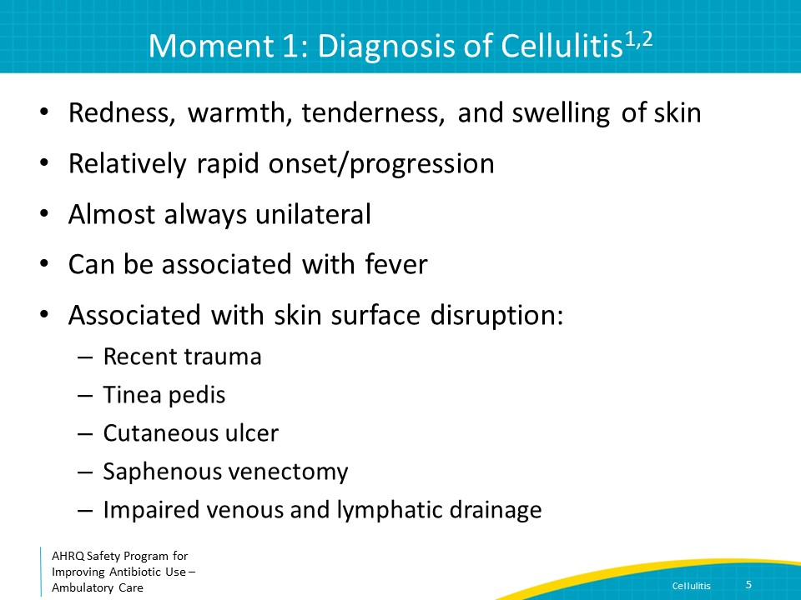
Moment 1: Cellulitis Mimics  SAY:  Several noninfectious conditions can be confused with cellulitis.  In a study of 145 patients hospitalized for presumed cellulitis, 28 percent had an alternative diagnosis. The most common alternative diagnosis was venous stasis dermatitis; other diagnoses included, trauma-related inflammation, deep vein thrombosis, nonspecific dermatitis, and thrombophlebitis. | Slide 6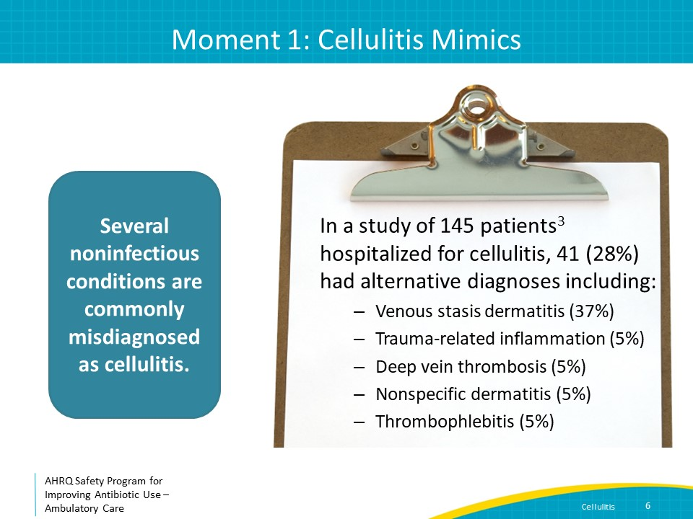
Moment 1: Mimics—Venous Stasis Dermatitis  SAY:  Venous stasis dermatitis can be distinguished from cellulitis in several ways. It is often bilateral; usually present for a long period of time; and associated with chronic skin hyperpigmentation, itchiness, scaling, pitting edema and/or serous drainage. Patients have less pain with venous stasis dermatitis than with cellulitis and should not have fever or significant leukocytosis. Venous stasis dermatitis can be treated with elevation of the extremity, compression, and topical steroids. | Slide 7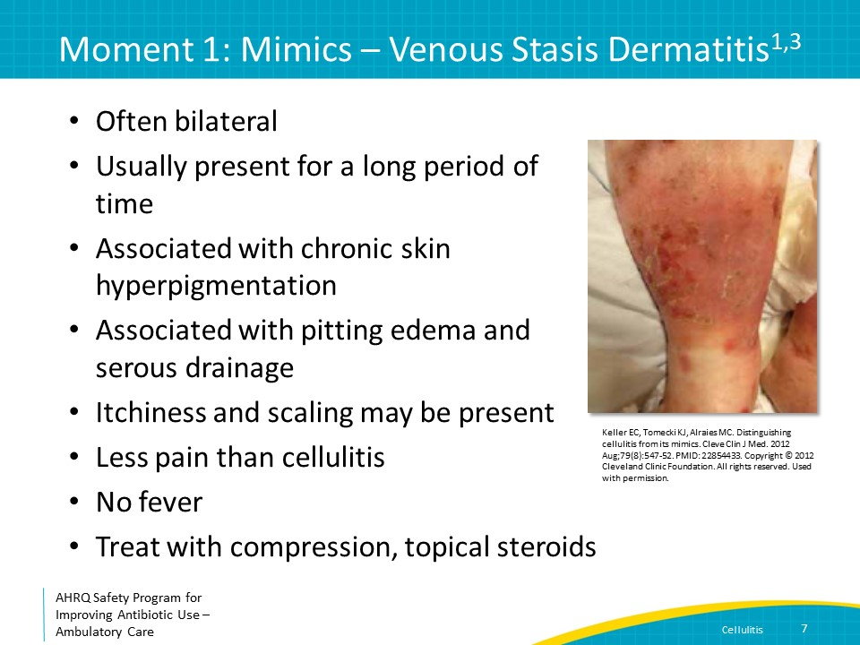
Moment 1: Mimics – Lymphedema  SAY:  Lymphedema results from disruption of lymphatic drainage. It can be congenital but is usually related to obesity or lymph node dissection. It is usually unilateral (distal to the lymphatic disruption) and associated with diffuse nontender erythema that improves with elevation. There is minimal associated warmth. Fever should not be present.  Both venous stasis and lymphedema can predispose to cellulitis, so history and physical exam are important.  Ask if there has been an acute change in symptoms that would suggest a new process, such as new fever, or increased warmth, tenderness, or erythema. Examine the extremity for evidence of new superficial cutaneous edema and/or shiny and smooth skin. These symptoms and signs suggest cellulitis. | Slide 8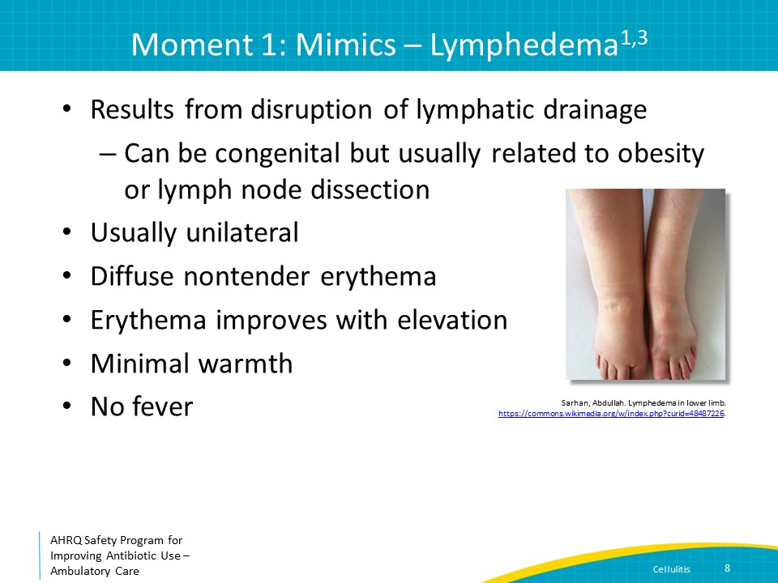
Moment 1: Other Mimics  SAY:  Other noninfectious syndromes that can be confused with cellulitis are listed on this slide. Patients with peripheral arterial disease can present with dependent rubor, defined as erythema that can be bright or dusky red that goes away when the leg is elevated. Dependent rubor can be associated with pain when patients have severe arterial insufficiency, but is not associated with warmth or edema.  Patients with contact dermatitis can have lesions that look like cellulitis but are confined to the site of contact with the allergen. Patients will often be able to identify potential exposures such as bandages or lotions.  The skin is generally not involved in patients with deep venous thrombosis, although they can have swelling of the extremity with associated erythema and some warmth.  The skin surrounding the affected joint(s) in patients with gout can mimic cellulitis with warmth, erythema, and pain.  The remainder of the presentation will focus on the diagnosis and management of cellulitis and skin and soft tissue abscesses after alternative diagnoses have been ruled out. | Slide 9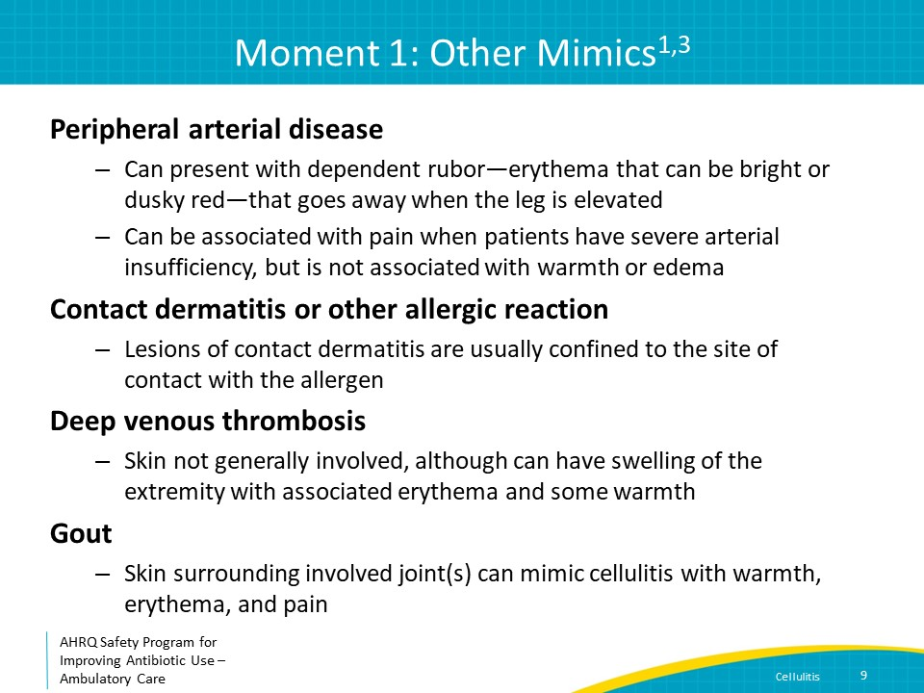
The Four Moments of Antibiotic Decision Making  SAY:  Moment Two is: Do I need to order any diagnostic tests? | Slide 10
Moment 2: Microbiologic Diagnosis  SAY:  Wound cultures should be considered if purulence or an abscess is present. While it may be reasonable to treat empirically for an initial, mild episode of cellulitis associated with purulence (along with drainage of the purulent material), patients who present with recurrence or with immunocompromise or foreign material in place, or who are being admitted to the hospital should have wound cultures obtained. It is best to send the pus itself in a sterile container, not a swab of pus, so a Gram stain can be performed and to optimize the likelihood of recovering a microorganism from the cultures.  Aspiration of the cellulitis margin is generally not necessary. Punch biopsy can be considered for unusual skin findings particularly in immunocompromised hosts but not for routine cellulitis cases. | Slide 11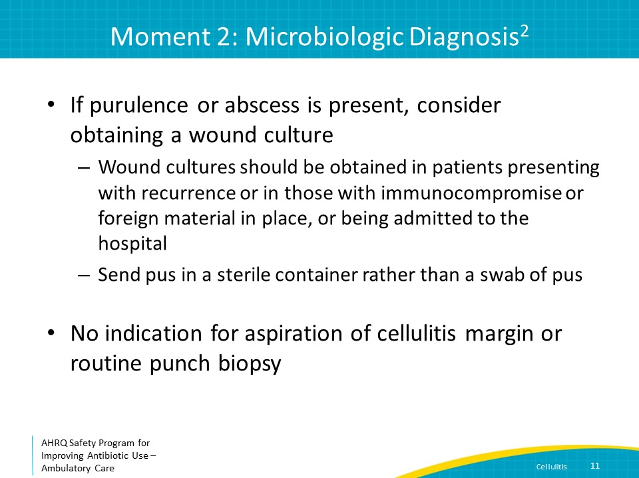
The Four Moments of Antibiotic Decision Making  SAY:  Moment Three is: If antibiotics are indicated, what is the narrowest, safest, and shortest regimen I can prescribe? | Slide 12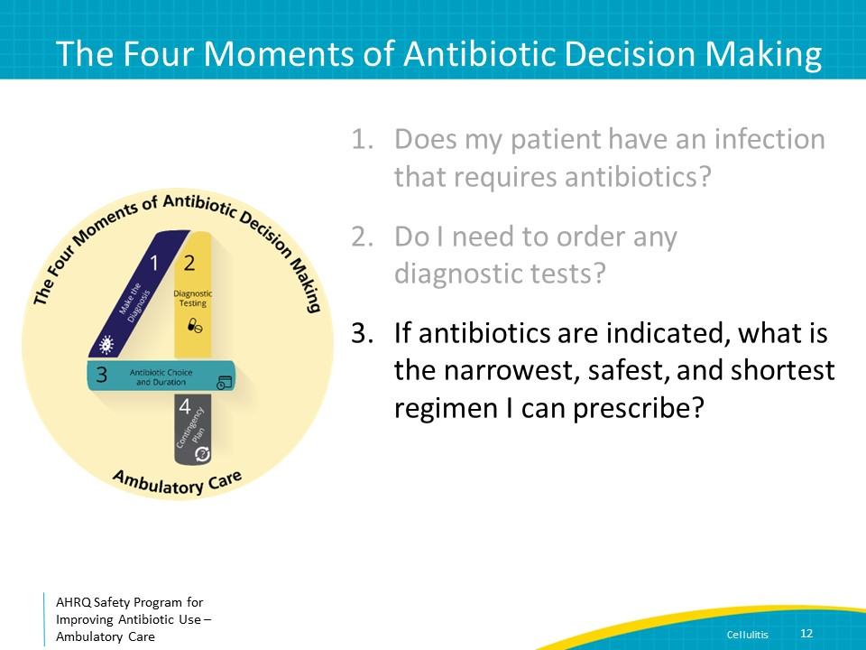
Moment 3: Diagnosis of Type of Cellulitis  SAY:  Before making decisions about empiric antibiotic therapy in patients with cellulitis, it is important to assess whether the patient has nonpurulent or purulent cellulitis.  With nonpurulent cellulitis, there is no evidence of fluid collection, phlegmon, or abscess. With purulent cellulitis there is evidence of fluid collection, phlegmon, or abscess associated with the cellulitis. | Slide 13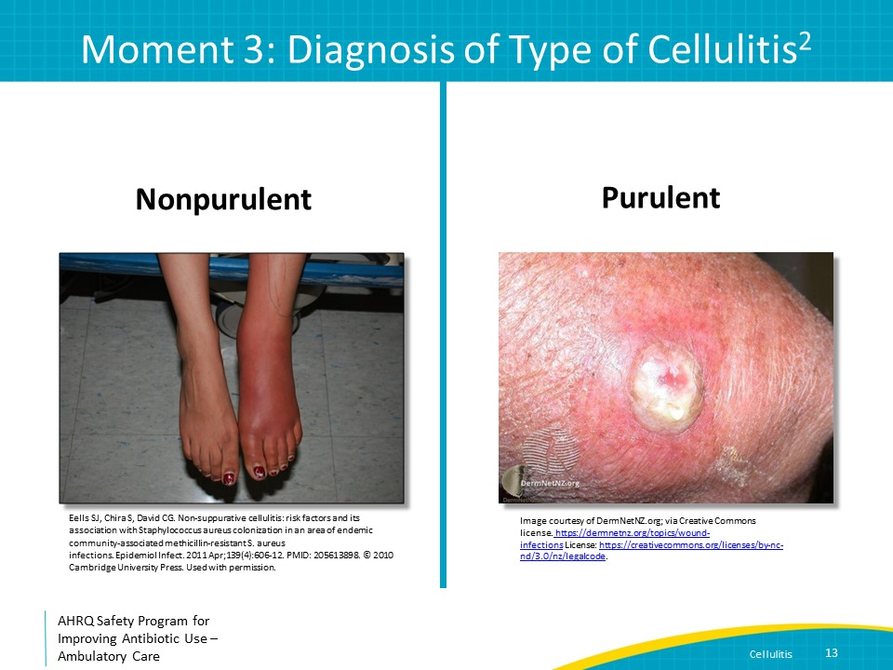
Moment 3: Decisions Around Antibiotic Prescription  SAY:  The microbiologic etiology of cellulitis can be predicted by the type of cellulitis.  Nonpurulent cellulitis is primarily caused by beta-hemolytic streptococci--usually group A streptococcus, but sometimes group B, C, or G streptococcus. Methicillin-susceptible Staphylococcus aureus or MSSA is estimated to cause only approximately 10 percent of nonpurulent cellulitis cases.  All beta-hemolytic streptococci are penicillin susceptible. Clindamycin resistance is increasing in beta-hemolytic streptococci in the United States. Data from the Centers for Disease Control and Prevention, or CDC, indicate that the proportion of group A streptococcal isolates resistant to clindamycin is greater than 20 percent. The portion of group B streptococcal isolates resistant to clindamycin is greater than 45 percent. Similarly, clindamycin resistance is also increasing in MSSA.  Antibiotic agents such an oral first-generation cephalosporin or amoxicillin/clavulanate will provide coverage for both beta-hemolytic streptococci and MSSA. For patients who report a severe penicillin allergy where use of a first-generation cephalosporin is contraindicated, doxycycline or trimethoprim/sulfamethoxazole can be considered. More recent data indicate that both doxycycline and trimethoprim/sulfamethoxazole may be effective treatment options for beta-hemolytic streptococci. Both agents are also effective therapies for MSSA. Clindamycin or linezolid are alternative agents when severe allergies or intolerance preclude the use of all other agents.  Purulent cellulitis is primarily caused by S. aureus, both MSSA and methicillin-resistant S. aureus or MRSA. Drainage of any associated abscess should occur whenever possible; ultrasound may be helpful to detect abscess or phlegmon in cases where physical exam is equivocal. Empiric treatment should include coverage for MRSA. Oral options include trimethoprim/sulfamethoxazole, doxycycline, and clindamycin. If using clindamycin, it is important to assess local susceptibility data given significant increases in resistance among S. aureus isolates in many areas of the United States.  More severe cases of purulent cellulitis can be treated with oral linezolid. However, linezolid is associated with a number of important side effects such as peripheral and optic neuropathy, myelosuppression, lactic acidosis, and serotonin syndrome if taken with selective serotonin reuptake inhibitor or SSRI antidepressants. These adverse events are more common with prolonged durations of therapy, underscoring the importance of avoiding extended durations of antibiotic therapy for cellulitis, as discussed later in the presentation.  Treatment recommendations for cellulitis in children and adults are similar. Of note, traditional teaching was that doxycycline should generally be avoided in children younger than 8 years of age because of risks of enamel hypoplasia and permanent teeth staining. However, newer data indicate that permanent teeth staining with doxycycline is extremely unlikely to occur when using durations of therapy of 10 days or less. | Slide 14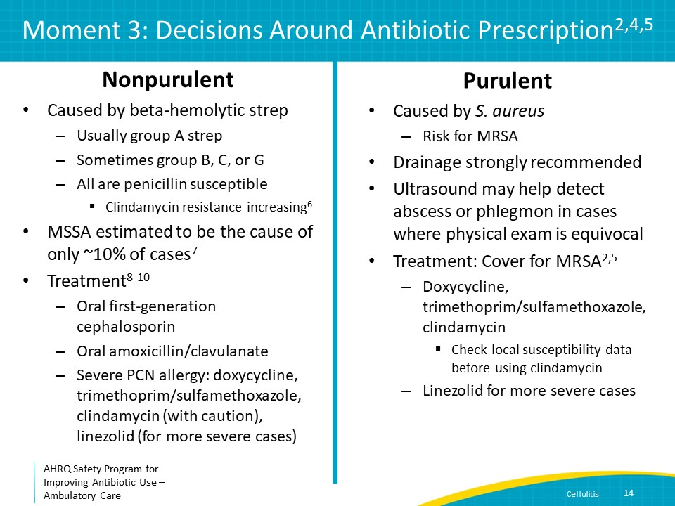
Moment 3: MRSA Coverage in Nonpurulent Cellulitis  SAY:  A common consideration is whether antibiotic therapy for nonpurulent cellulitis requires anti-MRSA coverage. A 2017 randomized controlled trial in 500 outpatients older than 12 years with uncomplicated, nonpurulent cellulitis compared a regimen without MRSA activity to one with MRSA activity.  Patients received either cephalexin alone or cephalexin plus trimethoprim/sulfamethoxazole for 7 days. All patients had ultrasounds of the lesion to confirm no abscess was present.  The proportions of patients with prior MRSA infection (4%) and diabetes (about 10%) were comparable in both arms. Clinical cure was similar between the two treatment arms at 86 percent in the cephalexin only group versus 84 percent in the cephalexin plus trimethoprim/sulfamethoxazole group. This clinical trial provides support that the addition of MRSA coverage is not needed in patients with nonpurulent cellulitis. | Slide 15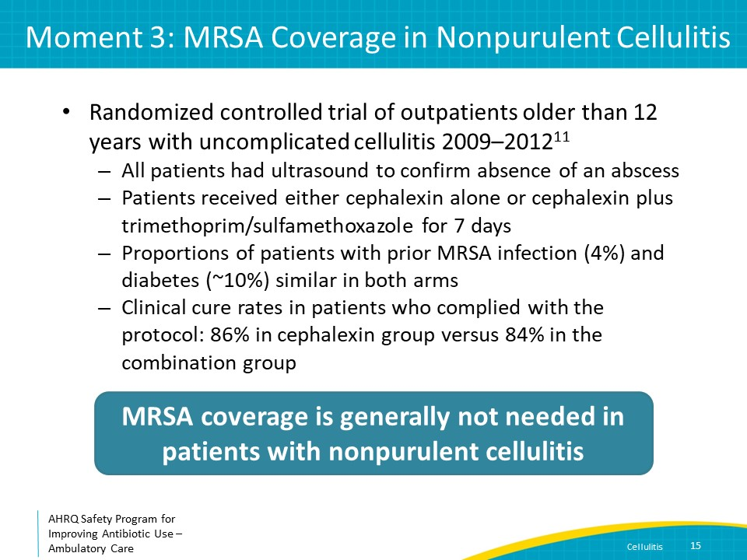
Moment 3: Role of Antibiotics for Skin Abscesses With Minimal Cellulitis  SAY:  Another clinical concern is the role of antibiotics in the treatment of skin abscesses with minimal associated cellulitis. While the primary treatment for cutaneous abscesses is drainage, adjunctive antibiotic therapy may be useful in some patients.  A 2016 study suggests a modest benefit of antibiotic therapy for adult outpatients with drained abscesses at least 2 cm across. In the study, 617 patients received trimethoprim/sulfamethoxazole, and 630 patients received placebo for 7 days. Baseline patient and lesion characteristics were similar—8 percent had prior MRSA infection, 11 percent had diabetes, the median abscess dimension was 2.5 cm and Staph aureus (predominantly MRSA) was isolated in more than 60 percent of cases. Clinical cure in the evaluable population was 95 percent for trimethoprim/sulfamethoxazole and 86 percent for placebo with a p-value < 0.001.  Overall, clinical cure rates were high in both groups. Clinicians should weigh the higher cure rate with antibiotics with the potential for antibiotic side effects when making the decision about prescribing antibiotics for patients with uncomplicated skin abscesses. | Slide 16
Moment 3: Indications for Antibiotics for Skin Abscesses  SAY:  There are certain patients and conditions in which antibiotics should be prescribed for skin abscesses. These include signs and symptoms of systemic illness; underlying immunosuppression, including diabetes, AIDS, and active malignancy; extremes of age; location of abscess in area that makes complete drainage difficult or that can be associated with septic phlebitis of a major vessel; lack of response to initial incision and drainage, or I & D, and more extensive surrounding cellulitis. Note that many of these criteria could also mean the patient should be considered for hospital admission. | Slide 17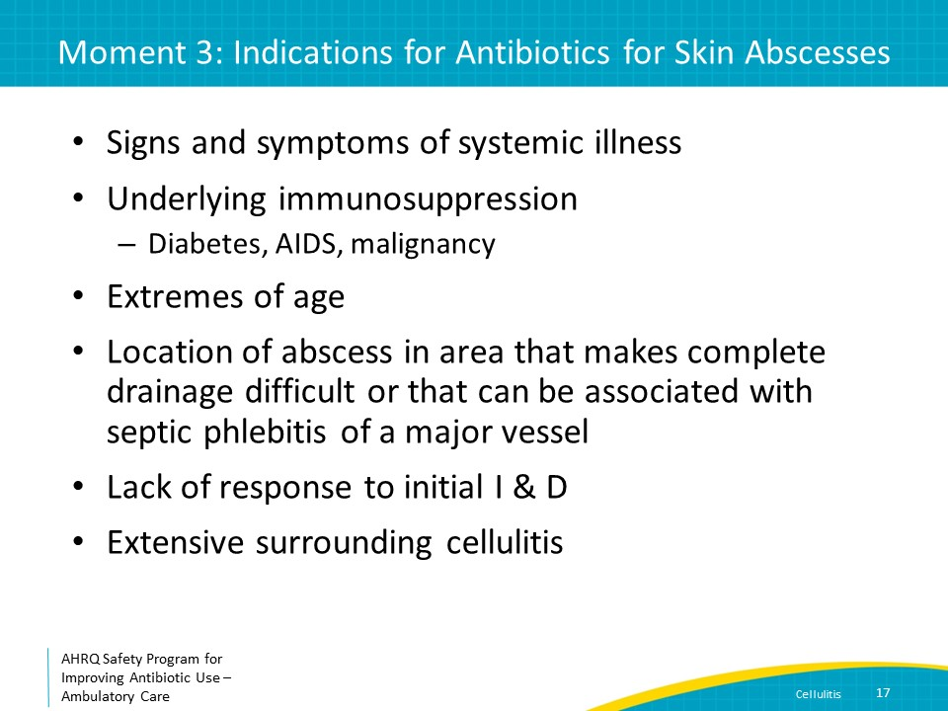
Moment 3: Treatment of Other Types of Skin and Soft Tissue Infections  SAY:  Human and animal bites should be treated with amoxicillin/clavulanate rather than first-generation cephalosporins which lack activity against Pasteurella multocida and Capnocytophaga canimorsus, organisms often found in the oral flora of animals, as well some oral anaerobes. Moxifloxacin or doxycycline can be considered for patients with penicillin allergies.  Patients with diabetes who have cellulitis do not need Gram-negative coverage in most cases and can be treated with the regimens described previously. For patients with cellulitis associated with a diabetic ulcer, Gram-positive organisms are the most common colonizing organisms with the exceptions of longstanding ulcers and/or prior receipt of multiple antibiotic courses. Gram-negative coverage can be considered in these patients. | Slide 18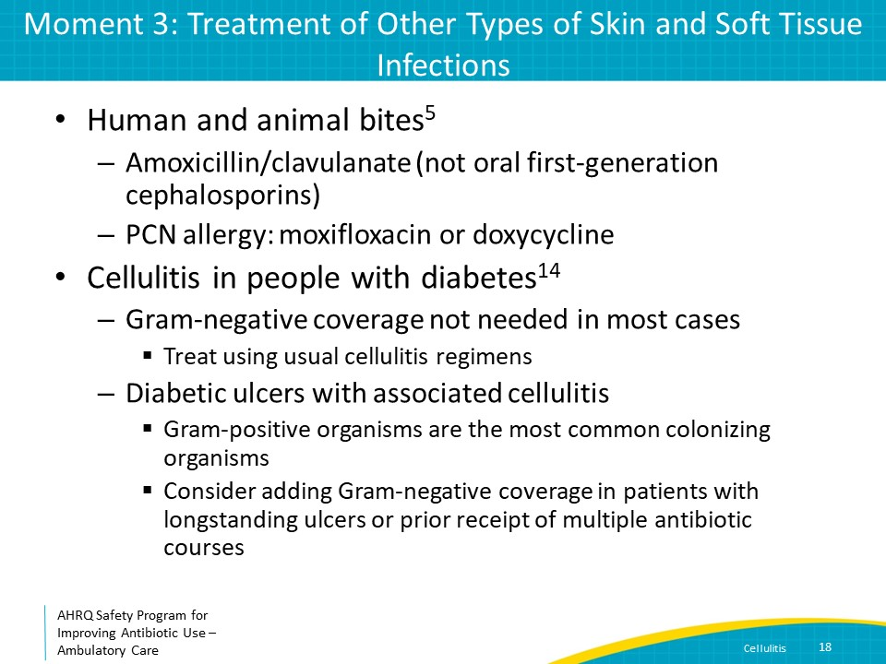
Non-Antibiotic Therapy  SAY:  Successful treatment of cellulitis requires more than just antibiotics. Most importantly, patients must elevate the affected extremity.  In addition, it is important to assess for and treat tinea pedis if it is found. If the cellulitis is associated with venous stasis or lymphedema, these conditions must be managed at the same time. | Slide 19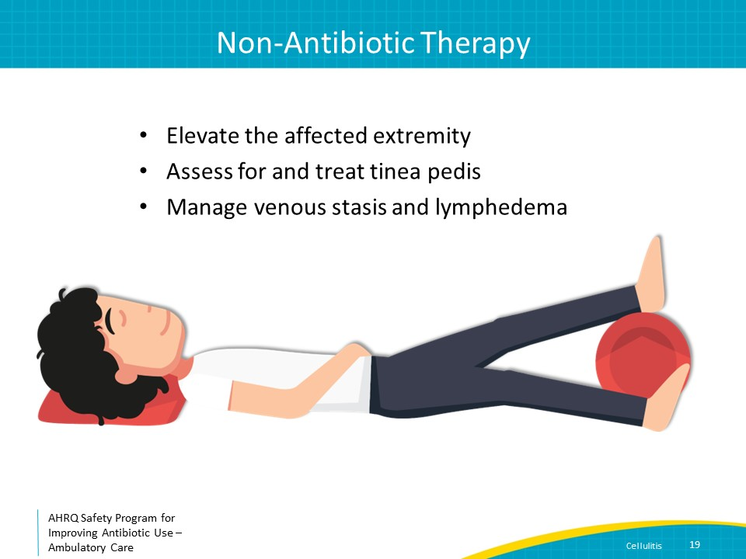
Moment 3: Duration of Therapy for Uncomplicated Cellulitis  SAY:  Most cases of cellulitis can be treated with 5–7 days of antibiotics. This recommendation is supported by evidence from clinical trials showing that shorter course therapy is as effective as longer courses.  For example, a randomized controlled trial compared 5 versus 10 days of therapy for patients with uncomplicated cellulitis. Patients with bacteremia, severe sepsis, and deep soft-tissue infections were excluded. All patients received antibiotics for 5 days. If they were experiencing at least minimal improvement in warmth, erythema, tenderness, and edema on day 5, they were randomized to receive either placebo or 5 more days of antibiotics therapy. Clinical success was achieved by 98 percent of patients in both groups. | Slide 20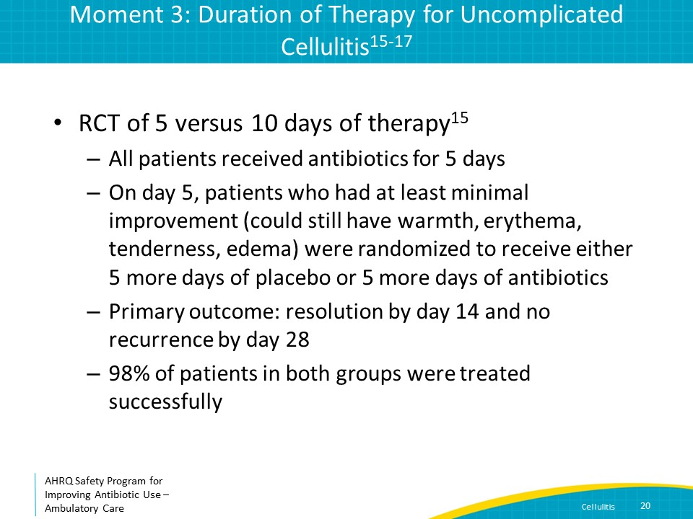
The Four Moments of Antibiotic Decision Making  SAY:  The last moment to consider is, “Does my patient understand what to expect and the followup plan? | Slide 21
Moment 4: Followup Plan for Patients  SAY:  It is important to let patients and families know the expected time course for improvement in symptoms and when they may need to come back to the office.  An increase or lack of change in the size of margins of erythema after a few doses of antibiotics does not indicate antibiotic failure. Toxin production can cause extensive local inflammation, and its persistence or extension over the first two days of therapy does not by itself indicate antibiotic failure. However, the erythema should become less intense, and systemic symptoms such as fever should improve in 48–72 hours.  The graph on the slide shows results of a study of the natural history of cellulitis on days 1, 2, and 3 of antibiotic therapy (moving left to right). The blue bars show the proportions of patients with cessation of lesion spread. The red bars show improvement in local inflammation. The green bars show both cessation of lesion spread and improvement in inflammation. The purple bars show defervescence.  Note that only about half of patients have cessation of lesion spread on day 1 of therapy. This proportion increases to more than 90 percent by day 2–3. Similar findings can be noted for improvement of local inflammation. But when these variables are combined in the third green bar, you can see that overall improvement is generally not seen until day 3 of therapy. Finally, note that many patients remain febrile until day 3.  If patients do not have cessation in lesion spread and improvement of local inflammation, or defervescence by day 3, they should be re-evaluated. Patients should also return to medical care if the cellulitis is rapidly spreading, bullae are developing, the lesion is becoming necrotic, or they are feeling increasingly ill. | Slide 22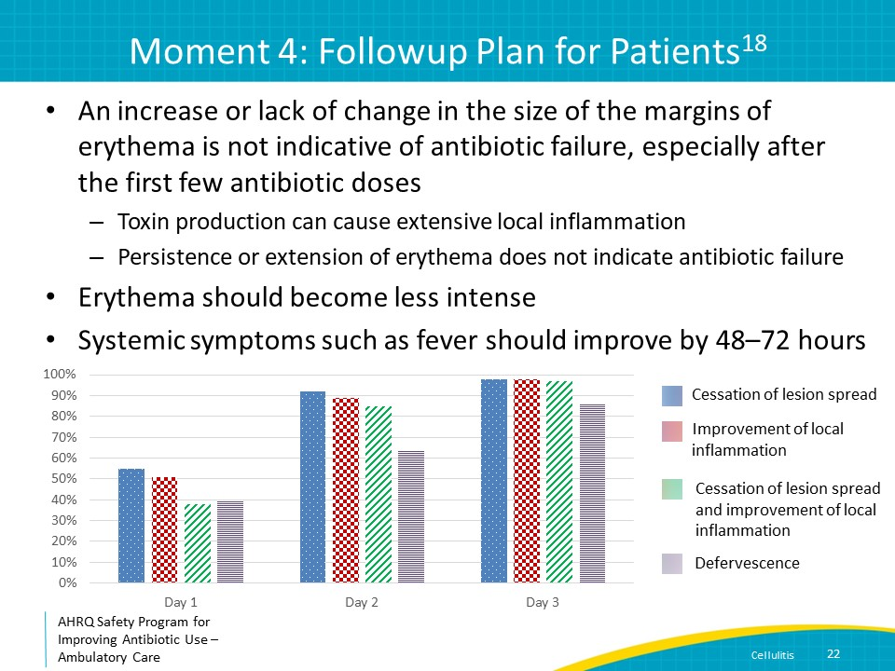
Take-Home Messages  SAY:  Make the right diagnosis! Cellulitis is generally of sudden onset, unilateral, and associated with significant warmth, erythema, fever, and evidence of inflammation (e.g., elevated white blood cell count and inflammatory markers). Always rule out noninfectious diagnoses that mimic cellulitis before diagnosing and starting antibiotic treatment for patients with “red” extremities.  Distinguish between nonpurulent and purulent cellulitis and treat based on the expected microbiology of these different syndromes.  Patients should be improving by day 3, but at that time may have some residual signs and symptoms. Lack of complete resolution does NOT mean that the therapy is not working.  If patients have no improvement or worsening symptoms by day 3, they should be re-evaluated.  Five-to seven-day courses of therapy are sufficient for most cases of cellulitis. | Slide 23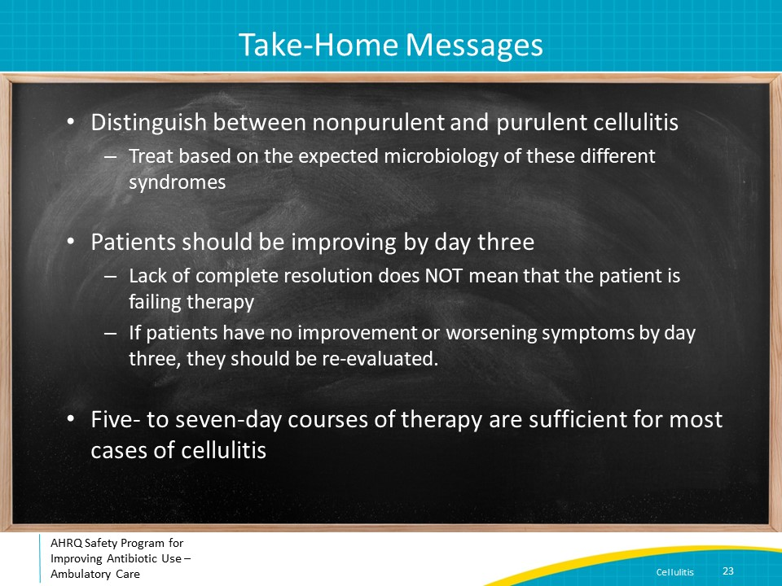
Additional Toolkit Resources  SAY:  For more resources on cellulitis and skin and soft tissue abscesses, please access tools listed below, available on the AHRQ Toolkit To Improve Antibiotic Use in Ambulatory Care.  Refer to the Discussion Guide to help your practice develop a standardized approach to the diagnosis and management of patients with cellulitis and skin and soft tissue abscesses.  Refer to the One-Page document for a concise summary of the diagnosis and treatment of cellulitis and skin and soft tissue abscesses.  The Patient Handout explains the symptoms and symptomatic treatment of cellulitis and skin and soft tissue abscesses. It is available in both English and Spanish. | Slide 24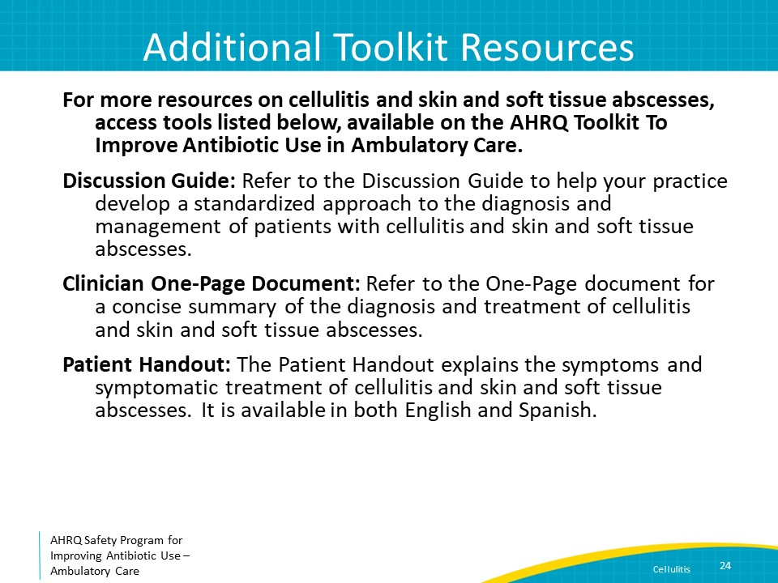
Disclaimer  SAY:  The findings and recommendations in this presentation are those of the authors, who are responsible for its content, and do not necessarily represent the views of AHRQ. No statement in this presentation should be construed as an official position of AHRQ or of the U.S. Department of Health and Human Services.  Any practice described in this presentation must be applied by healthcare practitioners in accordance with professional judgment and standards of care in regard to the unique circumstances that may apply in each situation they encounter. These practices are offered as helpful options for consideration by healthcare practitioners, not as guidelines. | Slide 25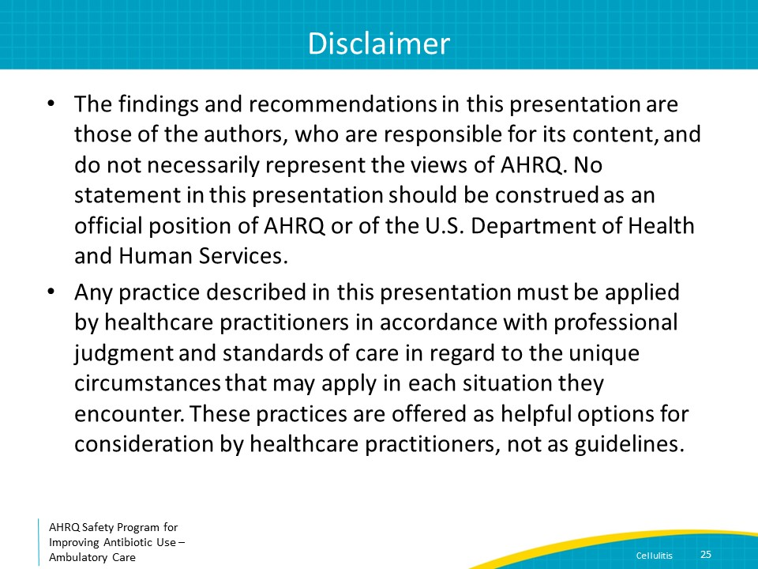
References  SAY:  Here are the references. | Slide 26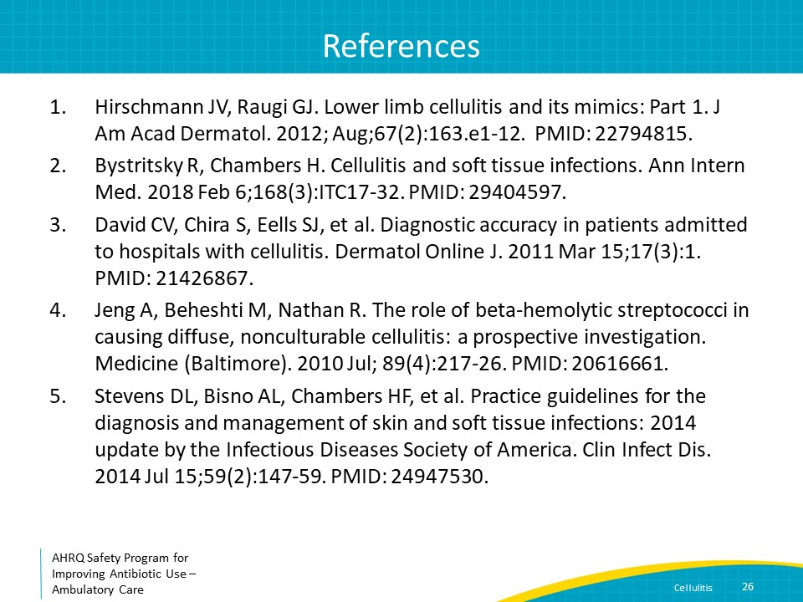
References | Slide 27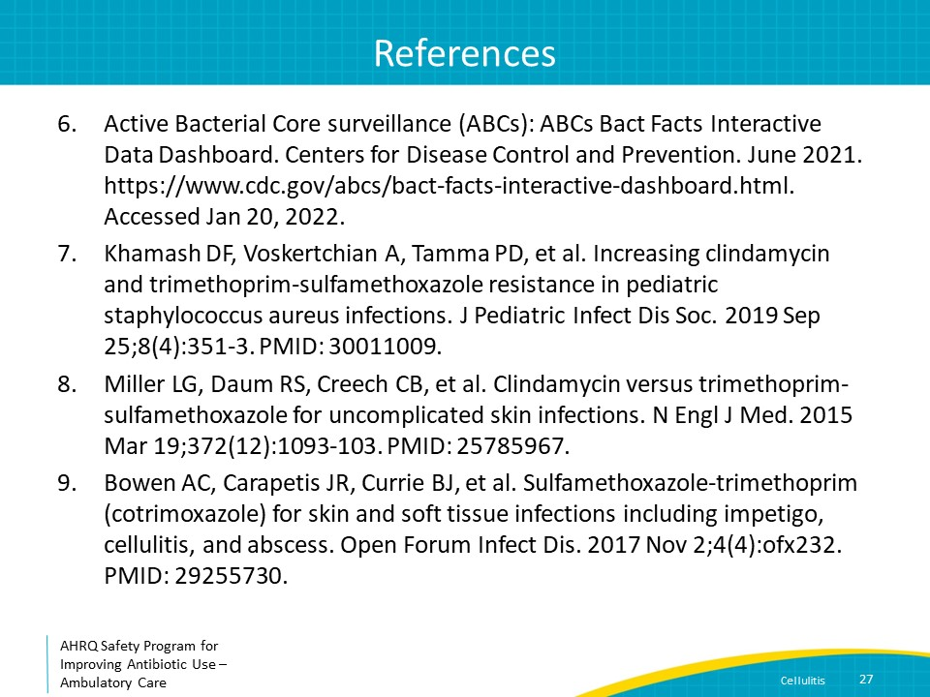
References | Slide 28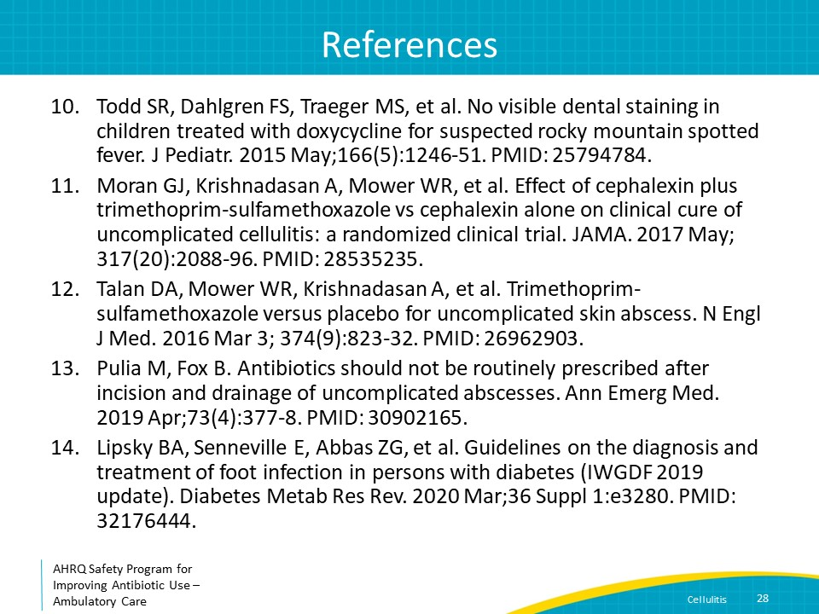
References | Slide 29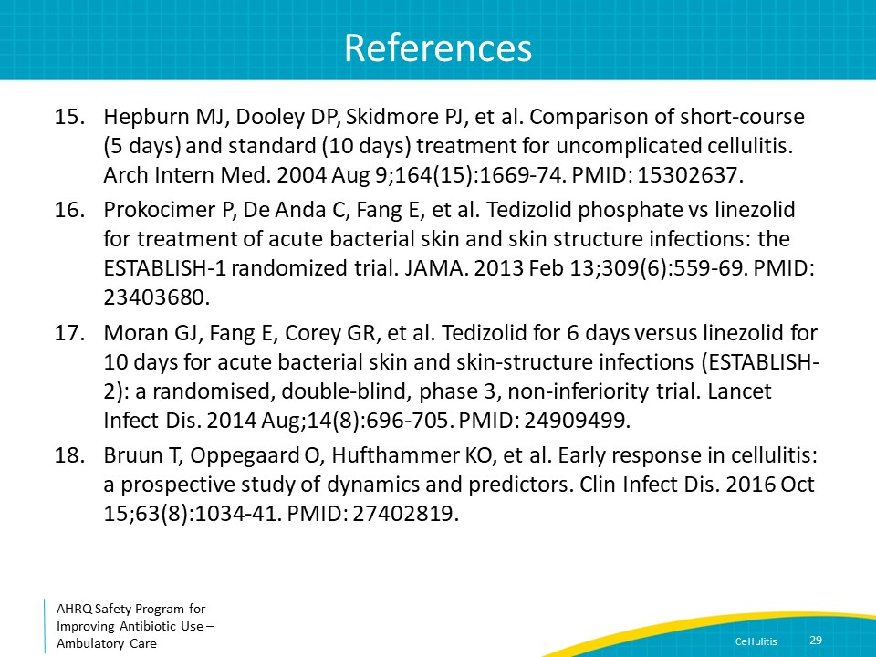
AHRQ Pub. No. 17(22)-0030
September 2022

