Sustaining Antibiotic Stewardship Efforts
Ambulatory Care
Slide Title and Commentary | Slide Number and Slide
Sustaining Antibiotic Stewardship Efforts  SAY:  Welcome to the presentation titled, “Sustaining Antibiotic Stewardship Efforts.” | Slide 1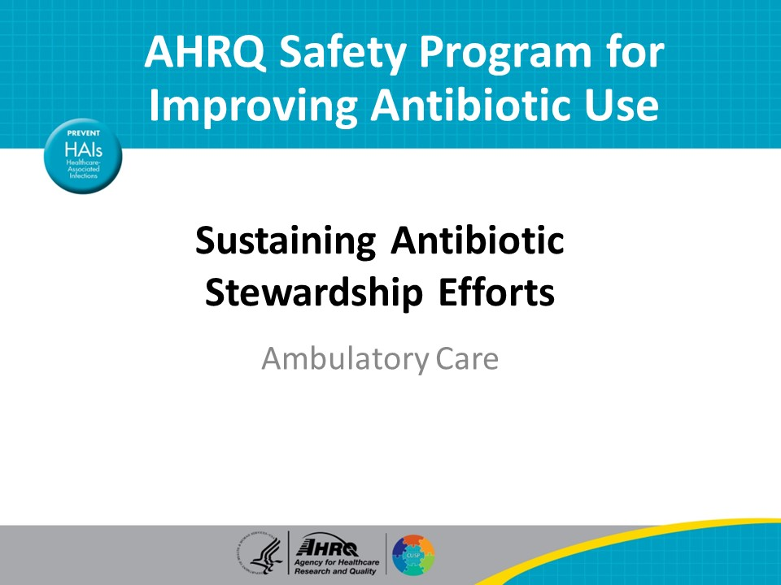
Objectives  SAY:  By the end of this presentation, participants will be able to—  - Develop sustainability plans to determine month to month antibiotic stewardship activities over the next 1–2 years  - Identify targets for future antibiotic stewardship efforts based on antibiotic prescribing patterns  - Understand the importance of completing a gap analysis on an annual basis | Slide 2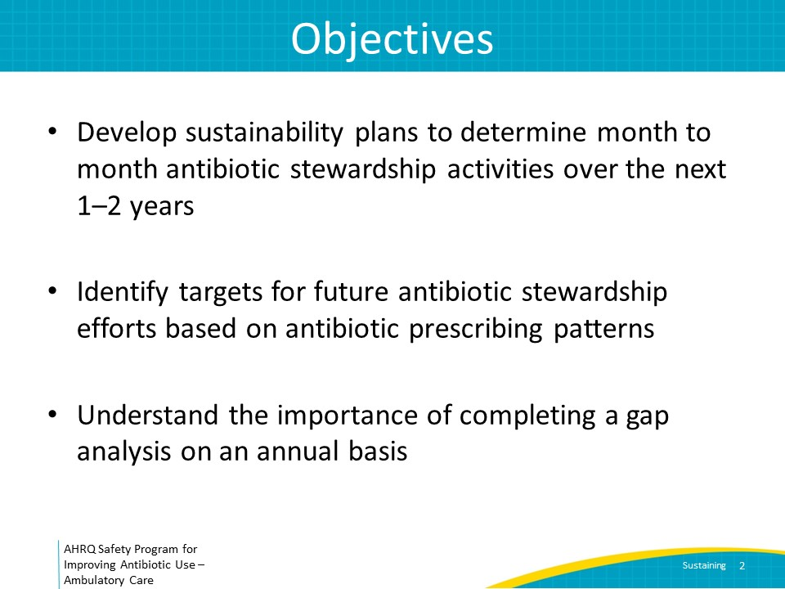
Looking Ahead  SAY:  The AHRQ Toolkit to Improve Antibiotic Use in Ambulatory Care contains a presentation titled “Implementing Antibiotic Stewardship in Your Practice” (slides and facilitator guide) that describes the step-by-step approach that should be used to establish an antibiotic stewardship team and interventions in the ambulatory setting. These steps should ideally be completed in approximately 2 years, although it may take longer. It is important not to rush through the steps.  The current presentation focuses on what the stewardship team can consider after these steps are completed to continue to improve antibiotic prescribing efforts in a practice. Finding new targets after initial steps are completed are important to keep practice members and the antibiotic stewardship team engaged. As a brief recap, the next slide reviews the initial steps that should have been completed prior to reviewing this presentation. | Slide 3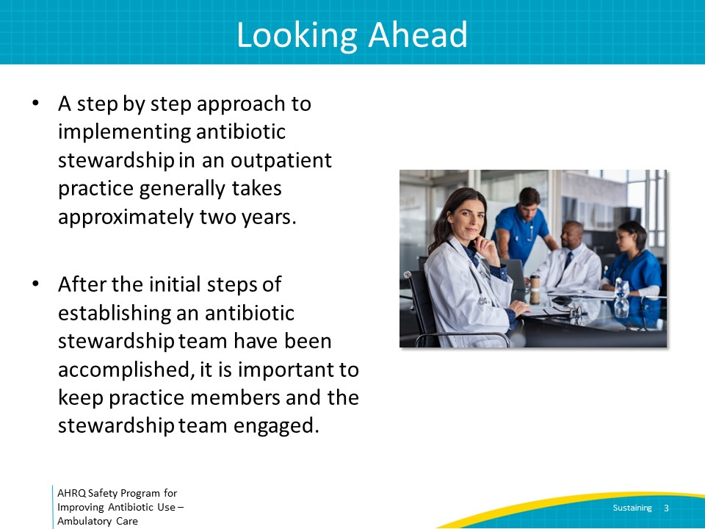
Implementation Steps  SAY:  First, support from senior leadership should have been obtained to both ensure the stewardship team has the necessary protected time to lead antibiotic improvement efforts and assist stewardship teams with the necessary informational technology resources to periodically review antibiotic prescription data.  Second, a clinician lead and administrative lead should have been identified and recognized by other members of the practice as the core members of the antibiotic stewardship team.  Third, a case should have been made to all members of the practice including physicians, advanced practitioners, nurses, medical assistants, front desk staff, and pharmacists so that they consider antibiotic stewardship to be a patient safety issue and are committed to working together to improve antibiotic decision making across the practice.  Fourth, the antibiotic stewardship team should have determined how to access antibiotic prescription data using the metric of number of antibiotic prescriptions over number of clinic visits. Additionally, approaches to accessing provider-specific antibiotic prescription data and infectious condition specific antibiotic prescription data should be in place. Moreover, a process of generating antibiotic prescribing data at least quarterly should have been developed to monitor changes in antibiotic prescribing over time.  Fifth, the stewardship team should have worked with other members of the practice to improve communication skills between practice members and standardize practices around antibiotic prescribing for common infectious diseases, as well as develop effective communication among practice members and patients about management of common infectious diseases, including when antibiotics are and are not needed.  Sixth, through discussions with other members of the practice, the antibiotic stewardship team should have prioritized a list of infectious conditions to target and at practicewide meetings discussed best practices in the diagnosis and treatment of these infectious processes. Discussion guides should have been used to build consensus around practicewide approaches for managing these infections.  Seventh, after efforts focus on educating and building consensus around specific infectious conditions, antibiotic prescribing data should be monitored and reported back to the practice. As an example, if a “never antibiotic” condition such as bronchitis was the focus of recent educational efforts, data on the proportion of visits for acute bronchitis that have an antibiotic prescription across the practice and by individual prescriber should have been reviewed before and after the educational initiative.  The eighth step is to develop a sustainability plan. | Slide 4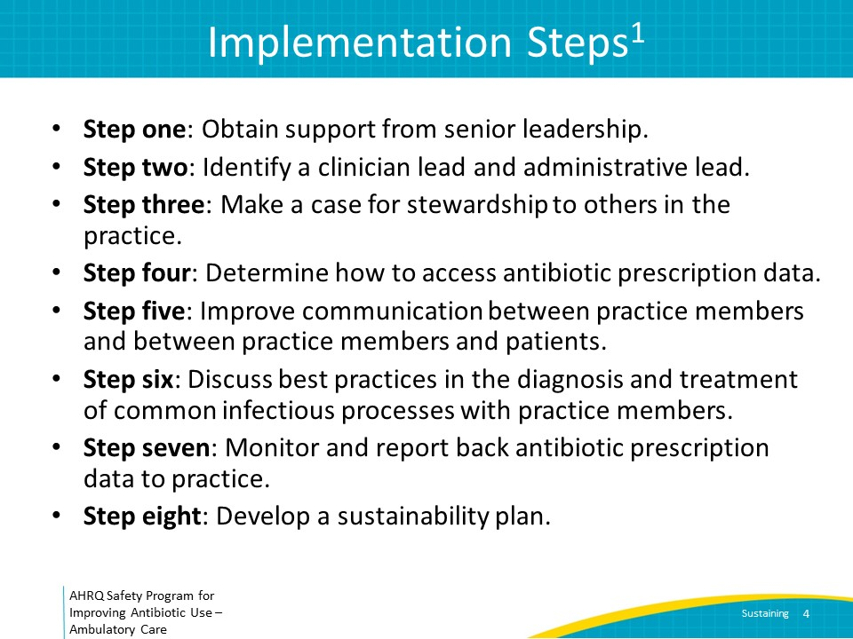
Sustainability Plan  An initial sustainability plan should be developed within the first 2 years of establishing the stewardship team to review the primary goals of the stewardship team. The initial sustainability plan should include an approximate outline of the month to month plans during the first 1–2 years (e.g., the order of the infectious conditions to focus on, the approximate amount of time that will be spent on each condition, how frequently to review antibiotic prescription data as a practice, the frequency of practicewide meetings). The initial sustainability plan should be reviewed with senior leadership. After approval from senior leadership, review the sustainability plan with practice members. Refer to the document titled “Timeline for Improving Antibiotic Stewardship in Ambulatory Care” to assist with developing the initial sustainability plan.  After the above steps have been completed (likely in approximately 1–2 years), the sustainability plan should subsequently be updated on an annual basis. It should continue to have month to month plans outlining goals of the stewardship team for the next 12 months.  To successfully execute these efforts, the stewardship team must continue to have protected time or effort to focus on stewardship activities and continue to have dedicated time to present during standing practice meetings, even after the initial 2-year period. Review the annual sustainability plan with both senior leadership and practice members. | Slide 5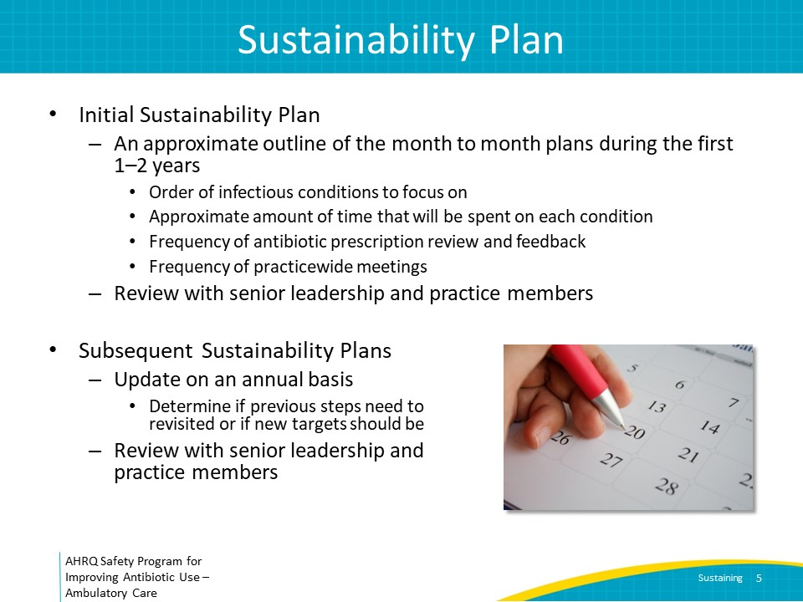
Cluster-Randomized Trial  SAY:  Consider this example that highlights the potential impact of antibiotic stewardship in ambulatory practices but also underscores the importance of sustaining stewardship activities.  A cluster-randomized controlled trial of pediatric practices was undertaken in which entire practices were enrolled into one of two arms.  Practices in the intervention arm received a 1-hour education session followed by a year of practice-level antibiotic prescribing data for upper respiratory tract infections and sinusitis. In quarterly antibiotic prescription reports, the practice’s antibiotic prescribing rates were compared to each of the other 24 participating practices. Practices in the control arm did not receive any targeted education and did not receive periodic reports on their antibiotic use.  At the end of the one-year study period, practices in the first group experienced a 50 percent reduction in the use of guideline noncompliant antibiotic use compared to the second group, demonstrating the importance of implementing interventions coupled with measuring and reporting associated changes in antibiotic use. | Slide 6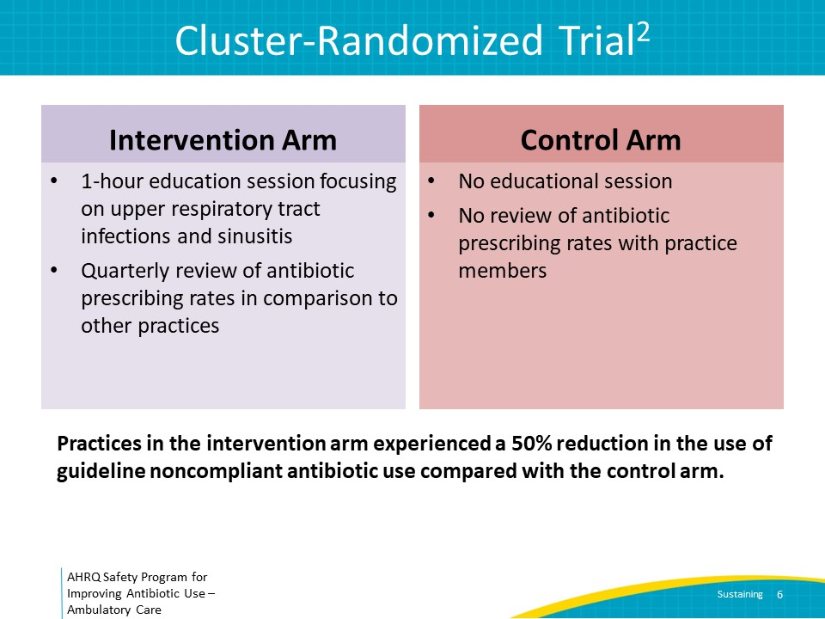
Post-Intervention  SAY:  After the 1-year study period, neither group received ongoing education or quarterly antibiotic prescribing data reports. In the figure on this slide, the intervention period is shaded in blue. The orange line represented antibiotic use before the intervention, during the intervention, and after the intervention, for the group that received education and antibiotic use data during the intervention period. As can be seen, the intervention group’s antibiotic prescription practices reverted back to the pre-intervention period after the intervention and became similar to that of the control group, represented by the black line.  This study emphasizes the importance of developing a plan to sustain stewardship activities to ensure effective antibiotic prescribing practices are maintained even after the focus is shifted to new infectious conditions or non-infection-related initiatives such as improved blood pressure control initiatives. | Slide 7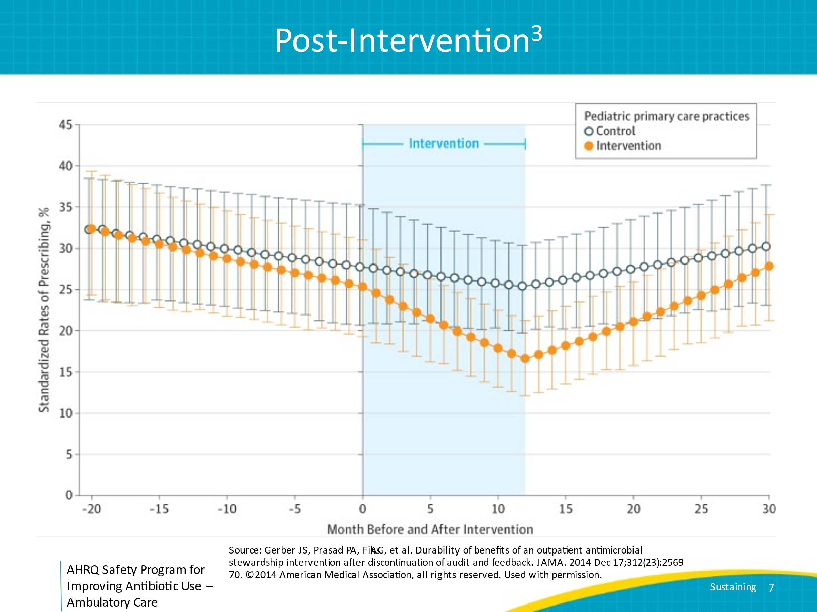
Proportion of Visits With an Antibiotic Prescription  SAY:  Even after the first 2 years, certain stewardship activities will be ongoing components of the sustainability plan. These include reviewing antibiotic prescription data at least quarterly and feeding it back to clinicians in the practice. As antibiotic use unexpectedly increases for certain agents (e.g., fluoroquinolones) or for certain indications (e.g., never antibiotic conditions), additional interventions may be necessary.  An approach to consider where to target educational efforts that will inform the annual sustainability plan is to examine the proportion of clinic visits for which antibiotics are prescribed over time. On the slide is a chart of a hypothetical clinic’s prescribing pattern for upper respiratory tract infection, acute bronchitis, and influenza. These are three of the “never antibiotics” diagnoses—that is, diagnoses for which antibiotics should never be prescribed.  Review the total number of clinic visits for each of these diagnoses in a given time period. Then, review the proportion of these visits for which an antibiotic was prescribed. Consider such a review on a monthly or at least quarterly basis, to measure antibiotic prescribing over time.  In this example, the proportion of visits in which an antibiotic was prescribed went down over time for these never antibiotic conditions, suggesting that while there is always room for further improvement, focusing on additional efforts to reduce antibiotic prescribing for these conditions may not be as pressing as for some other conditions. | Slide 8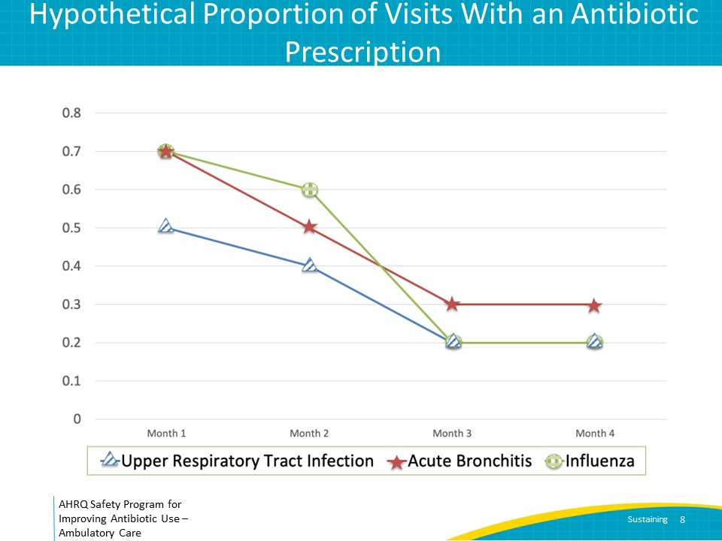
The Iterative Nature of Stewardship  SAY:  This slide represents hypothetical changes in antibiotic prescriptions over time for patients with a diagnosis of influenza.  In this example, after the practice reviewed the AHRQ Toolkit To Improve Antibiotic Use in Ambulatory Care material on influenza and implemented changes, the practice had a decrease in the proportion of influenza visits for which antibiotics were prescribed from approximately 60 percent in November to 20 percent the following March. However, during the subsequent influenza season, percentages increased from 20 percent in November to 60 percent by January.  After reviewing these data, the stewardship team should refocus efforts on influenza again rather than moving on to a new infectious condition to target. Consider once again succinctly presenting the educational content such the presentation (slides and facilitator guide) or one-pager on influenza during practice meetings. Also, review the discussion guide with practice members to enhance consistency regarding issues such as what rapid diagnostics should be available, who should undergo influenza testing, how influenza results will be communicated to patients, and what symptomatic treatment the practice will recommend for patients with influenza.  Consider investigating whether any other changes could have negatively impacted antibiotic prescribing for influenza, such as new staff who were not part of the initial educational efforts, after-hours triaging by a call center not familiar with the practice’s approach to managing influenza, or delays in receiving influenza testing results leading to antibiotic prescriptions.  Similarly, after re-education efforts occur, if the stewardship team still notices an unacceptably high rate of antibiotic prescribing for influenza, consider additional interventions. Examples might include working with information technologists to develop an electronic link to the influenza one-pager which includes the diagnostic criteria for when a clinical diagnosis of influenza is reasonable. Similarly, informational technologists may be able to develop an alert in the electronic health record reminding clinicians that antibiotics are generally unnecessary for influenza when an influenza diagnosis is entered. If the practice prefers an approach to testing for influenza, the stewardship team might consider identifying an alternate influenza test with a more rapid turnaround time. | Slide 9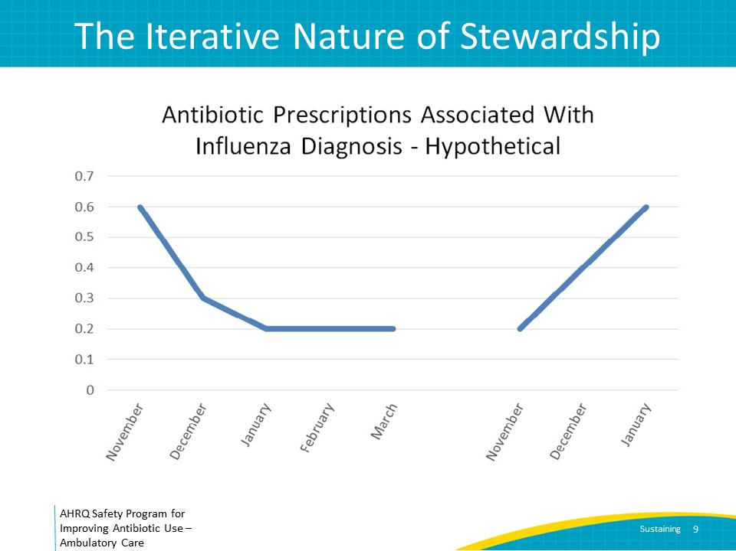
Gap Analysis  While planning ahead to identify new targets for the stewardship team, consider completing the Gap Analysis Tool for Antibiotic Stewardship in Ambulatory Care. A gap analysis should be completed at least annually to evaluate existing stewardship activities and to define areas for further improvement that will inform the sustainability plan.  The gap analysis tool can be found in the AHRQ Toolkit To Improve Antibiotic Stewardship in Ambulatory Care. Approaches to address the antibiotic stewardship areas outlined in the gap analysis document can be found throughout the toolkit.  The questions labeled “fundamental” on the gap analysis tool indicate components that all antibiotic stewardship teams should have in place. The questions labeled “enhanced” indicate components that may further enhance antibiotic stewardship activities. If fundamental components are missing or if the stewardship team is not performing core interventions, the tool should help you determine how to manage these deficiencies, including meeting with senior leadership to discuss the need for additional resources before moving on to enhanced items.  If the practice is missing some of the enhanced items included in the gap analysis (for example, “Does your practice have access to an antibiogram?”) discuss whether implementation of these items might be of benefit to your antibiotic stewardship activities and what resources would be needed to operationalize them. | Slide 10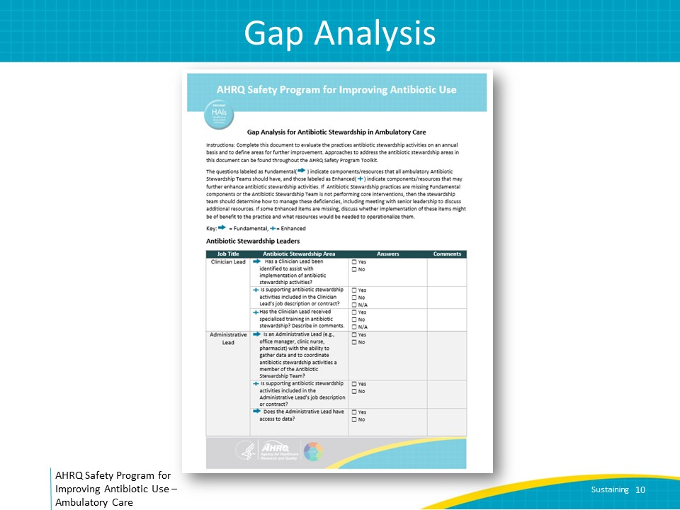
Take-Home Messages  SAY:  After the initial steps to establishing antibiotic stewardship principles in a practice occur, ongoing stewardship efforts are needed to continue to observe optimal antibiotic prescribing.  An initial sustainability plan should include a month-to-month description that addresses the order of the infectious conditions to focus on, the approximate amount of time that will be spent on each condition, the frequency of antibiotic prescription data review, and the frequency of practicewide meetings.  New sustainability plans should be developed approximately every year after the initial steps are implemented. Measuring antibiotic prescriptions by agent, provider, and condition can inform infectious condition targets to include in the sustainability plan. Similarly, completion of an annual gap analysis can inform ongoing or new stewardship efforts to include in the sustainability plan. | Slide 11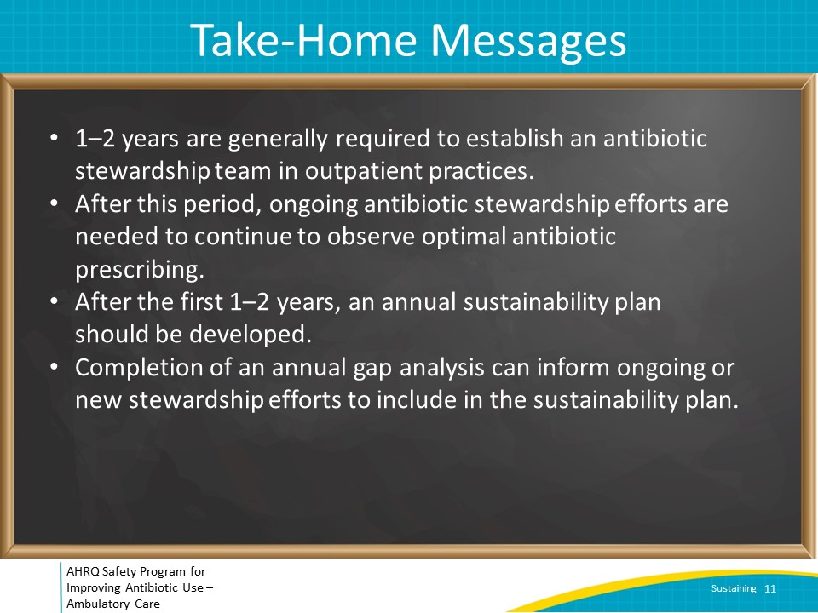
Disclaimer  SAY:  The findings and recommendations in this presentation are those of the authors, who are responsible for its content, and do not necessarily represent the views of AHRQ. No statement in this presentation should be construed as an official position of AHRQ or of the U.S. Department of Health and Human Services.  Any practice described in this presentation must be applied by healthcare practitioners in accordance with professional judgment and standards of care in regard to the unique circumstances that may apply in each situation they encounter. These practices are offered as helpful options for consideration by healthcare practitioners, not as guidelines. | Slide 12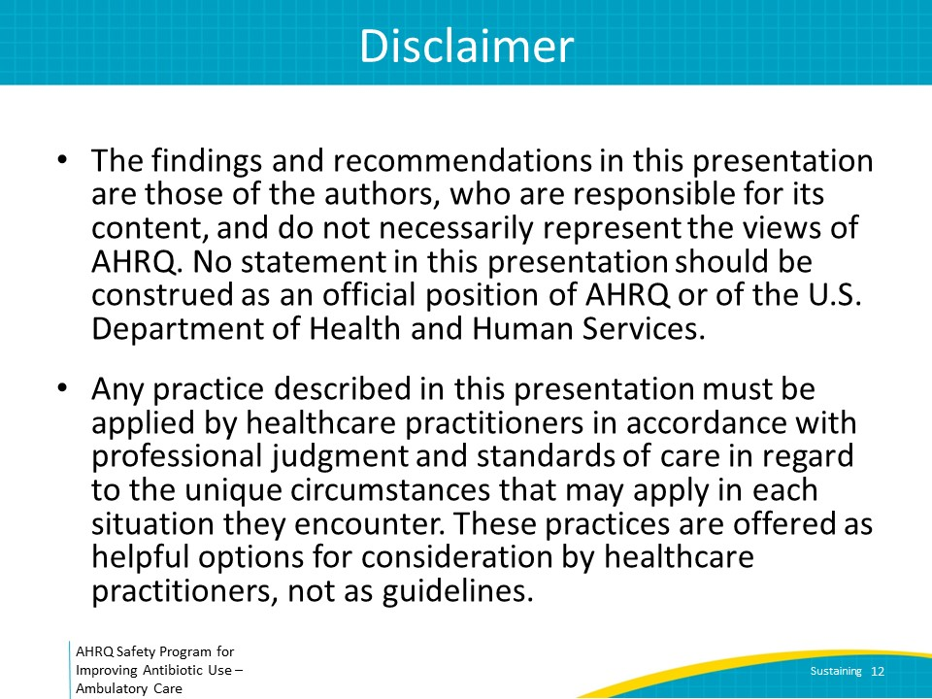
References  SAY:  Here are the references for this presentation. | Slide 13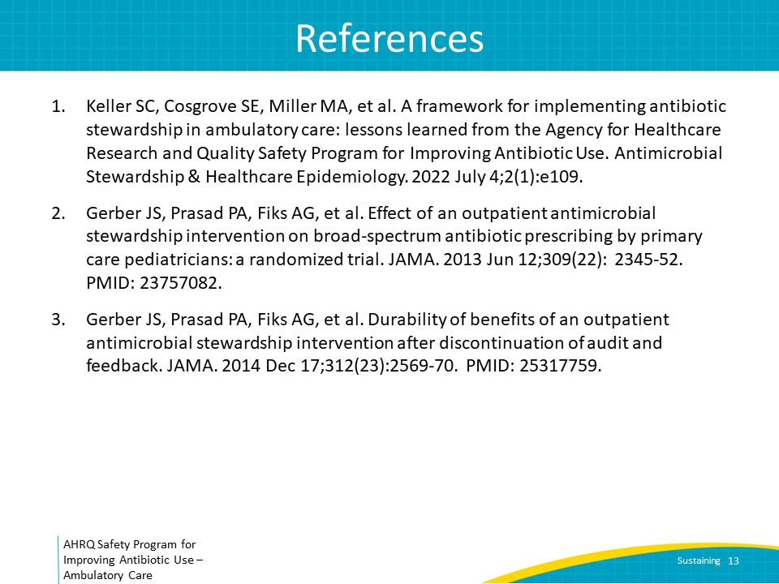
AHRQ Pub. No. 17(22)-0030
September 2022

