Best Practices in the Diagnosis and Treatment of Asymptomatic Bacteriuria and Urinary Tract Infections
Ambulatory Care

Slide Title and Commentary | Slide Number and Slide
Best Practices in the Diagnosis and Treatment of Asymptomatic Bacteriuria and Urinary Tract Infections  Ambulatory Care  SAY:  Welcome to the presentation titled “Best Practices in the Diagnosis and Treatment of Asymptomatic Bacteriuria and Urinary Tract Infections.” | Slide 1
Objectives  SAY:  By the end of this presentation, participants will be able to—  - Distinguish asymptomatic bacteriuria or ASB from urinary tract infection or UTI  - Discuss indications for sending urine cultures  - Discuss empiric antibiotic options for UTIs that are effective while also minimizing the potential for antibiotic-associated adverse events and  - Discuss recommended durations of antibiotic therapy for UTIs | Slide 2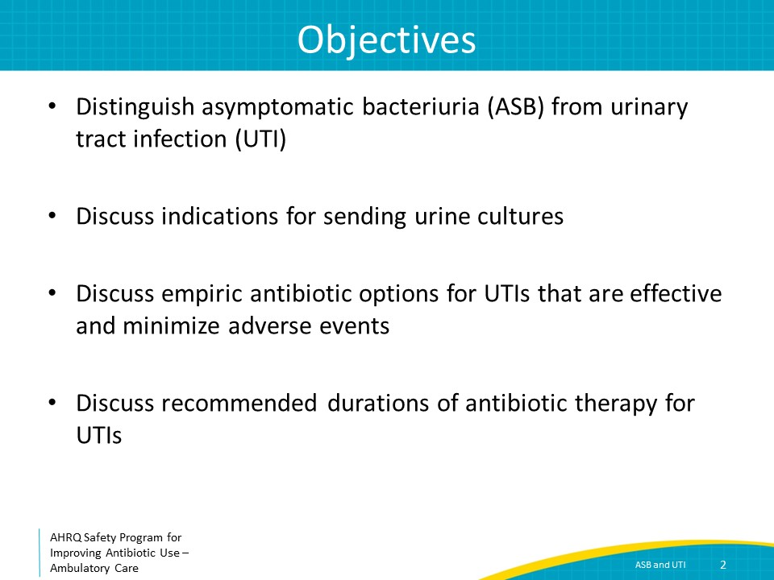
The Four Moments of Antibiotic Decision Making  SAY:  We will review UTIs using the Four Moments of Antibiotic Decision Making. | Slide 3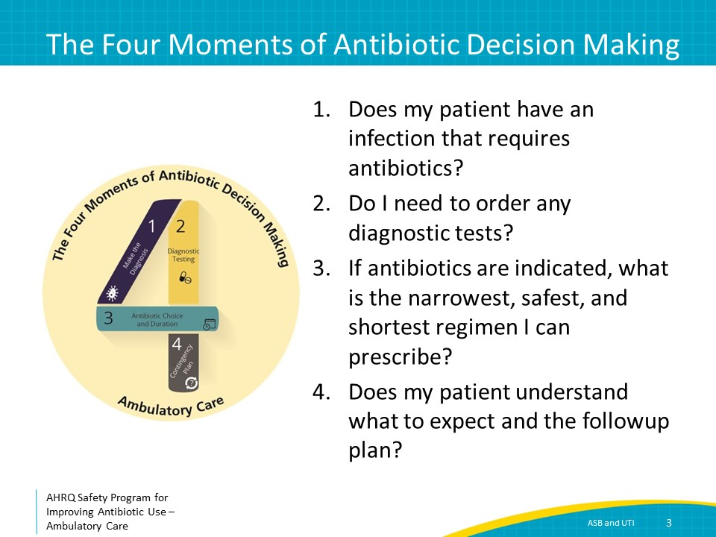
The Four Moments of Antibiotic Decision Making  SAY:  Moment One is: Does my patient have an infection that requires antibiotics? | Slide 4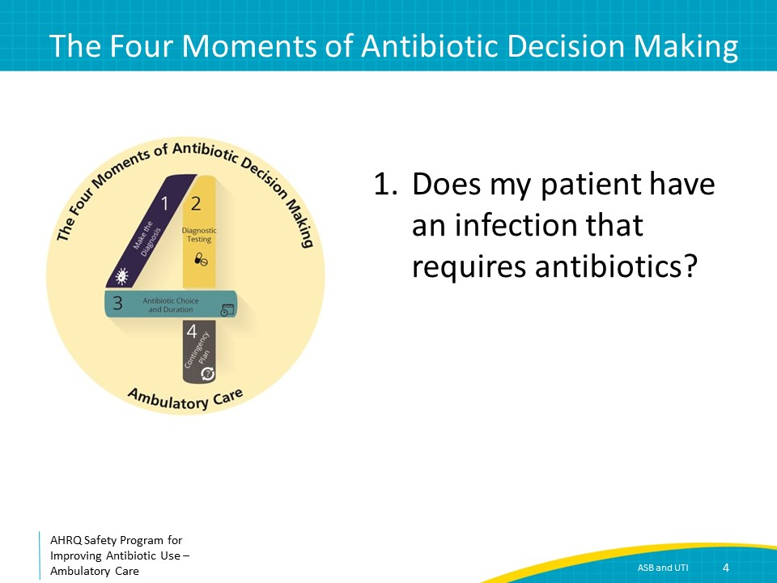
Symptoms of Urinary Tract Infections  SAY:  The diagnosis of a UTI is dependent on the presence of symptoms of a UTI. There are two common types of UTI seen in outpatients: cystitis, which is an infection of the bladder, and pyelonephritis, which is an infection of the kidney. Common symptoms of cystitis are dysuria, frequency, urgency, and suprapubic pain. Common symptoms of pyelonephritis are fever and flank pain, in addition to the symptoms of cystitis.  Foul-smelling or cloudy urine by itself does not indicate a UTI. Furthermore, mental status changes in the absence of urinary symptoms are highly unlikely to indicate a UTI. | Slide 5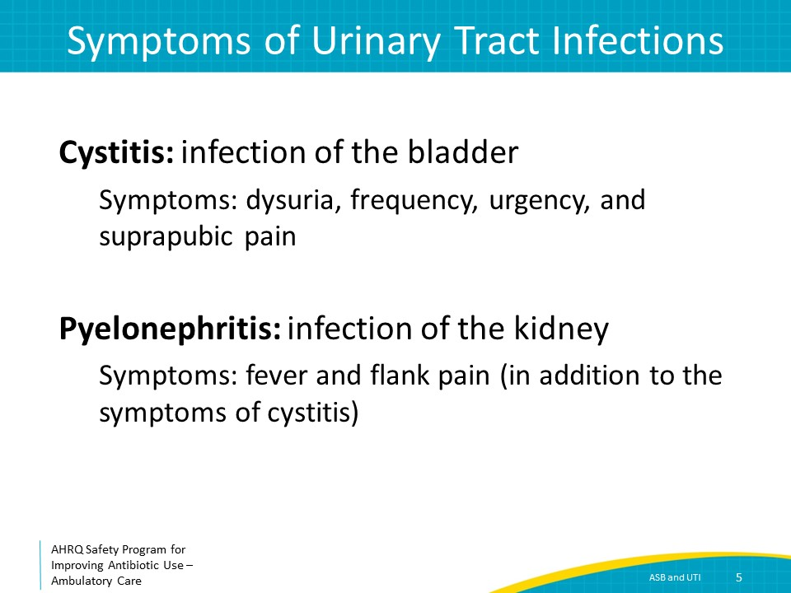
UTI Diagnosis in Children and Adolescents  SAY:  Children at least 4 years of age are usually able to verbalize the presence of UTI symptoms, making the criteria for diagnosing a UTI in children 4 years and older identical to the criteria in adults.  In children under 4 years of age, UTIs can be more challenging to recognize. It is reasonable to obtain a urinalysis and urine cultures in febrile and irritable children in this age group, in the absence of alternative explanations. | Slide 6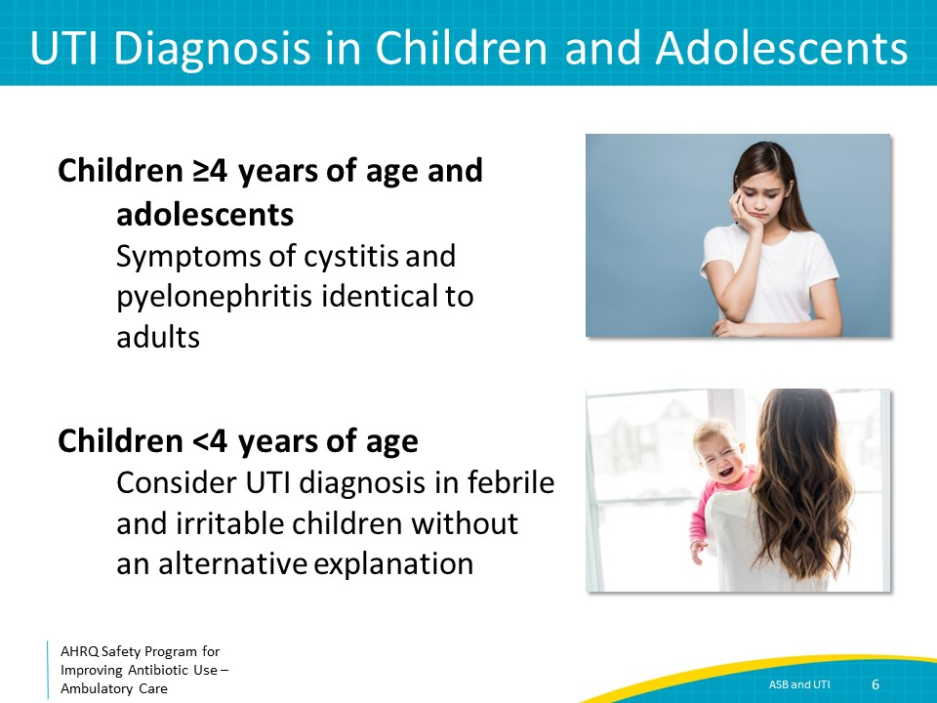
Asymptomatic Bacteriuria (ASB)  SAY:  Frequently, urine cultures collected from patients without UTI symptoms may grow bacteria. This is called asymptomatic bacteriuria, or ASB, and does not indicate a UTI. ASB is defined as the presence of significant colony counts of bacteria in the urine from a person without symptoms of a UTI. Urine cultures should only be obtained from patients with symptoms of a UTI.  Urine from patients with ASB may contain a large number of white blood cells or WBCs, which is referred to as pyuria. The presence of pyuria in the absence of abnormal urinary symptoms also does not indicate a UTI. | Slide 7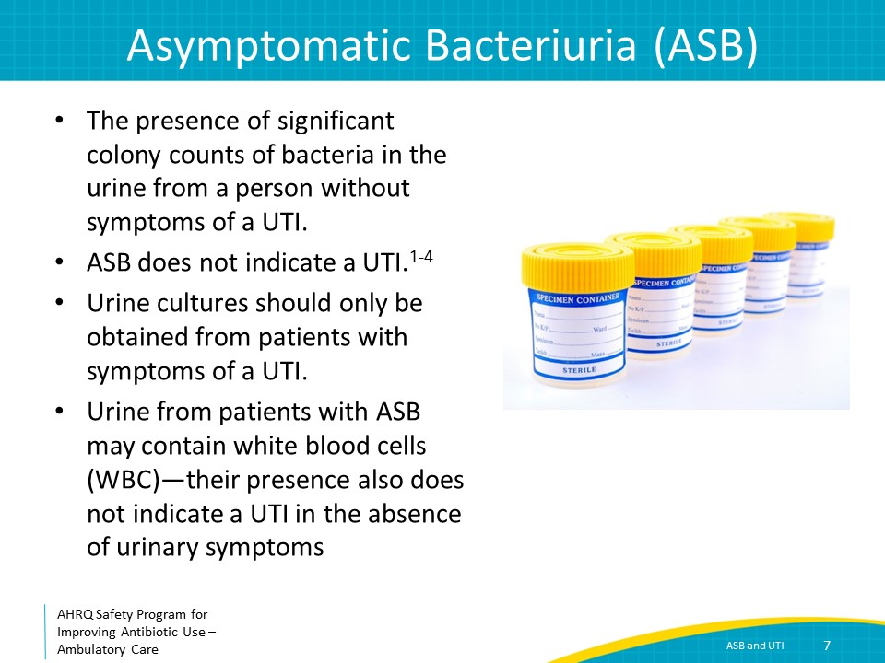
Asymptomatic Bacteriuria  SAY:  ASB is common. The prevalence of asymptomatic bacteriuria differs depending on the population, but generally, the risk increases with age. It is common among people living in long-term care facilities. People with long-term indwelling urinary catheters may grow bacteria in urine cultures because of bacterial colonization of their catheters. | Slide 8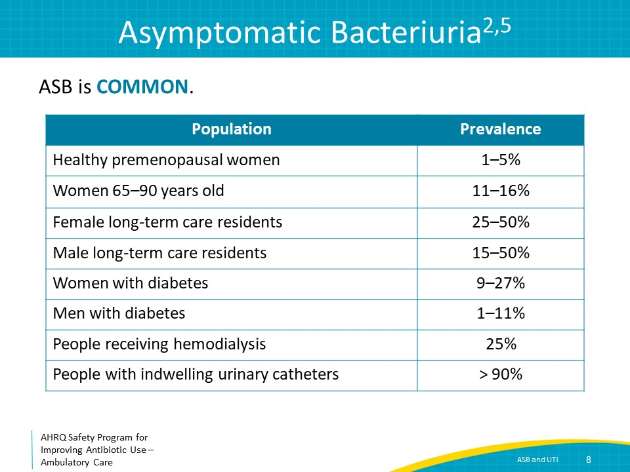
Treatment of Asymptomatic Bacteriuria May Cause Harm  SAY:  In the majority of cases, ASB does not need to be treated with antibiotics. Randomized controlled trials have not shown that treatment reduces risk of progression to UTI. Furthermore, other studies have suggested that treatment of ASB may cause harm to patients.  In addition to antibiotic-associated adverse events, antibiotic treatment of ASB has been shown to increase the risk of subsequent clinically significant episodes of UTIs such as cystitis or pyelonephritis that have an increased likelihood of being antibiotic resistant. | Slide 9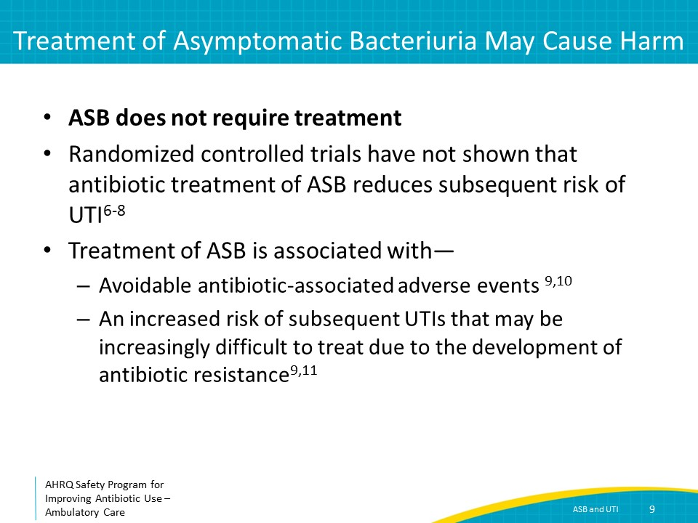
Mental Status Changes and Asymptomatic Bacteriuria  SAY:  Bacteriuria and delirium are both common in the elderly; thus, it can be difficult to understand if there is a causal relationship between these two conditions. While a UTI diagnosed based on the traditional symptoms reviewed earlier may also be associated with delirium, there is no evidence that delirium, falls, or confusion are symptoms of a UTI in the absence of development of symptoms related to the urinary tract, such as dysuria or systemic signs of infection.  In a study in which 72 elderly residents without traditional UTI symptoms were questioned about symptoms of well-being when they did and did not have asymptomatic bacteriuria detected in urine specimens over a year, no differences in insomnia, malaise, fatigue, weakness, or anorexia were noted in the presence or absence of asymptomatic bacteriuria.  These findings suggest that asymptomatic bacteriuria is not associated with a reduction in neurologic function. In the absence of local genitourinary symptoms or systemic signs of infection, older patients with bacteriuria experiencing delirium or falls should be assessed for other causes, such as dehydration, and careful observation rather than antibiotic therapy. It is important to remember that if a patient has symptoms suggestive of a systemic infection, such as fever or hypotension, antibiotic initiation should be considered, regardless of the presence of symptoms related to the urinary tract. | Slide 10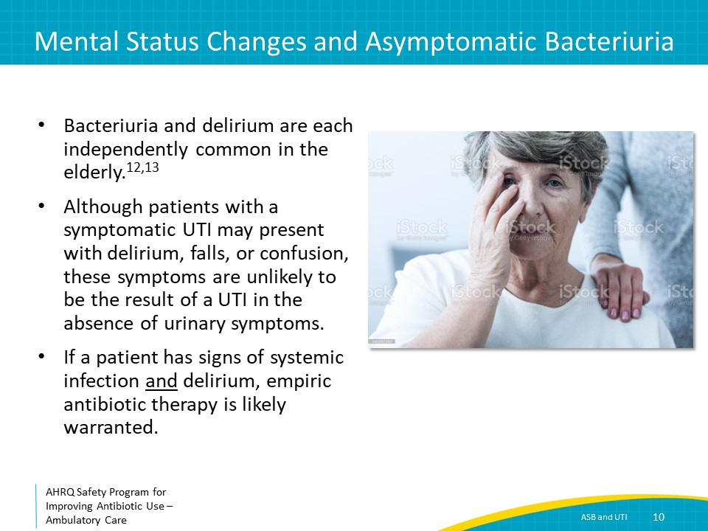
When Is Screening/Treatment for ASB Indicated?  SAY:  Screening for ASB, and treating if present, should be considered in two specific situations: early during pregnancy and in individuals about to undergo a urologic procedure in which mucosal bleeding is expected.  ASB during pregnancy confers a 20- to 30-fold increased risk of the development of pyelonephritis. It is also associated with preterm labor and low birth-weight infants. The optimal duration of antibiotic therapy has not been yet determined; a course of 4–7 days is suggested depending on the antibiotic selected.  ASB has been associated with urosepsis in patients undergoing urologic procedures involving mucosal bleeding. This does not include the insertion of a urinary catheter. For patients about to undergo urologic procedures involving mucosal bleeding, a screening urine culture should be obtained prior to the procedure. If bacteriuria is identified, no more than one to two doses of an antibiotic targeting the organism is necessary, with one dose 30 to 60 minutes before the beginning of the procedure. | Slide 11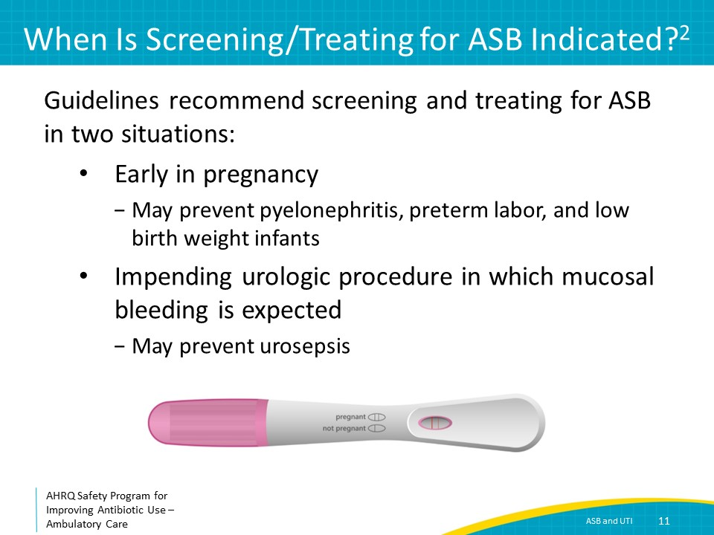
The Four Moments of Antibiotic Decision Making  SAY:  Moment Two of the Four Moments of Antibiotic Decision Making is:  Do I need to order any diagnostic tests?  Let’s change topics from ASB to UTIs. Once you have determined that your patient may have a UTI based on clinical signs or symptoms, what diagnostic tests are necessary? | Slide 12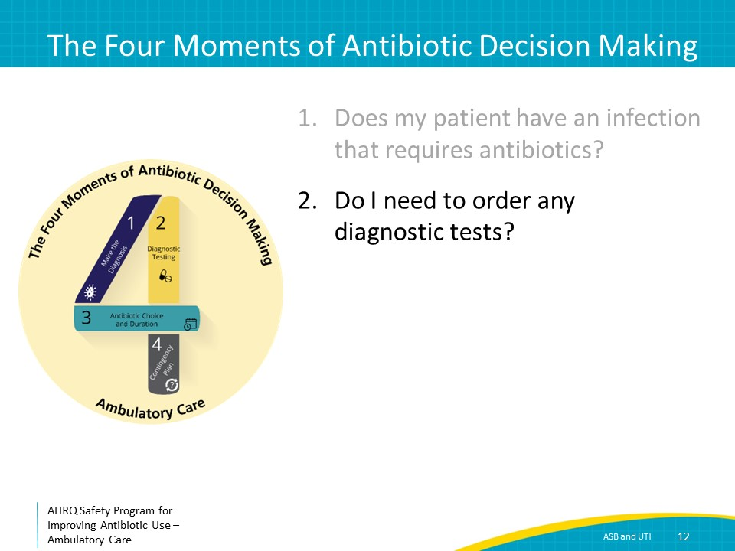
Moment 2: Urinalysis and Urine Cultures  SAY:  Most adolescent and adult women with acute symptoms of cystitis, such as dysuria, urgency, or suprapubic pain, do not require a urinalysis or a urine culture, as these symptoms are strongly suggestive of the presence of cystitis.  For infants and children in whom the diagnosis of a UTI may be more uncertain, a urinalysis and urine culture are recommended.  A urinalysis and urine culture should be obtained at any age when cystitis is suspected if any of the following are true:  First, the patient has risk factors for antibiotic-resistant organisms such as recent treatment for a UTI and presence of lingering or new symptoms of a UTI suggestive of therapeutic failure. Antibiotic-resistant organisms may also be present in patients with a history of UTIs because their bacterial flora may become resistant to commonly used antibiotics over time. Additionally, patients who have other underlying medical conditions and are frequently exposed to antibiotics also have a risk of antibiotic-resistant organisms, and a urine culture can be helpful in guiding antibiotic therapy decisions.  A second reason to obtain a urinalysis and urine culture is if a complicated UTI is suspected. A complicated UTI is any UTI in an adolescent or adult male or a UTI occurring in the presence of obstruction, chronic urinary stasis, or urinary catheterization. Examples of complicated UTIs include UTIs in the presence of renal stones, benign prostatic hyperplasia, spina bifida, chronic urinary catheters, or nephrostomy tubes. Because patients with complicated UTIs are at risk for UTIs caused by organisms such as Pseudomonas aeruginosa or drug-resistant bacteria such as extended-spectrum-beta-lactamase or ESBL-producing E. coli, obtaining a urine culture helps ensure the patient is receiving effective antibiotic therapy as these organisms are unlikely to be covered by common antibiotics prescribed for UTIs, as discussed later.  The third scenario for when obtaining a urinalysis and urine culture is important is when you suspect the patient has pyelonephritis or is ill appearing and hospitalization is planned. Because it is important to ensure patients who are ill appearing from an infection potentially arising from the urinary tract are receiving effective antibiotic therapy, obtaining a urine culture can assist with adjusting antibiotic therapy that was started empirically, if necessary. | Slide 13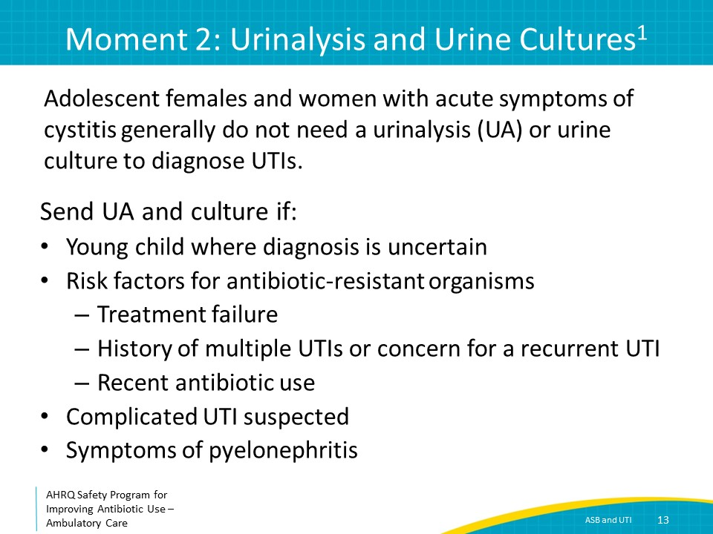
UTIs in Males  SAY:  As already discussed, any UTI in an adolescent or adult male is considered complicated. If a UTI is diagnosed in a male unexpectedly, an evaluation for an underlying cause that may be causing urinary obstruction should be pursued such as the presence of renal stones (particularly in the presence of colicky pain), ureteral strictures, or an enlarged prostate. Alternative diagnoses such as prostatitis, epididymitis, or sexually transmitted infections should also be considered. | Slide 14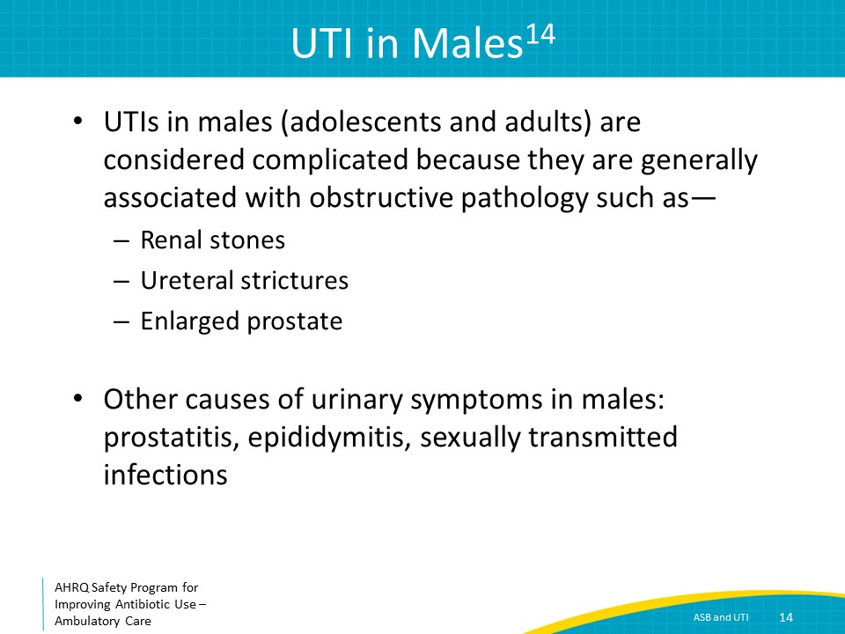
Collecting Urine Samples  SAY:  How urine cultures are collected matters because improper collection can lead to urine culture contamination, resulting in unnecessary antibiotic use, and potential antibiotic-associated harm.  To obtain a clean-catch specimen, instruct the patient to first clean the perineum, then start the flow of urine, and catch the urine in a cup.  For children who are not sufficiently toilet trained, urine catheterization is preferred. If catheterization is difficult, another option is to obtain a clean-catch urine sample, and if significant quantities of bacteria and WBCs are observed, follow it up with a catheterized specimen. | Slide 15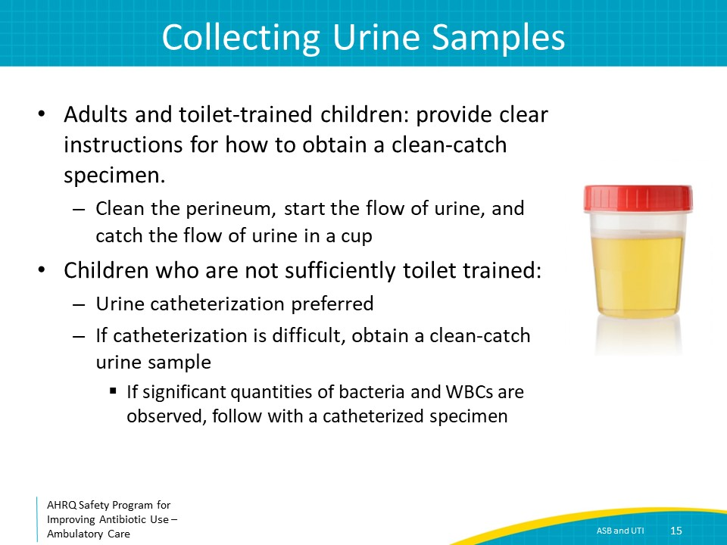
Moment 2: Urinalysis and Cultures  SAY:  A urinalysis is considered abnormal when there are more than the normal number of WBCs identified. The range of WBCs that is considered normal may differ between laboratories, but generally 10 or more WBCs per high-power field in the urine is indicative of pyuria. Although pyuria without relevant urinary symptoms make the diagnosis of a UTI unlikely, the absence of pyuria is helpful to exclude the diagnosis of a UTI.  Other findings that may be reported on a urinalysis include leukocyte esterase and nitrites. Leukocyte esterase indicates the presence of WBCs, and nitrates may indicate the presence of certain bacteria. Since the presence of WBCs or bacteria in the urine in the absence of relevant clinical symptoms does not indicate a UTI, the significance of positive leukocyte esterase or nitrites is not always clear. Furthermore, these values may be positive even in settings of small quantities of WBCs or bacteria in the urine.  The colony count representing a positive urine culture generally ranges from greater than or equal to 10,000 colony forming units or cfu per milliliter or mL to greater than or equal to 100,000 cfu per mL of a urinary pathogen in adults; this may vary by microbiology laboratory. Lower cutoffs may be considered if the patient has received antibiotics before the culture was sent, if there is strong clinical suspicion of a UTI, or if the culture is from a suprapubic catheter.  In febrile children under 2 years of age, the American Academy of Pediatrics has determined that the presence of at least 50,000 cfu per milliliter of a uropathogen such as E. coli is sufficient if pyuria or bacteriuria are present on urinalysis. The criteria are lower in this age group as urine cultures are generally collected by urinary catheterization.  In patients with indwelling urethral, suprapubic, or intermittent catheterization, 1,000 cfus per milliliter may be acceptable to diagnose a UTI, in settings with appropriate clinical signs and symptoms. | Slide 16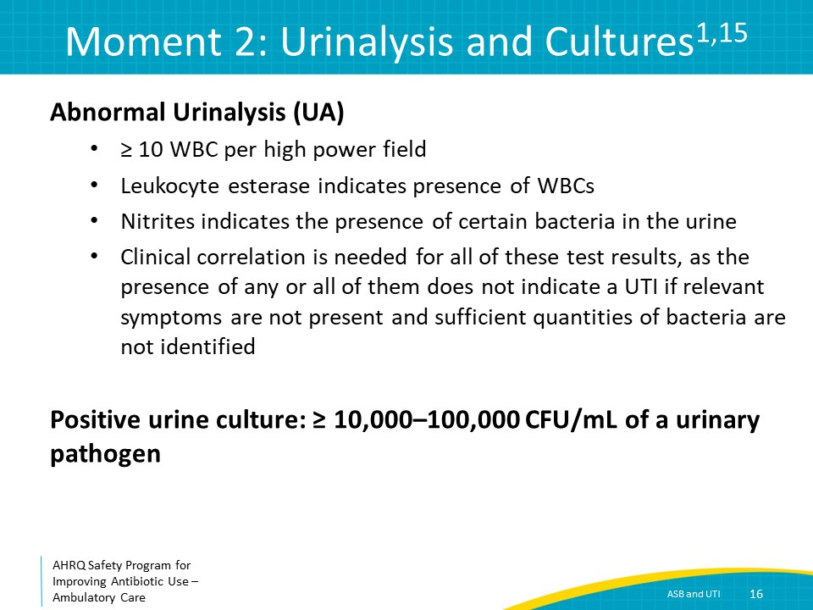
The Four Moments of Antibiotic Decision Making  SAY:  Getting back to the Four Moments, Moment Three is: If antibiotics are indicated, what is the narrowest, safest, and shortest regimen I can prescribe? | Slide 17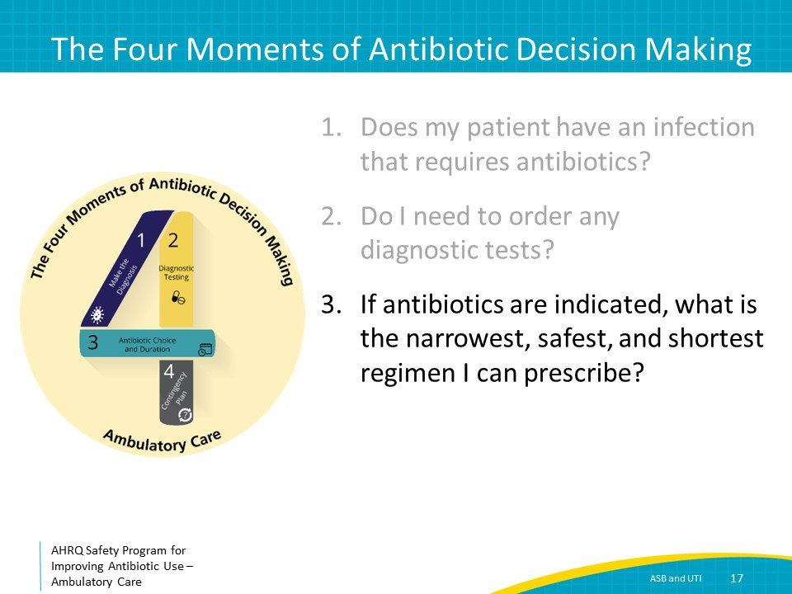
Empiric Therapy: Uncomplicated Cystitis  SAY:  The choice of antibiotics to treat cystitis and pyelonephritis, whether uncomplicated or complicated, is similar for both children and adults. Differences exist, however, in the dosing of antibiotics.  Preferred options for uncomplicated cystitis include nitrofurantoin or trimethoprim-sulfamethoxazole. Alternative options include oral cephalosporins.  Fluoroquinolones are not considered first-line therapy for uncomplicated cystitis because of both increasing E. coli resistance and their associated side effects that include tendinitis, aortic dissection, and Clostridioides difficile infection. They can also cause mental status changes and arthropathies.  Consider contacting the microbiology laboratory that processes urine culture specimens in your region to determine whether it is able to provide you a local antibiogram from urine cultures. Alternatively, if there is a hospital close to your practice, you might want to contact the microbiology laboratory or the antibiotic stewardship leaders at the hospital to see if they have developed such an antibiogram. An antibiogram summarizes the percent susceptibility of commonly recovered organisms to commonly prescribed antibiotics and can help you and others in your practice with selecting effective empiric antibiotic therapy.  Importantly, if your patient has had UTIs in the past, review their previous urine culture and antibiotic susceptibility results as this information can be very helpful in ensuring you select effective antibiotic therapy for the current UTI. | Slide 18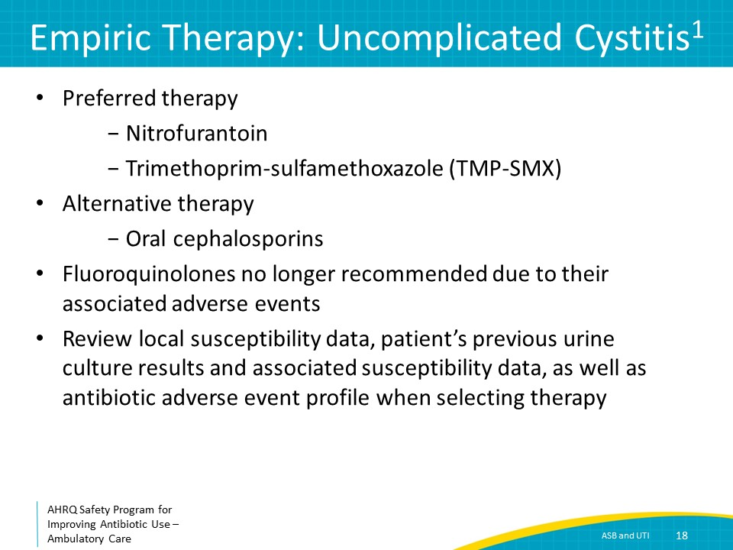
Moment 3: Uncomplicated Cystitis Treatment  SAY:  A number of randomized controlled trials indicate that antibiotic durations of 3 to 5 days are sufficient for cystitis.  The table shows the recommended durations of antibiotic therapy for preferred and alternate agents based on clinical trial results. If prescribing nitrofurantoin, 5 days is generally sufficient.  For trimethoprim-sulfamethoxazole, 3 days is sufficient. Some of the differences in suggested durations of therapy described on this slide are related to the durations that were included in clinical trials. For example, cefpodoxime was studied for a 3-day duration, whereas cephalexin and cefadroxil were studied for a 7-day duration; however, 3–5 days of these agents may still be sufficient to effectively treat an uncomplicated cystitis. | Slide 19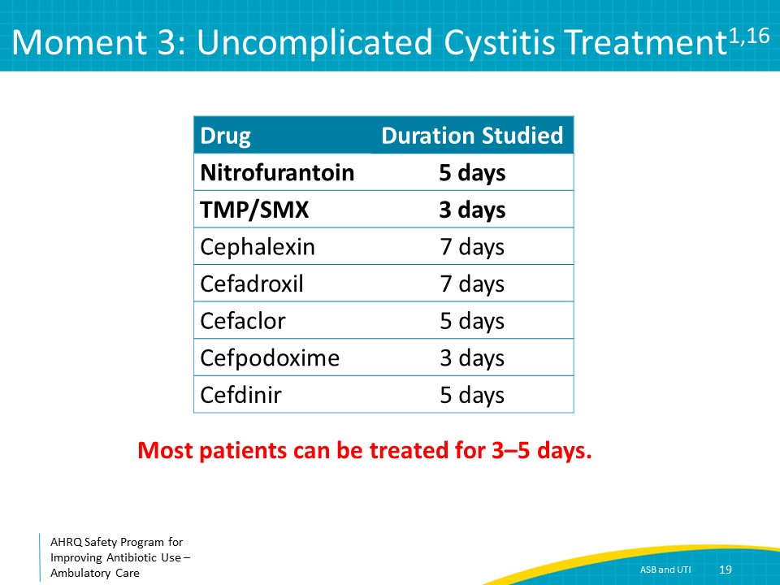
Moment 3: Uncomplicated Pyelonephritis Treatment  SAY:  Unlike uncomplicated cystitis, fluoroquinolones, such as ciprofloxacin or levofloxacin, along with trimethoprim-sulfamethoxazole, are considered preferred therapy for uncomplicated pyelonephritis. Both fluoroquinolones and trimethoprim-sulfamethoxazole have excellent urinary penetration, are available in oral formulations, and have very good serum concentrations in the oral form.  As with cystitis, reviewing previous urine cultures and antibiotic susceptibility results are important to guide the selection of effective antibiotics. The susceptibility of common uropathogens such as E. coli to both fluoroquinolones and trimethoprim-sulfamethoxazole is declining. For patients with suspected pyelonephritis who are not ill appearing, use of these agents empirically is generally acceptable, with close followup for clinical improvement.  Alternative options for non-ill–appearing patients with suspected pyelonephritis with previous uropathogens resistant to these agents or for patients with known intolerance to these agents include oral cephalosporins. Clinical failure rates for oral cephalosporins are higher than with fluoroquinolones or trimethoprim-sulfamethoxazole and instructions for when to return to medical care if the patient does not experience clinical improvement are important.  Ill-appearing patients should promptly be referred to an emergency department for broad-spectrum beta-lactam therapy to increase the likelihood of effective empiric antibiotic therapy, as well as to ensure close monitoring of the patient’s clinical status. | Slide 20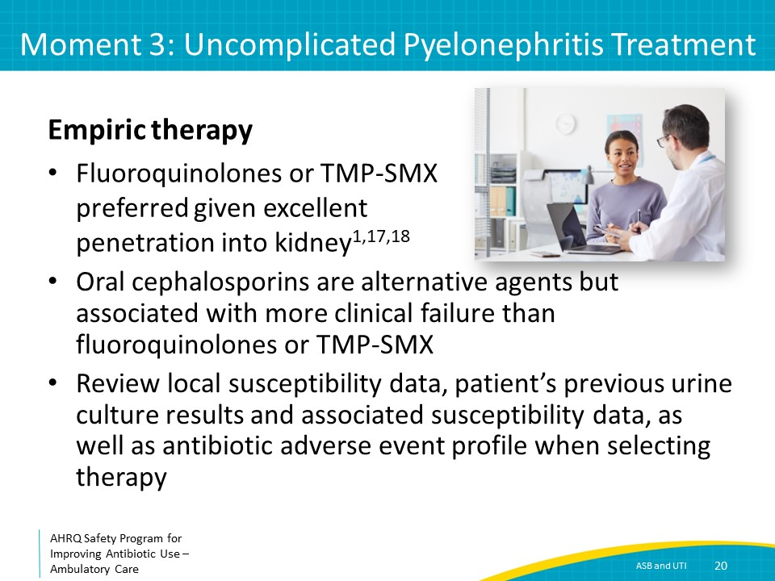
Moment 3: Duration of Treatment  SAY:  The recommended duration of therapy for uncomplicated pyelonephritis varies depending on the antibiotic prescribed. In randomized controlled trials, 7 days of ciprofloxacin and 5 days of 750 mg of levofloxacin have been demonstrated to be sufficient. For both trimethoprim-sulfamethoxazole or oral cephalosporins, although 14 days of therapy have been studied in clinical trials, observational data and clinical experience suggest 7 days for trimethoprim-sulfamethoxazole and 10 days for oral cephalosporins may be sufficient.  Although similar clinical trials are lacking in children, multicenter observational data suggest that approximately 7 days of antibiotics—for any of the above agents—are generally sufficient for uncomplicated pyelonephritis in children. | Slide 21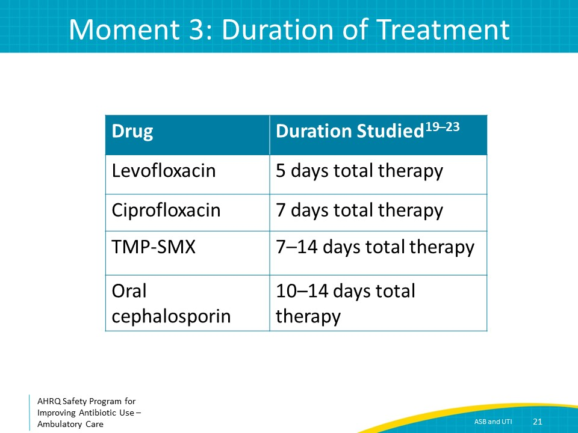
Moment 3: Complicated UTIs  SAY:  Let’s move on to the duration of therapy for complicated UTIs. As a reminder, complicated UTIs include any UTI in an adolescent or adult male and UTIs in females that occur in the presence of an obstructive process or urinary catheterization.  It can be challenging to distinguish cystitis and pyelonephritis when a patient presents with a complicated UTI. In addition to antibiotics, a key component of the management of complicated UTIs is relief of the obstruction and removal of any nidus of infection. For example, placement of stents or nephrostomy tubes when ureteral strictures are present or a transurethral resection of the prostate when benign prostatic hyperplasia is present.  The duration of therapy is generally based on the clinical response of the patient and whether persistent obstruction is present. A randomized controlled trial including 272 adult males with urinary tract symptoms without fevers—by definition complicated UTIs—demonstrated that 7 days of fluoroquinolones or trimethoprim-sulfamethoxazole antibiotic therapy led to equivalent clinical outcomes as 14 days of antibiotic therapy. This study indicates that 7 days of fluoroquinolones are trimethoprim-sulfamethoxazole are generally sufficient for afebrile outpatients with complicated UTIs.  In the absence of a similar study of patients with systemic signs of infection or patients who received oral cephalosporin therapy, 10–14 days of antibiotics may be reasonable. | Slide 22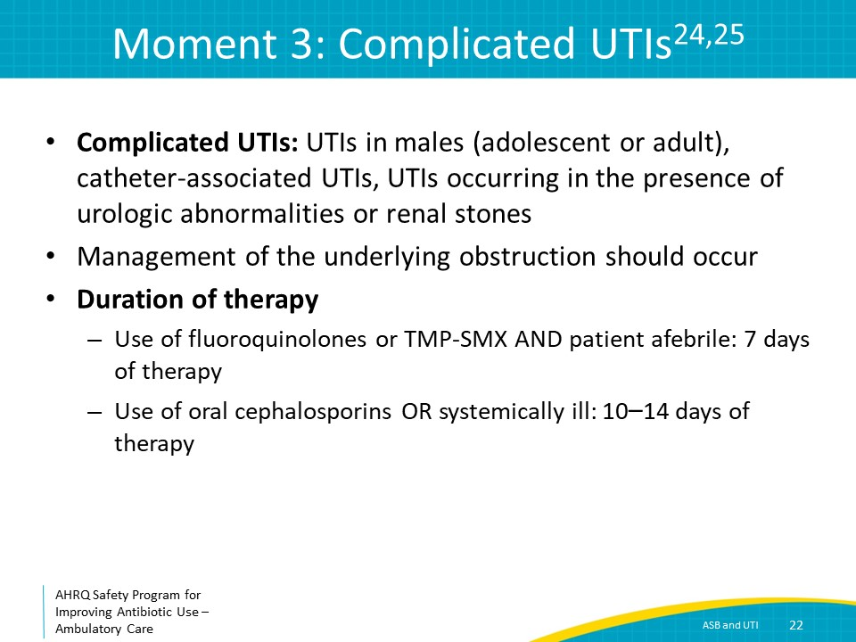
The Four Moments of Antibiotic Decision Making  SAY:  Finally, Moment Four is: Does my patient understand what to expect and the followup plan? | Slide 23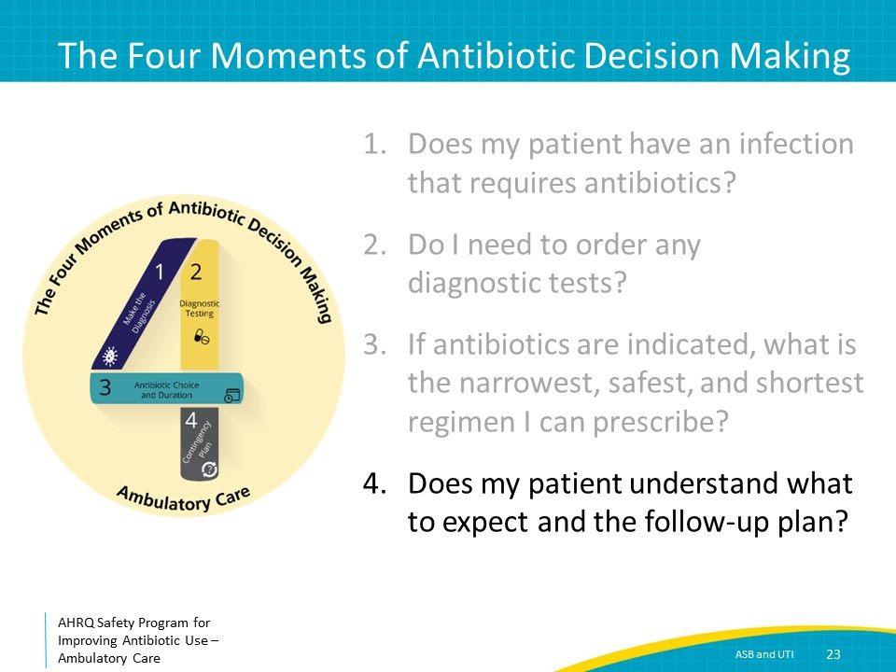
Moment 4: Patient Followup  SAY:  Patients with UTIs should be told that it may take approximately 1–2 days for clinical improvement to occur.  Patients with cystitis should seek further medical care if their symptoms are not improving by day 3 or if they are developing flank pain or fevers, or generally feel more ill.  Patients with pyelonephritis or complicated UTIs should seek medical care if fevers persist by day 3, rigors develop, or if they are generally feeling more ill at any time.  It is important to ensure patients understand when a telephone call to the clinic is warranted for followup guidance versus a visit to an emergency department. | Slide 24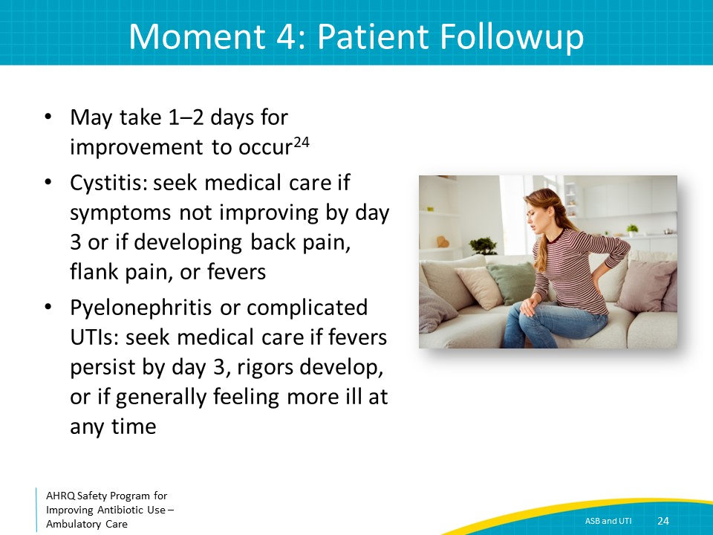
Moment 4: Clinician Followup  SAY:  If you obtained a urinalysis and urine culture, it is helpful to anticipate when to expect results. Urinalysis results are generally available within 1 day, assuming same-day transit to the laboratory. Organism identification from a urine culture is generally available within 1–2 days, and final antibiotic susceptibility results are available within 2–3 days.  If the organism recovered is not susceptible to the antibiotic prescribed, call the patient to inquire whether symptoms have improved or not. If symptoms have significantly improved, no change in therapy is necessary. However, if symptoms are lingering or have worsened, change therapy to an active antibiotic. | Slide 25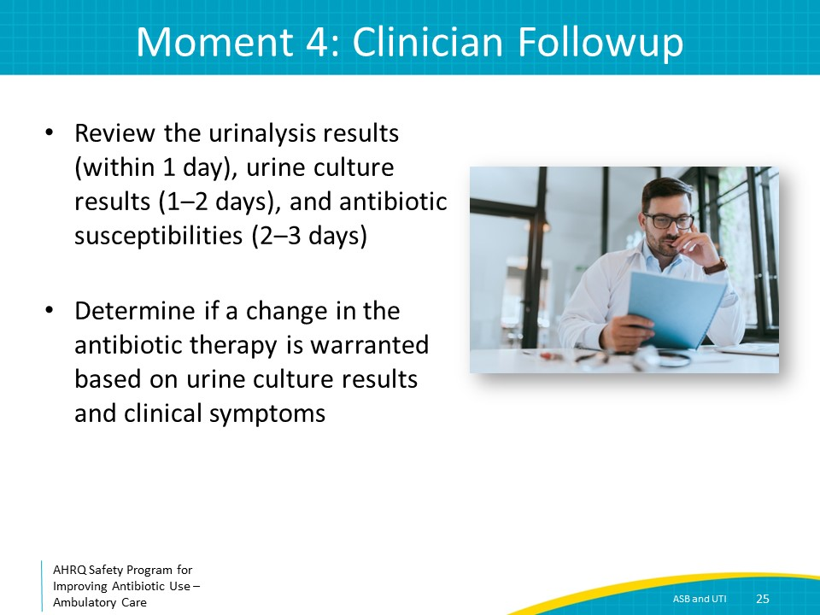
Take-Home Messages  SAY:  To summarize, only obtain a urinalysis and urine culture when patients express clinical signs and symptoms suggestive of a UTI.  For positive urine cultures that were obtained in the absence of urinary symptoms, there is no need to prescribe antibiotic therapy. In fact, antibiotic administration to patients with ASB can increase the risk of antibiotic-associated adverse events and make future UTIs more drug resistant and increasingly challenging to treat.  Fluoroquinolones are no longer considered first-line therapy for treatment of uncomplicated cystitis. Most cases of uncomplicated cystitis can be treated with 3 to 5 days of antibiotics. Most cases of uncomplicated pyelonephritis can be treated with approximately 7 days of antibiotics.  Complicated UTIs in outpatients can generally be treated for 7 days if patients are afebrile and a fluoroquinolone or trimethoprim-sulfamethoxazole is prescribed. Outside of these parameters, a 10- to 14-day course of therapy may be warranted for complicated UTIs. | Slide 26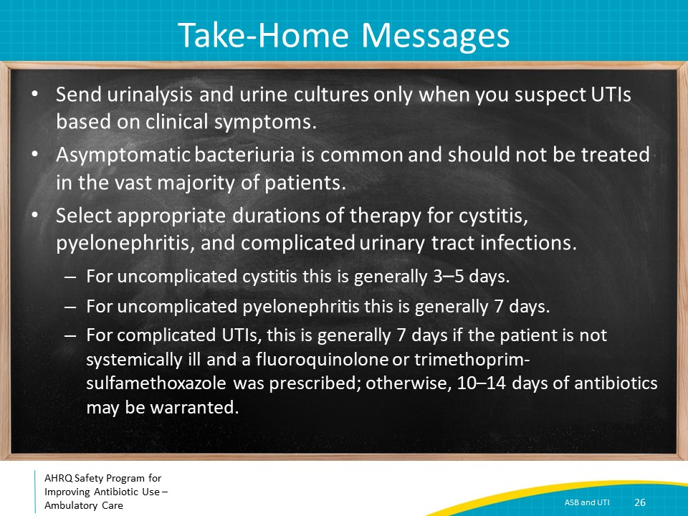
Additional Toolkit Resources  SAY:  For more resources on asymptomatic bacteriuria and urinary tract infections, please access tools listed below, available on the AHRQ Toolkit To Improve Antibiotic Use in Ambulatory Care.  Refer to the Discussion Guide to help your practice develop a standardized approach to the diagnosis and management of patients with ASB and UTI.  Refer to the One-Page document for a concise summary of the diagnosis and treatment of ASB and UTI.  The Patient Handout explains the symptoms and symptomatic treatment of sinusitis and emphasizes that antibiotics are not always needed. It is available in both English and Spanish. | Slide 27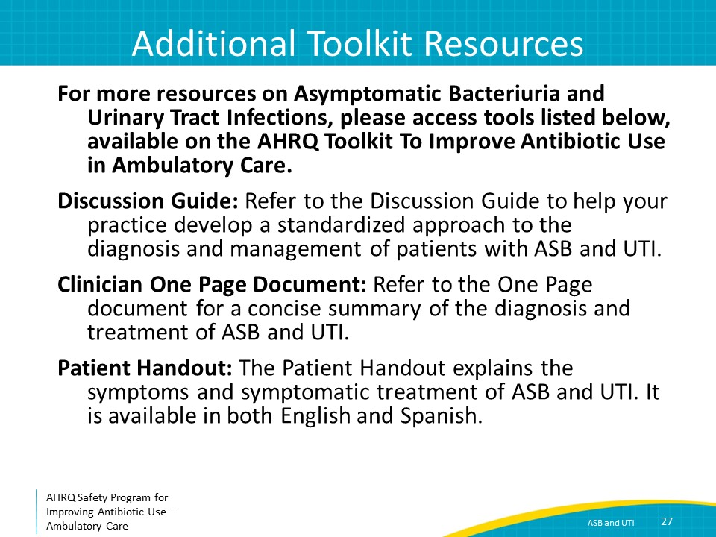
Disclaimer  SAY:  The findings and recommendations in this presentation are those of the authors, who are responsible for its content, and do not necessarily represent the views of AHRQ. No statement in this presentation should be construed as an official position of AHRQ or of the U.S. Department of Health and Human Services.  Any practice described in this presentation must be applied by healthcare practitioners in accordance with professional judgment and standards of care in regard to the unique circumstances that may apply in each situation they encounter. These practices are offered as helpful options for consideration by healthcare practitioners, not as guidelines. | Slide 28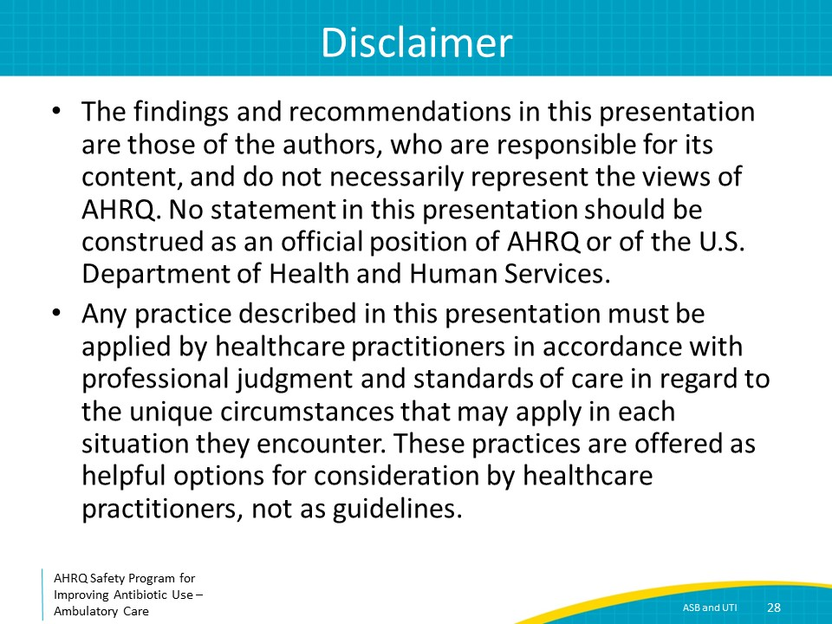
References  SAY:  Here are the references. | Slide 29
References | Slide 30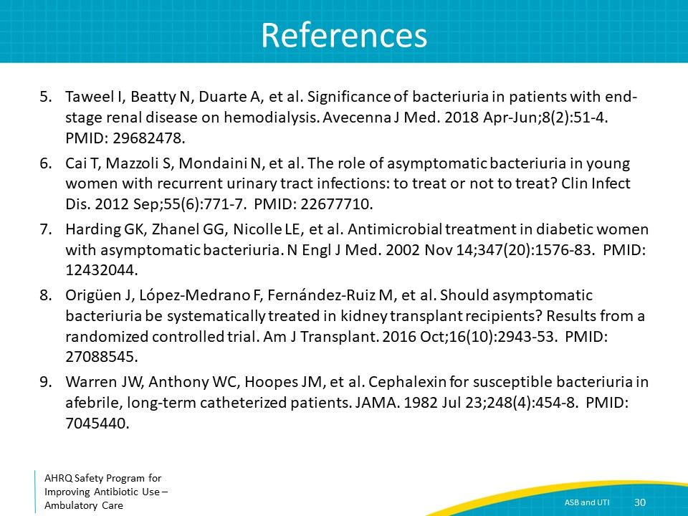
References | Slide 31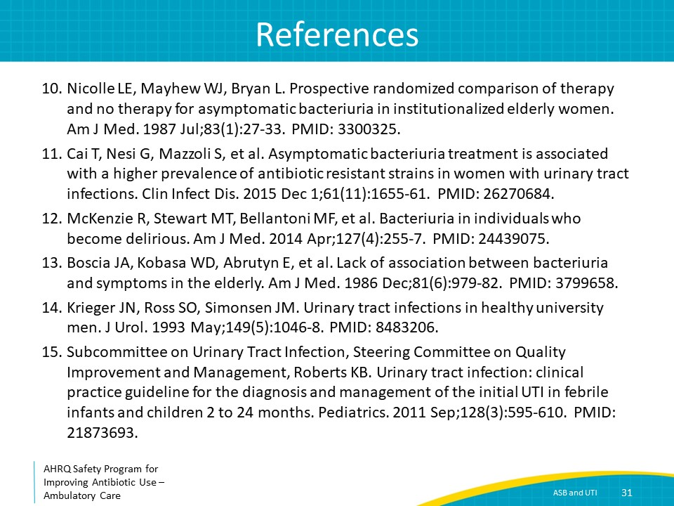
References | Slide 32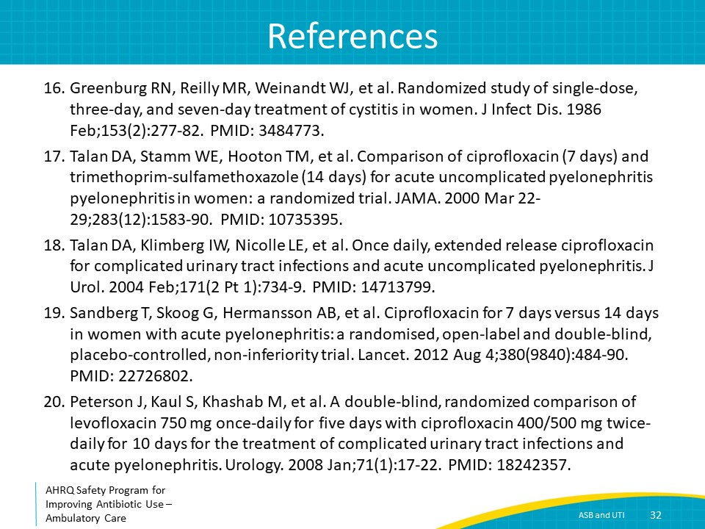
References | Slide 33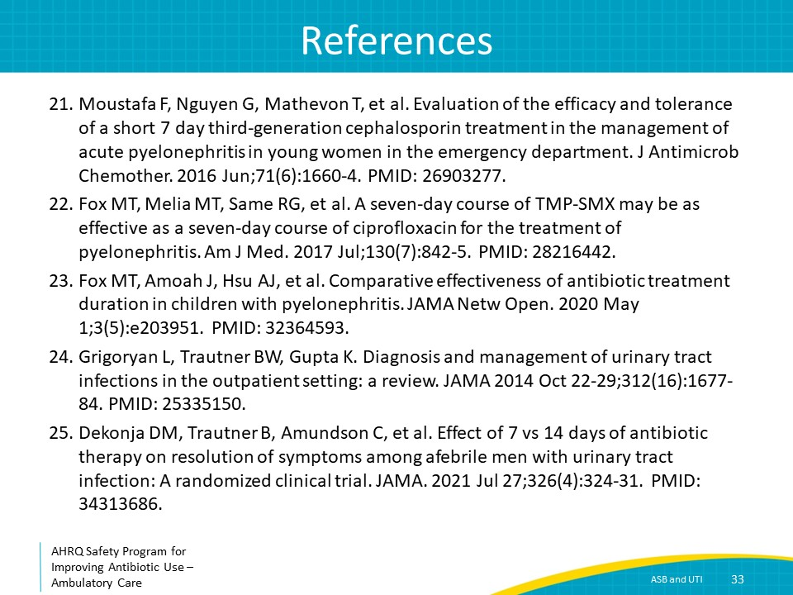
AHRQ Pub. No. 17(22)-0030
September 2022

