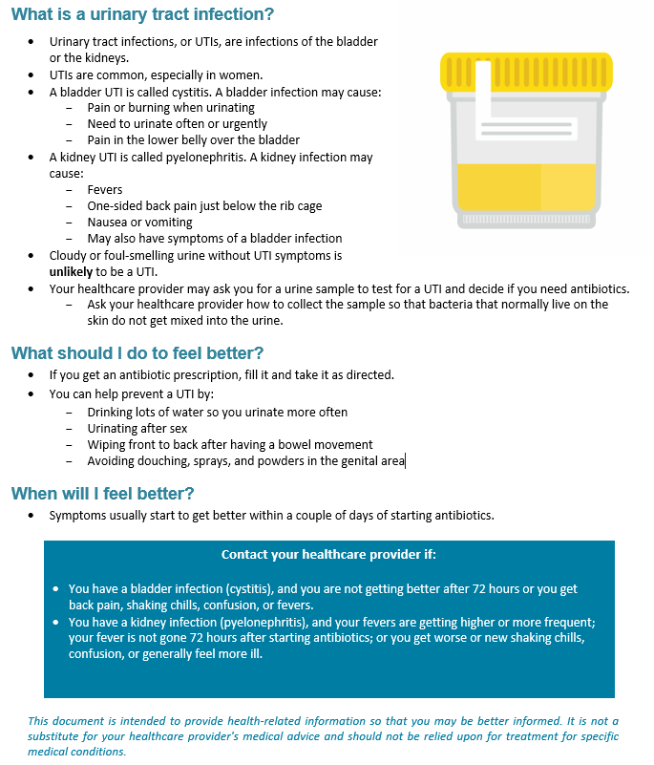

Directions for Adding Your Logo to Your Document
If you chose to add a logo to this document, you can place it in the footer, below the article development content.
Steps:
- Open the footer section (either double click in the footer section of the document or go to the “Insert” tab→ select the drop-down menu for “Footer”→ and click on “Edit Footer”).
- Make sure your cursor is below the bottom line (or wherever you want your logo).
- Go to the “Insert” tab.
- Click on “Pictures” from the “Insert” tab.
- A window will pop up so you can search your computer for the logo. Select your logo (.jpg or .png format) and click the insert button.
- Your logo will appear in your footer. If you are happy with the placement, skip step 7.
- If you want to move the logo image around, click on the logo→ go to the
“Format” tab→ click on the “Wrap Text” drop-down menu→ and select “In front of text.” This formatting will allow you to move the logo freely around the screen.
- When you are satisfied with the placement of the logo, exit the footer section (either double click outside of the footer area or go to the “Design” tab$→$ and click the “Close header and footer” button).
AHRQ Pub. No. 17(22)-0030
September 2022

