Improving Antibiotic Use Is a Patient Safety Issue
Long-Term Care

Slide Title and Commentary | Slide Number and Slide
Improving Antibiotic Use Is a Patient Safety Issue  Long-Term Care  SAY:  Welcome to this presentation titled “Improving Antibiotic Use Is a Patient Safety Issue.” | Slide 1  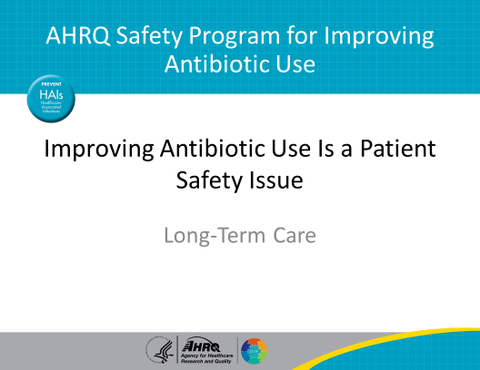
Objectives:  SAY:  By the end of this presentation, participants will be able to —  - Discuss the potential harms associated with antibiotic use  - Recognize that patient harm is largely preventable  - Recognize that changes to the system, not just the behavior of individuals, lead to sustained improvements | Slide 2  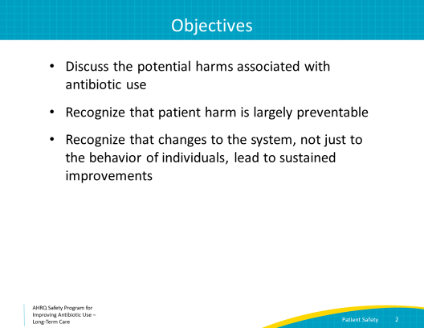
The Importance of Antibiotics  SAY:  Antibiotics have revolutionized modern medicine and have saved countless lives. Prompt administration of the correct antibiotic at the right dose is critical for treating people with serious infections. However, antibiotics, whether necessary or not, come with risks and may cause harm.  Antibiotics can be associated with adverse events and, when administered to residents who do not need them, can cause more harm than good. | Slide 3  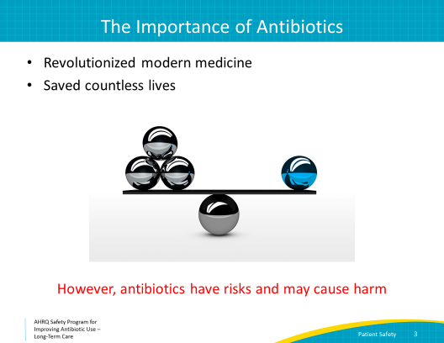
Antibiotic Development Is on the Decline  SAY:  Antibiotics are a precious resource. Few new antibiotics are in advanced phases of development. For all of us, using antibiotics judiciously is critical to making sure antibiotics continue to remain effective. | Slide 4  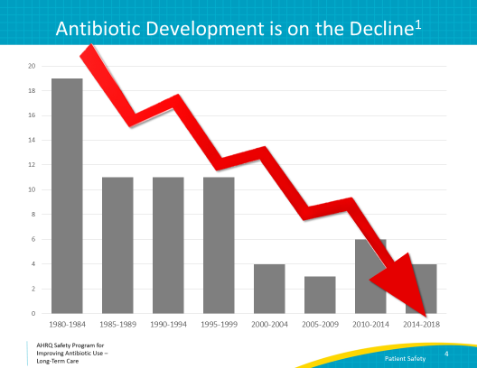
Antibiotic Overuse  SAY:  Unfortunately, antibiotic overuse is a major problem in long-term care facilities. An estimated 4.1 million Americans are admitted to nursing homes every year. Seventy percent of nursing home residents will receive at least one course of antibiotics annually. Up to 75 percent of antibiotic courses are considered unnecessary or inappropriate.  As health care practitioners, we would not tolerate this for any other class of medicine. Can you imagine giving an antihypertensive medication such as lisinopril “just in case” someone has high blood pressure? | Slide 5
Antibiotics Alter the Bacteria in the Gut  SAY:  When people take antibiotics to treat an infection, the antibiotic also affects the normal, healthy bacteria that live in our intestines. These effects may last for weeks to months after the antibiotic stops, especially for older adults.  This can set up older adults for two problems. The first is an infection with Clostridioides difficile – or C. difficile. The second is colonization or infection with a drug-resistant bacteria. | Slide 6  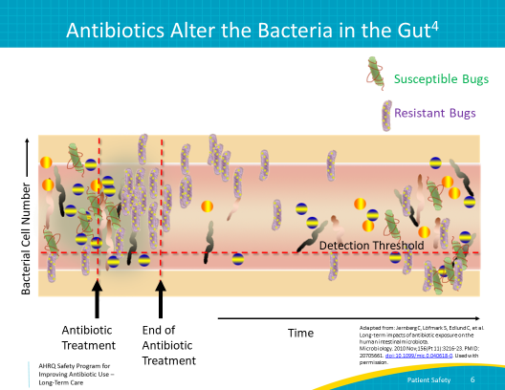
Antibiotics & Clostridioides difficile  SAY:  After taking an antibiotic, people are at greater risk of becoming infected with C. difficile, a bacteria that causes diarrhea.  Virtually all antibiotics can increase the risk of a subsequent C. difficile infection. However, the greatest risk occurs with clindamycin, third-generation cephalosporins, and fluoroquinolones.  The risk is highest when patients are still receiving antibiotics, but this risk remains elevated for several months after antibiotics are discontinued. Over 90 percent of deaths associated with C. difficile infection occur in people over the age of 65, and one out of every nine older adults with C. difficile infection dies within 30 days of diagnosis. | Slide 7  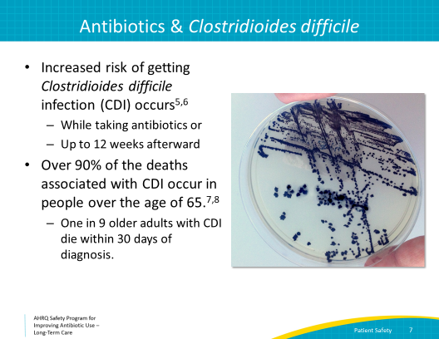
The Next Infection…  SAY:  People are also at risk for becoming colonized or infected with a drug-resistant bacteria. This means their next infection may be much more difficult to treat. For nursing home residents, this means they may also become a reservoir for spreading C. difficile or a drug-resistant bacteria to other residents.  A study of 4 million nursing home residents found that 4 percent of residents developed an infection with a drug-resistant bacteria. That’s about 160,000 people.  Infection prevention and control is important to preventing long-term care residents from becoming sick with drug-resistant bacteria. Using antibiotics only when necessary is also key to reducing the prevalence of drug-resistant bacteria and C. difficile. | Slide 8  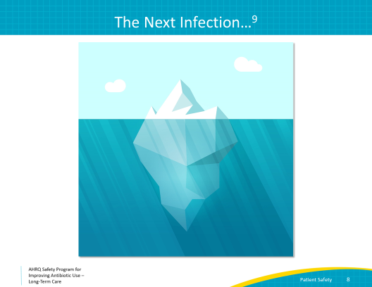
Social Factors Influence Antibiotic Prescribing  SAY:  A number of social factors influence antibiotic prescribing decisions. Remember that medicine is an art and not an exact science.  Some of these social influences include:  - The prescriber’s own emotions. Prescribers may fear missing an infection or worry about legal risks or being cited by surveyors. Sometimes simple fatigue makes prescribers more likely to write for antibiotics.  - Prescribers outside of the long-term care facility can also influence antibiotic use. It can be hard to stop antibiotics that were started by someone else. This can include antibiotics started in the hospital or by on-call clinicians, specialists, or emergency department clinicians. There is a fear of causing harm by stopping a medicine someone else thought the resident needed.  - Clinicians may also worry that they will be viewed as dismissive or disrespectful if they stop or change antibiotics initiated by another clinician.  - The relationship among the clinical staff can influence how people communicate concerns about a resident. The way a nurse communicates an assessment to a prescriber may influence whether the prescriber is comfortable trying hydration and supportive care instead of writing for an antibiotic.  - Of course, residents themselves and family members also influence antibiotic prescribing. Residents and family members may insist on antibiotics for what they think is a urinary tract infection. They are well-intentioned and have been taught for years that a nonspecific change in mental status or foul odor in urine are symptoms of a urinary tract infection or UTI. Sometimes education about the signs and symptoms of a UTI will help.  - There may be other emotional issues involved. For example, if a patient is at the end of life, clinicians may start antibiotics just to “do something” because they feel helpless.  To promote a culture of safety around antibiotic prescribing, the potential harms associated with antibiotic use must be conveyed to prescribers, patients, and family members so that the potential risks versus benefits are considered every time an antibiotic is prescribed. | Slide 9  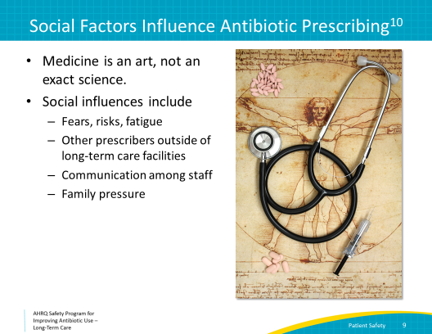
Program Goals  SAY:  One goal of the AHRQ Safety Program is to improve the culture of safety. To do this, we will provide frontline staff with the tools and support they need to identify and tackle hazards that may threaten residents. The intent is to reduce preventable harm by identifying problems which cause harm to residents. Sometimes these are problems in the work system. These problems may be behavioral, technical, or both. Throughout the program, we will think about problems as opportunities for improvement.  Our program also encourages a team approach to addressing problems. | Slide 10  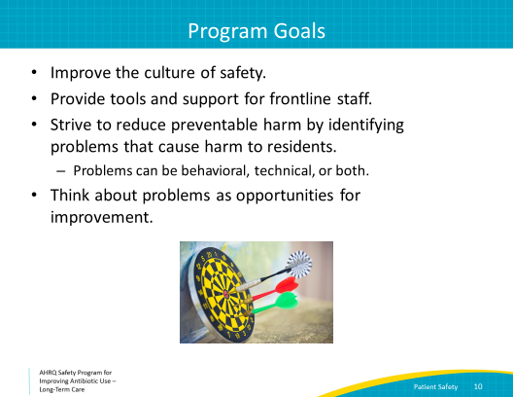
5 Steps for Improving the Culture of Patient Safety  SAY:  As a quick reminder, this program discusses both adaptive, or behavioral topics, as well as technical topics.  This is one of our five presentations that focus on adaptive, or behavioral approaches to stewardship. | Slide 11  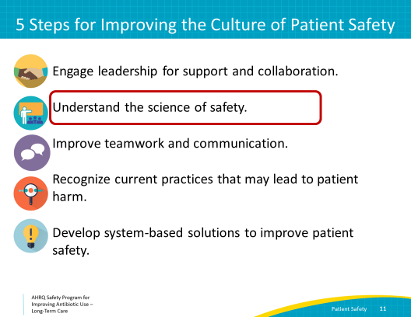
The Science of Safety  SAY:  There are three basic principles of safe design.  First, standardize care and eliminate any unnecessary steps. When there is routine from standardized steps, there is less of a chance for unintentionally forgetting to do something or missing a step.  An example of standardized care outside of health care is an ATM. With some ATMs, you put your card in, the ATM gives you money, and your card comes back out. Some people used to forget to wait for the last step and left before their card was returned. Some ATMs have been redesigned so that you insert and pull out your card in a single step. The card never leaves your hand, so customers are less likely to leave their card in the machine. Workflow is simplified. People are less likely to leave their card in the machine as a result.  An example in long-term care is the use of written protocols to diagnose and treat common infections. These can be used to improve communication among teams at the time of a change in status, such as when the nurse may alert the clinician. They may also help with reassessment of the resident over the following 2 to 3 days by providing standardized documentation of the initial change in status. | Slide 12  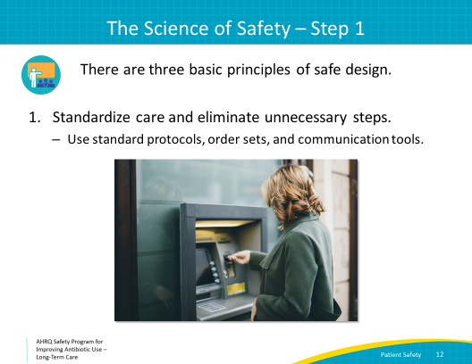
The Science of Safety  SAY:  The second basic principle to safe design is to create independent checks to reduce potential harm. An example not related to health care is seatbelts. Drivers are not on their own to remember to buckle their seatbelts every time they get in their car. A system of dashboard lights as well as that annoying dinging noise remind everyone to buckle up.  An example from long-term care is automated checks for drug-drug interactions by the dispensing pharmacy. | Slide 13  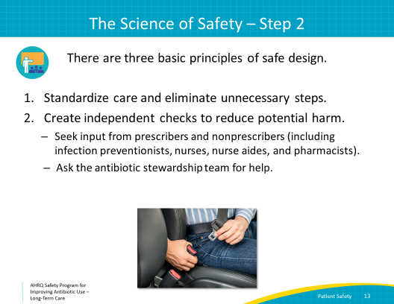
The Four Moments of Antibiotic Decision Making  SAY:  Another example is reviewing antibiotic prescriptions 2 to 3 days after the initial order. Remember our Four Moments of Antibiotic Stewardship? This is the fourth moment: Two to three days have passed. Can we stop antibiotics? Can we narrow therapy? | Slide 14  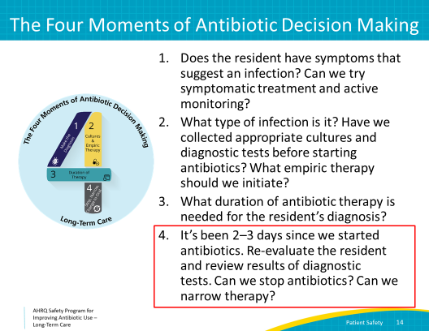
The Science of Safety  SAY:  The last principle is to learn to recognize problems and use them as opportunities to improve. As a group, when a problem related to antibiotic prescribing occurs, ask—  What happened?  Why did it happen?  How can we reduce the risk of this happening again?  How will we know that our changes worked?  We will discuss identifying and learning from problems in more detail in other presentations.  Let’s apply these three principles to a case. | Slide 15  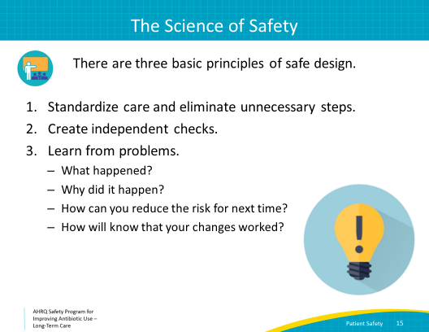
Clinical Case  SAY:  On Saturday, a nurse aide noted that a 76-year-old woman in the facility did not eat breakfast and just picked at her lunch. The on-call provider was notified and requested a urine culture in case the resident’s symptoms were related to a urinary tract infection.  The resident’s appetite was normal by Sunday.  On Monday, the lab faxed over the results, which were ≥100,000 colony forming units per milliliter of a pan-susceptible E. coli in her urine culture.  A different provider saw the urine culture results and prescribed a 7-day course of ciprofloxacin. The resident completed the antibiotic course. | Slide 16  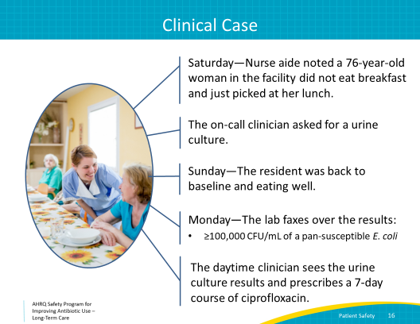
Clinical Case, Continued  SAY:  Two months later, the same resident developed fevers, dysuria, and flank pain. A urine culture was sent, and she was started on another course of ciprofloxacin. The next day she felt worse and had fevers and flank pain.  She was transferred to the emergency department and admitted with hypotension. She was given fluids and started on intravenous cefepime. Her urine culture grew greater than 100,000 colony-forming units per mL of E. coli resistant to ciprofloxacin but was susceptible to a number of other antibiotics. The resident received a 7-day course of intravenous cefepime for pyelonephritis and stayed at the hospital to complete the course. | Slide 17  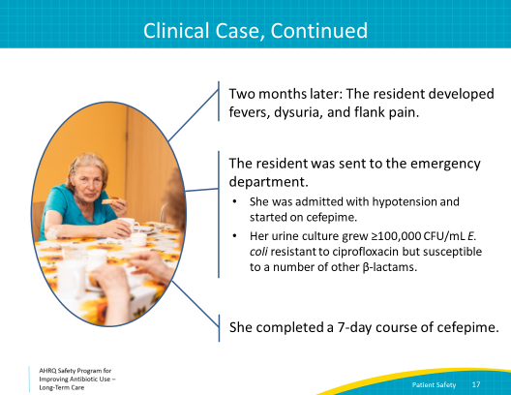
Where Are the Problems in This Case?  SAY:  In this slide you will see what we refer to as the Swiss cheese model. Each slice represents a potential safety check. The holes are the errors or missed opportunities to stop harm of a resident. Notice that there are several slices, which means that there are many chances for a harmful situation to be stopped, but when the holes all line up, as they did in the case you just heard, residents may be harmed. | Slide 18  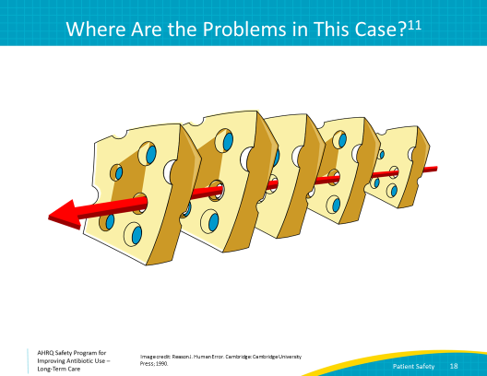
Where Are the Problems in This Case?  SAY:  Let’s review this case. A number of problems affected the care of this resident. We’re only going to focus on those that occurred in the long-term care facility.  There are many reasons someone can have a poor appetite. A change in appetite is not a symptom of a urinary tract infection and is not a reason to get a urine culture. Without signs or symptoms of infection, a urine culture should not have been obtained. A positive urine culture without signs or symptoms of a UTI means the resident has asymptomatic bacteriuria, which is not an infection.  As discussed in the presentation “Assessment of the Resident With a Suspected Urinary Tract Infection,” it is common for long-term care facility residents to have pyuria and bacteriuria. | Slide 19  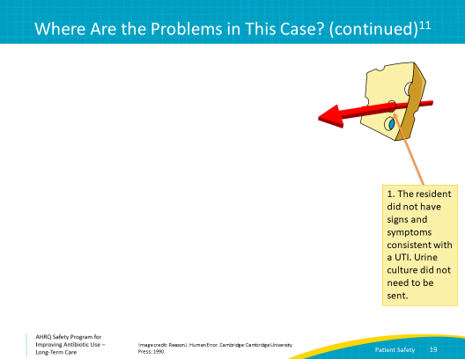
Where Are the Problems in This Case?  SAY:  A second problem occurred when the daytime health care practitioner prescribed antibiotics. This is a common mistake. When prescribers are told of a positive urine culture, they make an almost reflex decision to treat with antibiotics.  The prescriber should have either seen the resident herself or asked a nurse to reassess the resident and find out if she was having any signs or symptoms of a UTI.  Another good response would have been to ask why the provider who was covering on Saturday decided to send a urine culture.  Finally, ciprofloxacin is usually not a good choice for empiric treatment of a urinary tract infection. It poses several risks including cardiac arrhythmias and tendinopathy. | Slide 20  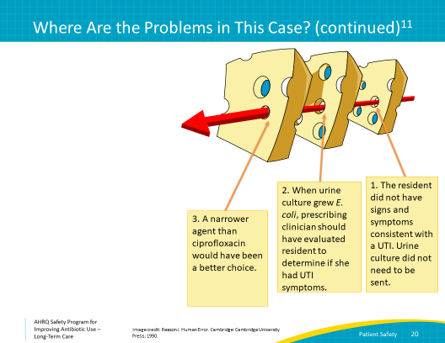
Where Are the Problems in This Case?  SAY:  The rest of the problems took place outside of the long-term care facility.  Cefepime was not a good choice to complete her course of therapy since an agent with a narrower spectrum would have also worked. She likely could have received an oral antibiotic to complete the course, avoiding several days in the hospital and placement of an intravenous line.  The resident’s unnecessary exposure to ciprofloxacin caused a problem with consequences that may not seem readily apparent. First, she acquired a drug-resistant organism that went on to cause a serious infection. Second, she could unintentionally spread this resistant bacteria to other residents.  Treating asymptomatic bacteriuria with antibiotics can be harmful. Data show that this practice increases the risk of subsequent, clinically significant UTIs. That is what happened for this resident. | Slide 21  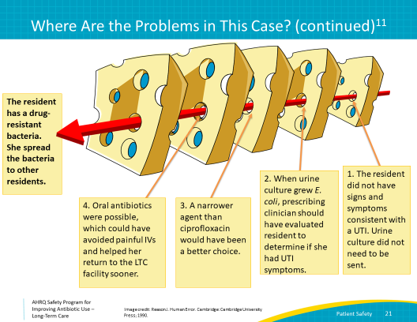
Apply the Science of Safety  SAY:  Let’s apply the three basic principles of safe design to the problems that occurred at the long-term care facility.  First, when the staff noticed a change in behavior, they should have used some kind of criteria to see if urine studies were necessary. Some facilities use either the Loeb minimum criteria or the revised McGeer criteria. The AHRQ Safety Program for Improving Antibiotic Use Web site also has tools you may use.  Second, the nurse who received the urine culture results could have helped provide some clinical context for the daytime clinician. Specifically, the nurse could have explained that the reason for the urine culture was for poor appetite and that the resident was back to her baseline, eating well, and not complaining of dysuria. A communication form or checklist might make this easier for the nurse to share and for the prescriber to listen.  An independent check would be the reassessment at 48 to 72 hours after the first prescribing event to review the indication, choice, and duration of the antibiotic. This is our fourth moment of antibiotic prescribing and could have revealed that the ciprofloxacin was too broad for the bacteria recovered, in the event that an infection had been diagnosed.  Another independent check would have been for someone from the antibiotic stewardship team to review the charts of residents on whom urine cultures were sent. Did the staff use the order set to support evaluation for diagnostic criteria? How were the results communicated to the prescribers?  The third principle is to view these problems as opportunities to improve the system. One way would be to implement a standard communication tool and order sets. These should be developed with input from stakeholders including nurses and providers so they can be incorporated into their existing workflow. Once developed, staff will need to be educated about how to use the tools.  Another change would be to post the facility’s criteria for when to send a urine culture at the nurses’ station and in other common work areas. Coupled with education and a standard order set, these criteria could improve resident care. | Slide 22  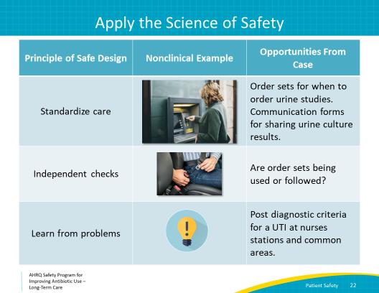
Identifying Problems  SAY:  The case we discussed shows how problems can become opportunities to improve the system.  There is a form called the Staff Safety Assessment that you can use to identify problems at your institution.  Try answering the following questions:  - Describe the next scenario for which antibiotics will not be prescribed appropriately  and  - Describe what you think can be done to prevent this from happening  Start with asking your core antibiotic stewardship team members and other key stakeholders to use the form. This form is available in the toolkit. | Slide 23  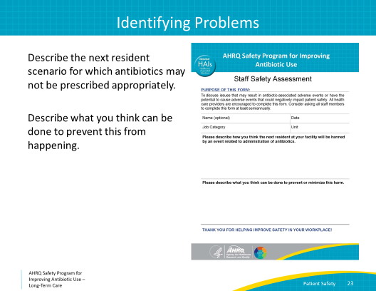
Reality Check  SAY:  It is important to remind ourselves that the clinical status of a resident evolves on a daily basis and sometimes we start antibiotics when we are unsure if a resident has an infection or not. As we receive more information, it is important that prescribers and frontline staff readdress the issue of whether antibiotics are still needed or if therapy can be adjusted.  You must foster a culture of safety in which all team members understand that they can contribute to optimizing the care of their residents and reducing unnecessary harm. No one should worry about offending a clinician who started antibiotics. Frontline staff, consultant pharmacists, and infection preventionists all should feel comfortable talking with clinicians about stopping or adjusting antibiotic therapy in subsequent days. In other presentations, we will discuss how to communicate during difficult conversations. | Slide 24  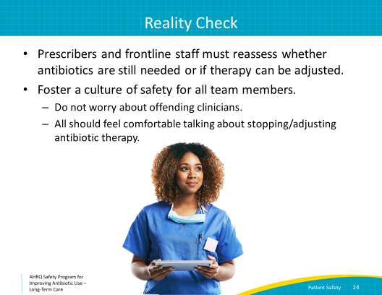
Summary  SAY:  In summary, the AHRQ Safety Program strives to improve the culture of safety while providing frontline staff with the tools and support needed to identify and tackle hazards related to antibiotic use that threaten their patients.  At this point, you should—  - Recognize that changes improving patient safety often mean making changes to the system.  - Understand the three methods to eliminate unnecessary harm  These methods are to standardize practices, create independent checks, and learn from problems. Each problem is an opportunity to improve. | Slide 25  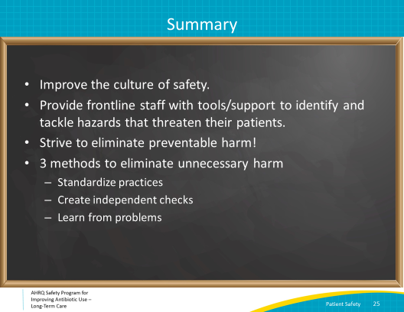
Activities To Pair With This Presentation  SAY:  These are the activities you may want to work on that align with the concepts described in this presentation.  Have the stewardship team use the Staff Safety Assessment form to identify problems. Once identified, discuss those problems and choose an intervention. Designate someone to collect baseline data and use the Checkpoint Tool to keep track of your progress.  In addition, you can introduce frontline staff to the Staff Safety Assessment and ask them to complete forms. Team members may need to coach the frontline staff on filling out the forms.  Supporting materials for these activities are listed on the slide and are available in the toolkit. | Slide 26  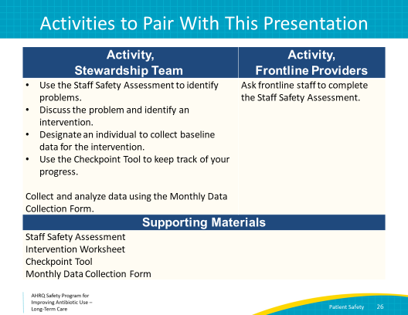
Disclaimer  SAY:  Disclaimer:  The findings and recommendations in this presentation are those of the authors, who are responsible for its content, and do not necessarily represent the views of AHRQ. No statement in this presentation should be construed as an official position of AHRQ or of the U.S. Department of Health and Human Services.  Any practice described in this presentation must be applied by health care practitioners in accordance with professional judgment and standards of care in regard to the unique circumstances that may apply in each situation they encounter. These practices are offered as helpful options for consideration by health care practitioners, not as guidelines. | Slide 27  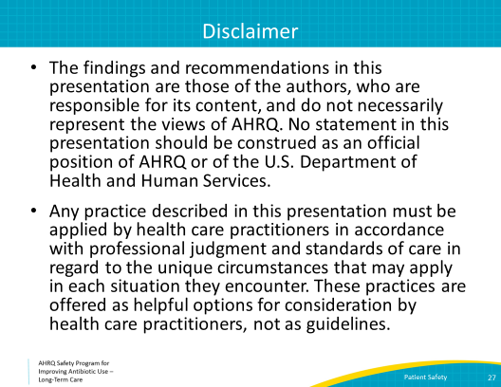
Slide 28
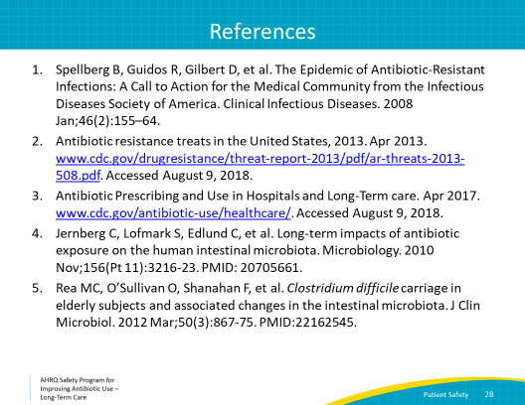
Slide 29
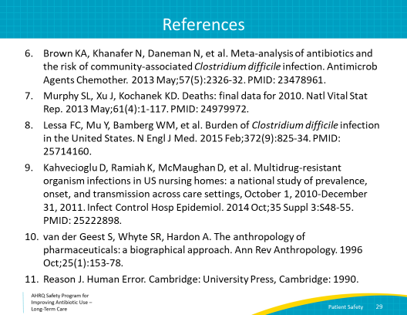
AHRQ Pub. No. 17(21)-0029
June 2021

