Identifying Targets To Improve Antibiotic Use
Long-Term Care
Slide Title and Commentary | Slide Number and Slide
Identifying Targets To Improve Antibiotic Use  Long-Term Care  SAY:  Hello and welcome to the presentation, “Identifying Targets To Improve Antibiotic Use.” | Slide 1  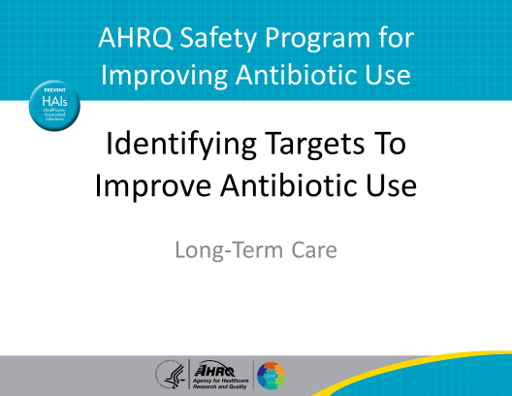
Objectives  SAY:  By the end of this presentation, participants will be able to:  - Identify opportunities to improve antibiotic prescribing  - Recognize how to leverage frontline staff to guide safety improvement efforts around antibiotic prescribing  - Recognize opportunities to use the Four Moments of Antibiotic Decision Making framework to improve antibiotic use | Slide 2  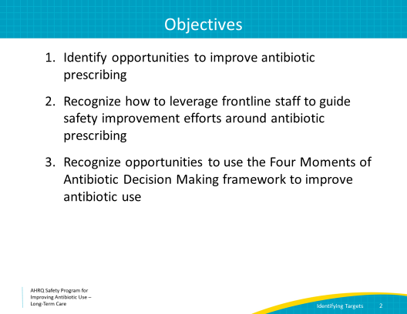
5 Steps for Improving the Culture of Patient Safety  SAY:  Let’s begin by reviewing the 5 steps for improving the culture of patient safety. This presentation will focus on Step 4, which involves engaging frontline staff to talk about how they think residents are being harmed by antibiotic-related issues. They are on the front line every day. They know what the issues are and may have ideas on how to reduce or eliminate them. | Slide 3  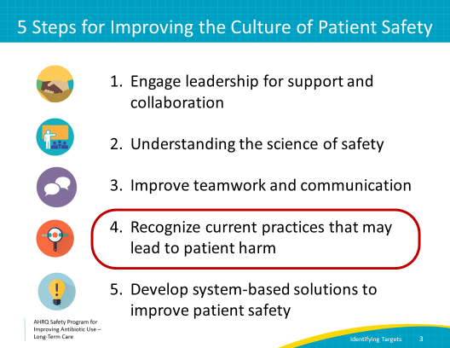
Recognizing Potential Harm  SAY:  Before we move forward, let’s take a moment to talk about the potential for patient or resident harm. Improving the culture of safety involves identifying events in which residents were harmed or could have been harmed.  Other words we could use to describe this are mistakes, errors, failures, near misses, defects, or problems.  From a systems perspective, and to support the work we are doing here, we encourage you to think about events in which residents were or could have been harmed as opportunities to improve. No person and no system is perfect. By recognizing our mistakes or problems, we can learn, improve, and avoid these in the future. | Slide 4  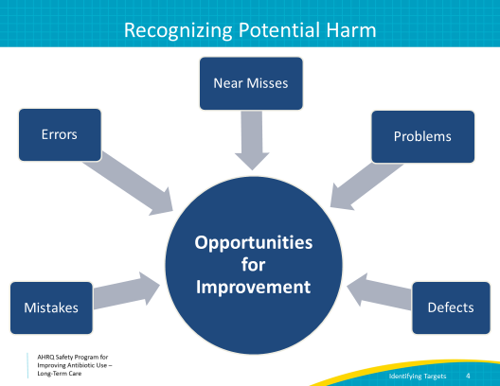
Examples of Potential Harm  SAY:  A few examples of potential harm related to antibiotic use are—  - Prescribing antibiotics without evidence of a bacterial infection  - Forgetting to write an end date or clear indication for antibiotics  - Forgetting to order indicated cultures or diagnostic studies  - Prescribing antibiotics for too long  - Forgetting to stop antibiotics when they are not needed  - Accidentally miscounting days of therapy during transitions of care | Slide 5  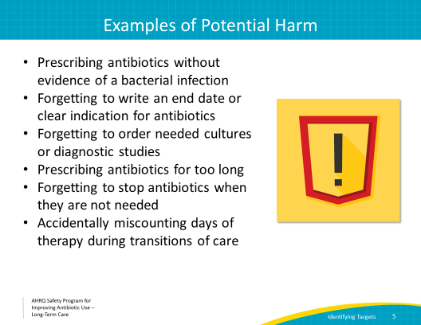
How Can You Identify Potential Harm?  SAY:  It is important to identify potential harm associated with antibiotic prescribing by seeking input from a diverse group of health care workers. This includes frontline staff like nurses and nursing assistants, as well as pharmacists and prescribers like physicians, nurse practitioners, and physician assistants. The consultant and dispensing pharmacist(s) will have a distinct point of view, as will people from administration and allied health professionals working in recreational, physical, and occupational therapy.  In the presentation “Improving Antibiotic Use is a Patient Safety Issue,” the Staff Safety Assessment is introduced. As a reminder, this tool uses the knowledge and experience of people working in your setting to help reduce the potential for patient or resident harm.  The tool uses two questions to proactively identify the potential for resident harm related to antibiotics.  The first question asks staff to describe the next patient scenario for which antibiotics will not be prescribed appropriately. The second question asks staff to describe what they think can be done to prevent this from happening.  We’d like for all frontline staff to be invited to use this tool and answer the questions. Please print several copies and share with staff members throughout your facility. Make sure to explain what it is and why you are asking for their input. Give them a specific date by which they should return the forms to a member of the antibiotic stewardship team. | Slide 6  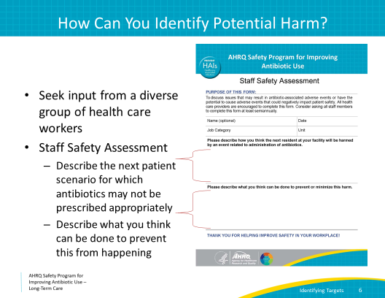
Case #1  SAY:  Let’s walk through a case, and we can consider what someone on the frontline staff might put on their Staff Safety Assessment form.  One of the residents in your facility develops pain with urination. She feels tired but otherwise indicates she is feeling OK. Her vital signs are all within normal limits. On assessment, she has mild suprapubic tenderness.  The clinician decides to send a urinalysis and urine culture and starts the resident on a 7-day course of ciprofloxacin. | Slide 7  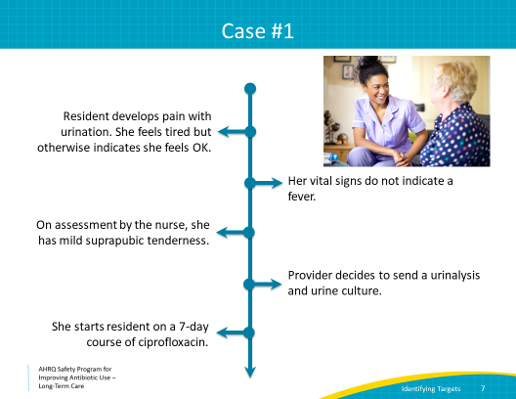
Case #1, Continued  SAY:  The laboratory faxes the urine culture results 2 days later. The results arrive around 8 p.m. and are placed into the chart with no notification to the clinician or other daytime clinical staff. The culture results show >100,000 colony forming units per milliliter of Klebsiella pneumoniae, sensitive to trimethoprim-sulfamethoxazole and nitrofurantoin, but resistant to ciprofloxacin.  The resident remains on ciprofloxacin. | Slide 8  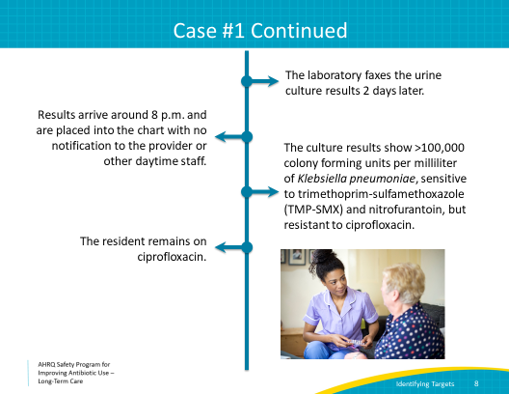
Case #1 Completed  SAY:  Five days later, the resident develops back pain and a fever and appears drowsy. She is transferred to the emergency department, started on intravenous antibiotics for pyelonephritis and admitted to the hospital. | Slide 9  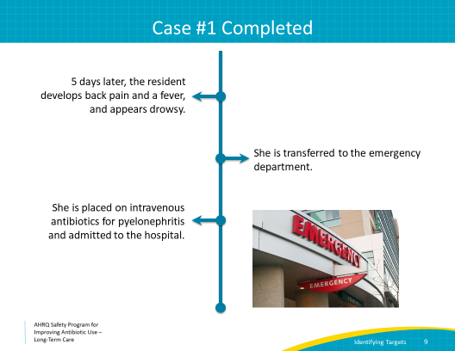
Four Moments in Antibiotic Decision Making  SAY:  Let’s consider this case by looking at it through the framework of the “Four Moments of Antibiotic Decision Making.”  We will use this framework to review antibiotic prescribing decisions to identify potential harms and to find solutions. We encourage you to use the Four Moments whenever you’re thinking about prescribing antibiotics.  The Four Moments are—  - Does the resident have symptoms that suggest an infection? Can we try symptomatic treatment and active monitoring?  - What type of infection is it? Have we collected appropriate cultures and diagnostic tests before starting antibiotics? What empiric therapy should we initiate?  - What duration of antibiotic therapy is needed for the resident’s diagnosis?  - It’s been 2–3 days since we started antibiotics. Re-evaluate the resident and review the results of diagnostic tests. Can we stop antibiotics? Can we narrow therapy?  In the case we just reviewed, the prescriber made a reasonable decision to prescribe antibiotics. The resident had pain with urination and suprapubic tenderness. She met criteria for empiric antibiotics.  The prescriber also considered part of Moment 2; she ordered appropriate cultures before prescribing antibiotics. However, she decided to initiate ciprofloxacin as empiric therapy. Ciprofloxacin is a fluoroquinolone. Antibiotics in the fluoroquinolone class are often in the long-term care setting, but can have significant side effects in older adults, such as Clostridioides difficile infection, tendonitis, or mental status changes. Additionally, because they are used frequently, many residents have bacteria that are resistant to fluoroquinolones, so choosing ciprofloxacin as empiric therapy may not have been the best choice. For these reasons, fluoroquinolones should generally be avoided for the treatment of cystitis.  Moving on to Moment 3. The prescriber wrote for a duration of antibiotic therapy of 7 days. This is probably too long for an uncomplicated urinary tract infection, and should be shortened to 3–5 days.  Moment 4 may have caused the most notable harm in this case. The results from the urine culture showed that the organism growing was resistant to ciprofloxacin. Unfortunately, the prescriber was not directly notified and did not to go back and review the results of the urine culture. The antibiotic was not changed to an agent that would be effective against the Klebsiella. And so, the resident did not improve and instead developed pyelonephritis.  Several opportunities for improvement occurred in this case of a resident with an uncomplicated cystitis. Let’s walk through the Staff Safety Assessment and see if we can consider how to avoid these harms in the future. | Slide 10  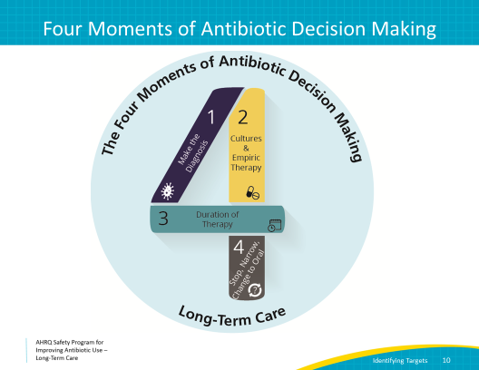
Staff Safety Assessment  SAY:  A member of the frontline staff wants to address the case we just discussed. Let’s consider what she would fill out on her Staff Safety Assessment form. If you have this form printed out and in front of you, please take a look at it now. If not, just follow along on the screen. Let’s look at and answer question 1:  “Describe the next patient scenario for which antibiotics may not be prescribed optimally.”  We discussed several opportunities that occurred in this case when we walked through the Four Moments.  Let’s imagine that the frontline staff member wants to focus on the missed review of the urine culture results.  For question 1, she may answer: “If urine culture results are not reviewed, there’s a missed opportunity to change antibiotics. Residents can get sick on the wrong therapy.”  Now we can consider question 2:  “Describe what can be done to prevent this from happening.”  For question 2 she could answer: “Create an alert that requires nurses to notify prescribers of urine culture results. Then prescribers would have to review and sign off on cultures when results are available from the lab.” Also, encourage nurses and clinicians to review and discuss indications for antibiotic therapy on a daily basis.”  These are just two examples of opportunities and solutions the frontline staff can address on the Staff Safety Assessment. | Slide 11  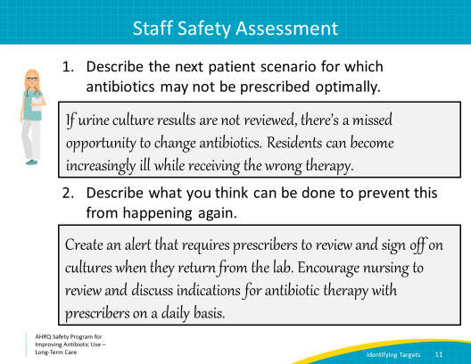
Use the Four Moments To Identify Problems  SAY:  As we saw when we walked through the 4 Moments of antibiotic prescribing, there were several problems. They can be thought of as the holes in the Swiss cheese model, which we described in the presentation, “Improving Antibiotic Use is a Patient Safety Issue.” All of these problems, or holes in the Swiss cheese model, have potential solutions. It is important to encourage frontline staff to be aware of these and address them continuously, in order to protect residents. | Slide 12  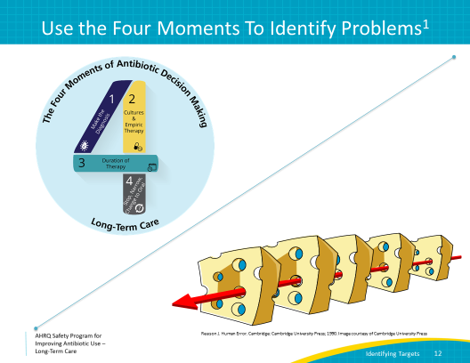
How Can You Identify Problems?  SAY:  Let's discuss identifying opportunities for improvement at your facility. The antibiotic stewardship team generally consists of a physician lead, pharmacist lead, and nurse lead. This team should review the problems identified by the frontline staff and prioritize the top three.  The stewardship team and a diverse group of frontline staff should identify all the factors that could lead to each problem identified. | Slide 13  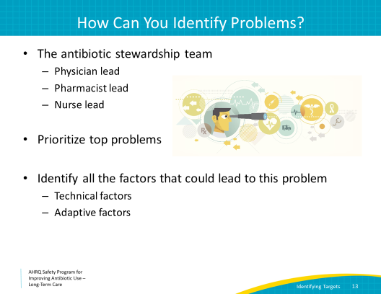
First-Order and Second-Order Problem Solving  SAY:  When working as a team to identify solutions to problems, there are first-order and second-order solutions.  First-order problem solving involves solving one problem at a time by focusing on one particular instance.  This type of problem solving generally does not help prevent future harm from occurring. This could involve calling a clinician who ordered antibiotics on an asymptomatic resident with a positive urine culture and telling him or her that the antibiotics should be discontinued. While this might solve the problem for that particular resident, it does not prevent this from happening again. It has no effect on the system as a whole.  Second-order problem solving uses technical and adaptive interventions to make lasting changes on the system or culture of safety in the facility. It identifies problems in the system and works to prevent them from occurring again.  For example, a resident is sent to the emergency department for chest pain and then returns with a diagnosis of a urinary tract infection or UTI and a prescription for an antibiotic. We all know that UTIs do not cause chest pain, and in this case, an antibiotic is not appropriate.  A first-order solution would be to notify the clinician and ask him or her to consider discontinuing the antibiotic. There should also be a discussion with the family to let them know that the physician at the emergency department may not understand that many older adults will have a “positive” urine test. While these steps are important, they will likely help only this resident.  A second-order solution is to create a policy and procedure for an automatic review of all medication changes when a resident returns from the hospital or emergency department. It would also involve telling residents and family members on admission and before they go to the emergency room that clinicians sometimes overdiagnose urinary tract infections. Although well intentioned, clinicians sometimes misinterpret urine tests in older adults.  Second-order problem solving and systematic changes are needed to decrease the potential harms associated with unnecessary antibiotic use. | Slide 14  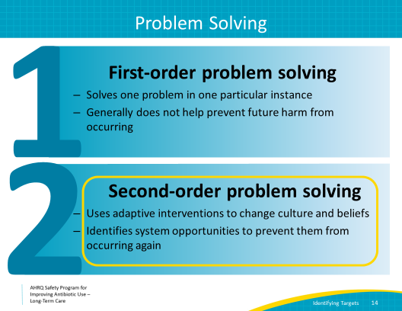
Technical Problems  SAY:  Technical problems are problems for which the potential solutions are clear. These may require a checklist or protocol to guide change.  Thinking back to Case 1, the daytime nurse and prescriber never received notification of urine culture results. A technical solution might include an electronic notification or form faxed by the nurse to the provider about culture results. The clinician must acknowledge receipt of these culture results.  Let’s consider other examples that can be solved with a technical solution:  The clinicians in one facility commonly order urine studies on residents who are confused or upon request from a family member. They are not using appropriate diagnostic criteria before ordering urine cultures. This leads to unnecessary antibiotics prescribed for residents with positive urine cultures.  Some potential technical solutions may include pocket guides describing the criteria for ordering urine cultures. These could be given to clinicians and nurses. A checklist for nurses to use before asking for an order for a urine culture or for collecting a urine sample may also be helpful.  Technical solutions are relatively easy to develop. However, gaining buy-in for implementation of the solution often requires adaptive work. | Slide 15  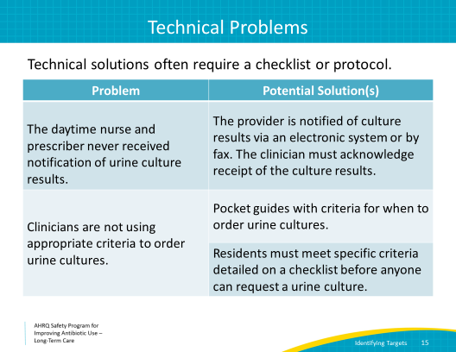
Adaptive Problems  SAY:  Adaptive problems are problems for which solutions require a change in attitudes, beliefs, and behaviors.  Solving an adaptive problem is complex. It requires fostering a culture of safety where clinicians and family members understand that antibiotics are not without risks. They should also understand that prescribing antibiotics without evidence of a bacterial infection can harm patients.  For example, clinicians may feel uncomfortable not prescribing antibiotics for a positive urine culture, particularly if family members were involved with the decision to test the urine. An adaptive solution to this problem involves encouraging a culture of safety. Use posters and commitment letters to help make everyone—clinicians, nurses, and family members—aware that antibiotics are medicines with the power to harm as well as to heal. Antibiotics should only be used when necessary, not “just in case.”  Thinking back to Case 1—where the results of the urine culture were never communicated to the clinician—nurses may feel that when they call with laboratory results, that they are “bothering” that clinician.  An adaptive solution may involve encouraging nurses to communicate all the information needed to help the clinician make an informed decision about antibiotic prescribing. This includes urine culture results and an updated assessment of the resident. Nurses should feel comfortable alerting a clinician that a resident does not have signs or symptoms of an infection, if that is the case. Because the prescribing clinician is often not physically in the facility, they rely on the frontline staff to alert them to changes in a patient's status, and this communication should be encouraged. This is important information for the care team to help make the right decisions and improve patient safety. Also, tell clinicians to expect nurses to communicate this information. If they don’t receive a status update about the resident, they should ask for one.  Teamwork and effective communication are key parts of adaptive solutions. | Slide 16  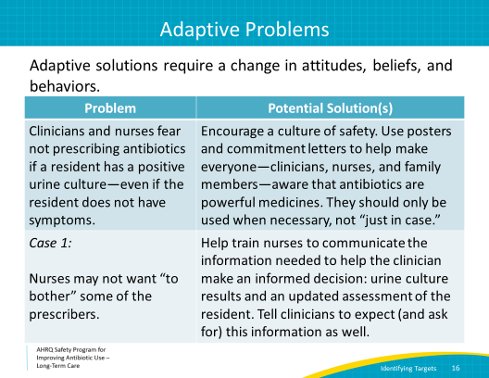
Summary  SAY:  At this point, you know that—  - The Staff Safety Assessment should be completed by all staff in your facility. You might consider making this an annual event.  - Consistently using the Four Moments of Antibiotic Decision Making may help identify problems.  - Although problems and the potential for harm are plentiful, so are opportunities to improve. Start with potential harm that is easy to fix. That win builds team momentum and provides experience.  - Use second-order problem solving to determine technical and adaptive solutions. Some problems may require several solutions over time. | Slide 17  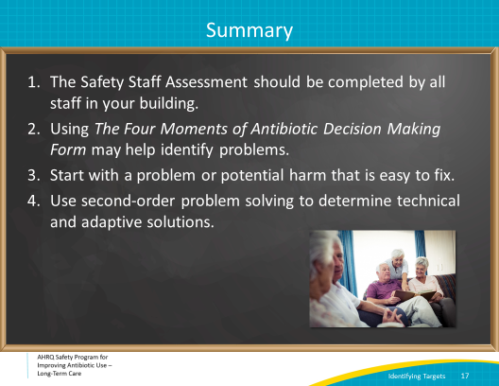
Activities To Complete  SAY:  These activities are intended to provide your team with activities that may pair well with this presentation.  The stewardship team may consider distributing the Staff Safety Assessment to staff to identify problems with antibiotic prescribing in your facility. If you have been using the Four Moments of Antibiotic Decision Making Form, the stewardship team should also review that data to identify any issues and continue their monthly data collection to track progress.  In addition, frontline providers may want to distribute the Antibiotic Side Effects One-Pager to clinicians and frontline staff.  Supporting materials for the activities are listed on the slide and are available on the Safety Program Web site. | Slide 18  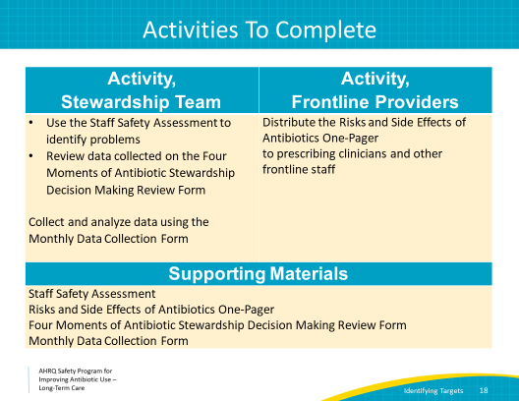
Disclaimer  SAY:  Disclaimer:  The findings and recommendations in this presentation are those of the authors, who are responsible for its content, and do not necessarily represent the views of AHRQ. No statement in this presentation should be construed as an official position of AHRQ or of the U.S. Department of Health and Human Services.  Any practice described in this presentation must be applied by health care practitioners in accordance with professional judgment and standards of care in regard to the unique circumstances that may apply in each situation they encounter. These practices are offered as helpful options for consideration by health care practitioners, not as guidelines. | Slide 19  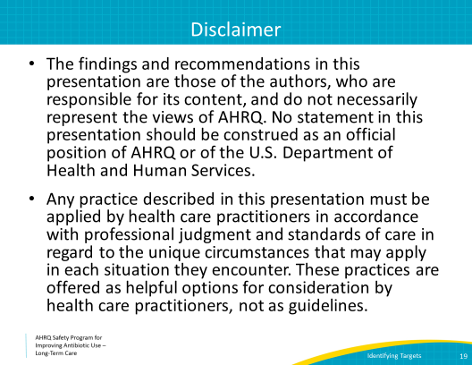
References | Slide 20  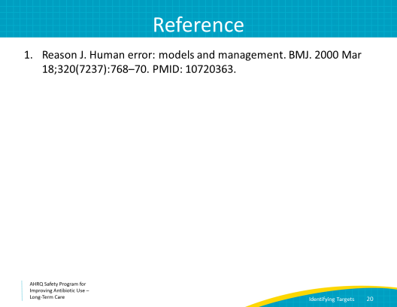
AHRQ Pub. No. 17(21)-0029
June 2021

