Assessment of the Resident With a Suspected Respiratory Tract Infection
Long-Term Care

Slide Title and Commentary | Slide Number and Slide
Assessment of the Resident With a Suspected Respiratory Tract Infection  Long-Term Care  SAY:  Thank you for joining us. This presentation is titled “Assessment of the Resident With a Suspected Respiratory Tract Infection.” | Slide 1  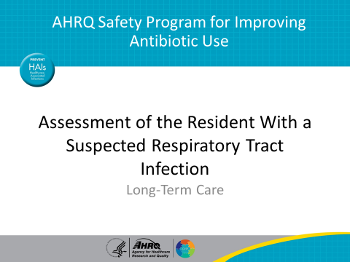
Objectives  SAY:  This presentation will focus on distinguishing between upper and lower respiratory tract infections.  At completion, you will be able to recognize the signs and symptoms of a suspected respiratory infection that should be reported and discussed within the health care team.  You will be able to identify the indications for empiric antibiotics in residents with a suspected respiratory tract infection and understand supportive care measures to alleviate symptoms when antibiotics are not indicated.  You will also be able to recognize syndromes that may be confused with acute bacterial pneumonia.  The overall objective of this presentations is to enable making informed decisions about antibiotic prescriptions for residents. | Slide 2  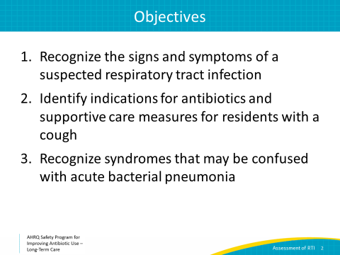
Terminology  SAY:  Respiratory tract infections are common. They range from the common cold to pneumonia. Let’s start with some basic terminology. It can be helpful to use some of this terminology when communicating with residents or family members. Remember, the vast majority of respiratory infections in the community and in long-term care, such as the common cold, bronchitis, and influenza, are caused by viruses. Because these are not bacterial infections, they will not get better with antibiotic therapy.  The common cold is an upper respiratory infection that can be caused by many different viruses. The key word here is viruses. Because the culprit is a virus, antibiotics will not help the infection get better. Treatment is supportive care, such as rest, fluids, analgesics, and above all, time. The common cold typically takes about 2 weeks to resolve.  Acute bronchitis refers to inflammation of the large airways. Again, the vast majority of cases of acute bronchitis are caused by viruses. Bronchitis can be difficult to distinguish from pneumonia, because the resident may have a wet cough and increased oxygen requirements. Often, a chest x ray will help to distinguish the two.  Influenza is a viral infection most common between October and March, but it can occur in any month, particularly in long-term care. All long-term care facilities should have a protocol for facilitywide influenza vaccination to help prevent this infection. This includes offering all staff members seasonal influenza vaccinations. If your antibiotic stewardship team has not already done so, consider making this one of your first interventions. Remember that any resident presenting with respiratory symptoms in the winter months should be screened for influenza. Early identification and treatment can decrease morbidity and mortality for the affected resident. Missing this diagnosis could lead to an outbreak in your facility, and the consequences could be devastating for your residents.  Coronavirus disease 2019, or COVID-19, a viral infection caused by severe acute respiratory syndrome coronavirus 2, or SARS-CoV-2, has emerged as a significant threat globally. Residents of long-term care facilities are at particular risk of severe infections due to the presence of other co-morbidities and because of the ease with which infection with the virus can spread within a communal living setting. Although we will not discuss COVID-19 further in this presentation, like influenza, a single case of COVID-19 in the long-term setting requires an aggressive containment response and may need to be considered in your differential. Further information about management of COVID-19 in the long-term care setting can be found on the Centers for Disease Control and Prevention Web site and on State and local health department Web sites.  Pneumonia refers to inflammation of lung tissue. Pneumonia can be caused by both viruses and bacteria. Residents with pneumonia often have a cough, fever, increased oxygen requirements, high white blood cell count or WBC, and evidence of an infiltrate on chest x ray. Unless a viral cause for pneumonia has been detected through testing,, residents will likely require antibiotic therapy. | Slide 3  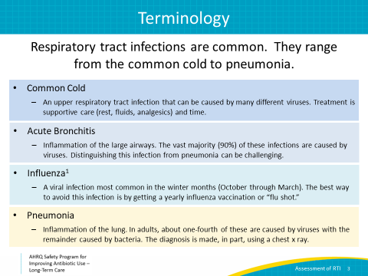
Upper or Lower Respiratory Tract Infection Descriptions  SAY:  This is a visual model of some of the respiratory infections we discussed on the previous slide.  Sinusitis, the common cold, and laryngitis are all largely caused by viruses and affect the upper airways.  Strep throat, caused by group A Streptococci, is a bacterial infection. Rapid strep tests can be used to determine if a resident has this bacterial infection for which antibiotics are indicated.  Bronchitis and pneumonia affect the lower airways. While bronchitis is largely caused by viruses that affect the lower respiratory tract airways, about 75 percent of pneumonia cases are caused by bacteria that affect lung tissue. | Slide 4  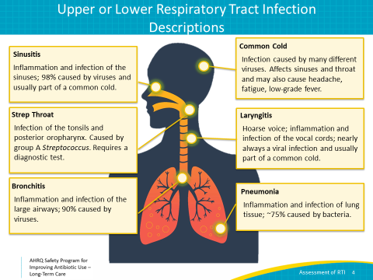
Case 1: Sandy  SAY:  Let’s walk through a case.  Sandy is a 75-year-old resident with moderate dementia and congestive heart failure who is wheelchair bound. She says for the past 2 days she has been feeling stuffy, has a headache, complains of muscle pain, and has been coughing up some yellow phlegm. She has no trouble breathing but says all she wants to do is sleep. Last week, her whole family came to visit for Christmas, and her 7-year-old granddaughter was coughing.  She has a temperature of 99.8, a heart rate of 98, blood pressure of 124/86, and she is saturating 96% on room air. | Slide 5  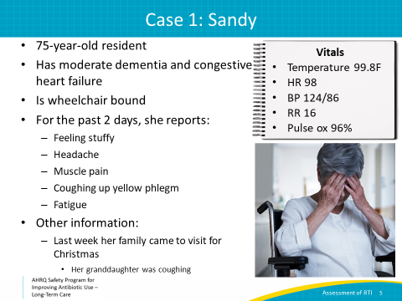
Case 1: Sandy, continued  SAY:  You observe that she appears congested with a runny nose and red eyes. Her lungs are clear on exam, and she is breathing comfortably.  What is your next step in management?  Answer 1, Test her for influenza, is a good answer. Her complaints of muscle pain, headache, and congestion during the winter months, particularly after exposure to her sick granddaughter, should raise suspicion for influenza. Every resident with these symptoms should be screened for influenza. If she does have the flu, you will need to take precautions to avoid spreading it to other residents, which we will discuss later in this presentation.  Answer 2, starting antibiotics, is incorrect. Her symptoms are more consistent with a viral infection. She will require further workup before starting antibiotics. Her lungs are clear, suggesting this is not likely pneumonia and is more likely a viral infection. Antibiotics will not be helpful and, as you know, may cause harm. Though the resident or her family members may ask for or expect antibiotics for a “quick fix,” taking the time to explain your reasoning for supportive care and active monitoring in this situation can be very helpful.  Answer 3, sending a further diagnostic workup including a urinalysis or UA and urine culture, is also incorrect. She does not complain of any urinary symptoms; therefore, sending a UA and urine culture is not indicated. If her urine is positive for bacteria (which is often the case in older adults), team members may feel inclined to treat for a urinary tract infection, even though this situation would be consistent with asymptomatic bacteriuria and does not require treatment. The chest x ray to evaluate for pneumonia is reasonable to obtain if her cough continues, her oxygen requirements increase, and she does not improve with supportive care.  Answer 4 is also incorrect—her low-grade fever and her risk of influenza exposure warrant further workup to the cause of her symptoms. Remember, missing this diagnosis can have major consequences, so make sure that frontline staff members have access to influenza testing kits and know how to use them. Educating staff about seasonal influenza is important. | Slide 6  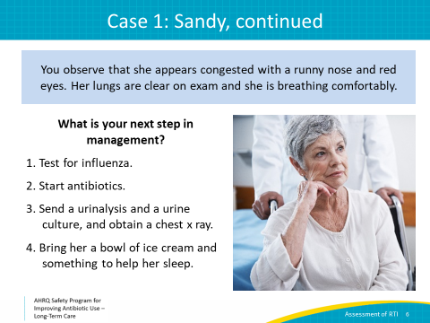
Case 1: Sandy, Next Steps  SAY:  You decide to test Sandy for influenza.  Her test comes back positive for influenza A.  First off, congratulations for taking the appropriate steps to diagnose an influenza infection. These infections carry a high mortality, particularly among older adults. The flu is very contagious, so this decision also helped to prevent a flu outbreak in your facility.  Once you have a resident with a positive flu test, preventative measures to reduce the spread are incredibly important. These are suggested next steps..  - Start Sandy on oseltamivir, or Tamiflu®, 75 mg twice daily for 5 days. This medication can reduce the length and severity of illness if started within 2 days of symptoms. Even for those with up to 4 days of symptoms, oseltamivir may be helpful. Chicken soup and other supportive measures also can be helpful to ensure the resident’s comfort during this uncomfortable illness. She will need to be watched closely to ensure she is recovering well and remains hydrated.  - In order to prevent other residents from getting influenza, place the resident on standard and droplet precautions—this means she will need her own room, and this should be arranged as soon as possible.  - Next, test for influenza in any close contacts. This includes the resident’s roommate, anyone else with close exposure to the resident, and any of the residents in the facility with respiratory symptoms.  - Last, confirm that all residents in the facility have received the seasonal influenza vaccine and vaccinate those who have not. Residents should be vaccinated yearly to prevent future outbreaks.  When at least two patients are ill within 72 hours of each other and at least one resident has laboratory-confirmed influenza, the Centers for Disease Control and Prevention recommends that all exposed residents should receive antiviral chemoprophylaxis for a minimum of two weeks and at least 7 days after the last known case was identified. The dose for prophylaxis is 75 mg of oseltamivir by mouth once daily. Remember to adjust the dose for people with renal insufficiency—this means reducing the dose by 50 percent for residents with a creatinine clearance less than 30.  As part of preparing for influenza season, you might want to consider working with your consultant pharmacist to develop a spreadsheet for your residents. Around the time when they receive their annual influenza vaccine, you might also get their weight and get a blood test to determine their renal function. Then, if there is an outbreak, it makes it much easier to safely start antiviral prophylaxis right away.  It is important to remember that people who do develop influenza are at a small risk for bacterial superinfection, so they should be monitored for new clinical decline, such as new fevers or shortness of breath after having a period of improvement, throughout their illness to ensure they have not developed a secondary bacterial pneumonia.  In addition to providing annual influenza vaccination for residents, you should also ensure that you have a process to confirm they are up to date with their pneumococcal vaccinations, which can help to prevent invasive bacterial infection with Streptococcus pneumoniae, one of the most common causes of bacterial pneumonia. | Slide 7  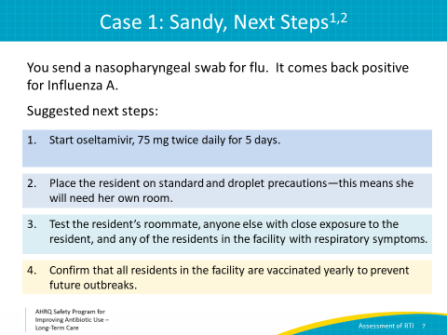
Case 2: Jonas  SAY:  Let’s walk through another case.  Jonas, a 73-year-old man with a 50 pack-year smoking history and diabetes, is at your facility for physical therapy as he recovers from a recent stroke. He has done relatively well and recently went home for a weekend.  Two days later, he reports feeling “lousy,” and is now coughing up green sputum. He complains of scratchy pain in his upper chest when he coughs or takes a deep breath. He hasn’t gone outside to smoke all day, which is definitely a change for him.  His temperature is 99.4, his HR is 96, his RR is 22, and his blood pressure is 102/66.  His oxygen saturation is 95% on room air, which is his baseline. | Slide 8  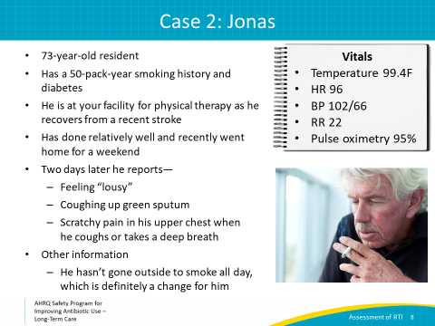
Case 2: Jonas, continued  SAY:  You perform a physical exam and note that he is coughing up dark green sputum while you examine him.  He has a few wheezes on exam in both lungs, but otherwise his exam is normal. | Slide 9  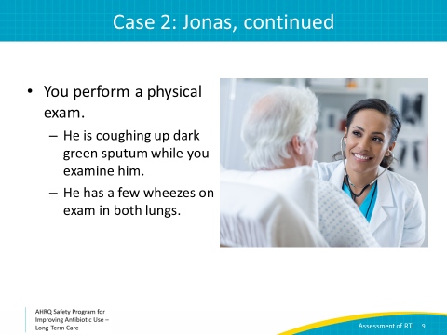
Case 2: Jonas, Next Step  SAY:  Because you learned from your last case, you decide to test for influenza. It comes back negative.  Now let’s consider the following best options for management. Think about his most likely diagnosis as we walk through each response.  Answer 1, starting levofloxacin for 10 days for pneumonia treatment, is incorrect. You haven’t done a diagnostic workup to confirm pneumonia. Even if he did have pneumonia, 10 days of treatment for this diagnosis is too long. Five to seven days of antibiotic therapy is now recommended for most cases of pneumonia. Also, levofloxacin and other fluoroquinolones should be avoided unless the resident has a severe penicillin allergy. Fluoroquinolones are associated with an increased risk of Clostridioides difficile infection and other side effects such as altered mental status in the elderly.  The next answer, providing a cough suppressant and close monitoring, is probably the best choice. This is most likely a viral infection and should be treated with supportive care. Avoiding smoking can significantly help recovery time. Remember that viruses other than influenza can cause symptoms like those seen with influenza. However, these will not be detected with an influenza test..  The third option, sending him to the emergency department, is unnecessary at this time based on his symptoms. He does not have increased oxygen requirements or any evidence of decompensation. He should be monitored closely, and should his condition change or deteriorate, transfer may be necessary. | Slide 10  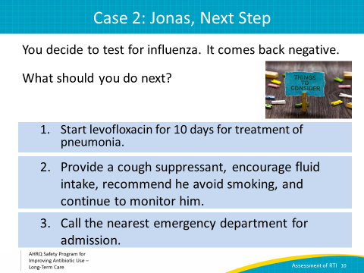
Case 2: Jonas, 5 Days Later  SAY:  You decide to proceed with supportive measures and close monitoring.  Five days later, he says he feels better, but he still has a cough that just won’t go away. While the cough is no longer productive, he says he feels worn out and his chest hurts from coughing so much.  What should we do next?  1. Ask for a set of vital signs and assess Jonas,  2. Obtain a complete blood count or CBC and chest x ray to evaluate for pneumonia, or  3. Start antibiotics  Here, the best choice is to start with a set of vital signs, including a room air pulse oximetry and an assessment. Depending on his physical exam findings, Jonas may need some reassurance that he will feel better in a few more days. Sometimes it takes several weeks for a cough to go away after a viral infection. He may benefit from a cough suppressant and/or a mucolytic agent.  If he has an elevated temperature, tachycardia, increased oxygen requirements or is otherwise looking ill, it is reasonable to consider a diagnostic workup, including a thorough physical exam, CBC, and chest x ray, in order to confirm that he has not developed a pneumonia that needs to be treated with antibiotics. | Slide 11  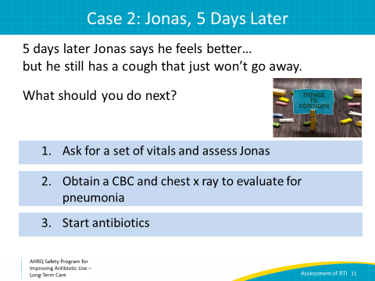
Bronchitis Versus Pneumonia  SAY:  Remember the difference between bronchitis and pneumonia. These conditions can be very challenging to differentiate, particularly in the elderly. The differentiation is important because pneumonia often requires antibiotic therapy while bronchitis largely does not.  Acute bronchitis is inflammation of the larger airways of the lower respiratory tract while pneumonia is inflammation of the lung tissue.  Note that bronchitis can last for up to 3 weeks, particularly in residents with a smoking history.  Residents with pneumonia often have leukocytosis, fever, and evidence of an infiltrate on chest x ray. These residents usually should be treated with antibiotics.  While bronchitis is most often caused by viruses, a few bacterial causes of bronchitis include Mycoplasma pneumoniae, Chlamydophila pneumoniae and Bordetella pertussis, which causes whooping cough.  Antibiotics are only appropriate for bronchitis caused by Bordetella pertussis, or “whooping cough,” which is quite rare in older adults, causing infection in less than 1 of every 2,000 cases of bronchitis. For people deemed high risk—like those with a known exposure or no history of immunizations—special tests on nasopharyngeal samples should be used to make the diagnosis. | Slide 12  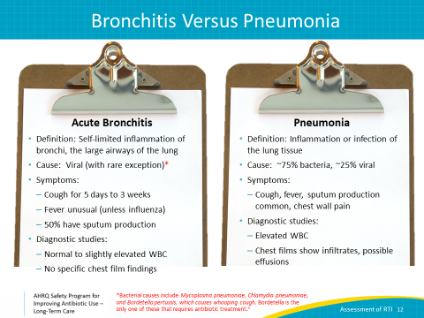
Case 2: Jonas, X Ray  SAY:  Let’s get back to our case. Because of his pleuritic chest pain, which is pain with a deep breath, and a mildly increased oxygen requirement, Jonas gets a chest x ray and CBC. His white count is normal, and there are no changes that suggest acute pneumonia on his chest x ray.  Based on the information we just discussed, what is the most likely diagnosis?  This is a case of acute bronchitis. While his symptoms have lasted for over a week, this is actually common with acute bronchitis.  It’s less likely that he has influenza because he had a negative influenza test. Although most influenza testing platforms used now give accurate results, some are less sensitive. It can be useful to determine the accuracy of the test used in your facility.  This likely is not pneumonia because he is feeling somewhat better, he has a normal white blood cell count, and his chest x ray is unchanged.  Finally, while his illness is almost certainly due to a virus, his clinical presentation is different from a common cold. Specifically, he has sputum production without rhinorrhea or other typical “cold-type” symptoms. | Slide 13  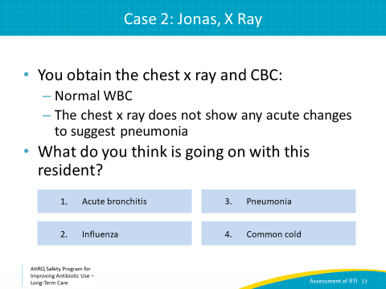
Chest X Rays in Older Adults Diagnostic Testing  SAY:  Among older adults, especially nursing home residents, chest x rays are frequently abnormal. Sometimes this is because of other chronic health conditions, like chronic obstructive pulmonary disease (COPD) or congestive heart failure. Sometimes this is because it’s hard to help residents position themselves in order to get a good quality film. Also, there are often delays in getting a chest x ray and its subsequent interpretation.  Comparing chest x rays to previous films, when those are available, may help to clarify what are new findings and what are chronic changes.  The chest x rays shown here are from the same resident, taken 2 weeks apart. The film on the right was taken because he developed a cough. If you only saw the film on the right, the concern for an acute change is much higher. Looking at both films side by side, however, and seeing that there are essentially no changes over 2 weeks is reassuring.  Also, a bedside pulse oximetry, or pulse ox, can help diagnose pneumonia. Among people who are usually comfortable on room air and in whom there is concern for a chest infection, an oxygen saturation of less than 94% has a positive predictive value of 95% for diagnosing pneumonia. | Slide 14  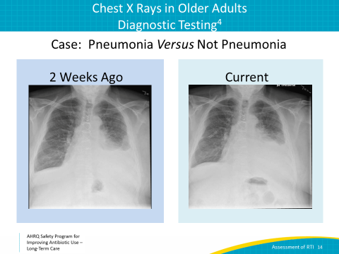
Case 2: Jonas, Antibiotics?  SAY:  As we discussed, you decide that Jonas probably has acute bronchitis. His daughter, however, is upset about his prolonged cough and feels that he is uncomfortable. She asks you for antibiotics to make his cough go away.  Let’s walk through some potential responses.  1. “Sure! Antibiotics are great at making coughs go away in just a few days. We will prescribe him levofloxacin and he should be better in no time.”  2. “We checked some bloodwork and a chest x ray, and it does not look like your dad has pneumonia. He most likely has bronchitis, which is due to a virus over 90 percent of the time. It is best to avoid antibiotics unless we are sure there is a bacterial infection. Antibiotics can have harmful side effects.”  3. “Let me see about getting him some cough suppressants, and we can try some breathing treatments. That usually helps with these types of symptoms. He also should avoid smoking, because that can make it difficult to recover from bronchitis.”  In this case, answers 2 and 3 are correct.  Effective communication is very important in order to ensure proper care of your residents and to make the resident and their family feel comfortable with their medical care.  By taking the time to address the daughter’s concerns, explain your reasoning, and offer alternative options to ensure the resident’s comfort, you are promoting good antibiotic use and likely improving resident satisfaction.  Because you decided to avoid antibiotics, the resident was not placed at increased risk for an allergic reaction to antibiotics, C. difficile infection, or development of a resistant bacteria. He felt better in the next few days, and he thanked you for being so conscientious with his care. Better still, he even cut back on his smoking. | Slide 15  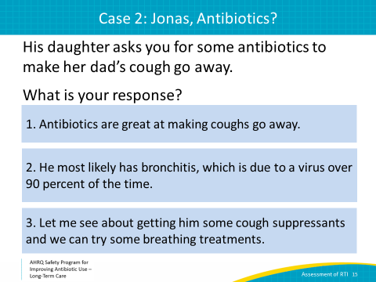
Case 3: Peter  SAY:  Let’s walk through one final case.  Peter is an 83-year-old resident with a history of congestive heart failure. He complains of being short of breath with a wet cough.  He says he hasn’t felt well for the past 10 days and today he feels even worse.  - He reports no fevers, chills, pleuritic chest pain, or sinus congestion.  - His cough is productive with clear sputum.  - His roommate reports that last night they ordered delivery pizza and wings, and Peter also had a bag of potato chips when they were watching football. | Slide 16  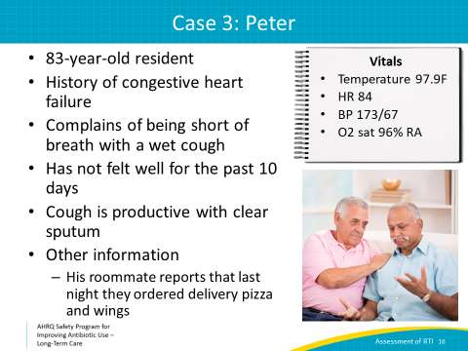
Case 3: Peter, continued  SAY:  You decide to do a physical exam and obtain a chest x ray.  His vitals are: temperature 97.9, heart rate 84, blood pressure 173/67, and oxygen saturation 96% on room air.  - He has crackles in the bases of his lungs bilaterally  - His abdomen is soft  - He has pitting edema in bilateral lower extremities  - His chest x ray shows bilateral lower lobe infiltrates | Slide 17  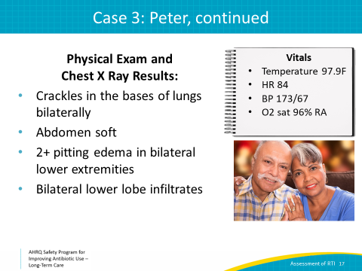
Case 3: Peter, Diagnosis?  SAY:  Based on the information provided so far, what do you think is going on with Peter?  1. He has a viral pneumonia because he has not been feeling well for 10 days  2. He has bronchitis based on his lung exam  3. He is having a heart failure exacerbation  4. He has bacterial pneumonia and needs antibiotics  The answer is most likely number 3, a heart failure exacerbation.  This is a common scenario in long-term care. Sometimes, a heart failure exacerbation can be difficult to distinguish from pneumonia. Remember that heart failure exacerbations can cause fatigue and also lead to crackles in the lungs.  Also, chest x ray findings may look like pneumonia, so considering the resident’s history is important here.  In this setting, Peter had a large amount of salt intake prior to his symptoms, and his vital signs do not show evidence of infection.  Giving the resident diuretics and managing him on a low-sodium diet would be a good first step. Of course, active monitoring is important. If his symptoms do not improve or he gets worse, he should be evaluated further. He may still be having symptoms of heart failure, or it is possible that something else could be going on, including pneumonia. | Slide 18  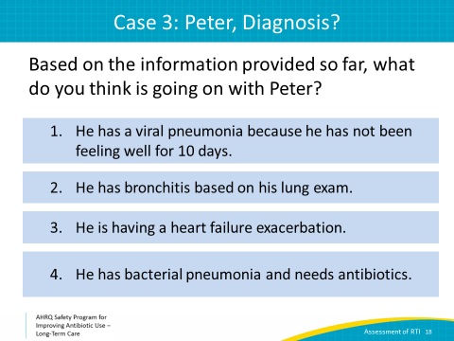
Take-Home Points  SAY:  We have walked through several common cases seen in long-term care to help you to recognize different types of respiratory tract infections. We have also discussed how a heart failure exacerbation can be distinguished from pneumonia.  Here are some key take-home points from this presentation:  The majority of upper respiratory infections are caused by viruses and do not require antibiotics.  During the winter months, all residents with fever and cough should be tested for influenza.  Clear communication regarding decision making with residents and family is key, and supportive measures should be provided for resident comfort. | Slide 19  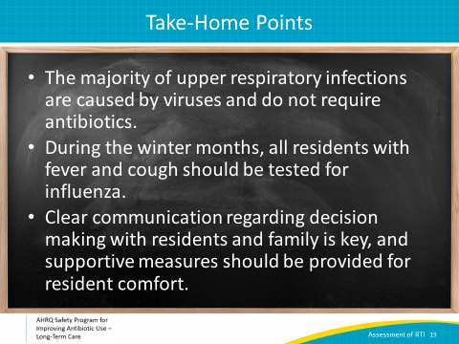
Activities To Complete  SAY:  These are the activities you may want to pair with this presentation, which are intended to help your team stay on track with the overall program.  The Antibiotic Stewardship Team should continue to hold monthly meetings and test interventions. Use the Staff Safety Assessment as well as the Learning From Adverse Antibiotic Events tools to help identify potential interventions. Make sure an individual is designated to collect data. The data might include information the Antibiotic Stewardship Team is already collecting using the Monthly Data Collection Form. Notify the Senior Executive of your plans and also use the Checkpoint Tool to keep track of your progress. If you already have an intervention in place, continue to collect data relevant to your intervention.  Ask Frontline providers to complete the Staff Safety Assessment. Also, review and distribute the Respiratory Virus Infections, Bacterial Pneumonia, and COPD Exacerbation one-pagers to frontline providers. With minor modifications, the Antibiotic Stewardship Team could render these one-pagers into antibiotic use protocols.  The Antibiotic Stewardship Team should collect or continue to collect and analyze data using the Monthly Data Template, and frontline staff should continue to apply the Four Moments of Antibiotic Decision Making Form to 5–10 residents each month.  Supporting materials for the activities are listed on the slide and are available in the toolkit | Slide 20  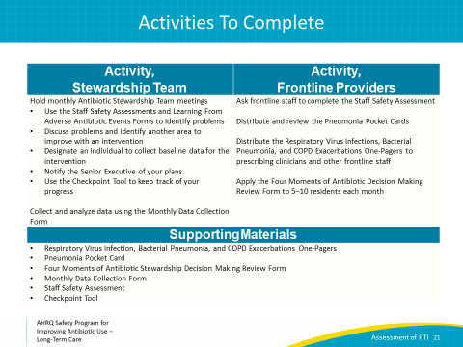
Disclaimer  SAY:  - The findings and recommendations in this presentation are those of the authors, who are responsible for its content, and do not necessarily represent the views of AHRQ. No statement in this presentation should be construed as an official position of AHRQ or of the U.S. Department of Health and Human Services.  - Any practice described in this presentation must be applied by health care practitioners in accordance with professional judgment and standards of care in regard to the unique circumstances that may apply in each situation they encounter. These practices are offered as helpful options for considerations by health care practitioners, not as guidelines. | Slide 21  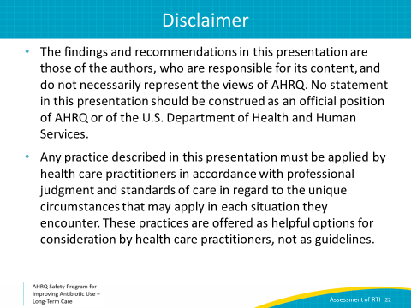
References  SAY:  References | Slide 22  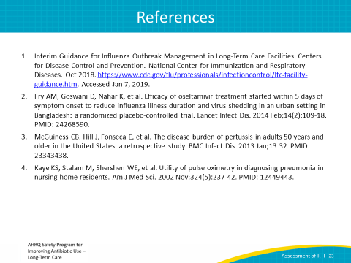
AHRQ Pub. No. 17(21)-0029
June 2021

