Changing the System To Improve Patient Safety
Long-Term Care
Slide Title and Commentary | Slide Number and Slide
Changing the System To Improve Patient Safety  SAY:  Hello, and welcome to this presentation: “Changing the System To Improve Patient Safety.” | Slide 1  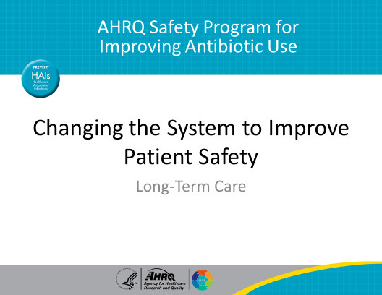
Objectives  SAY:  By the end of this presentation, participants will be able to—  - Use barriers as opportunities to improve the system and prevent problems from recurring.  - List factors that may compromise patient safety.  - Develop an intervention to reduce problems and then evaluate if the intervention is effective. | Slide 2  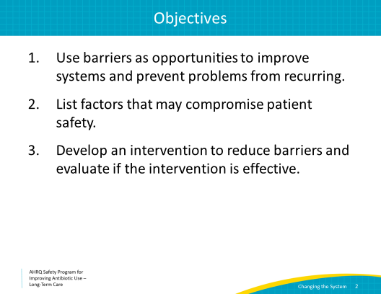
View Potential Harms as Opportunities  SAY:  In health care, when problems cause harm to patients or residents, we call those problems sentinel events. A problem that almost led to patient or resident harm is called a “near-miss.” Sentinel events and near-misses can be viewed as opportunities to make improvements and to prevent the problems from happening again.  We can categorize problems and potential problems into two broad categories:  - The first is problems or potential problems resulting from the design or organization of the system. These result in latent failures.  - The second is problems or potential problems resulting from human behavior. These result in active failures.  We will discuss both latent and active failures on the next few slides. | Slide 3  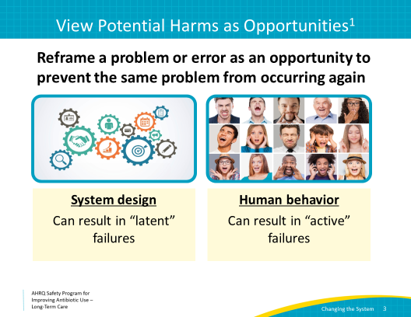
System Failures  SAY:  System failures are considered latent problems. They are considered latent because they have to do with how the work environment was set up and could happen at any time and to anyone. These often arise from managerial and organizational decisions (or lack of decisions) that shape working conditions. Latent failures may include lack of training or inadequate supervision. They may not be obvious until a triggering event occurs. Imagine not knowing that a fire extinguisher was not fully charged during an actual fire. Or having to walk down the hall in order to perform hand hygiene after leaving a resident’s room.  Some examples of system failures you may encounter in antibiotic prescribing may include lack of a system to notify health care practitioners when culture results become available or absence of alerts to indicate antibiotic allergies in medical records. | Slide 4  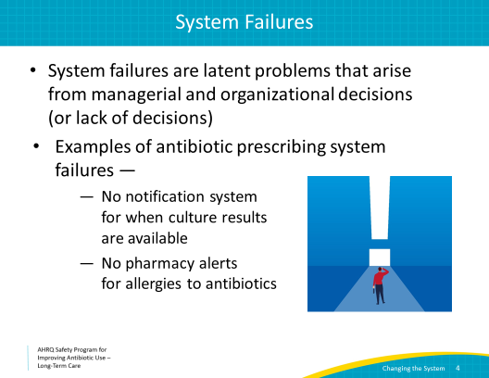
Active Failures  SAY:  Active failures occur because of human error. An example of an active failure is a resident receiving the wrong medication because someone misread the medication label.  These failures are usually readily apparent, and we try to prevent them by designing systems that protect against human error. To help prevent someone from misreading a medication label or a resident’s name, facilities may include “name alerts” for similar names of residents or drugs so that the health care worker will be less likely to misread them.  Another example of an active failure is not including a duration for an antibiotic prescription. Forgetting to put in a stop date may lead to a default stop date of 2 weeks or 30 days, far longer than is necessary to treat the most common bacterial infections. Also, a health care practitioner may write the wrong dose of an antibiotic because he or she is unaware of the resident’s renal function.  Pharmacists may catch some medication errors. Unfortunately, the time it takes to correct these errors, which involves contacting the facility or the prescriber, may lead to delays in starting or stopping the antibiotic, and can lead to adverse consequences for the resident. | Slide 5  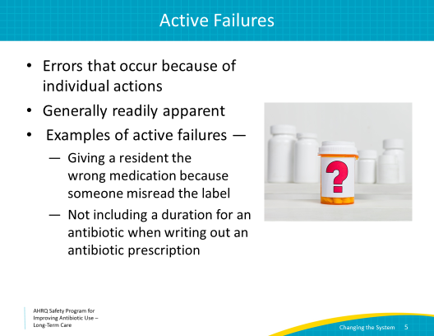
Swiss Cheese Model  SAY:  Let’s return to our “Swiss cheese model” to help visualize where mistakes can occur.  As you can see, along the process of an antibiotic prescribing decision, latent failures can occur if the system design is flawed. We rely on system design and organization to prevent unsafe acts. For example, we often embed alerts in the electronic medical system to notify a health care practitioner or pharmacist that a resident is allergic to a specific antibiotic in order to prevent giving the resident a medication that he or she is allergic to.  Though the resident can still receive the wrong medication due to human error, or active failures, we try to prevent this with double checks by pharmacy, electronic alerts, and/or required checklists that nursing must review before administering a medication. Without these defenses, an “active” or human failure can occur, resulting in a poor outcome.  Let’s put these ideas into action by reviewing a case. | Slide 6  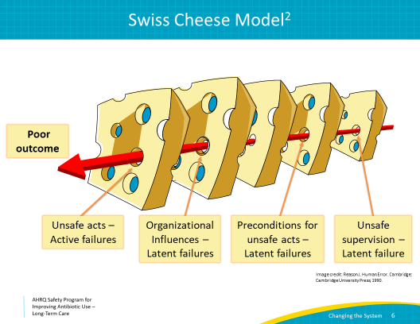
Case: 1  SAY:  One of the residents in your facility develops lethargy, leg swelling, increased oxygen requirements, and a nonproductive cough.  His symptoms are concerning, and he is transferred to the emergency department for evaluation. At the time of transfer, he is afebrile but appears uncomfortable. In the emergency department his electrocardiogram shows changes that suggest a recent heart attack. The ED providers also note that both of his lower legs are painful, red, and swollen with some serous weeping. There is no associated warmth or lymphadenopathy. | Slide 7  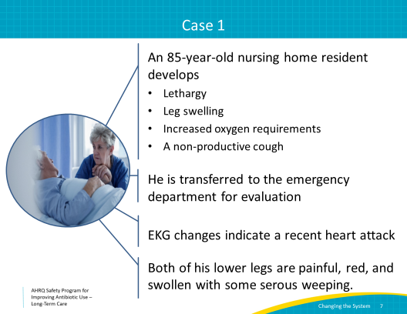
Case 1: Continued  SAY:  The resident is admitted to the hospital for management of a heart attack.  At the time of his admission, he is also started on intravenous (IV) vancomycin for lower extremity cellulitis.  After 3 days in the hospital, he is transferred back to your long-term care facility. His heart medications were adjusted, with an increase in anti-hypertensives and beta-blockers. He was also prescribed a 14-day course of amoxicillin/clavulanate for presumed cellulitis. | Slide 8  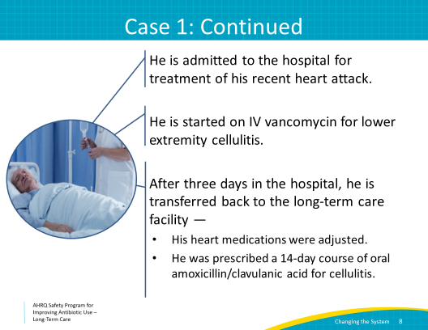
Case 1: Continued  SAY:  At the time of his transfer, the antibiotic prescription is for 14 days of amoxicillin/clavulanate even though he already received 3 days of treatment in the hospital. His legs are no longer weeping. His lower extremity swelling is slightly improved. The redness is also somewhat improved but both of his legs remain swollen and discolored. Ten days later, he complains of itching. | Slide 9  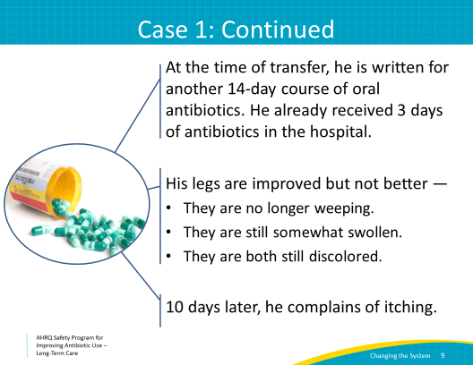
Case 1: Continued  SAY:  On exam, he has a rash over his chest, trunk, back, upper arms, and thighs. He is afebrile, with a heart rate of 84 beats per minute and an oxygen saturation of 97% on room air. You do not palpate any lymphadenopathy. Pertinent labs are:  - A normal white blood cell count of 7,200 cells per milliliter  - An elevated proportion of eosinophils at 9%, with an absolute eosinophil count of 600 cells per milliliter  - And, an elevated serum creatinine of 1.9 milligrams per deciliter; his baseline is 1.0 milligrams per deciliter.  The resident not only had a heart attack but has developed a rash and acute kidney injury. These are adverse events most likely caused by an antibiotic that he probably did not need. | Slide 10  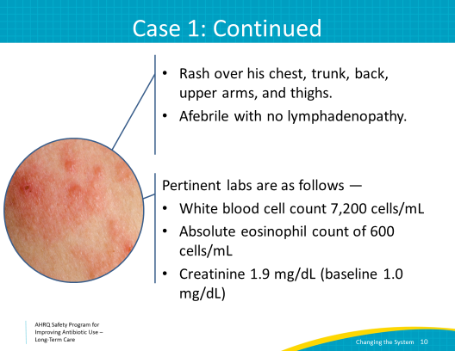
Four Moments in Antibiotic Prescribing  SAY:  Let’s review the case using the framework of the “Four Moments of Antibiotic Decision Making.”  Moment 1: Does my patient have an infection that requires antibiotics?  While the decision to prescribe antibiotics occurred in the hospital, whether to continue antibiotics should always be reassessed upon transfer back to long-term care. While discoloration of the lower extremities is common in older adults, not all red legs indicate cellulitis, particularly if it affects both extremities.  Stasis dermatitis, a condition which occurs because of inadequate function of the venous system, can lead to red or hyperpigmented legs. It is often misdiagnosed as cellulitis. This patient had a recent cardiac event, which can lead to lower extremity swelling. In this situation, diuretics, leg elevation, and compression stockings would have likely improved his red legs. Without an elevated white blood cell count or fever it is unlikely that the resident had cellulitis. Bilateral cellulitis is very rare.  Let’s move to Moment 2: Have I ordered appropriate cultures? What empiric therapy should I initiate?  The emergency department decided to initiate empiric therapy with vancomycin. There was no clear evidence of infection, or any purulence that would suggest the need to cover for methicillin-resistant Staphylococcus aureus or MRSA. The resident likely did not need any antibiotics.  Next, Moment 3: What duration of antibiotic therapy is needed for the resident’s diagnosis?  Current recommendations suggest that an appropriate duration of treatment for cellulitis is 5–7 days. Fourteen days of therapy is too long. Although this was prescribed by the hospital, the need for continued antibiotic therapy should be assessed on admission and daily in the long-term care setting.  Additionally, because of poor communication or human error, when the resident returned to long-term care, the antibiotic order was written for 14 days, even though he had already received 3 days in the hospital. He would have received 17 days of antibiotics—again, too long of a duration even if he truly did have cellulitis.  Last, Moment 4: A day or more has passed. Can we stop antibiotics? Can we narrow therapy?  Antibiotics should have been re-evaluated and stopped early on in his course. Stopping antibiotics would likely have prevented the development of a rash and acute kidney injury.  Next, we will review an approach to help us view problems as opportunities and apply it to this case. | Slide 11  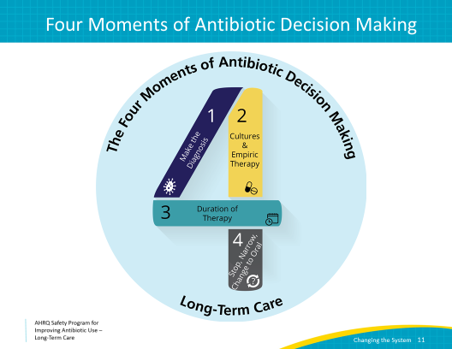
Problems Are Also Opportunities To Improve  SAY:  Learning to see problems as opportunities can help your stewardship team learn from sentinel events and near-misses. Then, the team can address the problem and takes steps to prevent it from happening again. A simple way to put this approach into action is by asking four questions:  - What happened?  - Why did it happen?  - What could you do to reduce the risk of this happening again?  - Once the potential for harm is addressed, how do you know the risk was reduced?  This four-step approach is incorporated into the Learning From Antibiotic-Associated Adverse Events form, pictured here. This form is available in the toolkit. | Slide 12  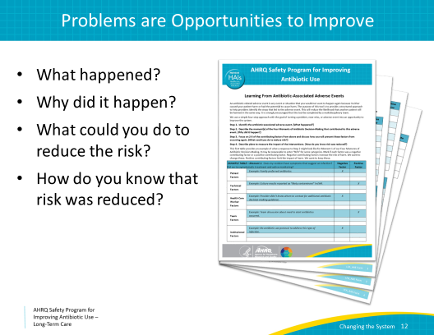
What Happened?  SAY:  Let’s first consider what happened to our resident.  From the perspective of the long-term care provider, this resident was transferred from the hospital with a set course of antibiotics. Because of this, the health care practitioner likely did not want to change the orders issued by a hospital physician. This may be for fear of offending the prescribing clinician or for fear of “missing something” that was known to the hospital team.  These are common challenges in long-term care settings. Encouraging a safe environment to discuss and reassess clinical plans for residents is essential to reduce bad outcomes.  Additionally, when the resident returned back to long-term care, the new order for amoxicillin/clavulanic acid did not account for the 3 days of treatment he received in the hospital. This could have been due to a system failure, such as no universal electronic medical record between facilities or inadequate transfer of hospital records. It could also be due to human error, or “active failure”— the long-term care clinician did not count the days of antibiotics given in the hospital prior to transfer or the hospital physician did not communicate the remaining duration. A simple clerical error is another possible human error. | Slide 13  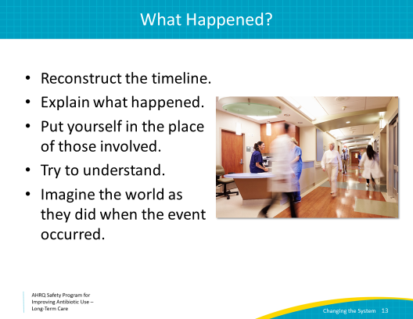
Why Did It Happen?  SAY:  Let’s consider the resident’s poor outcome, which was an allergic reaction to amoxicillin/clavulanic acid which led to a rash and acute kidney injury. We can make a list of negative and positive contributing factors in this resident’s case.  Negative contributing factors are those that caused harm or almost caused harm. These are factors you want to change. In this case, negative contributing factors were:  1. The antibiotic duration was not communicated correctly at the time of transfer.  2. There was no reassessment of the resident’s legs or the need for antibiotics when he returned to the long-term care facility.  Positive contributing factors are those that limit or prevent harm. Sometimes we forget to acknowledge the factors that reduce potential harm from the adverse event. It is important to recognize positive contributing factors so we make sure they remain in place or are enhanced in some way, if possible.  In this case, positive contributing factors included—  1. The resident was transferred to long-term care on oral, not intravenous, antibiotics.  2. Once the staff became aware of the rash, the appropriate evaluation occurred.  3. The provider became aware of the laboratory results in a timely manner, the antibiotics were held, and the acute kidney injury was addressed. | Slide 14  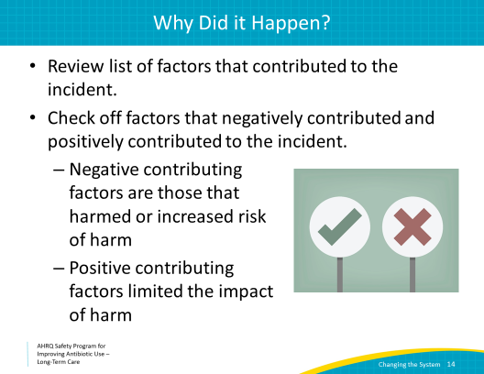
What Could You Do To Reduce the Risk?  SAY:  Now that we have reviewed the positive and negative contributing factors, let’s review safe design principles. These help us change or redesign the system to help reduce the risk of an event like this happening again.  As we discussed before, standardizing actions helps reduce the risks of problems. In health care, we often use checklists and other protocols to standardize our actions.  Second, design systems to require independent checks. An alert from the electronic medical record about a medication allergy is one type of independent check. Another is an automatic review of the dose, duration, and indication of antibiotic prescriptions by a pharmacist. Designing systems that independently check for errors will reduce the risk of active failures, or human error, downstream.  Last, it’s important to talk about near misses and sentinel events. While it’s natural to want to hide problems, when we make them visible, it helps everyone learn so they can avoid similar problems. When we say making the problem visible, we mean sharing your findings with other staff.  Also, make sure the changes made to prevent the problem from happening again are also visible. This is really important and can have a long-lasting positive effect on institutional culture. It lets people know that they are part of a culture that cares enough to recognize problems and to work to make them better. Sharing and understanding our previous mistakes helps everyone improve! | Slide 15  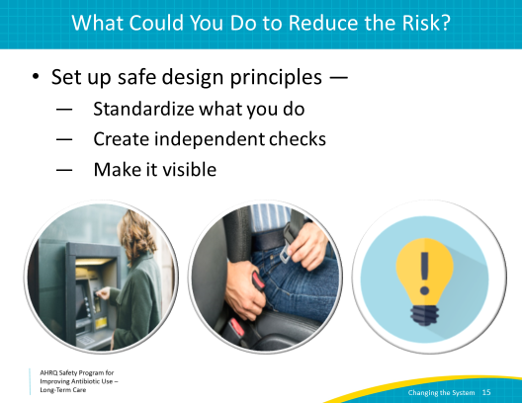
Strength of Interventions  SAY:  While there are many different ways to solve problems, some actions can be stronger than others. This chart shows different types of actions, from weaker to stronger. Sometimes a weaker action is the only one that can be applied to some specific situations. You should choose the strongest action possible for each situation.  As your antibiotic stewardship team evaluates a problem, near-miss, or sentinel event, the team should try to select two to five interventions to address the problem. The stronger the intervention, the better.  To implement those interventions, the stewardship team should assign specific tasks and followup dates to individual team members. Record which people committed themselves to specific tasks and discuss successes and barriers at the next scheduled meeting. | Slide 16  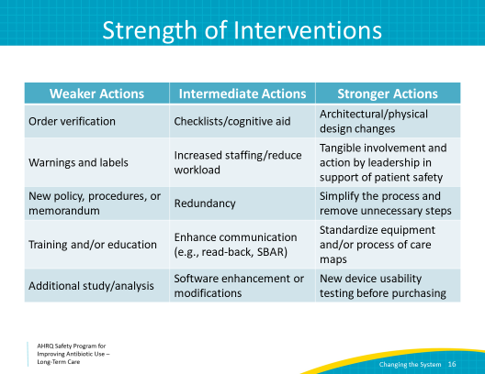
How Do You Know the Risk Was Reduced?  SAY:  Finally, how do we know that the risk was reduced?  In order to know if risks were reduced, you should gather baseline data or observations before you intervene, as we discuss in the “Developing an Antibiotic Stewardship Program” presentation. This will help you evaluate your results. It’s important to use the same measurement strategy in the before and after period.  For example, you can obtain baseline data regarding number of adverse events related to antibiotic use in the facility. Then compare this to the number of adverse events after your intervention to determine if the intervention helped to reduce unwanted outcomes.  You can also ask a few questions to determine if the risk was reduced.  - First, did you create a new policy or procedure? For example, you may have implemented a policy for a 48-hour "time out" to encourage the staff to continuously review the need for antibiotics. If a new policy is created, it is particularly important to ensure that the staff is aware of the new policy.  - Next, if the staff knows about the policy, are they using it and, if so, are they using it as intended? For example, are staff using the time out to review residents’ symptoms and look up the results of diagnostic tests, or are they simply checking a box stating they reviewed antibiotic doses and durations?  - You may have to use observations or audits to analyze whether the staff is following a new policy.  - Finally, find out if staff members believe that the policy or change is effective at reducing risks. Did the change make things safer for residents? Has the policy led to unintended consequences? For example, if the results of diagnostic tests are not available when the time out is performed at around 48 hours, has that led to staff forgetting to continue to look for and respond to those results? | Slide 17  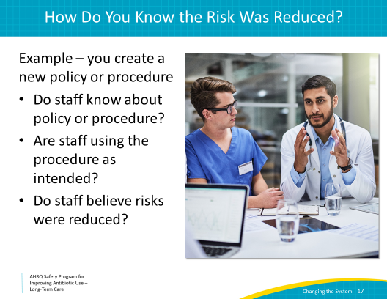
Review  SAY:  Let’s review some steps in using problems as opportunities to make the system better, with the end goal of improving antibiotic prescribing.  First, identify a problem. This can come from a near-miss or sentinel event, as in the case described in this presentation. The problem may also be something that frontline staff members notice as a potential problem or workaround they have to do in order to prevent harm related to antibiotics.  Second, it is helpful to apply the Four Moments of Antibiotic Decision Making in order to identify potential harms all along the prescribing pathway. As you have seen in some of the cases we have discussed, there can be many potential harms along the pathway. Without considering the decisions in a stepwise process, some important factors may be missed.  Third, think about using the problem as an opportunity to improve antibiotic prescribing.  We learned about latent failures, which are problems in the system. We also discussed active failures which are human errors. Does the problem you are addressing involve latent failures, active failures, or both?  Imagine what changes you can make to the system which may protect against human error. Based on this, you can form an intervention. Try to choose stronger interventions, like standardizing equipment or care processes, if possible.  Next, obtain baseline data and test your intervention.  Most importantly, don’t forget to disseminate your findings to staff and stakeholders. Change cannot occur if the workforce is not aware and engaged, so share the results from your hard work with everyone. | Slide 18  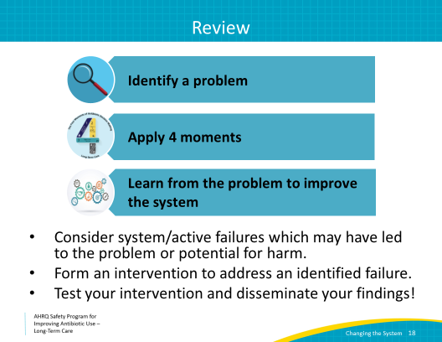
Activities To Complete  SAY:  These are activities you may want to pair with this presentation. These are intended to help your team stay on track with the Safety Program.  Your team may want to focus on opportunities to improve antibiotic use in your facility. Each team should complete a Staff Safety Assessment form. Also, review the Staff Safety Assessment and identify common themes, problems, or ideas to work on. Hang on to the completed forms as they may help your team identify another intervention down the road. Use the Learning From Antibiotic-Associated Adverse Events form to develop a plan.  If you have not already done so, introduce the frontline staff to the Four Moments of Antibiotic Decision Making Form. Ask them to complete 5–10 forms each month. Similar to monthly data collection by members of the Antibiotic Stewardship Team, these are meant to completed on an ongoing basis.  Supporting materials for the activities are listed on the slide and are available in the toolkit. | Slide 19  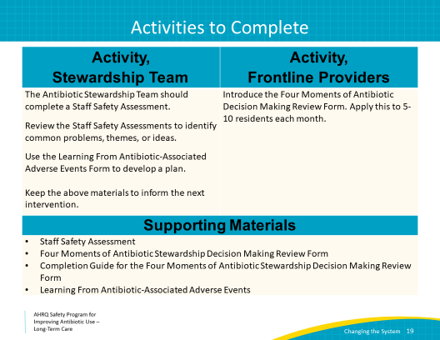
Disclaimer  SAY:  The findings and recommendations in this presentation are those of the authors, who are responsible for its content, and do not necessarily represent the views of AHRQ. No statement in this presentation should be construed as an official position of AHRQ or of the U.S. Department of Health and Human Services.  Any practice described in this presentation must be applied by health care practitioners in accordance with professional judgment and standards of care in regard to the unique circumstances that may apply in each situation they encounter. These practices are offered as helpful options for consideration by health care practitioners, not as guidelines. | Slide 20  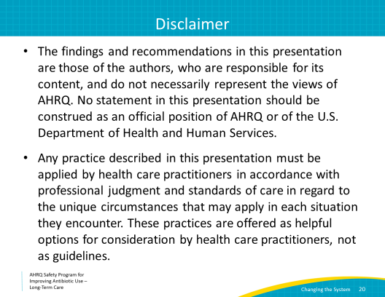
Slide 21
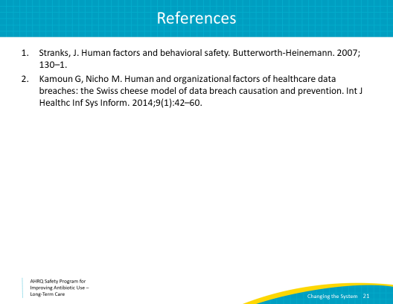

AHRQ Pub. No. 17(21)-0029
June 2021

