Discussing Infection Concerns About Residents With Family Members and Caregivers
Long-Term Care
Long-Term Care
Slide Title and Commentary | Slide Number and Slide
Discussing Infectious Concerns About Residents With Family Members and Caregivers  Long-Term Care  SAY:  Welcome to this presentation, titled “Discussing Infectious Concerns About Residents With Family Members and Caregivers.” | Slide 1
Objectives  SAY:  In this presentation, we are going to discuss some scenarios that may occur when talking with residents and their family members about concerns related to infections.  Although antibiotics are necessary to treat many bacterial infections, antibiotics can also be associated with harm. We will review strategies to discuss the potential harms of antibiotic use with family members. Then, we will address end-of-life care as it relates to antibiotic use.  Finally, we will discuss approaches to providing supportive and comfort care measures for residents who are uncomfortable. These measures do not always involve antibiotics.  We hope to give you some options for a practical dialogue you can use when family members request antibiotics that may not be indicated. | Slide 2  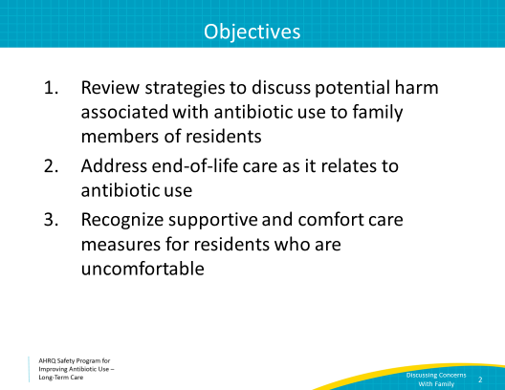
Social Pressure Can Drive Antibiotic Prescribing  SAY:  Social pressure can drive antibiotic prescribing.  Research shows that family pressure to prescribe antibiotics is common in long-term care, and this often drives unnecessary prescriptions.  Family members are concerned about their loved ones. They have likely been told at some point that an infection—most often a urinary tract infection or UTI—is a common cause of mental status changes. A variety of other factors are more common causes of changes in mental status in the elderly, including pain, constipation, and even a poor night’s sleep. Unfortunately, people outside of health care may not understand this and it is important for the health care team to share this information with them.  Education and involvement of family members in the care plan can reduce social pressure to prescribe antibiotics. | Slide 3  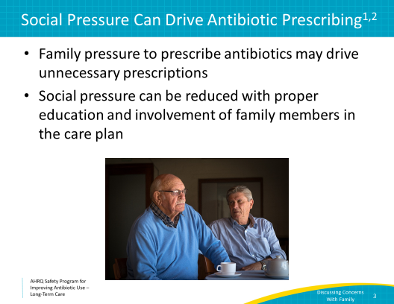
Pressure To Prescribe  SAY:  Consider the following quotes. These are excerpts from a 2014 study that conducted interviews with physicians working in long-term care facilities.  One doctor said: “… if [the family] insists, then we should [prescribe antibiotics] because I don’t know the man. So, it’s difficult to predict. I think it won’t make much of a difference, but still, if the family really insists, then I am quite willing to prescribe [antibiotics].”  Another doctor said: “… I just happened to have had some patients recently of whom I thought in retrospect I just shouldn’t have [prescribed antibiotics]. But sometimes you do it for the family. […] In the past I used to be more principled about this, I would say, look, you shouldn’t do this, and now I think, well, it’s a process for them, too… [so] … if they can’t go along with that yet then I don’t push harder.”  Can you relate to quotes like this? Consider how practices may change if a small amount of time is dedicated towards having an open discussion with family members about these issues. | Slide 4
Case 1: Ms. Alvarez  SAY:  Let’s jump right into a case.  You are approached by the daughter of Maria Alvarez, a long-term care resident with a history of Parkinson’s disease and dementia.  Maria refused breakfast and seems less “vibrant” than she usually is. She also keeps talking about her husband, who passed away several years ago.  Maria’s daughter says that the last time this happened, her mother was diagnosed with a urinary tract infection or UTI, and she requests that a urine culture be obtained. | Slide 5  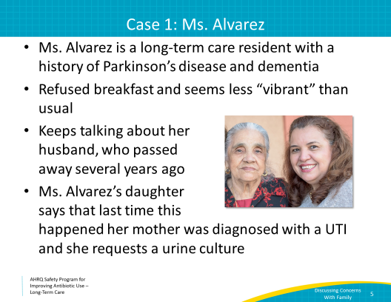
Case 1: Ms. Alvarez, Continued  SAY:  When you evaluate Ms. Alvarez you find that:  - She is sitting in a chair looking out the window.  - Her vital signs are all within the normal range.  - She does not have a Foley catheter and denies any pain, and her examination is normal.  - She does not verbalize any symptoms.  - She tells you she did not eat breakfast because she is waiting for her husband to join her.  Your assessment is that Ms. Alvarez is clinically stable, and she is a bit more confused than baseline. While she does have baseline dementia, she doesn’t usually talk about her husband, so this new behavior may represent a clinical change for her. It may also be a progression of her dementia. | Slide 6  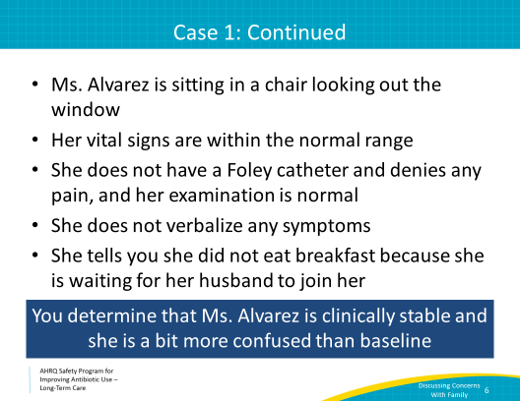
Effective Communication  SAY:  Let’s circle back and communicate with the daughter.  First, in addition to your assessment, communicate to the daughter that you have listened to her concerns: “I agree that she seems a bit more confused.”  Now, let’s address those concerns. Start with empathy and understanding. Then explain your plan and reasons for that plan. Finally, offer solutions and reassurance. | Slide 7  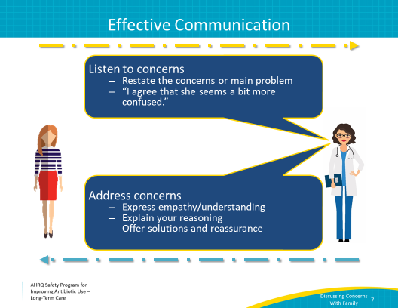
Empathy & Understanding  SAY:  The daughter’s main concern is that her mother is more confused this morning. Try to empathize and understand that concern. You might say: “It must be hard to see your mom like this. She must be very different from the person you knew even just a year ago.”  Remember that while family members may have a lot of requests, and this can sometimes be difficult, it is usually because they are worried or concerned about someone they love. They may be grieving the loss of the mother or significant other they’ve known and who is now harder to recognize because of dementia. There are likely other strong emotions at play, like fear, anger, and guilt. Sometimes, family members just want something to be done in hopes of making their loved one better—which may not be realistic. Some may ask for specifics that may not be indicated, such as urine cultures, chest x rays, or antibiotics. You can offer them other options such as hydration, nutrition, and reorientation. These are tasks that family members can also participate in, which may help them regain a sense of control. | Slide 8  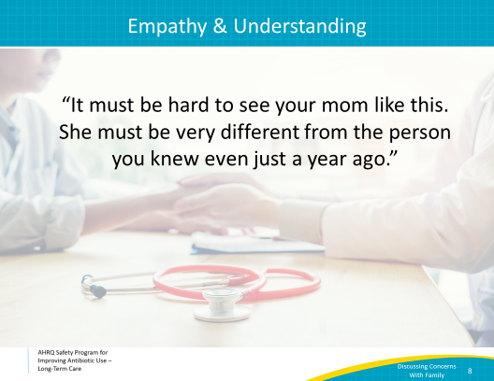
Explain Your Reasoning  SAY:  Next, explain your plan and the clinical reasoning behind a decision to consider antibiotics only when necessary.  There are several options to try. Let’s go through several of them because we expect you’ll have many chances to use these in real life:  “Physically, your mom looks OK. She does not have a fever, and her assessment is normal. I understand you are concerned, but she does not have signs or symptoms of an infection right now. There are lots of reasons why she might be more confused today. Research from the last few years tells us that UTIs are not really a common reason for confusion. Sometimes a bad night’s sleep or a change in medication can make someone confused. Sometimes even just a little dehydration can affect an older adult.” | Slide 9  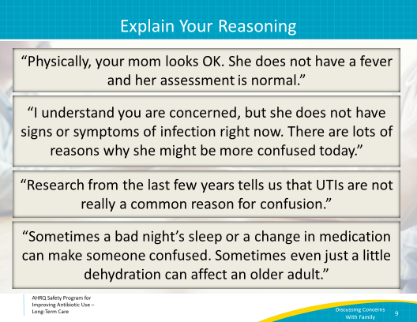
Explain Your Reasoning, Continued  SAY:  You might also explain the difficulties with collecting a good urine sample. “It’s really hard to get a clean urine sample. Often, when the culture comes back looking positive it’s because of contamination. To get a really good sample, we may have to do an in-and-out catheterization—which is pretty uncomfortable, and I don’t think the pain she will feel is worth it when the suspicion for a UTI is very low.”  Or, you can address the downsides of getting a urine culture: “Getting a urine culture, which is likely to be contaminated, could lead to treating her for an infection she does not have. She might be better tomorrow, but when the urine culture comes back, if it has bacteria in it, sometimes prescribers will feel obligated to start antibiotics, even though she’s not sick. This could lead to her getting a medicine she does not need—which may cause harm.” | Slide 10  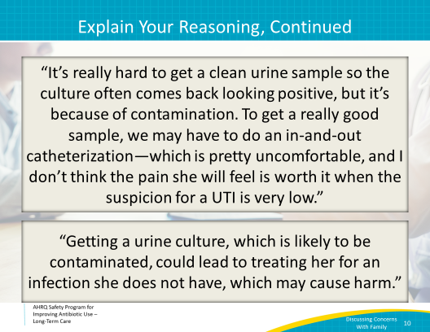
Explain Your Reasoning, Continued  SAY:  Or you can talk about the risks of antibiotics in general: “Antibiotics are pretty strong medications, and we want to use them only when we know they are necessary. They can have significant side effects, including allergic reactions, diarrhea, or other gastrointestinal upset. Sometimes they cause people to get a type of diarrhea called Clostridioides difficile or C. diff. A C. diff infection requires even more antibiotics and could make your mom really ill. Also, exposure to antibiotics puts your mom at risk for developing future infections with resistant bacteria, which could make future antibiotics less effective for her.”  If family members recognize that you also want to protect their loved one, they may be less likely to pressure you about antibiotics because they are reassured that you are on their side and are also concerned. | Slide 11
Offer Solutions  SAY:  Finally, let’s offer some things to try to solve the problem. This includes a plan of care from the health care team. We’ve talked about active monitoring before. As a quick reminder, active monitoring is often a great way to avoid unnecessary antibiotic starts in residents with no clear evidence of infection. Most residents will improve with supportive care alone. A plan for active monitoring should address the family’s concerns, and it ensures that you do not miss a potential clinical decline.  Let’s tell the family about our plan for active monitoring:  “We will watch her closely over the next 24 hours and check her vital signs on a regular basis.”  “It is possible that she is dehydrated or did not get enough sleep last night. I think we should try and make sure she drinks enough fluid and continue to reorient her.  You also engage the family members: “If you’re going to be here for a while, maybe you can encourage her to keep drinking some water or juice.”  And end with reassurance that you’ll be responsive if there are changes that suggest a more serious clinical concern. Tell the family, “If she does not get better in the next day or two, or looks worse before that, we’ll talk again and see what else we can try.” | Slide 12  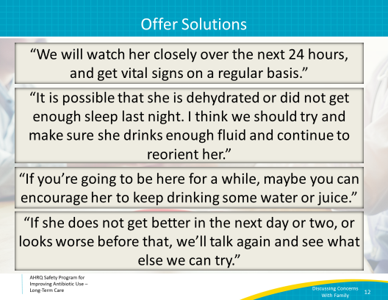
Offer Solutions  SAY:  Delirium pocket cards (4x6 and 8x11) are found on the “Best Practices Pocket Cards & Posters” page of the AHRQ Safety Program toolkit Web site.  These cards help the family and nursing staff identify delirium and understand some common causes of delirium symptoms. Notice that there are a variety of causes not related to infection.  These cards also provide some supportive interventions that allow nursing and family members to proactively prevent and treat delirium. These interventions should be attempted before starting antibiotics if there is no evidence of a bacterial infection.  These cards offer tasks that family members can do to help someone with delirium. | Slide 13  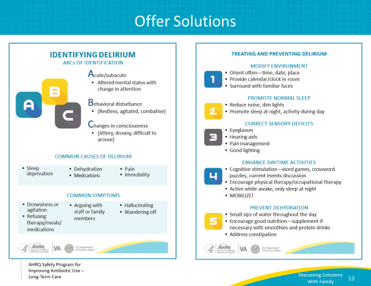
Success!  SAY:  Thanks to your excellent communication skills, Ms. Alvarez’s daughter agrees to the plan for active monitoring and helps encourage her to drink some juice and then eat lunch.  The next morning, Ms. Alvarez seems back to her baseline, and her daughter is relieved.  She understands why you made the decision you did. She decides that in the future, she will not immediately ask for antibiotics every time her mom has a change in mental status and will work with her health care providers to try some other interventions first. | Slide 14  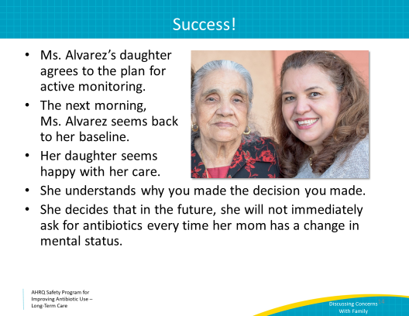
End-of-Life Care  SAY:  Let’s shift gears now and discuss end-of-life care.  Antibiotics are often prescribed to people who are dying, even when they don’t have signs or symptoms of a bacterial infection.  Studies have shown that 42 percent of nursing home residents with advanced dementia are prescribed antibiotics during their last 2 weeks of life. Twenty-five percent of hospice patients receive antibiotics during their final weeks of life. | Slide 15  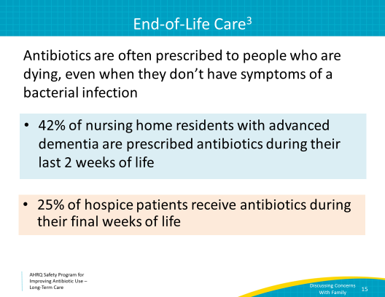
End-of-Life Care  SAY:  The decision to start antibiotics in someone who is approaching the end of life may be associated with harm. These include the potential for rehospitalization and invasive diagnostic testing or procedures such as blood draws, catheter insertion, or the need for intravenous or IV access. Also, like all medications, antibiotics have potential side effects, including rashes, GI symptoms, or even C. difficile infections.  The risks of antibiotic use may not align with residents who have expressed their wishes for comfort as the main goal of their end-of-life care.  Also, as we’ve discussed before, antibiotic exposure increases the risk of a resident acquiring a drug-resistant organism that causes future infections that are increasingly difficult to treat with antibiotics. Even if a drug-resistant bacteria does not make the resident sick, it might mean the resident has to be on contact precautions, which is disheartening to residents and caregivers alike. Reducing inappropriate or unnecessary antibiotic use helps reduce the prevalence of resistant organisms. | Slide 16  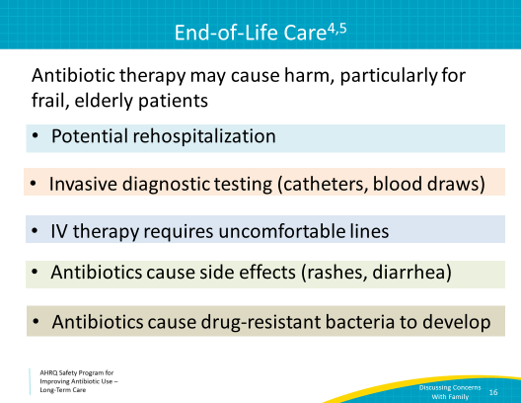
Case 2: Ms. Jones  SAY:  Let’s walk through one more case.  Hannah Jones is a 72-year-old woman who was recently transferred to your facility for hospice care for stage 4 metastatic lung cancer. She has brain metastases and has a limited capacity to make medical decisions.  Over the last several months of her illness, she made it clear to her family and health care team that her goal was to die comfortably, and her family was in agreement with these wishes.  A few days after she is transferred, she develops a productive cough. | Slide 17  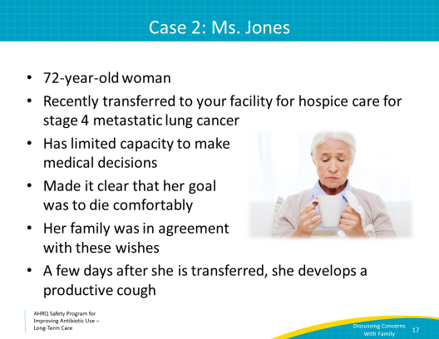
Case 2: Ms. Jones, Continued  SAY:  You are approached by her husband.  He says: “I think she has pneumonia; she’s been coughing like crazy. We better start her on antibiotics.”  You go in to evaluate Ms. Jones. She has a productive cough and crackles at the base of her left lung. She is lying in bed breathing comfortably on 2 liters of oxygen per minute by nasal cannula, which has been her baseline for the last month.  She does not have a fever, and her pulse oximetry is 99 percent. She does not have increased oxygen requirements. | Slide 18  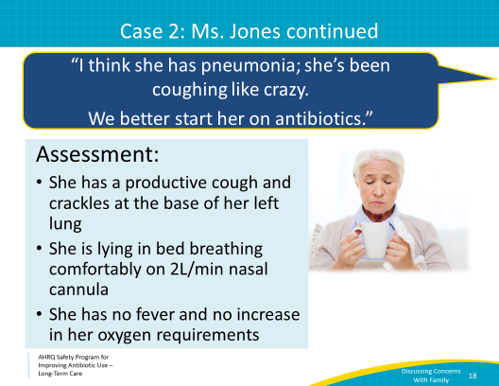
Case 2: Support and Comfort  SAY:  Before leaving the room, you offer her comfort and support, and other supportive measures including:  - Humidified oxygen  - Giving her the option of getting oxygen through a mask because it’s hard to inhale through her nose when coughing  - Tissues and a cup at her bedside to spit into  - Additional pillows, including one to hug while she’s coughing because she complained of being sore from coughing so much  - Refilling her water pitcher  - Lozenges  - Cough suppressants | Slide 19  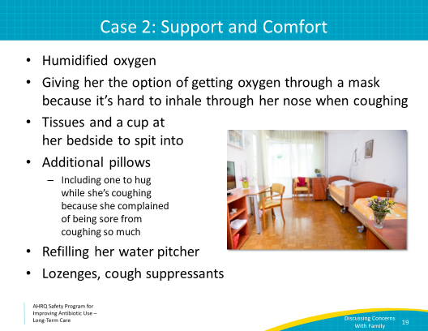
Case 2: Ms. Jones, Continued  SAY:  You also review her advance directive. She is “Do Not Resuscitate/Do Not Intubate” (DNR/DNI) and has requested no life prolonging interventions.  Her goal is comfort care.  You discuss this with her husband and state: “I understand that you are concerned about your wife. I think we should set up a time to review her advance directives and your goals for her care.”  Defining goals of care should happen before emergent situations come up. In this situation, it is appropriate to sit down and have a family meeting.  While she does not clinically appear to have pneumonia at this time, Ms. Jones is likely to develop pneumonia given her underlying disease, and the progression of her disease may also look like pneumonia, making it hard to tell the difference. Understanding her expressed wishes prior to exposing her to potential discomfort is important. | Slide 20  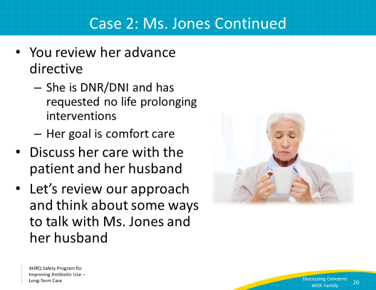
Effective Communication  SAY:  Let’s go over our elements for effective communication.  First, communicate to the husband that you have listened to his concerns: “I understand why you are concerned about this cough. I hear it, and it sounds pretty rough.”  Now, let’s address those concerns. You’ve already done a lot by providing comfort measures. Let’s continue with some empathy and understanding. Then explain your plan and reasons for that plan. Finally, offer solutions and reassurance, which may have to include revisiting the goals of care with the husband and other family members. | Slide 21  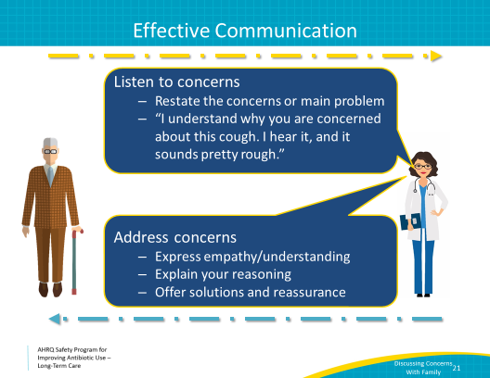
Empathy & Understanding  SAY:  We’ll start with some empathy and understanding. There are some types of statements to try:  - “This must be so hard for you, to see her suffer with such a terrible disease.”  - “We expect her to have a cough as the lung cancer progresses.”  - “It is possible that your wife may develop pneumonia; this is a common infection at the end of life, especially with her underlying disease.” | Slide 22  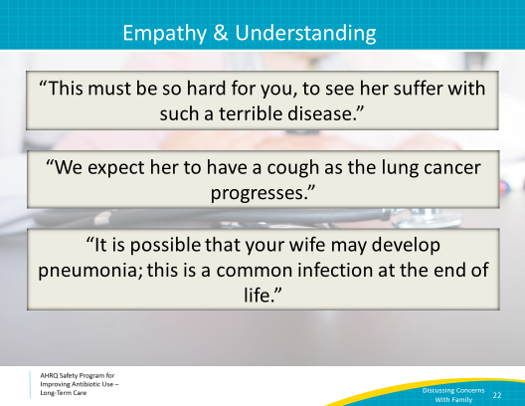
Reasoning  SAY:  Next, let’s talk about reasons why antibiotics might not be started in a terminally ill woman.  Inform the family that infections are expected at the end of life, and may often be the terminal event. You might say, “People in hospice care often die from infections. What we understand is that attempting to treat these infections does not change the overall situation and sometimes actually decreases their level of comfort.”  Even if an infection is treated, the terminal illness will remain. You could try using words to the effect of, “Even if we treat her for pneumonia, it won’t make her any better than she was a day or two ago.”  Explain what evaluation and treatment of an infection may entail. You might mention that aggressively treating potential infections at the end of life may require rehospitalization and could result in distress and discomfort for their loved one. Even if oral antibiotics can be given in the facility, they can result in significant side effects, such as diarrhea, rash, or kidney failure, and these side effects should be considered if comfort is the main priority. | Slide 23  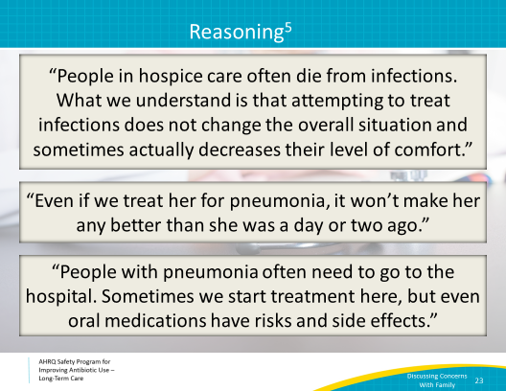
Solutions and Reassurance  SAY:  It is helpful to provide alternative palliative or comfort measures to help to provide symptomatic relief, and keep the resident’s comfort at the end of life at the forefront of treatment goals when this is the expressed goal of the patient.  In this case, you can try to help make her coughing more effective by providing good respiratory therapy options. “We can try to make her more comfortable by making it easier to cough phlegm out of her lungs. We can give her humidified oxygen and nebulizer treatments. There are also over the counter medications that help.”  You can also work with the health care team to offer cough suppressing medications. You might tell them, “Some medications, like codeine or morphine, will help suppress the cough reflex, which means she can get some rest. They also cause sedation and will make it easier for her to be comfortable.” | Slide 24  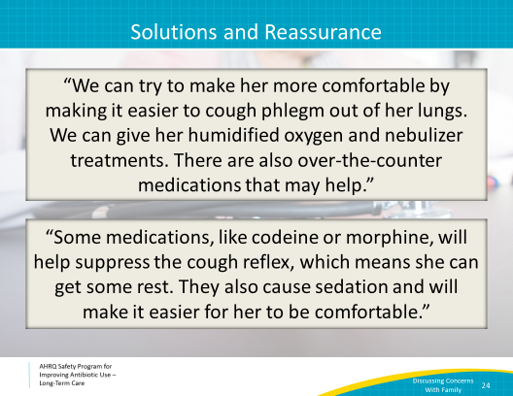
Family Meetings Regarding End-of-Life Care  SAY:  It’s very important to have a family meeting to discuss and establish resident and family goals of care. Depending on the situation, this may need to happen more than once.  If the main goal is life prolongation rather than comfort, then antibiotics could be indicated if there is evidence of infection. If the resident’s expressed main goal is comfort, consider not starting antibiotics as they may prolong suffering or lead to additional adverse events. Medications for pain and other symptoms caused by pneumonia can be used to improve comfort. The possibility of an itchy, painful rash, or cramping and frequent diarrhea from C. difficile would be very uncomfortable at the end of life.  Finally, reassure the resident and family that you will continue to provide symptomatic relief, and keep the resident’s comfort at the end of life at the forefront of treatment goals.  These can be emotionally difficult conversations to have. While you may have experience with caring for someone at the end of life, this is a new and frightening experience for most residents and family members. Sometimes they want some measure of control over tragic life events. Acknowledging these struggles may help some residents and families find some measure of peace.  Keep in mind that the risk and benefit balance at the end of life of all medical treatments, including antibiotics, differs for each patient. This balance and the decisions around it may need to be revisited over time as a patient’s needs and wishes change. | Slide 25  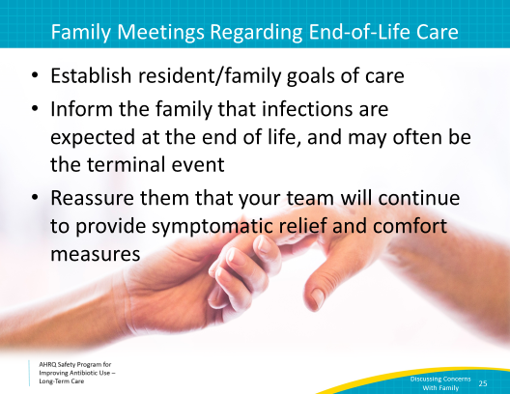
Key Points  SAY:  We have now completed the Communicating Infection Concerns About Residents With Family Members and Caregivers presentation. Some key points include:  Effective communication is a key component to ensure resident safety and family satisfaction with care.  Educating residents and family members about the risks of antibiotic treatment is recommended prior to prescribing antibiotics.  Goals of care, especially for the end of life, should be established early on in the treatment plan. | Slide 26  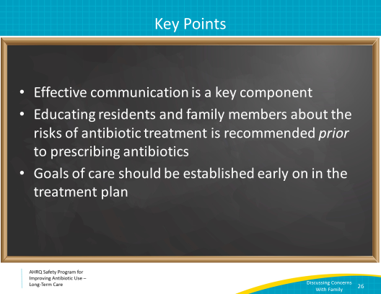
Narrated Presentation  SAY:  There is a narrated presentation in the Safety Program toolkit for your viewing. It covers the material for Discussing Infectious Concerns About Residents With Family Members and Caregivers. This video can be used to train or orient staff in your facility. | Slide 27  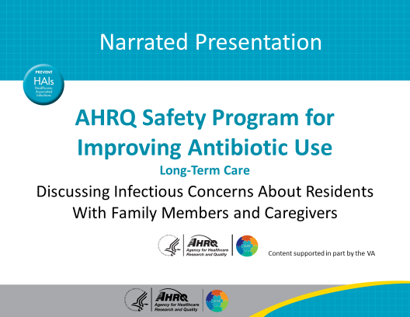
Activities To Complete  SAY:  These are the activities that you may want to work on that align with the concepts described in this presentation.  Frontline staff can review the poster titled Talking With Residents and Family Members About Antibiotics. You can display that poster in common areas as well.  The Antibiotic Stewardship Team can collect or continue to collect and analyze data using the Monthly Data Collection Form, and frontline staff should continue to apply the Four Moments of Antibiotic Decision Making Form to 5–10 residents each month.  Other supporting materials for the activities are listed on the slide and are available on the project Web site. | Slide 28  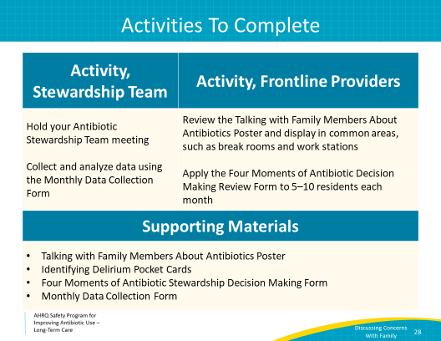
Disclaimer  SAY:  The findings and recommendations in this presentation are those of the authors, who are responsible for its content, and do not necessarily represent the views of AHRQ. No statement in this presentation should be construed as an official position of AHRQ or of the U.S. Department of Health and Human Services.  Any practice described in this presentation must be applied by health care practitioners in accordance with professional judgment and standards of care in regard to the unique circumstances that may apply in each situation they encounter. These practices are offered as helpful options for consideration by health care practitioners, not as guidelines. | Slide 29  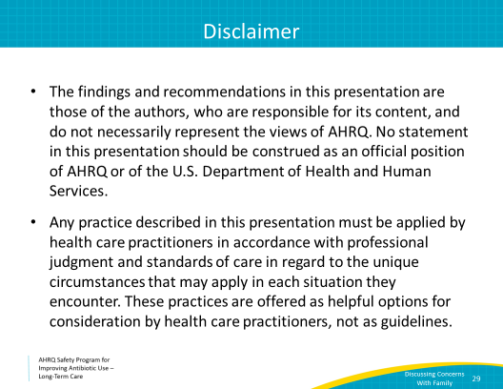
References  SAY:  Here are the references. | Slide 30  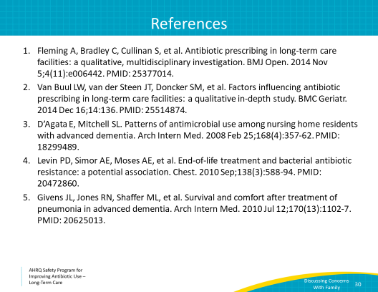

AHRQ Pub. No. 17(21)-0029
June 2021

