Management of a Resident With a Suspected Respiratory Tract Infection
Long-Term Care
Slide Title and Commentary | Slide Number and Slide
Management of a Resident With a Suspected Respiratory Tract Infection  Long-Term Care  SAY:  Welcome to this presentation, titled “Management of a Resident With a Suspected Respiratory Tract Infection.” | Slide 1  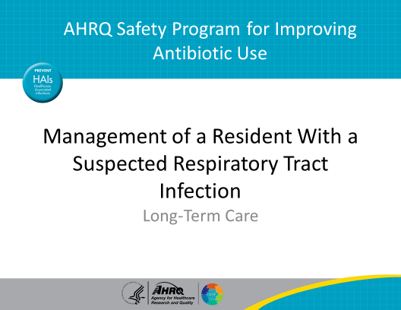
Objectives  SAY:  There are three main objectives of this presentation.  The first is to understand the diagnostic and treatment approach to pneumonia in residents of long-term care settings.  This includes residents with pneumonia likely caused from common community pathogens like Streptococcus pneumoniae as well as residents who are at higher risk for infection with organisms such as Pseudomonas aeruginosa.  The second objective is to discuss opportunities to de-escalate antibiotic therapy using the results of diagnostic tests.  Finally, appropriate durations of antibiotic therapy for long-term care residents with pneumonia will also be reviewed. | Slide 2  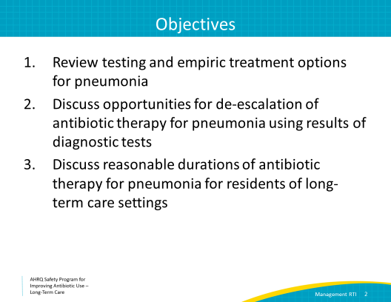
Risk Stratification  SAY:  Residents with suspected bacterial pneumonia who are generally in good health and have not been hospitalized or needed broad-spectrum antibiotic therapy in the previous 90 days are usually infected with bacteria such as Strep pneumoniae or Haemophilus influenzae. These are bacteria commonly known to cause community-acquired pneumonia in otherwise healthy adults.  Residents who meet any of the following criteria are at risk of pneumonia with more resistant bacteria such as Pseudomonas aeruginosa: (1) recent hospitalization or exposure to broad-spectrum antibiotics, (2) previous growth of Pseudomonas, (3) bronchiectasis or tracheostomy dependency, or (4) immunocompromise. Treatment considerations for both types of residents will be discussed in this presentation. | Slide 3  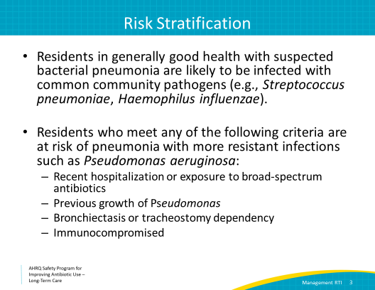
Case 1: Mary  SAY:  Let’s discuss a clinical case.  Mary is a 90-year-old resident with mild dementia. She recently was treated for a suspected urinary tract infection with a 5-day course of nitrofurantoin.  She is typically active and functional in her activities of daily living, and she has never had a problem with swallowing or aspiration events.  Her nurse notices that she has developed a cough and her temperature is 99.2 degrees Fahrenheit. | Slide 4  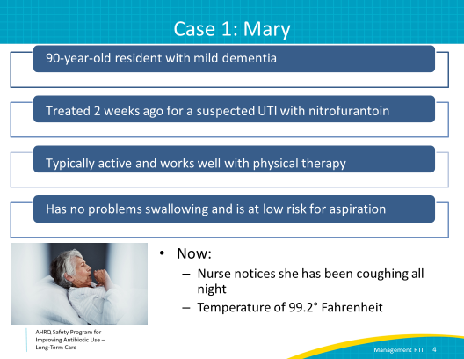
Case 1: Diagnostic Evaluation  SAY:  Mary’s nurse obtains vital signs, assesses her, and then notifies her health care practitioner about her condition.  The nurse reports that Mary has an elevated temperature at 99.2 degrees Fahrenheit, her heart rate is 98 beats per minute, and her respiratory rate is elevated at 22 breaths per minute. Her oxygen saturation is 95 percent on room air. She has a few crackles at the base of her left lung.  The team decides to obtain some laboratory tests and a chest x ray. Mary has an elevated white blood cell count and her chest x ray shows an infiltrate in the left lower lobe. | Slide 5  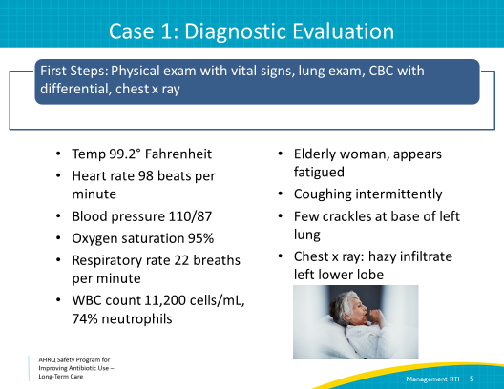
The Four Moments of Antibiotic Decision Making  SAY:  Let’s review our Four Moments of antibiotic decision making.  The first moment is to consider whether the resident is likely to have a bacterial infection that requires antibiotics.  Mary has an elevated temperature, a new cough, an increased respiratory rate, slightly decreased oxygenation, leukocytosis, and an infiltrate on her chest x ray. She has had no witnessed aspiration event and is at low risk for aspiration. | Slide 6  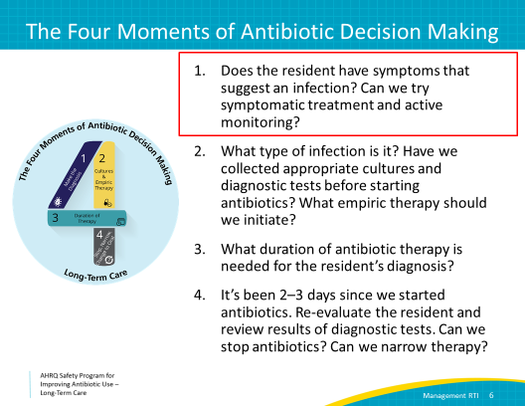
Bronchitis Versus Pneumonia  SAY:  It can sometimes be difficult to differentiate between bronchitis and pneumonia, but making this distinction is important because bronchitis rarely warrants antibiotic therapy, while pneumonia generally does warrant antibiotic therapy.  Bronchitis is generally viral in nature. A cough is usually present. Fevers may or may not be present, and if a chest x ray is obtained, a new infiltrate is unlikely.  Residents with bacterial pneumonia will have evidence of an infiltrate on their chest x ray and typically have an elevated white blood cell count.  Now let’s consider Mary’s case. She has a cough, elevated temperature, sputum production, leukocytosis, and a new infiltrate on her chest x ray. This sounds like bacterial pneumonia, and it is reasonable to treat her with antibiotics in addition to supportive care. As we discussed previously, if Mary’s illness is occurring during respiratory virus season, respiratory viruses also should be considered as a cause of her symptoms. | Slide 7  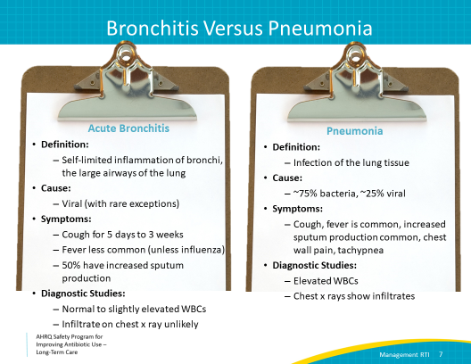
The Four Moments of Antibiotic Decision Making  SAY:  Now that we have determined that Mary likely has an infection that requires antibiotics, let’s consider our second moment of antibiotic decision making.  Have we ordered appropriate diagnostic tests, and what empiric therapy should we initiate while waiting for diagnostic tests to return? | Slide 8  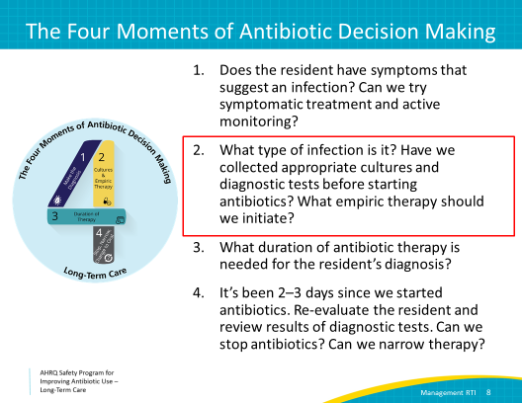
Diagnostic Tests  SAY:  Several diagnostic tests should be considered as part of the evaluation of residents in whom we suspect a respiratory tract infection.  All facilities should have influenza testing available. This may be a stand-alone test or part of a respiratory viral panel. Influenza testing should be performed on all residents with a cough and fever during influenza season, which usually starts in October and goes through March. A respiratory viral panel, if available, can also identify other respiratory viruses that can mimic bacterial pneumonia. Facilities also should test for the 2019 coronavirus infection or COVID-19 as appropriate for residents with new-onset respiratory symptoms.  A Gram stain and sputum culture can help determine which bacterial pathogen might be causing pneumonia and can provide antibiotic susceptibility data.  Encourage the resident to cough up deep sputum from their lungs, rather than spitting into a cup, to increase the likelihood of recovering a bacterial organism, if bacterial pneumonia is present. A negative sputum culture does not exclude the possibility of pneumonia.  Blood cultures are recommended for residents with persistent fevers or those who are ill appearing but otherwise are not routinely indicated. | Slide 9  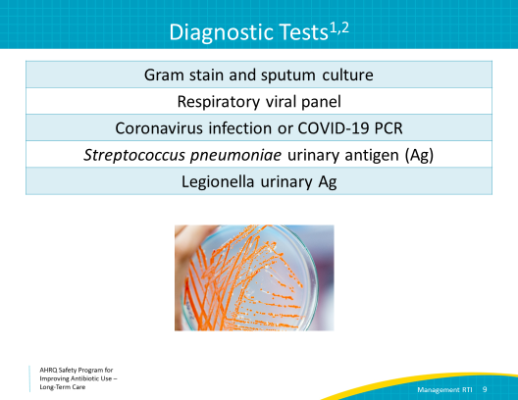
Urinary Antigen Tests  SAY:  Two different urinary antigen tests, which both have relatively rapid turnaround times, can be helpful in guiding therapy. These urinary antigen tests are not always available in the long-term care setting.  The pneumococcal urinary antigen test evaluates specifically for the organism that is the most common cause of community-acquired pneumonia, Strep pneumoniae. If the urinary antigen is positive for Strep pneumoniae, antibiotic therapy can be narrowed to amoxicillin.  The second test is the Legionella urinary antigen test.  Legionella can cause severe disease in the elderly and can cause outbreaks in nursing homes. It can be treated with azithromycin. It is also covered by quinolones if they are being used for other reasons. | Slide 10  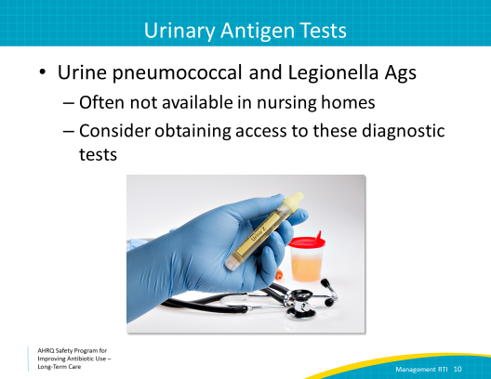
Treatment: Low Risk for a Resistant Organism  SAY:  Mary most likely has pneumonia caused by common community pathogens, as she does not have any of the risk factors previously discussed that increase the likelihood of infections caused by more resistant bacteria.  For residents at risk for pneumonia caused by community-associated organisms such as S. pneumoniae or H. influenzae, consider initial treatment with amoxicillin-clavulanate. Alternatives include oral second- and third-generation cephalosporins if there is an intolerance or a nonsevere allergy to amoxicillin-clavulanate.  Azithromycin or doxycycline should be added to these beta-lactam agents to provide coverage for atypical bacteria. Azithromycin has been associated with prolonged QTc intervals and should be avoided in patients with underlying cardiac disease.  For residents who cannot take oral therapy, consider ampicillin-sulbactam or ceftriaxone. Azithromycin or doxycycline also should be added to these agents.  If the resident has a severe penicillin allergy, consider a respiratory fluoroquinolone such as moxifloxacin or levofloxacin. Because fluoroquinolones pose a high risk of C. difficile infection and are associated with several other toxicities, fluoroquinolones should be used only for residents with severe penicillin allergies. If a respiratory fluoroquinolone is used, azithromycin or doxycycline do not need to be added.  Remember that many people with penicillin allergies—especially if they never had difficulty breathing or hives from penicillin antibiotics before—can tolerate cephalosporins and can receive ceftriaxone. It’s helpful to determine if a penicillin-allergic resident has tolerated a cephalosporin in the past. | Slide 11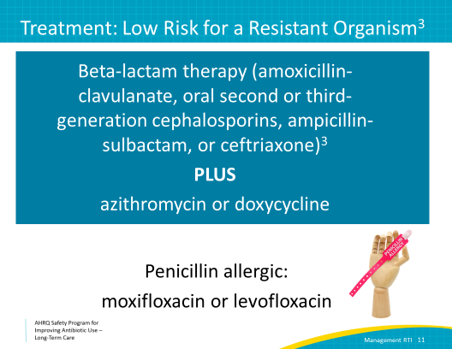
Narrated Presentation  SAY:  A narrated presentation is available in the toolkit titled “Approaching the Resident With a Penicillin Allergy.” This presentation provides guidance on managing residents with reported penicillin allergies. | Slide 12  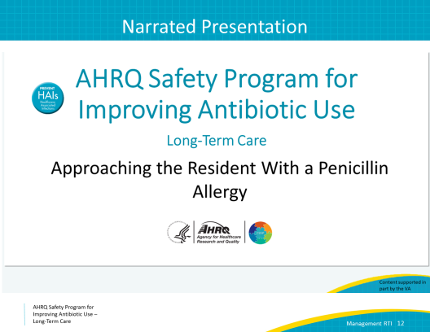
Treatment: At Risk for a Resistant Organism  If Mary had underlying bronchiectasis or was recently admitted to a skilled nursing facility, her pneumonia might be caused by more resistant bacteria, and an anti-pseudomonal agent such as cefepime should be used, in addition to azithromycin. If she recently recovered from influenza or has a necrotizing pneumonia (or if she has other risk factors), consider the addition of vancomycin or linezolid to provide coverage against methicillin-resistant Staphylococcus aureus or MRSA. | Slide 13  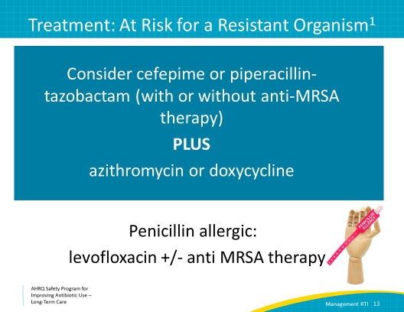
Case 1: Mary  SAY:  Let’s get back to our case. When the health care practitioner on call overnight hears about Mary’s suspected pneumonia, he starts her on a 10-day course of levofloxacin, even though she is not allergic to penicillin.  Fortunately, her daytime provider remembered to send a test for influenza as well as urine pneumococcal antigen. | Slide 14  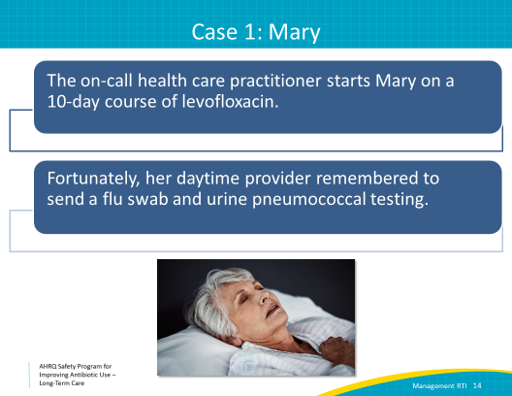
The Four Moments of Antibiotic Decision Making  SAY:  Moment 3 addresses the appropriate duration of antibiotic therapy. | Slide 15  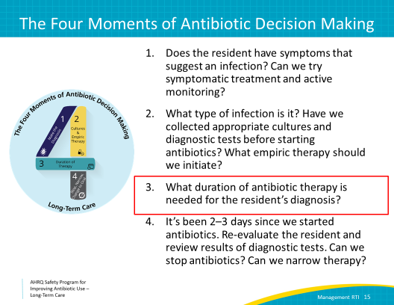
Duration  SAY:  Guidelines recommend using shorter courses of therapy for pneumonia as long as a patient has a clinical response to treatment such as resolution and fever and improvement in shortness of breath. Most residents can be treated for 5 days. Seven days may be needed for residents with a slower clinical response or underlying structural lung disease such as emphysema.  Ten days of antibiotics is likely too long in Mary’s case, especially if she is improving and appears stable within a few days after starting antibiotics.  A lingering cough and chest x ray abnormalities may take several weeks to improve. There is no need to prolong antibiotic therapy or repeat imaging if the resident is otherwise showing improvement, even if there is a lingering cough.  Remember, Mary already received her first dose of levofloxacin, which counts as day 1 of antibiotic therapy. Even if we decide to transition her to another antibiotic, she will only need 4 more days of therapy. | Slide 16
Case 1: Mary  SAY:  The next morning, the daytime provider follows up on Mary’s additional diagnostic tests. Her pneumococcal urinary antigen is positive.  What is the next best step in management?  1. Continuing the previous levofloxacin course is not the best choice. While levofloxacin will likely be effective, it carries many side effects that may be avoided by narrowing her antibiotic therapy.  2. Stop levofloxacin and switch to a beta-lactam antibiotic such as amoxicillin is correct. Amoxicillin provides excellent coverage of Strep pneumoniae, and generally has fewer side effects compared with fluoroquinolones. The vast majority of Strep pneumoniae isolates are susceptible to penicillin. In fact, in 2017, the Centers for Disease Control and Prevention reported that 96 percent of Strep pneumo isolates were susceptible to penicillin.  3. Stopping antibiotics is not correct. Since Mary has a cough, elevated temperature, leukocytosis, and infiltrate on a chest film, her clinical picture suggests a diagnosis of bacterial pneumonia. Further, her positive Streptococcus pneumoniae test indicates the presence of a bacterial pathogen known to cause pneumonia.  4. Transferring Mary to the hospital does not appear necessary at the present time as she is clinically stable. However, she should be monitored closely in case her status changes. | Slide 17  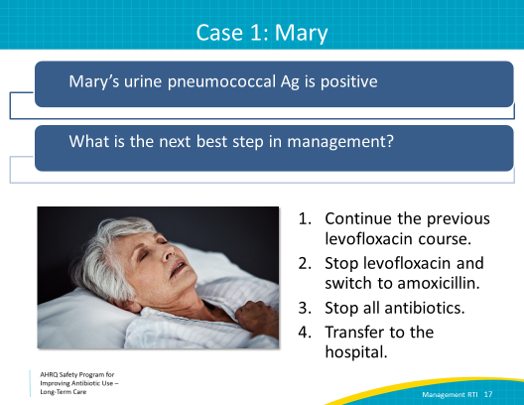
When to Consider Transfer  SAY:  While Mary’s case looked like it could be treated in place at the facility, there are some instances where transfer to a hospital is necessary.  Consider transferring residents to acute care who have not shown any clinical improvement within 24 hours of starting antibiotics. Also, consider transferring residents who are clinically unstable, which includes persistent tachycardia, hypotension, an inability to maintain a stable oxygen saturation, or a generally ill appearance. Always make sure that the decision to transfer a resident to a hospital is consistent with the resident’s expressed goals of care. | Slide 18  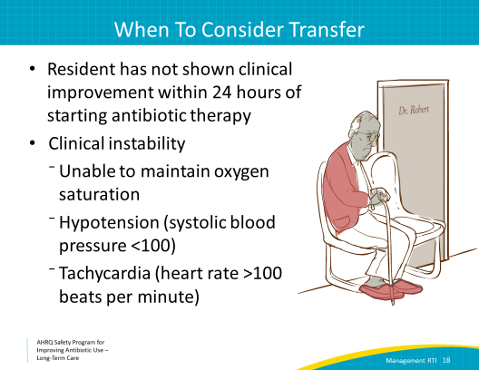
Case 2: Francisco  SAY:  Let’s move on to another case.  Francisco is a 92-year-old male who has been a resident at your facility for more than 10 years.  He has dementia and is bedbound due to a prior stroke and had several infected sacral decubitus ulcers in the past.  One of the nurses noted that when she was feeding him applesauce earlier that day he choked, and he was coughing afterwards.  The evening nurse notes that he is coughing a lot, and his oxygen saturations are in the range of 92 to 94 percent. Usually, he is at least 98 percent on room air. His heart rate is 72 and his blood pressure is 142/82. When he’s put on 2 liters per minute of oxygen by nasal cannula, his oxygen saturation returns to 97 percent. | Slide 19  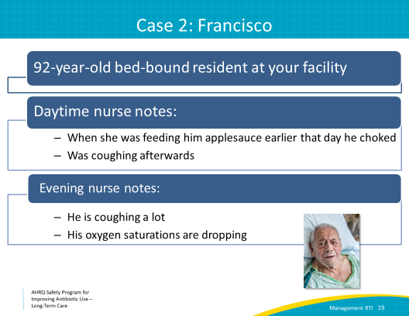
Francisco’s Chest X Ray  SAY:  It is Friday afternoon, and the covering provider orders a chest x ray on Francisco because he knows it will be hard to get one over the weekend should he decline. This generally is not necessary, and continued monitoring would have been adequate, as Francisco is otherwise clinically stable and he had a recent witnessed aspiration event.  Nevertheless, Francisco’s chest x ray shows a new consolidation in the right lower lobe.  This x ray pattern is classic for aspiration pneumonia or pneumonitis. We typically see infiltrates on the right, because the right mainstream bronchus is shorter than the left one with a more direct path to the lungs. If patients are lying flat when they aspirate, the infiltrate is often seen in the right upper lobe.  In general, prophylactic antibiotics should not be started in patients only because aspiration is suspected or witnessed. Prophylactic antibiotics can contribute to the development of antibiotic resistance and C. difficile infection, which can have devastating consequences for residents. | Slide 20  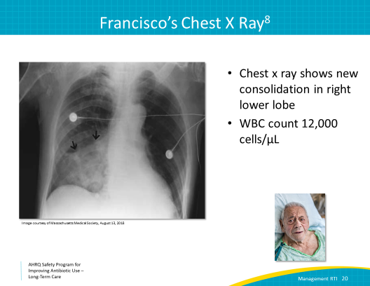
Aspiration Pneumonia Versus Pneumonitis  SAY:  Let’s differentiate aspiration pneumonitis and pneumonia that occurs as a consequence from an aspiration event.  Aspiration pneumonitis occurs from inhaling gastric contents into the lungs, which in turn causes inflammation. The inflammation caused by aspiration can lead to changes on chest films as well as fever and increased white blood cell counts.  Aspiration pneumonitis symptoms should improve within 48 hours without antibiotic therapy. When a resolution in symptoms is not observed in the first 48 hours, this should heighten the concern for the development of pneumonia, and antibiotic therapy is recommended.  Measures should be taken to prevent residents from experiencing aspiration events. Positioning the resident to sit up during meals and working with speech therapy to provide thickened liquids at meals will help reduce the risk of aspiration. | Slide 21  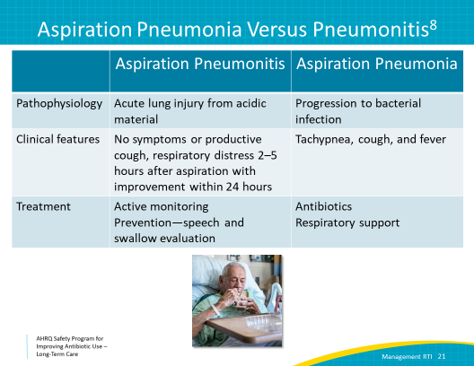
Case 2: Management  SAY:  Based on our review of these syndromes, what should we do next to help manage Francisco?  Should we start levofloxacin? No. As we discussed, starting a resident on antibiotics because of a witnessed aspiration can cause more harm than good.  Should we obtain a sputum culture, urine Legionella antigen, and urine pneumococcal antigen? While these are good tests to consider as part of our diagnostic workup, it is premature in this case as we do not have evidence that Francisco has pneumonia.  Should we transfer Francisco to the emergency department? This is also premature. He is clinically stable and does not appear septic, so we probably do not need to transfer at this time.  That leaves us with number 4, which is the correct answer. We should start active monitoring and also place Francisco on speech and swallow precautions to decrease the likelihood that he develops pneumonia.  Antibiotic therapy should be considered for residents with aspiration pneumonitis who do not have clinical improvement by 48 hours after the aspiration event, as this may suggest the development of pneumonia.  Antibiotics should also be considered for patients before this 48-hour time period who are hemodynamically unstable. This includes residents with tachycardia and/orhypotension, or who are unable to maintain oxygen saturation even with supplemental oxygen. | Slide 22  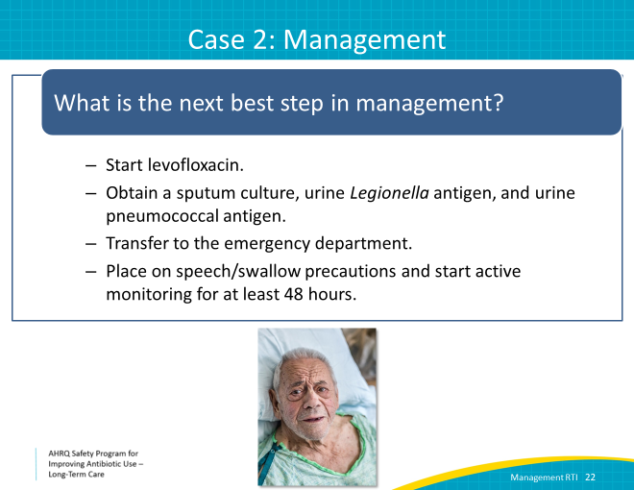
Treatment Recommendations  SAY:  If Francisco was otherwise in good health but had progressed to aspiration pneumonia, ampicillin-sulbactam or amoxicillin-clavulanic acid would be reasonable choices. These cover typical organisms found in the oropharyngeal flora. Ceftriaxone or oral second- or third-generation antibiotics are an alternative option. If the resident has a severe allergy to penicillin, consider using a fluoroquinolone such as moxifloxacin or levofloxacin.  Based on Francisco’s risk factors of being bedbound with chronic wound infections, he is at risk of pneumonia caused by more resistant pathogens, and cefepime would be a reasonable treatment regimen if he were to progress to aspiration pneumonia. | Slide 23  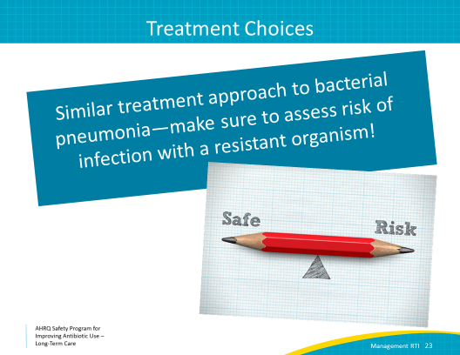
Key Points  SAY:  Let’s review some key points.  First, remember that appropriate diagnostic testing can help to determine if an infection is present. Diagnostic testing can also help with targeting antibiotic therapy.  Five to seven days is sufficient for most cases of pneumonia.  And, in the event of a witnessed aspiration, active monitoring of the resident is recommended for at least 2 days. If the resident does not improve within 48 hours or is hemodynamically unstable before that, consider starting antibiotics. | Slide 24  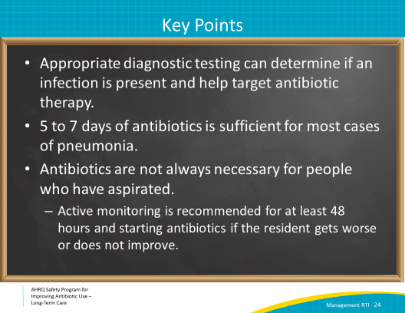
Activities To Complete  SAY:  These are the activities you may want to work on that align with the concepts described in this presentation.  The stewardship team should continue to hold monthly meetings and collect and analyze any data about antibiotic use they have chosen.  There are several materials available that pair with this webinar and specifically address respiratory infections in long-term care.  You may want to post the Talking With Residents and Family Members About Lower Respiratory Tract Infections poster in the staff charting room.  The Bacterial Pneumonia in Long-Term Care, Respiratory Virus Infections, and Aspiration Pneumonitis and Aspiration Pneumonia one-pagers are available for review by health care practitioners or nursing staff. With minor modifications, the antibiotic stewardship team could render these one-pagers into antibiotic use guidelines.  Brainstorm about interventions that may help improve antibiotic use related to respiratory infections in your facility.  Supporting materials for the activities are listed on the slide and are available in the toolkit. | Slide 25  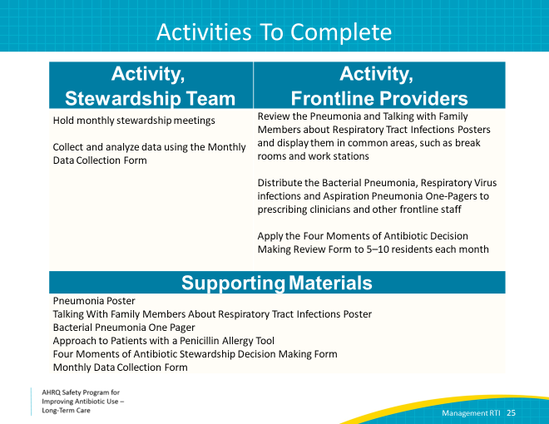
Disclaimer:  SAY:  The findings and recommendations in this presentation are those of the authors, who are responsible for its content, and do not necessarily represent the views of AHRQ. No statement in this presentation should be construed as an official position of AHRQ or of the U.S. Department of Health and Human Services.  Any practice described in this presentation must be applied by health care practitioners in accordance with professional judgment and standards of care in regard to the unique circumstances that may apply in each situation they encounter. These practices are offered as helpful options for consideration by health care practitioners, not as guidelines. | Slide 26  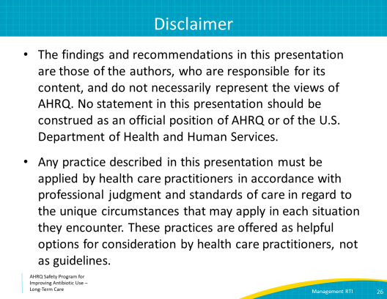
References | Slide 27  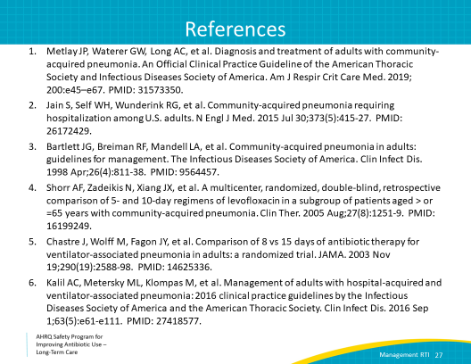
References | Slides 28  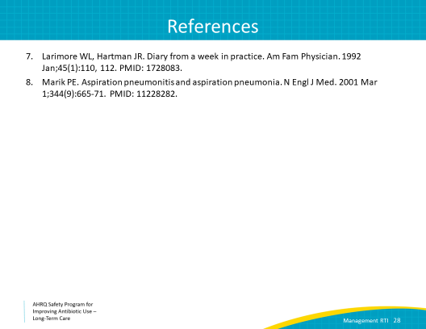
AHRQ Pub. No. 17(21)-0029
June 2021

