Management of the Resident With a Suspected Urinary Tract Infection
Long-Term Care

Slide Title and Commentary | Slide Number and Slide
Management of the Resident With a Suspected Urinary Tract Infection  Long-Term Care  SAY:  Welcome to the presentation titled “Management of the Resident With a Suspected Urinary Tract Infection.” | Slide 1
Objectives  SAY:  By the end of this presentation, participants will be able to:  - Describe empiric treatment options for urinary tract infections, or UTIs.  - Discuss reasonable durations of antibiotic therapy for UTIs.  - Discuss opportunities for de-escalation of antibiotic therapy for UTIs after additional clinical data are available. | Slide 2  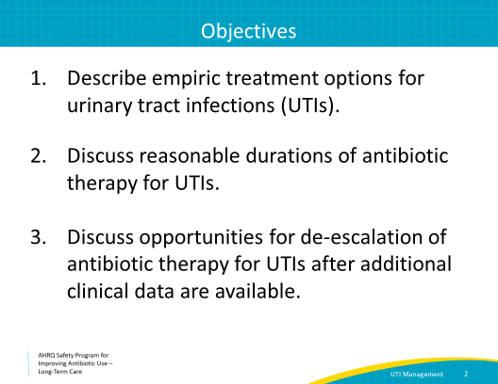
Asymptomatic Bacteriuria  SAY:  Let’s start by reviewing an important concept from the presentation “Assessment of the Resident With a Suspected Urinary Tract Infection.” Remember that residents who have positive urine cultures but have NO symptoms of infection do NOT have urinary tract infections. They have asymptomatic bacteriuria and should NOT be treated with antibiotics. | Slide 3  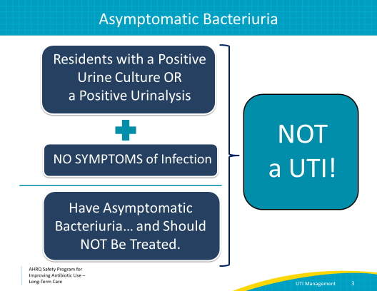
Asymptomatic Bacteriuria  SAY:  Asymptomatic bacteriuria affects approximately 50 percent of residents. Large-scale clinical research studies found no increase in morbidity or mortality among residents with asymptomatic bacteriuria. And, in fact, people treated with antibiotics for asymptomatic bacteriuria are more likely to develop future symptomatic UTIs and with increasingly drug-resistant bacteria.  This is an extremely important concept to remember, especially because studies show that up to 70 percent of residents treated for UTIs in long-term care do not meet criteria for treatment. These residents actually have asymptomatic bacteriuria, and are frequently given antibiotics that they do not need.  We have learned that unnecessary antibiotics needlessly put individual residents at risk for adverse side effects and Clostridioides difficile infections. Unnecessary antibiotic use also contributes to broader public health risks such as widespread antibiotic resistance. | Slide 4
Diagnosing a UTI  SAY:  A resident with dysuria, which is pain with urination, may have a UTI. Also, a resident with a fever AND a symptom localized to the genitourinary tract may have a UTI. | Slide 5  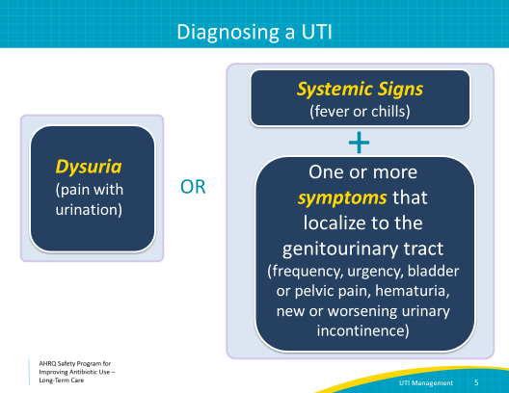
Case 1: Melba  SAY:  Let’s walk through a few cases to discuss the management of potential UTIs in your facility.  Melba is an 88-year-old resident in your facility who is here for rehabilitation after a hip replacement. She tells you she just started having a stinging sensation and a feeling of urgency when she urinates. She does not have any other symptoms, including fever, chills, or fatigue.  Melba is having dysuria, or pain with urination, so she should be evaluated for a UTI. We will order a urinalysis and urine culture.  Since she is experiencing symptoms, she should be started on a course of antibiotics. Next, it is important to consider how to decide the best choice for an empiric antibiotic. Empiric antibiotics are those given before culture results are available. | Slide 6  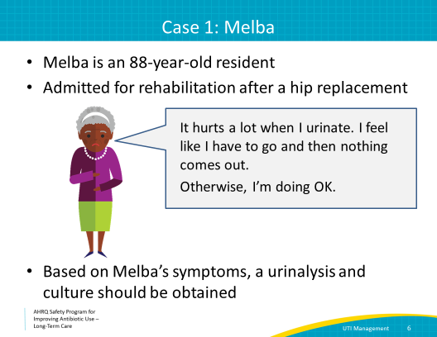
Case 1: Allergy Assessment  SAY:  In order to make an informed choice about empiric antibiotics, you should review the resident’s chart to make sure that they do not have any contraindications or significant reactions to certain antibiotics.  Melba’s chart reveals that she had recent lab testing showing normal kidney and liver function, but she has a listed allergy to penicillin.  Many people have an allergy to penicillin listed on their charts because their mother told them they had a stomach ache or a rash after taking penicillin as a child. This listed allergy can remove a large number of antibiotics from potential treatment options, and can have a negative effect on the care of the resident. This is especially true for older adults who, due to frequent exposure to health care settings, are more likely to have antibiotic-resistant bacteria. Even true allergic reactions tend to fade after 10 years.  The allergic reaction should always be verified with the resident. If the reaction is unknown, consider referring them for allergy testing to determine if the allergy is real. | Slide 7  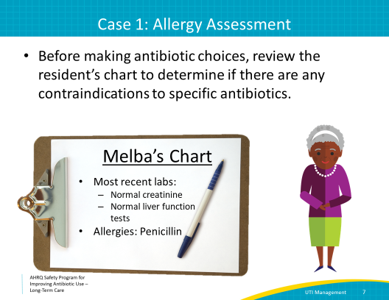
Case 1: Allergy Assessment  SAY:  In this case, you ask Melba if she remembers what her allergic reaction to penicillin was.  She said she was recently given a “penicillin-type” antibiotic in the hospital and after that had terrible hives and itching after the first dose of antibiotics.  This sounds like a real allergy. Melba may not be a good candidate for many of the commonly used empiric therapy choices. Let’s consider how to choose a safe and effective empiric antibiotic regimen for her. | Slide 8  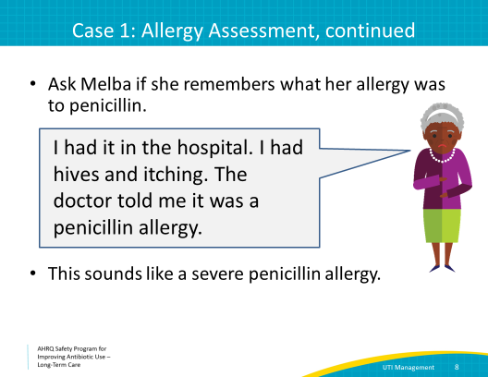
Common Urinary Pathogens  SAY:  Reviewing your facility’s antibiogram, if available, can be helpful. The antibiogram lists the antibiotic resistance patterns for different species of bacteria from your facility. An antibiogram can guide your choice for empiric antibiotics before culture results have returned.  The microbiology laboratory develops an antibiogram by compiling culture results from your facility over the last year. For smaller facilities, the microbiology laboratory may combine culture results from several years or from nearby facilities, which may include hospitals. It’s helpful to ask your microbiology laboratory how they develop the antibiogram for your facility.  This slide shows just a few lines from a typical antibiogram. The common urinary pathogens are listed in the first column on the left. The second column of the antibiogram shows the number of bacterial cultures in the last year that grew that particular bacteria. The remaining numbers show the proportion of those organisms that are susceptible to the antibiotic in the same column. Susceptible antibiotics are expected to be effective against that percentage of the specific bacteria. This antibiogram focuses on oral antibiotics, abbreviated in the top row and defined at the bottom of the slide.  Let’s look at Klebsiella pneumoniae as an example. Out of 31 isolates, none were susceptible to ampicillin or amoxicillin while 84 percent were susceptible to amoxicillin/clavulanic acid. Seventy-four percent of the Klebsiella isolates were susceptible to cefazolin, which is expected to be the same for cephalexin (the equivalent oral drug). Sixty-eight percent were susceptible to ciprofloxacin and levofloxacin, 97 percent of isolates were susceptible to nitrofurantoin, and 94% were susceptible to trimethoprim/sulfamethoxazole.  If you look at the row for E. coli, there is a similar pattern, with 97 percent of isolates susceptible to nitrofurantoin. The information in the antibiogram is telling us that for the urinary pathogens—namely E. coli and Klebsiella—nitrofurantoin and trimethoprim/sulfamethoxazole are our best choices for effective antibiotics. Amoxicillin/clavulanic acid and cephalexin would be second-line options. | Slide 9  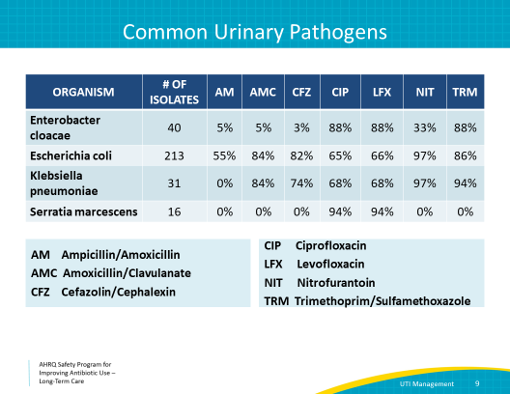
Case 1: What Empiric Antibiotic Should We Use?  SAY:  So, which antibiotic would you empirically choose to treat Melba?  Would you choose ciprofloxacin?  This is not a great choice for this situation. While this antibiotic does not cross-react to penicillins, based on the antibiogram, this will only be effective about two-thirds of the time. Studies indicate that about 40 percent of E. coli strains recovered from long-term care facilities are resistant to ciprofloxacin. Further, the Food and Drug Administration has issued black box warnings for the fluoroquinolone class recommending that they should be avoided if possible in the elderly population due to an increased risk of side effects such as confusion, tendinopathy, and Clostridioides difficile infections.  The susceptibility to trimethoprim-sulfamethoxazole varies by region and your local antibiogram can help you determine if it is good choice for your residents.  Only a small percentage of E. coli strains are resistant to nitrofurantoin, meaning that this agent is likely to be effective. An important point to remember about nitrofurantoin is that it can work well for cystitis, which is a term for lower urinary tract infections that present with symptoms like painful and frequent urination. However, it is not a good choice if your resident has fevers, chills, or flank pain or looks ill, as it does not kill bacteria in the kidneys well. This is true even if it is active against the bacteria growing in the urine culture.  Would you choose cephalexin?  This would be a great choice…IF the resident had not reported that she recently developed hives after receiving a penicillin antibiotic. Cephalosporins have less than 5 percent cross-reactivity with penicillins. This class of antibiotics should be avoided when patients report having has a severe reaction to penicillins. Note that if the patient reported a non-hives rash that was self-limited, then use of cephalexin could be considered.  Would you choose nitrofurantoin?  This is a good empiric choice. Nitrofurantoin is often underutilized in older adults because of its contraindication in patients with renal insufficiency. However, recent data suggest that nitrofurantoin is safe for use in residents with reduced creatinine clearance as long as it is used for 5 days and not for longer durations. A common brand name for nitrofurantoin is Macrobid; this formulation can be given twice a day.  How about trimethoprim-sulfamethoxazole?  This is also a good choice. There is no cross-reactivity with penicillin. Potential side effects from trimethoprim-sulfamethoxazole are an increase in creatinine, an increase in potassium and, for people taking warfarin, an increase in a laboratory test called institutionalized normalized ratio, or INR. | Slide 10  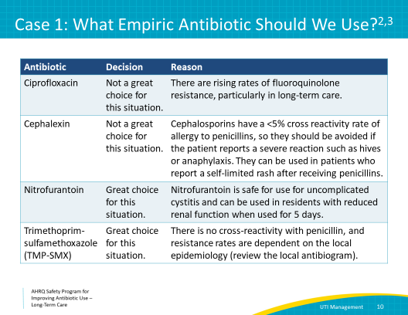
Common Antibiotics Used to Treat UTIs  SAY:  Now that we have some idea of which antibiotic to choose, think about how long Melba should be treated with antibiotics.  Here is a brief table summarizing some of the antibiotics used to treat UTIs. It displays some of the common side effects to monitor for in nursing home patients. | Slide 11  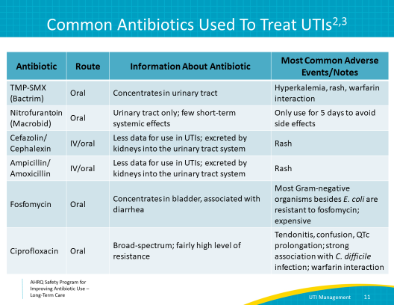
Recommended Antibiotic Durations  SAY:  Let’s get back to our case to discuss the appropriate length of antibiotic therapy.  Melba has uncomplicated cystitis: she has no systemic symptoms, such as fever or chills, and she is a woman with no known urologic abnormalities. She should be treated for 3 to 5 days, depending on the antibiotic selected.  For complicated UTI, including any male patients, any residents with a urinary catheter or urologic abnormalities, a longer course of therapy is recommended. Usually, 7 days of antibiotics is enough for people to get better and stay better, even for pyelonephritis, an infection of the kidneys. For people who are slow to respond, consider 10 to 14 days of antibiotics. Fourteen days is the longest course recommended to treat a UTI.  You elect to treat Melba empirically with nitrofurantoin for 5 days. However, it is important to remember to  follow up on Melba’s urine culture results from the lab. | Slide 12  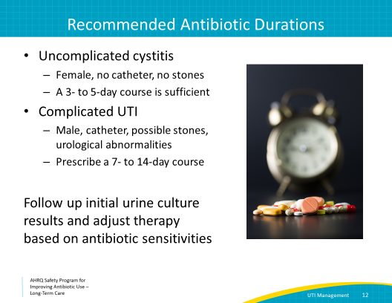
Case 1: Urine Culture Results  SAY:  You receive Melba’s urine culture results. We will discuss interpreting these results in more detail in the next case; for now, note that the letter “S” means the organism is susceptible to the antibiotic and “R” means it is resistant.  As you can see, despite all your forward thinking, the urine culture results return and the organism is resistant to almost every antibiotic tested except meropenem. Meropenem is a possible choice, but it would require an IV.  Before adjusting therapy for cystitis, it is important to confirm if Melba still has urinary symptoms. If she no longer has any symptoms, it is reasonable to continue the original treatment plan. Melba still has dysuria and some incontinence. She has no fevers, and her vital signs are otherwise normal. She continues to eat well.  Melba continues to have symptoms of uncomplicated cystitis and would likely benefit from a change in treatment. It would be a shame to have to transfer her to the hospital for IV therapy.  In this situation, it may be reasonable to consider using fosfomycin, an oral antibiotic used to treat UTIs that should be reserved for drug-resistant E. coli. | Slide 13  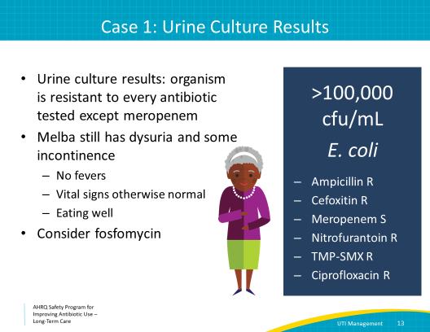
Antibiotic-Resistant Infections  SAY:  Fosfomycin is an antibiotic used for uncomplicated urinary tract infections caused by E. coli. Unfortunately, most Gram-negative bacteria such as Klebsiella species and Pseudomonas aeruginosa are naturally resistant to this antibiotic. Fosfomycin is generally not recommended for cystitis caused by organisms beyond E. coli.  One 3-gram dose is sufficient to treat uncomplicated cystitis. It can be dissolved in water and taken by mouth.  However, it can be expensive and can cause some mild diarrhea. It should only be used if the patient has cystitis and not pyelonephritis and the organism is resistant to other oral antibiotic options.  Fosfomyin should only be used when none of the preferred cystitis agents can be used because in one study it was found to cure fewer cased of cystitis when compared to nitrofurantoin. | Slide 14
Case 2: Billy  SAY:  Melba’s case was fairly straightforward in that she could tell us about her symptoms. Now, let’s discuss a situation that can happen often in long-term care—a resident who is not able to verbally report symptoms.  Billy is a 83-year old nursing home resident with a history of a stroke; he is nonverbal due to the stroke and has an indwelling urinary catheter due to chronic urinary retention.  He refuses to eat his dinner and seems to be sleeping more than usual.  On assessment, he has a temperature of 100.5 degrees Fahrenheit. He does not have a cough, tachypnea, or increased oxygen requirements. He appears to have some suprapubic tenderness on physical exam. He does not have any skin lesions. | Slide 15  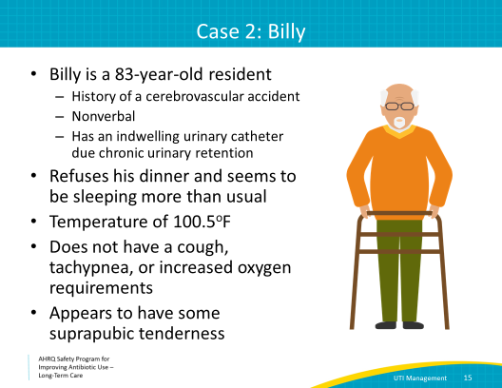
Case 2: Should We Test His Urine?  SAY:  Is there an indication, based on Billy’s symptoms, to send a urine culture?  The answer is yes.  Billy has a long-term indwelling catheter, a new fever, and a change in mental status. He is not able to verbalize any symptoms. We have assessed him and found that he does not have any signs or symptoms suggestive of pneumonia. He does not appear to have a skin infection. Since there are no obvious indications of other infections, it is reasonable to send a urinalysis and culture.  Remember from our culture collection presentation that urine cultures should always be obtained from a newly placed catheter if the catheter has been in place for greater than 2 weeks.  You collect a urine cultures and start Billy on cephalexin for possible UTI based on your local antibiogram. | Slide 16  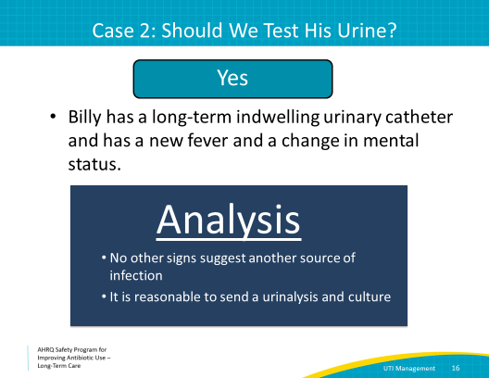
Interpreting Urine Culture Results  SAY:  Billy’s urine culture results return in 3 days. There are three columns on the microbiology report.  The first column lists the antibiotics. The second shows the minimum inhibitory concentration or MIC and the third shows the interpretation.  The only columns you should consider are the name of the antibiotic and the interpretations.  “S” means susceptible, “R” means resistant, and “I” means intermediate. You should choose only from those antibiotics that have an S next to them.  When there are several choices, use the most narrow spectrum agent. So, ampicillin or amoxicillin are better choices than amoxicillin/clavulanic acid if both are listed as susceptible. Cefazolin or cephalexin are better choices than ceftriaxone. As noted before, fluoroquinolones like ciprofloxacin are broad-spectrum antibiotics and also have a number of side effects.  Finally, do not use the number in the minimum inhibitory concentration or MIC column. That number is different for every antibiotic. Comparing an MIC of 0.25 micrograms per milliliter for ciprofloxacin to an MIC of 4 mcg/mL for ampicillin is like comparing 25 mg of atenolol to 10 mg of lisinopril. Both of these medications can lower blood pressure but their chemical structure, mechanism of action and dosing are completely different. It’s the same for antibiotics. And to make it more confusing, the MICs are different for different bacteria and even sometimes for the type of specimen they grew in. The MICs for bacteria in urine are sometimes different for bacteria in blood or sputum. The bottom line is to select antibiotics that have an S and choose the narrowest therapy with the safest side effect profile that is appropriate for the clinical scenario.  In this example, trimethoprim/sulfamethoxazole, nitrofurantoin, or cephalexin would be the best options to treat the E. coli. | Slide 17  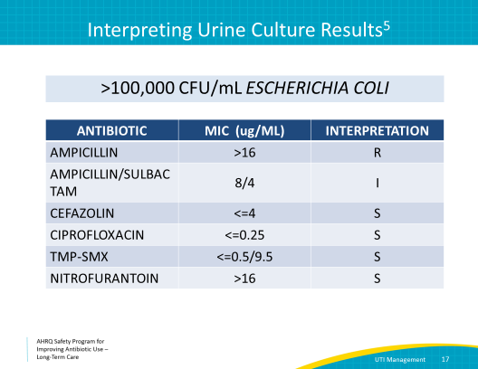
Case 2: What Antibiotic Should We Use?  SAY:  Let’s go back to Billy. Note he does not have any known allergies to antibiotics.  Here are the results of Billy’s urine culture and the results from his chart review. You already started him empirically on cephalexin and the microbiology report shows his E. coli is susceptible to cefazolin, which has the same activity as cephalexin, so you can continue cephalexin. But pretend you instead initially started Billy on an ineffective antibiotic, so let’s go through some antibiotics to decide what antibiotic options there are when the microbiology report returns.  Would you choose ampicillin-sulbactam?  This is a good choice with a relatively low adverse event profile. Further, a related antibiotic, amoxicillin/clavulanate, is available in an oral formulation.  Would you choose meropenem?  Meropenem is a very broad antibiotic to use and is only available in IV formulation. The goal is to choose the narrowest antibiotic with the fewest potential side effects for the patient.  What about nitrofurantoin?  This antibiotic is not typically used for complicated infections. Since Billy is a male with a UTI, by definition he has a complicated UTI. Additionally, the presence of a urinary catheter makes his UTI complicated.  What about trimethoprim-sulfamethoxazole, which is often referred to by its common brand name Bactrim?  This is a good antibiotic for UTIs when it is susceptible. However, because of Billy’s underlying renal insufficiency, he may be at higher risk of hyperkalemia.  Would you choose ciprofloxacin? This is an option and could be used for only 7 days. However, there are many harmful side effects associated with fluoroquinolones, which we discussed earlier.  Because his infection is complicated, it is recommended to treat for at least 7 and no more than 14 days. | Slide 18  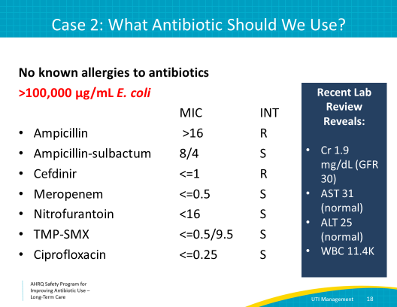
Case 3: Shirley  SAY:  Let’s look at a third scenario.  Shirley, one of the long-term care residents in your facility, fell while getting up to go to the bathroom last night after she tripped over her call button.  She was sent to the emergency department for evaluation and x rays. All of her x rays were normal.  The emergency department ordered a urinalysis, which returned with more than 100 white blood cells, positive nitrites, and positive leukocyte esterase.  The emergency department sent her back to the facility with a prescription for a 7-day course of ciprofloxacin. | Slide 19  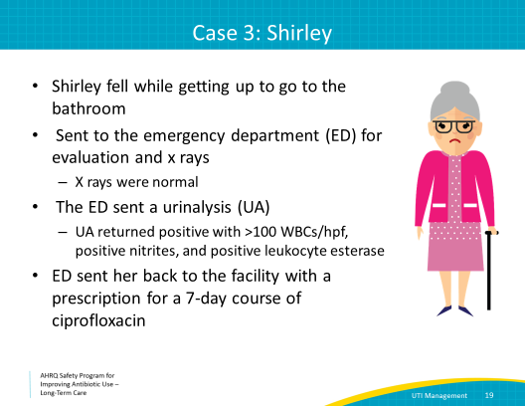
Do You Think Shirley Needs an Antibiotic?  SAY:  Do you think Shirley needs an antibiotic?  Remember that Shirley had not complained of any urinary symptoms the day before her fall, and she still denies any urinary symptoms.  She says that she got up to go to the bathroom and tripped over her call button. She had no fever and no indwelling catheter. While she had a positive urinalysis, this is a common finding in many elderly patients. Since she has no symptoms, she has asymptomatic bacteriuria.  After talking with Shirley and other members of the health care team, you all agree to stop the antibiotic started in the emergency room. | Slide 20  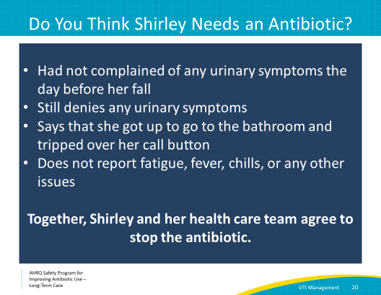
Important to Understand  SAY:  Changing the plan does not reflect poorly on the prescribing clinician. It may just mean that you have more information about the resident, like finding out that another medication was recently changed. It may also mean that you are responding appropriately to new information, such as the results of diagnostic tests. All antibiotic prescriptions from the hospital should be re-evaluated when the resident transfers to long-term care.  In fact, this is a recommended practice by the Centers for Medicare & Medicaid Services in their revised Conditions of Participation. | Slide 21  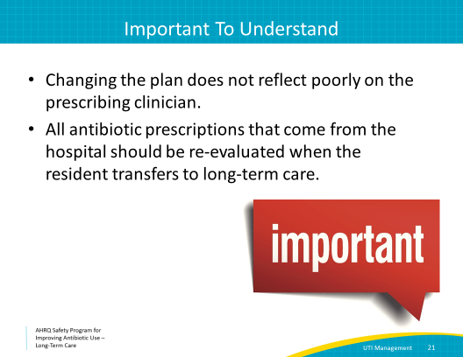
Key Points  SAY:  Here are some key points from this presentation.  It is important to choose the most narrow-spectrum antibiotic based on culture results to treat UTIs.  Fluoroquinolones should be avoided as an empiric choice due to resistance and side effects.  Antibiotics should be continued for 3 to 5 days for uncomplicated cystitis. For complicated cystitis, if the resident has a good clinical response, consider stopping after 7 days. If they are slow to respond, treat no longer than 14 days.  Follow up on culture results, even from the hospital, and narrow or stop treatment accordingly.  The toolkit has several tools that may help you create interventions in your facility to reduce unnecessary treatment of asymptomatic bacteriuria. There are pocket cards available describing indications to send a urine culture, decision trees for assessing the resident with a suspected UTI, and some empiric antibiotic recommendations that can be circulated throughout your facility. | Slide 22  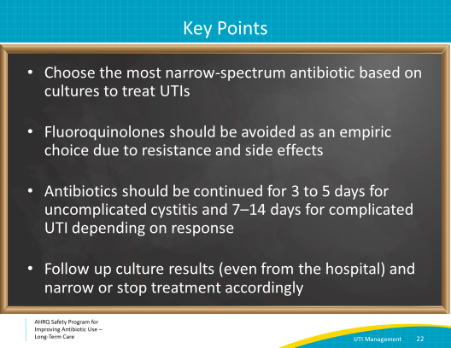
Activities to Complete  SAY:  These are the activities you may want to pair with this presentation, which are intended to help your team stay on track with the overall program.  The Antibiotic Stewardship Team should continue meeting and developing or analyzing ongoing interventions. Share the results with your senior executive, healthcare staff and other stakeholders, like the resident and family council.  Health-care practitioners should use the Learning From Antibiotic Adverse Events form and be encouraged to use this when they are aware of actual harm or a “near-miss” for a resident who received antibiotics or was being evaluated for an infection. They should also review the Talking With Residents and Family Members About Urinary Tract Infections poster and the Asymptomatic Bacteriuria and Urinary Tract Infections one-pagers. With minor modifications, the Antibiotic Stewardship Team could render these into antibiotic use protocols also.  The Antibiotic Stewardship Team should collect or continue to collect and analyze data using the Monthly Data Collection Form and health care staff should continue to apply the Four Moments of Antibiotic Decision Making Form to 5–10 residents each month.  Supporting materials for the activities are listed on the slide and are available on the project Web site. | Slide 24  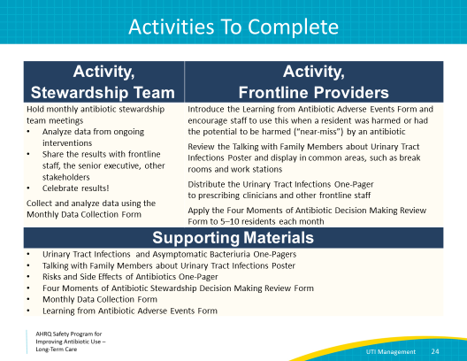
Disclaimer  SAY:  The findings and recommendations in this presentation are those of the authors, who are responsible for its content, and do not necessarily represent the views of AHRQ. No statement in this presentation should be construed as an official position of AHRQ or of the U.S. Department of Health and Human Services.  Any practice described in this presentation must be applied by health care practitioners in accordance with professional judgment and standards of care in regard to the unique circumstances that may apply in each situation they encounter. These practices are offered as helpful options for consideration by health care practitioners, not as guidelines.  Use of brand, manufacturer, or vendor names is for identification only and does not imply endorsement by the Agency for Healthcare Research and Quality of the U.S. Department of Health and Human Services. | Slide 25  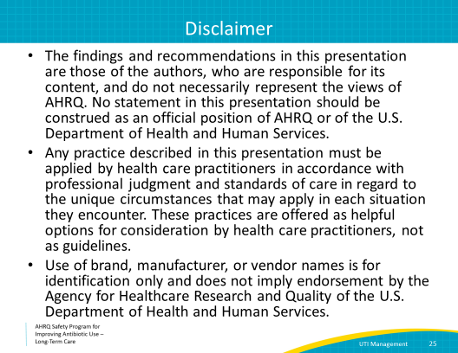
References | Slide 26  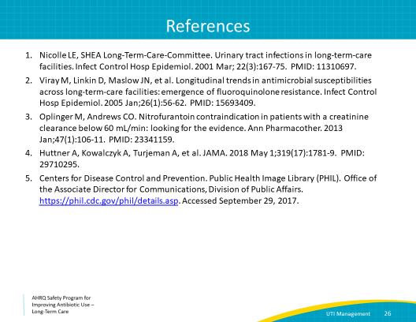
AHRQ Pub. No. 17(21)-0029
June 2021

