Appropriate Collection of Microbiologic Specimens
Long-Term Care
Slide Title and Commentary | Slide Number and Slide
Appropriate Collection of Microbiologic Specimens  Long-Term Care  SAY:  Welcome to this presentation, titled, “Appropriate Collection of Microbiological Specimens.” | Slide 1  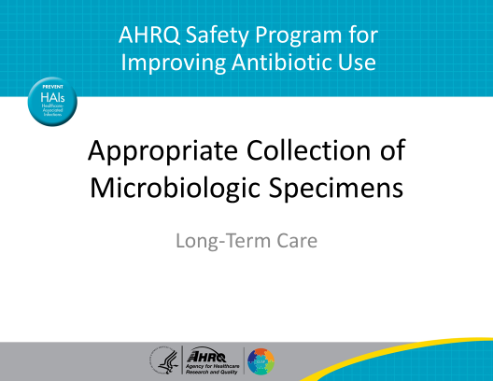
Objectives  SAY:  By the end of this presentation, you will be able to recognize that collecting a good microbiologic specimen is important to determine whether a resident needs to be treated with antibiotics. You will also be able to detail procedures for collecting urine and respiratory samples from nursing home residents.  Finally, you will be able to describe strategies that reduce the risk of collecting contaminated microbiologic samples.  The overall goal of this presentation is to help you collect high-quality samples, which will lead to better decisions about antibiotic prescribing for your residents—and protect your residents from unnecessary antibiotic exposure and associated harm. | Slide 2  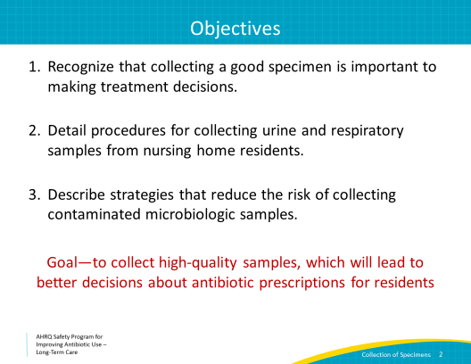
Case 1: Clara  SAY:  Let’s start by looking at a case.  Clara is an 86-year-old resident who is in your facility for physical therapy after she broke her hip. Today, she tells you it burns when she urinates, and she feels like she always has to go.  You tell the clinician about Clara’s pain with urination, or dysuria, and urgency. She asks you to collect a urine sample for urinalysis and for culture.  Let’s take a minute to review our indications for collection of urine cultures. Residents without urinary catheters, who develop new pain with urination, or dysuria, should be evaluated with a urinalysis and culture. Change in urine color or odor, or incontinence or urgency alone—in the absence of pain with urination—are not indications to obtain a urine culture; these changes can be common in older adults and do not necessarily indicate infection.  Clara did report new pain with urination, so we should obtain a urine specimen. | Slide 3  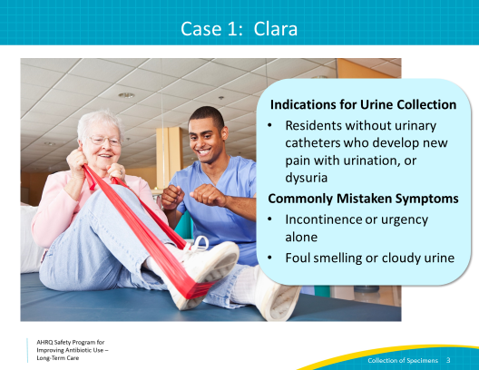
Case 1: Continued  SAY:  A midstream “clean catch” is the preferred method to collect urine. Unfortunately, Clara does not think she can stand long enough to do this on her own.  This is often the case for residents in nursing homes, so let’s discuss some alternatives for collecting the urine when these midstream specimens cannot be collected by the resident alone. | Slide 4  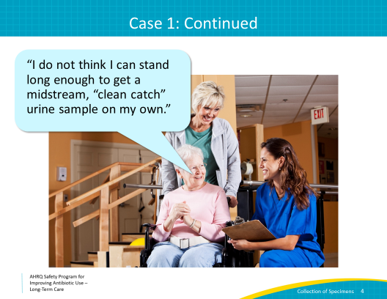
Case 1: Options for Female Residents  SAY:  Take a minute now to think of some alternative ways to collect the urine when the resident is not able to on her own, and consider the pros and cons of each.  One option would be to offer to help Clara catch the urine while she urinates.  While this seems like a good idea in theory and does not require invasive techniques, this method is likely to lead to some bacterial contamination from her skin.  An option in this case would be to help the resident take a shower or a sponge rinse with soap and water prior to collection to ensure her genitals are clean. Next, make sure that you allow the resident to void the first portion of her stream before you begin collection. This will minimize the bacterial contamination from her skin.  The next option, giving her a toilet hat to collect urine, also runs the risk of obtaining a contaminated specimen. Toilet hats are great for measuring ins and outs, but they are not usually suitable for collecting urine for culture. Collecting the urine in a clean sterile container is important. Toilet hats are not sterile. The urine will be contaminated with bacteria from her skin and could be contaminated by the toilet hat itself. By the time toilet hats are in position, used to collect the urine, and removed, they will have bacterial contamination. The urine that is transferred from the hat to a sterile container and sent to the lab also will be contaminated.  The last option, obtaining an in-and-out catheterization, is probably the best way to obtain a good sample if you cannot adequately obtain the sample with the clean-catch method. The downside to this approach is that it is invasive and can be uncomfortable for the resident. Using sterile technique and cleansing the genitals before obtaining the sample is important. | Slide 5  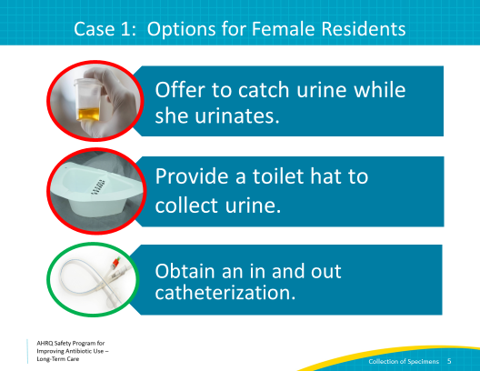
Case 1: Options for Male Residents  SAY:  Let's consider how the previous case would change if the resident was a man.  With male residents, it remains important to clean the skin around the genitals with a wipe or soap and water to reduce bacterial contamination. It is typically easier to obtain a midstream specimen in men, but if this is not possible, then consider placing a condom catheter to obtain the specimen. Condom catheters are generally more comfortable than performing an in-and-out catheterization though this is also an option for men.  After the condom catheter is placed, check the collection bag every 30 minutes. Because this is a newly placed catheter, you can collect the sample from a collection bag that has held the urine for a short period of time.  Regardless of the approach, you can take steps to minimize bacterial contamination of your sample by cleansing the genitals prior to collection, washing your hands, wearing clean gloves, and collecting the specimen in a sterile container. | Slide 6  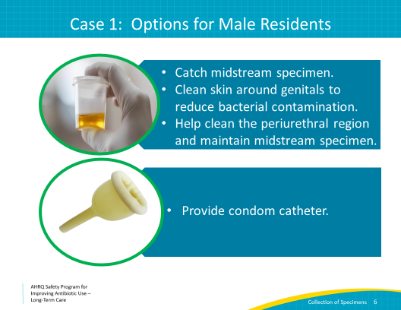
Case 2: Bernard  SAY:  Let’s move on to another case.  One of the residents you are caring for in the nursing home has a chronic indwelling urinary catheter due to urinary retention and an inability to void independently.  He develops a fever with flank pain, and you are concerned about a urinary tract infection. You call the clinician on call to report his symptoms, and she asks you to place a new urinary catheter before collecting a sample for urinary culture.  Take a moment to consider the reason she recommended this, and we will discuss the possibilities on the next slide. | Slide 7  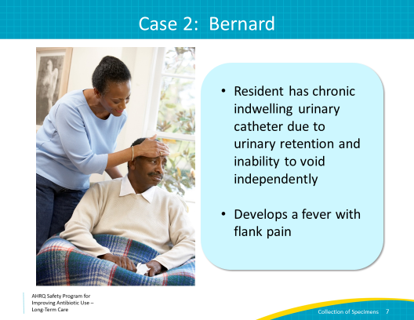
Why We Collect Urine From a Clean Catheter  SAY:  Here are the reasons why it is important to obtain your urinary specimen from a new, clean catheter, rather than one that has been in place for a prolonged period.  - Rapid colonization  - Within 1–3 days of placement, bacteria will colonize in urinary catheters and coat the plastic with a biofilm  - Biofilm formation  - A biofilm is a layer of slime secreted by bacteria that protects them from antibiotics, drying out, and other threats. Once the biofilm is formed, it is very challenging to eradicate bacteria without removing the catheter itself.  - False positive culture  - A “positive” urine culture obtained from an indwelling urinary catheter may grow bacteria that came from the biofilm. Bacteria from the biofilm do not usually cause problems for the resident, and are not necessarily representative of what is going on inside of the bladder. | Slide 8  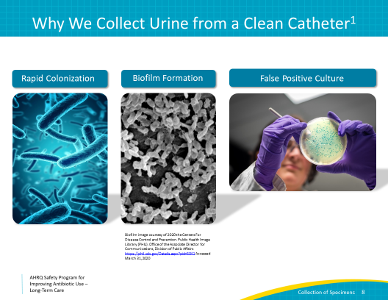
Case 2: True/False  SAY:  Let’s go through the possible answers and decide if each is true or false.  - If the urinary catheter has been in too long, the urine specimen is not helpful. Is this true or false?  - This is true. The plastic surfaces on the catheter become coated with a biofilm soon after placement. This biofilm contains bacteria that may not necessarily be related to the resident’s new symptoms. A new catheter should be placed before obtaining the specimen.  2. Placing a new catheter can help hasten the resolution of symptoms.  - This is also true. If a urinary catheter has been in place for more than 2 weeks, a new catheter can help hasten the resolution of symptoms and reduce the risk of a subsequent catheter-associated urinary tract infection.  3. The catheter does not need to be changed before the sample is collected.  - This is false. It is actually recommended to change the urinary catheter before collecting a urine sample, particularly if it has been in place for more than 2 weeks. This is because colonizing bacteria from the catheter can get into the sample and lead to inaccurate culture results. Collecting a urine sample from a new catheter is good practice. | Slide 9  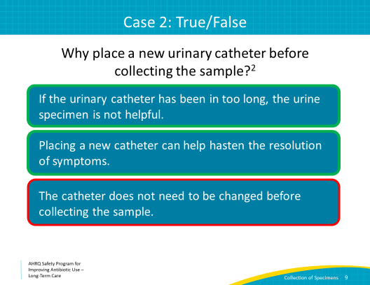
Steps To Collect a Urine Sample From a Clean Catheter  SAY:  It is acceptable to collect urine from the port of a freshly placed catheter but not from a catheter that has been in place for at least 2 weeks. We recommend removing the catheter and placing a new catheter before obtaining the urine specimen.  To obtain a urine sample from a clean, newly placed catheter, you must follow these steps:  - Wash your hands and change to new sterile gloves before obtaining your specimen.  - If no urine is in the tube, clamp the tube for 15–30 minutes prior to procedure.  - Alcohol wipe the port prior to access.  - Insert a 10 cc syringe at an angle into the port. Draw back 3–5 mL.  - Insert specimen into sterile container.  - Date, label, and time the specimen. Transfer to lab or refrigerator within 15 minutes. | Slide 10  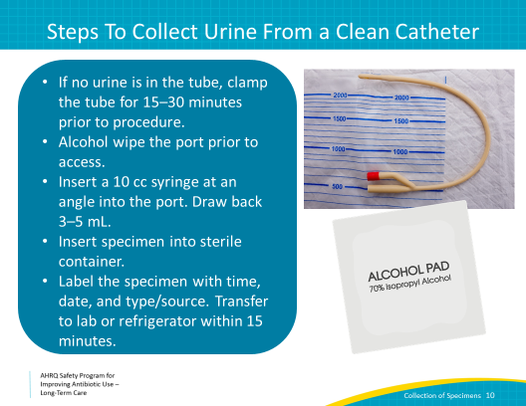
Knowledge Check  SAY:  Now it’s time for a quick knowledge check. Try and think about the correct answer to these questions, and then we will review.  First, why do you need to change gloves before a new catheter is placed?  - You just removed a contaminated catheter. If you don’t change gloves, you will immediately transfer bacteria to the new catheter and contaminate the urine specimen. | Slide 11  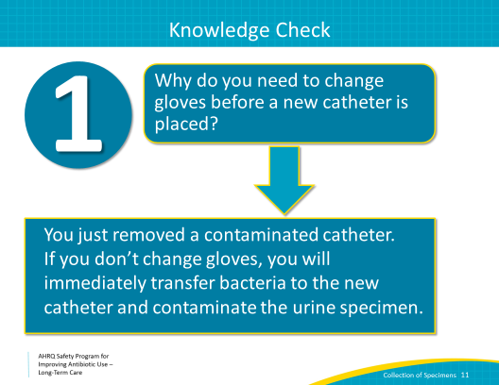
Knowledge Check  SAY:  Second, why is it important to refrigerate the specimen if it can’t be transported to the lab within 2 hours?  - Specimens that aren’t handled properly are at risk for bacterial overgrowth and should not be accepted for analysis in the laboratory. All the hard work and potential discomfort to the resident that went in to obtaining the urine sample will be useless if the specimen isn’t stored and transported appropriately. | Slide 12  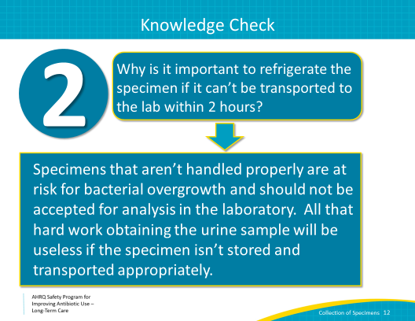
Take-Home Messages: Urine Collection  SAY:  Here are our take-home messages regarding good urine sample collection:  - Always help residents clean the periurethral region prior to collecting sample.  - If midstream clean-catch specimens are not possible, perform an in and out catheterization for female residents or use a condom catheter for male residents.  - For residents with a catheter, urine culture specimens should be obtained from freshly placed catheters when feasible.  - Always wash your hands and obtain the specimen in a sterile container.  - If urine samples cannot immediately be transported to the lab, they should be refrigerated promptly and until transport. | Slide 13  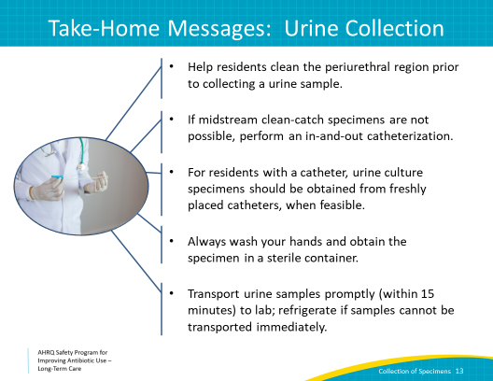
Case 3: Carol  SAY:  Let’s move on to discuss sample collection of respiratory cultures.  One of the residents in your facility develops a new cough and a temperature of 100.4 degrees Fahrenheit. She appears ill and reports being short of breath. Her O2 saturation is 98 percent, and her vital signs are otherwise within normal limits.  Orders are placed to obtain a sputum sample and chest x ray to evaluate for pneumonia.  Before we move on to discuss the best way to obtain a sputum culture, what else do you think would be a good idea to send as part of the diagnostic evaluation here?  - A complete blood count (or CBC) with differential could help to determine if the resident had leukocytosis, or a high white blood cell count, which could be a sign of a developing bacterial infection.  - Urine Legionella and Strep pneumoniae antigen are great rapid diagnostic tests that can help to evaluate for common causes of pneumonia quickly. If one of these tests is positive, it can also help to choose the right antibiotic early on, which is a major benefit for the resident. If available, these tests should be considered for a resident with pneumonia.  - Respiratory viruses—rapid influenza testing is always recommended during flu season, from October to March. Influenza is very contagious, and if we don't monitor for it, an outbreak can occur in the facility. Also consider testing for other respiratory viruses such as SARS-CoV-2—the virus that causes Coronavirus disease 2019 or COVID-19—as appropriate based on community prevalence.  - Urine culture—the resident has symptoms of cough and fever, with no complaints of urinary symptoms. Without urinary symptoms and with another good reason for fever, there is no good reason to obtain a urine culture.  Note that Coronavirus disease 2019, or COVID-19, a viral infection caused by severe acute respiratory syndrome coronavirus 2, or SARS-CoV-2, has emerged as a significant threat globally. Residents of long-term care facilities are at particular risk of severe infections due to the presence of other comorbidities and because of the ease with which infection with the virus can spread within a communal living setting. Although we will not discuss COVID-19 further in this presentation, like influenza, a single case of COVID-19 in the long-term setting requires an aggressive containment response and may need to be considered in your differential. Further information about management of COVID-19 in the long-term care setting can be found on the Centers for Disease Control and Prevention Web site and on State and local health department Web sites. | Slide 14  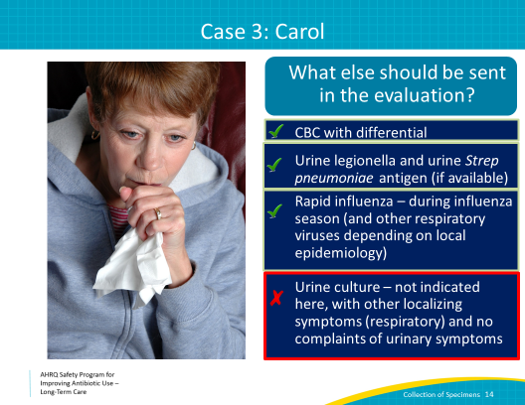
Case 3  SAY:  In the afternoon you ask the resident to cough and spit in a cup. She coughs twice, a dry cough, and then spits some clear fluid into the cup.  After giving medications to the three other residents you are covering, you transfer the fluid from the cup into a sterile container and send the specimen to the lab.  Next, she is started on broad-spectrum antibiotics.  Two days later, the laboratory returns results from the specimen you sent. The results read: “Insufficient sample; normal respiratory flora.”  At this point, the resident has had her chest x ray, which shows a right lower lobe pneumonia. Her influenza and SARS CoV-2 tests are negative, and she continues to cough.  She continues on broad-spectrum antibiotics because culture results are not available to tailor the therapy to the bacteria growing in her lungs.  Let’s consider how you could have prevented this from happening and improved the likelihood of obtaining a good sputum sample the first time. | Slide 15  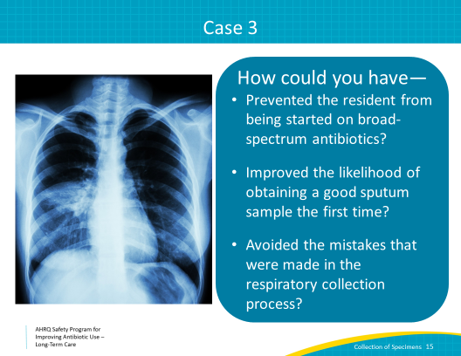
Collecting a Good Respiratory Sample  SAY:  Here are some suggestions to help you collect a good respiratory sample:  - Obtain an early-morning specimen. Often, residents are better at coughing up a good specimen in the early-morning hours, so we recommend obtaining specimens at this time when possible.  - Wash hands and use new gloves for specimen collection.  - Ask the resident to rinse her mouth out with water before collection. This helps to remove some of the loose cells from her mouth and may reduce contamination of the phlegm.  - Explain to the resident that you need phlegm from her lungs, not just spit from her mouth. If the resident is unable to cough up a specimen, you want to request an order to give a treatment with aerosolized saline to induce a deep cough for the sputum collection.  - Collect the specimen in a sterile container. Transferring it from a cup can increase the risk of contamination.  - Transfer the specimen to the lab or refrigerator promptly. If the specimen sits at room temperature for more than 15 minutes, bacteria may die before being cultured. | Slide 16  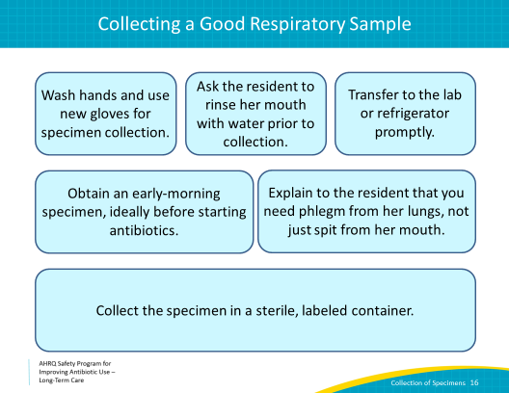
Remember That Clinical Context Is Important!  SAY:  While the resident in the previous case clearly had evidence of pneumonia with a new positive chest x ray, fever, and cough, we must remember that bacteria do colonize our mouth and upper respiratory tracts. A positive sputum culture must be interpreted based on the clinical presentation.  - Sputum cultures should only be sent on residents whom you are concerned have a lower respiratory tract infection.  - A positive sputum culture does not necessarily mean that that organism is responsible for infection. Remember that bacteria and yeast colonize our mouths, and these can be captured if you do not obtain a good deep sputum specimen. For example, we often see sputum cultures positive for yeast, or Candida albicans. This almost never causes pneumonia and should not be treated without specific recommendation from an infectious disease specialist.  - Sputum cultures should NOT be collected on residents with bronchitis or chronic obstructive pulmonary disease exacerbations. These are often caused by viral infections, and the sputum culture will likely represent colonizing bacteria rather than an underlying infection. | Slide 17  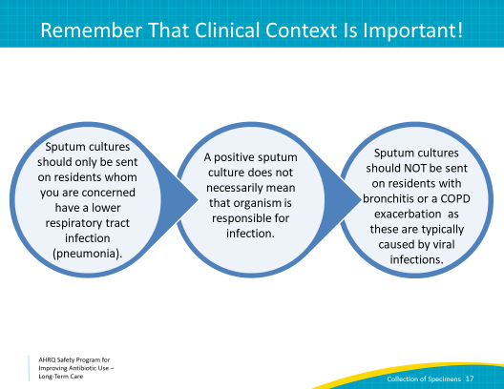
Summary  SAY:  Here are some general take-home messages from this culture collection module.  - A resident should be symptomatic before we start collecting samples to send to the microbiology laboratory.  - Bacterial colonization does not necessarily represent infection.  - A good microbiologic specimen can help to make the correct diagnosis and direct treatment. Following the correct procedures and using sterile technique are very important for the well-being of the residents in your facility! | Slide 18  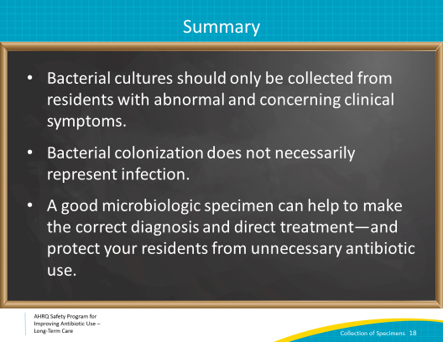
Activities To Complete  SAY:  These are the activities you may want to pair with this presentation, which are intended to help your team stay on track with the overall program.  Frontline clinicians may want to review sample collection processes for urine at your facility and use the supporting materials to help guide this process.  The Antibiotic Stewardship Team should collect or continue to collect and analyze data using the Monthly Data Collection Form and frontline staff should continue to apply the Four Moments of Antibiotic Decision Making Form to 5–10 residents each month.  Supporting materials for the activities are listed on the slide and are available on the AHRQ Safety Program Web site. | Slide 19  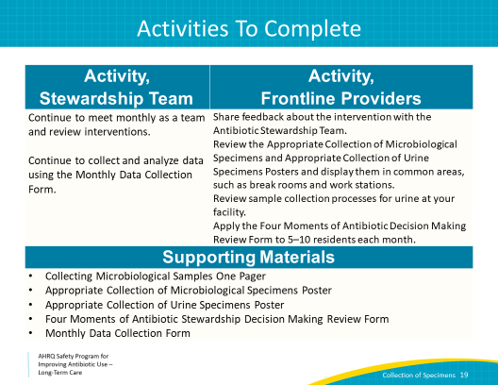
Disclaimer  SAY:  The findings and recommendations in this presentation are those of the authors, who are responsible for its content, and do not necessarily represent the views of AHRQ. No statement in this presentation should be construed as an official position of AHRQ or of the U.S. Department of Health and Human Services.  Any practice described in this presentation must be applied by health care practitioners in accordance with professional judgment and standards of care in regard to the unique circumstances that may apply in each situation they encounter. These practices are offered as helpful options for consideration by health care practitioners, not as guidelines. | Slide 20  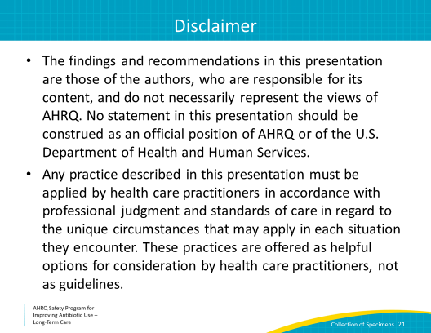
References | Slide 21  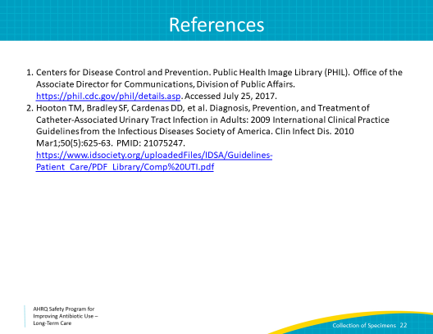
AHRQ Pub. No. 17(21)-0029
June 2021

