Partnering With a Senior Executive
Long-Term Care
Slide Title and Commentary | Slide Number and Slide
Partnering With a Senior Executive  Long-Term Care  SAY:  Thank you for joining us. This presentation is titled “Partnering With a Senior Executive.” This is our first presentation about adaptive skills. Adaptive skills help improve the patient safety climate by putting the resident at the center of decision making.  Lessons learned from this and the other four presentations focusing on adaptive skills will better equip you with how to use your technical antibiotic knowledge to reduce preventable antibiotic harm. | Slide 1  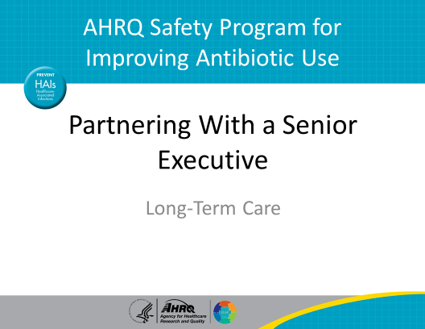
Objectives  SAY:  The objectives of this presentation are to—  - Identify the qualities a senior executive brings to a team and recognize how they can help improve patient safety.  - Describe the responsibilities of the senior executive.  - Identify strategies for engaging executive leaders in your safety and quality projects. | Slide 2  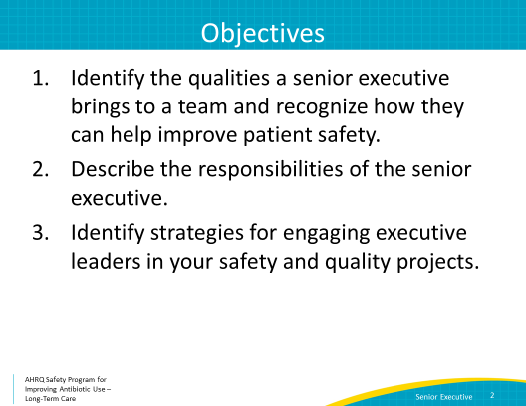
5 Steps for Improving the Culture of Patient Safety  SAY:  Our patient safety program provides frontline caregivers with the tools and support that they need to identify and tackle the hazards that may threaten their residents. It strives to eliminate preventable harm.  In this presentation, we will talk about how to engage leadership for support and collaboration. | Slide 3  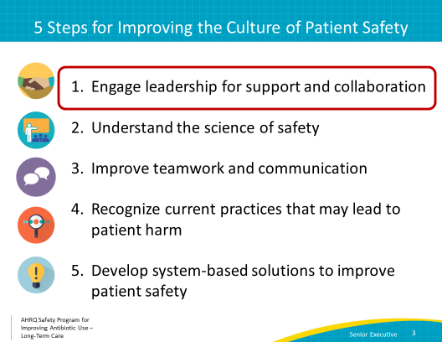
Why Focus on Leader Engagement?  SAY:  Leadership support is a vital tool for a successful patient safety improvement project. In fact, inadequate leadership support is the most commonly reported barrier to patient safety projects.  Having a strong leader who is invested in the stewardship program can provide—  - A shared sense of purpose,  - Access to an institutional decision maker who can help find solutions to barriers,  - A focus on accountability and results, and  - An overall culture of collaboration  Together, these benefits can greatly improve the success of the project. | Slide 4  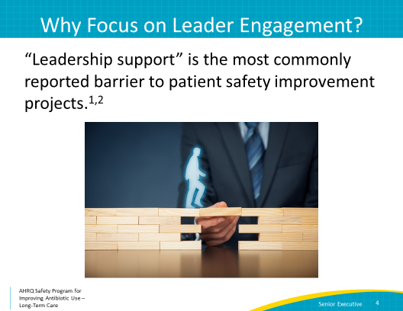
What Does an Executive Offer?  SAY:  A senior executive can be an important part of any project because he or she can offer some support on the administrative end, which may not be readily available to other staff.  The senior executive can help make sure that the necessary structure is in place to make your antibiotic stewardship program or ASP a success. This includes ensuring that the people, roles, authority, and responsibility of the team are available and adequate.  They can also make sure that decision making, problem solving, and conflict management are consistent across the entire facility, or group of facilities if your nursing home is part of a larger system.  The executive can help ensure that the material resources needed for your project, such as pharmacy support, diagnostic tests, or information technology or IT support, can be obtained to support your intervention.  Also, the senior executive can make sure that the appropriate financial tracking mechanisms are in place to confirm that your intervention is within budget. | Slide 5  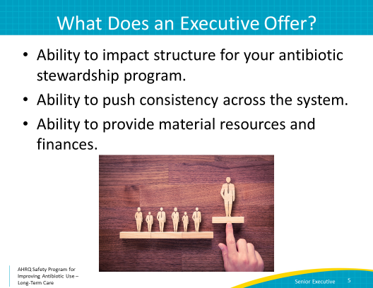
Scenario  SAY:  Let’s walk through the scenario about engaging a senior executive in your facility.  First, the background. It is the second meeting of your newly formed antibiotic stewardship team. After the first meeting, you ask the staff members to tell you about problems they have noticed around antibiotic prescribing that may be putting residents at risk for harm.  The consulting pharmacist mentions that it took the lab 3 days to return results of an elevated INR for a resident who had started an antibiotic that interacted with the patient’s warfarin. He states that delays in getting lab results back in a timely fashion make it hard to know how to adjust warfarin doses.  A nurse reports concerns about a resident who had an increase in their creatinine after being on an antibiotic. Because the lab result took 4 days to come back, the resident was exposed to an additional 4 days of the antibiotic. The nurse worries that the resident’s kidneys were permanently damaged.  Support from the administration may be needed to help remedy this situation and ensure that the lab is communicating these results effectively.  You realize that your team will be more successful with an engaged senior executive, and decide to try to identify some potential candidates. | Slide 6  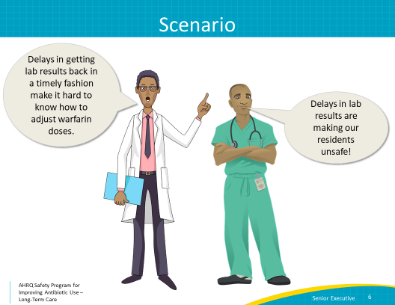
Identifying Your Executive  SAY:  In a nursing home, a senior executive may be the administrator or executive director, the medical director, or the chief executive officer or CEO, or the vice president of the group of nursing homes or your facility.  They do not have to have clinical knowledge.  That said, it is important that they be actively engaged in the project. This means that they must be willing to learn from and listen to staff to improve patient safety. Humility and the ability to listen and actively learn are characteristics of a good senior executive. | Slide 7  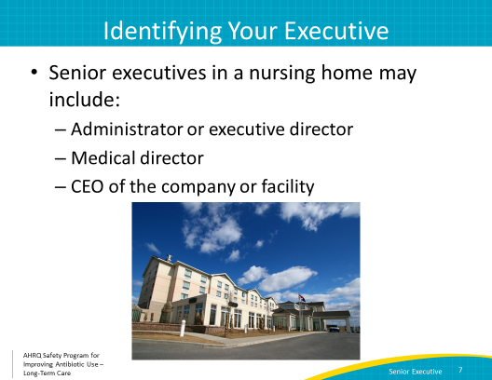
Scenario  SAY:  After some deliberation, your stewardship team identifies the company’s CEO, Dawn Silver, as a good candidate for your senior executive.  She is engaged in the community and previously served on a board to address reducing catheter-associated urinary tract infections or UTIs in long-term care. You decide to set up a meeting. | Slide 8  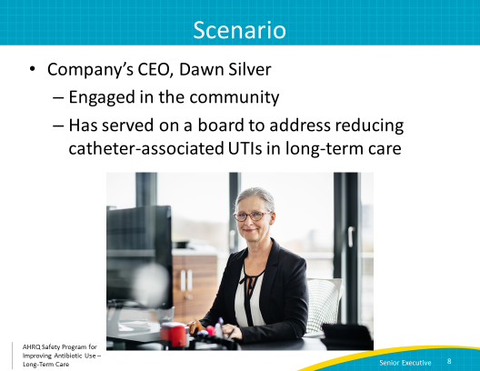
Engaging Your Executive  SAY:  Here is what to consider when you approach a potential senior executive.  - Make sure you clarify requests. What exactly is your team asking for?  - Be specific.  - For example: “We want to initiate an intervention to improve antibiotic prescribing practices in our facility”  - Be prepared.  - Have evidence to support your requests, such as:  - “50 percent of the antibiotics prescribed in our facility do not meet guidelines for treatment, and we have several residents who have suffered adverse events from antibiotics.”  - Anticipate obstacles and solutions.  - For example: “We will need support from a senior executive to make sure we have the resources we need to formulate interventions. Scheduling and time constraints will probably be an issue, but we can work this out by being prepared and planning a schedule that works for everyone ahead of time."  - Give a reasonable time frame to address your concerns.  - Such as: “We are going to start our intervention in January, getting the new year off to an exciting start. And, we hope to show changes by April so we can share our results for the annual Founders Day celebration on April 20. | Slide 9  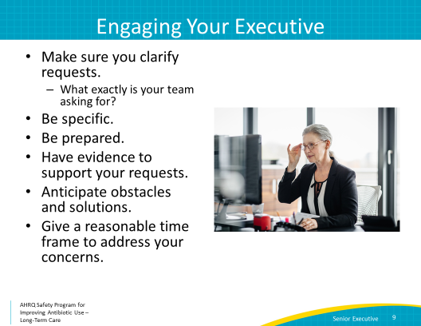
Executive Partnership: Win-Win  SAY:  Next, sell the collaboration.  The executive benefits from the collaboration, too, and this information should be shared with them! This is a win-win situation. By collaborating with your team, the executive can—  - Develop strategies that can be used across the entire organization  - Realize fiscal benefits for the facility  - Achieve improvement by collaborating with engaged team members, instead of demanding things from reluctant staff  - Quantify and report reductions in adverse drug events or Clostridioides difficile rates  - Gain many other potential benefits that can lead to improved quality for their facility and the surrounding community | Slide 10  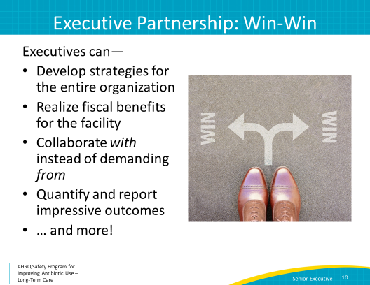
Success/Challenges  SAY:  Your meeting and your encouragement for the program worked—Dawn Silver agrees to be your senior executive!  However, after she misses two meetings due to scheduling conflicts, you realize that there are some challenges to partnering with a senior executive.  Often, senior executives have busy schedules and are not available to meet on a regular basis. They also often do not have a clinical background. You should address these challenges by creating a reasonable schedule for all of you (perhaps quarterly meetings) and by helping to explain any clinical information that may not be easily understood. | Slide 11  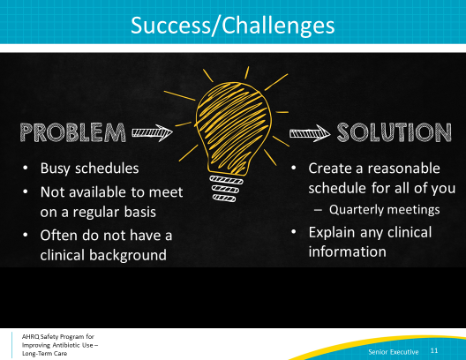
How to Engage Your Senior Executive  SAY:  Now let’s talk about how to engage your senior executive and keep them engaged. It will be important to make sure that meetings with the senior executive are organized and efficient.  Start with a meeting schedule that works for the senior executive as well as your team, perhaps quarterly. You should continue at least monthly meetings with your stewardship team to make sure your stewardship efforts are on track and to prepare for the quarterly executive meetings.  The meeting with your executive needs to be organized and efficient. Tailor discussions to issues that are relevant to the senior executive. Try to focus on the issues that the senior executive can help improve, rather than discussing staff interactions during these meetings.  Gather relevant information about your facility’s prescribing patterns and your planned interventions before the meeting.  Identify and discuss safety issues that could benefit from the senior executive’s influence or expertise that you may have noticed, and get your senior executive’s input about resolution for these problems during the meeting. | Slide 12  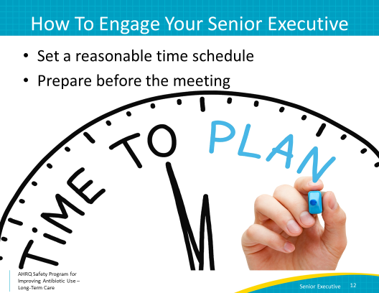
Dialogue for Senior Executive Rounds  SAY:  Consider this sample dialogue for your first senior executive rounds:  “Thanks for joining us, Ms. Silver. We have identified a patient safety issue that our antibiotic stewardship team would like to address.  There have been several incidents where we have not gotten results from the lab in a timely manner. When the results do come, they are sent by fax and often are not routed to the correct individual in a timely fashion. This has resulted in missed lab results showing adverse effects of antibiotics, such as worsening kidney function.  We are concerned that this issue is putting our residents’ safety at risk, and it could be avoided. We have thoughts about a few potential solutions.  We would like your support in changing our communication system with the lab. Instead of sending a fax, we would like to have the lab automatically send results to the providing clinician’s secure email address. We think this could help prevent many safety issues in our residents.  What do you think about this? Is this something that could be changed for the system as a whole?” | Slide 13  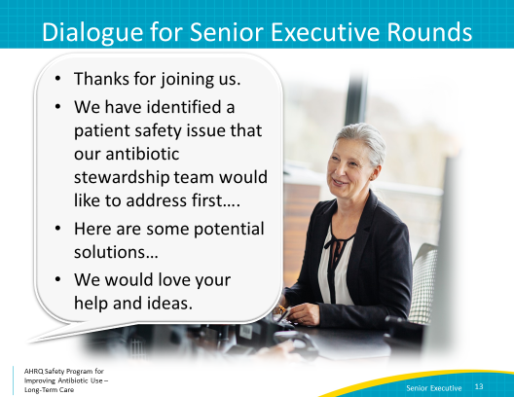
Second Example  SAY:  Let’s work through a second example.  - The antibiotic stewardship team decides to tackle the problem of concerned family members who insist on antibiotics.  - The team works with the nurse managers to develop a communication tool for nurses to use to talk about antibiotics.  - Two months after launching the tool, the antibiotic stewardship team continues to hear about pressure from family members, including complaints to the resident and family council.  - It seems like the situation is getting worse.  - It appears that staff were not remembering to use the tool, likely because they had not been given enough training on how and when to use it. | Slide 14  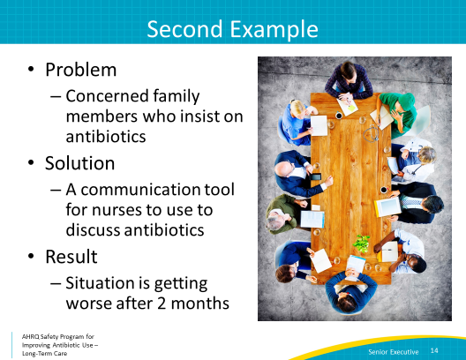
Framing the Discussion  SAY:  How can your senior executive help?  When you tell her about the problem, be specific with your requests. For example, you may tell her, “We need to improve our communication about antibiotic stewardship with concerned family members.”  After you present a request, make sure you are prepared with evidence to support it. The support could sound like, “We developed a communication tool and did an in-service in March. When we asked the nurses and nurse aides about using it in May, two months after implementation, most of them could not remember that the tool existed.” | Slide 15  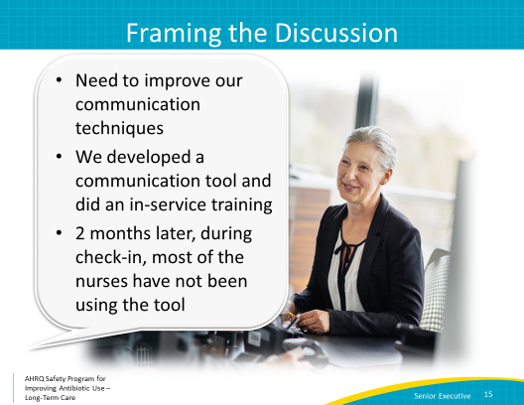
How Can the Senior Executive Help?  SAY:  When talking with your executive, you must anticipate obstacles and solutions. You could say something like, “We need time to train the staff, and time for them to practice or role play. We also need to educate families about using pamphlets. There are good posters highlighting the importance of using antibiotics carefully to avoid unnecessary harm and pamphlets available online. We’d like to have them printed in color and include the pamphlets in the admission packet. ”  Then you should offer a reasonable timeframe to address concerns. This could sound like, “We can start training staff this July and have posters and pamphlets available by August if you agree.” | Slide 16  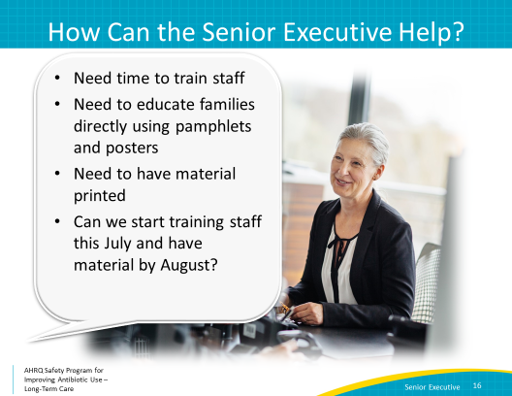
Benefits of Senior Executive Support  SAY:  The senior executive can provide a lot of backing and support to your program. They should meet at least quarterly with your team to stay abreast of your team’s progress and challenges they help you address. Some of the benefits they bring can include—  - Helping to emphasize effective communication between the organization  - Using networking opportunities to coordinate outside services to meet the needs of the team  - Supporting technical and adaptive work of change  - Collaborating to develop and implement a plan addressing resident safety issues  - Helping ensure teams have resources to conduct their work  - Holding staff accountable for reducing resident harm | Slide 17  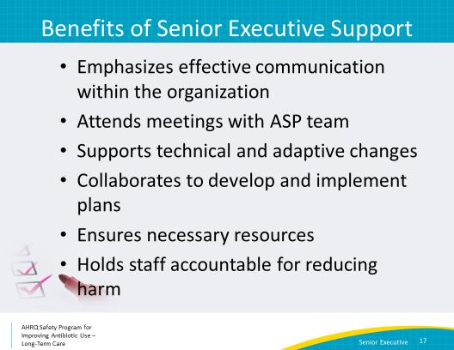
Summary  SAY:  Think about some effective ways that leaders can work with your staff to bring about change and what changes you would like to make.  Remember:  - Your senior executive does not need a clinical background but should be an active team member.  - Your senior executive is responsible for supporting effective communication, meeting with the antibiotic stewardship team, understanding technical and adaptive work, collaborating with the team to address safety issues, and holding staff accountable.  - Lastly, you should engage your senior executive by acknowledging his or her perspective and sharing the benefits of collaborative work for the facility. | Slide 18  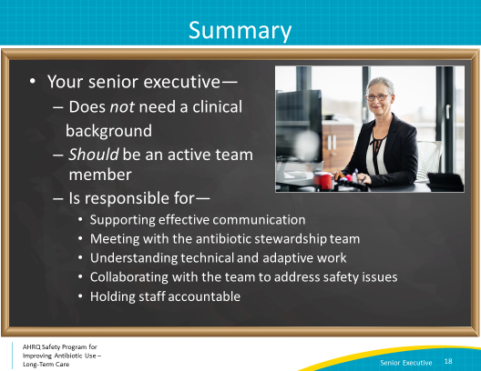
Activities To Complete  SAY:  These are the activities you may want to work on that align with the concepts described in this presentation.  The antibiotic stewardship team may want to plan and schedule a meeting with the senior executive. In preparation for the meeting, identify a specific issue or concern based on the brainstorming from the first meeting. Put together current data, goals for the project, and reasons you need funding.  Introduce the stewardship team and its mission statement to the facility. Invite interested parties to join the stewardship team.  Other supporting materials are posted on the AHRQ Safety Program Web site. | Slide 19  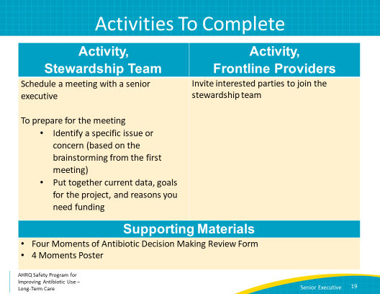
Disclaimer  SAY:  Here is the disclaimer.  The findings and recommendations in this presentation are those of the authors, who are responsible for its content, and do not necessarily represent the views of AHRQ. No statement in this presentation should be construed as an official position of AHRQ or of the U.S. Department of Health and Human Services.  Any practice described in this presentation must be applied by health care practitioners in accordance with professional judgment and standards of care in regard to the unique circumstances that may apply in each situation they encounter. These practices are offered as helpful options for consideration by health care practitioners, not as guidelines. | Slide 20  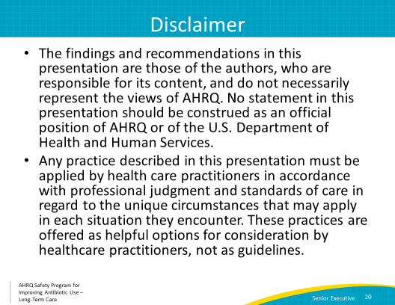
References | Slide 21  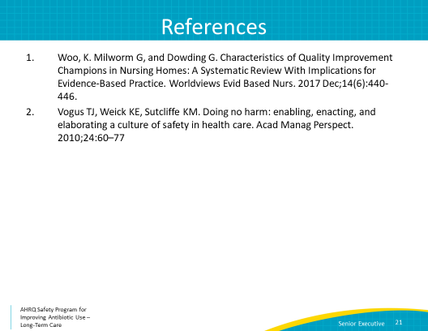
AHRQ Pub. No. 17(21)-0029
June 2021

