Communicating Infectious Concerns With Antibiotic Prescribers
Long-Term Care

Slide Title and Commentary | Slide Number and Slide
Communicating Infectious Concerns With Antibiotic Prescribers  Long-Term Care  SAY:  Welcome to the presentation titled “Communicating Infectious Concerns With Antibiotic Prescribers.” | Slide 1  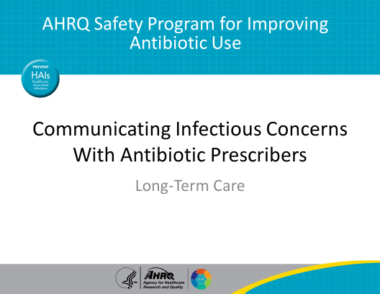
Objectives  SAY:  This presentation will discuss techniques to improve communication between members of the health care team as well as techniques to discuss concerns about potential infections with other health care practitioners.  Communication is the lifeline of a well-functioning team and serves as a coordinating mechanism for strong teamwork. Effective communication skills are vital for resident safety and are an important component of antibiotic stewardship interventions.  First, we will review the SBAR tool we introduced in the presentation, “Improving Teamwork and Communication.” SBAR stands for Situation, Background, Assessment, and Recommendation.  Next, we will walk through some cases that use SBAR to improve the communication between nursing staff and prescribers.  Finally, we will show how the SBAR tool can support the role of nurses as advocates for antibiotic stewardship. | Slide 2  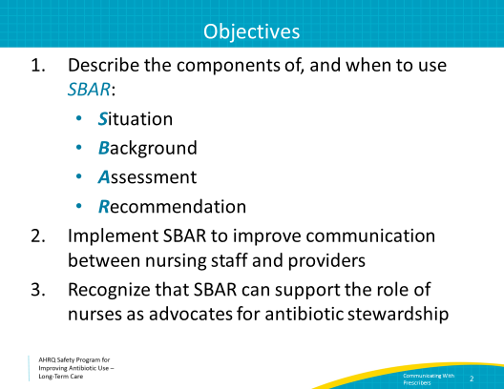
Communication Errors Can Have Disastrous Effects  SAY:  Failure to communicate effectively as a team significantly increases the risk of errors. A 2013 report from The Joint Commission showed that human factors and communication failures were the top two causes of sentinel events. A sentinel event is any unanticipated event in a health care setting resulting in death or serious physical or psychological injury that is not related to the natural course of the patient's illness.  In a survey of 2,000 health care professionals, intimidation was found to be the root cause of medication error. Half of the respondents in that study reported feeling pressure to give a medication for which they questioned its safety but could not effectively communicate concerns. Learning how to improve communication and alleviate this feeling of intimidation can reduce unnecessary prescriptions or medication errors. | Slide 3  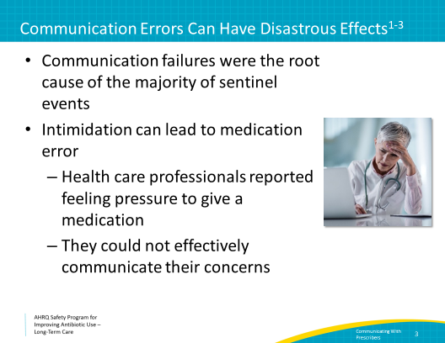
Barriers to Communication in Long-Term Care  SAY:  In long-term care, there are many barriers to communication. Health care practitioners in this setting report a lack of physician openness to communication or a lack of on-site availability of physicians, which may delay responses. They also describe logistical challenges, including no team rooms or private locations to discuss resident issues. Some cite inconsistencies in nurse preparedness, often due to high staff turnover. | Slide 4  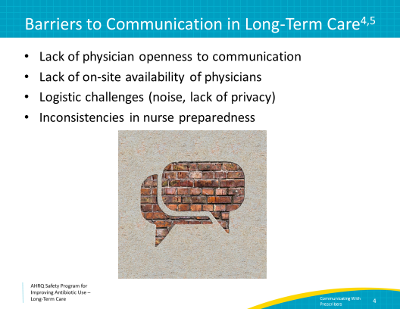
Effective Communication is….  SAY:  There are many challenges to effective communication including an overwhelming workload, frequent shift changes, varying communication styles, or personality differences.  Sometimes it is difficult to overcome these challenges, but it is helpful to remember a few points to improve communication, even in challenging situations.  Effective communication should be complete through ensuring that all relevant information is provided without unnecessary details. It should be clear with use of standard terminology and by checking that the team understands. It should be brief to accommodate heavy workloads and distractions. It should be timely with regular updates to family members and other providers about status changes of the resident. Strive to avoid delays that could compromise a resident’s condition even if you are busy with another activity. | Slide 5  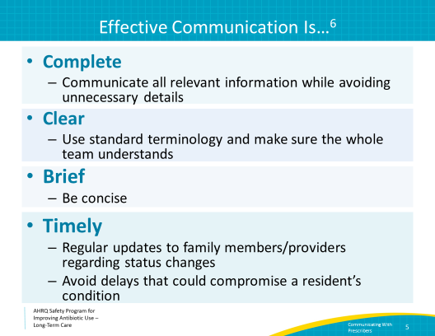
SBAR: Improving Communication in a Brief and Timely Manner  SAY:  SBAR stands for situation, background, assessment, and recommendation. SBAR is a framework that helps to guide communication among medical professionals. We discuss this tool in the presentation titled: “Improving Teamwork and Communication.”  SBAR is a communication style that was developed in the military. The purpose is to communicate in an organized style which is familiar to both the person talking and the person listening.  Using this method helps to present objective information and a complete clinical impression to the practitioner. This, in turn, should help the practitioner develop an informed response regarding changes in patient status.  Let’s walk through the steps. First, the Situation. State who you are calling about and why. Provide a 5- to 10-second summary.  Next, the Background. State briefly what you know about the history and the current status. Include objective data: recent vital signs, pertinent exam findings, and notable labs.  Then the Assessment. State what you think the problem is and how severe it is. A diagnosis is not necessary, but a specific concern should be stated in the assessment.  Finally, offer your Recommendation. State what you think needs to happen for the patient and also suggest a timeframe. | Slide 6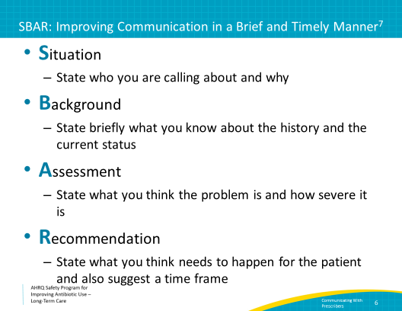
SBAR To Improve Communication  SAY:  A recent study found that nearly 90 percent of nurses who used the SBAR tool found it useful for organizing and communicating information to medical providers.  They reported that SBAR helps them to organize their thinking and feel more confident in communication. | Slide 7  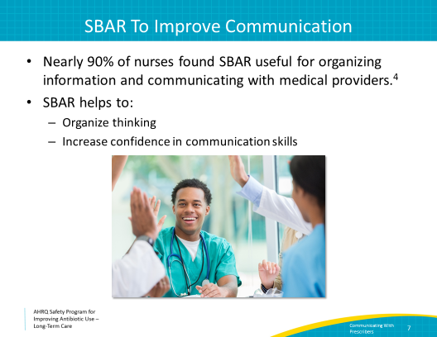
Case 1: Elma R.  SAY:  Let’s put our SBAR skills to use with a case.  Elma is a 92-year-old long-term care resident with a history of a pulmonary embolism. She is on warfarin.  Overnight, she got up and tried to reach the bathroom, but she tripped on the railing of her bed and fell on her hip.  When the nurse found her, she was confused. She did not think she had hit her head. She stated that she wanted to “just go back to bed.” | Slide 8  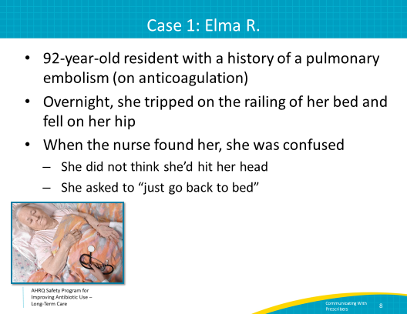
Case 1: Elma R.  SAY:  After the nurse helped Elma get back into bed, she paged the on-call physician to notify him of the event.  He called back about 3 hours later. | Slide 9  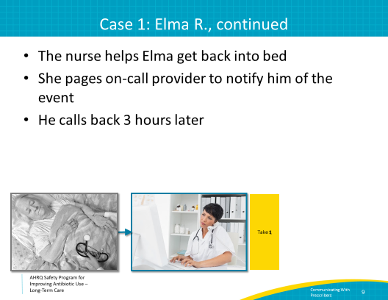
Case 1: Elma R.–Take 1  SAY:  Here is how the initial conversation goes.  Nurse:  Hello Dr. K., I am calling about Ms. R., a 92-year-old long-term care resident here. She fell out of bed tonight. She seemed confused, but we were able to get her back in to bed. She’s sleeping now.  Dr. K.:  She’s confused? Maybe she has an infection. Let’s get a UA and urine culture. You can also get some imaging of her head in the morning if she still seems disoriented.  Nurse:  OK, thank you, I will do that.  The nurse hangs up the phone, but she feels uneasy. Why didn’t Dr. K. ask more questions about the circumstances related to the fall? The resident wasn’t complaining of any urinary symptoms, so it doesn’t seem right to look for a urinary tract infection…but he sounded tired and distracted when he answered the phone, so she didn’t want to alarm him. | Slide 10  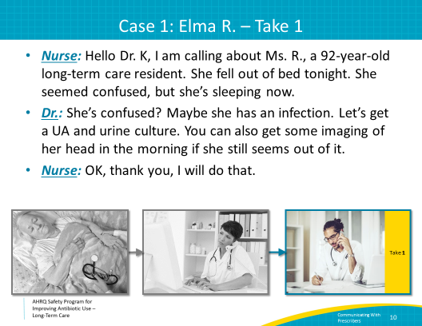
Was This Communication Effective?  SAY:  Let’s think through this communication and talk about what we may have missed.  Overall, was this communication effective?  - No, it was not. The physician did not get all of the needed information, and this could have a significant effect on the resident’s outcome.  Was the communication complete?  - No. The nurse did not provide information about the resident’s anticoagulation status, which is an important point to share, especially in the setting of a fall. She didn’t give any updates about the resident’s vital signs, physical exam, or other symptoms that may have helped to determine if the fall was secondary to an underlying infection.  Was the communication clear?  - No. The physician did not ask any questions. He should have asked about urinary symptoms before sending a urine culture. He also should have asked for basic information following a fall, such as whether she hit her head, if she was in pain, what part of her body she landed on, and if she is on anticoagulation medications.  Was the communication brief?  - Yes. Perhaps too brief in this instance. Given that the physician did not ask all needed questions, the nurse should have followed up with additional important information.  Was the communication timely?  - No. Despite the nurse’s prompt attempt at notification, the provider did not respond to the initial call, so there was a prolonged time interval before the communication occurred. | Slide 11  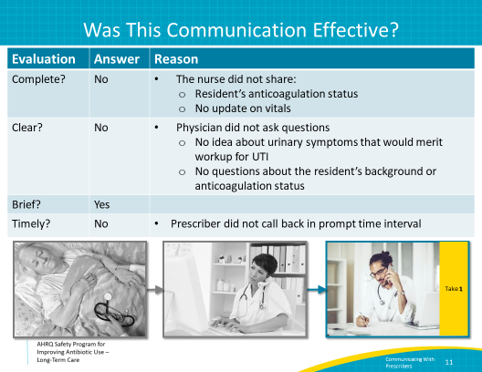
Case 1: Elma R. –Take 2  SAY:  Let’s walk through this again, applying SBAR principles to help guide the discussion.  Situation: Hello Dr. K., I am calling about Ms. R., the 92-year-old resident in room 332. She tripped and fell this evening and landed on her hip; she seems OK but slightly confused.  Background: She has a history of pulmonary embolism, is on warfarin, and has mild dementia. I think she was at her baseline mental status before the fall, and she seems to be at her baseline now. Her vitals are normal, and she did not complain of any symptoms other than pain in her hip.  Assessment: I am concerned because of her anticoagulation status; she is already developing a large hematoma on her hip.  Recommendation: I think she needs to be transferred to the hospital to have some imaging to confirm there is no bleed or fracture involving her hip joint. | Slide 12  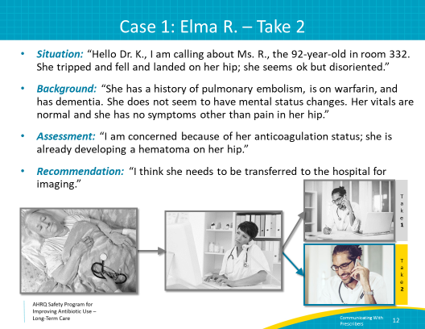
Getting a Response Using SBAR  SAY:  Remember take 1 of this call. The nurse hung up the phone feeling uncomfortable with the response she got from the physician.  Getting a response is also an important component of the SBAR format. You should expect a response from the practitioner, and you may want to suggest the kind of response you would like.  For example, the nurse could also have added: “I think that Ms. R. needs to be evaluated sooner rather than later, and I wouldn’t feel comfortable waiting until the morning.”  It is OK to give these recommendations.  This type of communication sets up the practitioner to offer an effective and appropriate response. He or she may ask for more information or recommend a different course of action. Regardless, the practitioner should be able to make an informed decision. An appropriate response is more likely if initial communication is effective. | Slide 13  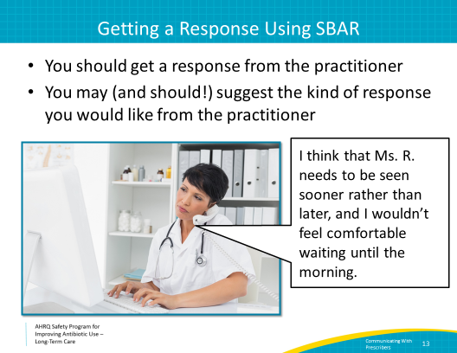
Case 2: Fred B.  SAY:  Elma’s case demonstrates how attention to complete and thoughtful communication can significantly influence the care of residents, including their outcomes.  Consider the following case: The microbiology lab must notify the facility whenever a patient has a culture growing a multidrug-resistant organism so that the resident can be placed on contact precautions.  You get a call saying one of your residents is growing a multidrug-resistant organism in his urine. The resident is not receiving antibiotics and feels fine. His urine was sent over a week ago, but no one on the floor can recall why. | Slide 14  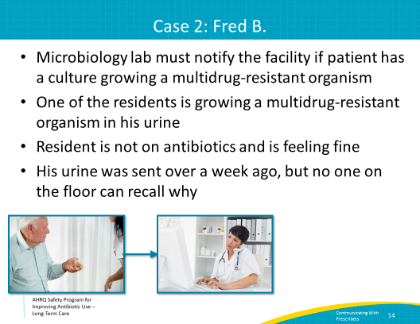
Case 2: Fred B. – Take 1  SAY:  It is Saturday at 8 pm. You call the covering physician to relay the information from the microbiology laboratory.  “This is the nurse for Mr. B. in room 214. The lab just called me and he has an antibiotic-resistant organism growing in his urine culture. | Slide 15  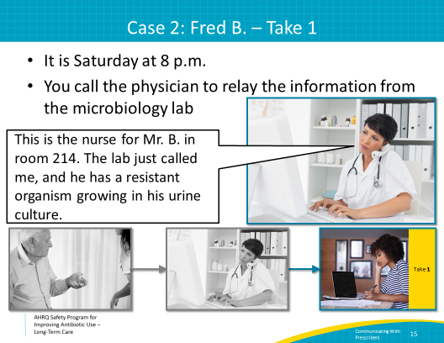
Case 2: Fred B. – Take 1  SAY:  Based on what the nurse relayed to the physician, how would you expect her to respond?  - Come in on the weekend and evaluate the resident. This is unlikely to happen and not necessary at this point, as the resident is feeling fine. If urgent evaluation was needed because the resident was sick, this information would need to be clearly communicated to the practitioner.  - Start an antibiotic. Although not appropriate, this is likely to happen if information regarding symptoms and resident status is not given because the practitioner may assume the resident is sick and start unnecessary antibiotics based on lab results.  - Tell the nurse to wait until Monday and notify the regular practitioner, saying “I’m too busy right now.” While it is probably reasonable to wait until Monday in this situation, telling the nurse they can’t be bothered is never an effective means of communication.  - Ask for more information regarding symptoms. This would be the ideal response as, in this situation, more information is critical to make appropriate decisions. Unfortunately, this may be unlikely unless the nurse sets up the practitioner to ask more questions. | Slide 16  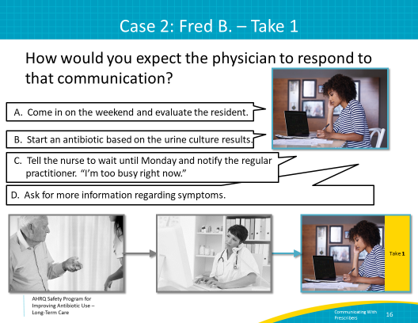
Provider Perceptions Vary  SAY:  In general, when health care practitioners receive a page, they often assume there is a clinical reason for the call.  Without context, a call about a positive urine culture often leads to an antibiotic prescription.  The fact that a nurse has to call to inform someone about the result of a laboratory test because of a policy requirement is not obvious to most health care practitioners. One example of how to frame the communication is to state:  “I’m calling because our policy states I must inform a provider about all positive cultures.”  Knowing this makes it much easier for the provider to understand that the call is not about clinical concerns, but is driven by a fax from the laboratory. | Slide 17  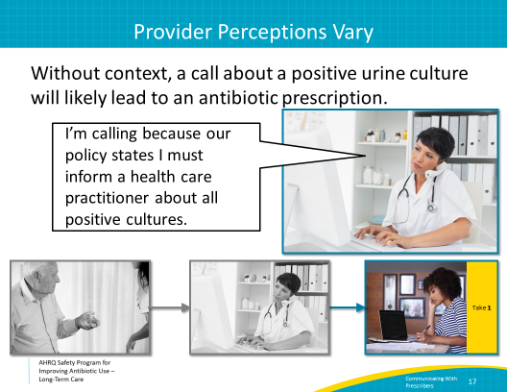
Case 2: Fred B. – Take 2  SAY:  Let’s try that call again using our SBAR format.  Situation: “Hello, I am calling about Mr. B. in room 214. The lab just called to notify me that he has a resistant organism in his urine. I'm calling because our policy states that I must inform the on-call physician about all positive cultures."  Background: Fred is an 83-year-old man with Parkinson’s disease in our long-term care unit. He does not have a urinary catheter. He is not on antibiotics, and no one can recall why the urine culture was sent.  Assessment: He has no signs or symptoms of a urinary tract infection; his vital signs are stable, and he is clinically at his baseline.  Recommendation: I think we should continue to carefully observe him. I placed him on contact precautions, which is our protocol. I don’t see a need to start him on antibiotics at this time. | Slide 18  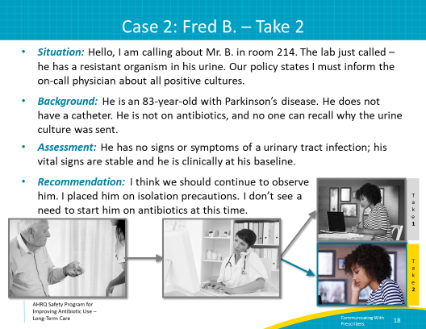
Take 2: The Response  SAY:  While take 1 could allow for any of the previous responses by the practitioner, take 2 provides information in a clear and concise manner.  Consider the previous possible responses the practitioner may take based on the more complete communication offered in take 2.  A. Come in on the weekend and evaluate the resident. Unlikely, as the nurse reassured her this was not necessary.  B. Start an antibiotic based on the urine culture results. Also unlikely—the clear communication and recommendations by the nurse suggest that there is no need to start antibiotics, and the resident will likely be spared unnecessary exposure to antibiotics and potentially harmful side effects.  C. Tells the nurse to wait until Monday and notify the regular practitioner, saying, “I’m too busy right now.” Hopefully, the clinician will be motivated to interact with more effective communication based on what was received, rather than saying he or she can’t be bothered.  D. Ask for more information regarding symptoms. The nurse did a great job providing a thorough assessment of the resident. The health care practitioner may still have some questions, which is good. It means that the SBAR framework laid the foundation for effective, respectful communication.  The most likely response by the practitioner after take 2 would probably sound more like this:  “Sounds good, thanks for the update!” | Slide 19  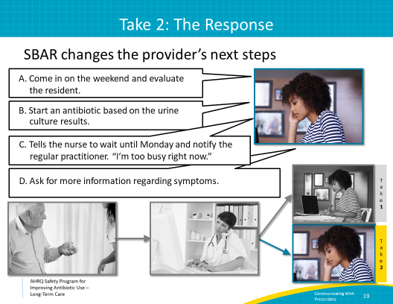
Case 3: Mark P.  SAY:  Let’s discuss a final case. Mr. P is a 75-year-old man with dementia and progressive multiple sclerosis. He has a chronic indwelling urinary catheter for neurogenic bladder.  On Saturday, he had two temperature readings of 99⁰ F and seemed more subdued. Mark felt like he had more pain than usual but is vague about where that pain is located. The nurse reached the on-call practitioner and communicated her impression via SBAR. Together, the nurse and on-call clinician decided on a plan of active monitoring to include vital signs every 4 hours, oral hydration, and acetaminophen for analgesia.  On Sunday, Mark continued to have a temperature of 99⁰ F. The practitioner ordered blood work, a chest x ray, placement of a new urinary catheter, and a urinalysis and urine culture. He also decided to start Mark on oral antibiotics, choosing a 10-day course of amoxicillin/clavulanic acid.  On Monday morning, chest x ray results were available and appeared unchanged from a previous x ray taken 2 months earlier. He is now on day 2 of amoxicillin/clavulanic acid. | Slide 20  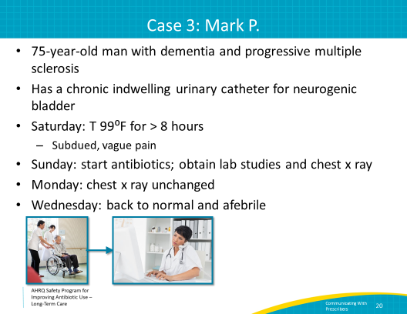
Case 3: Mark P. – Take 1  SAY:  On Wednesday, Mark’s urine culture results come back as negative or no growth. His nurse sees this and reviews Mark’s recent CBC and urinalysis results. The CBC indicated a white blood cell count of 9,200 and the urinalysis showed 67 WBC per high-powered field. She also notes that he has been at his baseline since Monday.  The nurse faxes the urine culture results to the provider’s office. The provider sees them at the end of the day, about 5 minutes before heading home for the evening. Mark receives another 6 days of amoxicillin/clavulanic acid.  Around day 8, he develops diarrhea. The stool is sent to the laboratory to evaluate for Clostridioides difficile infection. Those results come back negative 4 days later, and isolation precautions are discontinued. He has received 10 days of antibiotics.  In this situation, the nurse has kept the provider informed but did not set the provider up to think about stopping antibiotics. | Slide 21  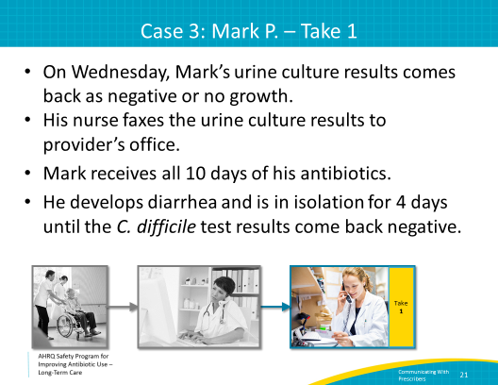
Case 3: Mark P. – Take 2  SAY:  How the nurse communicates Mark’s status to the provider can make a significant difference in Mark’s care.  Faxing the negative urine culture results did not set the provider up to think about stopping antibiotics.  Using SBAR, over the phone or by fax, would likely lead to a different result. Here’s an example of a written SBAR.  S: Mark P., 75 yo with multiple sclerosis.  B: Had a fever of 99⁰F over weekend. Started amoxicillin/clavulanic acid Sunday.  A: Urinalysis with 67 white blood cells per high powered field. He has a chronic indwelling urinary catheter. His urine culture came back negative. Also, his white blood cell count was normal. You may remember his chest x ray is unchanged. No fever since Sunday evening. Back to baseline on Monday.  R: He seems to be better. His labs are normal, except for the WBC in his urine, which he usually has. Should we consider stopping the antibiotics? Today is day 4 of a 10-day course.  The provider agrees to stop the antibiotics and checks up on Mark during her rounds on Friday morning. She thanks the nurse for helping remind her about the antibiotics, and she was glad they decided to stop them.  The nurse was a good advocate for antibiotic stewardship. | Slide 22  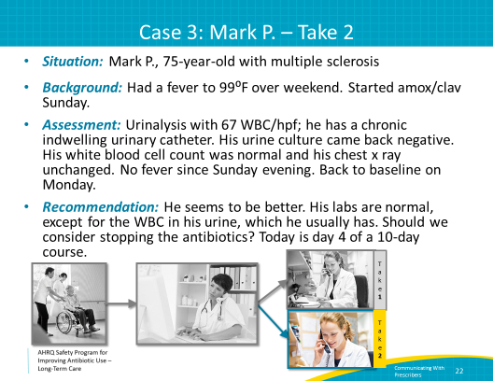
Key Points  SAY:  We have now completed the presentation “Communicating Infection Concerns With Antibiotic Prescribers.” Some key points include:  1. Effective communication is a key component to ensure resident safety.  2. SBAR provides the framework for clear, concise communication about a resident’s status.  3. Your assessment and impression of the resident is a critical part of the communication, and directly affects health care practitioner responses and resident outcomes. | Slide 23  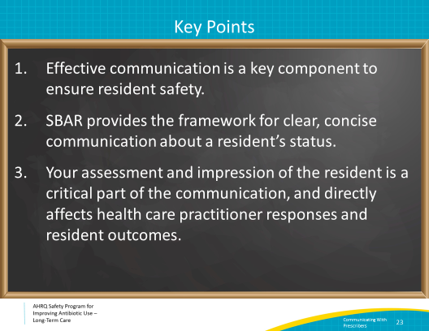
Narrated Presentation  SAY:  There is a narrated presentation available in the Safety Program toolkit for your viewing. It covers the material for Communicating Infectious Concerns With Antibiotic Prescribers. It can be used to train or orient new staff in your facility. | Slide 24  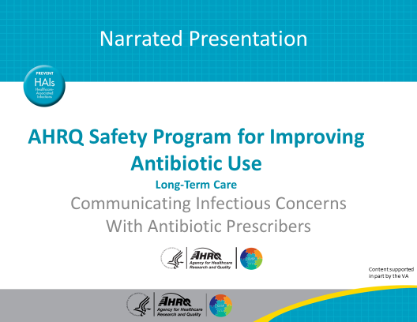
Activities To Complete  SAY:  These are the activities you may want to pair with this presentation, which are intended to help your team stay on track with the overall program.  The Antibiotic Stewardship Team should meet monthly and gather data on interventions.  Distribute the Delirium cards (4x6 and 8½x11) to frontline staff and ask them to review the material. Consider sharing the Delirium cards with residents and families as well. Also, display the Four Questions To Ask Your Doctor or Nurse About Antibiotics in common areas where residents and family members will see them, such as dining and recreation areas.  The Antibiotic Stewardship Team should collect and analyze data using the Monthly Data Collection Form, and frontline staff should apply the Four Moments of Antibiotic Decision Making Form to 5–10 residents each month.  Supporting materials for the activities are listed on the slide and are available on the project Web site. | Slide 25  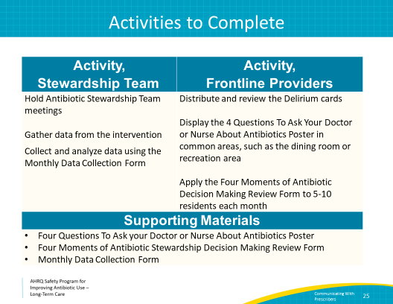
Disclaimer  SAY:  The findings and recommendations in this presentation are those of the authors, who are responsible for its content, and do not necessarily represent the views of AHRQ. No statement in this presentation should be construed as an official position of AHRQ or of the U.S. Department of Health and Human Services.  Any practice described in this presentation must be applied by health care practitioners in accordance with professional judgment and standards of care in regard to the unique circumstances that may apply in each situation they encounter. These practices are offered as helpful options for consideration by health care practitioners, not as guidelines. | Slide 26  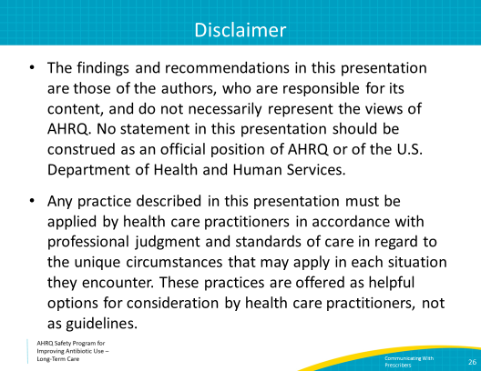
References | Slide 27  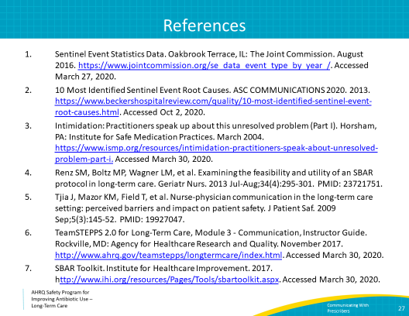

AHRQ Pub. No. 17(21)-0029
June 2021

