Developing an Antibiotic Stewardship Program
Long-Term Care
Slide Title and Commentary | Slide Number and Slide
Developing an Antibiotic Stewardship Program  Long-Term Care  SAY:  Hello and welcome to the presentation, “Developing an Antibiotic Stewardship Program in the Long-Term Care Setting.” | Slide 1
Objectives  SAY:  By the end of this presentation, participants will be able to:  1. Name the goals of antibiotic stewardship and why it is important in the long-term care setting  2. Describe the team members to include in an antibiotic stewardship program or ASP  3. Discuss the potential stewardship interventions in the long-term care setting, and  4. Discuss methods to measure and share outcomes of stewardship interventions in long-term care | Slide 2  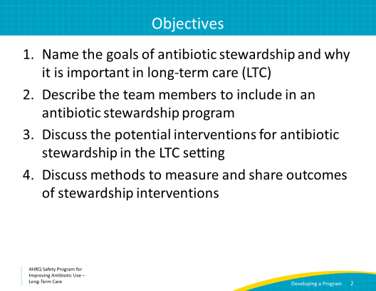
Overuse and Consequences  SAY:  Antibiotic overuse is very common in nursing homes. Up to 75 percent of antibiotics prescribed in nursing homes are considered inappropriate or unnecessary.  The use of antibiotics is not without consequences. Let’s consider some of the possible side effects from antibiotics.  Most people are aware of the risk of an allergic reaction. These can be mild, like an itchy rash, or severe, like anaphylaxis.  Other side effects include loss of appetite, diarrhea, kidney damage, liver damage, cardiac arrhythmias, seizure, confusion or mental status changes.  Receipt of antibiotics can also lead to infection with Clostridioides difficile, or C. difficile, and increase the risk of colonization or infection with an antibiotic-resistant bacteria. Both C. difficile and resistant bacteria can then be transmitted to others. This is one of the most distressing features of antibiotics. Using antibiotics in one person carries risks to people around that person. This is an important concern in the long-term care setting.  These are just some of the side effects that residents can experience from antibiotic exposure, so it is best to avoid these powerful medications when they are not necessary. Antibiotic stewardship can help prevent some of these consequences and protect the residents in your facility. | Slide 3  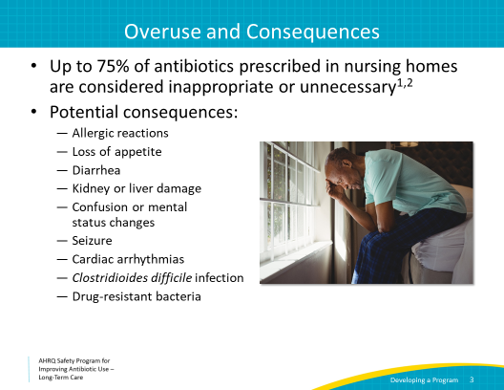
Forming an Antibiotic Stewardship Team  SAY:  Now that we know how important antibiotic stewardship is, let’s get started with forming a team. Depending on the size of the nursing home, the team should be about three to six members. The slide shows examples of potential members of your team. Let’s explore some individuals in your facility who may be a good addition to the antibiotic stewardship team.  The medical director can set standards for antibiotic prescribing practices for all clinical providers in the nursing home and should periodically review antibiotic use and ensure best practices are being followed.  Nurse leaders can help to motivate the nursing team and set standards for the nursing staff and medical assistants for assessing, monitoring, and communicating changes in a resident’s condition.  The infection preventionist has the knowledge and expertise to obtain outcomes and perform quality improvement projects in the facility. This expertise can be essential to support antibiotic stewardship activities.  The consulting pharmacist can help to provide oversight through quality improvement activities such as reviewing medications, monitoring for adverse events or interactions, and reporting antibiotic use data.  Representatives from a resident and family council can share the perspectives of family members who sometimes have strong opinions about antibiotics.  Involving senior executives such as the administrator of the nursing home in antibiotic stewardship is also very important. They can ensure that appropriate funds and time are allocated to antibiotic stewardship activities. Although they may not be core members of the stewardship team, they should be informed of the goals of stewardship and progress being made. | Slide 4
Forming a Team  SAY:  Consider starting with the following individuals for the core members of your team: the medical director, the infection control nurse, and the consultant pharmacist.  Some important qualities of team leaders include:  - A basic knowledge of antibiotics. At least one person on your team should know about antibiotics, but it’s not necessary for everyone to have this knowledge.  - Interest in a leadership role  - Respect of their peers  - Ability to work in teams to listen to feedback and solve problems and, above all,  - Interest in and devotion to improving antibiotic use in nursing homes. | Slide 5
Getting Off to a Successful Start  SAY:  Once you have chosen your team, we have some suggestions for getting your program off to a successful start. First, it is important to schedule regular team meetings. This helps to keep the team on track and make sure you are identifying problems and reviewing the results of your interventions at regular intervals. We recommend scheduling meetings every 2 weeks to start; this can be spaced to once monthly when the program is well established.  A sample meeting agenda for your team meetings is available on the Web site along with an antibiotic stewardship program policy. This policy is only a draft, and your team should adapt it to suit your needs. The document includes a sample letter to help communicate the Antibiotic Stewardship Program Policy to your staff.  Second, we recommend developing a mission statement. This will provide team members with a clear vision of the purpose of the program. It should also be used when sharing the goals of the antibiotic stewardship program with other staff or residents and their family members. Consider the following possible mission statements for your team:  - To ensure that every resident who is prescribed antibiotics receives the right drug, dose, duration, and route of administration.  - To use antibiotics only when necessary, thereby protecting residents from unnecessary antibiotic exposure and antibiotic-associated adverse events.  - To educate the staff and the community about the importance of appropriate antibiotic use in long-term care and to guide them toward this practice. | Slide 6  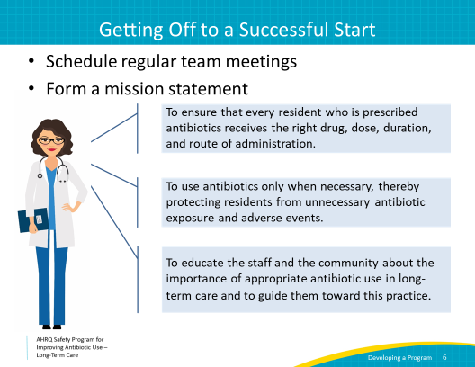
Where To Start  SAY:  Once you have scheduled regular team meetings and formed a mission statement, the next step is to identify problems associated with antibiotic prescribing in your facility. It is important to identify problems in order to target areas that would benefit from change. In other words, each problem can become an opportunity for improvement.  Let’s work through an example.  You meet with your antibiotic stewardship team to brainstorm problems related to antibiotics in your facility. You recall a recent resident who was transferred to the hospital for an INR of >7.  She was on daily warfarin and had received several days of a fluoroquinolone. The high INR was only found because of her regularly scheduled labs—not because laboratory monitoring was set up for her. | Slide 7  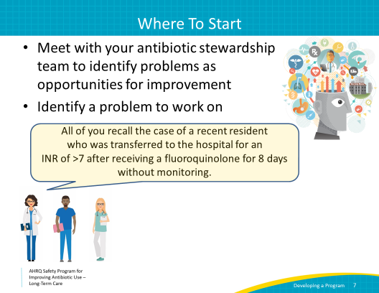
Reviewing the Events  SAY:  As you discuss what happened with your team, it seems there are several opportunities to improve the system. Let’s review the events that may have led to a poor outcome for this resident.  First, there was a clinical event that prompted the antibiotic prescription.  The resident’s son helped her with using the toilet. He noticed that her urine was darker than usual, and he thought he noticed a foul odor, too. He told the nurse that the last time his mother’s urine looked and smelled like this, she was diagnosed with a urinary tract infection, and he asked the nurse to send a culture of the urine.  The nurse sent the urine sample and paged the on-call clinician to sign the order for the culture.  Two days later, the urine culture returned and was growing >100,000 colony forming units per milliliter (CFU/mL) of Gram-negative rods. The nurse again notified an on-call clinician, who wrote an order for ciprofloxacin. The patient was started on ciprofloxacin that night.  Eight days later, an INR was sent for the patient’s routine monthly blood check, and it came back as greater than 7. She was sent to the emergency department. | Slide 8  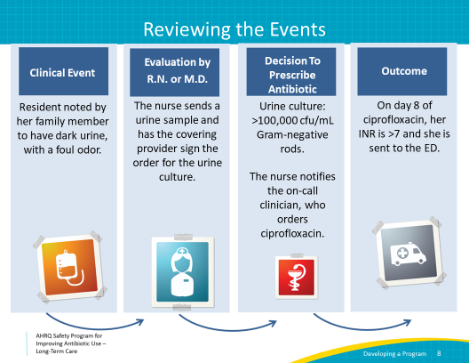
Identifying the Problems  SAY:  Let’s consider some problems in the events leading to this antibiotic prescription and the resident’s outcome.  We’ll start with the clinical event. The resident’s son notices a foul urine odor and change in color. He asks the nurse to send a urine culture. Here, the nurse did not discuss the indications for sending a urine culture or the potential side effects of antibiotics with the resident’s family member. Without signs and symptoms of infection, it is not indicated to send a urine culture for changes in appearance or smell of the urine. | Slide 9  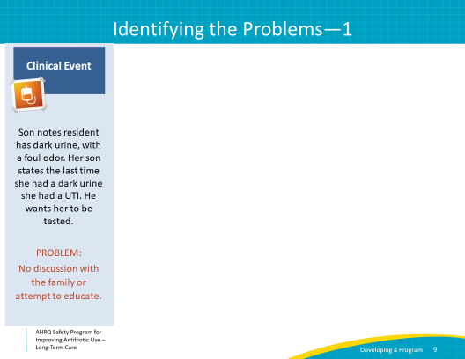
Identifying the Problems  SAY:  Once the clinical event occurs, it is important that the resident be evaluated by the nurse or a clinician. In this series of events, the nurses did not assess the resident, and the on-call provider did not ask for information regarding urinary signs or symptoms or otherwise attempt to evaluate the resident. The order is signed without using diagnostic criteria to determine whether the resident has signs or symptoms of an infection. | Slide 10  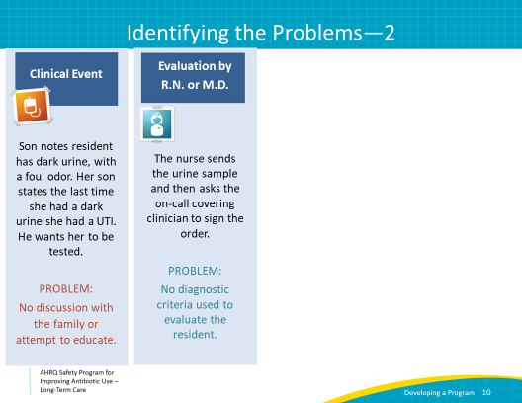
Identifying the Problems  SAY:  Two days later, after the culture results return, a different on-call provider is notified. The nurse does not assess the resident. The on-call provider orders a prescription for ciprofloxacin without asking if the resident is having signs or symptoms that would suggest a urinary tract infection or UTI.  Additionally, the on-call provider does not acknowledge the recommended duration of treatment for a suspected UTI and he does not write an end date on the prescription. Also, he does not consider the possibility for potential drug-drug interactions with the resident’s existing medications. This is also not detected by the pharmacy. | Slide 11  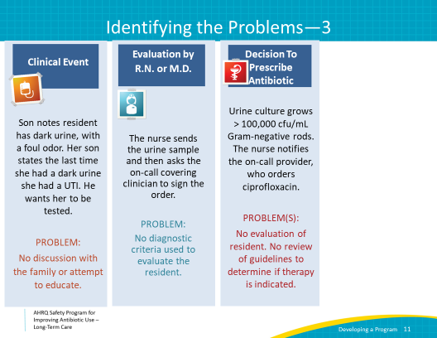
Identifying the Problems  SAY:  Eventually, the resident gets a routine check of her INR level, and it is dangerously high. At this point, she has been on antibiotics for 8 days. Her usual clinician was not notified of the new prescription, and there was no followup on the urine culture results to determine if the organism was sensitive to ciprofloxacin or if it could be narrowed to a medication with fewer side effects. There was also no clinician reassessment to determine if she needed the antibiotic in the first place.  Additionally, there was no followup with the resident to determine her response to antibiotics. Some other problems include the following:  - No discussion with the family or attempt to educate about signs or symptoms associated with urinary tract infections  - No clinical assessment or diagnostic criteria were used to evaluate the resident’s symptoms  - Phone prescribing without considering whether antibiotic therapy is indicated  - No stop date on the antibiotic  - No post-prescription monitoring for drug-drug interactions  - No followup on culture results to modify therapy  - No followup on the resident to note her response to antibiotics  - After hours prescribing; no notification to the daytime/usual clinician of the new prescription | Slide 12  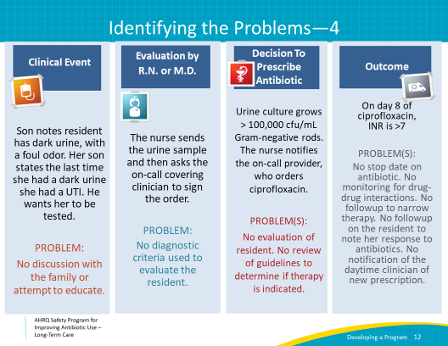
Identifying the Problems  SAY:  These are all opportunities for improvements in the system that may have led to a poor outcome for this patient. It can be helpful to separate the events into “pre-prescriptive” events, which are the events prior to the antibiotic prescription, and “post-prescriptive” events, which are those that occur after the prescription is written.  Post-prescriptive events are an important part of antibiotic stewardship. Reviewing culture results, narrowing or stopping therapy when indicated, and monitoring for side effects are just as important as preventing an unnecessary prescription from being written in the first place. | Slide 13  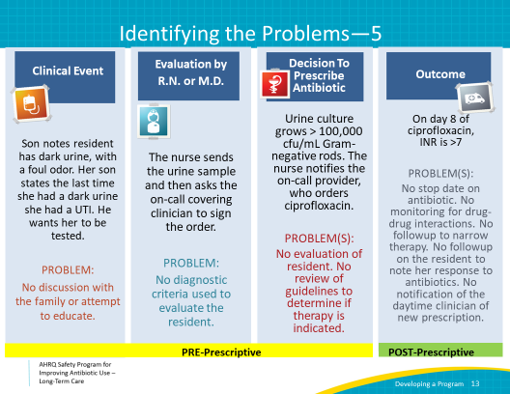
How to Start  SAY:  Now that we have identified problems in the system that may have led to the inappropriate antibiotic prescription, we can start to consider interventions to prevent this from happening in the future.  We recommend starting small and going for easy wins. This brings early success to your team, generates excitement and builds cultural and institutional support.  In our example case, you and the team choose to focus on two post-prescriptive problems.  One is to monitor for drug-drug interactions related to antibiotics. The second is to notify the primary clinician of any new antibiotic prescriptions ordered by an on-call or covering clinician. As you think about how to address the problems, consider how to change the system to make improvements. | Slide 14  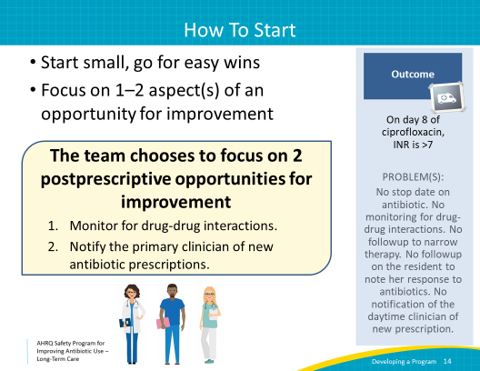
Baseline Data  SAY:  In order to develop and track outcomes of an intervention, it is important to start by collecting baseline data. What kind of baseline data would be helpful to better understand the two problems your team wants to work on?  After talking with your team, you decide to collect data on the following information:  To evaluate baseline monitoring for drug-drug interactions, you decide to count the number of antibiotic courses started on residents who were also on warfarin in the last month.  To understand how often covering clinicians start antibiotics, and how often regular clinicians are notified, you decide to count the number of antibiotic courses started by a covering clinician in the last month.  Getting these baseline data will help to give you an idea of the scope of these two problems at your facility. | Slide 15  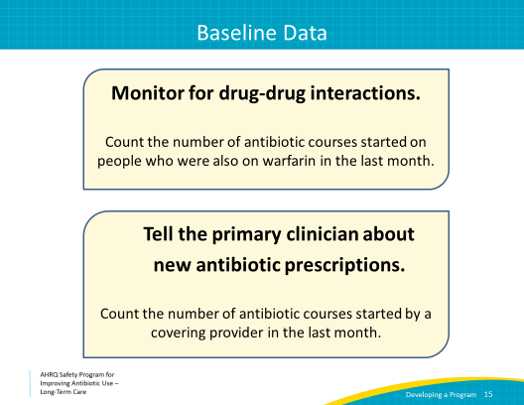
Baseline Data Collection  SAY:  After reviewing patient charts and obtaining your baseline data over the last month, you discover that in your facility—  - 12 antibiotic prescriptions were started,  - 8 by a covering clinician, and  - 3 of those were with residents on warfarin.  - There’s no indication based on chart review that anyone considered the potential for drug-drug interactions.  - Also, there was no process in place to notify the regular clinician about new medications started by the covering clinician.  Based on these data, your team has a sense of the scope of the problem. | Slide 16  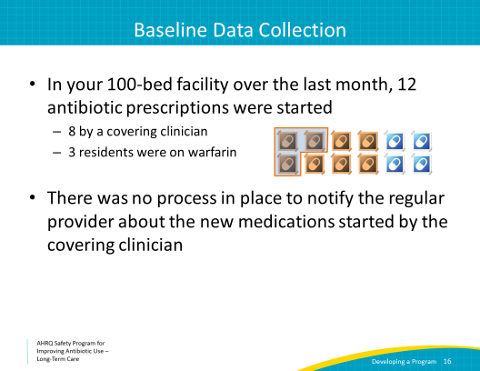
Intervention  SAY:  Your team decides to develop an intervention. We suggest that you develop a set of procedures and communicate those changes to introduce the intervention before actually implementing the changes. On the AHRQ Web site, in the Nursing Home Antimicrobial Stewardship Guide Toolkit, you will find Tool 5. Draft Policies and Procedures for the Antimicrobial Stewardship Program. This document outlines developing a new antibiotic stewardship procedure for your facility. It includes a sample letter to help communicate those changes to your staff. The same document also contains the draft Antibiotic Stewardship Policy.  You decide to develop an intervention in which the dispensing pharmacist sends an alert via an email to the regular clinicians about all antibiotics started by an on-call or covering provider. Your team notifies the clinicians about this new policy and the reason for the change via an email and signs posted in charting areas. Your team also confirms that the dispensing pharmacist has the email and pager numbers for the regular clinicians. The team asks the pharmacist to keep a file of the emails sent. | Slide 17  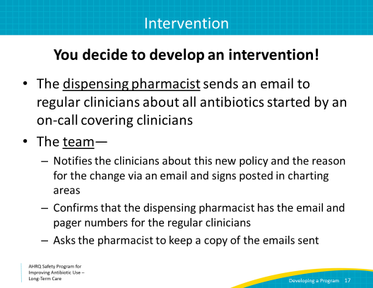
Outcomes  SAY:  The outcome of this intervention was a success! At the end of the month, the team reviews antibiotic starts and compares the number of changes and adjustments made by the regular clinicians.  After reviewing the charts, they find that the regular clinicians reviewed all of the antibiotic prescriptions and they stopped or changed the antibiotics in five of eight cases. Over half of the cases had problems that the clinicians addressed.  This is a great success and your team should feel proud of themselves. They should also congratulate the clinicians who reviewed and stopped or changed antibiotics and especially the dispensing pharmacist for her hard work. | Slide 18
Sharing/Distribution/Reporting  SAY:  Sharing the results of your intervention is just as important as implementing the intervention and obtaining outcomes. Telling the long-term care staff about positive outcomes sends a powerful message. Your team is sharing and celebrating success. It helps others learn about the antibiotic stewardship team and gets them excited. This in turn will help sustain changes and keep people interested in helping future interventions.  Consider sharing your results with the following stakeholders of the nursing home:  - Nursing home staff. Communicating results to the frontline staff helps to show progress and remind them that stewardship is an ongoing effort.  - Prescribers and other clinicians. Letting all clinicians know about the improvements lets them know about the success of your team and also lets them know that what they do—that is how they care for the residents—matters.  - Nursing home leadership, including the director of nursing, the medical director and administrator. It is important that leadership at the facility knows about changes to the system and the outcomes of those changes. A reduction in adverse events means improved resident safety and sometimes cost savings. These positive outcomes may bring further support for your antibiotic stewardship program.  - Centers for Medicare & Medicaid Services. As part of their Quality assurance and performance improvement, or QAPI, programs, nursing homes are expected to identify problems and work to fix them. Reporting your interventions can support your nursing home’s QAPI program and satisfy regulatory requirements.  - Residents and family members. It is always helpful for residents and family members to know that your facility is always working to improve. This will give them confidence in your ability to provide good care and help spread the word about antibiotic stewardship. You might decide to share the results in newsletters, meetings, posters, emails, or social media. | Slide 19  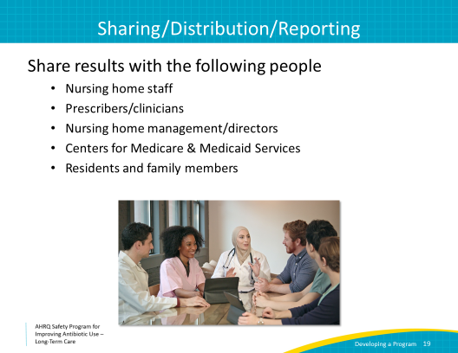
Pre-prescriptive Interventions  SAY:  The work of the antibiotic stewardship team does not stop here. Implementing the intervention can help the team to develop and brainstorm more ideas for the next project.  Today’s example focused on post-prescriptive process. Here are some examples of pre-prescriptive interventions you could consider in your facility.  - Checklist of signs and symptoms for nurses to use before calling a clinician about a resident with a change in status  - Prescribing guidelines distributed to staff and clinicians  - Pocket cards distributed to staff indicating minimum criteria for starting antibiotics  - Electronic medical record “stops” to notify clinicians if a resident does not meet criteria for antibiotic therapy or needs monitoring  - Dose recommendations for residents with decreased kidney function  - Requirement that all antibiotic orders have an indication, dose, and duration | Slide 20  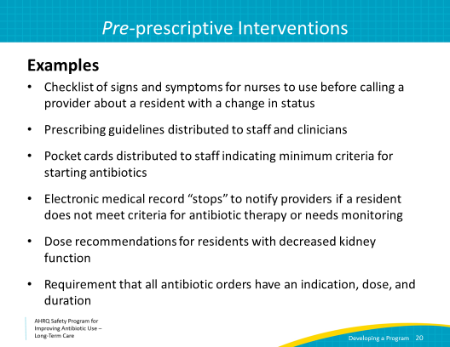
Post-prescriptive Interventions  SAY:  Here are some other options for post-prescriptive interventions which may be useful in your facility.  - Automated or pharmacy instituted antibiotic “time out” at 48 or 72 hours. This would require the prescriber to reassess antibiotic prescriptions and verify the need to continue them.  - Review the results of cultures and diagnostic tests to make sure antibiotics are necessary and effective  - Formal review of “appropriateness” of antibiotic prescriptions by infectious diseases trained consultants 24 to 72 hours after the initial prescription. These consultants can be pharmacists or physicians. | Slide 21  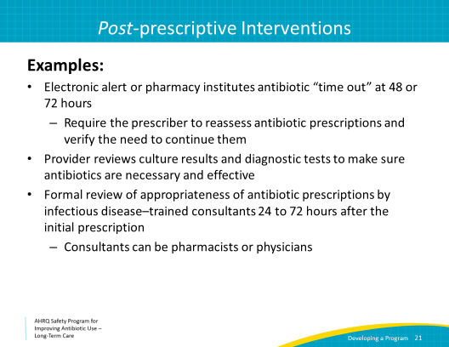
Outcome Measures for Post-prescriptive Interventions  SAY:  Here are examples of measures for antibiotic use and outcomes related to antibiotic use. These can be used to monitor progress with the interventions you have chosen.  - Number of antibiotic starts per 1,000 resident-days  - Days of antibiotic therapy per 1,000 resident-days  - Length of therapy  - Cost of antibiotics  - Use of guideline-concordant antibiotics  - Clostridioides difficile infection rates  - Adverse events related to antibiotics | Slide 22  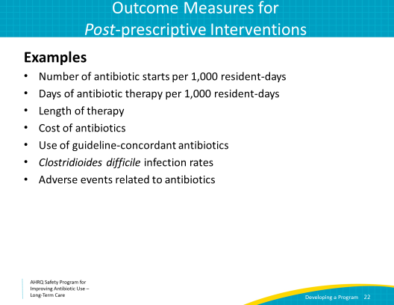
Summary  SAY:  Let’s summarize the pathway to developing an antibiotic stewardship program.  First, identify people to be part of the antibiotic stewardship team. We identified key qualities to look for in the core members of your team. In the Nursing Home Antimicrobial Stewardship Guide Toolkit you can find the document titled, Tool 1. Start an Antimicrobial Stewardship Program to see further guidance.  Second, schedule meetings and identify problems that may lead to inappropriate antibiotic prescriptions in your facility. Reframe the problems as opportunities for improvement. You can access a sample planning agenda, Tool 4. Implementation Planning Sample Agenda, and sample policies, Tool 5. Draft Policies and Procedures for the Antimicrobial Stewardship Program, on the Nursing Home Antimicrobial Stewardship Guide to bring to your first meeting. Remember to start small and go for easy wins.  Third, select one problem and collect baseline data before starting an intervention. Find the data collection sheet on the Web site to collect your antibiotic usage data. This can be easily uploaded to the website on a monthly basis throughout this project.  Fourth, use this baseline data to plan the intervention and inform the nursing home staff and leadership of your plan. Ideas for potential interventions and ways to measure your outcomes are provided in the intervention worksheet. Bring this to the meeting and brainstorm ideas based on the needs in your facility. Refer to the sample policy letter, which can be sent out to staff educating them on your plans for an intervention.  Fifth, start the intervention and collect outcomes to compare to your baseline data. Antibiotic tracking sheets and monthly summary reports are located on the AHRQ Safety Program Web site. They will help you to collect and track your outcomes.  Sixth, it is important to share your outcomes with nursing home stakeholders so that you can fuel future interventions and sustain your outcomes. And celebrate your successes!  Finally, keep meeting as a team to brainstorm new interventions and further develop your Antibiotic Stewardship Program. | Slide 23  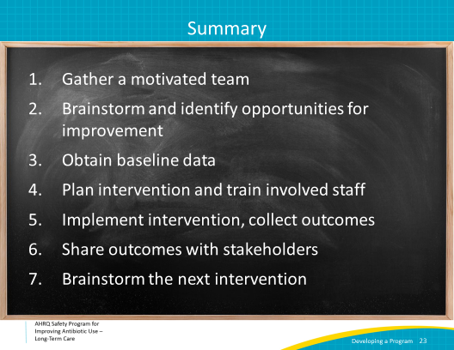
Review Steps and Resources  SAY:  This slide contains links to resources to help you with steps 1 through 6. | Slide 24  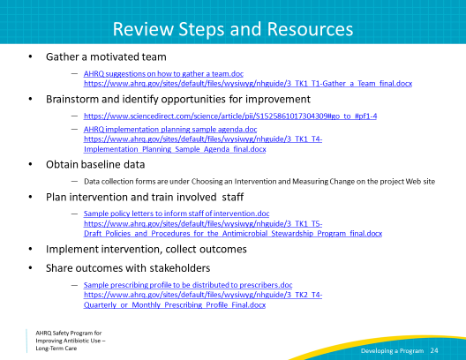
Activities To Complete  SAY  Shown here are some activities you may want to pair with this presentation. These suggested activities are intended to help your team pair action items to each presentation as you develop your stewardship program.  Your Antibiotic Stewardship Team should include at least three motivated individuals. The infection preventionist is an important and necessary part of the team. Consider also the medical director or designee, other prescribing clinicians, and the consulting pharmacist. Schedule an ASP meeting within the next 2–3 weeks, unless you already have a regularly scheduled ASP meeting. During this meeting, develop a mission statement and brainstorm an intervention based on identified problems.  In addition, ask frontline clinicians to sign the Commitment Poster and hang it somewhere where most people can see it. These activities could be led by the Antibiotic Stewardship Team and are a great way to introduce the team to the rest of the building.  Supporting materials for the activities are listed on the slide and are available on the toolkit Web site. | Slide 25  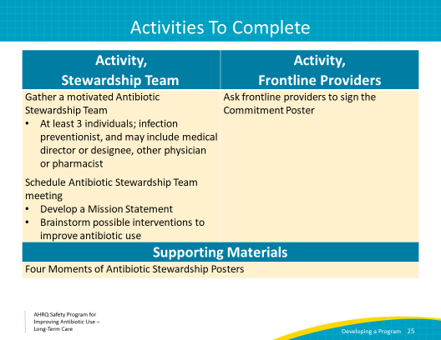
Disclaimer  SAY:  Disclaimer:  The findings and recommendations in this presentation are those of the authors, who are responsible for its content, and do not necessarily represent the views of AHRQ. No statement in this presentation should be construed as an official position of AHRQ or of the U.S. Department of Health and Human Services.  Any practice described in this presentation must be applied by health care practitioners in accordance with professional judgment and standards of care in regard to the unique circumstances that may apply in each situation they encounter. These practices are offered as helpful options for consideration by health care practitioners, not as guidelines. | Slide 26  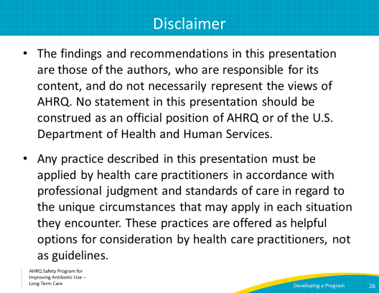
References | Slide 27  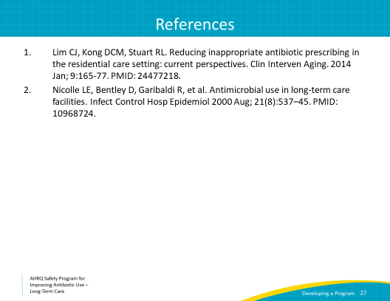

AHRQ Pub. No. 17(21)-0029
June 2021

