Sustaining Your Antibiotic Stewardship Program
Long-Term Care
Slide Title and Commentary | Slide Number and Slide
Sustaining Your Antibiotic Stewardship Program  Long-Term Care  SAY:  Welcome to this presentation, titled “Sustaining Your Antibiotic Stewardship Program.” | Slide 1
Objectives  SAY:  The objectives of this presentation are to discuss how to continue to sustain your antibiotic stewardship program (ASP) to ensure continued positive results;  discuss approaches for identifying new stewardship targets; and discuss the personnel and resources that are necessary to sustain your stewardship program. | Slide 2  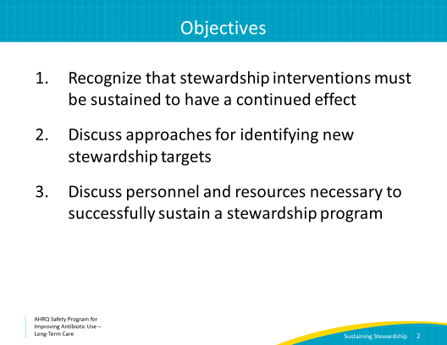
Evidence Review  SAY:  In order to guide the content included in the AHRQ Safety Program, a review was completed of published antibiotic stewardship interventions that have been tested specifically in long-term care settings.  Results of an analysis of 20 published interventions provided the basis to select specific educational tools and suggestions to build a successful stewardship program.  First, interventions that aligned local policy and published guidelines were more likely to have lasting results. This means that any interventions instituted by a facility focusing on urinary tract infections (UTIs), as an example, should align with both published recommendations, such as the revised McGeer criteria for diagnosing UTIs, as well as any State requirements relating to UTI diagnosis and reporting. This ensures that staff are not tasked with meeting two separate requirements, which leads to confusion and increases workloads.  Second, stewardship programs that provided some type of individualized feedback to health care practitioners were more likely to be sustained. Teaching clinicians about their individual practices may help them understand what was done well and where there was room for improvement. It also reminds them that their clinical decisions are noticed and meaningful.  Third, interventions aimed at feasible targets, such as focusing on one particular syndrome, were more likely to have positive, sustainable results. This is likely because it is challenging to address everything at once. Starting small and celebrating successes is a realistic approach to building a stewardship program over time. | Slide 3  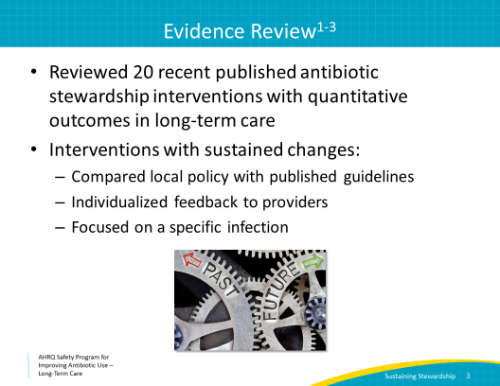
Intervention for Catheter-Associated Asymptomatic Bacteriuria  SAY:  The following is an example of a successful intervention that employed the second and third points. An intervention to reduce unnecessary antibiotic prescriptions for catheter-associated asymptomatic bacteriuria occurred at several acute care units and nursing home units.  The intervention included prescriber-level feedback and focused on a specific syndrome. Participating sites assigned to the intervention arm were provided with prescriber-specific review and feedback of catheter-associated UTI (CAUTI) treatment practices (otherwise known as audit and feedback). This was in contrast to the control sites, which were provided didactic slides about treatment of CAUTIs without individualized prescriber feedback.  In all participating units, the intervention and the didactic education were directed at both nurses and prescribers. | Slide 4  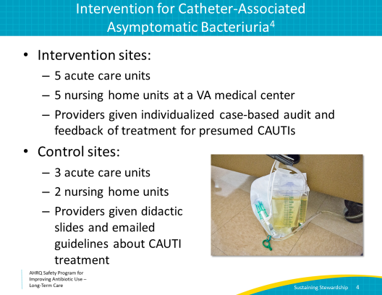
Monthly Rates of Urine Cultures per 1,000 Bed-Days  SAY:  The graph shows changes in the rates of urine cultures ordered in both study arms. Time is on the horizontal axis and includes a 3-year period. The investigators started collecting and analyzing data in July 2010 and the intervention began in July 2011. The vertical axis measures the rates of urine cultures sent per 1,000 patient bed-days, and the two vertical lines divide the graph into baseline, intervention, and maintenance (or post-intervention) periods.  The intervention resulted in a significant reduction in the number of urine cultures sent. This translated to a reduction in treatment of asymptomatic bacteriuria as well as a reduction in total antibiotic use, particularly of fluoroquinolones, which are an antibiotic class commonly misused in the long-term care setting.  The reduction in unnecessary urine cultures was sustained, even after the intervention period was over. | Slide 5  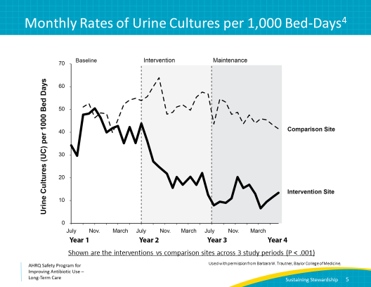
Case 1: Identifying the Problem  SAY:  Let’s discuss a case.  Lisa is the director of nursing at a small long-term care facility in Maryland.  When reviewing antibiotic prescriptions in her nursing home over the previous month, she noted that her facility had especially high rates of fluoroquinolone prescriptions.  At the next antibiotic stewardship team meeting, she raised her concern and the stewardship team decided to collect baseline antibiotic prescribing data on fluoroquinolone usage to determine what was driving this practice. They wanted to see if the high number of fluoroquinolone prescriptions was being driven by a single practitioner or if fluoroquinolones were frequently being prescribed to treat specific types of infections, like respiratory infections or UTIs, across prescribers. | Slide 6  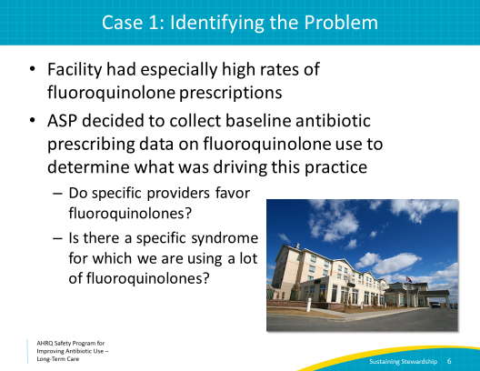
Case 1: Formulating the Intervention  SAY:  After evaluating the baseline data, Lisa and her team realized that over 60 percent of fluoroquinolone prescriptions in the facility were coming from one practitioner.  The stewardship team decided that individualized prescriber review and feedback would have the most impact as an initial intervention.  They created an individualized prescriber portfolio that educated each prescriber about his or her antibiotic prescribing practices. This was distributed to all prescribers. They also developed diagnostic and treatment protocols for UTIs and respiratory tract infections that detailed recommended antibiotics and durations of therapy. The protocols, in accordance with local and national guidelines, did not recommend fluoroquinolones as first-line treatments. | Slide 7  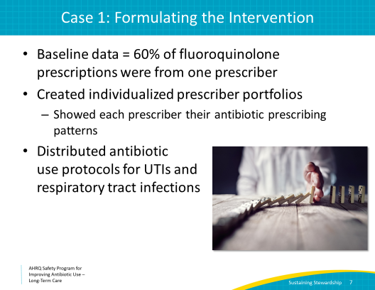
Example of Individualized Feedback  SAY:  Here is an example of the individualized feedback that Lisa and her stewardship team provided to Dr. A.  Notice the differences in his prescribing practices for UTIs when compared with other prescribers in the facility. Dr A. prescribes more ciprofloxacin, a fluoroquinolone, than any other health care practitioner.  Showing data like this to prescribers, along with an evidence-based protocol with recommended antibiotics, can change prescriber practices. Feeding back prescriber specific data should continue to occur periodically to have a sustained impact. | Slide 8  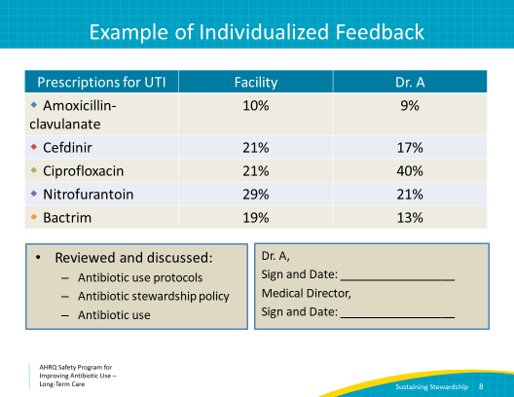
Another Example  SAY:  Here is another example of prescriber review and feedback. This shows the percentage of time that Dr. A appropriately documented the dose, duration, and indication for antibiotic therapy. Compared with his peers, who did this about two-thirds of the time, Dr. A documented this information for all of his prescriptions. So he is doing well from a documentation standpoint. The data also show how frequently he ordered a urine culture prior to initiating antibiotics for a UTI. It indicates there is room for improvement.  The table illustrates Dr. A’s median antibiotic duration of therapy compared with other prescribers in the facility. In general, he seems to favor longer courses, so this is another opportunity for improvement.  The stewardship team should provide feedback at least annually. The team should document how and when this feedback is given, which can be achieved using the boxes at the bottom of this example. Prescribers should acknowledge receipt of feedback in writing so it is clear that the data were reviewed and acknowledged.  Sharing this type of data with your clinicians demonstrates that your facility is monitoring antibiotic use, providing feedback to prescribers as well as to the facility at large, and evaluating adherence to diagnostic and treatment protocols. Sharing these data will underscore your facility’s dedication to antibiotic stewardship. It will also support the facility’s efforts to fulfill the antibiotic stewardship requirements implemented by the Centers for Medicare & Medicaid Services (CMS) in November 2017. | Slide 9  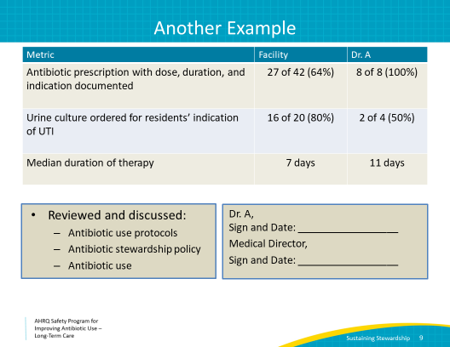
Antibiotic Use Protocols  SAY:  Distributing diagnostic and treatment protocols will provide clinicians guidance to incorporate best practices into their daily workflow.  Consider focusing on common infections encountered in the nursing home. Protocols should include information about how to evaluate someone for a specific infection, including which diagnostic tests to order, whether to treat an infection before obtaining the results of diagnostic testing (i.e., empiric therapy), appropriate antibiotic choices, and recommended durations of therapy.  Remember that antibiotic use protocols are most helpful if you match local policy and guidelines with national recommendations. These can be adapted from resources such as the Loeb minimum criteria for starting antibiotics, the revised McGeer criteria, or the AHRQ Nursing Home Antibiotic Stewardship Guide, Toolkit 2. | Slide 10  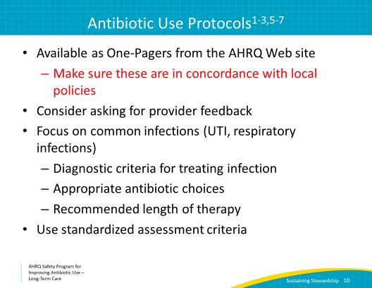
Adapt Materials  SAY:  Information from the presentations as well as the materials listed under “tools” in the Safety Program toolkit might give you some ideas for protocols to circulate in your facility. These can be adapted to serve the specific needs of your facility.  Choose tools and materials that will help address prescribing errors that you identify as common at your facility. | Slide 11  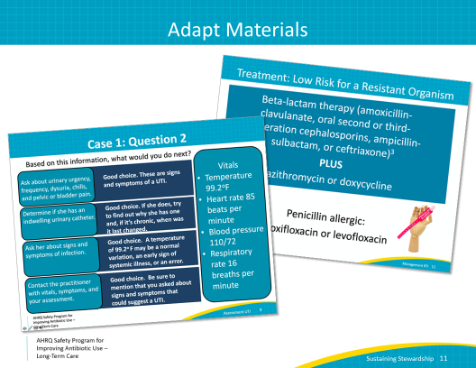
Case 1: Results  SAY:  Thanks to the hard work by Lisa and the antibiotic stewardship team, the followup data show a significant reduction in fluoroquinolone prescriptions and durations of antibiotic therapy.  It is important to share these results with stakeholders, staff, and the administration. This improves buy-in and shows everyone that their hard work is making a difference, which in turn increases sustainability. | Slide 12  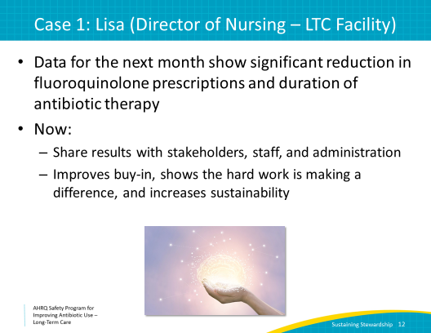
Share Your Successes!  SAY:  The antibiotic stewardship team sent out a newsletter showing the difference in prescription practices before and after the intervention.  The chief executive officer reviewed the newsletter and awarded Lisa employee of the month for all of her hard work and coordination with the team.  Other employees in the facility saw Lisa’s commendation for her hard work and were motivated to continue stewardship efforts as they recognized and appreciated the support from leadership. | Slide 13
Monitor Antibiotic Use and Resistance  SAY:  In order to sustain your stewardship program, it is important to set up a system to monitor and measure antibiotic use and resistance.  In the initial case, Lisa reviewed antibiotic prescriptions and noticed a flaw in antibiotic prescribing. Setting up a regular practice to monitor antibiotic prescriptions can help to identify issues before they become a problem and provide the impetus to develop solutions.  Consider designating an individual to review antibiotic prescriptions (1) upon admission, (2) at the time of return from a hospital or emergency department, (3) started overnight or on weekends by covering practitioners, and (4) during a monthly medication review. Some of this work may be performed by the consultant pharmacist.  Your lab should have information on resistant bacteria identified in both clinical and surveillance cultures. We encourage your facility to develop a tracking process to monitor rates of resistant bacteria in order to detect potential outbreaks or changes in the resistance patterns that may necessitate changes to antibiotic treatment protocols. | Slide 14  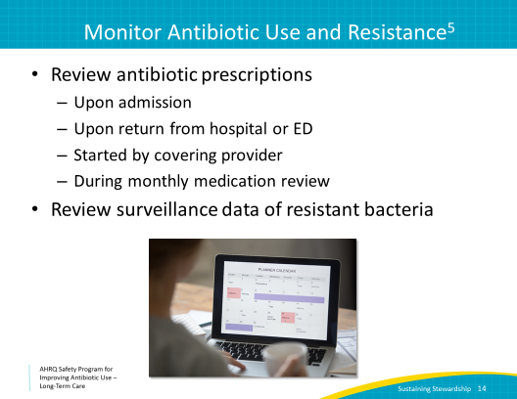
Measure Antibiotic Use  SAY:  Measuring antibiotic use can be challenging, but if you set up a method and adhere to it, the process becomes easier over time. Having these data are vital to the success of your stewardship program.  There are several ways to measure your antibiotic usage, and all have pros and cons.  Days of therapy allows you to measure the total burden of antibiotic use in the facility, and it tracks changes in overall use, but it does not specifically indicate the median duration of individual treatment courses, and it can be labor intensive.  Antibiotic starts have been commonly used in long-term care settings. Antibiotic starts can be relatively easy to track and provides a general measure of the frequency of prescribing, but it does identify the total antibiotic burden.  Some facilities may only track prescriptions that have a duration of greater than 7 days. This can be helpful to monitor lengthy prescribing practices, but it doesn’t provide data on antibiotics discontinued before 7 days.  While there are pros and cons to all of these measurements, it is important to measure one or two of them. This is a necessity for CMS mandates. Also, having a tracking mechanism is essential to allow your program to detect improvements and celebrate successes. | Slide 15  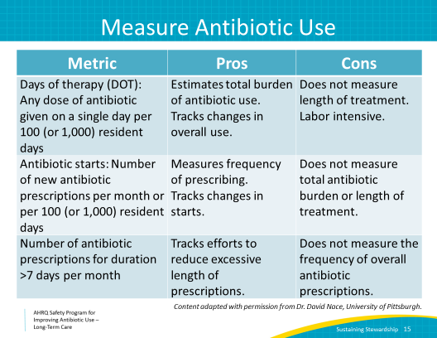
Feedback: How and What To Distribute  SAY:  Now that you are familiar with various ways to measure antibiotic use data, let’s discuss how to distribute and report data to your clinical staff.  Reporting data back to staff members after interventions occur is a key component of sustaining change.  Measuring and reporting antibiotic use data underscores to all staff that your facility values antibiotic stewardship and also provides the data needed to request ongoing support from leadership.  Consider written reports to the staff summarizing educational initiatives by the stewardship team on at least an annual, but preferably a quarterly basis. Written reports could include data on facilitywide antibiotic use, class-specific antibiotic use (e.g., fluoroquinolones), compliance with protocols, and the prevalence of resistant organisms in the facility.  Also, as stated earlier, consider reports to individual prescribers on at least a yearly basis. This should include feedback on the prescriber’s antibiotic use and compliance with protocols related to diagnosing and treating infections. Prescribers should provide written acknowledgment of this feedback to close the communication loop. | Slide 16  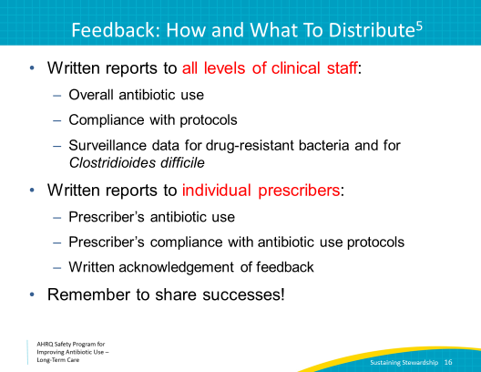
Pair Feedback With Appropriate Education  SAY:  Both institution-level and prescriber-level feedback is most meaningful if it is linked to education and strategies for staff and prescribers to improve their practices. They may simply be unaware of antibiotic use protocols.  Antibiotic use protocols should be distributed to prescribers and nursing staff regularly and should be updated as new evidence becomes available. Consider distributing protocols via email or as pocket cards or signs displayed in charting rooms. This is important for the general education of your staff as well as for surveyors who may be evaluating your stewardship program.  Additionally, antibiotic stewardship education should be part of an annual training course for all levels of staff.  Involvement of residents and family members is also important. Without their support, following antibiotic protocols will be challenging. Displaying Antibiotic Commitment posters that are available in the Safety Program Toolkit and training staff to discuss the risks and benefits of antibiotic therapy every time a new antibiotic prescription is considered will also assist ongoing stewardship efforts. | Slide 17  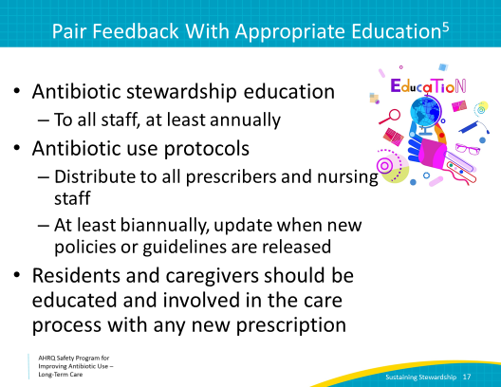
Leverage the Data  SAY:  This presentation has reviewed how to track compliance with protocols and measure and report antibiotic use.  After you implement an intervention, measure the impact of your intervention, compliance with protocols, and/or bacterial resistance profiles in your facility. Remember to make stewardship interventions focused and feasible.  Provide both institution-level and prescriber-level feedback and pair feedback with appropriate education.  The efforts that you put into building your ASP should align with the antibiotic stewardship requirements reenacted by CMS in 2017. CMS recommends that facilities develop and disseminate antibiotic use protocols and measure both antibiotic use and compliance with protocols. Leveraging that data can help meet additional requirements including providing feedback to clinicians and providing education to practitioners, staff, residents and their families.  Make this an annual or quarterly practice, so that results are sustained. | Slide 18  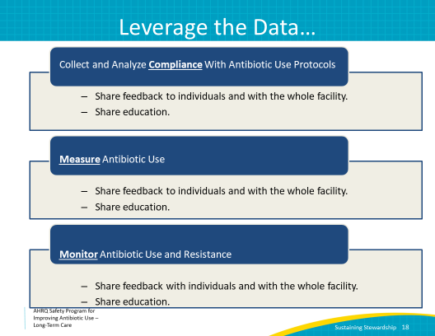
There’s Help  SAY:  Follow the link on this slide to an article with a free template that can help you create your antibiotic stewardship policy and provide a framework for stewardship interventions.  The policy and the Web site also provide a list of resources to continue to support your antibiotic stewardship activities. | Slide 19  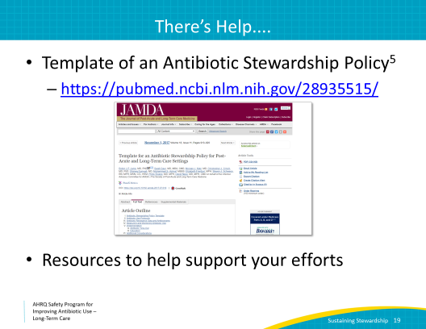
Key Points  SAY:  Thank you for taking the time to participate in this presentation. Continue to use these tools and this education to allow your ASP to sustain and flourish.  To quickly review the key points from this presentation:  Feedback paired with education for prescribers and other staff is key to the sustainability of your ASP.  Choose a method to measure and feedback your antibiotic usage. Make this a regular activity, at least quarterly.  Share your successes with leadership and staff. Distribute the data for buy-in and continued support. | Slide 20  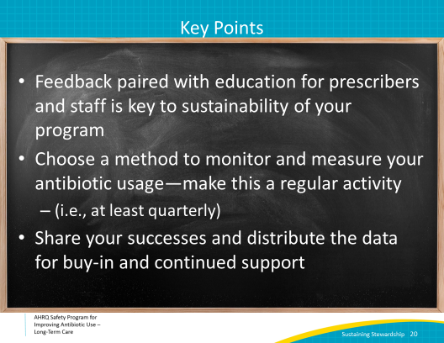
Activities To Complete  SAY:  These are the activities you could consider pairing with this presentation. This list will help keep your team on track, and maintain the momentum necessary to sustain your stewardship program.  The stewardship team should continue to hold its monthly meetings. Remember to share your successes with stakeholders, staff, and your administration.  If you are nearing the 1-year point of initiating your stewardship program, consider performing an annual assessment and analyze the data collected using the Monthly Data Collection Form.  Also, consider planning a new intervention. The Gap Analysis Tool can help your team identify opportunities to improve your program.  The antibiotic stewardship team should continue to collect and analyze data using the Monthly Data Collection Form and frontline staff should continue to apply the Four Moments of Antibiotic Decision Making Form to 5–10 residents each month.  Supporting materials for the activities are listed on the slide and are available in the Safety Program toolkit. | Slide 21  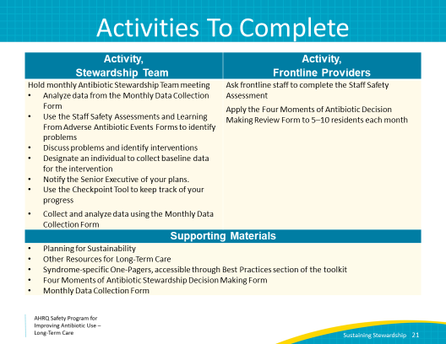
Disclaimer  SAY:  The findings and recommendations in this presentation are those of the authors, who are responsible for its content, and do not necessarily represent the views of AHRQ. No statement in this presentation should be construed as an official position of AHRQ or of the U.S. Department of Health and Human Services.  Any practice described in this presentation must be applied by health care practitioners in accordance with professional judgment and standards of care in regard to the unique circumstances that may apply in each situation they encounter. These practices are offered as helpful options for consideration by health care practitioners, not as guidelines. | Slide 22  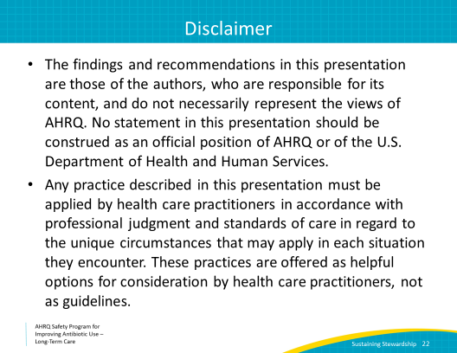
References  SAY:  Here are the references. | Slide 23  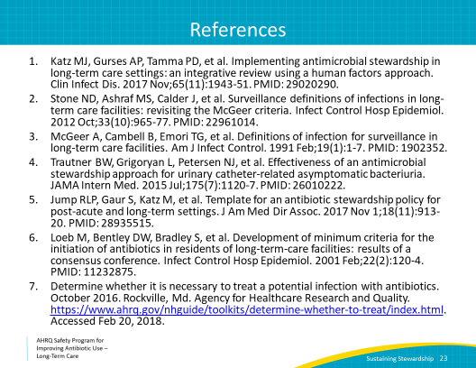
AHRQ Pub. No. 17(21)-0029
June 2021

