AHRQ Safety Program for Improving Antibiotic Use
Tracking and Measuring Antibiotic Use Data
Long-Term Care
Slide Title and Commentary | Slide Number and Slide
Tracking and Measuring Antibiotic Use Data  Long-Term Care  SAY:  Welcome to the presentation titled “Tracking and Measuring Antibiotic Use Data.” | Slide 1
Objectives  SAY:  This presentation discusses how to collect and track antibiotic use on a monthly basis and reviews  a data collection form designed to facilitate tracking antibiotic use, orders for urine cultures, and Clostridioides difficile LabID events. This form may be helpful to facilities that do not already have a method to track antibiotic usage, and can be adapted to suit the needs of each facility.  Facilities can use data on antibiotic use, orders for urine cultures, and C. difficile LabID events to monitor outcomes of interventions. | Slide 2  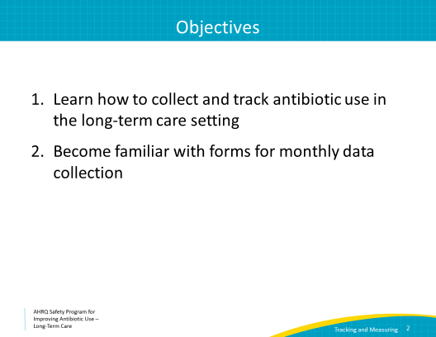
Measuring Antibiotic Use  SAY:  The Centers for Medicare & Medicaid Services (CMS) now requires all long-term care facilities to track antibiotic use.  There are two common ways to measure antibiotic use. The first is to calculate days of antibiotic therapy. This is the total number of days all residents at your facility were on an antibiotic during a specific time period such as a month. It is useful to look at individual antibiotics as well as the combined total of all antibiotics. Antibiotic days should be presented as a rate with the denominator being 1,000 resident days of care or bed days of care.  The second common way to measure antibiotic use is to count the number of antibiotic starts. This is the number of new prescriptions for each antibiotic and for all antibiotics. These can also be measured as the number of antibiotic starts per 1,000 resident days of care or as the number of starts per month.  We will review more detailed examples of these measures in a few slides. | Slide 3  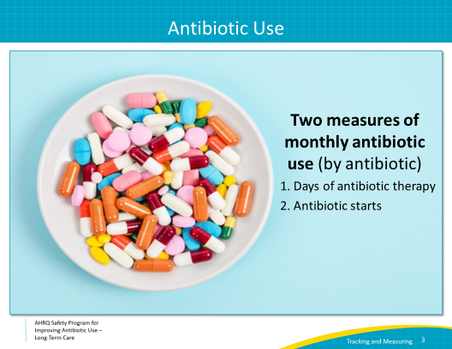
Monthly Data Collection Form  SAY:  Facilities should identify a method to track antibiotic usage on a monthly basis. If a method has not already been established, the Safety Program has developed a form that can be used. It is important to establish a consistent system of tracking antibiotic use.  The form asks for the total number of days residents were administered each antibiotic listed on the form during the reporting month. It also asks for the total number of antibiotic starts for each antibiotic listed on the form. The form can also be used to keep track of C. difficile LabID events and the number of urine cultures sent each month. | Slide 4  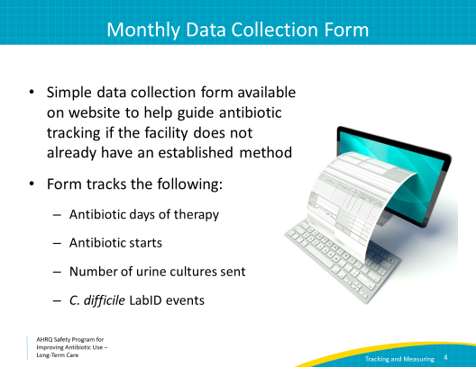
Monthly Data Collection Form  SAY:  This slide shows the data collection form available on the Safety Program toolkit Web site. The instructions are included on the top of the form, or on the first page if the form is printed. The monthly data to be completed are on the bottom half of the form. This portion is on the second page of the printed form.  Facilities can download it and fill it out electronically, or you can print it out and fill it out manually.  We will go through each element of the form in more detail. | Slide 5  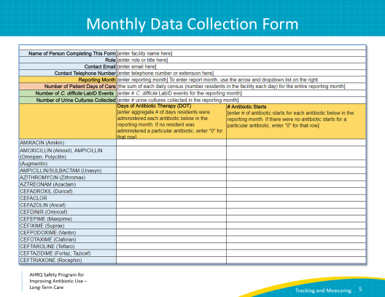
Antibiotic Days of Therapy  SAY:  Antibiotic days of therapy is the most common measure to assess overall antibiotic use. It measures the total number of days residents received a particular antibiotic. If a resident is on an antibiotic scheduled three times daily, and they only receive 1 dose because they are just starting the medication, it still counts as 1 day of therapy. | Slide 6  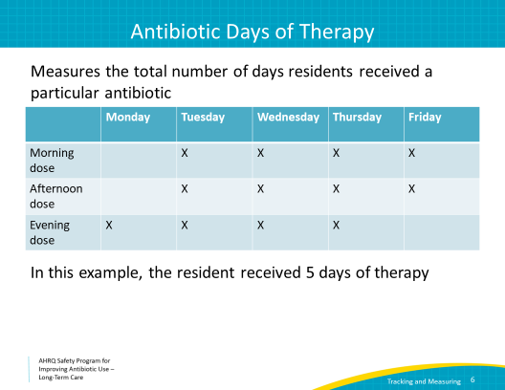
Antibiotic Days of Therapy  SAY:  The days of antibiotic therapy should be entered into the first column at the bottom of the form. The generic name is listed first followed by the most common brand name.  For each antibiotic, enter the total number of days of therapy for all residents who received that antibiotic during the month on the corresponding line. For example, if three residents were on ciprofloxacin during the month of January, one for 3 days, one for 5 days, and one for 14 days, the number listed on the ciprofloxacin line should be 3+5+14, or 22.  If a resident is on chronic cephalexin and receives two doses every day, in other words, for the entire month, you would enter 31 on the cephalexin line (if no other residents were on cephalexin that month). | Slide 7  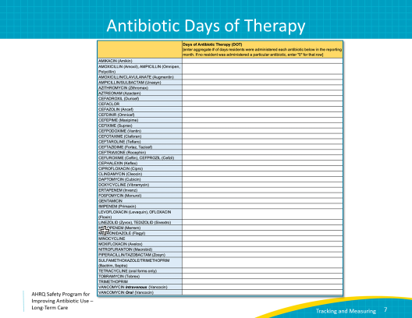
Antibiotic Starts  SAY:  Facilities should also consider tracking antibiotic starts. Antibiotic starts are the number of new antibiotic prescriptions started in a resident. Antibiotic start data can be easier to obtain than days of antibiotic therapy. Note that new admissions already on antibiotics should be counted as an antibiotic start. If a resident receives two different antibiotics, count each as a start. | Slide 8  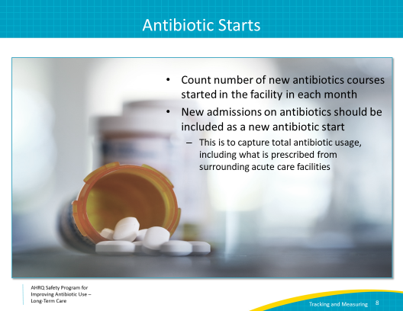
Antibiotic Starts  SAY:  The number of antibiotic starts for the month should be entered into the second column at the bottom of the form.  For each antibiotic, enter the total number of antibiotic starts for all residents who received that antibiotic during the month on the corresponding line. For example, if three residents were started on ciprofloxacin during the month of January, one for 3 days, one for 5 days, and one for 14 days, the number listed on the ciprofloxacin line should be three—one for each start.  If a resident is started on chronic cephalexin and receives two doses every day, enter 1 on the cephalexin line (if no other residents were on cephalexin that month). If that same prescription continued into the next month, it would not count as a new start for the next month.  If a resident started amoxicillin on the first of the month for 5 days and then had a new prescription for amoxicillin on the 20th of the month, enter two separate starts. | Slide 9  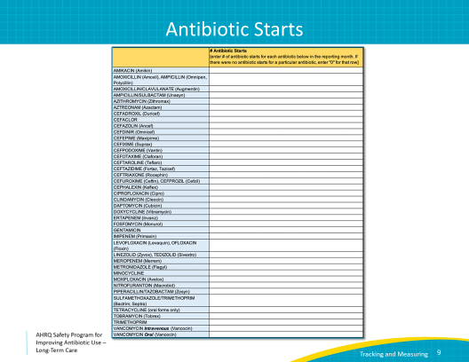
C. difficile Lab Events and Urine Cultures  SAY:  In addition to tracking antibiotic usage, facilities should also consider collecting data on Clostridioides difficile LabID events. This information can be obtained by contacting the microbiology lab used by the facility, or may already be collected for facility quality improvement purposes.  Another data measure to consider tracking is the number of urine cultures collected. This is the total number of urine cultures obtained while a resident is receiving care from the nursing home during the reporting month. All urine cultures should be collected, even if they are not positive. Start by contacting the microbiology lab, as they often keep a record of this information. If they do not, designate an individual to review these orders and keep a monthly log to be included in the facilities quality assurance (QA) review. | Slide 10  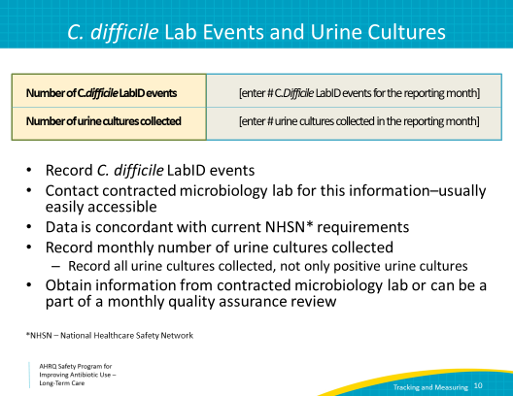
Strategies to Make Data Collection Easier  SAY:  Here are recommendations to improve success with monthly data collection.  First, facilities should contact their contracted pharmacy early on to determine if they can obtain and share antibiotic usage data. Many pharmacies are already doing this, and establishing a relationship with them can be very helpful. Consider sharing the data collection form to demonstrate the data needed. Alternatively, antibiotic use and start data can be obtained from facility line lists.  A specific individual should be designated as responsible for collecting this data in order to ensure consistent data collection. This person should train and work closely with a second person who can also perform these tasks. This overlap in responsibility will ensure continuity of data collection and knowledge and makes it easier to be flexible around vacation and sick days.  Finally, use this data to drive facility interventions! Distribute it at QA meetings to monitor improvement, and share successes when they are noted. | Slide 11  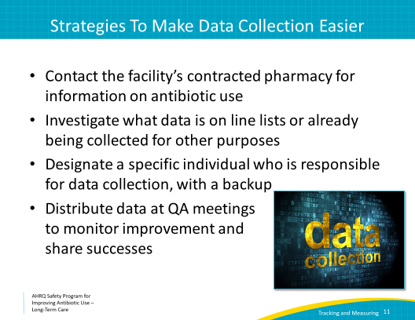
Key Points  SAY:  There are a few takeaway points from this presentation:  This presentation was created to provide some examples of how facilities can track antibiotic use. Every long-term care facility is now required by the Centers for Medicare & Medicaid Services have a system to track antibiotic usage. This presentation describes two strategies to track antibiotic use: days of therapy or antibiotic starts. Both of these measures can be monitored using the data collection form available on the AHRQ Safety Program toolkit Web site.  The data collection sheets can be used as is or adapted to address outcomes that facilities find most pertinent, such as antibiotic resistance.  Finally, remember to identify two individuals to be responsible for tracking and logging data, so that if one individual is not present or does not remain at the facility, there is a backup who is familiar with the data collection and there are no resultant lapses in data collection. | Slide 12  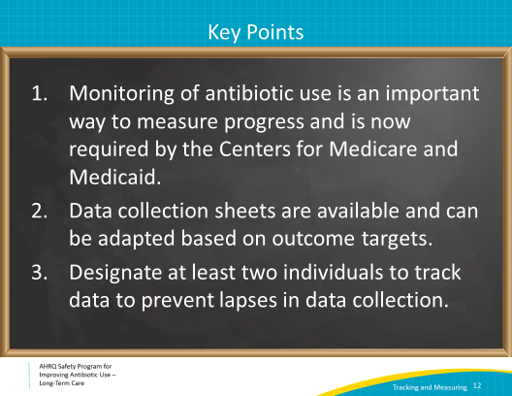
Activities To Complete  SAY  These are activities you may want to pair with this presentation. They are intended to help your team stay on track with the overall program.  We recommend designating two people who will be responsible for collecting and analyzing antibiotic use data each month. Having more than person in this role will help ensure continuity for your program during vacations, holidays and periods of transition among personnel.  If you haven’t already, introduce the Antibiotic Stewardship Team to the facility, including your mission statement. Also introduce them to the Four Moments of Antibiotic Decision Making. Invite others to join the team if they are interested. Ideally, one of these individuals will become a champion to help support implementing activities geared toward front-line providers.  In addition, ask frontline clinicians to sign the Commitment poster. These activities could be led by the Antibiotic Stewardship Team and are a great way to introduce the team to the rest of the building.  Supporting materials for the activities are listed on the slide and are available on the toolkit Web site. | Slide 13  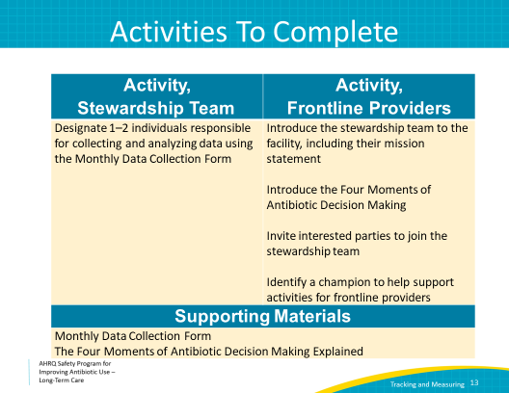
Disclaimer  SAY:  The findings and recommendations in this presentation are those of the authors, who are responsible for its content, and do not necessarily represent the views of AHRQ. No statement in this presentation should be construed as an official position of AHRQ or of the U.S. Department of Health and Human Services.  Any practice described in this presentation must be applied by health care practitioners in accordance with professional judgment and standards of care in regard to the unique circumstances that may apply in each situation they encounter. These practices are offered as helpful options for consideration by health care practitioners, not as guidelines. | Slide 14  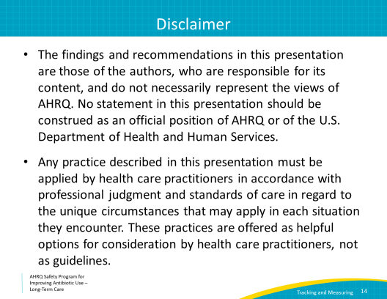
AHRQ Pub. No. 17(21)-0029
June 2021

