Preventing CAUTI in the ICU Setting

Facilitator’s Guide

AHRQ Pub No. 15-0073-4-EF
September 2015

Contents
Introduction 5
Using This Guide 5
Preparing for a Session 5
Delivering the Session 6
Module 1: Overview 7
Potential Questions To Ask Before You Begin 7
Content Delivery Instructions 7
Module 1 Content 8
Slide 1 8
Slide 2 9
Slide 3 10
Slide 4 11
Slide 5 12
Slide 6 13
Slide 7 14
Slide 8 15
Slide 9 17
Slide 10 18
Slide 11 19
Slide 12 20
Slide 13 21
Slide 14 22
Slide 15 23
Slide 16 24
Slide 17 25
Slide 18 26
Slide 19 27
Slide 20 28
Slide 21 29
Slide 22 30
Module 2: Urinary Catheter Maintenance 31
Potential Questions To Ask Before You Begin 31
Content Delivery Instructions 31
Module 2 Content 32
Slide 1 32
Slide 2 33
Slide 3 34
Slide 4 35
Slide 5 36
Slide 6 37
Slide 7 39
Slide 8 40
Slide 9 42
Slide 10 43
Module 3: Conversations Around Device Necessity 44
Potential Questions To Ask Before You Begin 44
Content Delivery Instructions 44
Module 3 Content 45
Slide 1 45
Slide 2 46
Slide 3 48
Slide 4 49
Slide 5 50
Slide 6 51
Slide 7 52
Slide 8 53
Slide 9 54
Slide 10 55
Slide 11 57
Module 4: Summary and Next Steps 58
Potential Questions To Ask Before You Begin 58
Content Delivery Instructions 58
Module 4 Content 59
Slide 1 59
Slide 2 60
Slide 3 61
Slide 4 62
Slide 5 63
Slide 6 64
Slide 7 65
Finishing Up Strong 67
Making Learning Stick 67
Being a Change Agent 67

Introduction
Catheter-associated urinary tract infections, or CAUTI, are a large problem in health care, accounting for 75 percent of the 560,000 total urinary tract infections that patients develop every year from hospital stays. The Health Research and Education Trust, working in partnership with the Association for Professionals in Infection Control and Epidemiology, developed a series of materials aimed at reducing that number, especially in the intensive care unit (ICU) environment. The training videos associated with this Facilitator’s Guide is one part of that effort.

Using This Guide
Please note that for the purposes of this training, you are not expected to be a teacher, but, rather, a facilitator. You might be asking, what’s the difference?
Teacher: Often thought to be a “holder of wisdom” and expected to impart that wisdom and knowledge to a student. Generally, information goes to the recipient for consumption, not processing.
Facilitator: Guides and assists learners in learning for themselves by highlighting points for consideration, then letting the learners form their own thoughts about them, which helps them own material through self-exploration and dialogue.
As the facilitator for this training, you will be working with one or more trainees, guiding them through the videos associated with this Guide.

Preparing for a Session
For many people, especially experienced trainers, the transition from a teacher-centered delivery to a student-centered delivery can be difficult. Here are some suggestions on how to make this transition:
- Know the content
  - It might seem obvious, but take time to become familiar with both this Facilitator’s Guide and the training videos. For example, know ahead of time when you are expected to pause the presentation and know what a module will cover and how long it will run.
There is no surer way to lose the attention of a learner than to show that you don’t understand what it is you are facilitating.
- Know your facility
  - If you are the Facilitator for this information, then you are expected to know about the facility’s CAUTI rates, policies, and processes. Learn this information before you facilitate for the first time.
- Start by asking questions
  - Who is your learner? What does he/she know about the topic? What is his/her background? Before each module, you will see a list of potential questions to ask. It is not an exhaustive list, but should provide you with a place to start developing your own questions.
- Take time to introduce the topic and information slowly
  - Often, trainers make the mistake of trying to rush the learner through the content. Doing so often robs the learner of the opportunity to develop his or her own understanding of the content.
- Make the content applicable
  - You know the facility in which you and the leaner are working. How can you create questions that apply directly to that environment? How can you use that knowledge to encourage the learner to determine how he or she will apply the lessons from the content?
- Be creative and innovative
  - Although we have highlighted places where you can stop the video and assist the learner in understanding the content, these are not the only places to do so. As you familiarize yourself with the content, look for other ways to make the experience more interactive.
- Create a positive learning environment
  - Is the room comfortable? Is the video screen easily seen? Volume at an appropriate level? Take the time to set up a positive environment before you put your learner into it.
- Let the learner be a teacher
  - Whenever possible, let the learner rephrase what he or she has seen and teach to you (or other learners also watching the video). Doing so helps the learner visualize how he or she will apply the lessons learned and will aid in knowledge retention.

Delivering the Session
“Preventing CAUTI in the ICU Setting” is a series of four videos, lasting between 4 and 13 minutes each. In keeping with the guidance mentioned previously, we recommend that you don’t rush through all the videos. Be sure to allot an additional 30–45 minutes for preparation, discussion during appropriate moments, and post-presentation summarization.
Although it isn’t required, you can also recommend to the learner that he/she takes notes. Taking notes has been shown to improve knowledge processing and retention. It’s also recommended that you take notes of the learner’s responses, too, as it will help you anticipate questions in the future.

Module 1: Overview
Module 1 sets the stage for the entire video by providing the overarching learning objectives, the scope of the CAUTI problem, and some research-based information on ways to reduce them.
Time required: 13 minutes

Potential Questions To Ask Before You Begin
- Ask the most basic of questions: Why is he/she with you at this time? Does he/she understand what the video will be about or why he/she is there?
- What does the learner know about CAUTIs? How many happen every year?
- What is his/her unit’s approach to catheter use?

Content Delivery Instructions
- After asking the questions above, ask the learner if he/she has any questions about the content, what is expected of him/her, or anything else.
- Note that the following slide has instructions to stop and reflect on questions:
  - Slide 10 (slide header is “Stop and Think”)

Module 1 Content

Slide 1
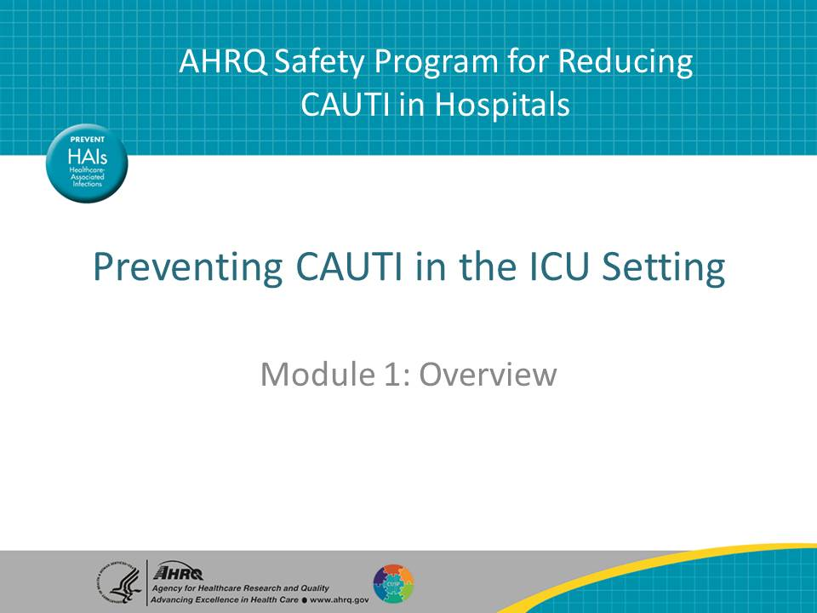
Narration:
“Preventing CAUTI in the ICU Setting” is a four-module program designed for intensive care unit, or ICU, nurses to gain a sense of confidence and demonstrate competence in catheter-associated urinary tract infection, or CAUTI, prevention concepts and techniques. It is a part of the AHRQ Safety Program for Reducing CAUTI in Hospitals.
The education format will be a mix of concepts and case studies. From time to time, the narrator will ask that you pause the presentation to think about questions as they relate to your facility’s practices and processes. Although you aren’t required to do this, you might find that it will help you understand how to apply information to your work.
You are now about to view Module 1: Overview.
Discussion points or potential questions from learner:
- Am I expected to enact these changes by myself?

Slide 2
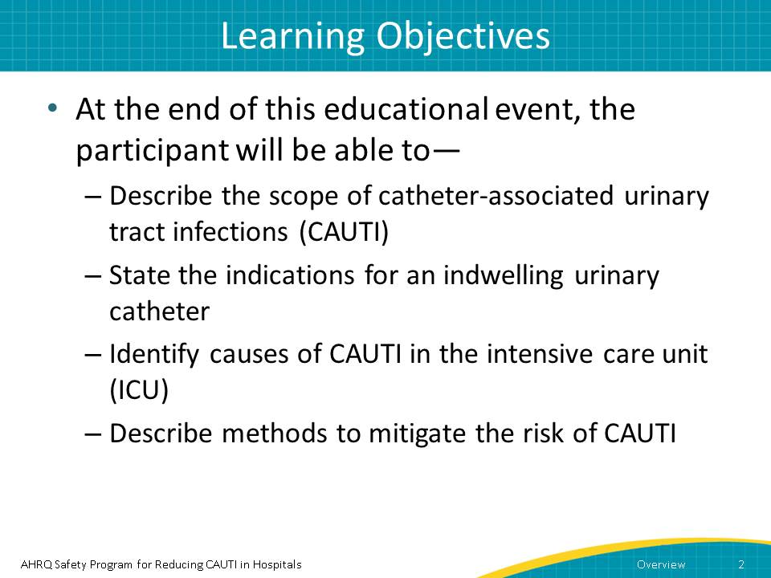
Narration:
The learning objectives for this entire training are as follows.
After you listen to all the modules, you will be able to—
- Describe the scope of CAUTI
- State the indications for an indwelling urinary catheter
- Identify causes of CAUTI in the ICU
- Describe methods to mitigate the risk of CAUTI
Discussion points or potential questions from learner:
- Ask the learner what those objectives mean to him or her
- The learner might ask, will I need to write down anything?
  - You can respond: We don’t require that you write down anything, but you can take notes if that will help you remember.

Slide 3
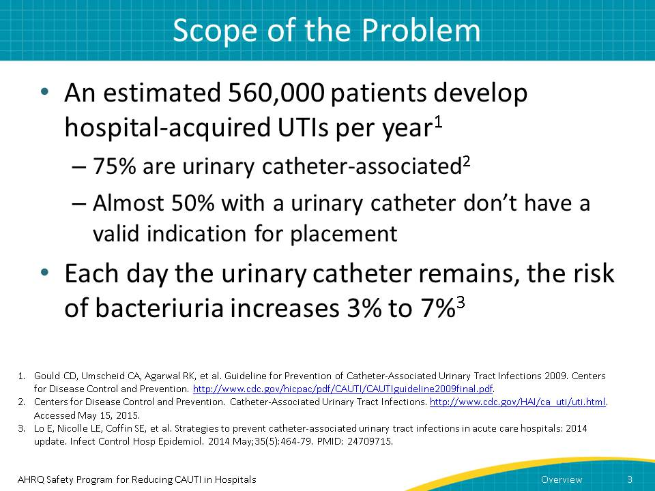
Narration:
So, what is the scope of the CAUTI problem? Large. In fact, around 560,000 patients develop UTIs per year from hospital stays, and of those, three-quarters are associated with urinary catheters. However, nearly half of those patients with a urinary catheter don’t have a valid indication for placement.
For those with catheters, the risk of bacteriuria increases 3 to 7 percent every day the catheter remains in place.
Potential points for discussion or questions from the learner:
- Does the learner understand the term “bacteriuria”?
- You can provide the sources at the bottom of the screen if the learner wants to learn more.
- The learner may ask, how many of those has my facility had?
  - You should know this answer before you start the training.

Slide 4
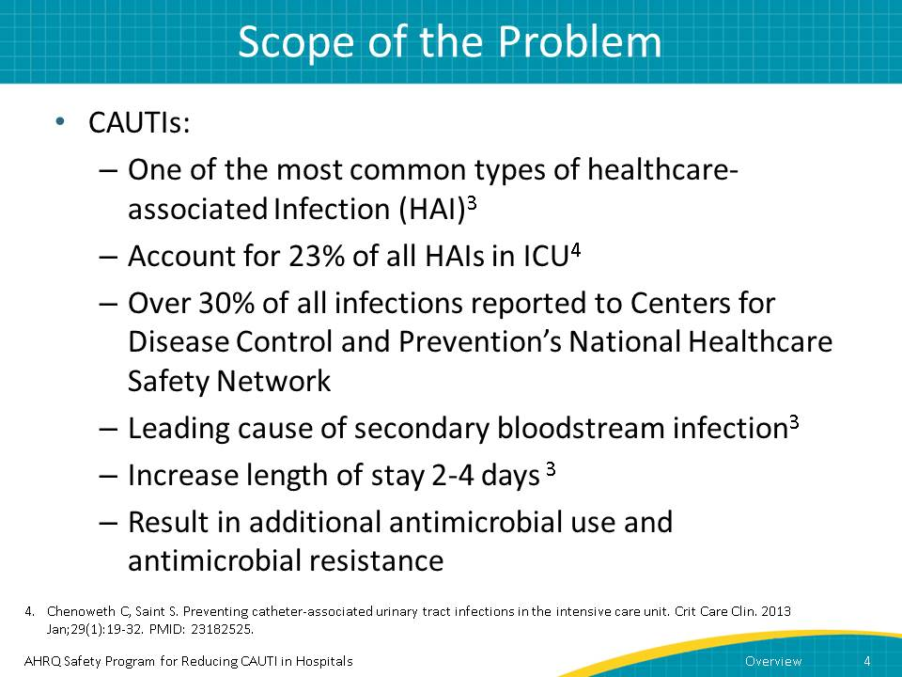
Narration:
With that in mind, it’s easy to understand why CAUTIs are one of the most common types of healthcare-associated infections, or HAIs. They represent one-fourth of all HAIs in intensive care units and nearly one-third of all infections reported to the Centers for Disease Control and Prevention’s National Healthcare Safety Network, and are the leading cause of secondary bloodstream infections.
For a patient who develops a CAUTI, it can mean a longer stay in the hospital, by as many as 4 days. From a public health standpoint, CAUTIs pose another risk, namely that their frequency leads to additional antimicrobial use and antimicrobial resistance.
Potential points for discussion or questions from the learner:
- Does the learner know the facility’s CAUTI rate? How about the rate in the ICU?
- What does the learner know about “antimicrobial resistance”?
  - Note that this term is used often in the training, so you would do well to understand it.

Slide 5
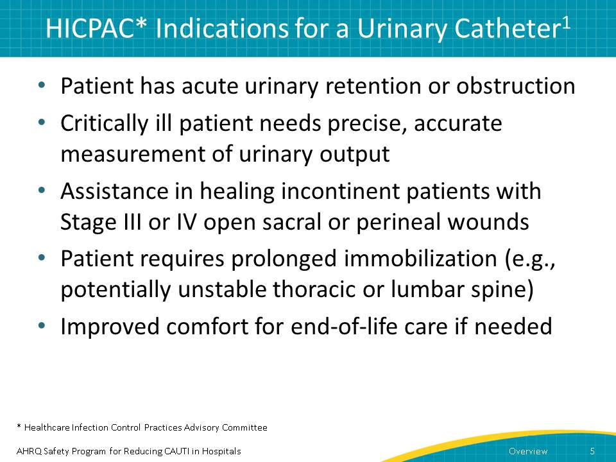
Narration:
But if overuse of catheters is a problem, what do we know about guidelines related to catheter use? In 2009, the CDC’s Healthcare Infection Control Practices Advisory Committee, or HICPAC, described appropriate indications for catheter use.
- Use 1: Patient has acute urinary retention or obstruction
- Use 2: Critically ill patient needs precise, accurate measurement of urinary output
- Use 3: Assistance in healing incontinent patients with Stage III or IV open sacral or perineal wounds
- Use 4: Patient requires prolonged immobilization (e.g., potentially unstable thoracic or lumbar spine)
- Use 5: Improved comfort for end-of-life care if needed
Potential points for discussion or questions from the learner:
- How many of these situations do you encounter regularly? In other words, how often would the ICU’s urinary catheter use conform to HICPAC indications?

Slide 6
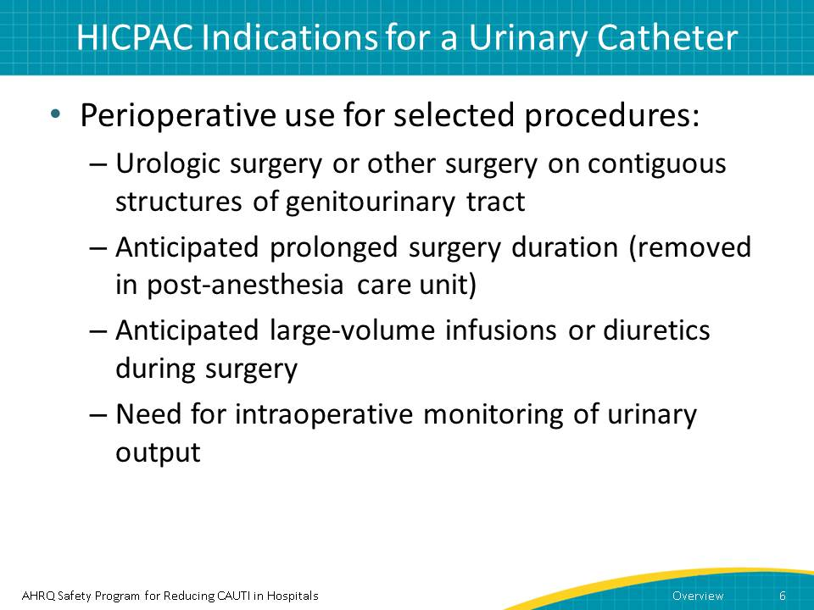
Narration:
In the perioperative setting, catheters are used for selected procedures:
- Urologic surgery or other surgery on contiguous structures of genitourinary tract
- Anticipated prolonged surgery duration (removed in post-anesthesia care unit)
- Anticipated large-volume infusions or diuretics during surgery
- Need for intraoperative monitoring of urinary output
Potential points for discussion or questions from the learner:
- Continue the discussion from the previous slide about what the learner’s ICU experience indicates about facility urinary catheter use.

Slide 7
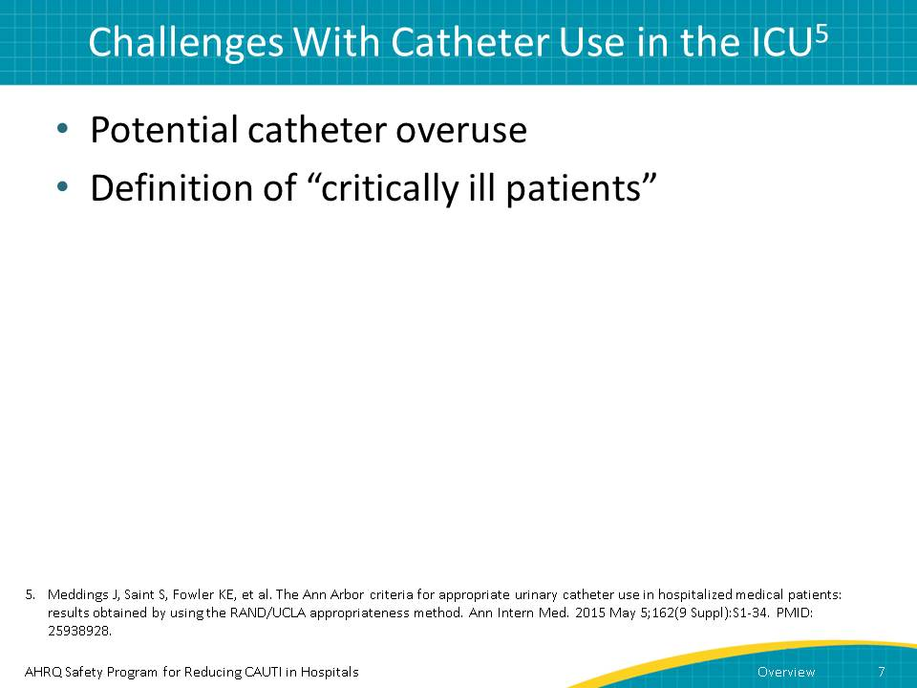
Narration:
But catheter use in the ICU has two main challenges.
- The first is potential catheter overuse. A recent national survey of catheter placement practices in acute care hospitals demonstrated that many hospitals reported placing catheters for reasons not included in the HICPAC list of appropriate indications.
- The second is that the term “critically ill patients” is not well defined. We know that just because a patient is in the ICU, the patient may not require a urinary catheter.
Potential points for discussion or questions from the learner:
- Is it common practice in the learner’s ICU to use a urinary catheter on all patients?

Slide 8
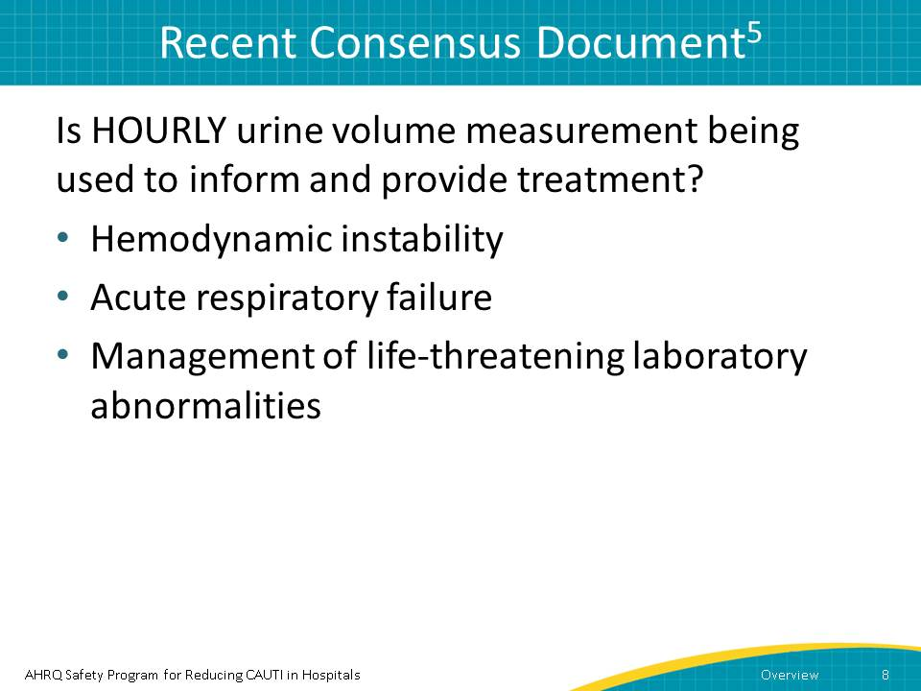
Narration:
A recent document published by Meddings and colleagues took a deep dive into appropriateness issues. After reviewing the literature, a 15-member multidisciplinary panel used a standardized process to rate scenarios as appropriate, inappropriate, or of uncertain appropriateness. This was used as a means to further explore the broad definition of critically ill patients who would need a urinary catheter.
The following questions and indications may be helpful in guiding ICUs in developing protocols for urinary catheter use.
- Is a urinary catheter still appropriate for your ICU patient? If your patient does not have one of the following criteria, you may consider removing the catheter.
- Is HOURLY urine volume measurement being used to inform and provide treatment? For example, does the patient have hemodynamic instability that requires hourly or multiple daily titrations per day, ongoing fluid resuscitation, vasopressors, inotropes, or diuretics?
- Does the patient have acute respiratory failure that requires invasive ventilation and hourly urine output assessment for frequent (i.e. every 4 hours) decisions regarding diuretic administration?
- Another consideration to leave the urinary catheter in place would be the need for hourly measurement of urine studies or urine volumes needed to manage life-threating laboratory abnormalities.
Potential points for discussion or questions from the learner:
- Does the learner have any questions about the study?

Slide 9
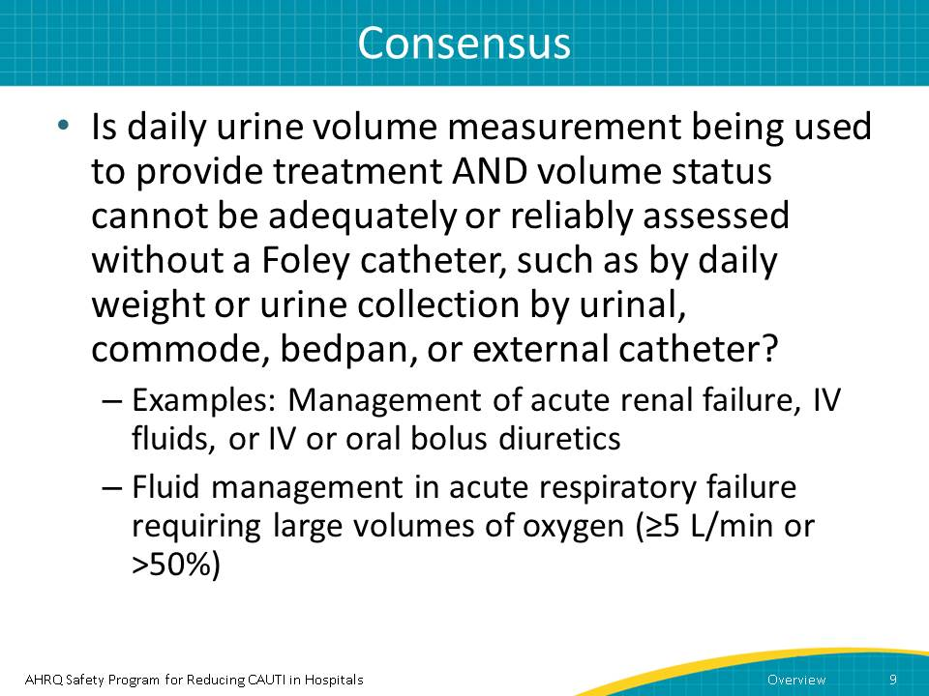
Narration:
In some instances, you might need to do a daily urine volume measurement to provide treatment. One instance is management of patients with acute renal failure, intravenous or IV fluids, or IV or oral bolus diuretics or fluid management in acute respiratory failure requiring large flow rates of oxygen of greater than or equal to 5 liters per minute or 50 percent. However, in many cases, you can determine volume status through other means, such as by daily weight or urine collection by urinal, commode, bedpan, or external catheter.

Potential points for discussion or questions from the learner:
- None

Slide 10
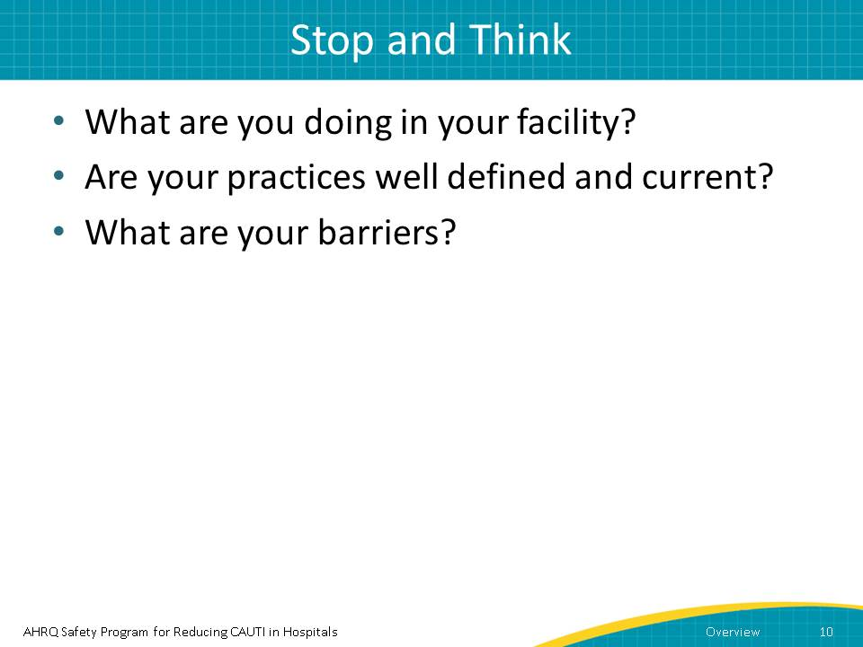
Narration:
Take this opportunity to stop this presentation and think about some questions:
- What are you doing in your facility, as related to catheter use?
- Are your practices well defined and consistent with current recommendations?
- Why or why not? Do they need further clarification?
- What barriers keep you from following the recommendations?
After you’ve given this some thought, press play to resume viewing the presentation.
Potential points for discussion or questions from the learner:
- Encourage the learner to think through these questions. Discuss them one by one.
  - Note that if you are expected to facilitate many people going through this training, it might be smart for you to record their responses. In this way, you can see trends and beliefs related to catheter use. Remember that you are not only facilitating this training; you are also a change agent regarding catheter use.

Slide 11
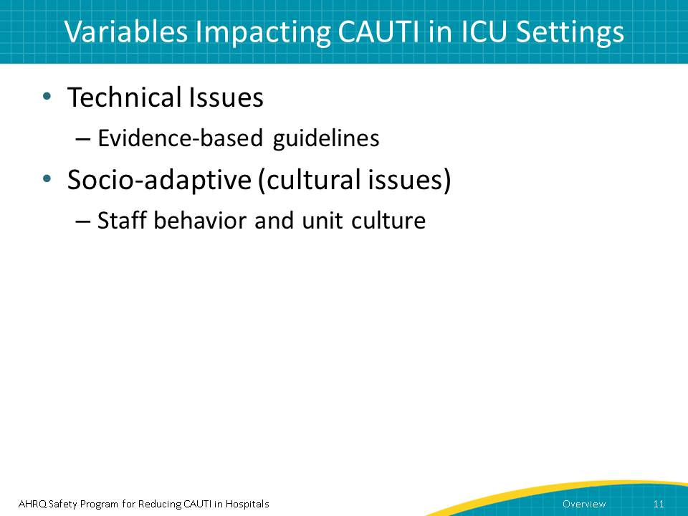
Narration:
Many facilities don’t follow these recommendations, or confusion exists due to ambiguity. Often, two variables impact compliance.
First are technical issues, specifically those related to evidence-based guidelines.
Second are the more challenging socio-adaptive, or cultural, issues.
We’ll talk about each one individually.

Potential points for discussion or questions from the learner:
- None, because they will be discussed in detail on slides following this one.

Slide 12
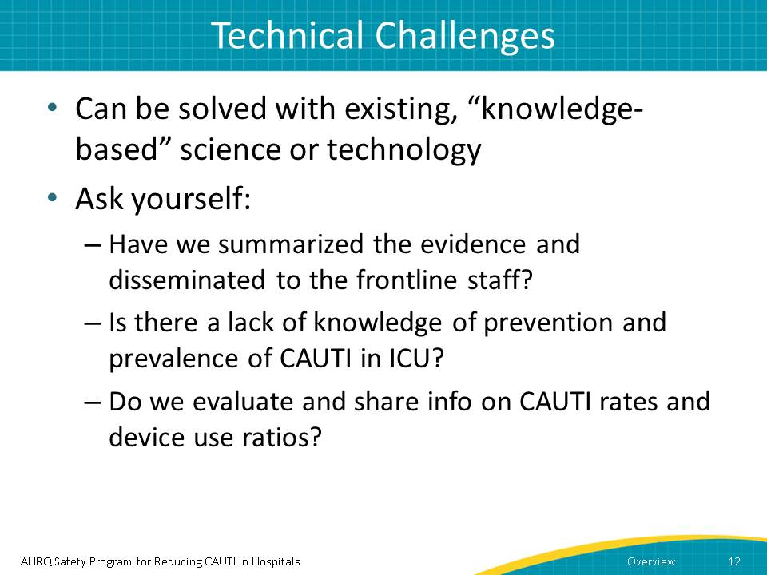
Narration:
In some instances, resistance to changing catheter use practices comes from the belief that there’s no real reason to change them. However, you can challenge that by using evidence-based guidelines.
But how do you know if this is an issue? To determine if staff lack a deeper understanding of the impact of CAUTI, ask yourself:
- Has your facility summarized the evidence and disseminated to the frontline staff?
- Is there a lack of knowledge of prevention and prevalence of CAUTI in ICU?
- Does your facility evaluate and share information on CAUTI rates and device use ratios?
As you would imagine, staff want to provide the best care possible for their patients, so sharing science-based information will help them understand the importance of appropriate urinary catheter usage.

Potential points for discussion or questions from the learner:
- Although not mandated, this is another opportunity to stop the video and have a discussion. Go over each of the above questions, one by one. How much of this information does the learner know? What does the learner think about these questions?

Slide 13
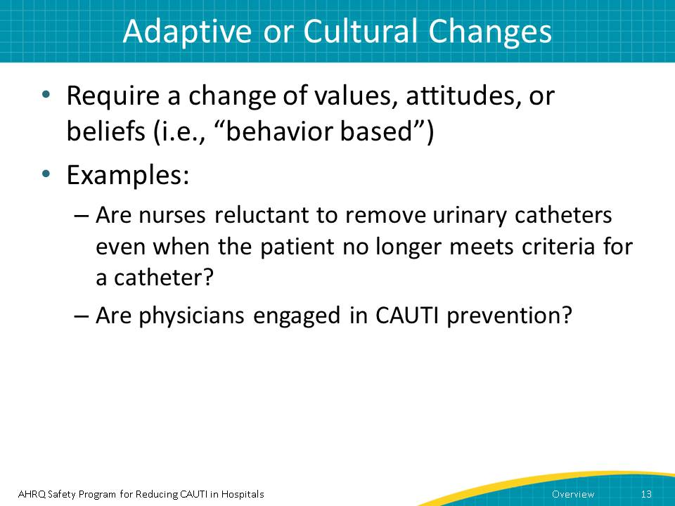
Narration:
So, how do you know if you are facing a cultural challenge? When you ask a caregiver why they are using a urinary catheter, do they say “we’ve always done it this way” or “it’s standard practice for all patients”? Are nurses reluctant to remove urinary catheters even when the patient no longer meets criteria for a catheter? Are physicians engaged in CAUTI prevention?
Behavior-based beliefs are a challenge. It is important to first engage care providers and connect the situation directly to the impact on the patient. There are strategies that may be helpful. For example—
Can we connect the dots to harm? Can we share stories of patients who were harmed by a urinary catheter? Perhaps you have a patient who became septic because of a CAUTI, or who developed a Clostridium difficile infection as a result of antibiotic treatment for a CAUTI. Storytelling is a powerful tool.
Potential points for discussion or questions from the learner:
- Does the learner think his/her ICU has a culture problem regarding urinary catheter use?
- Which of the two issues does the learner think has the largest influence in his/her ICU?
- Does the learner know a story about a patient who became septic or developed Clostridium difficile as a result of antibiotic treatment for a CAUTI?

Slide 14
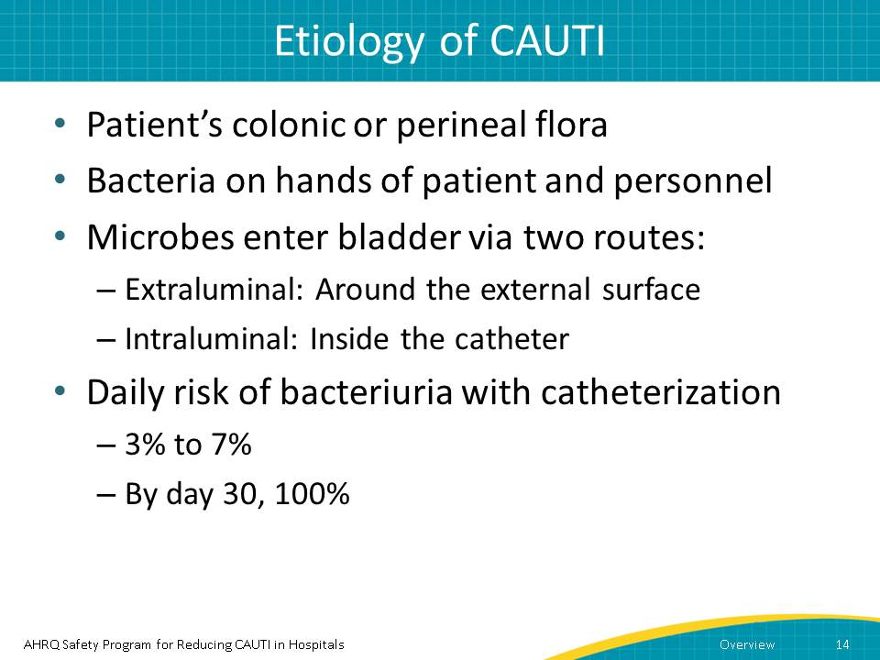
Narration:
Understanding how CAUTIs develop can help with educating fellow staff members.
CAUTIs develop from a patient’s colonic or perineal flora, generally because of bacteria on the hands of the patient and medical personnel. Harmful microbes enter the bladder via two routes:
- Extraluminal: Around the external surface
- Intraluminal: Inside the catheter
The daily risk of bacteriuria with catheterization is estimated between 3 percent and 7 percent. By day 30 with the catheter, the risk is at 100 percent. Obviously, the best way to prevent CAUTIs is not to insert a urinary catheter in the first place. But as discussed earlier, there are cases of ICU patients whose conditions require a continued need for a urinary catheter.
Potential points for discussion or questions from the learner:
- Does the learner understand the etiology of CAUTI?

Slide 15
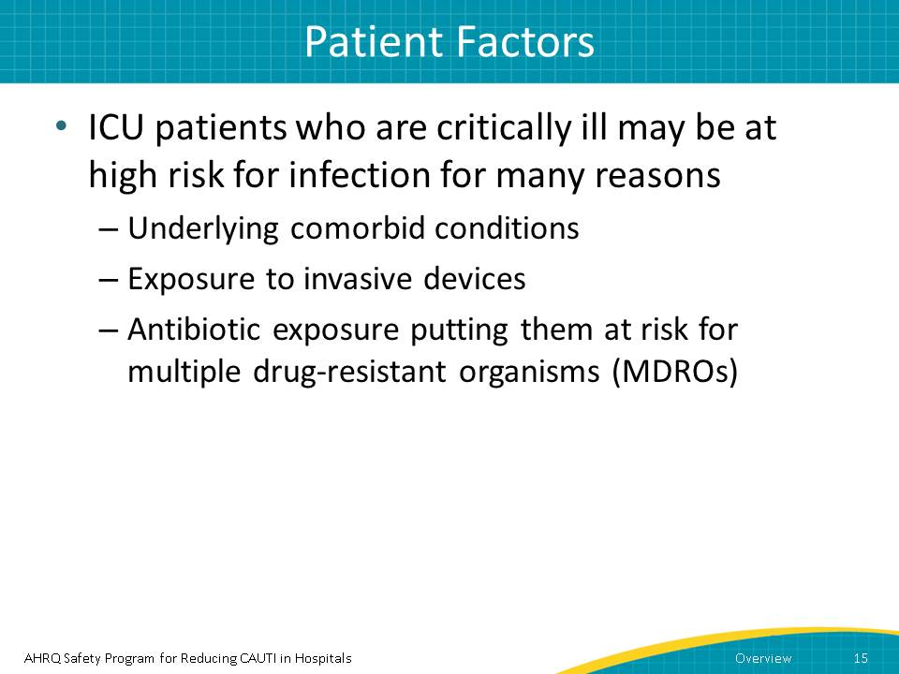
Narration:
However, there are also times when we have to be extremely careful about catheter use. For instance, ICU patients who are critically ill may be at high risk for infection due to underlying comorbid conditions. Add an invasive device such as a urinary catheter, and you are increasing their risk for infection. Going a step further, if such a patient develops a CAUTI, then using an antibiotic to treat the infection may put them at even higher risk for Clostridium difficile infection and multiple drug-resistant organisms.
Potential points for discussion or questions from the learner:
- Does the learner understand how antibiotics can be linked to Clostridium difficile and multiple drug-resistant organisms?

Slide 16
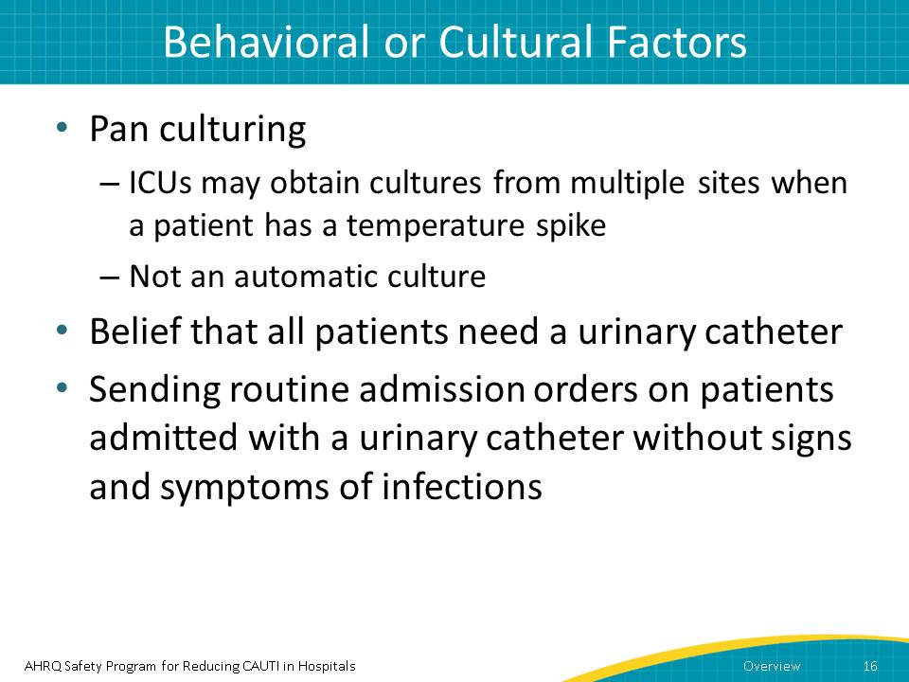
Narration:
Many ICUs obtain cultures from multiple sites when a patient has a temperature spike. However, the temperature increase should warrant a critical evaluation of the patient rather than an automatic culture.
As we discussed earlier, the daily risk of catheter colonization grows between 3 percent and 7 percent per day, so we know that unnecessary culturing without signs or symptoms of UTI could lead to detection of microorganisms in the urine that may not be reflective of a true urinary tract infection. This can lead to inappropriate use of antibiotics.
Understand that historically, care providers thought that just being in the ICU meant a patient needed a catheter.
Potential points for discussion or questions from the learner:
- Does the learner feel his/her facility does an automatic culture?

Slide 17
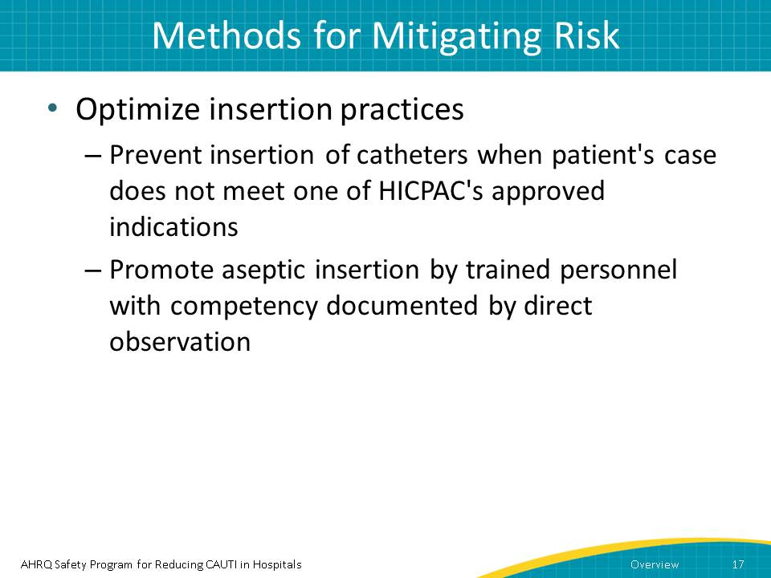
Narration:
But what can you do about it? Obviously, the best thing you can do is avoid use of a catheter unless the patient meets one of HICPAC's approved indications.
But if you must use one, then you must also optimize insertion practices by ensuring the catheter is inserted aseptically by trained personnel. Competency in aseptic insertion should be documented by direct observation.
Potential points for discussion or questions from the learner:
- How much training around aseptic insertion practices occurs in the facility?

Slide 18
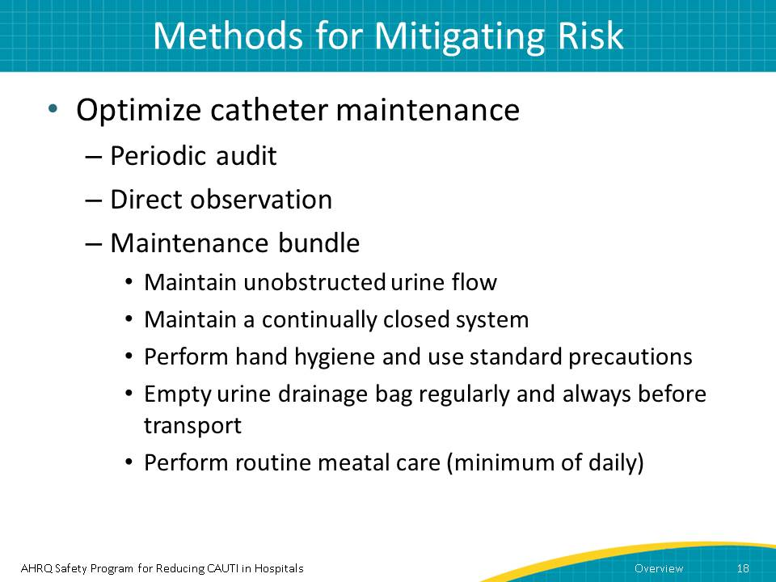
Narration:
It is important to monitor not only outcomes of care, but the processes of care as well. Periodic audits and direct observation are some ways to do this. When assessing the indication on a daily basis, ask the question, does my patient still need a urinary catheter?
In the previous slide we talked about aseptic insertion, so now let’s discuss how we maintain the catheter in what is sometimes referred to as the maintenance bundle:
- Maintain unobstructed urine flow
- Maintain a continually closed system
- Perform hand hygiene and use standard precautions before touching the catheter
- Empty urine drainage bag regularly and always before transport
- Perform routine meatal care (minimum of daily)
Potential points for discussion or questions from the learner:
- Is there any element to this bundle that confuses the learner? Does the learner think this bundle is realistic to implement?

Slide 19
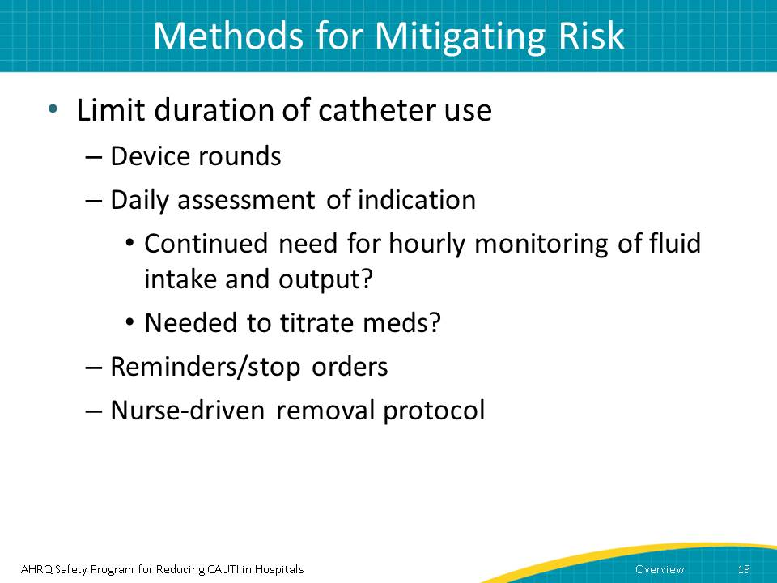
Narration:
Another obvious way to limit CAUTI risk is to limit the length of time a urinary catheter is indwelling. How can you do this? One easy way is through device rounds so that you do a daily assessment of indication.
Automatic reminders and stop orders are ways to remind physicians to discontinue the catheter if no longer needed or to reorder it. These practices keep the length of catheter use to a minimum.
Another way is to implement a nurse-driven removal protocol. Many hospitals have adopted protocols that permit the nurse to remove the catheter without a specific order if a patient meets certain criteria.
Potential points for discussion or questions from the learner:
- Does the facility have a nurse-driven protocol in place? If so, what is it? If not, does the learner feel one might be useful? How would he/she go about creating one?

Slide 20
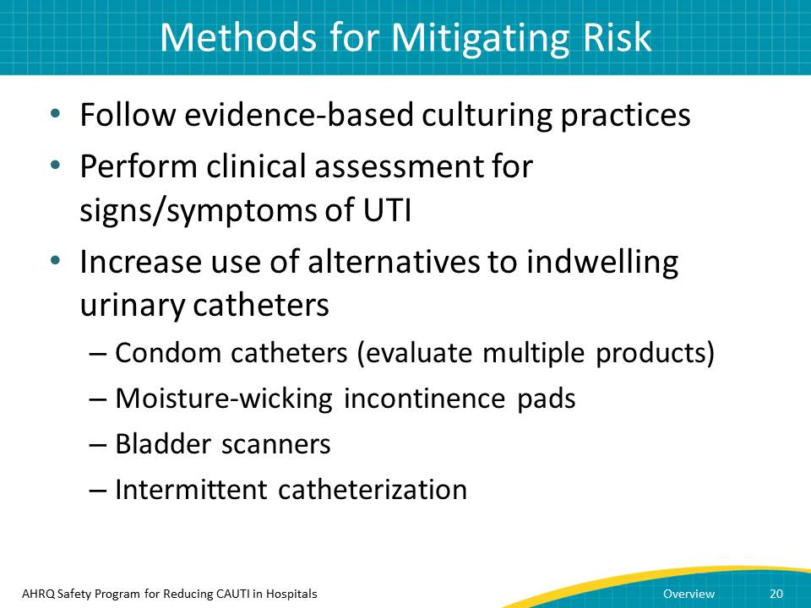
Narration:
We talked earlier about indications for insertion, so now let’s discuss other ways to decrease the risk of CAUTI. For instance, establish evidence-based culturing practices.
You should also perform clinical assessments for signs/symptoms of a UTI.
You also have alternatives to indwelling urinary catheters, and you should consider increasing their use. Alternatives include—
- Condom catheters (evaluate multiple products)
- Moisture-wicking incontinence pads
- Available bladder scanners
- Intermittent catheterization
And these are just a few of the many options that exist.

Potential points for discussion or questions from the learner:
- Does the facility use any of the alternatives mentioned in the audio?

Slide 21
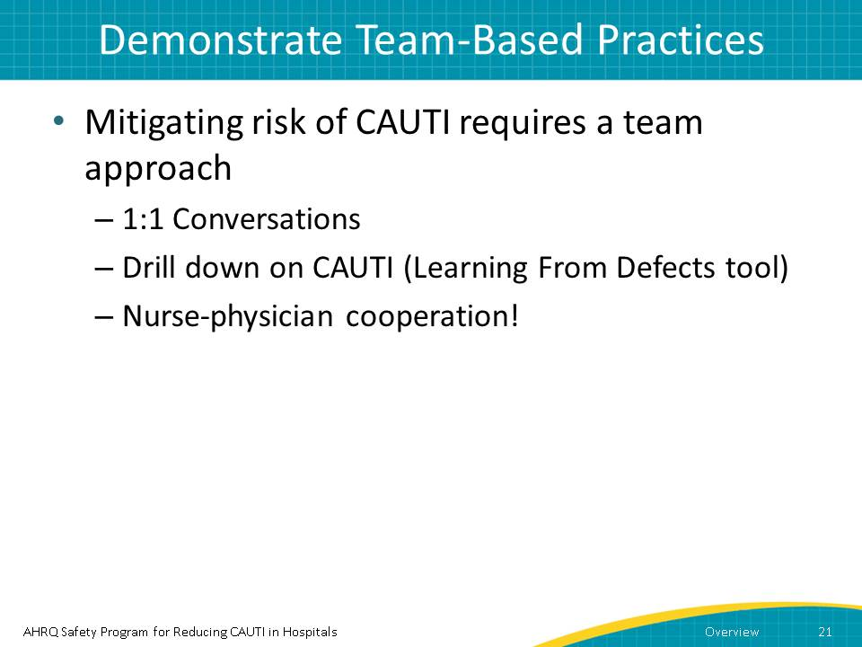
Narration:
Above all, reducing the risk of CAUTI requires a team approach through communication with your fellow staff. Have one-on-one conversations to provide a safe environment to support frontline staff by openly communicating with one another.
You can also drill down on CAUTI using the “Learning From Defects” tool on the AHRQ Web site and review each case with frontline staff. Ask staff, what could we have done differently? How can we prevent the next CAUTI?
Frontline staff and unit leaders need time and resources to work together to investigate causes of CAUTI and brainstorm solutions to prevent them from recurring.
Nurses and physicians can also work together to develop ICU-specific indications for catheter use.
Remember that with some careful thought and attention, you can make a difference.
Potential points for discussion or questions from the learner:
- How much nurse-physician communication occurs in the ICU?

Slide 22
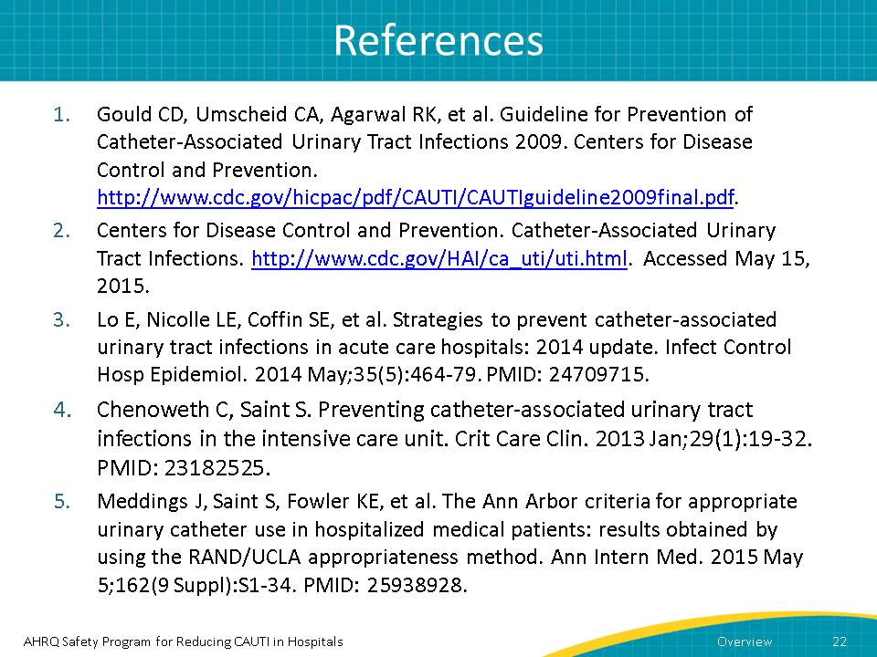
Narration:
None
Potential points for discussion or questions from the learner:
- If the learner wants to explore any of these references, be prepared to help him/her do so.

Module 2: Urinary Catheter Maintenance
Module 2 builds on Module 1 and presents a case study. In the case study, a nurse and a transporter ready a patient for transport. The process highlights potential ways to prevent a CAUTI from happening.
Time required: 6 minutes

Potential Questions To Ask Before You Begin
- How do patient handoffs occur in the ICU when a patient has an indwelling catheter?
- How comfortable do you feel with having a difficult conversation with another staff member?

Content Delivery Instructions
- After asking the questions above, ask the learner if he/she has any questions about the content, what is expected of him/her, or anything else.
- Note that the following slide has instructions to stop and reflect on questions:
  - Slide 3 (slide header is “Question”)
  - Slide 5 (slide header is “Question”)
  - Slide 8 (slide header is “Moving the Patient”)

Module 2 Content

Slide 1
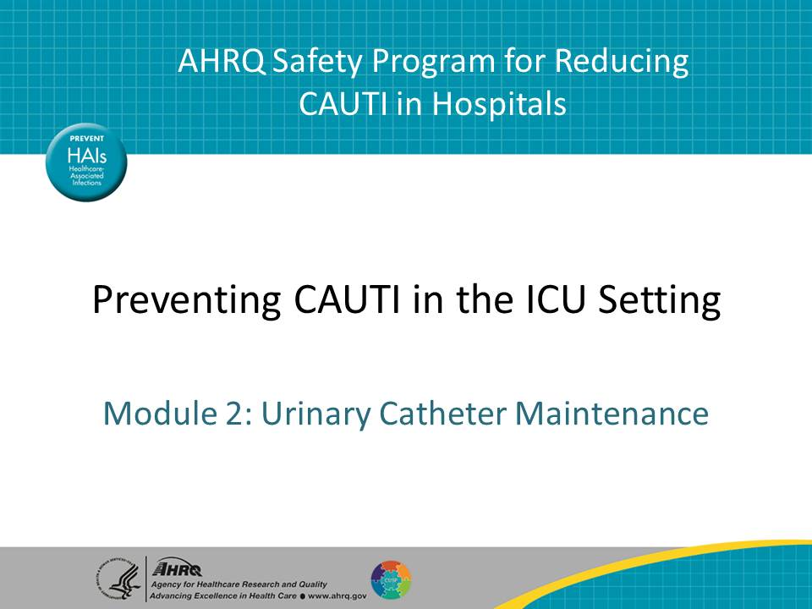
Narration:
In Module 1, we discussed the indications for an indwelling urinary catheter, the causes of catheter-associated urinary tract infections or CAUTI in the intensive care unit or ICU, as well as methods to mitigate the risk of CAUTI. In this module, we will use a case scenario to examine ways to prevent CAUTI when a catheter is already in place.
Potential points for discussion or questions from the learner:
- None

Slide 2
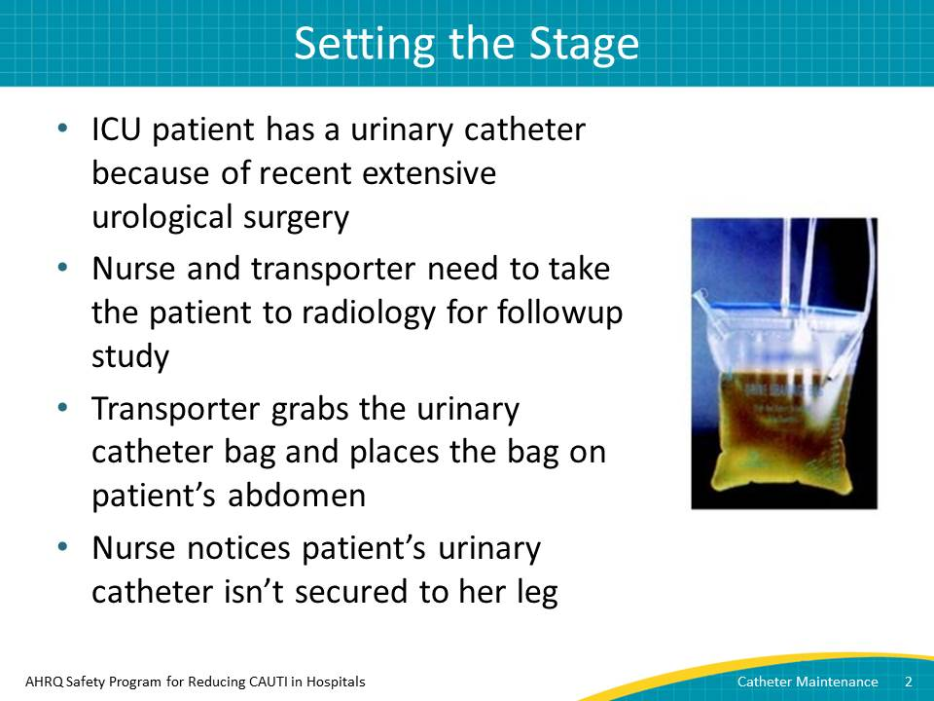
Narration:
This case scenario involves an ICU patient who has a urinary catheter because of recent extensive urological surgery. The nurse and transporter need to take the patient to radiology for a followup study. In preparation for moving the patient from the bed to the cart, the transporter grabs the urinary catheter bag and places the bag on top of the patient’s abdomen. The bag is approximately two-thirds full with urine. The nurse also notices that the patient’s urinary catheter isn’t secured to her leg.
Potential points for discussion or questions from the learner:
- None

Slide 3
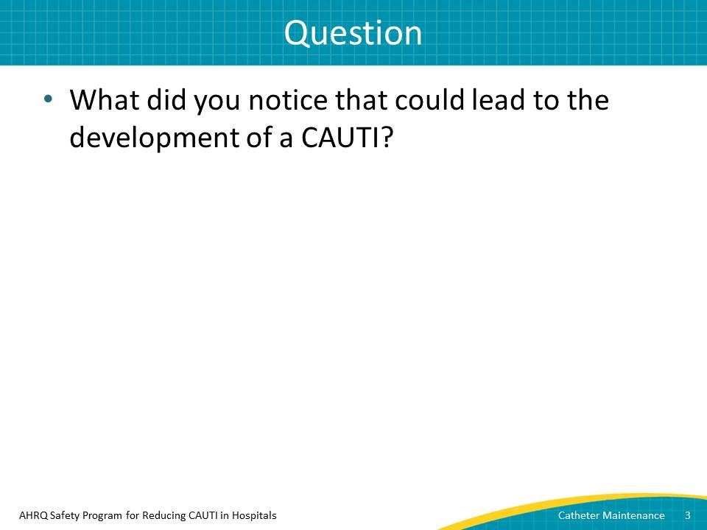
Narration:
I recommend that you stop the video and think about this question for a few minutes: What did you notice in the case scenario that could lead to the development of a CAUTI? If it would be helpful, you can go back and listen to the case scenario again before moving on in the presentation.
Potential points for discussion or questions from the learner:
- Pause the presentation, as instructed, to discuss the scenario. What did the learner notice?
  - Note that if the learner seems to flounder, say there were three things that he/she should have noticed.

Slide 4
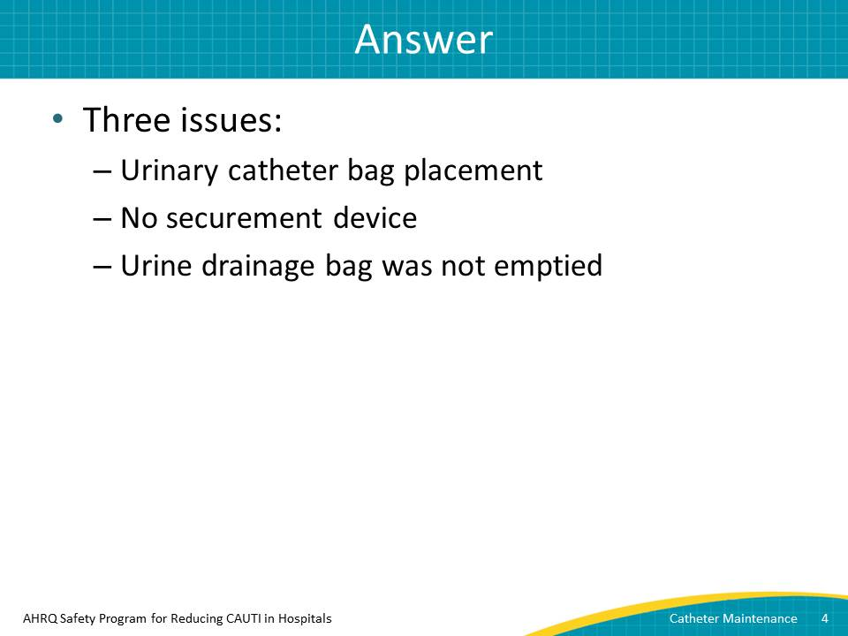
Narration:
You should have identified three issues that can lead to the development of a CAUTI:
- The transporter put the urinary catheter drainage bag, which has a measurable amount of urine in it, on top of the patient. This is dangerous because urine could flow back from the bag into the bladder.
- The nurse failed to use a securement device to attach the catheter to the patient’s leg. Not attaching the catheter to the leg can lead to urethral irritation.
- The drainage bag was not emptied. Emptying the drainage bag will help keep the urine from flowing back into the tubing when the patient is moving.
Potential points for discussion or questions from the learner:
- Did any of these surprise the learner?

Slide 5
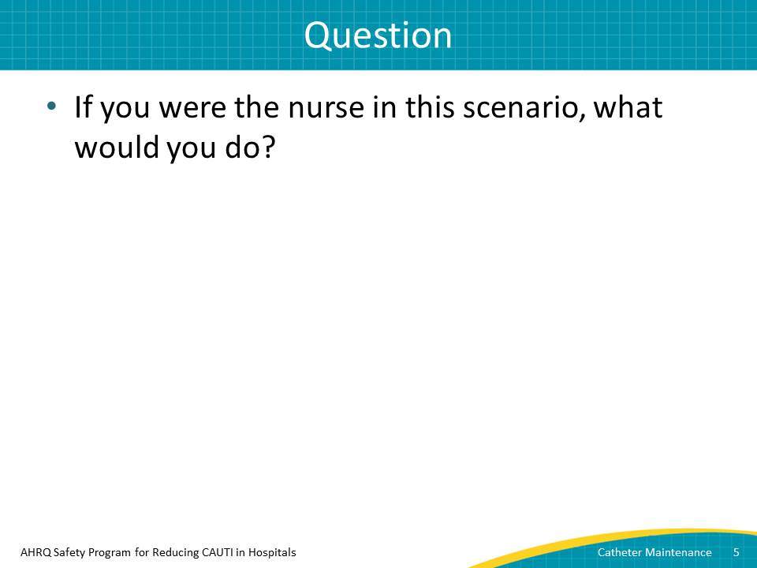
Narration:
This leads to another question. Once again, I recommend that you stop the presentation so that you can think about this question: If you were the nurse in this scenario, what would you do?
Potential points for discussion or questions from the learner:
- Focus on discussing having a hard conversation with a co-worker. Ask if the learner has ever had a similar experience. How did he/she handle it?

Slide 6
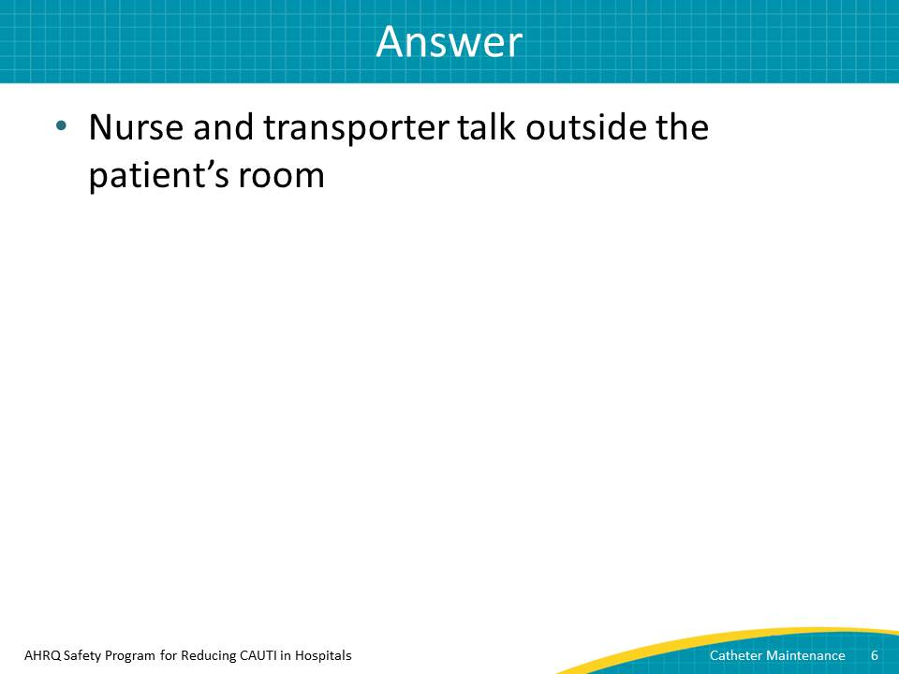
Narration:
The worst thing you can do in this case is ignore the problem. The second-worst thing is talking about it in front of the patient. Your best option is to ask the transporter to step outside the room with you so that you can have the difficult but very important conversation about the two points you noticed. The conversation might go something like this:
(Discussion between two males)
Nurse: “Hey, Mike, I wanted to talk with you about something before we move Mrs. Ramirez.”
Transporter: “Sure, what’s up?”
Nurse: “You know that we’ve been trying to decrease our CAUTI rates here, right? Well, how we handle the catheter tubing and bag can make a big difference.”
Transporter: “Did I do something wrong?”
Nurse: “Not exactly. It’s just that when we prepare a patient for transport, it’s important that I empty the patient’s urinary catheter bag before we move him or her. Doing that will help keep the urine from flowing back into the tubing when the patient is moving. It will also help if we keep the bag below the level of the bladder when we move her from the bed to the cart.”
Transporter: “That makes sense. So we shouldn’t put the bag on the patient’s abdomen, because that is above the bladder?”
Nurse: “Yes, you’re correct.”
Transporter: “OK, I got it. Anything else?”
Nurse: “Another thing we can do to help prevent a CAUTI from developing is to find a safe place to hang the bag on the cart. Also, with Mrs. Ramirez, I can show you how I apply a securement device on the tubing and secure it to her leg. With all the moving around, it will prevent irritation of her urethra, which is another potential risk for a CAUTI.”
Transporter: “OK, thanks.”
Potential points for discussion or questions from the learner:
- Does the learner agree with how the nurse handled the conversation? If not, how would the learner have done it differently?

Slide 7
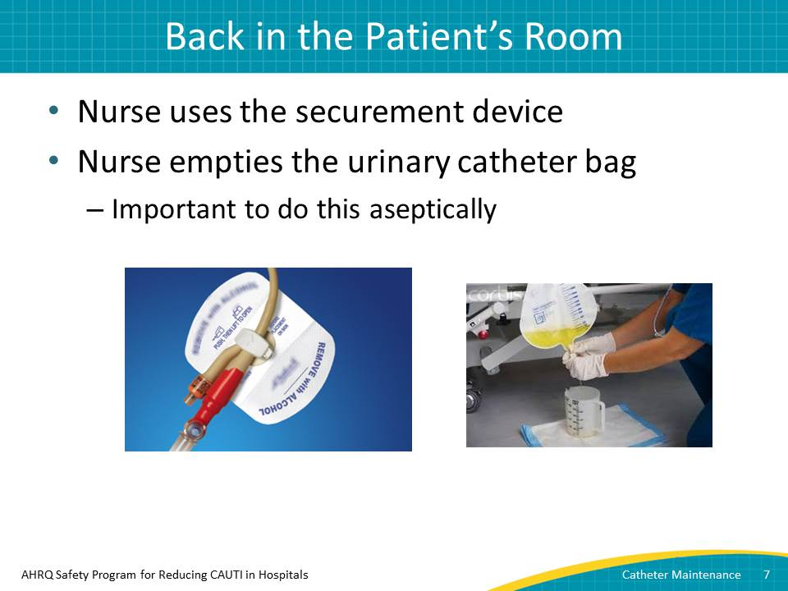
Narration:
After having the conversation, the nurse and the transporter go back into the patient’s room. The nurse places the securement device on the patient’s leg, making sure to show the transporter how to use this device.
Next, the nurse empties the urinary catheter bag. Remember, it’s important to do this aseptically by using good hand hygiene practices and avoiding contamination by keeping the spout from touching the sides of the graduated cylinder.
Potential points for discussion or questions from the learner:
- Does the learner feel comfortable teaching another co-worker how to do things, like attach the securement device?

Slide 8
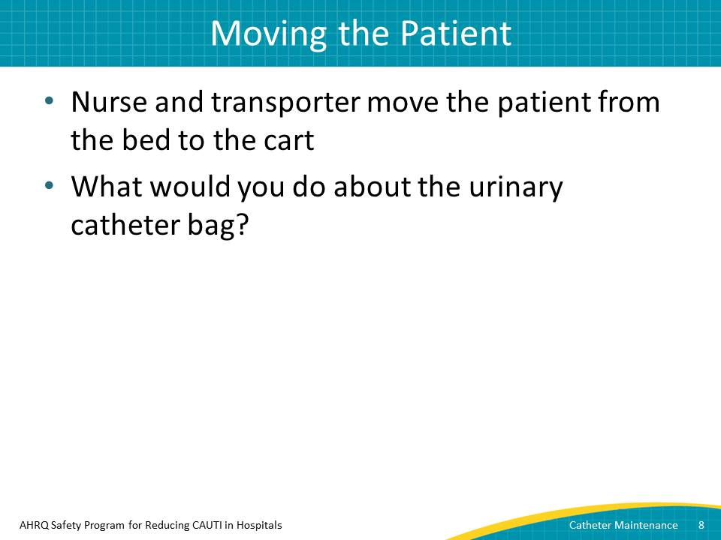
Narration:
But the conversation doesn’t end there because the nurse and the transporter still need to do some things once they’ve moved the patient. They will need to continue the important conversation they started.
(Same two male voices)
Nurse: “OK, now we’re ready to transfer her from the bed to the cart.”
Transporter: “I’m making sure the urinary catheter bag is below her bladder. Let’s move her now.”
(Narration resumes)
Together, they move Mrs. Ramirez from the bed to the cart successfully. Although the patient has been moved successfully, what would you do with the urinary catheter bag? I recommend that you pause the presentation briefly to think about this.
That’s right. The nurse should hand the urinary catheter bag to the transporter so he can attach it to the side of the cart, instead of laying it on the patient’s abdomen.
Potential points for discussion or questions from the learner:
- Pause the presentation, as instructed. What should be done with the urinary catheter bag?

Slide 9
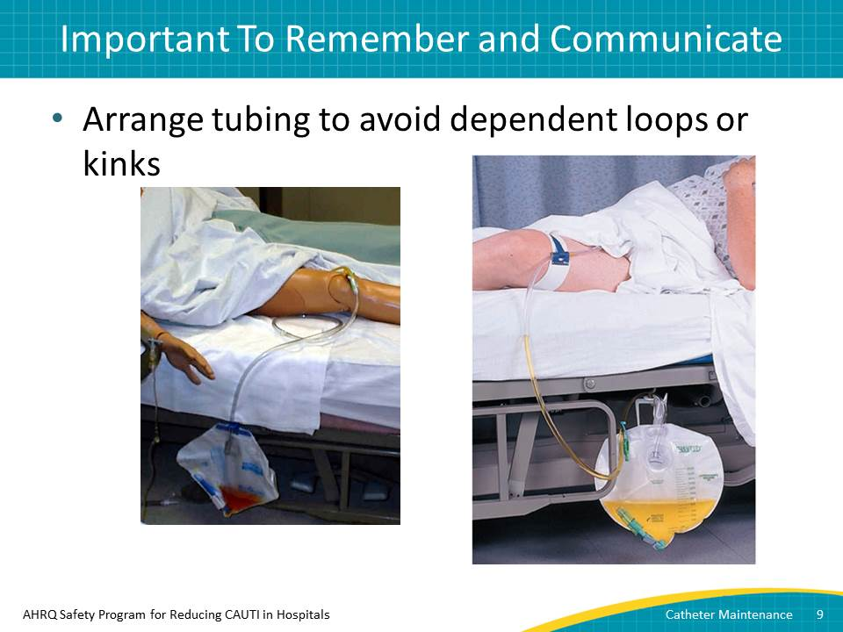
Narration:
Although the patient is on the cart, the urinary catheter bag is attached to the side of the cart, and a securement device is in place, the work isn’t quite done. It’s important to arrange the urinary catheter tubing on the cart so it isn’t hanging down in what is called a dependent loop. You can see a loop like that in the picture on the right. A dependent loop would prevent urine from flowing freely. Instead, be sure the tubing looks like the picture on the left side of this slide.
At this point, the patient is ready to go.
Potential points for discussion or questions from the learner:
- Is the learner comfortable with the difference between a “dependent loop” and what is best practice?

Slide 10
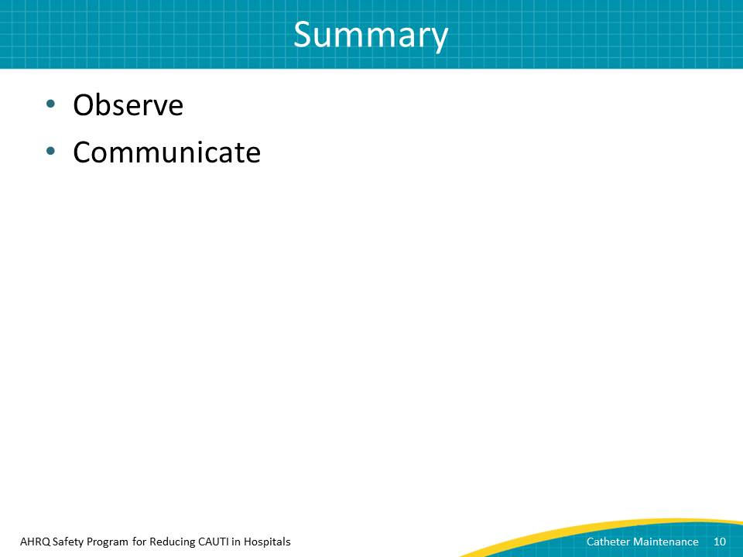
Narration:
So, what did you learn in this module?
First, a major part of preventing CAUTIs in the ICU is being observant. Would you have noticed the transporter putting the urine catheter bag on a patient’s abdomen? What about using a securement device?
Second, communicate. In this scenario, the transporter didn’t understand what might happen because of wrong bag placement or because a securement device was not in place. If this happens where you work, take the time to have this difficult conversation, but do it outside the patient’s room. Keep in mind that this difficult conversation actually educates and empowers the transporter to be part of the efforts to prevent CAUTI.
Lastly, consider including ancillary personnel such as transporters and other members of the interprofessional team who care for patients with an indwelling urinary catheter in CAUTI prevention training.
Potential points for discussion or questions from the learner:
- Did the learner have any questions about what was discussed in module 2?

Module 3: Conversations Around Device Necessity
Module 3 features another case study. In it, a day nurse removes a catheter, based on her facility’s nurse-driven protocol. Doing so leads to a difficult conversation with the night shift nurse. In the process, learners see issues connected to communication and culture around catheter use.
Time required: 7 minutes

Potential Questions To Ask Before You Begin
- How does the learner communicate with other shifts? Is there ever a miscommunication? If so, how is it handled?
- What does the learner think about nurse-driven protocols related to urinary catheter use?

Content Delivery Instructions
- Note that the following slide has instructions to stop and reflect on questions:
  - Slide 3 (slide header is “Is This the Right Call?”)
  - Slide 6 (slide header is “Questions For You”)

Module 3 Content

Slide 1
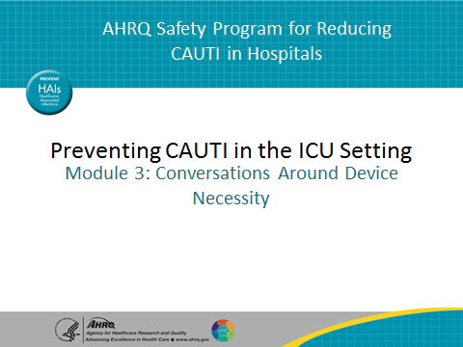
Narration:
In Module 1, we discussed the indications for an indwelling urinary catheter, the causes of catheter-associated urinary tract infections, or CAUTI, in the intensive care unit, or ICU, as well as methods to mitigate the risk of CAUTI. In Module 2, you learned about the importance of observation and communication, both about placing the urinary catheter bag and using a securement device.
In this module, we will look at a case scenario involving communication between a day nurse and a night nurse.
Potential points for discussion or questions from the learner:
- None

Slide 2
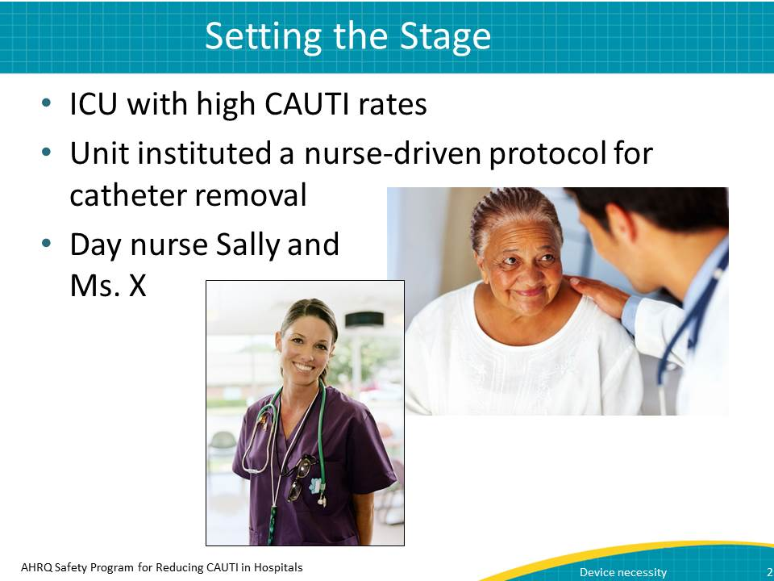
Narration:
Let’s begin with the case study.
This ICU had a high urinary catheter utilization rate that might have contributed to high CAUTI rates. Three months ago, the ICU implemented a nurse-driven indwelling catheter removal protocol, which included removing catheters that met criteria defined in the protocol. This was a major change for the nursing staff.
Sally was new to the ICU and was very engaged.
Sally identified that Ms. X, a patient on a ventilator, no longer required a urinary catheter. She implemented the nurse-driven protocol because there was no need for hourly output measurement. In addition, the patient was awake, alert, and able to void using a female urinal or bedpan. Sally noted that the patient was on a chronic diuretic, but it was not being adjusted. She removed the catheter according to the protocol, with no exceptions noted, after discussing solutions with the team. In case the patient developed incontinence, Sally placed an absorbent pad under Ms. X and instructed her on how to call the nurse when the bedpan was needed.
Potential points for discussion or questions from the learner:
- To this point, what does the learner think about the scenario? Does anything like this happen in his/her facility?

Slide 3
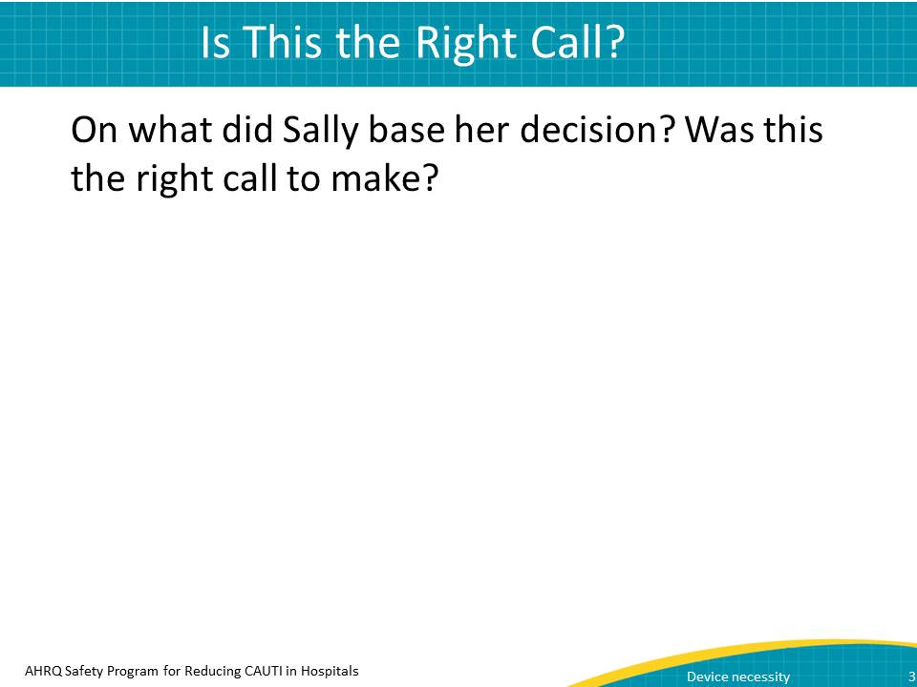
Narration:
Pause the presentation and think: Was this the right decision? What elements of the situation led Sally to make her decision?
You might have noted several key factors:
First, there was no need for hourly outputs.
Second, Ms. X was awake, alert, and able to void using a female urinal or a bedpan.
Third, although Ms. X was on a chronic diuretic, which would lead to high urinary output, it was not being adjusted.
Potential points for discussion or questions from the learner:
- Pause the presentation, as instructed, and discuss the questions.

Slide 4
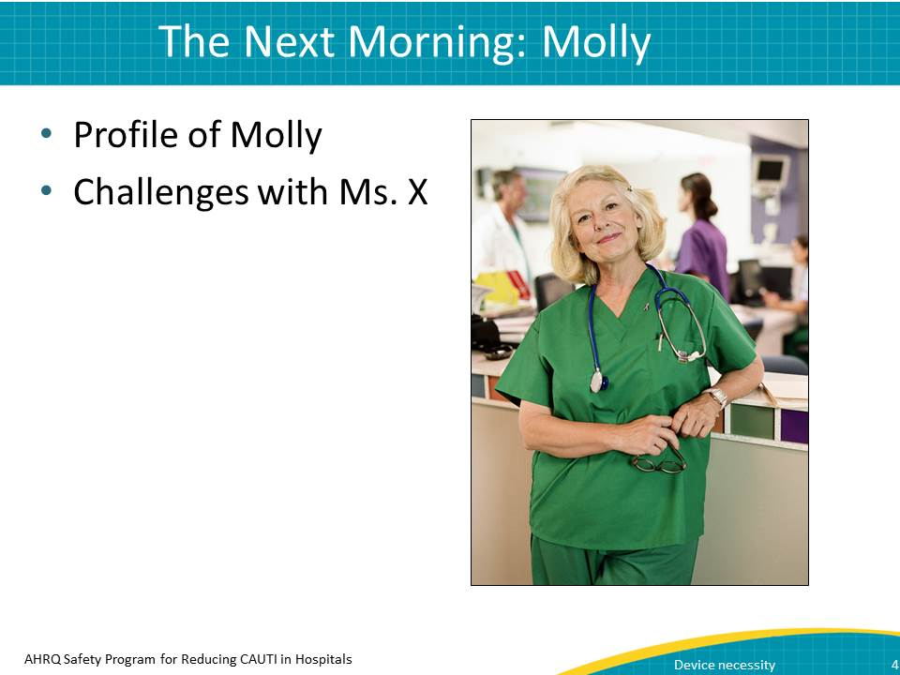
Narration:
That night, Molly arrived for the night shift. Molly was an experienced nurse and had worked in the ICU for 15 years. When conducting her patient rounds, she found Ms. X was incontinent. The urine had soaked through the pad, onto the bed, and even on her stockings. Shortly after the bed was changed, Ms. X was incontinent again. Molly was very upset.
Potential points for discussion or questions from the learner:
- Has the learner ever been in Molly’s position? Or in Sally’s?

Slide 5
Narration:
The next morning when Sally arrived at work, Molly reprimanded her.
(Dialogue between two females)
Molly: I can’t believe you pulled the catheter on Ms. X. She was incontinent all night, and I’m afraid her skin will break down. What were you thinking?
Sally: I was following the nurse-driven protocol, and she didn’t meet criteria for continued catheter use. I put a pad under her and instructed her on how to ring for the bedpan.
Molly: I think you better brush up on your nursing skills because that showed a complete disregard for patient dignity. I’m reporting this to management.
Sally: I’m sorry you had such a difficult night, but I did run the situation by the team and they all agreed with my decision. Sounds like we need to talk this over with our manager.
Potential points for discussion or questions from the learner:
- How did this conversation go? Has the learner experienced anything like it? How did it make him/her feel?

Slide 6
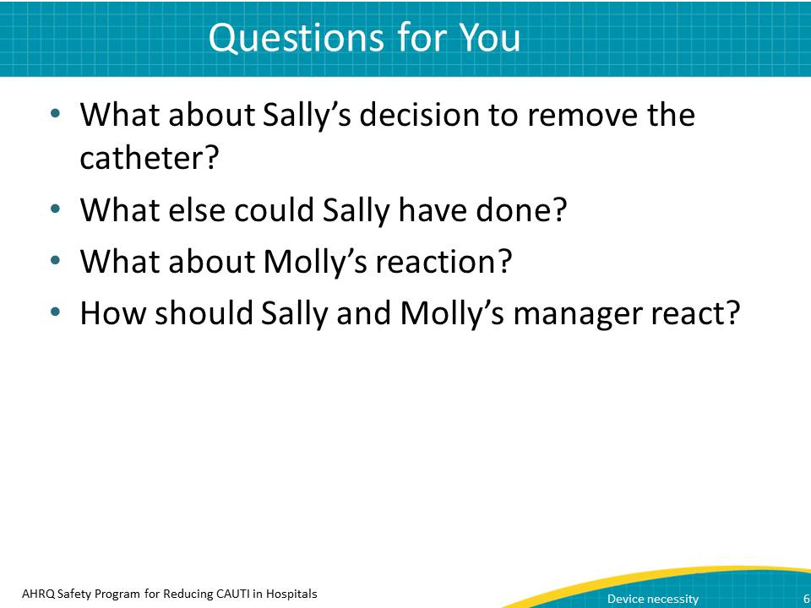
Narration:
Think back to the points we discussed about Sally’s decision. Did you agree with her? Was she right to remove the catheter? What other actions might Sally have taken? Was Molly’s behavior appropriate? What might the manager do to mitigate this situation?
Ask yourself: Could this have happened in my ICU?
Pause the presentation and think about these questions. Once you’ve considered them, resume playing the presentation.
Potential points for discussion or questions from the learner:
- Because subsequent slides will discuss each question, have the learner write down what he/she thinks on these points.

Slide 7
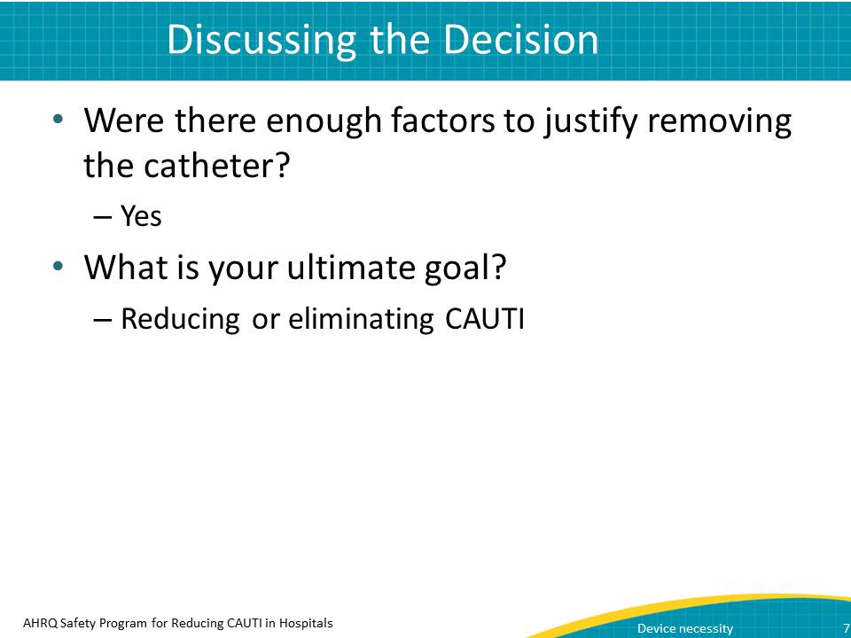
Narration:
Did you agree with the decision to remove the catheter?
Nurses are busy, and for many nurses, removing a catheter is a change in practice. Clearly, Ms. X met criteria for removal according to the protocol. Although these are difficult decisions, it is important to keep the overall goal in mind. Continued use of an indwelling catheter can lead to a CAUTI which may also result in bacteremia and sepsis. In addition, antibiotic treatment for the CAUTI can put the patient at risk for multiple drug-resistant organisms or Clostridium difficile.
Potential points for discussion or questions from the learner:
- Did the learner agree with the decision? Why or why not?

Slide 8
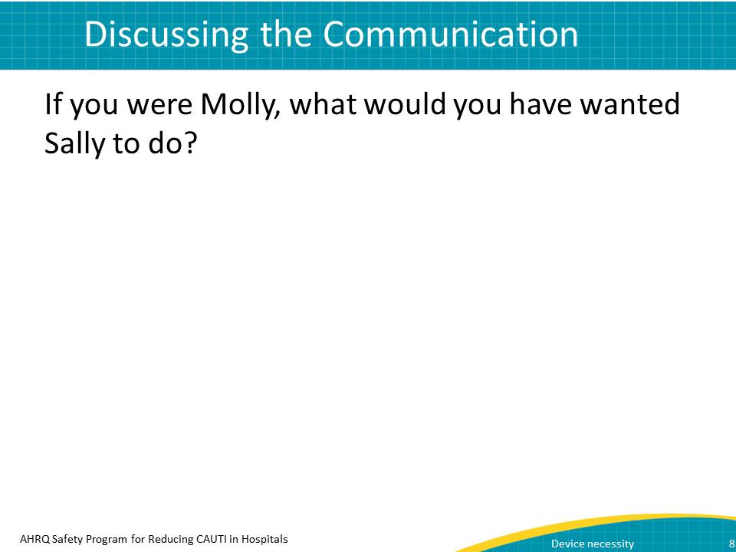
Narration:
What other actions might Sally have taken?
Sally could have communicated better. In the handoff between shifts, Sally could have reported to the night staff that the catheter was removed during the day because Ms. X no longer met criteria for continuation of the urinary catheter. Additionally, she could have shared the alternative strategies that she put in place, which were use of the bedpan and absorbent pads.
Additional interventions may have included offering the bedpan or female urinal at scheduled intervals.
Last, engaging the family was important, as family members can reinforce the plan of care.
Potential points for discussion or questions from the learner:
- Does the learner think that communication could have been handled better? Has the learner experienced a communication breakdown in another situation? How did he/she react?

Slide 9
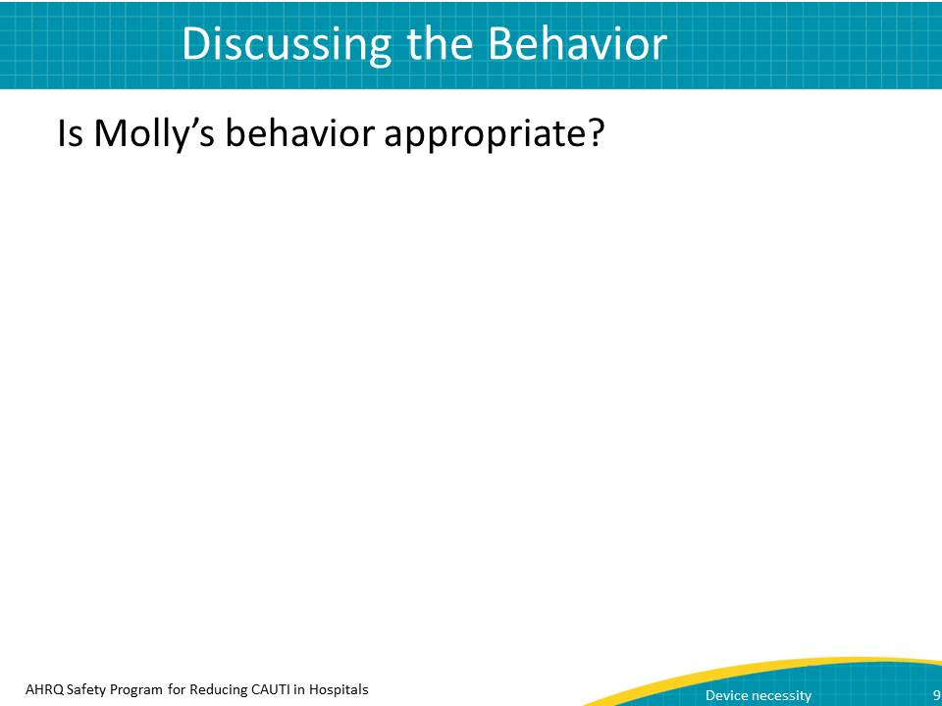
Narration:
Was Molly’s behavior appropriate?
No. Although Molly’s concern for patient dignity was well-meaning, Sally’s decision followed department protocol. Change in practice can be difficult, so this situation was an opportunity for staff to discuss the plan of care.
Potential points for discussion or questions from the learner:
- Does the learner agree that Molly’s behavior was inappropriate?

Slide 10
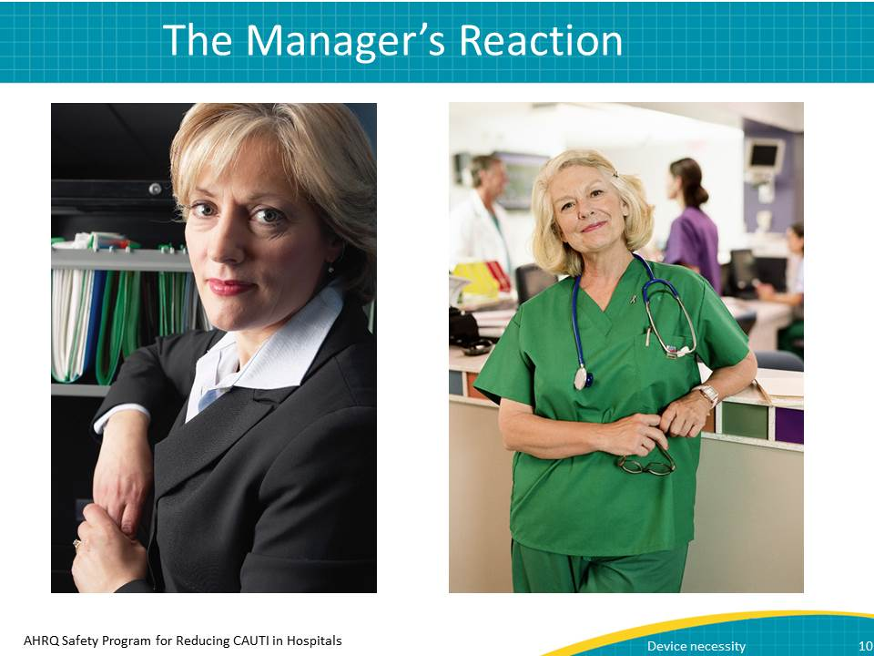
Narration:
What might the manager do to mitigate this situation?
Janet, the manager, should take the opportunity to talk with Molly about the situation and make some recommendations.
(Dialogue between two females)
Janet: Molly, Sally told me about your concerns for Ms. X.
Molly: I can’t believe she did that. Poor Ms. X was probably uncomfortable all night.
Janet: I completely understand your position. But, would you agree that patient safety is our highest priority?
Molly: (Pauses) Yes, obviously, but…
Janet: Well, our indwelling catheter utilization rate has historically been in the 90th percentile as compared with similar type ICUs. Would you agree that’s pretty high?
Molly: Yes.
Janet: I do, too. However in the last 3 months, since we initiated the nurse-driven protocol, it’s dropped to the 50th percentile.
Molly: Wow, that’s a big change. I had no idea.
Janet: I know we have more opportunities for improvement, and there may be times when the catheter has to be reinserted, but every patient who meets the criteria deserves that chance. You are an important part of this process.
I tell you what. How about you and some of the other personnel develop a communication tool so that changes in catheter use and alternative approaches are communicated clearly between shifts?
Molly: I like that idea. Thanks for letting me be involved.
Potential points for discussion or questions from the learner:
- How does the learner feel this conversation went?

Slide 11
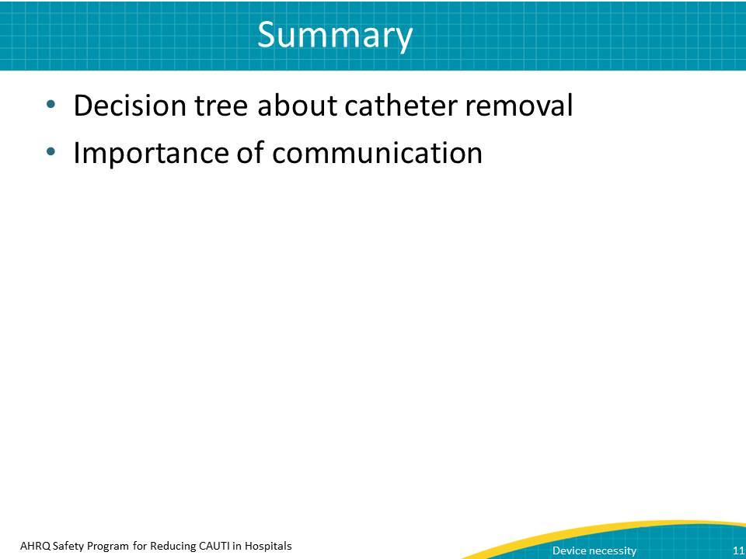
Narration:
So, what did you learn in this module?
We started off by looking at a scenario that dealt with the decision process for whether to remove a urinary catheter. Next, we learned the importance of good communication related to catheter removal. In our scenario, Molly raised valid concerns regarding patient dignity. However, Sally’s decision to remove the catheter was based on a unit protocol which optimizes patient safety. It is also important to remember that catheter removal can improve a patient’s comfort and mobility, thereby also contributing to patient dignity.
Potential points for discussion or questions from the learner:
- Does the learner have any questions about the module?

Module 4: Summary and Next Steps
Module 4 summarizes the content from the first three modules and adds information related to the urinary catheter “life cycle” and some easy-to-remember steps related to CAUTI prevention.
Time required: 4 minutes

Potential Questions To Ask Before You Begin
- How much does the learner remember from modules 1–3? Can he/she summarize those modules in a few sentences for each?

Content Delivery Instructions
- Note that no slides contain instructions to stop the video.

Module 4 Content

Slide 1
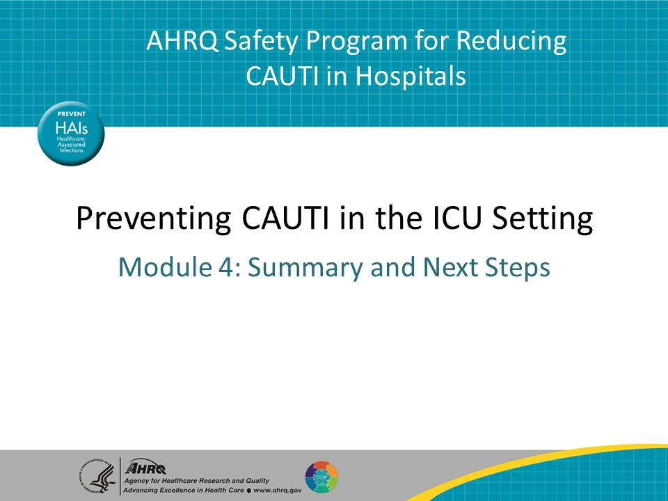
Narration:
- None
Potential points for discussion or questions from the learner:
- None

Slide 2
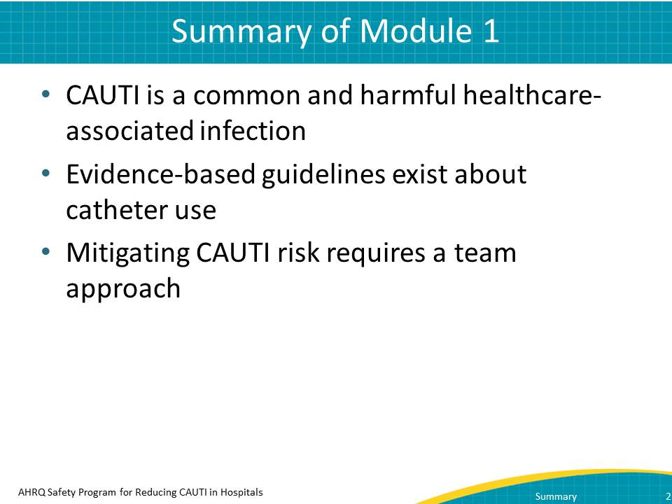
Narration:
You’ve now seen three modules on how to stop catheter-associated urinary tract infections, or CAUTI, in your intensive care unit, or ICU. In Module 1, you learned that hospital-acquired urinary tract infections impact almost 560,000 people every year in the United States alone. Of that number, almost 75 percent are catheter associated. Furthermore, of all healthcare-associated infections reported in the ICU, CAUTI accounts for nearly one-quarter of the infections.
You also learned in Module 1 that very clear, evidence-based guidelines exist about catheter use. In addition, you learned about the influence of unit culture on practice change and the importance of a team approach to reduce CAUTI.
Potential points for discussion or questions from the learner:
- Ask the learner if he/she has any questions about Module 1.

Slide 3
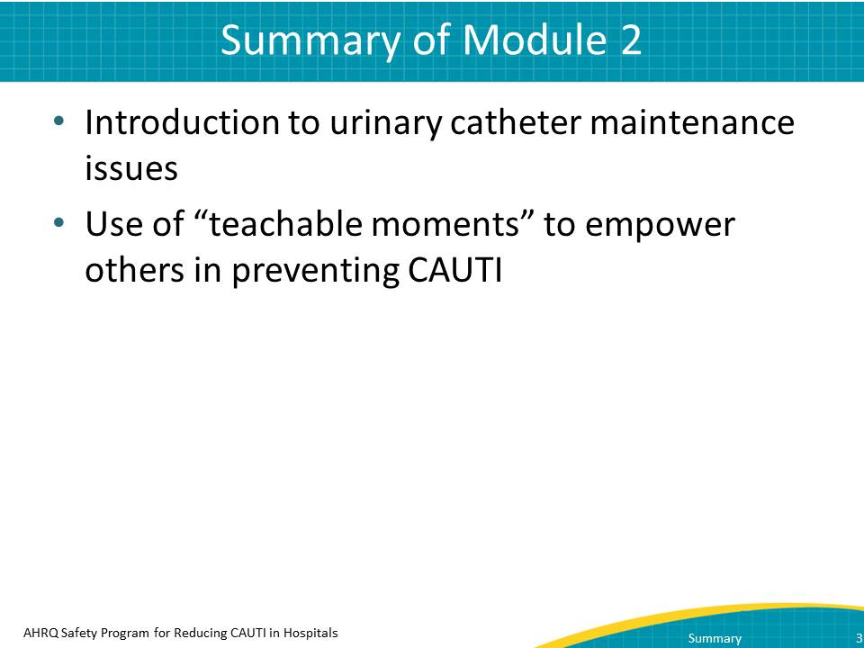
Narration:
Module 2 was about urinary catheter maintenance, and it featured the scenario of the nurse and the transporter. In it, you learned about aspects of catheter maintenance that can help prevent CAUTI, including bag placement and use of securement devices. You also learned about the power of teachable moments related to catheter use.
Potential points for discussion or questions from the learner:
- Ask the learner if he/she had any questions about this module.

Slide 4
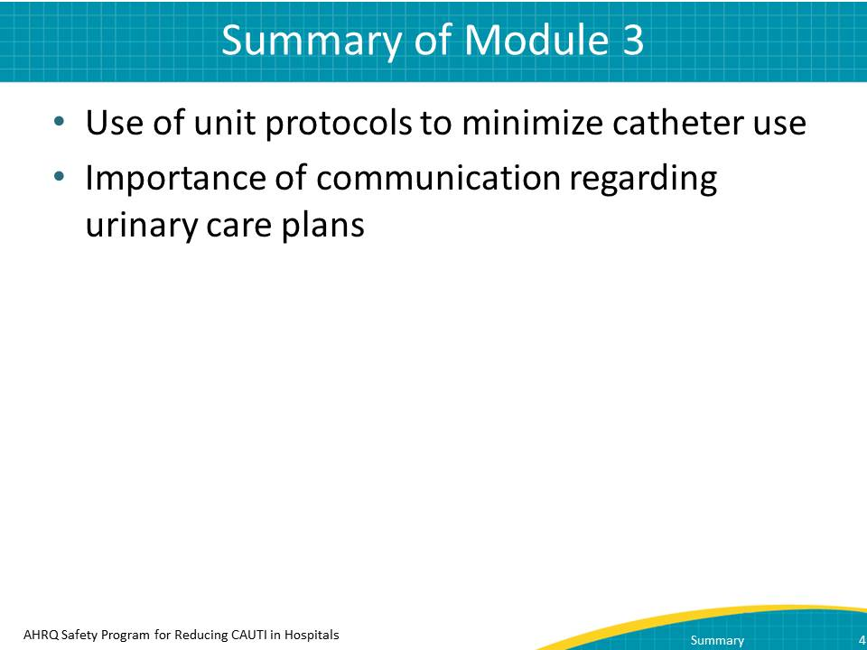
Narration:
Module 3 featured the interaction between a day-shift nurse and night-shift nurse around an elderly patient with a catheter. It highlighted the use of unit protocols related to catheter use. Even more importantly, it emphasized the importance of communication. Being sure that you foster communication between nurses and doctors or between shifts will help you reduce and ultimately eliminate CAUTI.
Potential points for discussion or questions from the learner:
- Does the learner have any questions about Module 3?

Slide 5
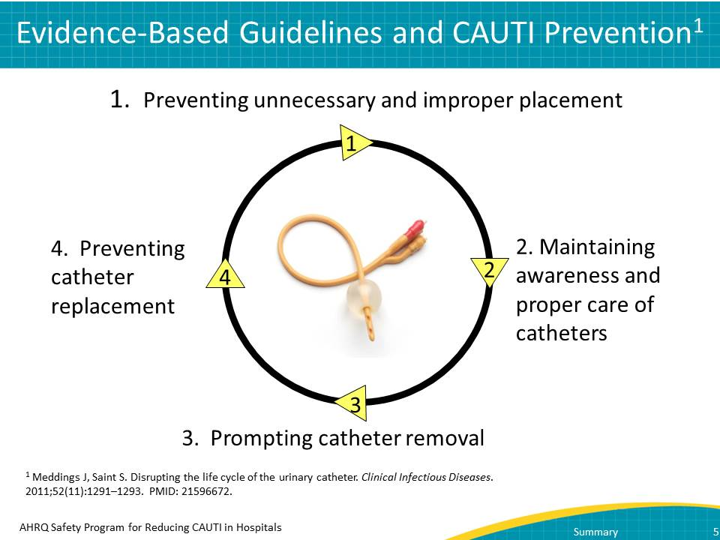
Narration:
In the first three modules, you learned a great deal about catheter use and its impact on CAUTI. This graphic summarizes many of the points at which you can impact catheter use. Ultimately, breaking the catheter life cycle disrupts the progression toward CAUTI.
First, try not to use a catheter at all. Prevent unnecessary and improper placement.
Second, if a catheter is used, maintain awareness and proper care of catheters already in place.
Third, promote prompt catheter removal. You can do this through catheter reminders and stop-orders.
Fourth, prevent catheter replacement.
Potential points for discussion or questions from the learner:
- Although this is a new image, the learner has seen the information elsewhere in the presentation. Is there anything contained in the image that the learner found new or confusing?
- What does the learner think about the image? How could it impact his/her work?

Slide 6
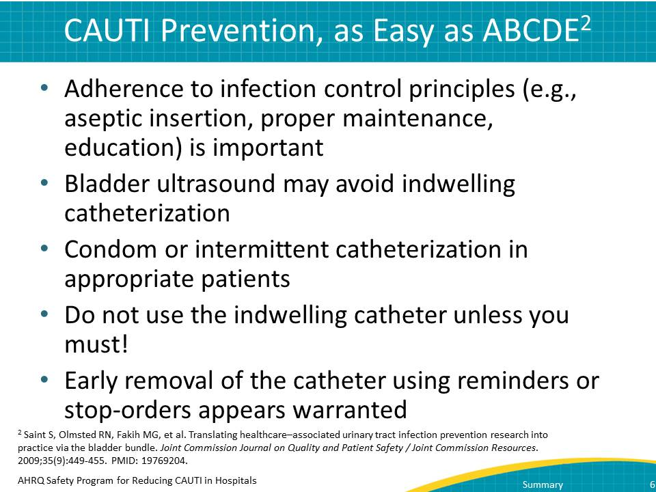
Narration:
When thinking about ways to break the catheter life cycle, consider these ABCDE prevention strategies:
- A, for adhering to sound infection prevention principles when using catheters
- B, for using equipment like the bladder ultrasound to assess patients’ ability to void adequately
- C, for thinking about alternatives to an indwelling urinary catheter like condom or intermittent catheterization
- D, meaning don’t use an indwelling catheter in the first place, if you can avoid it
- E, for removing the catheter as early as possible
Potential points for discussion or questions from the learner:
- As with the previous slide, the information on this slide has been presented elsewhere, but is merely summarized in a different way. Is there anything on this slide that especially interests the learner?

Slide 7
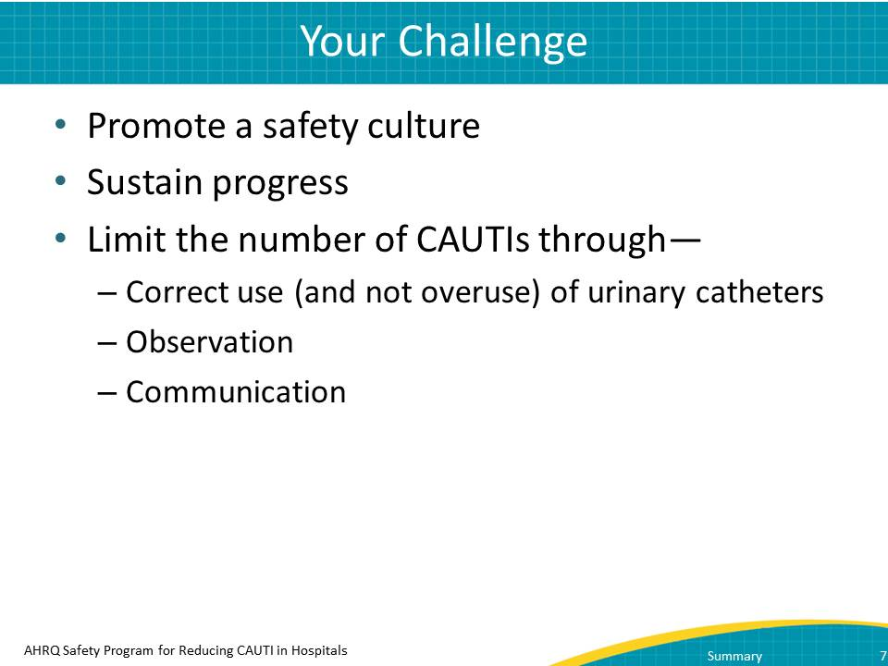
Narration:
Obviously, we all want to care for our patients. We have to view preventing CAUTI as part of that responsibility. Promote a culture in your ICU that emphasizes constant vigilance around safety and ending CAUTI.
Once you have helped contribute to that safety culture, you will need to sustain your progress. Sometimes, sustaining progress can be the hardest part. As things become routine or part of the way of doing business, attention to them can slip, and you go back to old routines. Fight that urge and help your unit maintain its commitment to excellence.
Above all, remember that you can limit the number of CAUTIs directly, through a few key ways:
- Use urinary catheters correctly. Avoid overuse.
- Observe what happens in your unit and how catheters are used. Step in to make sure they are used correctly.
- Communicate with others from both inside and outside your unit.
You can make a difference in CAUTI reduction and elimination.
Potential points for discussion or questions from the learner:
- How does the learner think he or she could contribute to creating a safety culture?
- What about sustaining progress related to CAUTI?

Finishing Up Strong
As Facilitator, your role doesn’t end once the video ends. Here are some tips for making sure that the training sticks with the learners.

Making Learning Stick
Watching videos is a passive learning task, although you’ve helped make it more active when you stopped the presentation and asked the learner to consider issues related to the video. To make the learning stick even more, the learner must take control of how he/she will implement changes and information seen in the video.
Some ways to do this include:
- Have the learner create a list of ways in which he/she can contribute to a safety culture.
- List ways that he/she can positively impact urinary catheter use in the ICU. (It becomes an even more powerful tool if the learner prints these reasons out and puts them somewhere that others in the ICU can see them.)
- Ask the learner to summarize the videos in a few sentences.

Being a Change Agent
Before the learner leaves the training room, communicate that you and the learner are working together to reduce CAUTI in the facility. You are both change agents and the learner should feel free to come back to you with ideas for improving the training. Be sure that the learner knows you are open to ideas.
Remember, you can make a difference in CAUTI reduction and elimination.

