CLABSI Module:

Central Venous Catheter Indications and Alternatives
Facilitator Guide | Slide Number and Image
This module, titled “Central Venous Catheter Indications and Alternatives,” is part of the Agency for Healthcare Research and Quality’s Safety Program for intensive care units (ICUs) and addresses central line-associated bloodstream infections, also known as CLABSIs. This module will review when placing a central venous catheter—a CVC—is appropriate by reviewing existing guidelines on general indications and how to choose the best CVC for a patient if one is necessary. Using ICU-specific scenarios, you will then use this information and other tools to help guide decision making. | Slide 1  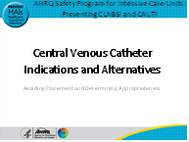
Let’s begin with a case study.  Mr. Vargas, an 81-year-old man who is living independently at home with his wife, is brought into your hospital and is found to have the flu. He is hypotensive, having trouble breathing, and delirious. He is admitted to the ICU, is intubated, and has a central line placed. He is treated supportively and is doing well, and is extubated a few days later. His team has kept the central line in because the patient said he has had trouble in the past with health care workers “finding veins on him.”  The day before his discharge, he develops a fever. He is found to have methicillin-resistant Staphylococcus aureus or MRSA in his blood.  After a diagnostic workup he is found to have a central line-associated bloodstream infection (CLABSI). The infection is too overwhelming, and he dies after heroic measures.  This situation escalated quickly and may have been preventable. By providing information on when a CVC should be placed and which CVC is best for which patient, and resources that can help with these decisions, this module may help your team avoid CLABSIs. | Slide 2

Facilitator Guide | Slide Number and Image
One way to think about catheter insertion is as a lifecycle. In cases of a vascular or urinary catheter, we begin with understanding the clinical indications for use. If you can avoid placing a central line, there is no chance of a CLABSI developing down the line, so “Step 0.—Avoid Placement,” is the most important part of this lifecycle, and what will be the focus of this module. | Slide 3  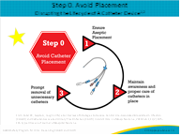
Let’s start by addressing the fact that a procedure is considered appropriate when the net benefit of having the procedure outweighs the net harm.  Times when there is greater benefit than harm to placing a central line may include some of the following common indications in the ICU setting:  - Administration of irritants such as vasopressors, chemotherapy, or total parenteral nutrition;  - Support of high-volume flow for therapy such as hemodialysis;  - Advanced hemodynamic monitoring in critically ill patients (with labile blood pressures);  - Venous access for placement of a device, such as a pacemaker;  - Inadequate or difficult peripheral venous access when ultrasound guidance has failed, and  - Diagnostic indications, such as placement of a pulmonary artery catheter to determine pulmonary hypertension or detect right heart failure.  In our initial story of Mr. Vargas, he had a need for a central line for hemodynamic monitoring and administration of vasopressors. | Slide 4  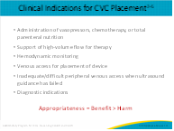
Resources are available for hospitals to assist with the complex decision making about when to use a CVC. You may find that printing out or having a guide for indications for CVC may be a good way to help decrease unnecessary central line use. You will find here an example of three resources in the references for more information.  The Infusion Nursing Society’s Infusion Therapy Standards of Practice specifically highlights which catheter may be best suited for a patient, and when to consider midline versus other types of lines. General advice that is recommended and important to note from this guideline is to use a CVC with the fewest lumens and the smallest diameter (unless the clinical situation mandates otherwise). The guideline also reviews indications for CVC, as noted in this table. It is important to note that failed or difficult access is still included but is added after ultrasound guidance has failed.  The Society for Interventional Radiology adds to the previously indicated criteria a few more indications for placing a central line, which include diagnostic indications, confirming a diagnosis, establishing prognosis, or monitoring a patient’s response to a treatment.  The Michigan Appropriateness Guide for Intravascular Catheters, also known as MAGIC, helps you understand which catheter is best indicated for which duration and type of patient in a controlled line placement situation.  Especially for PICC use in critical illness, they state that it is inappropriate for infusion of peripherally compatible infusate unless duration of treatment > 15 days.  For a CVC in critical illness, it is appropriate if duration of therapy is between 6 and 15 days or the patient is hemodynamically unstable or monitoring is required for less than 14 days. The guidelines also state CVC and PICC are the preferred lines if the patient is hemodynamically unstable or is receiving vasopressors.  Recommendations are also included for when to use a PICC, midline, or ultrasound-guided peripheral access. We have included this resource in the event that you find the diagrams, such as the algorithm within the “MAGIC paper,” useful. For example, you can print these diagrams out and tack them up in the infectious disease rounding room so that you and your team can look at these when recommending line placement for long-term antibiotics. | Slide 5  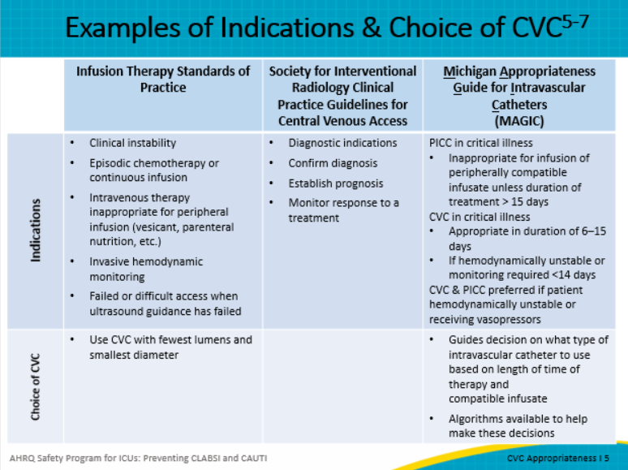
Specifically, the MAGIC guidelines help you choose the right vascular access for the right infusate for the right length of time to ensure the clinical team is not placing unnecessary central lines. | Slide 6  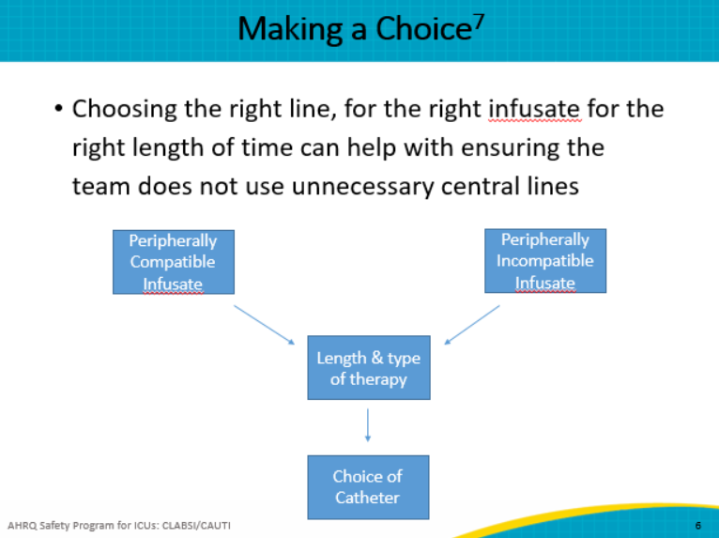
Using these indications can be challenging because each patient is different. And, there are limitations to using the indications listed in guidelines such as the ones that were just reviewed because there is limited evidence-based information for CVC use. It is up to your ICU to review the guidance and determine what practices will work best in your unit.  Another limitation is that the guidelines do not distinguish between types of CVCs As the number of lumens increases, the risk of infection and thrombosis increases. In addition, provider skill can impact complication rates. It’s important to take all of these factors into account when reviewing the guidelines because your ICU setting has its own unique characteristics that may not be the same as another ICU.  Additionally, not all recommendations account for duration of use and the length of time a venous catheter is in place. These should also influence CVC choice.  With all of that said, during emergencies, lines are in a separate category and cannot always be triaged by use of evidence-based guidance and practices. | Slide 7  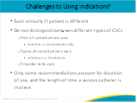
Here are some strategies that can help you and your team overcome challenges regarding CVC use.  Identify champions (nurses and physicians at the local and organizational level) to reinforce use of indications and alternatives to avoid placement in CLABSI prevention efforts.  Educate staff on appropriate indications and on the use and benefits of alternatives. For example, share stories on how other ICUs have followed the guidelines and lowered CLABSI rates. While doing this, address staff attitudes and beliefs toward concerns around changing practices.  Provide staff and physicians with a checklist to assess appropriate indications for CVC or other non-catheter alternatives in the ICU. Provide staff with opportunities to discuss and problem-solve how to use checklists.  Make sure that alternatives are available and accessible to unit staff and, if feasible, that frontline staff have been trained on using an ultrasound-guided peripheral intravenous catheter or PIV.  Remember the case of Mr. Vargas? What may have happened if his care team had followed the indications and considered alternatives instead of keeping his central line in because he had trouble in the past with IV access? | Slide 8  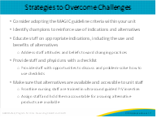
You will see here a few alternative options to central lines. These may have a lower risk of infection and should be considered in patients who may benefit from these alternatives. Consider using the MAGIC guidelines to drive the decision on the best alternative for infusate and duration of therapy.  If your ICU has a vein finder or ultrasound, then a peripheral IV catheter would be an appropriate alternative. An IV team or difficult access team can be handy in helping use these as alternative options or if they are not available training a core group of ICU nurses on this technology.  Midlines are also often a good option, and if there is someone on staff in your unit who is trained to insert midlines, this can be another alternative to a central line. Many institutions vascular access or PICC teams are inserting midlines as well.  A recent multicenter study compared risk profiles for midlines versus PICCs in over 10,863 patients with short-term indications. Midline catheters had a significantly lower risk of occlusion and bloodstream infections versus PICC catheters after adjusting for patient characteristics, comorbidities, number of lumens, and dwell time.  In emergencies, many institutions, both academic and community-based hospitals, have trained their staff on the use of intraosseous infusions, which are inserted into the bone marrow for IV delivery of fluid and medications. This type of access is considered an appropriate alternative when line insertion fails.  In our case of Mr. Vargas with difficult access, using a vein finder or ultrasound to place a peripheral IV may have been a better way to maintain access after he was stabilized. | Slide 9  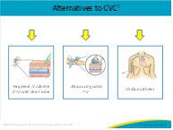
Using the MAGIC criteria, site selection once a short-term CVC—that is, one that is in place for less than 14 days—has been deemed necessary is also very important.  Three options are usually available: subclavian, femoral, and internal jugular.  But which site is best or most appropriate for CVC placement? | Slide 10  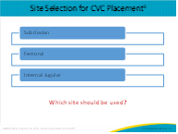
Let’s look at this large, randomized controlled trial on subclavian site versus femoral site versus internal jugular site for CVC placement. The outcomes the authors looked at included bloodstream infections, symptomatic deep-vein thrombosis or DVT, and mechanical complications like pneumothorax.  When you’re looking at this graph, focus on the red portion of each column that indicates bloodstream infections. Which site was associated with a lower risk of CLABSI?  The results confirm that the subclavian site is associated with a lower risk of catheter-related bloodstream infection but had an increased risk of mechanical complications. The orange part, again, is symptomatic DVT, and the gray is mechanical complications.  The authors thought it was important to note that the overall complication rate was similar among the three CVC groups. Because different complications might be of different relevance for the individual patient, the decision at which site to insert the CVC must be made considering a variety of individual patient-specific factors. In addition, on the individual physician's level, the training and experience with different techniques for CVC placement might influence the decision regarding the CVC insertion site. One can speculate that the relatively high insertion failure rate in the subclavian group (15%) might be attributable to a lack in training with this insertion site.  Central lines placed in the jugular and femoral veins have similar risk profiles for infection versus the subclavian vein. However femoral lines show greater risk for catheter colonization likely due to dressing disruption. Most publications still recommend avoiding the femoral site unless no other option is available.  It is important to remember that lines inserted in an emergency or determined not to be placed sterilely should be removed in 24 hours after arrival to ICU providing the team time to re-examine the best type, location for the line, and assess for indications. | Slide 11  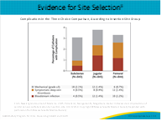
One of the most well-known studies in prevention of CLABSI, the Keystone Study in Michigan, made avoidance of the femoral site a priority in their CLABSI bundle, since other studies had shown this site is more often associated with infection.  Again, a takeaway from this talk is, if possible, the femoral site in a nonemergent situation should be avoided. | Slide 12  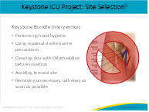
As you consider integrating interventions to include a review of clinical indications and alternates to CVCs:  - First, use clinical guidelines like the ones highlighted in this course to help decide if a CVC is appropriate.  - Remember that appropriateness of CVC depends on patient, device, and provider characteristics.  - Alternative options to CVCs include peripheral IV catheters with help of a vein finder or ultrasound to guide placement, and midlines.  - And most importantly, if a CVC needs to be placed, remember to remove it as soon as clinically possible to limit the risk of complications. Avoiding placement and removing a CVC when not indicated makes getting to zero infections more of a reality. | Slide 13  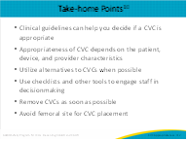
 | Slide 14
AHRQ Pub. No. 17(22)-0019
April 2022

