CLABSI Module:

Central Venous Catheter Insertion
Facilitator Guide | Slide Number and Image
This module, titled Central Venous Catheter Insertion, is part of the Agency for Healthcare Research and Quality’s Safety Program for Intensive Care Units (ICUs) that addresses central line-associated bloodstream infections, also known as CLABSIs. This module will review supplies necessary for aseptic insertion of a central venous catheter—a CVC—and strategies to ensure supplies are assembled and readily available to staff. Using ICU-specific scenarios, you will then use this information and a CVC insertion checklist to help guide decision making in an effort to prevent CLABSI and improve patient safety. | Slide 1  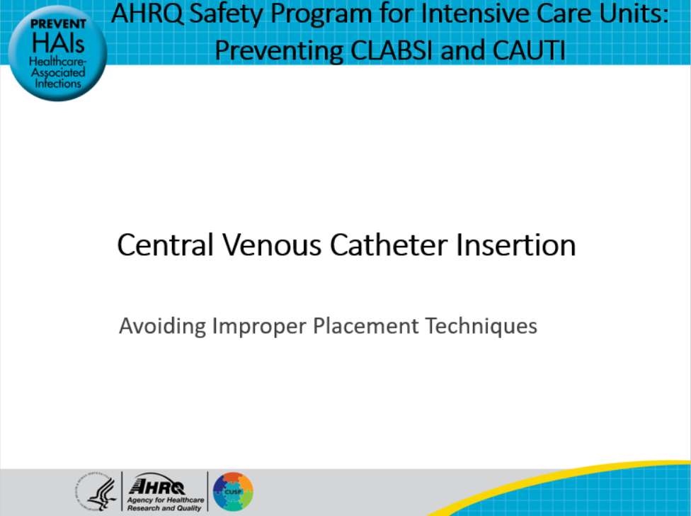
Let’s get started by revisiting the lifecycle of the catheter. In cases of a central vascular catheter, aseptic insertion is critical to preventing a CLABSI. If the decision is made that the patient meets criteria for placement of a CVC, then proper placement is important. So, we will focus on “Step 1, Ensure Aseptic Placement,” which is a critical part of this lifecycle. | Slide 2  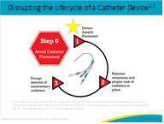

Facilitator Guide | Slide Number and Image
Consider the following situation:  Mr. Peterson, a 69-year-old, was admitted to your ICU at midnight with severe sepsis. He was hypotensive but responded initially to fluid boluses by peripheral intravenous access, but by 4 a.m., he was being prepared for an emergency central line due to persistent hypotension because he was no longer responsive to fluids.  Supplies of essential components to place a central line have not been replenished on the central line cart or in the supply room as there were several uses of the line cart during the day and evening. There are a number of supplies missing from the clinical supply room including correctly sized sterile gloves, sterile dressing kit, and head covers. You have to send someone to another unit to borrow supplies as the central supply department is closed. What are the potential consequences of missing supplies? | Slide 3  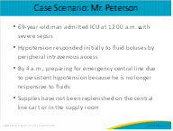
When patient care procedures do not proceed as planned, undesirable results might occur:  - Staff frustration can result in difficult communication situations.  - A lack of necessary supplies can also delay treatment while supplies are located, decreasing team efficiency.  - Delays in care might contribute to further patient deterioration, as appropriate and timely care is missed.  - If staff are resorting to workarounds and substitutions of care, then additional patient harm could occur if there are breaks in sterility or the team is unable to follow the evidence-based practice. These could result in a CLABSI. | Slide 4  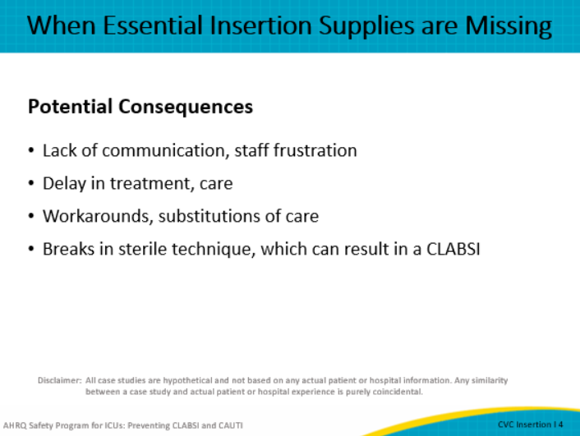
You may be wondering how to overcome the challenges we just outlined in the case. A proposed solution is using an approach that incorporates a central venous catheter insertion bundle.  The Institute for Healthcare Improvement (IHI) defines a bundle as “groupings of best practices with respect to a disease process that individually improve care, but when applied together result in substantially greater improvement. The science supporting the bundle components is sufficiently established to be considered a standard of care.” There are many examples of such standardization in healthcare, including disease-specific protocols for diagnoses such as diabetic ketoacidosis, sepsis, and respiratory failure.  The central venous catheter insertion bundle can incorporate a variety of components including hand hygiene, use of aseptic technique, full barrier precautions, site selection, sterile dressing, availability of supplies, and a checklist to ensure adherence to proper practices. Consider not only a line insertion cart, but insertion kits and dressing kits designed to include all the evidence-based practices in the order of how they are to be performed to help force function correct behavior. | Slide 5  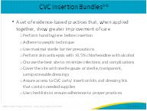
Consistent use of evidence-based practices suggests sustainable reductions in CLABSI rates related to placing central lines. Care bundles have become prevalent in healthcare as tools to ensure that care and interventions for certain situations are standardized. This standardization prevents variations in the delivery of care that have the potential to result in patient harm.  In addition, the use of bundles can help reduce healthcare-associated infections (HAIs) by improving compliance with evidence-based care and ensuring availability of necessary equipment and supplies that can reduce inefficiencies, workarounds, and substitutions for critical supplies.  Establishing a list of essential central line insertion components and implementing a process to replenish supplies can eliminate potential barriers to safe care that can occur when essential supplies such as skin asepsis products, sterile gloves, correctly sized central line catheters, and catheter stabilization devices are missing.  Standardization of communication can include using strategies such as:  - SBAR-Q where you explain the situation, background, assessment, recommendations, and pose questions;  - The use of white boards in patient rooms to improve communication among staff, patients, and families; and  - Patient handoff tools that ensure patient information is not forgotten.  Each of these strategies helps staff focus on incorporating a CVC insertion bundle into practice so that every patient receives optimal care every time. | Slide 6  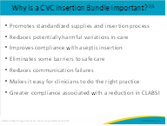
When we are compliant with the elements of the bundle, there is an associated reduction in CLABSI.  The goal of this study by Furuya and colleagues was to describe compliance with the central line insertion bundle overall and then look at the individual elements as well in U.S. ICUs to determine if there is a relationship between bundle compliance and CLABSIs.  The researchers surveyed 984 ICUs for compliance with the insertion bundle and various elements. There was greater than 95 percent adherence in about 50 percent of the ICUs surveyed with hand hygiene and maximal barrier. The highest level of adherence was seen with CHG prep at 65 percent, and the lowest adherence was observed in optimal CVC site selection at 40 percent. Twenty-two percent of the ICUs rarely adhered to or did not monitor compliance with the insertion bundle.  A decrease in CLABSI was associated with more than 95 percent adherence in a least one bundle element, with the greatest reduction in CLABSI occurring when all five elements had more than 95 percent adherence. If compliance was lower than 75 percent overall, there was no reduction in CLABSIs seen.  This study demonstrates the importance of measuring and achieving bundle compliance to reduce CLABSIs. | Slide 7  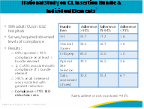
Using the ICU Assessment in the AHRQ Toolkit will help you evaluate whether central line components are currently stocked, available, and organized for efficient and effective use.  Are they currently in a prepackaged kit supplied by your materials management department? Depending on your facility purchasing agreements and whether your ICU is the only unit in your facility, or whether you are one of multiple ICUs in a large hospital system, you may have an all-inclusive central line kit that includes all personal protective equipment, the central line, needles, syringes, and skin antisepsis. Alternatively, is the central line available in a sterile package, and are the other components such as sterile gown, gloves, mask, and drape individually packaged for you to “gather” these supplies along with the central line kit? Do you have a minimally packaged central line, and insertion requires gathering additional supplies?  Reducing variation in practice is the goal so that is it easy for the clinicians to the right thing all the time.  Let’s take the issue of adequate supplies one step further. | Slide 8  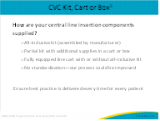
Is there a clear process for assembling and restocking the central line cart? If so, who is this responsible owner of this process? Is it the materials and supplies department or someone in your unit or department? Maybe your ICU hasn’t assigned anyone in particular to this process. In times of high acuity and use, there needs to be a way to rapidly resupply the materials needed to allow professionals to focus on patient safety. Display a list of contents in each drawer on top of the cart—making it easy to find what you need and easier to restock.  Assessing your current practices, processes, and policies is a critical starting point in identifying opportunities for improvement. Staff input is essential, and staff should be involved in decisions regarding kit assembly or design and restocking. Be sure to include physician stakeholders who insert central venous catheters and give them an opportunity to evaluate supplies or kit components. If possible, try to standardize across units so that CVC inserters find the same equipment and supplies regardless of the location. Consider standardizing the storage method including the kit, carts, boxes as well as the methods of restocking. Lastly, consider keeping duplicates of insertion items, even if included in a kit, in the event an item becomes contaminated. | Slide 9  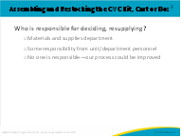
Another component of the CVC insertion bundle is a checklist. Checklists are becoming increasingly common during the performance of healthcare procedures to verify competencies, ensure the correct procedure is performed on the correct patient by the correct personnel, and serve as reminders of the correct sequence and steps.  We know that in emergency situations, shortcuts may be taken to save a patient’s life. In nonemergent procedures, the use of a checklist can be used to verify that procedures, such as central line insertion practices, are performed correctly, as well as prevent other examples of patient harm. In emergencies, the checklist can identify the timing and need for removal of the emergency catheter within 24 hours after resuscitation.  There are many benefits of using checklists, including standardization, promotion of evidence-based care, improved communication, appropriate use of equipment, minimized errors, and reduced reliance on sometimes-unreliable memory.  Overall, checklists can promote process improvement and increase patient safety. In 2010, a HealthLeaders Media Industry Survey reported that 88.8 percent of quality leaders use checklists to prevent errors in hospital operating rooms. With that said, it is important to note that the effectiveness of a checklist depends on its quality and thoroughness, acceptance and compliance by staff, and a strong culture of safety in the organization.  With the incorporation of the checklist into the electronic health record (EHR), the original intent of the tool being used during the procedure versus just documentation of the procedure after completion has changed. If possible, the checklist should be completed in real time by the nurse observer in the room and then the physician after completion of the procedure. The role of the nurse is to evaluate the process and focus on any breaks in sterility. | Slide 10  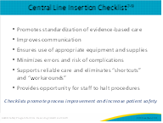
Many facilities utilize a standardized checklist during central line insertion to document insertion practices. Usually this document is not part of the patient’s health record, but is used to monitor, collect data, identify practice gaps, and target specific practices and interventions for the purpose of improvement. However, some facilities have incorporated many of these insertion practices into EHRs to document bundle compliance. This EHR component can be modified to suit the compliance and documentation needs of your facility. Examples of this include procedural insertion notes, monitoring of the central line site, dressing and tubing changes, and removal of the central line.  With the incorporation of the checklist into the EHR, often the practitioner who is inserting the catheter completes the documentation on the checklist. The original purpose of the checklist was to have the secondary individual in the room assisting and observing the procedure use the checklist to identify and notify the insertion provider of any breaks in the process or sterile procedure. Consider ways to make this happen using the EHR.  This table reviews three different central line insertion checklists commonly used in hospitals. Review these checklist templates and gather staff input as to which might be best suited for use in your ICU. | Slide 11  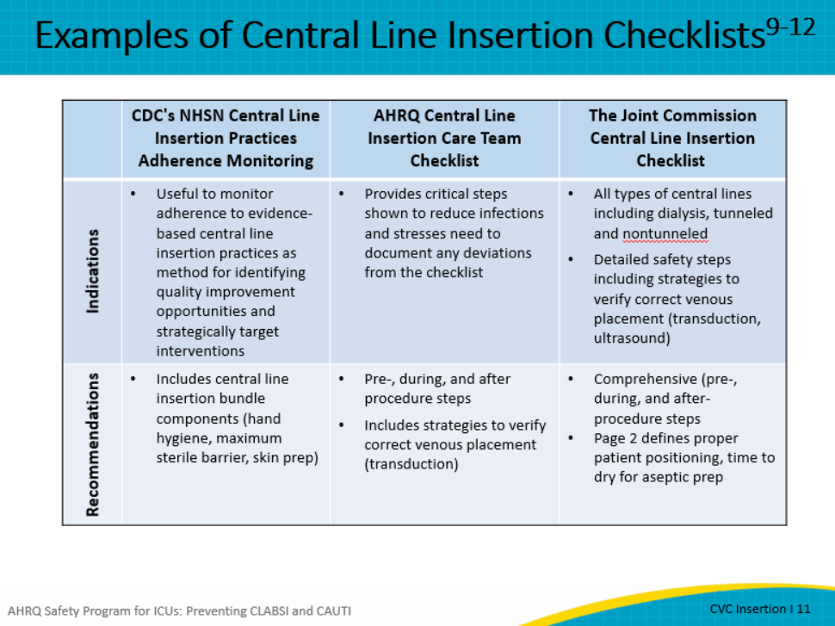
Now that you know the importance of a central venous catheter bundle and have a few different checklists to choose from, you may be making a mental list of all the barriers to implementing and sustaining the use of this bundle in your ICU.  It is often difficult to ensure that essential supplies are always available in busy ICUs. It also might be the case that there is not adequate staffing to ensure that a trained “observer” is available to assist with central line insertion and observe the aseptic procedure. Consider if you have the appropriate policies and procedures in place to assure adequate supply and responsibility delineation. These all can impact unit readiness.  Another challenge might be rooted in the culture of your ICU as it pertains to eliminating HAIs, including staff engagement in the quality improvement process as well as empowering staff to speak up to eliminate unsafe practices. Units may face the additional challenge of engaging management or senior leaders and might find that HAI education and training is not prioritized and thus limited.  Consequently, this leaves staff with inadequate knowledge to provide proper aseptic placement of a CVC. Consider incorporating some type of onboarding education around the central line insertion process for new physicians and nurses to help them understand their role in implementing the bundle elements to reduce CLABSI. | Slide 12  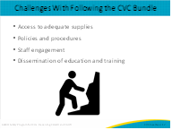
Challenges related to adequate supplies can be overcome by employing a few best practice strategies. Let’s start with some creative solutions to support your unit’s teamwork in the implementation and use of the central venous catheter bundle.  Use responses from the ICU Assessment and find opportunities for improvement. You may have identified that an all-inclusive central line insertion kit wasn’t readily available to your staff. Work with staff to identify the necessary components and the assembly/restocking procedure. Consider including a checklist in this process.  Evaluate your unit or hospital policy and procedure to determine if critical elements are included, information is easy to use and references are up to date. Do the staff know how to access the policy? Do the staff find the policy useful? Do physicians and other providers who insert central venous catheters know of the policy and are they aware of their role in patient safety and in the elimination of CLABSIs? Are they included in review of infections?  The Plan-Do-Study-Act (PDSA) model for quality improvement, discussed in the module “Quality Improvement in Action,” can guide your team in making small changes, evaluating the impact of the change, and rolling out the change (with or without revisions) on a larger scale. PDSA can be used to help improve availability and standardization of CVC insertion components and effective use of an insertion checklist.  Taking small but consistent steps with good follow through can create a sense of team empowerment, engage team members in the success of the planned interventions, and start your team on the road to eliminating CLABSIs. Let’s review an example of a PDSA intervention next. | Slide 13  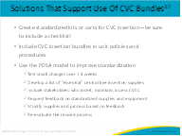
Here is an example of using a PDSA cycle to implement and evaluate the use of a central line checklist.  First step is to Plan: Choose a checklist to pilot. Select a small number of staff to evaluate the chosen checklist of a short period of time. The period should not be so short that the checklist is not able to be evaluated effectively, but not so long that the momentum of the change loses staff interest.  Next step is Do: Have the staff use the checklist for the determined trial period for every central line insertion. Have the staff evaluate the checklist not only for ease of use but meaningful use. How will the information obtained by the checklist be used? Does it promote increased compliance with the central line insertion bundle? Are staff using the checklist in “real time” or “after the fact”? Is the location of the checklist conducive to using it or is it hard to find?  Next step is Study: Following the trial period, review staff feedback and make necessary changes to the checklist. This might include where to keep the checklist to improve compliance with using it. Should it be with the central line cart if your unit uses one or should it be with a central line kit?  Finally, Act: This portion of the cycle involves educating, training, (if necessary) and informing all staff about the change—in this case, the use of a central line checklist to improve compliance with the central line bundle and reduce patient harm.  While this is just one example, this PDSA improvement model could be used to standardize a central line cart, standardize a central line kit, or modify and revise a central line dressing kit. | Slide 14  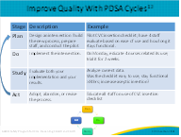
Process improvements, including those identified through the PDSA model, can have higher adoption rates when you engage all stakeholders in making changes to unit practices around CVC insertion. Stakeholders can provide important input on necessary supplies to stock for central line insertion and maintenance as well as the restocking process. Stakeholders may include essential staff who insert, maintain, and access central lines, as well as staff who are responsible for ensuring supplies are available. Be sure to hold those responsible staff accountable for assuring supplies are available when needed.  These roles may include:  - Physicians, advanced practice providers, or vascular access team staff who insert central lines  - Nursing staff who assist with central line insertions, access, and maintain lines  - Materials management personnel who stock supplies  - Unit personnel who ensure resupply of central line supplies  - Infection preventionists who monitor practices and infection rates  - Chief medical officer with oversight of process and guidelines and personnel responsible for placing lines  Seek consensus and agreement on central line insertion supplies, kits, and/or carts. This may include decisions on:  - Essential supplies and components to be stocked  - The use of kits, central line cart, or combination of both  - Purchasing, the stocking and restocking process  - Adjusting the amount of product stock on the unit to ensure it meets the needs of the clinicians. The process for ensuring supplies are available 24 hours a day and any differences in the process during business hours versus after hours and weekends processes should be considered.  When a new product (or change in product) is made by corporate healthcare, there needs to be education about the changes and efforts to ensure that teams are familiar with the new product.  What are some of the solutions that can be implemented by your team to improve?  There should be consensus on product standardization. This is not to say there should be only one type of every central line. But streamlining products can save time and money and prevent opportunities for error if staff are unfamiliar with a product and suddenly must use the product during an emergency. | Slide 15  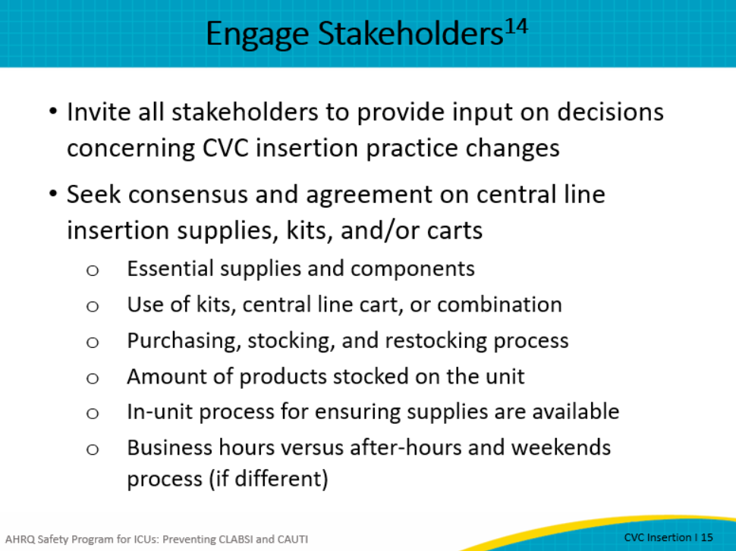
Once you have engaged stakeholders and created buy-in, take action to empower the stakeholders.  Provide opportunities for staff to share concerns related to changes in CVC insertion practices. For example, until processes are hardwired, should this topic be included in change of shift reports several times per week or shift huddles, as a 5-minute topic at staff meetings, during monthly critical care meetings, or during safety huddles? Be sure to take an opportunity to listen to staff attitudes and beliefs. It is important that staff members feel part of the “team.” This sense of belonging can impact whether nurses and other trained staff feel empowered to call attention to patient safety issues such as breaks in sterile procedure or request a halt to the process.  Use teamwork and communication tools (such as CUSP or TeamSTEPPS) to promote consistent use of CVC insertion checklists.  - According to the Centers for Disease Control and Prevention, communication failures may account for as many as 70 percent of patient safety events.  - TeamSTEPPS® is an evidence-based teamwork system aimed at optimizing patient care by improving communication and teamwork skills among healthcare professionals, including frontline staff. It includes a comprehensive set of ready-to-use materials and a training curriculum to successfully integrate teamwork principles into a variety of settings.  - The CUSP modules included in this toolkit include training tools to make care safer by improving the foundation of how your physicians, nurses, and other clinical team members work together. It builds the capacity to address safety issues by combining clinical best practices and the science of safety.  Designate someone to serve as the central venous catheter champion.  The champion or champions could be a nurse, a physician, or a combination of both. Some creative ways to implement the champion program might be to advertise within the unit. Consider the champion position as a unit leadership position for a specified period of time with a well-planned handoff at the end of the time period.  Ask leaders to support the use of checklists to prevent improper placement of central lines. Including unit leaders (formal and informal), departmental leaders, and hospital leaders in efforts to prevent improper central line placement, ensure compliance with central line bundles, and consistency with the use of a central line insertion checklist demonstrates the importance of patient safety in a complex and busy environment where often the sickest patients are the most vulnerable and at highest risk for infection. | Slide 16  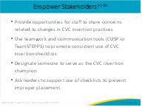
In summary, this module reinforces the importance of standardizing the process of insertion to prevent improper placement and reduce the chance of a CLABSI. Standardizing the type and location of supplies needed with the input of all stakeholders in these decisions will help assure a consistent process. Each unit should designate a person to maintain CVC insertion supplies and ensure all staff have easy access to the supplies. This is especially important in ICUs that have periods of heavy use of central venous catheters. By using checklists you can ensure that evidence-based practices are followed in every patient, every time. It is also important to identify and engage champions for an initiative such as this. This includes engaging hospital leaders and unit staff to provide real time feedback and support changes that will promote proper CVC insertion practices and reduce CLABSIs in your ICU. | Slide 17  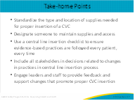
Slide 18
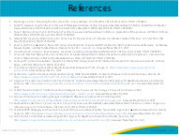
AHRQ Pub. No. 17(22)-0019
April 2022

