CLABSI Module:

Central Venous Catheter Maintenance
Facilitator Guide | Slide Number and Image
This module, titled Central Venous Catheter Maintenance, is part of the Agency for Healthcare Research and Quality’s Safety Program for Intensive Care Units (ICUs) and addresses central line-associated bloodstream infections, also known as CLABSIs.  This module will review the interventions in a central venous catheter maintenance bundle and will also explain the importance of proper care of a central venous catheter (CVC) as a means to prevent infection. | Slide 1  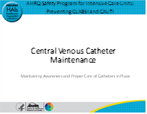
Let’s get started by revisiting the life cycle of the catheter. In cases of a CVC, maintaining awareness and proper care of the catheter is critical to preventing a CLABSI.  In this module, we will focus on step 2 on the slide, maintain awareness and proper care of catheters in place, which is an important part of this life cycle. | Slide 2  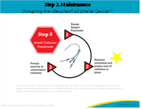
To start this discussion, let’s first consider a case study. Mrs. Dunn is admitted to the ICU for urosepsis, and a CVC is placed for hemodynamic monitoring and vasoactive medication administration. The CVC insertion bundle is used, and no breaches of technique are noted. Over the next few days, Mrs. Dunn improves, and the vasoactive medications and intensive monitoring are no longer necessary. Because Mrs. Dunn’s acuity has decreased, the nurses have been assigned to care for other patients at the same time. The central venous catheter continues to be used for antibiotics and for blood withdrawal for lab testing. | Slide 3  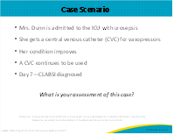

Facilitator Guide | Slide Number and Image
On day 7, Mrs. Dunn becomes febrile again and is diagnosed with a CLABSI due to another organism. The physicians and nurses in the ICU realize that her central venous catheter could have been removed days earlier, which would have prevented her from developing the CLABSI. The staff also mention that they changed the central line dressing every day despite the site being clean, dry, and intact.

A number of challenges identified in this case scenario can be addressed by consistently using a central venous catheter maintenance bundle checklist. Before discussing the checklist, it is important to address one the biggest challenges that occurred in late 2019 – the COVID-19 pandemic and its impact on CLABSI.
Analysis of National Healthcare Safety Network CLABSI standard infection ratios from 936 hospitals reported that a 28 percent (95% confidence interval: 20 to 33.6%) increase was observed in quarter 2 of 2020 compared with quarter 2 of 2019. Increases in device utilization, reduced contact between staff and isolated patients that could impact catheter maintenance, increased use of prone positioning in ICUs, and an overall increase in patient complexity and acuity were likely drivers of this increase. This may have led to lapses in infection prevention best practices. There is a need within our ICUs to reset or reboot our infection prevention culture and get back to the basics of line prevention care. | Slide 4  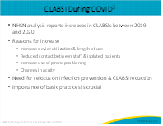
The fundamental care and maintenance of the central line is critical in preventing infection. It is recognized that COVID-19 created circumstances that even impacted practices that had been hardwired due to overcrowding, staffing shortages, movement of patients to nontraditional COVID units, and use of temporary and float staff.  The ICU team must refocus efforts on the basic components of the maintenance bundle, which includes: discussion of daily need in shift handoff and multidisciplinary rounds, ensuring the dressing is occlusive and not soiled, performing a CHG bath on all patients in the ICU unless they are allergic, correct process to access the CVC line to minimize the risk for infection, and lastly, changing the administration sets and tubing according to hospital policy. | Slide 5  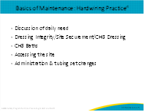
One way to assure we consistently follow key risk reduction strategies is to include a discussion of the necessity of the central venous catheter as a standard item in the daily team rounding process. It is important to take advantage of the expertise of the entire team when assessing whether the central line is needed as well as considering the risk associated with both keeping the line in and removing the central venous catheter.  Use of a rounding checklist ensures that all important items are covered in the daily rounds. Electronic medical record (EMR) prompts can also help highlight assessment criteria, ensure accurate documentation of necessity, and support monitoring of adherence to best practice. You may also post or print and share checklists for CVC indications to use as a guide during the daily assessment. The use of these indications should become part of your daily patient care, so discuss with your team members how best to integrate this knowledge and practice into your daily routines and processes.  For patients who have been assessed and continue to meet the indications for CVC necessity, evidence-based care strategies should be implemented by properly trained clinicians. These strategies include daily bathing with a CHG preparation and following essential CVC maintenance procedures, which we will discuss next. | Slide 6  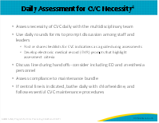
Here is an example of a central line maintenance bundle. Care bundles are groupings of best practices for a disease or care process in which each practice can improve care, but when “bundled” together, can result in substantially greater improvement. It is essentially a checklist with elements of an effective central venous catheter maintenance bundle, including a daily assessment for CVC necessity, and having a standardized central line entry, dressing care, and tubing change procedure. So, let’s discuss these four components of the central venous catheter maintenance bundle in more detail. | Slide 7  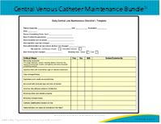
A variety of checklists is available. The slide shows part of a checklist from the Centers for Disease Control and Prevention (CDC) and highlights various maintenance strategies. Some highlights from this 2011 CDC Guideline for CLABSI Prevention Checklist include hand hygiene compliance, daily bathing with CHG, and use of aseptic technique for dressing changes. The following slide will address more on dressing care. | Slide 8  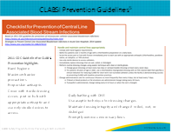
Maintaining a clean and intact central line dressing is an important part of central venous catheter care. Clinicians should conduct a daily assessment of the CVC dressing and should replace all dressings that become damp, loosened, or soiled. For short-term central venous catheters, unless soiled, damp, or loose, both the CDC and Infusion Nurses Society recommend changing the gauze dressings every 2 days, and to change transparent dressings every 7 days.  Clinicians should use aseptic technique when performing dressing changes. This includes wearing sterile gloves, mask, and performing appropriate skin antisepsis with a CHG solution.  Clear documentation of the date changed, or change due date (as facility policy dictates), also facilitates timely interventions, as well as auditing for compliance. It important to not disturb or change a clean, dry, intact dressing until the recommended date. Consider the case study at the beginning of this module and the unnecessarily frequent dressing changes. Changing CVC dressings too frequently can increase the risk of introducing bacteria to the entry site, as we saw in the case study.  Performing dressing changes with a standardized kit helps to set up the users to follow the correct steps to ensure an evidence-based dressing change each time. This is called force functioning since the only products available are the ones recommended. | Slide 9  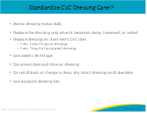
CHG bathing has been shown to reduce CLABSI in large cluster randomized trails from 29 percent to 40 percent and should be integrated into overall prevention practice within the ICU.  An article written by the lead author on the MRSA trials in the ICU and medical-surgical area provided guidance around CHG bathing. The method of application and training to do the bath correctly is essential.  Key points include:  The CHG bath is an actual bath rather than a topical application.  Commonly missed areas included the neck, back of the knees, and between fingers and toes.  It is important to leave CHG on the skin and not rinse it off, to achieve the full effect of its disinfectant ability through persistent activity.  Application with cotton materials should be avoided since the CHG can bind with the cotton rather than remain on the skin.  Several lotions and creams in the hospital can negate the benefits of CHG.  It is important to check for compatibility.  Practitioners are often skeptical about washing clean wounds with CHG if not dressed. The research demonstrated that it is safe and that the wounds can be a source of bacteria. Part of the bath procedure requires wiping over line dressings and cleaning within 6 inches of the catheter. It is important to clean the perineum as well as the face, especially around the nose and mouth, because of the heavy colonization in those areas. However, it is important to avoid the eyes and ears because studies have shown that CHG can cause damage to them. | Slide 10  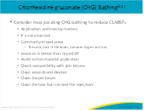
In much the same way, risk can be lessened by reducing the number of times that the central line is accessed and consistently following proper procedures when entering a central venous catheter. When we enter or access a central venous line, we should remember that every entry increases the risk of a CLABSI. You should consider opportunities to reduce central line entries as much as possible. This could include converting IV (intravenous) medications to PO (oral), and consolidating lab draws.  Disinfecting the connection site prior to accessing the central line reduces any external contamination and lessens the risk of transfer of pathogens to the internal lumen of the central venous catheter. Before accessing catheter hubs, needleless connectors, or injection ports, vigorously apply mechanical friction or “scrub the hub” for no less than 5 seconds with an antiseptic such as alcoholic CHG preparation, 70 percent alcohol, or povidone-iodine. In recent years, port devices like alcohol-impregnated port protector caps have become widely used. If using these devices, make sure to follow the manufacturer’s recommendation for proper use. Hubs, connectors, or ports should be changed at least as frequently as the administration set, but no more frequently than every 72 hours, unless specified by manufacturer recommendation.  And as always, hand hygiene should be performed before and after all central line care, including accessing or changing any hub, connector, or injection components.  As we discussed, improper disinfection procedure of hubs, connectors, or ports can increase the risk of infection, but can also impact other aspects of care, including contributing to contaminated blood cultures. Units may consider auditing central line entry processes for fluid, and medication administration and blood culture specimen collection, and provide that feedback to key stakeholders and frontline staff to enhance quality improvement efforts and improve staff knowledge and compliance with hospital policy.  If a line infection is suspected, both a peripheral and a central line specimen should be collected. Bloods samples drawn from a central line need to be clearly labeled.  Care needs to be taken with the choice of connectors. A wrong connector can lead to CLABSI. | Slide 11  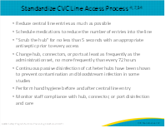
Now let’s discuss care of the CVC administration tubing sets. It is important to perform hand hygiene before changing the tubing. It is also important to reduce the number of times the central line is opened. Whenever possible, it is preferable to change all tubing and add-ons at the same time. Keep in mind that add-on devices (such as stopcocks, extension tubing, and connectors) may increase the risk of contamination, misuse, and disconnection of the central line, so discuss among the team the risks and benefits of such add-ons, and make sure your policies are written to reflect the best option for your ICU and the patients.  Recommendations for administrative tubing set change frequency are based on the likelihood and rate of bacterial growth known to be associated with different fluids. According to The Joint Commission, administration sets that do not use blood, blood products, or lipids should be changed no more frequently than at 96-hour intervals. For other fluids, like blood and lipids, hospitals should review current guidelines to determine the frequency and impact of these fluids on tubing change frequency. | Slide 12  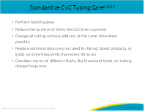
We have covered a number of best practices that include using a central venous catheter maintenance bundle and highlighting the importance of proper care of a central venous catheter as a means to prevent infection. What are the barriers that may affect you in your individual practice? Or your unit’s overall consistent adherence to these practices? Here are some possible barriers to consider:  Staff may feel they do not have the knowledge, both initially and on an ongoing basis, in terms of evidence-based practices. Staff may not understand why they need to change behaviors and practices so there is no buy-in. Often teams note that time constraints and staffing impacts their ability to follow specific guidelines, or they may not be able to locate the necessary supplies for CVC maintenance. We also know that the absence of audits of compliance, and feedback concerning processes and outcomes can be barriers to consistent performance of best practices in CVC maintenance. | Slide 13  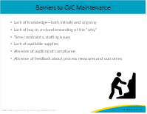
So, how do you overcome the barriers to CVC maintenance?  As noted in the tool shown on the slide, the Central Line Maintenance Audit Form from the AHRQ Toolkit for Reducing Central Line-Associated Blood Stream Infections, first take time to identify which barriers may exist in your unit. Talk with the team members and ask what they believe are the barriers and solicit their ideas for solutions to overcome these barriers. Engage them in developing any plans to change processes or practices. Identify staff who are passionate about patient safety as champions and make this work part of already existing work flow. These champions can educate and assist new and seasoned staff to hold everyone accountable.  Some ideas to consider include—  - Utilizing advanced tools and strategies such as vascular access teams to perform routine maintenance and “just-in-time” education, advice, or trouble shooting.  - Incorporate prompts into existing EMR charting that remind staff to assess for CVC line necessity and remove the central line if indications are not met.  - Create customized checklists/standardized processes that use evidence-based practices and address any unique cultural issues in your unit.  - Use prepackaged dressing change kits to make it easier to access supplies and follow proper procedures.  - And, conduct audit bundle compliance rounds and provide with “just-in-time” coaching and feedback. Feedback about performance is crucial for us to know what we are doing well, as well as identify opportunities for improvement. Ask champions to assess individual and unit compliance.  - Perform an immediate Learn From Defects to gather trends in missed care to identify performance improvement projects.  These are just a few of the strategies you can use to overcome barriers to CVC maintenance. We know you are balancing many priorities every day. Change is hard, and we need to find ways to make it easy to do the right thing. Give thoughtful consideration to what would work for you and your unit. | Slide 14  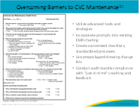
Recommended maintenance strategies have been validated to reduce central line infections. The reference here is a large international meta-analysis of several intensive care units with patients of all ages. The study notes that a large number were from the United States. In the meta-analysis the incidence of infections decreased significantly from a median of 6.4 per 1000 catheter-days (interquartile range 3.8-10.9) to 2.5 per 1,000 catheter-days (1.4 to 4.8) after implementation of bundles. Results were statistically significant.  A second meta-analysis examined the impact of quality improvement interventions on central line bloodstream infections in adult intensive care units. They found that the implementation of checklists and bundles appeared the strongest risk reductions. | Slide 15  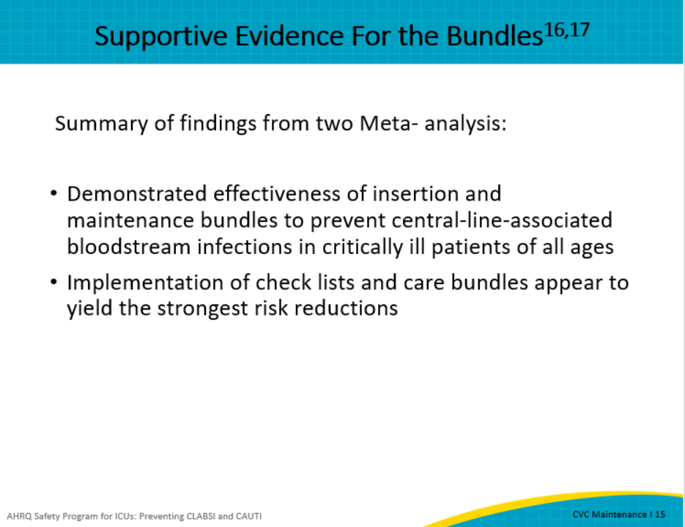
The following are the summary points from this module:  To help facilitate the consistent implementation of the maintenance bundle elements, checklists can be used to guide clinicians in the appropriate processes to follow. These key processes include reducing unnecessary access to the central venous catheters, appropriate assessment and dressing change procedures, and CHG bathing and proper maintenance of central line tubing and access ports. And remember, it’s really important to perform proper hand hygiene prior to accessing a central line, and be sure to “scrub the hub.”  Units should review possible barriers to implementation of these important maintenance bundle elements and apply solutions that will improve consistent application and outcomes. Finally, begin to identify solutions by using a quality improvement cycle such as Plan-Do-Study-Act. | Slide 16  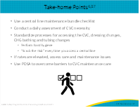
Slide 17
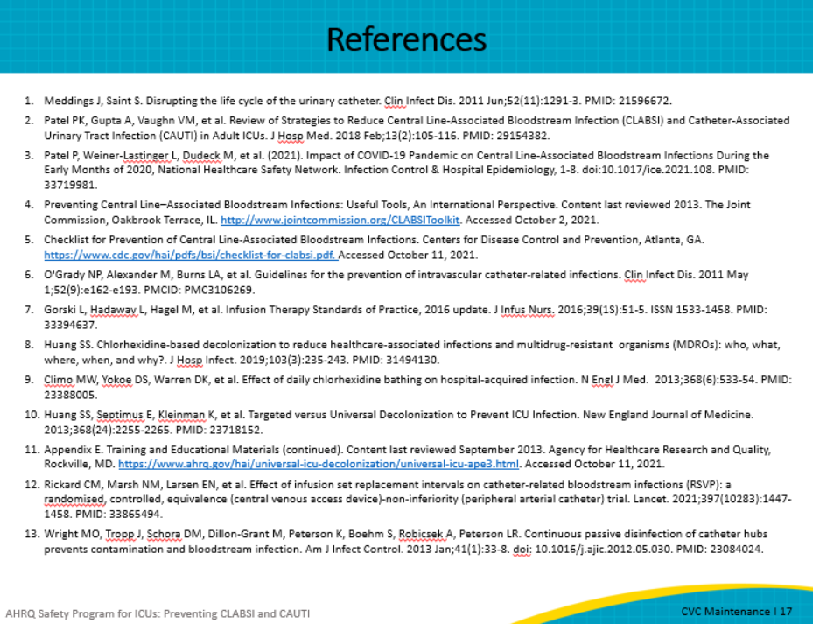
Slide 18
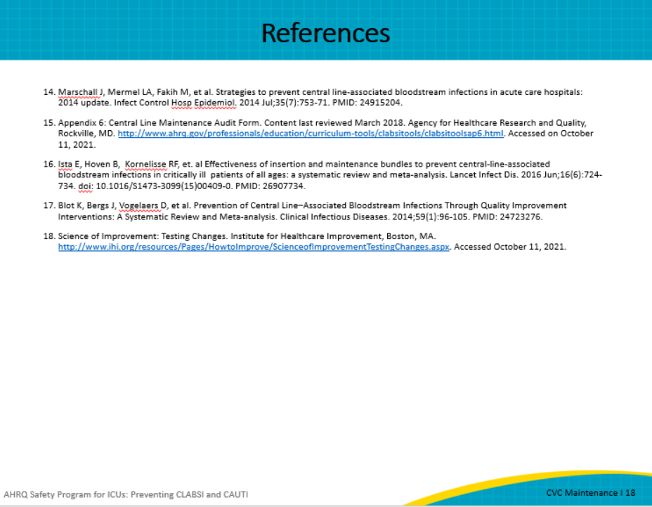
AHRQ Pub. No. 17(22)-0019
April 2022

