CUSP Module: Engaging the Team and Applying CUSP in the ICU Setting
Facilitator Guide | Slide Number and Image
This module, titled “Engaging the Team and Applying CUSP in the ICU Setting” is part of the Agency for Healthcare Research and Quality, or AHRQ, Safety Program for Intensive Care Units: Preventing Central Line-Associated Blood Stream Infection (CLABSI) and Catheter-Associated Urinary Tract Infection (CAUTI).  Engaging all unit staff is critical to CLABSI and/or CAUTI improvement project success and sustainability. This module explores strategies for the team to actively be involved in implementing and applying Comprehensive Unit-based Safety Program or CUSP interventions. | Slide 1  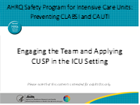
Objectives for this module include:  - Define key aspects of safety culture and why it is important  - Recall two strategies to obtain staff feedback to improve patient safety culture and engage the team  - Identify the three principles of safe design for systems​  - Describe how to identify defects from process monitoring | Slide 2

Facilitator Guide | Slide Number and Image
To begin, there are four primary concepts of the science of safety as a way to improve system performance, which includes the people doing the work. First, safety is the property of the system. This means that every system is perfectly designed to achieve its end results. Understanding this system approach to the work is a foundational first step to adopting CUSP and achieving success in implementation. Second, standardization, independent checks, and learning from defects are the principles of safe design and should be applied any time we seek to improve system performance. Errors often occur because systems frequently are not designed to catch mistakes before they reach the patient. When we design processes, such as checklists, and create independent checks for key processes, we improve our ability to reduce the risks of adverse events resulting in harm. Standardization makes errors in the system become more apparent, which allows us to address them. The third and fourth principles take a deeper dive into how to ensure the science of safety using a “people” strategy.  Principles of safe design apply to both technical and adaptive work. Not only can we use these principles to improve the technical aspects of our work, such as inserting central lines or urinary catheters with aseptic technique, we can also apply them to improving team communication and interaction. The key here that we’re going to hone in on is that teams with diverse and independent input have a better ability to make wise decisions. Understanding more about the science of safety helps providers recognize that most errors arise from the way our health care systems are organized. A systems thinking approach considers the organization of and interaction between individuals, resources, equipment, information, and other elements as we work toward a goal. It is important to teach or review the principles of the Science of Safety with your entire intensive care unit or ICU team. Even if concepts are familiar to you, we hope this will allow you the opportunity to optimize your use of these methods. | Slide 3  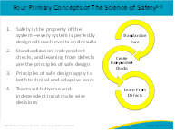
Throughout these toolkit materials, “safety culture” is a key term. Safety culture is the perceived priority of safety relative to other goals. From a sociological standpoint, a culture involves everything that happens around that given environment. Our culture shapes our behaviors, our attitudes, and our perceptions. In our work environment setting, we participate in a hospital culture and in a health care system culture. We think about manifesting culture when we ask ourselves, “What will I get praised for? What will I get reprimanded for? What is the right thing to do?”  In a way, this culture helps us understand what is good, bad, right, and wrong, so that we can also understand the appropriate way to behave. Culture shapes behavior on the job but it also improves outcomes. Not only does it improve patient and family safety, it also improves the safety of the care provider. Safety culture does not exist in a vacuum; it is being shaped while also shaping other factors. | Slide 4  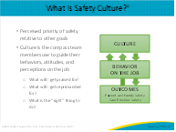
Safety culture has been shown to affect both patient and clinician outcomes. In terms of patient care experience, hospitals and units with a better safety culture tend to have lower rates of infection, sepsis, CAUTIs, CLABSIs, and fewer treatment error cases. The better a hospital’s safety culture, the better the incident reports tend to be in terms of clinicians being more willing to identify errors and learn from them. Safety culture also affects burnout and turnover rates. For instance, if safety culture is weak in a hospital or unit setting, the burnout rate among staff is more likely very high, causing the turnover rate to also be very high. A strong culture of safety can bolster staff resiliency and lower the risks of burnout.  Safety culture not only influences the effectiveness of other safety and quality interventions, but we have the ability to shape it, influence it, and change it. Safety culture is not static; you have the potential to transform it. So, it’s good to understand what the safety culture, in our unit, is like. | Slide 5  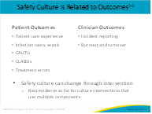
So how do you get your team engaged to be a high-performing team?  The CUSP Toolkit defines engagement as “to involve oneself or become occupied; to participate fully and deeply.” Full engagement in the initiative will require unit teams to actively support the CUSP implementation and its goals.  As exemplified by the upward sweeping arrow, the stages of engagement while assembling a CUSP team may span from feeling uninvolved to aversion, apathy, and fully engaged. When unit teams are fully engaged, their performance improves, and the overall likelihood of the initiative’s success increases. How can you engage and involve unit staff members in the initiative? How will you maintain their interest and support at the beginning? In an ongoing fashion to create the desired culture of safety? | Slide 6  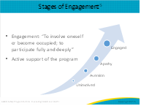
Barriers to team effectiveness include environmental or working conditions in your unit, resources, and as mentioned, team composition. For example, leadership challenges, such as low access to management, or high senior management turnover, can be barriers for teams. Many hospitals with persistently elevated healthcare-associated infection rates also report competing priorities, difficult work environments, and a lack of a shared vision for improvement. Poor collaboration among staff and negative interactions with other team members, including physicians, can make important changes difficult and even more time consuming.  Despite such barriers, ICUs can still make changes in systems or processes to make their units safer and prevent patient harm. The challenge is to figure out what they can control in the short term while they are working on overcoming cultural obstacles. For example, ICU staff who may be struggling with a safe environment that supports speaking up about safety issues can still use evidence-based guidelines to make local changes in processes such as dressing changes or supplies, or can identify local champions to guide education and training while they are tapping into outside resources. Examples of resources include hospital colleagues, hospital quality improvement staff, external coaches, or content subject matter experts, to help them address their cultural barriers. | Slide 7  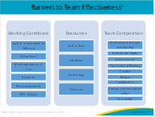
Working and learning as a team to implement and sustain the CUSP and CLABSI and/or CAUTI interventions will require that conversations and staff engagement are regularly discussed. When you’re making these plans, consider what existing structures (e.g., staff meetings, committees, shared governance councils) are available to help support its startup and sustainability. If you include CUSP as a standing agenda item for targeted meetings, it will be kept at the top of mind. Another opportunity to embed your initiative into existing structures is to incorporate it into daily rounds or unit staff meetings and unit, department, or hospital committees, which are vehicles that give nurses the opportunity to provide input as to their concerns, and most importantly the opportunity to share potential ideas for how to improve. In many organizations, shared governance structures have been initiated as a way to strengthen the voice of nurses and other caregivers on the front line. These structures create a forum for clinical staff communication and collaboration, a means to let the staff voices be heard, and a way to improve patient care in all areas of the organization.  You can also use patient-centered dialogue to compel the team to make changes by providing an example of when inaction (or action) led to patient harm.  You may consider looking for and reviewing data to discuss progress and challenges on a regular basis (at least monthly) such as device utilization or safety culture results.  Utilize these resources to support yourself and your team to dive into various topics in relation to CLABSI and CAUTI reduction in the ICU. Make learning and working together fun! Consider creating a competition or displaying progress such as the number of days without an infection in a central location. Make sure to celebrate successes and, if you can, provide recognition or rewards. | Slide 8  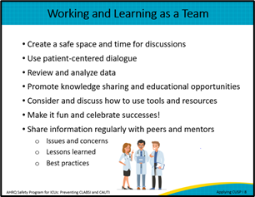
An activity for your team to celebrate a success or get folks involved in the work to prevent CLABSI and/or CAUTI is to use the template on this slide. This slide can be printed and used by team members to write down their “why” for improving CLABSI and/or CAUTI in their unit. The unit team can then take a picture or post the completed templates around the unit to showcase their commitment to the quality improvement project. | Slide 9  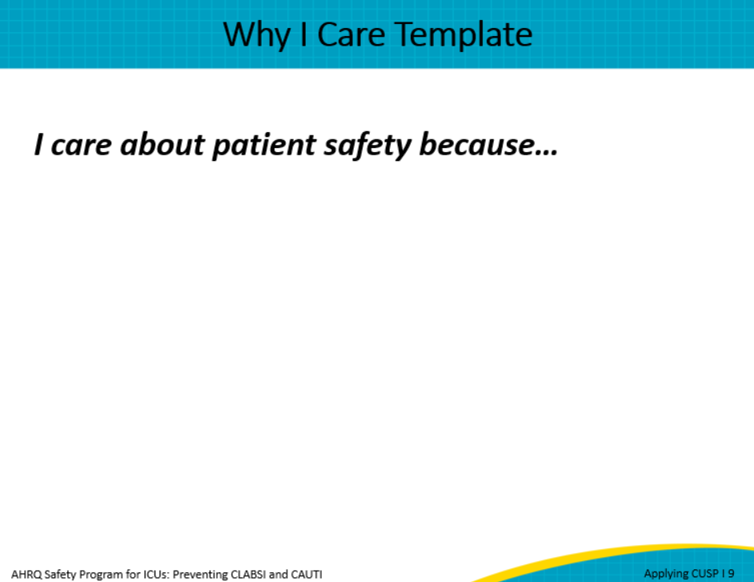
You may be working on developing a culture of safety in your ICU, where all staff know that safety is valued in the organization, and speaking up about safety issues or risks that pose a threat to safety is encouraged and valued. Some tools your team can use to help staff feel secure in speaking up around safety issues include standardized communication methods such as TeamSTEPPS. This is an evidence-based set of teamwork tools that aims at optimizing patient outcomes by improving communication and teamwork skills among health care professionals. You can find more information about these tools in the AHRQ TeamSTEPPS Pocket Guide linked on this slide.  The communication methods on this slide can be useful during handoffs between units and particularly if dealing with inappropriate medical staff responses to surfacing of a potential safety issue.  As we discussed at the beginning of this presentation, staff need a clear understanding of what will happen if such situations arise. This is where senior leaders, including the chief nursing officer, nursing directors, and the unit manager, along with unit and hospital physician leaders need to be fully engaged, aware of, and in agreement on any strategies to support speaking up. This work to align support from leadership reinforces a Just Culture and the systems approach to this work that we have discussed. As well, such strategies must be communicated to staff and physicians in advance of their implementation to ensure a shared mental model. | Slide 10  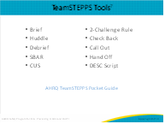
Beyond standard communication tools there are other ways to identify defects. One of these is adverse event reporting systems which are common in hospitals.  Another is sentinel events, as defined by The Joint Commission, or any claims data from your legal department provide high-profile defects.  Specifically for CLABSI and CAUTI, you may look at all cases reported by your infection prevention team as a key source of identifying outcome defects.  Keep in mind that process defects may be identified that did not cause harm but put patients at risk for harm, such as a breach in aseptic technique when inserting a central line. Audits are a great way to identify gaps in processes that increase risks to patients so that these can be addressed.  Another effective way to identify defects is by using the staff safety assessment. This form, available on the AHRQ website, is designed to tap into your experience at the front line of patient care to determine what risks are present in the unit that can jeopardize patient safety. | Slide 11  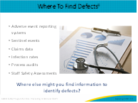
There are many ways to solicit staff feedback. It can be integrated into existing workflow such as rounding, staff meetings, and one-on-one conversations with staff.  We’ve outlined a few strategies your team can do to perform a defect analysis. The CLABSI and CAUTI event reporting templates are helpful tools that can be used as to demonstrate the complex systems that exist. There are many factors at play, and these tools take a deep dive into the circumstances that lead to the development of an infection. The 5 Whys technique helps understand why one contributing factor led to another contributing factor. It requires ground truth of what actually happened and not presumptions about what might have happened.  Lastly, the Staff Safety Assessment is an easy-to-use tool that takes very little time and offers an easy way to capture diverse input from a large group of staff.  We’ve outlined a few strategies your team can use to brainstorm; click on the links to learn more. This is also an opportunity to engage a member of your hospital’s quality improvement department to support defect analysis and brainstorming using a variety of tools and techniques. | Slide 12  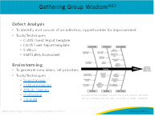
The CLABSI and CAUTI Learn From Defects tools and other event reporting tools, such as the CLABSI and CAUTI Event Report tools, provide a structured approach to help your teams identify system factors that contribute to defects, plan improvements, and sustain those improvements. Remember to ask these four basic questions when considering a defect:  - What happened?  - Why did it happen?  - How will you reduce the risk of the defect happening again?  - How will you know the risk is reduced?  You may call learning from defects by different names in your unit, such as “deep dives” or “mini-root cause analyses.” Whatever you call it, the purpose is to drive that second-order problem solving focused on learning the origins of a defect and devising solutions to lessen the risk of it happening again.  As your team works through this process, it is important to remain aware that infections very rarely result from one root cause. Infections are typically considered to be “multimodal” harms, which means that several factors add up to result in the infection. For example, some staff may omit hand hygiene, the next may not use best aseptic technique to insert the catheter, and the next may not scrub the hub, et cetera. Do not stop looking once you identify the first gap—keep looking until all reasonable causes are explored, based on the data you have.  Results from defects analyses can be pooled together to determine “common denominators” that defect shares. For example, let’s say you perform a defect analysis on every CLABSI, and you recognize that the majority of CLABSIs are related to dialysis catheters. That would give you a clue that perhaps examining what happens with dialysis catheters in more depth could help identify a driver of CLABSI in your unit. It would also indicate that your CUSP team would benefit from including a dialysis representative. So, data from defects analysis can be extremely valuable in helping to identify system errors and pointing out areas that need further investigation. | Slide 13  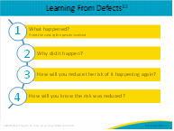
The event report tool is designed to be used as a guide through the initial investigation for a defects analysis where the primary goal is to learn what happened and factors that may have contributed to CLABSI and/or CAUTI; it is not a standalone tool. This tool is also a template, which means it can and should be adapted to each organization. Please manage this documentation according to your hospital’s patient confidentiality policy.  The questions in this event report tool are to assist teams in getting started, not limit what is examined. This list is a compilation of initial questions commonly asked during a CLABSI or CAUTI defect analysis/root cause analysis process and does not represent an exhaustive list of all questions that may need to be addressed. Indeed, the questions listed here may very well drive additional questions to understand active and latent issues more thoroughly. The goal is to learn as much as possible about potential latent and active errors contributing to the development of CLABSI or CAUTI in an individual patient. In addition, the data gathered from multiple CLABSI or CAUTI event investigations can and should be aggregated to look for trends and common denominators within a facility or unit, which furthers understanding to reduce risks. | Slide 14  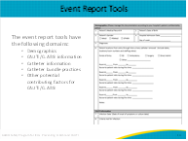
In order for the CUSP team to better understand why defects happen, make the "whys" visual. If your team created a process map, fishbone chart, or a drawing to illustrate what happened, use it to map out what happened and include the "why" under each defect. Use color-coded labels or sticky notes to engage the entire group. An issue can become much clearer when the whole team can see the full picture at one time.  As you examine the defect, look for weaknesses in the processes. Are there redundant steps? Are there variables that make care inconsistent among providers?  Evaluate the way your workplaces are designed and how they impact workflow. How do the workplaces and workflows impact patient care and the overall care process?  Remember to look for healthcare system factors discussed at the start of this webinar, such as departmental and work environment factors including managerial support, staffing, supplies, equipment availability and maintenance; team factors such as communication abilities; or task factors like the clarity of structure or processes. Drill down by using the "5 Whys" technique. | Slide 15  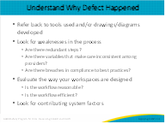
For example, one way to mitigate missing supplies from a kit or cart might be to develop a checklist for stocking the kit/cart, and appointing two staff to be responsible for this task on a regular basis.  Another defect identified may be that indwelling urinary catheters are being used when alternatives could be used instead. After reviewing the on-demand modules titled “Indwelling Urinary Catheter Indications” and “Alternatives to Indwelling Urinary Catheters,” the CUSP team might engage ICU frontline staff and Materials Management to coordinate trials of select alternatives.  Perhaps you identify that a short-term central venous catheter dressing is being changed daily, despite the site being clean, dry, and intact. The team can decide to implement a central line maintenance bundle checklist into daily rounding. Taking an example from The Joint Commission’s CVC Maintenance Bundles, checklist can include the evidence-based practice to replace dressings on short-term CVC sites if damp, loosened or soiled or every 2 days for gauze dressings and every 7 days for transparent dressings. It will also have space to document the date the dressing is changed and due date for the next dressing change. | Slide 16  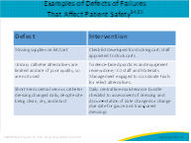
When choosing an intervention to work on, be mindful of the strength of the intervention. Telling someone to be more careful is a far weaker intervention because humans are fallible and are bound to make mistakes, whether intentional or not. We know that education is important to bring awareness to a problem, but it won’t change behavior.  As we continue up the strength of interventions, creating checklists like a central line or urinary catheter insertion checklist are stronger interventions. For example, an ICU had taken its central line insertion policy and created an independent check in the form of a checklist, to be completed on all line insertions. This standardized the ICU’s insertion protocol, making it much harder to miss a step, thereby creating a protocol with a much higher chance of achieving safer care. | Slide 17  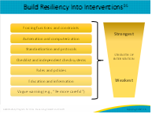
As part of this module, please use the following discussion questions to facilitate discussion with your team.  - What is the most common barrier to your CUSP team’s engagement?  - Where are the opportunities in your ICU to get new ideas and increase engagement?  - How have you engaged your team in learn from defects process? | Slide 18  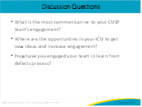
Here are a few resources from the AHRQ CUSP Toolkit that can help you better understand the importance of safety culture and ways to assess your ICU team’s safety culture. | Slide 19  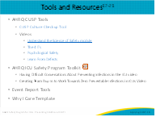
Slide 20
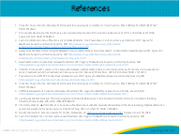
Slide 21
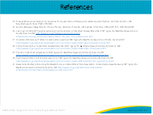
AHRQ Pub. No. 17(22)-0019
April 2022

