CUSP Module: Using Data To Drive Change and Improve Patient Safety
Facilitator Guide | Slide Number and Image
This module, “Using Data To Drive Change and Improve Patient Safety” is part of the Agency for Healthcare Research and Quality, or AHRQ, Safety Program for Intensive Care Units: Preventing Central Line-Associated Blood Stream Infection (CLABSI) and Catheter-Associated Urinary Tract Infection (CAUTI).  Data not only enable us to identify problems or gaps in care, but also help us prioritize quality improvement efforts using objective information and then assess progress toward meeting goals set forth by this program. This module will discuss data to drive change and improve patient safety, and will review the ICU assessment tool in more depth. | Slide 1  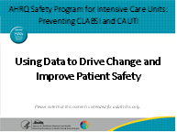
Objectives for this module include:  - Describe why data are critical to driving improvement in your ICU.  - List data elements required for program participation and how these are collected.  - Identify two best practices for sharing data with the ICU Comprehensive Unit-based Safety Program (CUSP) team and frontline staff. | Slide 2  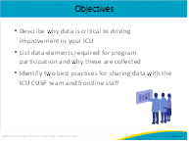

Facilitator Guide | Slide Number and Image
Data are important for performance improvement work because they provide you with an itinerary. When you want to go on a trip, you have a goal of where you want to go and an estimated time that you’ll arrive at the location. The data you’re collecting for this program are that map to achieving your goal; baseline data are your starting point—the driveway; and meeting your goal is making it to your destination. The data you collect will help you determine if you are on track to meet your goal or if you need to adjust your route (for example by modifying or developing new processes).  By regularly reviewing data with your colleagues and leadership, you will be able to assess progress toward meeting goals set by your ICU CUSP team. It also serves as a way to assess if the changes your unit made are effective. Data should be reviewed formally on a regular basis, at least monthly, to keep the goal on target. Some types of data may require more rapid turnaround to inform rapid Plan-Do-Study-Act (PDSA) cycles. For example, if central line maintenance audits conducted over a couple of days reveal a consistent issue with the application of the central line dressing, then this information should be surfaced rapidly so the process can be revised in order to drive the best practice.  Sharing data with unit staff, hospital administrators, and patients and families keeps quality improvement at the forefront, brings awareness, and increases engagement of various stakeholders. Leadership engagement is also vital to support and sustain changes your unit will make. Credible, timely data that is well planned, collected accurately, analyzed appropriately, and then shared in a concise and understandable way will engage clinicians and leaders, as well as frontline staff, in ways that few other changes can.  Data also showcase improvements in healthcare quality, which not only demonstrates that your team’s efforts impacted patient care, but can affect hospital reimbursement from programs, such as the Centers for Medicare & Medicaid Services’ (CMS) Hospital Value-Based Purchasing program. In particular, this demonstration can help engage hospital leadership. | Slide 3  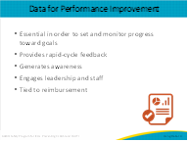
In this module, we will talk about the following sources of data.  First, the ICU Assessment is designed to help you understand your unit’s practices, policies, and procedures relative to infection prevention. Responses can help you hone in on specific evidence-based education, tools, and resources provided as part of this program to help address those gaps. Other questions on this assessment address a variety of cultural elements related to CUSP that can help you focus on communication, teamwork, and/or dissemination of information.  National Healthcare Safety Network (NHSN) data are likely already submitted by your hospital to the Centers for Disease Control and Prevention (CDC). NHSN data illustrates your unit’s healthcare-associated infection, or HAI, rate for the number of CAUTIs or CLABSIs per device days over time. It also provides your unit’s device utilization ratio, or the number of catheter or central line days, per patient days, over time. The standardized infection ratio and standardized utilization ratio are two other very useful risk-adjusted metrics you can use to see how your ICU compares with other similar units in both device utilization and infection ratios. Your ICU also can look at the number of infections each month and monitor the number of days since your unit’s last CAUTI and/or last CLABSI. Sharing raw numerator data to explicitly state how many people have been harmed by a CLABSI or CAUTI can help staff and administrators connect to the mission. We will talk more about data presentation when we address sharing in the data life cycle. If you are unfamiliar with NHSN data at the unit level, your infection preventionist can help you gain access to this data and understand the data points if needed.  Finally, using the results from your ICU assessment, data from NHSN, and any additional data sources such as unit culture surveys, your unit may want to develop an ICU-specific action plan. This action plan will help your ICU identify tools and resources to address missing HAI policies or practices. | Slide 4  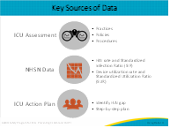
The ICU Assessment collects data on current HAI prevention practices, policies, and procedures in order to tailor the education program to meet your team’s needs.  The ICU Assessment covers the following:  - Team roles and responsibilities – this section identifies the composition of your current team. It will illustrate the current state of the team and roles and responsibilities that might be missing.  - Resources available in unit – do you have enough staff, time, equipment, and other necessary means to do the job?  - Top three strengths and weaknesses identified by unit – this is where the bulk of the discussion occurs. You might be surprised to see the similarities or differences in what your team members might identify as strengths and/or weaknesses.  - Team culture – see if your team remembers if and when the last staff culture of safety survey conducted in your unit. What was the result of that survey? How does it look now?  - CLABSI/CAUTI (indwelling central line and urinary catheter life cycle), which will be discussed more in the module titled Using a Tiered Approach With CUSP Principles. These CLABSI and CAUTI prevention modules cover appropriateness, alternatives, insertion, maintenance, and removal of the indwelling central lines and urinary catheters. For the CAUTI prevention modules, there is the urine culturing stewardship module to dive deeper into the topic. | Slide 5  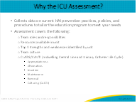
The aim statement is a specific, measurable goal that you believe you can achieve in a reasonable time period. Think about these questions as you draft your aim statement.  - Connect to one area that needs to be improved in your unit in order to reduce CLABSI and/or CAUTI rates. Pick a priority that will tie into a concrete process, practice, policy, or behavior.  - What are you trying to accomplish?  - Would the goal improve outcomes? Specifically, would it reduce rates of CLABSI and/or CAUTI?  - How will your team know that a change is an improvement? | Slide 6  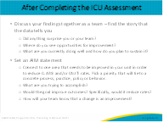
Fortunately, your organization likely already collects CLABSI, CAUTI, and related device utilization data, and submits the data to the CDC through the NHSN database. CMS requires that CLABSI and CAUTI data be submitted for most acute care facilities that receive Medicare funding, and most of these States also mandate reporting of these data. The hospital’s infection prevention team is in charge of reporting these data routinely, using specific CDC definitions. | Slide 7  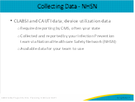
The standardized infection ratio (SIR) and the standardized utilization ratio (SUR) are risk-adjusted metrics to evaluate if the rates of CLABSI and/or CAUTI are increasing or unchanged over time and see how your ICU compares to other similar units To understand what this means, if the SIR is greater than 1, then your ICU has a higher number of infections than expected, based on numbers from other like units; if it is less than 1, the number is less than expected.  The SUR is a newer metric that compares device utilization with other similar units. If it is greater than 1, then your ICU has higher utilization of that particular device, such as central lines or urinary catheters, than other similar units. If the SUR is less than 1, your utilization is lower than other similar units. | Slide 8  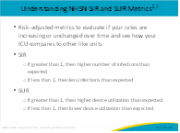
Your unit may already have additional data to assist you, which can help point you in the right direction to improve CLABSI and/or CAUTI outcomes. Such additional data may come from patient safety culture surveys, findings from defects analyses or root cause analyses, as well as process audit results for defined processes like central line or urinary catheter insertion and/or maintenance bundles. | Slide 9  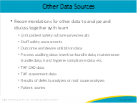
It is crucial to reiterate that safety culture is unique to each unit. Every unit serves a specific function and experiences unique challenges and successes. It is important to capture these unit-specific details in order to best understand the safety culture in your own unit. The CUSP lead can work with the team to determine which staff to include.  Keeping that in mind, one of the most common patient safety survey tools is the Hospital Survey on Patient Safety Culture, or HSOPS, which is a validated tool. It was created by AHRQ and has been used to measure safety culture within clinical units of hospitals across the country and internationally. This convenient online tool only takes each staff member about 10 to 15 minutes to complete. The HSOPS tool can also be used to examine details of your safety culture and how your units and hospitals compare with the national average of other units and hospitals that have completed this questionnaire.  While HSOPS is the most common patient safety survey tool in the United States at this time, there are other validated surveys out there, such as the SAQ or Safety Attitudes Questionnaire, and the SCORE, which is a revised version of the SAQ. Regardless of what survey tool your hospital may use, you are strongly encouraged to find your unit’s recent survey results, seek to understand them if you don’t already, and use the information as part of what your CUSP team examines to help develop your action plan. If you need assistance with using these survey results, consult with your quality department, or your senior executive can direct you to the best person in your facility to help you.  Keep in mind, it would be ideal to use the most current survey data and ensure that at least 60 percent of staff on the unit have responded to it, to generalize findings. If the survey is more than a year old, if there has been significant staff turnover since the last survey, or if the last survey had less than a 60 percent response rate, consider completing a safety culture survey again in your ICU for this program. | Slide 10  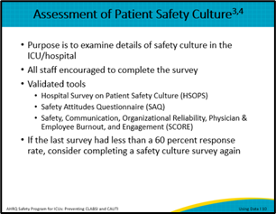
Sharing your unit’s action plan, referred to previously, along with unit-level data generates awareness and engages leadership and staff. It also helps monitor progress toward goals identified in your action plan.  First, to do this, it’s important to first identify the key stakeholders, from the senior leaders or executives in your hospital to patients and their families. Each stakeholder plays a vital role in ensuring you achieve the goals set forth in your action plan. Consider other units or teams that may need the data. For example, if you identify central line maintenance issues, you may look at all the areas where your ICU’s patients have their lines accessed. It’s not just unit staff, but may also include the emergency department (ED), operating room (OR) or radiology staff, environmental services (EVS), and physicians. Think about the audience you most need to reach with your data, and consider this when planning what data you need to collect. It’s also important to consider nonclinical stakeholders who need to understand requests for funding and materials for prevention strategies, such as a value analysis team, risk management, and/or the finance department. Educating them on the issues through credible data engages them as partners and allies in this work.  Second, you must consider what’s most relevant to each stakeholder when you communicate. For example, it may be more impactful to show physicians and senior leaders or executives the infection rates over time to help guide their decision making. Sharing the actual number of patients who have had CLABSI and/or CAUTI infections in the past months or year can help unit staff, patients, and their family members realize that behind every number, there is a patient! Sharing the days since the last CLABSI or CAUTI incident is a good way to show a safety committee and other units that you are striving for many more days without a patient acquiring an infection in your unit. Use data to celebrate and persuade all staff to be part of the changes that have been proven to prevent CLABSI and CAUTI.  Finally, communication should be constant and ongoing. This is crucial to ensure that your unit is truly able to achieve the goals identified in your action plan. It not only helps keep each of the stakeholders aware of your process improvements, but also holds everyone accountable.  Your CUSP team can help identify who needs to see the data and what data they need to see, so make sure your CUSP team is actively involved in making these decisions and ensuring sharing occurs on a regular basis. | Slide 11  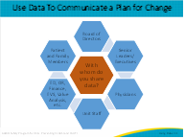
Here is a sample run chart that can be created in a spreadsheet. As you will note, this graph displays both the CLABSI rate per 1,000 device days and the raw numerator and denominator. While these data are from a fictitious unit, the story behind the data is real. In one ICU, CLABSIs increased in the first quarter of the year. Using an in-depth data review, the ICU found its utilization of central venous catheters had also increased. Through defects analyses, it found that there was a change in practice from the operating room anesthesiologists in central venous catheter placement and hemodynamic monitoring during specific cases. One anesthesiologist used the outdated technique of utilizing staples for securing the line, as opposed to sutures, which prevented the sterile dressing from being properly secured, allowing for a break in sterility in the postoperative days after surgery.  Using multidisciplinary teams and rounds for direct observation, as well as brainstorming with the anesthesiologists, the ICU developed a process to remove central lines no longer needed after recovery from the surgery, even before leaving the operating room in some instances, re-educated the anesthesiologist using staples, who agreed to stop using staples to secure the line so the dressings remained intact, and refocused the ICU team on removing the central lines as soon as no longer clinically indicated. Over the next 3 months, utilization dropped in half, and the CLABSI rate dropped by two-thirds—from six CLABSIs to two in a 3-month period. During the third and fourth quarters of the year, utilization was 30 percent compared with the first quarter, and the CLABSI rate was zero. | Slide 12  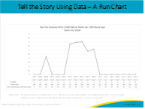
Another effective way to tell your story using data is by showing raw numerator data. This is particularly impactful since the goal for harm is zero. Having even one event is significant. This chart shows the number of CAUTIs occurring in this unit by month, along with annotations describing actions taken along the improvement journey. This type of chart has the advantage of a faster data turnaround, since it does not need a final tally of the denominator data after the end of the month. The raw numbers show exactly how many patients were harmed each month. Annotating data charts that display data over time is an effective way to track when key interventions were implemented so the team can identify actions that have the greatest impact. For instance, from this chart, CAUTI events dropped when a unit maintenance bundle was implemented, but did not drop to zero. However, once they engaged the ED to implement an insertion criteria protocol, given that the ED was where most urinary catheters in their unit were placed, their rates dropped. Allowing some time for the ED to fully implement and monitor this change, the CAUTI rate has been zero for the past 5 months. | Slide 13  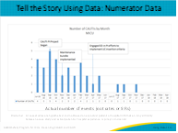
This is another example of using raw numerator data to tell a story. In this example, a large university hospital shows each unit its rates as SIRs but also show the number of total events comparing where it is currently to it was 1 year ago. On this particular patient harm index, the current year is in patterned blue and the past year is in orange. The hope is to see a decrease in total number of events from the previous year. This serves as a good visual reminder of where problem areas may lie and where you can focus prevention efforts. However, the most important reason for displaying raw data is to remind us that for each event on the graph, a patient was actually harmed by a HAI. Again, these numbers can be compiled in real time so there is no need to wait until the end of the month for the denominators to calculate a rate or SIR. This type of data display or harm index could be used for reporting to any group, even hospital boards, as it is understandable and drives home how many patients are sustaining harm from potentially avoidable infections, which after all, is the most important number. | Slide 14  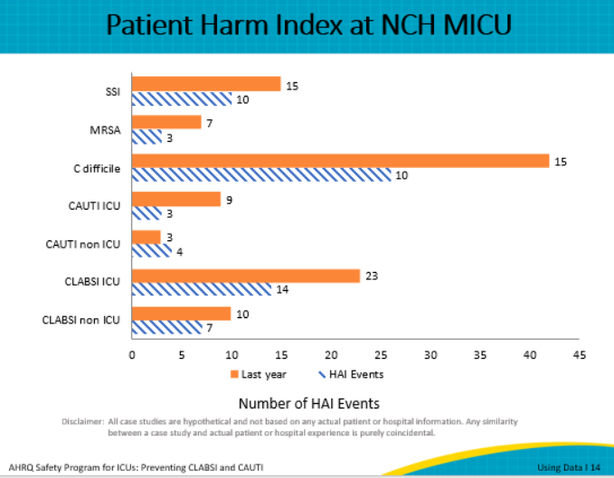
Publicly posting performance data in clinical areas is another practice that can engage stakeholders. Sharing information in this manner demonstrates that the organization has made it a priority to eliminate preventable complications. Transparency of data to staff, patients, and visitors opens up many opportunities to discuss goals and objectives, the organization’s action plan to reach these goals, and ways to collaborate for success. Such dialogue helps patients and their families feel part of the work and encourages them to support the staff’s efforts. You can have a laminated poster made on which you can update the information weekly, or even daily if you have the data. Just make sure the information gets updated on a regular basis and that patient information is not included.  If your organization is not yet ready to post this information in public areas on your unit, consider posting it in common areas where staff and physicians frequent. From there, you can begin exploring the possibility of transitioning it to a more public area for your patients and visitors to see. A way to start is to post just publicly reported data and expand from there. | Slide 15  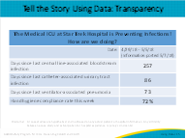
After data are shared and discussed with stakeholders in order to obtain their insight and perspectives on what the data means, it is time for the CUSP team to synthesize findings and integrate into work. In other words, it's time to evaluate where you are as opposed to where you need to be. Are you making progress? Is it enough and at the right speed? If it’s not progressing, why?  As you answer those questions, you need to then ask: Do any interventions need to be revised, stopped, spread? Do any failures need to be addressed? For example, a central venous catheter dressing change kit is not well received by clinicians because it is not organized to follow the desired process. Do the remaining kits need to be removed from stock? Should they be used with revisions to make them usable until the stock is depleted? Are there any reasons to celebrate, such as reaching a milestone or a goal, or maybe because something didn’t work initially and you decided to take a different approach that did work? Does the team need re-energizing and recognition for its hard work?  This final stage is one that is continuous and leads right back to planning. Using measurement and evaluation to sustain the gains made over time requires ongoing assessment and planning to ensure key metrics are monitored without taxing available resources. With changes in ICU staff and leadership, competing priorities, or staff who want to return to the way they used to do things, continuing to monitor key outcomes and processes provides the opportunity to sustain the gains and continue reaching for the goal of zero harm. | Slide 16  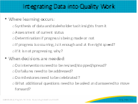
As part of this module, use the following discussion questions to facilitate discussion with your team.  - Has your ICU team set up regularly scheduled meetings to discuss learnings from this program?  - How is data used to engage your CUSP team?  - With whom do you share the data? | Slide 17  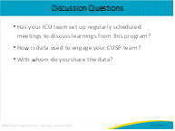
Here are a few resources from the AHRQ CUSP Toolkit that can help you better understand the importance of using data and its connection to the ICU assessment. | Slide 18  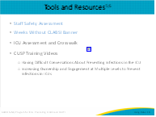
Slide 19
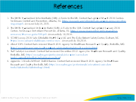
AHRQ Pub. No. 17(22)-0019
April 2022

