CUSP Module: Quality Improvement in Action
Facilitator Guide | Slide Number and Image
This module, titled “Quality Improvement in Action,” is part of the Agency for Healthcare Research and Quality, or AHRQ, Safety Program for Intensive Care Units: Preventing Central Line-Associated Blood Stream Infection (CLABSI) and Catheter-Associated Urinary Tract Infection (CAUTI).  In this module, you will be introduced to a series of quality improvement (QI) tools and techniques to assist your Comprehensive Unit-based Safety Program (CUSP) team with decreasing CLABSIs and CAUTIs in the intensive care units (ICU). These tools will assist with writing aim statements, developing action plans for improvement, and utilizing the rapid Plan-Do-Study-Act (PDSA) cycle. | Slide 1  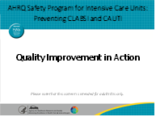
Objectives for this module include:  - Describe methods to identify your ICU’s focus area of improvement using QI strategies (i.e., to target CLABSI, CAUTI, or both), based on data assessment;  - Recall the components of a strong aim statement for developing an action plan; and  - Summarize next steps to create your ICU’s first test of change using the PDSA cycle. | Slide 2  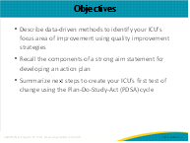

Facilitator Guide | Slide Number and Image
This module will lead you through the action planning process using a scenario. The action plan template, shown on this slide, will help guide your CUSP team through questions that identify gaps and steps necessary to close these gaps. Each of the questions will be addressed in more detail later in this module. | Slide 3  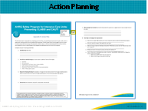
Neighborhood Community Hospital (NCH) is a fictitious, 400-bed community hospital. It has three ICUs, the medical/surgical unit being one of which the Centers for Disease Control and Prevention (CDC) identified as having a positive cumulative attributable difference (CAD), or cumulative attributable difference, for CLABSI and CAUTI. This particular unit receives primarily critically ill medical patients and may occasionally get critically ill surgical patients; it is not a major trauma center.  Of note, their CLABSI CAD is 12 and CAUTI CAD is 6, meaning that to reach the U.S. Department of Health and Human Services (HHS) healthcare-associated infection (HAI) goal, the unit will need to prevent 12 CLABSIs and 6 CAUTIs by the end of the year.  Their first priority is to pull together a CUSP team. The unit performance improvement team has not been very active due to staff turnover, so the unit leadership is reviving it.  The unit’s new clinical nurse specialist has been identified as the CUSP team leader. She has 10 years of ICU experience and recently earned her master’s in nursing. She is very enthusiastic and motivated to help this ICU make improvements.  The CUSP co-leader is the ICU nurse manager with 25 years of ICU experience, the last 5 as manager of this unit.  Dr. James is relatively new, having been in the unit now for about 8 months. He is a board-certified intensivist and has been identified as the team’s physician champion.  This ICU is a mixed unit in which intensivists care for patients along with specialists, but also private physicians from the community care for their patients in the ICU if they are credentialed to do so (e.g., pulmonologists who admit patients to the ICU). The intensivists and private physicians have a good relationship, and intensivists often cover calls on nights for private attendings. The intensivists’ contract with the hospital includes a patient outcomes clause, requiring them to participate in activities to improve outcomes for the units to which they are assigned.  The team’s senior executive champion is the vice president of clinical transformation. He is a doctor of pharmacy leading the hospital’s performance improvement department; infection prevention reports to him as well. He also oversees staff in his department.  The team also includes an experienced infection preventionist and a quality improvement specialist who recently joined the organization and works closely with the infection preventionist.  The region is experiencing a severe shortage of experienced nurses, so the unit is using a large number of traveling nurses to maintain staffing. The hospital recently implemented an ICU nurse internship program to bring new graduates into the ICU to close this gap. Seven ICU nurse interns are in training on this unit. | Slide 4  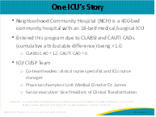
Now that the CUSP team has been identified, it must prepare for its first CUSP team meeting, so the CUSP team co-leaders, the ICU infection preventionist (IP), and a quality staff person meet to identify what data sources they have available to synthesize for presentation to the entire CUSP team. They will also identify what data they need but don’t have based on this list to assist the CUSP team in identifying gaps to begin developing an action plan.  This team decides to pull together CDC National Healthcare Safety Network (NHSN) CLABSI and CAUTI data such as the standardized infection ratio, or SIR, and SUR, or standardized utilization ratio, which will be reviewed in greater detail momentarily. They also look at their ICU Assessment results and review unit-level patient safety culture survey results from the Hospital Survey on Patient Safety (HSOPS) that they completed 6 months ago.  Other data the team reviews are results of hand hygiene compliance data and defects analyses, or root cause analyses, they began doing on at least two CLABSIs and CAUTIs per month over the last 3 months, with the help of their unit IP. The team recalls a recent patient that was harmed and decide to share that story because it will resonate with the ICU staff.  Other data that they realize might help tell the story might include process audits, such as insertion and maintenance data for central lines and urinary catheters.  By preparing this information during the planning meeting, the group will help the larger team identify where the biggest opportunities are. It knows the staff is stressed from high patient acuity and turnover, so it wants to ensure the actions it takes are focused to maximize the effectiveness and efficiency of staff time. | Slide 5  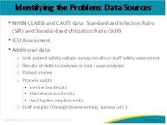
The first data the group pulls in the planning meeting are CLABSI and CAUTI data. The SIR and SUR are risk-adjusted metrics calculated by the CDC’s NHSN to see how an ICU compares with similar units in infection and device utilization ratios. This CUSP team’s co-leaders find that their CLABSI SIR is 1.28, meaning that the unit has 28 percent more CLABSIs compared to other med/surg ICUs reporting to NHSN. As already mentioned, they know the unit’s CLABSI CAD is 12. Their central line SUR is also greater than 1, meaning that the unit uses more central lines than other comparable units.  For CAUTI, the unit’s SIR is less than 1, meaning it had fewer infections than what would be expected for a comparable unit, which is good. However, the year’s HHS SIR goal for CAUTI is 0.75, which the unit hasn’t met yet, so it will need to prevent 6 CAUTIs to reach this goal. Their urinary catheter SUR is 1.1, which means it uses more indwelling urinary catheters than other comparable ICUs. The unit’s outcomes show both the SIR and SUR are greater than 1. There is still opportunity in CAUTI reduction, especially related to utilization. However, the unit will take this data to its CUSP team for discussion, recognizing the absolute necessity of getting the team’s perspectives and wisdom. | Slide 6  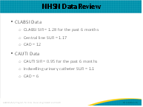
The next set of data the co-leaders examine is the ICU Assessment summary. The team has confidence their assessment is representative of the unit’s processes and practices since they brought their CUSP team together to complete it. This assessment reveals the unit’s areas of strength and potential gaps around CLABSI and CAUTI prevention practices. The co-leads understand that practice may not reflect policy, and the practice is what is important to understand.  In examining the CLABSI section of the assessment, they notice gaps in insertion and maintenance products, and monthly adherence and skills audits. For CAUTI, there are gaps in monthly adherence and skills audits, and multidisciplinary catheter rounds.  Other gaps identified in the unit are a lack of a CLABSI and CAUTI champion, unit culture, and senior leadership engagement. As the team discusses this, members refer to a copy of their notes from the meeting in which the ICU assessment was completed. These documents will help break down the source of each gap to reiterate the group’s initial discussion points. | Slide 7  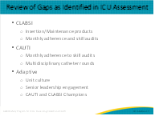
As they look through the summary, they see that the team identified strengths to capitalize on regarding commitment to teamwork and communication. However, they need a clearer understanding of why the number of nurses in the ICU was identified as a strength, as it seems to be counterintuitive. This ICU has a lot of travel nurses and is dealing with a nursing shortage and high turnover in the last year. This summary also identified competing patient safety initiatives as a unit barrier. This may impact the extent to which the team can realistically concentrate on this effort. This is definitely an aspect of unit culture that the team needs to be tuned into and to plan adaptive strategies for. Senior leadership lack of ownership is another barrier that needs to be explored further with the newly identified senior executive champion on the team. | Slide 8  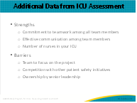
As the team talks through the ICU assessment, the nurse manager brings the ICU’s most recent HSOPS results to the table for review, which 68 percent of ICU staff completed. The hospital undergoes the HSOPS every other year and provides unit-level reports to support understanding of safety culture both at the aggregate (or hospital) level and the unit level. We know that culture is local and that it has a significant impact on the unit’s ability to make and sustain improvements. Culture shapes behavior on the job, but it also can improve outcomes. Not only can it improve patient and family safety, it can also improve the safety of the care provider.  After going through the responses, team members identify three dimensions that stand out as areas of concern for their unit: communication openness, communication about errors, and staffing.  Let’s look at these more closely:  The first area of concern is staffing and is driven by two topics. The unit is using more temporary or agency staff, and staff are working longer hours than is best for patient care. The ICU nurse manager shared that about 30 percent of staffing hours over the last quarter have been by filled by travel nurses, but those hours were increased to decrease the overtime unit staff were putting in to meet the nurse to patient ratios. She has stopped staff from working more than one overtime shift schedule in a week. Human Resources has been compiling exit interview results to understand more fully why staff find positions outside the unit, and so far, two reasons have been most common: opportunity for increased specialization at the university hospital across town and relocation to other geographical areas. Neither reason has an easy solution. She and Human Resources have been working together to develop a process to quickly hire into to open positions, or to anticipate staff leaving and hire proactively, but there is only a small pool of candidates due to the nursing shortage.  That said, it will be good to get the entire CUSP team’s diverse input into this complex problem so that everything possible can be done to get and keep committed staff. She feels that if they can create a strong culture where staff feel highly valued and there is strong teamwork, staff will feel more committed and be less likely to leave. The IP makes the point that whether staff are temporary or permanent, it is essential that all staff are adequately onboarded so their competencies are assessed and the necessary education and training is provided to ensure that at least minimum safety standards are met. The group agrees this is important to look at as they identify and prioritize interventions.  The second area of concern is communication openness: the lowest scoring item in this dimension was that the staff feel comfortable questioning the decisions of people with more authority. The team discusses the need to understand this more thoroughly prior to taking action. It will be critical to have leadership and physician input as well as frontline staff throughout this process. Do staff feel intimidated if they speak up? Have they encountered pushback? Have their efforts been met with criticism or were they blamed for an issue or near-miss in a punitive fashion?  The third area of concern is communicating about error: less than 40 percent of staff reported that errors are discussed in the unit. One of the hallmarks of a highly reliable organization is preoccupation with failure, so it is essential that everyone be on the lookout for errors or near misses and report them, and then that the errors be addressed in a nonpunitive manner for learning and improvement. The co-leaders, IP, and quality staff person discuss the CUSP Staff Safety Assessment tool as a way to gather staff input and send the message that they want to hear about everyone’s safety concerns, and then work together as a team to improve. | Slide 9  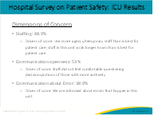
To focus on CLABSI and CAUTI defects specifically, the unit has been using the CUSP event report tools for these HAIs over the last 3 months, with help from the IP, and have done two learning from defects each month on CLABSI and CAUTI. The team looks at this information by case and by aggregate to determine common findings across cases, which can point to system gaps that need to be closed. For ease of review, this slide covers the CLABSI cases and slide 11 will cover the CAUTI cases.  The IP shares aggregate information from CLABSI and CAUTI events over the past 3 months. In looking at data from CLABSI defect analysis, some themes to bring to the attention of the CUSP team are:  Indications for insertion: Are there unitwide indications, and if so, what is the level of compliance to them? Are they being accurately applied? Remember, avoiding such devices unless they are clinically indicated is the most important harm-related prevention strategy you can implement.  Location of insertion and who is inserting them: Does this have implications for CUSP team members or ad hoc members? What if the central venous catheters in question are peripherally inserted central catheters or dialysis catheters? What implications does this information have for communication with any other units/departments about CLABSI prevention efforts? What about competency of inserters to insert devices?  Time from insertion to infection: This can point to whether insertion or maintenance needs to be the initial area of focus.  Device dwell time: This information can easily be “lost” between clinicians and rounding teams. Do we ask every day on rounds why the device is still in and if it can be removed? Are reasons true indications or unit culture?  Type of organisms: Considerations for how these organisms are transmitted will need to be a focus for prevention strategies (e.g., hand hygiene, skin prep, and maintenance of dressing and line for CLABSI; peri-care and maintenance for CAUTI).  Identification and reporting of errors and near-misses should also be rewarded, sharing findings of this process regularly. The nurse manager acknowledged the need to have patient safety as an agenda item at every staff meeting and to use it as an opportunity to both share events that happened on the unit in the prior month and seek staff feedback on how to prevent such errors, as well as proactively solicit staff members’ insight on where they see patients could be harmed in any way from what is happening on the unit. | Slide 10  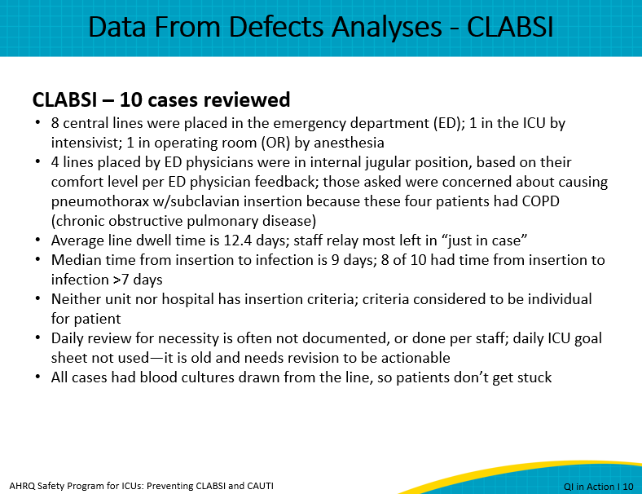
As you can see through this scenario, learning through identification and analysis of defects is a robust method for driving questions to understand issues deeply so developed strategies can focus on root causes. If you do not currently do such analyses on CLABSI and CAUTI cases, you are encouraged to do one on the next CLABSI or CAUTI that occurs in your unit and see what you learn. | Slide 11  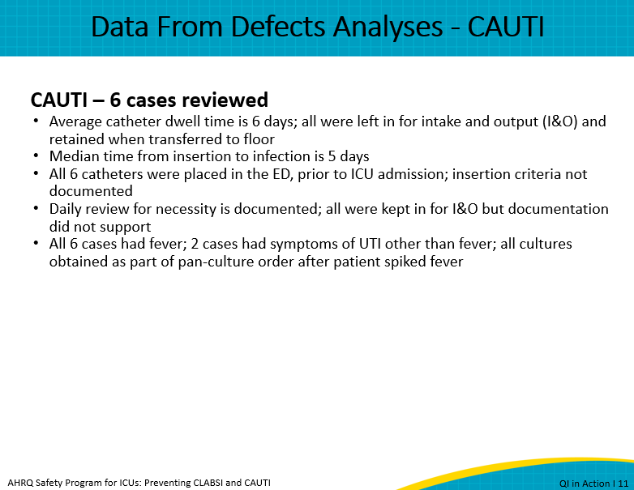
Now that the unit has reviewed the CUSP team’s data, how does it determine where to focus its improvement efforts? It is important to take into account several ways in which an infection has impact: How will addressing this harm impact my patients’ mortality and morbidity and prevent suffering? How often is this infection occurring? What is the cost of each of these infections? How do these infections affect the public’s perception of our organization? What Medicare or Medicaid reimbursement consequences exist by not preventing these infections?  Now that the smaller group identified the gaps in its CLABSI and CAUTI data, and considered the impact that each of these infections can potentially have on its patients, it is ready to decide where to focus and take that decision to the larger team. | Slide 12  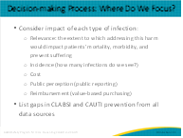
In a separate meeting, the CUSP team co-leads, the IP, and the quality nurse for this unit share the data they pulled together with the greater ICU CUSP team. The team determines that the data and staff input all point toward prioritizing CLABSI. The team feels both CLABSI and CAUTI have opportunity for improvement, but CLABSI has a higher SIR and SUR and increased morbidity and mortality, and therefore should be the initial focus.  Working on both CLABSI and CAUTI simultaneously is not feasible at this time due to competing priorities with other QI efforts. In addition, because several gaps in CLABSI prevention best practices are applicable to CAUTI prevention, such as daily reviews for necessity and tracking of device dwell times, the team may well be able to incorporate those strategies as it works on CLABSI.  Since the CUSP team will be adding emergency department (ED) representation, they are also building a foundation for future comprehensive work on CAUTI. They decide to add an ED nurse supervisor to the team, with the understanding that he will be the liaison between the ICU and ED, and that Dr. James, the team’s intensivist, will be available for physician discussions as needed, particularly around indications for and placement of central lines. | Slide 13  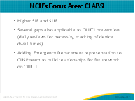
Now, let’s check back on the NCH CUSP team that is ready to draft its AIM statement to reduce CLABSI.  Remember, an AIM statement is a problem statement without solution indicated. If a solution is indicated the team may take action without any investigation.  An AIM statement does not describe how the goal will be achieved. Instead, it states what the goal is.  Regardless of the type of measure, using the SMART acronym is helpful to ensure that goals and aims state how you will measure success.  Aim statements should be SMART:  - S - specific, significant, stretching  - M - measurable, meaningful, motivational  - A - agreed upon, attainable, achievable, acceptable, action-oriented  - R - realistic, relevant, reasonable, rewarding, results-oriented  - T - timebound, timely, tangible, trackable  SMART aims to—  - Provide a structured approach to developing and designing a work plan.  - Systematically monitor progress towards a target.  - Set the stage for measuring performance and identifying opportunities for improvement.  - Communicate intended impact and current progress to stakeholders.  - Describe how goals will be met.  Now, let’s take a look at what NCH developed using its SMART criteria. | Slide 14  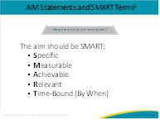
Based on the data from NHSN, ICU Assessment results, the patient safety culture results, defect analyses, and goals to reduce the CLABSI SIR to meet HHS goals, the NCH unit’s aim is to reduce the CLABSI SIR to at least 0.75 in the NCH medical/surgical ICU by December 31. This statement includes a specific target (reduce SIR, as reported by data submitted in CDC’s NHSN, to .75) and a deadline (December), making it easy to work toward and measure. It’s also a relevant goal in that it supports meeting the HHS goals of reducing CLABSI in ICUs by 50 percent, by the end of the year, which the hospital has adopted. | Slide 15  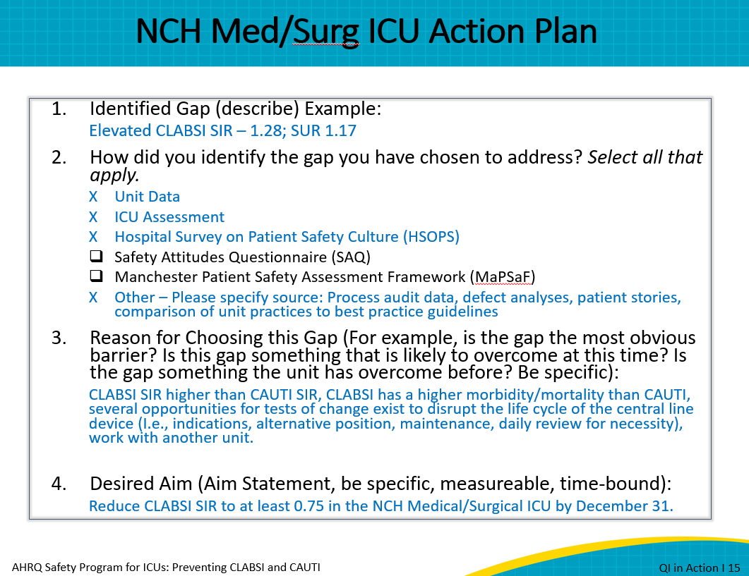
For the purpose of reaching your desired goals, it is important that you have a written action plan. This action plan is the jumping-off point to develop your first PDSA. The plan will be dynamic and may change over time, but it is essential it is written and shared with your unit, all stakeholders in your hospital, and your state lead.  To begin writing your plan, an aim statement is necessary. This statement addresses the question, “What are we trying to accomplish?” The aim statement determines direction and destination. Once you have an aim statement, you are ready to design the rest of your plan.  The next step is to ask, “What changes can we make that will result in improvement?” and plan those changes, based on available data. This includes determining metrics to measure “How will we know that a change is an improvement?” The planned actions will be carried out through rapid-cycle implementation, studied using the planned metrics, then acted upon in terms of incorporating into workflow if it helped to move towards the aim, or revising it if it did not. Thus, beginning the planning phase again, with what has been learned from the first cycle, to continually improve.  The aim statement determines direction and destination. Identification of gaps that exist between the current state and the desired aim help to pinpoint the changes that are needed. Once you have an aim statement and action plan, you are ready to design the rest of your plan. Data measures will help you track how well you are improving and working toward your team’s goals. Then, you will make small changes to test the potential solutions before you make changes to an entire unit.  As described, the “plan” phase begins with sharing ideas for improvement, assigned tasks, and expectations with the rest of the team. The team then identifies how they will measure improvement over time. Again, you have access to lots of data to help you look at your improvement over time.  The “do” phase involves implementing the small change and noting any problems, challenges, or barriers as you move forward with the change in practice, policy, or process. In the “study” phase you are observing the results from the “do” step. In this phase you should ask questions such as, “What went right, what went wrong, and what will be changed in the next test cycle?” The “act” phase is a chance to consider all lessons learned and to think about how to make the desired changes even better. The team can then decide how to proceed with the next test cycle. The success of the “small test of change” model depends on repeating this cycle over and over until you have sustained the change you determined could have the greatest impact on reducing CAUTI and CLABSI rates. Before you know it, you become a pro at using data to drive change—and improve performance! | Slide 16  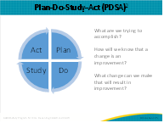
One strategy outlined as a way to engage the whole unit staff is to host a brainstorming session. When hosting a brainstorming session, you can tap into processes that you already have in place. For example, you can do this in a unit staff meeting.  To help you get started, you can follow these three steps.  For Step 1, “Great Service Experiences,” ask each of your staff members in the brainstorming session to take 1–2 minutes and think of an excellent service experience they have had in the past (it does not have to be healthcare related). Then, ask team members to share their experience with the larger group, keeping each story brief (1–2 minutes at most per story). This first step serves as an icebreaker that will help the team think more positively for the following steps.  For Step 2, “What’s Stopping Us?” (. . . from delivering great patient experiences like no HAIs?), ask the group as a whole to make a list of 10 things that, if they could change around their current CAUTI or CLABSI management, would help to consistently create a better experience for the patients, families, and providers. Ask one volunteer to record those 10 responses on the smartboard or computer.  For Step 3, “Brainstorm Topic List,” you can now create some brainstorming topics based on your team’s Great Service Experiences and What’s Stopping Us? Try to phrase your potential brainstorming topic into a “How might we . . .” statement. So, for example, one of your What’s Stopping Us items identified from process audits and defect analyses might be that “average dwell time was 12 days, and 8 out of 10 infections occurred more than 7 days after these were originally inserted,” pointing to maintenance issues. Your brainstorming session would now focus on “How might we ensure that a daily line review for necessity is completed and documented by ICU staff?”  When using your brainstorming list to identify your first tests of change, you want to select an idea that is specific to your unit and can be done within a short time period as a rapid-cycle PDSA. This can help build a culture of engagement around CUSP and earn a quick win, in order to support attitudinal and behavioral changes as well as to garner belief among staff members that they can make a difference in reducing CLABSI rates. For example, a CUSP team member could say, “I can influence the use of the appropriate insertion and maintenance products in my unit through education, competency validation, and daily rounding for compliance, but do I have authority or control over what products are purchased or used during insertion of central lines by the ED personnel? Is this a significant source of line placement in my unit?” Teams will want to focus their initial tests of change on ideas over which they have a circle of influence or control. | Slide 17  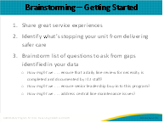
Turning back to NCH, the CUSP team conducted a brainstorming session to gather this final piece of data from frontline staff. The team felt that it was important to review data for lines inserted in the unit and not insert central lines if not clinically indicated. Because average dwell times were greater than 12 days and 8 out of 10 infections occurred more than 7 days after the lines were originally inserted, staff concluded that removing central lines as soon as no longer needed, and ensuring dressing changes and line maintenance are performed per evidence-based best practices were high priorities. The NCH unit team determined through voting to perform a small test of change to remove central lines as soon as they are no longer needed.  It’s important to note that while the unit chose to focus on removing catheters as soon as they were no longer needed, any of these options could have been the first test of change. Going back to applying CUSP principles, the unit likely prioritized this because it carried the greatest risk and harm to patients and had a high likelihood of intervention. The unit also identified that it would need to collect process data on maintenance to develop an action plan around this intervention. | Slide 18  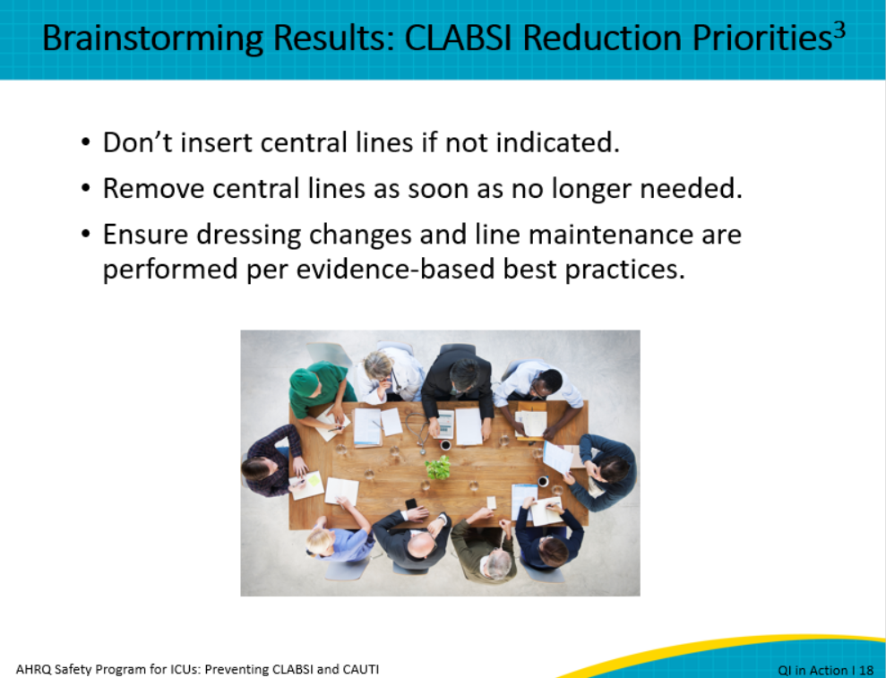
Another consideration is for the team to determine what next steps are to have the most impact as rapidly as possible for its first test of change to getting central lines out when no longer clinically indicated. The guidelines reinforce making sure lines aren’t placed without being clinically indicated and then removing the line as soon as it is no longer clinically required. The NCH team knows it has the following gaps related to best practices for this concept:  - The unit SUR is 1.17, or utilization of central lines is 17 percent higher than other similar ICUs  - There are no criteria for insertion or ongoing necessity  - Daily reviews for necessity are haphazard and not consistently done  - Central line dwell times average over 12 days, and most staff report leaving lines in “just in case needed, since the patient has been critically ill”  - Median time from insertion to infection is 9 days, so infections are most likely from maintenance issues  - Most lines are placed in the ED by ED physicians | Slide 19  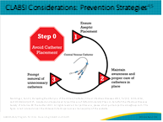
Other considerations to note as your team works to prioritize the team’s efforts and focus for the action plan are:  - What changes for best practice are in our control that would have the biggest impact as quickly as possible that we can start with?  - What changes do we have the resources for, including time, education, and the process of monitoring/collecting and analyzing data?  - What do we have the will to do, as far as staff and physician buy-in is concerned? | Slide 20  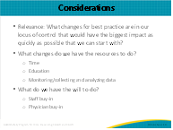
Once an action plan for your overarching goal is completed, it is important that your team create an action plan for each gap you identify. You can use the action plan template provided in the earlier slide or other tools your hospital uses. Based on a robust review of data, brainstorming, and evidence-based practices, the NCH ICU CUSP team determined the first change that needs to be addressed is to standardize daily reviews of necessity for central lines. Let’s review how this NCH unit decided to close their gap using the action plan template to illustrate how to use all the data you have, beginning with question 1 here. | Slide 21  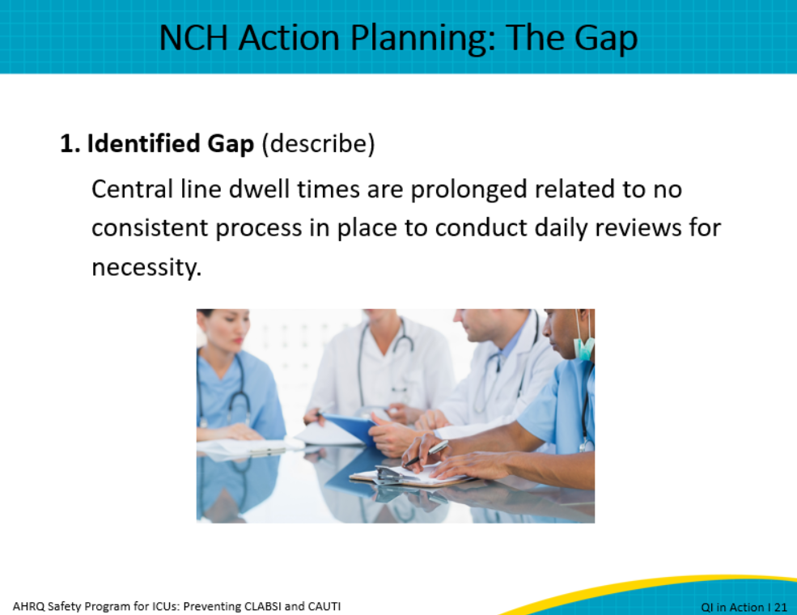
Question 2 asks how the unit identified the gap, and it responded by summarizing the key data sources we reviewed earlier, including device utilization and infection data, ICU assessment, HSOPS, and additional data.  The defect analysis identified prolonged dwell time and no documentation of daily review for necessity.  Staff brainstorming and the staff safety assessment identified removing central lines as a priority and strategies to improve communication.  Evidence-based practices outlined in the tiered approach to preventing CLABSI and CAUTI module titled Central Venous Catheter Removal also supports this strategy. | Slide 22  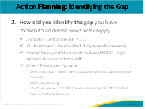
Question 3 asks for the rationale for choosing this gap. Here, NCH responded that staff felt this could be a quick win to decrease central line utilization and as a result, decrease risk to patients: This process can be implemented within the unit, by staff and intensivists, so they have ultimate control during the PDSA. It allows staff and intensivists to become familiar with current guidelines for clinical necessity, in preparation for future work of evaluating indications at the time of insertion. PDSA can be easily monitored for rapid feedback and revisions. Staff have familiarity with what the process needs to be and have ideas of how they can improve it for better sustainability. Staff feel they can achieve a quick win upon which to launch the next, maybe more challenging changes. | Slide 23  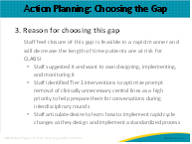
Question 4 asks for the desired aim, which is to reduce the CLABSI SUR to at least 0.9, or approximately a 22 percent reduction in central venous catheter utilization, in the medical/surgical ICU by December 31. To reduce CLABSI to this amount, they identify that central line dwell times are prolonged due to not having a consistent process in place to conduct daily reviews for necessity. To address this gap, they must create a SMART goal around this gap as part of their small test of change.  The SMART goal for this particular gap is: Achieve 80 percent compliance to daily review of necessity for all central lines in the med/surg ICU by December 31. | Slide 24  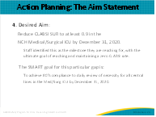
The final question in the action plan is number 5, which asks, which strength(s) can be used? This can be gleaned from your ICU Assessment Results or another strength that your team feels will be beneficial in achieving your goals. For example, the NCH unit will focus on using its staff engagement, and desire and eagerness to ensure patient safety to help it achieve its aim of CLABSI reduction. | Slide 25  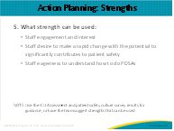
Here are a few resources from the AHRQ CUSP Toolkit that can help you better understand the tiered interventions and how they connect to the science of safety and CUSP principles. | Slide 26  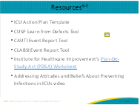
Slide 27
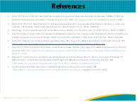
AHRQ Pub. No. 17(22)-0019
April 2022

