CUSP Module: Using a Tiered Approach With CUSP Principles
Facilitator Guide | Slide Number and Image
This module, titled “Using a Tiered Approach with CUSP Principles” is part of the Agency for Healthcare Research and Quality, or AHRQ, Safety Program for Intensive Care Units: Preventing Central Line-Associated Blood Stream Infection (CLABSI) and Catheter-Associated Urinary Tract Infection (CAUTI). | Slide 1  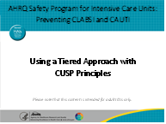
Objectives for this module include:  - Describe the tiered approach for CAUTI and CLABSI prevention;  - Give an example of how to develop a test of change using the tiered approach to CLABSI and CAUTI prevention; and  - Explain at least two CUSP methods to increase impact of the tiered approaches. | Slide 2  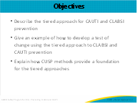

Facilitator Guide | Slide Number and Image
As we discuss how different units implement chosen evidence-based practices, we will hear variations, or adaptations, to fit unit culture differences and increase chances of success. The model in the slide shows the integration of adaptive and technical work to improve patient care.  CUSP includes engaging leadership for support, regularly educating staff on the science of safety, improving teamwork and communication, and identifying and learning from defects to deliver consistent, evidence-based care and develop system-based solutions. Ultimately, CUSP teams resolve defects, improve communication among team members, and improve overall safety culture of the unit. This work is called adaptive, as it pertains to teamwork and staff attitudes that impact clinical tasks. These adaptive challenges are often the more difficult obstacles a safety team will face.  Next, safety teams must integrate evidence into technical workflow. The middle column outlines the Translating Evidence Into Practice, or TRIP, framework. This framework aims to identify and implement the best science available to affect a best-practice approach to patient care. The TRIP framework first summarizes the evidence. This includes  - Identifying interventions  - Prioritizing interventions with the largest benefits and lowest barriers  - Implementing interventions to foster new behaviors.  After local barriers to implementation are identified, baseline performance is measured. Then, ensure all patients receive evidence-based care through engaging, educating, executing, and evaluating interventions.  The last column on the far right is specific to the evidence-based technical intervention(s) your ICU team will implement over the course of this program, if not already implemented. CUSP and TRIP work together to integrate technical and adaptive improvement initiatives to create the necessary synergy to improve care and patient outcomes. The benefit of this program is that it is designed to improve care for patients who have indwelling urinary catheters or central lines using a tiered approach. | Slide 3  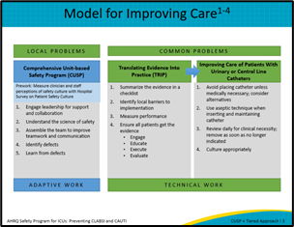
The Tiered interventions for CLABSI and CAUTI are meant to be implemented within a background of CUSP. CUSP combines improvements in teamwork, communication, and patient safety culture together with evidence-based practices in an effort to bring lasting change. The principles of CUSP provide a framework to support the behavior change needed to implement technical interventions in a unit.  Tier 1 includes basic, technical interventions that all ICUs should implement, always, to reduce infections. These include interventions such as placing indwelling urinary catheters only for appropriate reasons, encouraging use of alternatives to indwelling catheters, inserting and maintaining care of the catheter system, and optimizing prompt removal of unneeded catheters.  Tier 2 interventions are those strategies that extend beyond the bedside and that can enhance the tier 1 interventions. These interventions help you assess how well you are implementing tier 1 interventions and assist you in finding new ways to reduce your infection rates. The Guide to Patient Safety, is a tool that can help your CUSP team identify your unit’s barriers to successful CLABSI or CAUTI prevention and point you toward the appropriate tier 2 interventions. The link to this tool is available in the references slide. These interventions include conducting multidisciplinary rounds, providing real-time infection and device utilization data and feedback to frontline staff, observing competency of catheter insertion and maintenance, and performing a full root-cause analysis of CLABSI and CAUTI events; CLABSI interventions also include using additional technical interventions as indicated.  Tier 1 and tier 2 interventions implemented on your unit should be evaluated via periodic, ongoing risk assessments as part of a comprehensive infection prevention program. | Slide 4  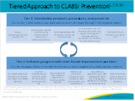
Now let’s consider the CAUTI prevention tiered-approach. In tier 1, the basic strategies should be implemented on all units for CAUTI prevention. To assess how well you are implementing tier 1 interventions and assist you in finding new ways to reduce your infection rates, consider enhanced practices in tier 2 interventions, beginning with the CAUTI Guide to Patient Safety, to determine which interventions to implement in your unit.  Remember to check out the CLABSI and CAUTI prevention modules to learn more about both tier 1 and 2 interventions. | Slide 5  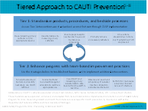
Now that you have learned about the tiered approach to CLABSI and CAUTI prevention, let’s discuss CUSP. CUSP is the foundation on which the tier can be placed and support success with the tiers. Another way of thinking of it is that CUSP is the way we work, and the tiers are the work we are doing.  CUSP begins with the science of safety. Designing a safe system is an essential component of achieving a positive safety culture. This can be achieved through standardizing care (tier 1 interventions for CLABSI and CAUTI prevention focus on standardizing processes, products, and procedures); creating independent checks to ensure processes are working (i.e., use of a checklist during central line insertions); and learning from defects (learning from each CLABSI or CAUTI by application of the Learn From Defects tool).  We know teams that provide diverse and independent input are also a part of a safe culture. Your CUSP team has members from multiple disciplines and should all be providing their thoughts and ideas as you work to prevent CLABSI and CAUTI.  As you can see, these principles are applied to both technical and teamwork outlined in the tiered interventions. | Slide 6  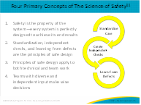
To enforce these safe design principles, the principles of “Just Culture” are crucial to the CUSP framework, driving the shared accountability necessary for CUSP implementation to be successful. A “Just Culture” is a system in which staff members and the system itself are held accountable. The system accountability includes such elements as ensuring safe work processes are in place along with adequate resources and that a safe environment is maintained. System accountability encompasses leadership by its very nature. Shared responsibility between staff and the system along with widespread commitment to eliminating the possibility of error are the hallmarks of a “Just Culture.”  David Marx, who is widely known as the father of “Just Culture”, developed this framework based on risk management concepts from high-reliability industries such as aviation and nuclear energy. More information to reinforce “Just Culture” principles can be found in a short, 5-minute video from the Core CUSP Toolkit on the AHRQ website. | Slide 7  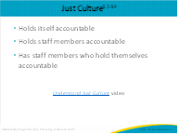
A “Just Culture” environment supports improved outcomes by emphasizing both well-designed systems and appropriate behaviors in a transparent environment. Within this model, there are five elements that contribute to improved outcomes:  - Mission, values, and expectations  - System design  - Behavioral choices  - Learning systems  - Accountability and justice  As mentioned in Engage the CUSP Team and ICU Staff module, defects that result in error leading to harm are most often a result of systems issues, not because someone intentionally tries to hurt a patient. This graphic illustrates some important principles of why that is.  An organization must first define its mission and communicate values and expectations that align with that mission to be effective in fulfilling its purpose, always striving to make improvement as a goal.  Humans make mistakes, whether through unintended errors or risky behaviors. To achieve optimal outcomes, organizations must design strong systems that minimize the risks of us making errors. Standardizing processes, creating checks, and seeking frontline staff knowledge and wisdom are some common and effective system design strategies used to minimize the risk of error. When creating these systems, you will want to design it to support desired human behaviors. For example, you might work with your supply chain department to stock central line kits that contain a full body drape, which supports providers in following best practices to use a full body drape during central line insertion.  Organizations can manage both system and human behavior through development of learning systems, which are a foundation for a “Just Culture.” Invite those that do the work to create the solutions and embrace all opportunities to learn as a team. This can be done by using strategies and tools like Learn From Defects and the Staff Safety Assessment to promote learning systems.  Additional foundational elements of a “Just Culture” are accountability and justice. Transparency is key within the unit and organization to promote justice and accountability. For example, people will not be willing to speak up and identify a mistake or harm if they feel like they or others will be blamed, shamed, or punished for human error. If people hold back from speaking up, opportunities will be lost to address system factors that may contribute to harm. | Slide 8  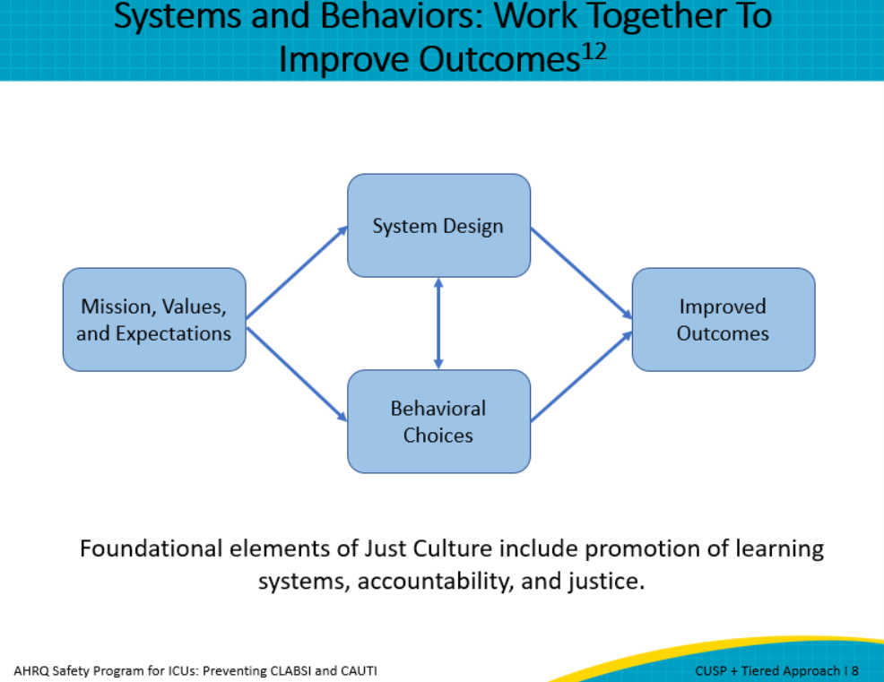
With the key concepts of “Just Culture” and systems theory being the backbone, CUSP can be applied. CUSP is a key foundation for the application of the tiered CLABSI/CAUTI interventions. It is a powerful and flexible model of sustainable safety improvement, and it recognizes that all culture is local and can be adapted to a unit’s specific needs and resources. CUSP also can be coupled with other performance improvement tools to support safer care. When the concepts of CUSP are utilized by a team, they provide a foundation for the tiered CLABSI/CAUTI interventions.  The five key tenets of CUSP are understanding the science of safety, identifying defects, engaging the senior leader, learning from defects, and implementing teamwork and communication. These five tenets become the way team works, this then facilitates technical interventions like the tiers to be successfully initiated by the team. Additionally, CUSP tools can be used to perpetuate the success of the tier interventions. It is an ever-growing circle of support that builds upon itself. | Slide 9  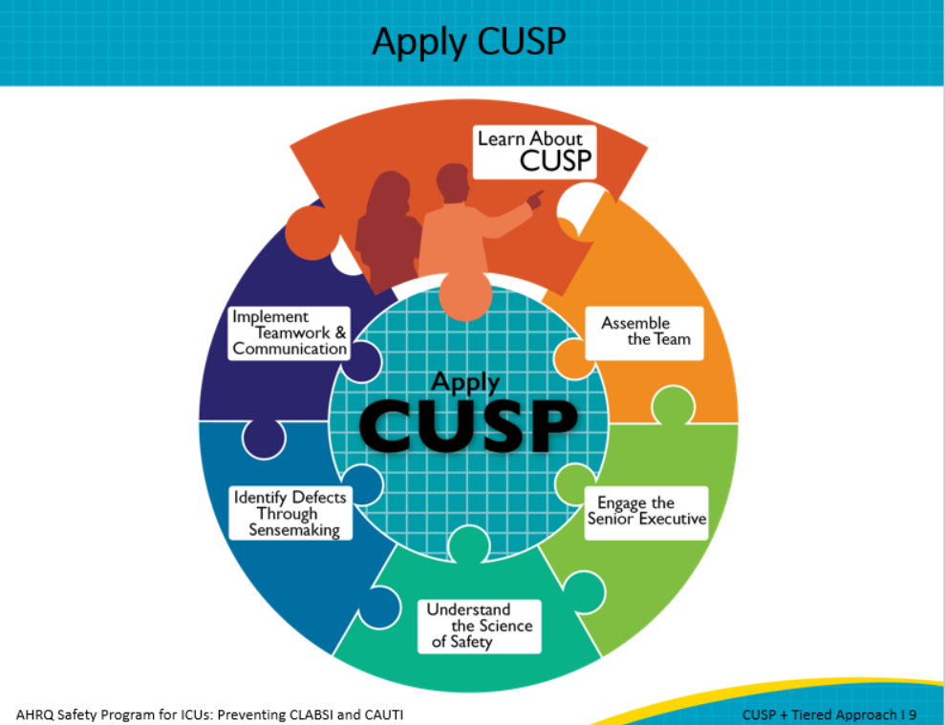
Let’s take a deeper look at one of the tiers and the how the CUSP tenets might look as examples in the way the team does work shown in the CUSP and Tier Playbook. The second CLABSI tier 1 intervention is ensure proper aseptic insertion techniques. This slide offers some examples of how each CUSP tenet can be brought to life in the team’s actions. Highlighting a few of the other examples listed here, an example of how the science of safety can be implemented is assuring there is a system in which all staff inserting lines receive training around the use of ultrasound guidance for line insertion. Additionally, there are ways to identify and learn from defects that involves those who are providing the care. | Slide 10  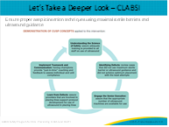
Here is another example from the CUSP and Tier Playbook focusing on CAUTI tier 1 intervention. This intervention also focuses on how to ensure proper aseptic insertion techniques and maintenance of indwelling urinary catheter. To highlight some of the examples here, we encourage starting from understanding the science of safety that emphasizes the use of two-person insertion and assures staffing supports are created to ensure a system is in place to support aseptic technique. Notice how all key concepts from CUSP fit into this specific tier 1 intervention and resembles a continuous improvement.  The CUSP Tier Playbook helps to establish how CUSP and the tier interventions work together. CUSP acts as a foundation for the tiers. Examples are written throughout the document for each of the tier interventions and CUSP concepts. | Slide 11  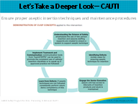
As part of this module, please use the following discussion questions to facilitate discussion with your team.  - What tier 1 intervention is most frequently used in your ICU?  - What tier 1 intervention has been the most challenging to implement?  - What tier 2 intervention is most frequently used in your ICU?  - What tier 2 intervention has been the most challenging to implement? | Slide 12  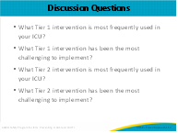
Here are a few resources from the AHRQ CUSP Toolkit that can help you better understand the tiered interventions and how it connects to science of safety and CUSP principles. | Slide 13  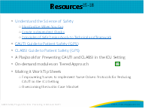
 | Slide 14
Slide 15
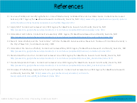
AHRQ Pub. No. 17(22)-0019
April 2022

