CAUTI Module:
Indwelling Urinary Catheter Alternatives
Facilitator Guide | Slide Number and Image
This module, titled “Indwelling Urinary Catheter Alternatives,” is part of the Agency for Healthcare Research and Quality’s Safety Program for intensive care units (ICUs) and addresses catheter-associated urinary tract infections, also known as CAUTIs.  This module will review when alternatives to indwelling urinary catheters are appropriate in the ICU setting by reviewing existing guidelines on general indications. Using ICU-specific scenarios, you will then use this information and other tools to help guide decision making. | Slide 1
One of the most important methods of preventing a CAUTI is not to insert the catheter initially. So, “Avoid Unnecessary Urinary Catheter Placement” is the most important part of this lifecycle, and in this module alternatives and methods to avoid urinary catheterization will be discussed. Of note, support for early removal also includes helping the patient to the bathroom, monitoring output, and observing for residual urine. | Slide 2  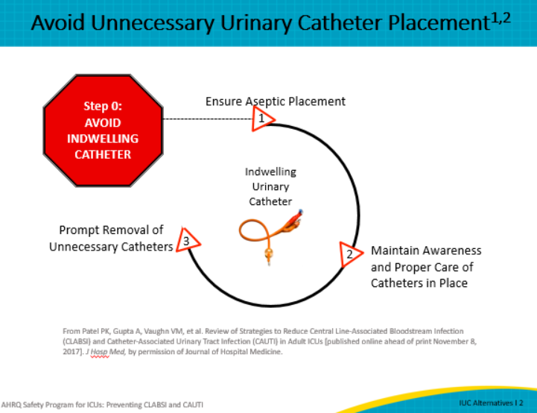

Facilitator Guide | Slide Number and Image
The first step is to stop and think critically about whether your patient needs an indwelling urinary catheter or if there are alternatives that may be appropriate. Historically, the ICU staff believed that all critical care unit patients need a urinary catheter, also commonly referred to as a Foley catheter. One of the most important reasons for urinary catheter insertion in an ICU is for intake (I) and output (O) monitoring in an ICU. The need for urinary catheter insertion can vary among different ICUs because not all patients need hourly measurement of urine. This module will address alternatives to the indwelling urinary catheter and tools to improve clinical decision making in order to avoid placement of the catheter. | Slide 3
Once you have assessed the patient’s individual care needs and determined if alternatives are appropriate for use, consider which alternatives to an indwelling urinary catheter are best suited for the patient. Alternatives provide a much lower risk of infectious complications, such as urinary tract infection. In a recent study, introduction of a new female collection device resulted in a 58 percent decrease in CAUTI rates. Use of alternatives reduces noninfectious complications, such as discomfort, pain, or blood in the urine, or sense of urinary urgency and immobility. There are many benefits to using urinary catheter alternatives, but there are some perceived barriers as well.  To ensure effective alternatives are available, consider the following:  - Involve the Supply Chain/Materials Management Department in the search for alternatives. Obtain samples of products so that staff can conduct a trial as a way to identify which products work best with the patient population.  - Collaborate with product representatives who can provide staff with guidance and instruction on how to use their devices correctly.  - Have your staff complete product evaluations so that this information can be used to determine the best alternative product(s). | Slide 4

Facilitator Guide | Slide Number and Image
An external catheter is a urine containment device that fits over or adheres to the genitalia and is attached to a urinary drainage bag. A condom catheter, seen on the left, is an acceptable alternative to the indwelling urinary catheter but challenges occur with fit and securement because of the male anatomy. Two new alternatives, seen on the right in the picture, do not require securement on the shaft of the penis, eliminating the issue in patients with small or buried penis. The device in the middle secures directly onto the glands penis, so the size of the shaft is irrelevant and can be used with circumcised and uncircumcised patients. The device on the far right can fit over any size penis, is secured in place by adhesive, and is connected to suction to divert the urine into the collection bag immediately. The healthcare worker should possess the ability to apply and remove the external male collection device correctly per institutional policies or manufacturer recommendations. | Slide 5  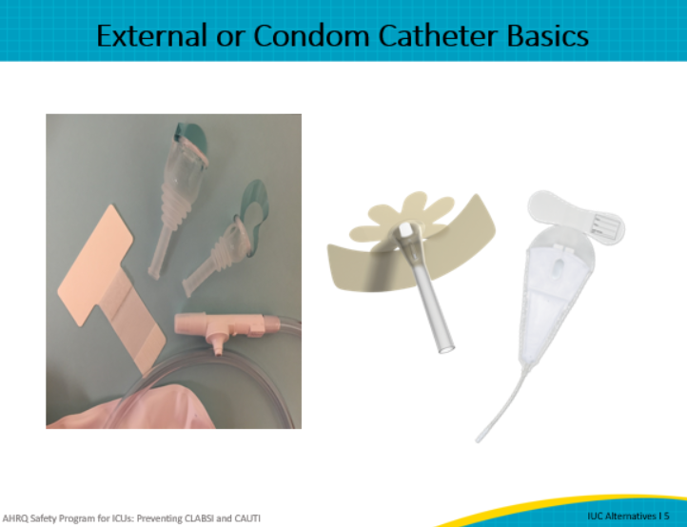
The indications shown here summarize important uses for the condom catheter in addition to intake and output.  They are as follows:  - Stage III or stage IV or unstageable pressure ulcers  - Moderate to severe incontinence-associated dermatitis  - Daily (not hourly) measurement of urine volume that is required for the treatment plan  - Single 24-hour urine analysis  - Urine sample for diagnostic testing  - Presence of acute, severe pain with movement  - Patient request for external catheter to manage urinary incontinence while hospitalized; and  - Improvement in comfort in a dying patient | Slide 6  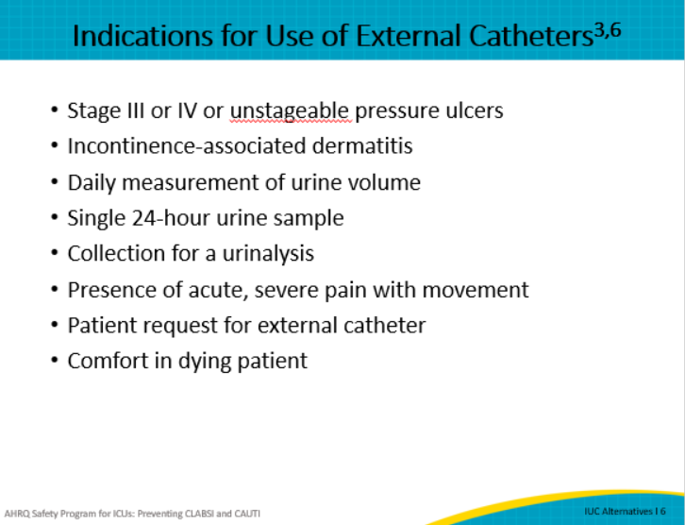
Although the risk of urinary tract infection is reduced with use of condom catheters as opposed to indwelling catheters, condom catheters do have some risk, including skin maceration or local tissue damage from securing the device too tight. The other types of external male devices are new to the market, and publications of their effectiveness or any complications have not been documented.  External catheters are inappropriate in the following cases:  - An uncooperative patient expected to pull at or manipulate the device, or a combative or agitated patient, because similar to an indwelling catheter, inappropriate manipulation or removal can cause harm.  - Any type of urinary retention such as acute or chronic, with or without bladder obstruction  - Hourly measurement of urine volume required to provide treatment  - Urinary incontinence when nurses can turn/provide skin care with available resources  - Routine use to manage incontinence without an appropriate indication  - Reducing the risk for falls by minimizing the need to get up to urinate  - For convenience of urinary management in patient during transport for tests and procedures  - Patient, family, or staff request when there are no expected difficulties managing urine by commode, urinal, or bedpan; or  - To prevent urinary tract infection in patients with fecal incontinence or diarrhea or to manage frequent, painful urination in patients with urinary tract infection | Slide 7  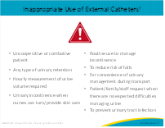
Now that we understand the indications and appropriate use of condom catheters, let’s summarize a few of the advantages and disadvantages. Ultimately, condom catheters do reduce the risk of complications and is an acceptable method of measuring intake and output. However, it is important to realize that one size does not fit all, and improper technique may lead to leakage, skin necrosis, edema, or allergic reaction.  With the newer technology that has been introduced on the market over the last several years, some of these challenges have been addressed. One device is secured directly to the glans penis, so fitting and leakage problems are significantly reduced. Another technology places a fitted bag over the penis and connects to suction. | Slide 8  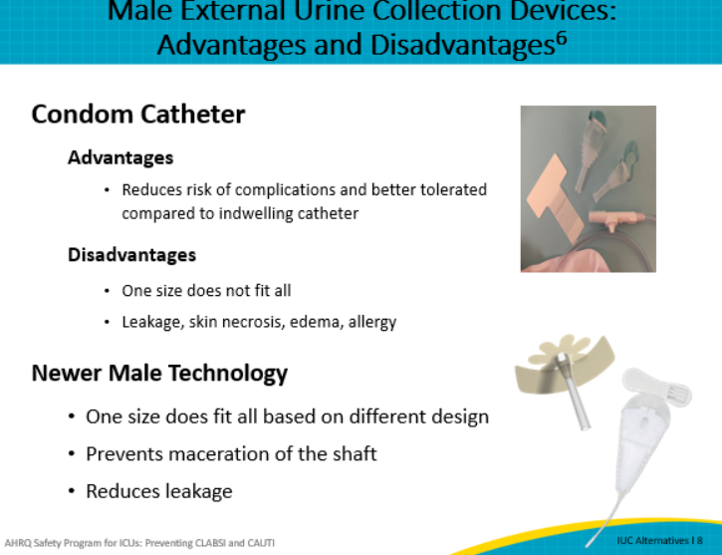
In addition, the female external catheter has now become an acceptable alternative. Studies have reported that the external female urinary collection device is a feasible alternative to an indwelling urinary catheter as well as a way to manage urinary incontinence. | Slide 9
Urinary retention may be a reason that a urinary catheter is used in the ICU. Both the bladder scanner and the straight catheter are excellent ways to assess and manage urinary retention. The bladder scanner is a tool used to assess and confirm urinary retention. Portable bladder scanners use ultrasound, which is a noninvasive way to determine the volume of urine remaining in the bladder after voiding. For example, bladder scanners are used to check postvoid residuals, and the amount of urinary retention pre-insertion of an indwelling catheter and after it is removed if the patient has not voided.  Straight catheters are designed to be used only once. Unlike the indwelling urinary catheter, the straight catheter does not have a balloon at the end to hold it in place. A straight catheter only has a single lumen, because it is only used for a one-time emptying of the bladder. Catheter sizes available for intermittent catheterization are similar to those available for an indwelling urinary catheter. Catheter diameter is measured in French (Fr) units, and sizes range from 14 to 22 Fr for adults. The funnel end of the catheter is usually color coded to easily identify the Fr size. Intermittent catheters have different lengths and are gender specific. Catheters with lengths of approximately 12 inches, which is about 40 centimeters, allow for adequate passage through a male urethra. It is important to use a straight catheter kit in order to reduce variation.  Women and children, whose urethras are shorter in length, may find a shorter length catheter of 6 to 12 inches (20 to 40 cm), which is easier to grasp and manipulate because it will not loop or kink, thus allowing easy urine flow and drainage through the catheter. Consider a straight catheter insertion kit to reduce variation in the procedure.  The American Nurses Association spearheaded an initiative to reduce catheter–associated urinary tract infections through an assessment and decision-making tool. This tool titled, “Guide to Preventing Catheter-Associated Urinary Tract Infections (2014),” provides precise recommendations for use of the bladder scanner.  Let’s discuss in greater detail the use of these alternatives. | Slide 10  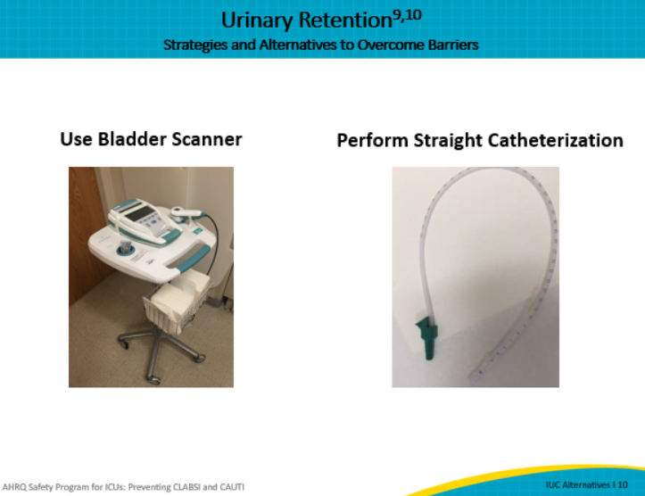
As highlighted in the previous slide, a straight catheter can be used for one-time, intermittent, or chronic voiding needs. Intermittent catheterization is often used in patients with neurogenic bladder or spinal cord injury, and it lessens the risk of urinary tract infection compared to chronic indwelling urinary catheters. After hospitalization, when these patients return to the community, intermittent catheterization enhances patient privacy and dignity and facilitates return to activities of daily living. Intermittent catheterization is often a preferable treatment method to indwelling urinary or suprapubic catheters in patients with bladder emptying dysfunction.  Intermittent straight catheters (ISC) are appropriate for the following indications:  - Acute urinary retention without bladder outlet obstruction, if the bladder can be emptied adequately by the ISC every 4 hours or less  - Acute urinary retention with bladder outlet obstruction due to noninfectious, nontraumatic diagnosis such as benign prostatic hypertrophy  - Chronic urinary retention with or without bladder outlet obstruction  - Stage III or stage IV or unstageable pressure ulcer, or similarly severe wounds of other types, that cannot be kept clear of urinary incontinence despite wound care and other urinary management strategies, if the ISC is adequate to manage the type of incontinence  - Urinary incontinence that is treated and can be managed by ISC  - Urine volume measurements (not hourly urine) or sample collections in patients using ISC for urinary retention/obstruction or overflow incontinence  - Random urine sample collection if unable to collect by other strategies  - Management of urination in patients with strict temporary immobility if the ISC does not require excessive movement, and  - Postvoid residual urine volume assessment if the bladder scanner is unavailable or is inadequate and more detail than suprapubic fullness is needed | Slide 11  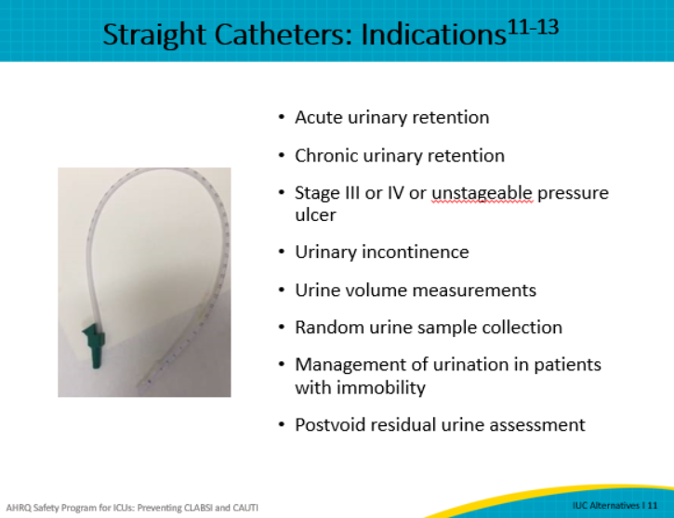
When faced with the incontinent patient, healthcare workers and family members may worry about possible skin breakdown. This possibility can be addressed by:  - Cleaning and drying the area right away after urinating or having a bowel movement.  - Using moisturizing creams can help keep the skin moist  - Avoiding products that contain alcohol, which may irritate the skin.  - Considering using a skin sealant (liquid film-forming acrylateszinc) or moisture barrier to protect the skin from the detrimental effects of urine. Creams or ointments that contain petrolatum-based, dimethicone-based, or zinc oxide–based products serve as excellent moisture barriers.  It is important to involve the wound nurse as soon as needed, especially whenever there is an issue related to skin care. By working collaboratively with a wound care specialist, the ICU nurse can optimize patient care and help prevent skin breakdown. | Slide 12
If the patient does not require hourly intake and output, one strategy studied to determining output is weighing pads. This method is used extensively in newborn nurseries by weighing diapers and can be adapted easily to the adult population. The use of diapers in adults is not recommended except for dignity purposes when the patient is in the chair or walking. The dry pad is subtracted from the wet pad, and the resulting difference equals the volume of urine leaked into the pad.  Compared with the system of documenting the number of incontinent episodes, this improved measurement of urine output can prevent the need for a urinary catheter or facilitate the removal of an indwelling urinary catheter as soon as possible. | Slide 13  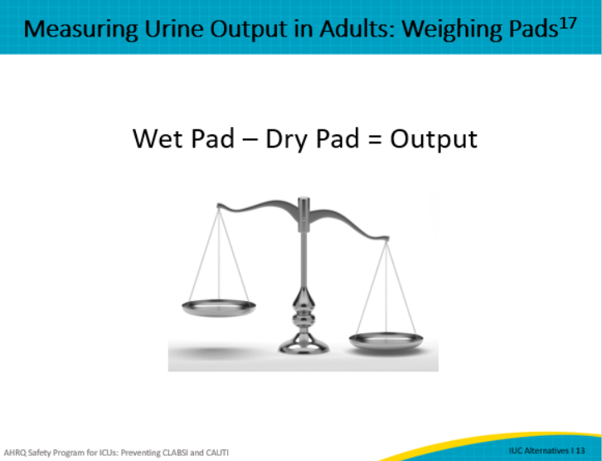
To adequately measure urine and help patients empty their bladder, bedside commodes, bedpans, hats (which are urine collection devices used inside the toilet and urinals) are essential alternatives. Additional planning resources and personnel may be required to ensure that patients are regularly prompted and assisted with voiding or assessed for incontinence. Lifting teams or electronic lifts can help with transferring larger patients to the bedside commode. Consider involving staff from other departments to assist unit staff with scheduled voiding/toileting, such as respiratory, physical, or occupational therapists. | Slide 14  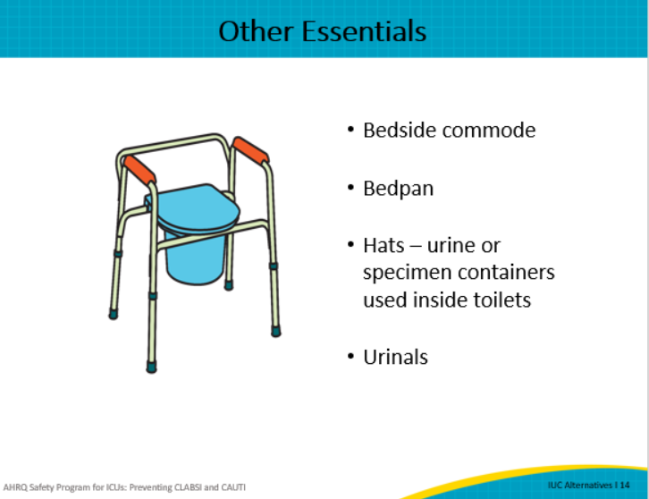
In the ICU, there are a variety of barriers to providing alternatives to the urinary catheter. With competing priorities and time constraints, healthcare providers may not prioritize indwelling urinary catheters as a device that should be assessed before insertion and daily for need, especially in critical care units. There is also a perception that the patient must have a urinary catheter for recording accurate urine output. During training, physicians and nurses are made aware of the advantages of indwelling urinary catheters. However, instructors often do not focus on the associated risks of these devices. This is why unit culture is also important. The culture in a unit can be one that is supportive of timely removal, or it may be one that prioritizes urinary catheter utilization.  Lack of availability and understanding of good alternatives available to provide bladder management and output measurement have contributed to this practice. Bedside nurses are ultimately managing the urinary catheter, and the advantages for them include reducing the amount of time they must spend managing the bladders of their patients and keeping their patients’ skin dry. Thus, they are often reluctant to consider alternatives.  Keeping this in mind, let’s continue with identifying some strategies to overcome these barriers. | Slide 15  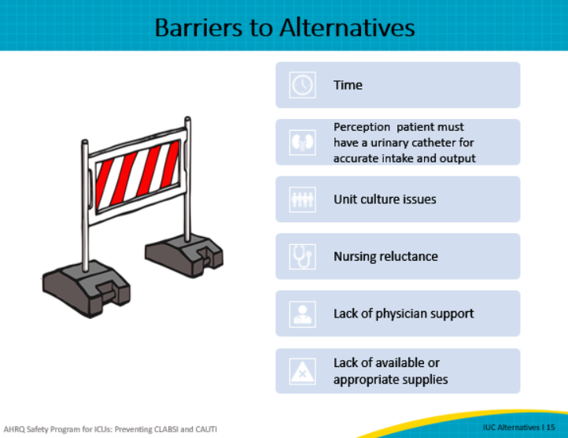
Realizing the many challenges in implementing the use of alternatives, here are some tips. First, physicians and nurses often see interventions differently. They may have different views on the use of certain alternatives. Therefore, including discussions on the use of alternatives during rounds will help bring concerns to the surface and address the issues in real time.  The use of a Comprehensive Unit-based Safety Program team, also referred to as the CUSP team, can help communicate the science behind the alternatives and work to promote team engagement in learning more about benefits of using alternatives to indwelling urinary catheters. If the ICU staff or physicians are resistant to using alternatives, conducting small tests of change might be indicated. | Slide 16
The previous slide suggested including discussions on the use of alternatives during rounds. Multidisciplinary rounds provide an excellent opportunity to verify the need for the catheter, evaluate alternative strategies, ensure post-residual voiding, and educate patients and families. More on this topic can be found in the Making it Work Tip Sheet: Multidisciplinary Rounds.  In order to use alternatives effectively, it is important to have the right people, the right supplies, and effective communication. CAUTI reduction can only be successful with dedicated champions. Engage and empower staff to feel part of the process, including lifting teams, care assistants, and physical therapy.  Bedside commodes, urinals, hats, daily weights, incontinence pads, and skin-care and barrier creams should consistently be made available on supply carts in all nursing units. Involve staff in the decision-making process and allow them to be a part of the trialing and purchasing of alternatives. Education on alternatives and their indications is critical and needs to be provided to all stakeholders.  Use your multidisciplinary rounds to not only evaluate if a catheter may be removed, but also use these rounds to discuss alternatives when the catheter cannot be removed.  Finally, communication at the bedside and among healthcare professionals is key to success. Make sure information flows between units or departments, for instance on transfer from the emergency department on the ICU or from ICU to the floor. | Slide 17  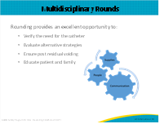
Here are a few take-home points from this module:  - Stop and think critically about whether your patient needs an indwelling urinary catheter or if there are alternatives that may be appropriate  - Accurate intake and output can be achieved without the use of an indwelling urinary catheter  - Educate staff on the use of alternatives and include them in the trialing and selection process  - Include discussion of alternatives in daily rounding | Slide 18
 | Slide 19
AHRQ Pub. No. 17(22)-0019
April 2022

