CAUTI Module:
Indwelling Urinary Catheter Insertion
Facilitator Guide | Slide Number and Image
This module, titled “Indwelling Urinary Catheter Insertion Bundle,” is part of the Agency for Healthcare Research and Quality’s Safety Program for Intensive Care Units (ICUs) and addresses catheter-associated urinary tract infections, also known as CAUTI.  Having appropriate supplies and using an insertion checklist are two common strategies suggested for use during indwelling urinary catheter insertion. However, supplies and checklists do not assure that catheters will be inserted aseptically. Clinicians are often are at a loss as to how to overcome barriers to evidence-based practice.  This module will highlight some barriers that nurses commonly face when inserting indwelling urinary catheters, and will discuss strategies to overcome those barriers. | Slide 1  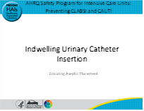
As we begin, it’s important to understand why this topic is worth discussing.  Although CAUTI rates have decreased steadily over several years, in 2020 the National Healthcare Surveillance Network reported a 10 percent increase in CAUTIs in ICUs over 2019. The overall number of CAUTIs in ICUs was 8,436 in 2019 infections compared with 9,633 in 2020. These data were gathered during the COVID-19 pandemic, which  placed a great deal of stress on healthcare facilities. Some reports indicate that during the pandemic, increased utilization of indwelling devices and increased patient acuity led to increases in device-associated infections. | Slide 2  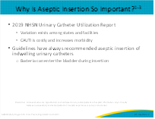

Facilitator Guide | Slide Number and Image
When patients develop a CAUTI, costs during hospitalization increase, and CAUTI adds another illness on top of whatever brought the patient into the hospital, thus increasing morbidity.

No one wants their patient to contract a CAUTI, and guidelines have always recommended aseptic insertion. Healthcare providers want to minimize or prevent harm to patients. But the healthcare system is not configured in a way that aligns with nursing workflow. Nurses develop workarounds to overcome system barriers, but sometimes those workarounds can have unintended consequences.

Here’s a story to illustrate this point:
A 50-year-old female is brought into the emergency department (ED) of a medium-sized community hospital in full-blown pulmonary edema. Her previous history is significant for breast cancer 2 years ago, and as a result of treatment for her cancer she now has heart failure. Knowing that she will be admitted to the ICU, the ED physician “lines” her. Within the space of 20 minutes, she has a central line and indwelling urinary catheter placed, and she is also intubated. It is chaotic in her cubicle, with lots of people doing lots of procedures at the same time. During the catheter insertion, the tip of the urinary catheter inadvertently touches the nurse’s scrub top. The nurse does not get another catheter but instead continues to insert the “dirty” catheter. Four days later in the ICU, the patient has been extubated, but still has the indwelling urinary catheter, and now she also has a fever and has become hypotensive. Blood cultures are positive for E. coli. The patient’s ICU and overall length of stay are significantly lengthened as a result of this complication.
Interventions to prevent CAUTI focus on disrupting the lifecycle of the urinary catheter. So, when discussing and prioritizing ways to prevent CAUTI, the most important step is step 0—avoiding placement of the indwelling urinary catheter. This is the most important intervention, because it is the presence of a catheter that causes CAUTI. If there is no catheter, there is no CAUTI. The Indwelling Urinary Catheter Indications module discusses step 0 in detail.  However, if an indwelling urinary catheter is needed, based on appropriate indications discussed in previous modules, then the next step is to ensure that the catheter is inserted using aseptic technique. This module will focus on that next step, which is ensuring aseptic placement. We call it step 1. Ensuring aseptic insertion, or placement, consists of four components. Before discussing the four components, let’s learn more about the tiered approach to CAUTI prevention activities. | Slide 3  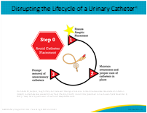
The Department of Veteran Affairs and the University of Michigan worked with a multidisciplinary panel to identify and summarize a tiered approach and prioritize CAUTI prevention activities for hospitals.  Tier 1 focuses on the foundational practices associated with CAUTI reduction by standardizing products, procedures, and practices. This includes placing a catheter only for appropriate reasons, encouraging use of alternatives, ensuring proper aseptic technique, optimizing prompt removal of the catheter, and ensuring culturing stewardship.  If rates remain unacceptably high despite interventions, hospitals are advised to implement tier 2 recommendations. This includes performing a needs assessment, conducting catheter rounds with targeted education, providing feedback of infection rates and catheter use information to frontline staff, observing competency of catheter insertion, and performing a root cause analysis or focused review of CAUTIs. Again, ensuring education and competency for catheter insertion is an important part of this module. | Slide 4  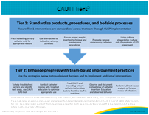
Here are the four components of the insertion bundle. Let’s begin by reviewing the first two: assessing the necessity for an indwelling catheter and encouraging the use of alternatives to an indwelling catheter.  One strategy to make sure that the necessity is assessed is to require staff to document the need for the catheter. A number of facilities with electronic medical record systems have hardwired the process by having a dropdown menu of acceptable indications. When indications are not automatically built into a medical record, organizational policies should reflect appropriate indications for a urinary catheter. Some organizations will post checklists of indications on the urinary catheter kit. Staff need to be empowered to challenge providers when urinary catheters are ordered but not indicated. If staff still encounters resistance, a physician champion or leader should be notified.  Some organizations have used a sticker process with a stop sign on the outside of the kit, which might have a message such as, stop and think – does this patient really need a catheter? Staff should be mindful of the risks and complications associated with urinary catheters.  The second component of the bundle is to encourage the use of alternatives, which are discussed in more depth in the Indwelling Urinary Catheter Alternatives module. Critical thinking is important when considering whether an alternative would be more appropriate. Nurses and other staff should be knowledgeable of appropriate indications and suggest the use of alternatives if indicated.  The first two components occur before a catheter is inserted, which may be surprising. The point here is that by thinking critically about the patient and his or her short-term and longer term urinary management needs, you can proactively prevent the most common healthcare-associated infection, CAUTI.  However, if you determine that an indwelling urinary catheter is clinically indicated, then move on to the third and fourth components of the bundle, which are to use a standard indwelling urinary catheter kit and ensure proper insertion technique. We will spend the remainder of our time on these last two components. | Slide 5  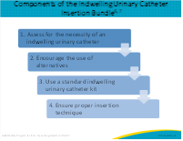
Let’s talk about some of the components of a standard indwelling urinary catheter kit. Although several different types of kits are on the market, it is recommended that a closed-system indwelling urinary catheter insertion kit be used because a closed system eliminates a possible entry route for bacteria.  The supplies in each standardized kit are organized by order of use. In order to maintain aseptic technique, the order of supplies in the kit should mirror the steps outlined in the process.  Frontline staff should provide input into what kind of kits to stock while keeping the patient population in mind. Engaging frontline clinicians in decision making helps to ensure buy-in from the staff.  The decision to remove individual catheters from stock has to be carefully made. Sometimes a larger or smaller sized catheter is needed, depending on the patient’s situation. For female patients, there may be more than one insertion attempt, and the cost of starting again with a whole new kit has to be weighed against the cost of one catheter. For elderly males, a coude catheter may be needed, and these usually do not come prepackaged in a standardized kit. | Slide 6  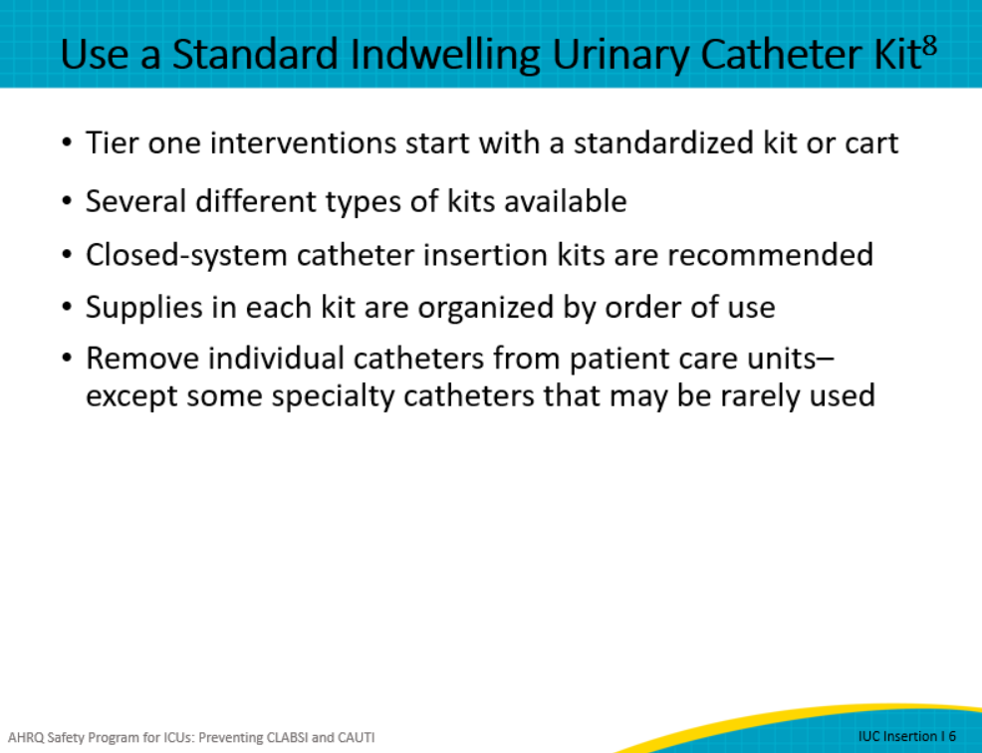
The final step of the indwelling urinary catheter insertion bundle is to ensure proper insertion technique. Evidence-based guidelines have always recommended aseptic insertion technique.  Nurses and other clinicians learn how to insert catheters using the proper technique in very controlled conditions. Even when inserting catheters during clinical rotations, the instructor is often hovering nearby, with a helping hand. In simulation labs, it is easy to find the urethra on female dummies, and male dummies do not have enlarged prostate glands. Physicians, too, learn how to insert catheters on the job. For example, they will catheterize patients in the operating room, which is again, a very controlled and sterile environment. The take-home point is that some of the lessons we learn about how to insert catheters aseptically do not apply once we’re out in the real world.  There are a variety of checklists available that provide structured guidance – making the steps for aseptic insertion easier to follow. In addition, the use of two-person insertion can help to maintain the sterile field. Benefits of this strategy will be addressed in a later slide. | Slide 7  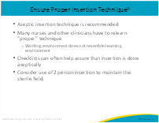
The American Nursing Association (ANA) tool includes an algorithm to help in deciding whether to insert a catheter, as well as a simple checklist to guide the insertion process. You can see that the checklist is divided into sections, with each section consisting of just a few items.  For a catheter insertion, it is helpful to assess if the inserter always follows the correct steps or if they may need a reminder. The need for a reminder is helpful in assessing educational opportunities. The “yes with reminder” is often used in simulation or educational sessions to evaluate competency. | Slide 8
Contrast the ANA checklist with what you see here. This is an example of a very detailed checklist. This checklist is more detailed and is appropriate for use in nursing school or with new nurses who did not get the experience of inserting a urinary catheter during school. The list was created from a procedure by subject matter experts.  Sometimes items on detailed checklists include steps that do not necessarily contribute to aseptic insertion but are included because they are part of the entire process. For example, the row highlighted in yellow here is a procedural step, and fenestrated drapes are included in many standardized kits. However, if you don’t use the fenestrated drape, aseptic insertion is not compromised.  Other checklists are available, but the point is that frontline staff should decide which checklist they want to use because it’s important to use a checklist everyone feels comfortable with.  Staff should have the checklist visible and check off the boxes as they proceed or immediately thereafter if aseptic technique would be compromised.  Staff should modify the checklist based on patient population. No matter what type of checklist you decide to use, it is important to give the inserter a copy of the checklist before he or she does the procedure because the steps on the checklist can serve as a prompt or reminder.  One way to implement an insertion checklist is to use a PDSA (or Plan-Do-Study-Act) cycle. You can learn more about PDSA cycles in the CUSP: Quality Improvement in Action module. | Slide 9
A number of strategies support effective implementation of checklists. First, there should be oversight for catheter insertion by an experienced licensed provider.  Registered nurses (RNs) are responsible for maintenance of indwelling urinary catheters, but unlicensed personnel sometimes insert catheters. If an unlicensed provider is inserting a urinary catheter, the registered nurse must verify that the unlicensed staff person is competent to perform the task. This competency may be part of the initial orientation through both education and return demonstration.  People who educate personnel must be competent by education and experience. In areas or departments where unlicensed personnel are inserting catheters, it may be included in the job description. It is important that the RN supervising the individual ensure that competency is maintained, usually on an annual basis.  The oversight described here is really what we might describe a competency. Competency refers to the knowledge and the skills necessary for the specific task at hand. All persons inserting a catheter should be competent to do so through education and return demonstration.  Having a buddy can keep the patient calm and the field aseptic.  It is also important that the buddy is able to “stop the line” if they see a break in technique either through subtle clues or a specific phrase that does not alarm the patient.  With male patients, especially the more elderly, the answer to this question: “How often do you get up during the night to use the bathroom?” before starting the insertion can help address whether or not there will be resistance due to an enlarged prostate gland (and need for a coude catheter). | Slide 10  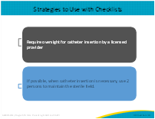
No matter what checklist you use, aseptic insertion comes down to these five elements:  - Set up a sterile field  - Perform hand hygiene immediately before and after insertion  - Use sterile gloves, drapes, and sponges  - Use appropriate antiseptic or sterile solution for peri-urethral cleaning, and a single-use packet of lubricant jelly for catheter tip  - If catheter is accidentally contaminated, discard it, and obtain a new sterile catheter  It may seem simple, but implementing these five elements consistently, in all situations, can be challenging. | Slide 11  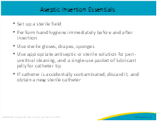
A team of investigators in a large academic medical center in Michigan sought: (1) to determine how frequently major breaks in aseptic insertion technique occur, (2) to identify barriers or facilitators to aseptic insertion, and (3) to identify the number of patients who developed bacteriuria after catheter placement in the ED. They prospectively observed patients who had indwelling urinary catheters inserted for 6 months in the ED of a level 1 trauma center within an academic medical center. During the 6 months of observation on insertion attempts, they found that 59 percent of the attempts had at least one major break in aseptic insertion technique! | Slide 12  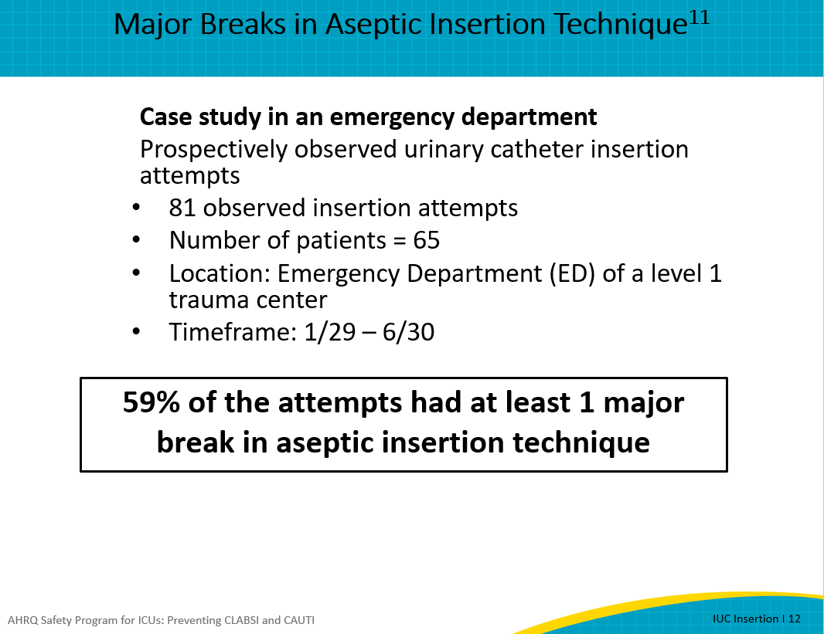
In many cases, there was more than one break in aseptic insertion per case. As discussed in the previous slide, these breaks in aseptic technique include contamination of the sterile field, contamination of the catheter, and breach of the sterile barrier. The examples on this slide show what constitutes each of these breaks in sterility.  So, how is this possible? Many catheter insertions were observed in the trauma bays. A sense of urgency pervades in many EDs, especially in the trauma bays where the sickest patients are triaged. Because of the urgency, clinicians perform multiple procedures at the same time so that patients can be quickly stabilized. As a consequence, though, aseptic technique may be difficult to maintain when multiple staff—in parallel—care for an unstable patient. There is a sense of urgency in the ICU setting as well, especially when a patient “crashes.” ICUs have the same sort of behavior; multiple procedures at once are performed by multiple clinicians, such as two people inserting peripheral IVs, while another is intubating the patient, and yet another is inserting a new arterial line. What if we waited before inserting a urinary catheter? The patient may urinate on the sheets during these other procedures, but the sheets would have to be changed anyway after the other procedures are completed. Urinary catheters do not contribute to patient stabilization, so consider changing your practice to hold off on a catheter insertion until the procedure can be done using aseptic insertion technique. | Slide 13  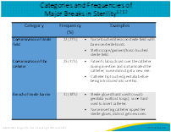
Competency involves the “knowledge, skills, abilities, and behaviors to perform a task correctly and skillfully.” Important points to remember for competency are to have an observation checklist with a process in place to observe a return demonstration of expected skills of the staff.  Develop a process to observe a return demonstration of expected skills of employee’s role (e.g., urinary catheter insertions).  The process should be based include a checklist based upon the policy and procedure. The checklist on slide 9 is a good example of taking the steps in a policy to develop a checklist.  For example, have the staff perform urinary catheter insertions. These could be done upon hire or periodically. This should be a minimum of annually, whenever new products or processes are introduced or when adverse outcomes may identify a performance gap. Ensure that this is included in your hospital’s policy. Remember to define who can insert the catheter. Is it only done by a licensed and experienced staff or can unlicensed staff with training insert the catheter? | Slide 14  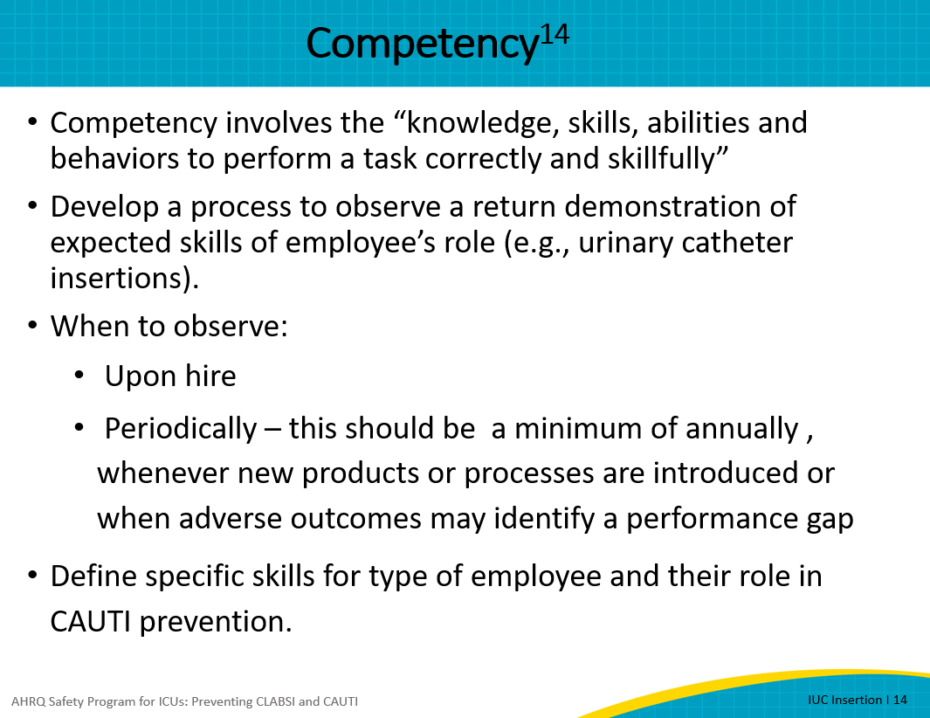
As discussed earlier, the tier 2 interventions focus on planned rounds and specific goals.  Having a nurse expert or champion to lead the rounds helps. It is helpful for this to be the nurse caring for the patient involved and to ask the question, “Does this patient still need the urinary catheter?” | Slide 15  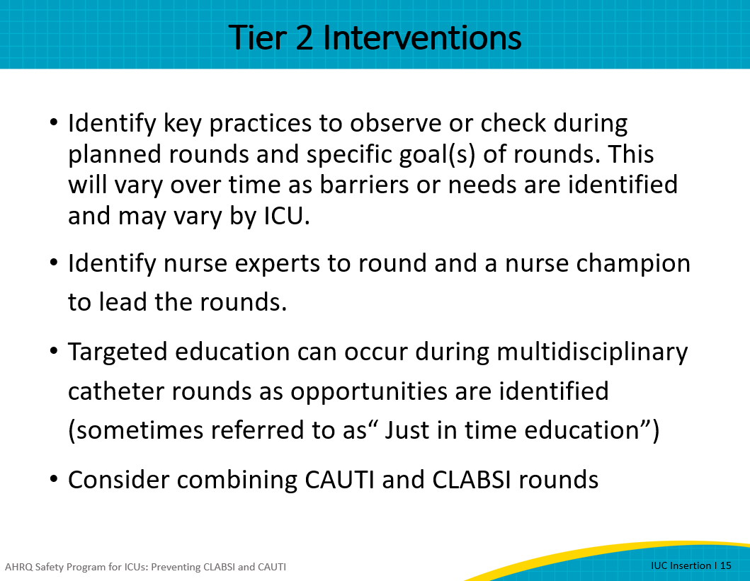
In addition to the context of the situation, which was previously described, these were some of the barriers to aseptic insertion:  - Supplies are not readily available or are not designed to facilitate aseptic insertion. For example, wisps from cotton balls tend to cling to tongs in some kits, so that a new cotton swab becomes contaminated by wisps from the previous swab, so many inserters just discard the tongs without using them. Remember that tongs provide an additional barrier between the inserter’s hand and the patient.  - Some units may find that the work space is not aligned with workflow. Inconsistent or inconvenient locations for hand gel or inconvenient location of sinks can either disrupt workflow. To keep to their workflow routines, clinicians may not use hand gel. If there is little room to set up a sterile field, then there is a greater chance a break in sterility of the field. Be sure to communicate these concerns openly with the leadership and address the issues sooner rather than later.  - When a gap exists due to availability of supplies or limited space, these issues should be brought to the attention of leadership. Various tools exist, including reports to the infection prevention committee, value analysis, or environment of care. Staff should make their medical and nursing leadership aware of the issues and work collaboratively to solve these problems  These barriers, although observed in one ED, are similar to what many ICUs may experience. Ask yourself how many of these barriers that you have confronted. | Slide 16  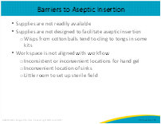
There are a number of strategies to overcome the barriers. These strategies focus on four key areas:  - Having the best type of kit to stock for your ICU’s patient population;  - Making sure you have other necessary supplies, such as over-the-bed tables, hand sanitizers, and sterile gloves;  - Ensuring there are adequate facilities for hand hygiene; and  - Locating the kits so that the kits are easily accessible to where the procedures will take place.  Advocating for products:  Most hospitals have a value analysis or product team. Frequently, this team consists of leaders and staff nurse representation. Nurses can advocate for appropriate kits, sanitizers, and other products through their manager or a representative from the purchasing/value analysis team.  Wall mounted hand hygiene products must meet fire code requirements. However, nurses can work with their safety officer or facility staff to determine if hand gel dispensers can be moved or added.  Nurses should also work with their infection prevention team to help advocate for additional hand hygiene products such as individual size alcohol dispensers that staff members can carry.  Another strategy to overcome the barrier of supplies not readily available include working with other clinical areas that may transfer patients to your ICU. On the floor there should be a few kits stocked with urimeters. Sometimes patients experience a floor crash, and need to be transferred to the ICU. If they come with an indwelling urinary catheter in place that doesn’t have the ability to monitor urinary output hourly, then the system has to be broken or opened to add the urimeter. Also work with ED staff to remind them to anticipate ICU admission and if insertion is necessary, ensure that a kit with a urimeter is used. Alternately, some ICUs ask that admissions from the ED wait until they arrive in the ICU to be catheterized in a more controlled environment.  So, think about ways you can be sure barriers to aseptic insertion can be reduced by sharing these best practices with other clinical areas. | Slide 17  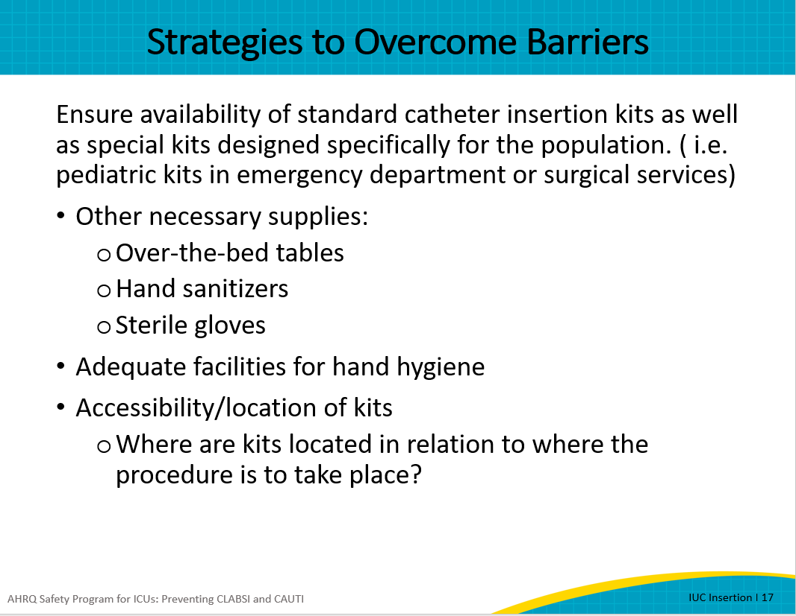
We’ve talked about physical barriers, but there are cognitive barriers as well…too many to be covered in one module! But one cognitive barrier relates to how well we focus on what we are doing. Catheter insertion is a very complex task that involves multiple steps that can be performed incorrectly and create significant harm. With many procedures in the ICU, when a mistake is made blood starts to spurt, or patients stop breathing and turn blue, just as examples. These events evoke a visceral response and serve as a lesson to prevent similar mistakes in the future. But when a mistake is made during urinary catheter insertion, the harm is not immediately apparent.  That is why it is important to be mindful during catheter insertion. Unless we are mindful, we will not be aware of the possible harm we are causing. Mindfulness is a cognitive process that, when applied, can overcome some barriers to aseptic insertion. One way of thinking about mindfulness is as a flexible state of mind “engaged in the present with acute awareness of external events.”  Mindfulness is the process of carefully assessing the task at hand, the potential harm involved when an invasive device is inserted, and a thoughtful approach to preventing that harm. Urinary catheterization is often seen as a task. However, the inserter needs to be mindful that any invasive device can cause harm.  Consider that multiple steps means that something can go wrong at any point in the process. Because this is so common, it does not evoke a visceral response, yet harms are very real. Instead of just performing a task, the person reflects on what that means to the patient and what could go wrong if not performed correctly.  Mindfulness maintains a big-picture view. For example, do we really have to insert this catheter right NOW, or can it wait until the dust settles a bit? | Slide 18  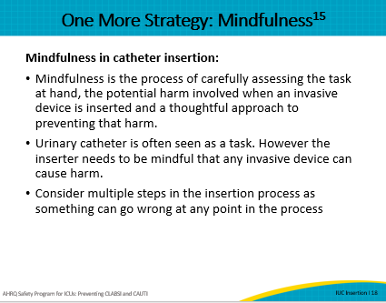
To summarize, the key points from this module are as follows:  Use judgment and critical thinking to decide if an indwelling urinary catheter is really needed in the first place.  Checklists can often help ensure that insertion is done aseptically.  Overcoming barriers to aseptic insertion may require a change in practice such as using checklists or at least reviewing checklists prior to insertion.  Delay catheter insertion until after the patient’s condition has stabilized.  And remember: catheter insertion is a complex task that requires mindfulness! | Slide 19  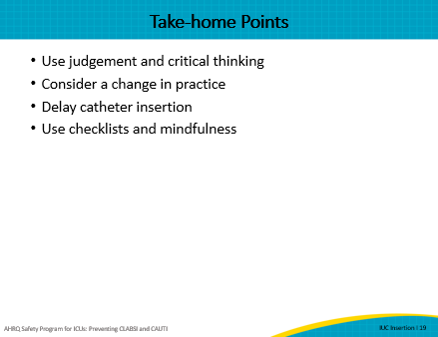
Slide 20
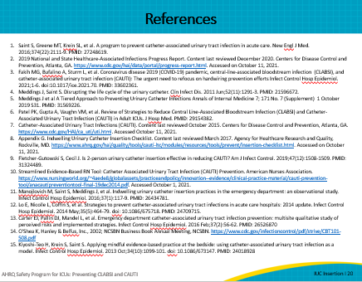
AHRQ Pub. No. 17(22)-0019
April 2022

